*qMTLab*: Software for Data Simulation, Analysis and Visualization

*qMTlab* is a powerful, open source, scalable, easy to use and intuitive tool for qMT data simulation, fitting and analysis. The program consists of two parts: 1) a qMT data simulator, and 2) a qMT data fitting and visualization interface. The simulation part allows end users to easily simulate qMT data using the above described methods, evaluate how well these models perform under known parameters input, determine the most appropriate acquisition protocol and evaluate how fitting constraints impact the results. The data fitting part provides a simple interface to import real-world qMT data, fit them using the selected fitting procedure, and visualize the resulting parameters maps. More advanced users could also use to command line tools used in the background by the GUI to include data fitting in their analysis script.

Table of content

1. Installing qMTLab 2

2. Interface 2

2.1. Menu panel 3

2.1.1. Method 3

2.1.2. qMT Data Fit 3

2.1.3. qMT Data Simulator 3

2.2. Main panel 4

2.3. Options panel 4

2.3.1. Simulation 4

2.3.2. Protocol 4

2.3.3. Fitting 4

3. Data fitting 4

3.1. Data format 6

3.2. Procedure 6

3.3. Viewing the fit results 6

4. SIMULATION 7

4.1. Single Voxel Curve 7

4.1.1. Procedure 7

4.2. Sensitivity Analysis 8

4.2.1. Procedure 8

4.3. Multi Voxel Distribution 9

4.3.1. Procedure 9

4.3.2. Plot types 10

5. Options panel 10

5.1. Simulation 11

5.1.1. bSSFP 11

5.1.2. SIRFSE 12

5.1.3. SPGR 12

5.2. Protocol 12

5.2.1. bSSFP 12

5.2.2. SIRFSE 13

5.2.3. SPGR 13

5.3. Fitting 14

5.3.1. bSSFP 14

5.3.2. SIRFSE 14

5.3.3. SPGR 14

6. Tutorials 14

6.1. Define a new bSSFP protocol. 14

6.2. Define a new SPGR protocol and compute the ‘Sf table’ for the Sled & Pike models 15

6.2.1. Defining the protocol 15

6.2.2. Computing the Sf table 15

6.3. Fitting data using scripts 15

1. Installing qMTLab

qMTLab can be downloaded freely here:

<https://github.com/neuropoly/qMTLab/archive/master.zip>

Alternatively, if you have a GitHub account (free) and wish to contribute to the software, you can go to <https://github.com/neuropoly/qMTLab> and fork the repository to your own account. If you made any contribution to the software that you feel should be included in the master, please do a pull request so that we can include your modifications.

Once you have downloaded the qMTLab-master.zip file, extract its content on your computer, in an easy to access location. Start Matlab, navigate to the folder you just extracted, and in the Command window, type ‘qMTLab’ and hit enter. After a few seconds of loading, you should be presented with a graphical user interface (gui) that will allow you to perform various tasks.

1. Interface

When you first launch *qMTLab*, you will be presented with a blank interface. The interface consists of three columns, or panels. On the left, you have the *Menu panel*, in the center you have the *Main panel*, and on the right, in a separate floating window, you have the *Options panel*.

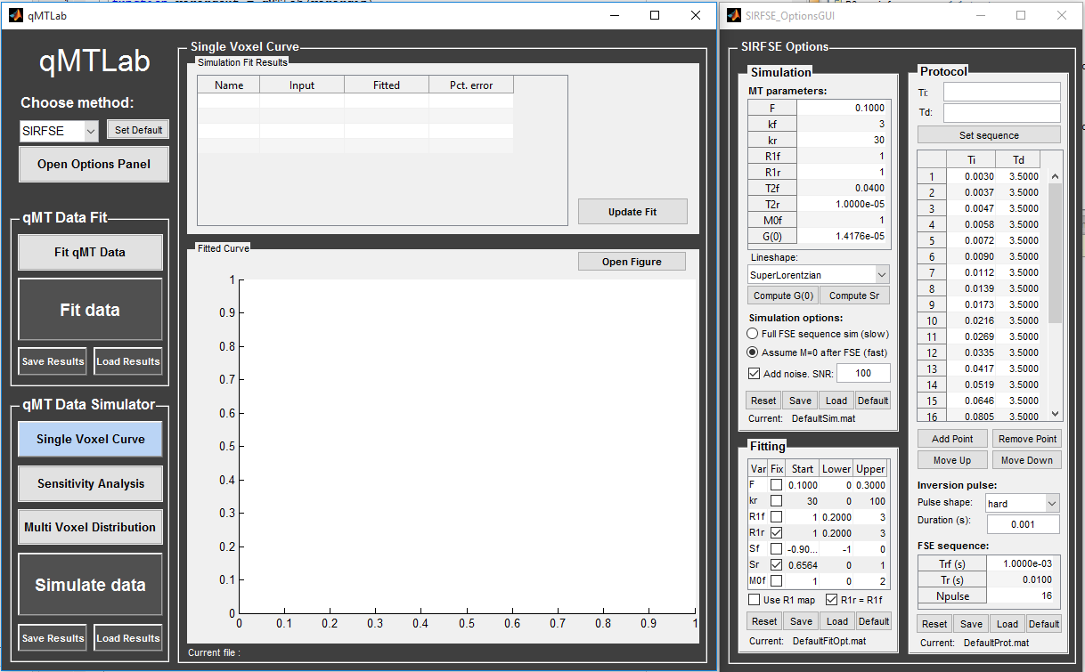

Figure 1 – The qMTLab graphical user interface. Left column: *Menu panel*; Center column: *Main panel*; Right window: *Options panel*.

* 1. Menu panel

The *Menu panel* is where you can choose the task you want to perform. It is divided in three sections: Method, qMT Data Fit and qMT Data Simulator.

* + 1. Method

At the top, you will find a drop-down menu where you can choose the qMT acquisition method that you want to be working with. You can choose between ‘SIRFSE’ for selective inversion recovery-fast spin echo, ‘SPGR’ for the MT spoiled gradient echo or ‘bSSFP’ for balanced steady-state free precession. Note that the *Options panel* will update to the appropriate window according to your selection.

If you plan to be working mainly with a particular method, select it from the drop-down menu first, and the click on the ‘Set Default’ button next to it. Next time you open *qMTLab*, your preferred method will be selected by default.

Clicking on the ‘Open Options Panel’ below the method drop-down menu will open the *Options panel* window and set its position on the right side of the *Main panel*. This is useful to bring back the *Options panel* window to the front if it’s hidden behind another window, to reset its position if you have resized the windows, or to reopen it in case you closed it.

* + 1. qMT Data Fit

Clicking on the light gray ‘Fit qMT Data’ button will change the *Main panel* to the *Fit qMT Data* view. This is where you can load your qMT data files for fitting and for viewing the resulting parameters maps. Refer to section 3 for more information.

Click the big ‘Fit Data’ button only when you have selected your data files, set up your protocol and fitting options and are ready to begin the fitting process, which, depending on the size of your data and the MT method, can take from a few minutes to a couple of hours. The ‘Save Results’ button will prompt you to save a .mat file with the results of your data fit. ‘Load Results’ will load previously saved results and display them.

* + 1. qMT Data Simulator

The three light gray buttons allows you to choose between three different data simulation mode: ‘Single Voxel Curve’, ‘Sensitivity Analysis’ and ‘Multi Voxel Distribution’. Clicking on any one of these buttons will bring the corresponding interface to the *Main panel*. When any of these interface are active, click the big dark gray ‘Simulate Data’ button will launch the simulation using the current setting. The ‘Save Results’ button will prompt you to save a .mat file with the current simulation results. ‘Load Results’ will load previously saved simulation results and display them in the appropriate panel.

The *Single Voxel Curve* panel is a simple interface to simulate MT data from a single voxel, using the defined MT parameters and protocol. It is the fastest way to evaluate various acquisition protocol, the performance of the model and fitting options. Refer to section 4.1 for more information.

The *Sensitivity Analysis* simulation allows you to systematically vary *one* MT parameter, over a defined range and number of points, while keeping the others fixed. For each simulated data point, noise is added with a given SNR, and the fit is run multiple times while adding Gaussian noise. This allows you to evaluate the variance of the fit at each point. When the simulation is done, a plot shows any variable input parameters as the independent variable, as well as the mean values and variance of any fitted parameters. Refer to section 4.2 for more information.

The *Multi Voxel Distribution* is a tool to simulate any number of voxels, where any parameters combination are allowed to be varied simultaneously. You can choose how many voxels to simulate and which parameters are to be normally distributed, with its mean value and variance. The results can be displayed in a number of ways such as distribution histograms, scatter plots of input vs fitted parameters, error histograms, etc. Refer to section 4.3 for more information.

* 1. Main panel

The *Main panel* is where the simulation or fit results are displayed. The view for this panel changes correspondingly to the task selected in the *Menu panel*.

* 1. Options panel

This is where you can set up all the parameters that are related to the simulation, the fitting and the protocol. The *Options panel* is displayed in a separate window than the *Menu panel* or *Main panel*. This is because each qMT acquisition method has its own particular options, and this window needs to be changed correspondingly. It can also be closed at any time, if it is not currently needed, to provide for a simpler interface. The *Options panel* consists of three sub-panels: ‘Simulation’, ‘Fitting’ and ‘Protocol’. At the bottom of all these sub-panels you will find buttons to ‘Reset’ the changes you made, ‘Save’ the current settings as a .mat file, ‘Load’ a .mat file of settings, or go back to the ‘Default’ settings. See section 5 for more information.

* + 1. Simulation

This is where you set up all the options related to the simulations. At the top of this group, the ‘MT parameters’ table is where you define all the parameters that describe the two-pool model of MT. You will also find options that are specific to how the simulation is actually performed. More info in section 5.1.

* + 1. Protocol

Here you define the acquisition protocol that you wish to use for simulation, or in the case of data fitting, the protocol you used to acquire the data. See section 5.2 for more information.

* + 1. Fitting

This is where you set up your fitting options. The fit parameters table lists all the variables that are available for fitting in the current method, a tick box to select which variables are to be held fixed, a starting value and lower/upper bounds. Depending on the method, additional options may be available. See section 5.3 for more information.

1. Data fitting

*qMTLab* provides a convenient interface to fit your qMT data and visualize the parameters maps. To ensure that the results are successful, you’ll need to define the appropriate protocol, as it was used for data acquisition, and to format your qMT data in the way *qMTLab* expect it to be.

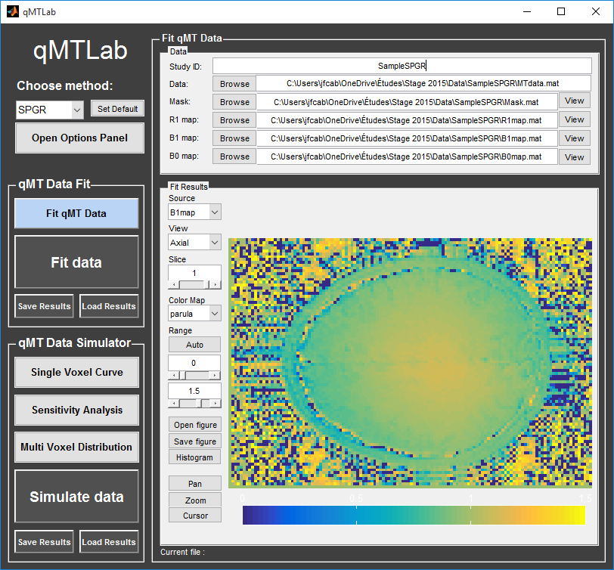

Figure 2 – Data fitting interface, showing a B1 map before the fitting process is started

* 1. Data format

Currently supported file types are .mat and .nii files. Your files should respect the following:

* For .mat files, the name of the file can be anything, but the array it contains should be named appropriately: MTdata (for the actual MT data array) or R1map / B1map / B0map / Mask respectively for a R1 / B1 / B0 or Mask file. Names are case-sensitive.
* For single slice (2D) imaging, MTdata is a 3D array with size [nx, ny, ndata], where nx/ny is the number of voxels in the x/y direction, and ndata is the number of data points for each voxel. For volume imaging (3D), MTdata is a 4D array with size [nx, ny, nz, ndata], where nx/ny/ndata are a above, and nz is the number of voxels in the z direction.
* Other files (R1map / B1map / B0map / Mask) are formatted the same as MTdata, but without the last dimension (ndata).
* In the case of MT-SPGR, MTdata should be **normalized**, i.e. MTdata is m = M/M0, where M is the measured signal when an MT pulse is applied, and M0 is the measured signal using the same acquisition sequence, but without the MT pulse.
* R1map is an (optional) map with actual observed R1 values (in s-1).
* B1map is an (optional) map scaled such that pulse flip angle (α, in degrees) correction at each voxel is given by:  
  α’ = α × B1map.
* B0map is an (optional) map scaled such that pulse offset (Δ, in Hz) correction at each voxel is given by:  
  Δ’ = Δ + B0map.
* Mask is an (optional) logical map with 0 for masked voxels and 1 for voxels to be fitted.
  1. Procedure

1. Select the acquisition method of your qMT data using the ‘Method’ drop-down menu in the *Menu panel*.
2. In the *Menu panel*, click on ‘Fit qMT data’ to display the fitting interface in the *Main panel*.
3. Enter a name for your study in the ‘Study ID’ box.
4. Load your MT data by clicking the browse button beside the ‘Data:’ line, or enter the full file path to it in the textbox.
5. If you have a Mask / R1 / B1 or B0 map, load them using the browse button or by entering the full file path in the appropriate text box. You can view any of these maps by click its ‘View’ button.
6. Define or load the appropriate protocol in the *Options panel* (see section 5.2 for details).
7. Define your fitting options in the *Options panel* (see section 5.3 for details).
8. In the *Menu panel*, click on ‘Fit data’ to start the fitting process.
9. Once the fitting is done, a temporary file will be saved in the ‘FitResults’ subfolder of the current working directory. You can save the current fit results elsewhere by clicking ‘Save Results’ in the ‘qMT data fit’ section of the *Menu panel*.
10. Use the controls in the ‘Fit Results’ section to visualize the results (see section 3.3 for details).

***Note****: You can place all your files (e.g. MTdata.nii, R1map.nii, Mask.nii, Protocol.mat, FitOpt.mat) in a directory, then use the ‘Set working directory’ button to select this directory. All data fields and protocol/fitting options will be filled automatically.*

***Note****: You can preview the fitted curve for a selected voxel by using the “View Data Fit” button. First click ‘View’ beside the MTdata file field, use ‘Cursor’ button to activate voxel selection mode, select a voxel to preview and click ‘View Data Fit’*.

* 1. Viewing the fit results

Once you have finished fitting your qMT data, or when you load previously saved fit results by clicking ‘Load Results’ in the ‘qMT data fit’ section of the *Menu panel*, the maps will be displayed in the ‘Fit Results’ section. Use controls on the left side of the figure to navigate the maps:

* *Source*: select the parameter map to display
* *View*: select the side from which to view the data (available only on 3D maps)
* *Slice*: navigate through the z direction of the current view (available only on 3D maps)
* *Color* *Map*: choose the color scheme to use from a set of pre-defined Malab colormaps
* *Range*: Control the colormap min/max values. Clicking ‘Auto’ will set the min/max values using the min/max of the currently displayed image. Top textbox/slider allows you to manually set the Min value, while bottom textbox/slider are for the Max value
* *Open figure*: open the current figure in a new window
* *Save figure*: save the current figure
* *Histogram*: open a new window with an histogram of the voxels in the currently selected slice (note that zooming in on a particular section while still produce an histogram of the full slice)
* *Pan*: change the cursor mode to ‘Pan’. Click and hold inside the figure to move around. Double click inside the figure to reset view. Clicking again the Pan button will turn off pan mode.
* *Zoom*: change the cursor mode to ‘Zoom’. Click and hold inside the figure to draw a region to zoom in on. Double click inside the figure to reset view. Clicking again the Zoom button will turn off zoom mode.
* *Cursor*: change the cursor mode to ‘Data Cursor’. Click on a voxel to display info (X/Y is the position of the voxel, index is the value of the map at this point, RGB is the mapped color code).
* *View data fit*: display raw data + fitted curve of the currently selected voxel (use ‘Cursor’ button to activate voxel selection mode).
* *Open viewer*: open the current data in an external viewer to display simultaneous axial/sagittal/coronal views.

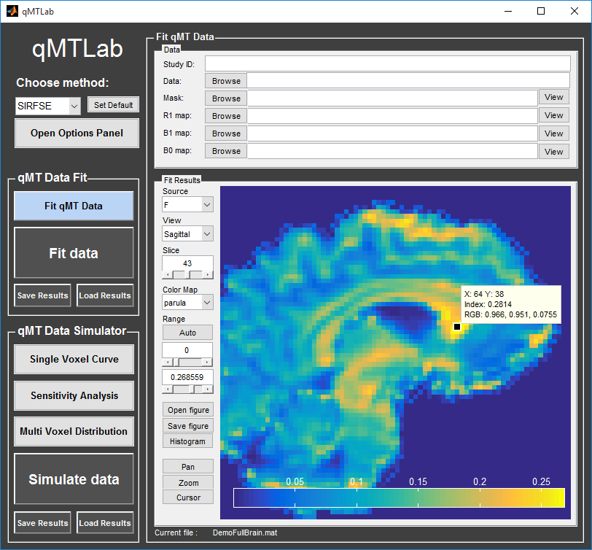

Figure 3 – Fit Results Viewer

1. SIMULATION
   1. Single Voxel Curve

The *Single Voxel Curve* simulation interface allows you to simulate qMT data for the defined MT parameters and protocol. Once the simulation is done, you can also rapidly test the effect of changing fitting options without having to run the simulation again. It is the fastest way to evaluate various acquisition protocol and the performance of the model and fitting options. A plot of the fitted curve over the actual data will be displayed, and the resulting fitted parameters are compared to the input parameters.

* + 1. Procedure

1. Select the acquisition method of your qMT data using the ‘Method’ drop-down menu in the *Menu panel*.
2. In the *Menu panel*, click on ‘Single Voxel Curve’ to display the interface in the *Main panel*.
3. Using the *Options panel*, define or load your simulation parameters (see section 5.1).
4. Using the *Options panel*, define or load the protocol you wish to use (see section 5.2).
5. Using the *Options panel*, define or load your initial fitting options (see section 5.3).
6. In the *Menu panel*, click on the big ‘Simulate data’ button. A progress bar will appear to show the progression of the simulation. Clicking ‘Cancel’ in the progress bar window will stop the current simulation.
7. Once the simulation is done, the results are displayed in the *Main panel*.
8. If you want to see the effect of changing fitting options, use the *Options panel* to make your changes. Then, in the *Main panel* inside the ‘Simulation Fit Results’ panel, click on ‘Update Fit’. Clicking this buttons without changing fitting options will also generate a new noisy data distribution and recalculate the fitted curve.
9. Once the fitting is done, a temporary file (SimCurveTempResults) will be saved in the ‘SimResults’ subfolder of the current active method (e.g.qMTLab/ SPGR/SimResults/). You can save the current simulation results by clicking ‘Save Results’ in the ‘qMT Data Simulator fit’ section of the *Menu panel*. You can later load it using the ‘Load Results’ button.

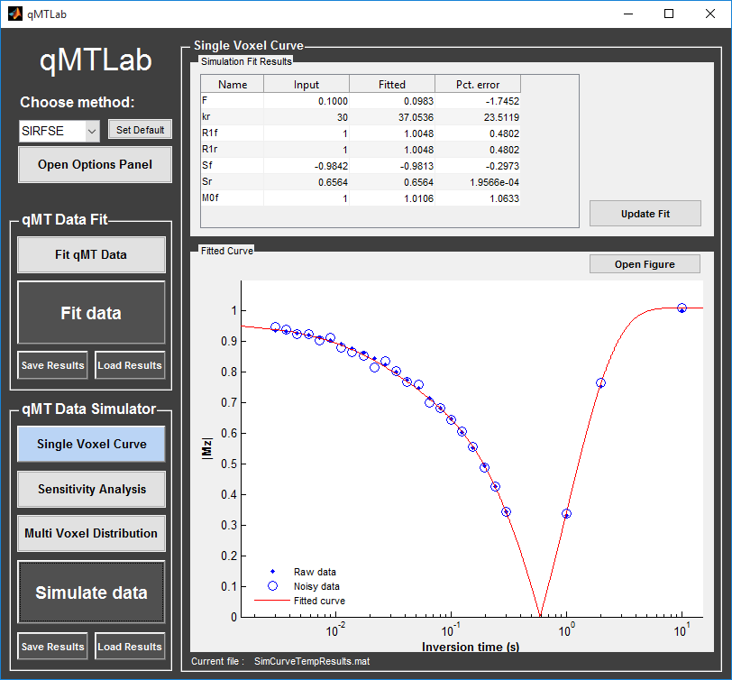

Figure 4 – The *Single Voxel Curve* interface, showing the results of a simulated SIR-FSE voxel.

* 1. Sensitivity Analysis

The *Sensitivity Analysis* simulation allows you to systematically vary *one* MT parameter, over a defined range and number of points, while keeping the others fixed. For each simulated data point, noise is added with a given SNR, and the fit is run multiple times while adding gaussian noise. This allows you to evaluate the variance of the fit at each point. When the simulation is done, a plot shows any variable input parameters as the independent variable, as well as the mean values and variance of any fitted parameters.

* + 1. Procedure

1. Select the acquisition method of your qMT data using the ‘Method’ drop-down menu in the *Menu panel*.
2. In the *Menu panel*, click on ‘Sensitivity Analysis’ to display the interface in the *Main panel*.
3. Using the *Options panel*, define or load your simulation parameters (see section 5.1). The MT parameters defined here are used as the fixed parameters values as one parameter at a time is systematically varied during the simulation process.
4. Using the *Options panel*, define or load the protocol you wish to use (see section 5.2).
5. Using the *Options panel*, define or load your fitting options (see section 5.3).
6. In the *Main panel*, use the ‘Parameters variation’ table to define your analysis settings. Select the parameters that are to be varied by setting a mark in the appropriate checkbox, set the minimum and maximum values for this parameter under the column ‘Min’ and ‘Max’, and the size of the incrementing step under ‘Step’. Set the number of times you want to add noise and fit for each data point by entering an integer value in the ‘# of runs’ box. These settings can be saved, retrieved or reset to their initial settings using the ‘Save’, ‘Load’ and ‘Reset’ buttons respectively.
7. In the *Menu panel*, click on the big ‘Simulate data’ button. A progress bar will appear to show the progression of the simulation. Clicking ‘Cancel’ in the progress bar window will stop the current simulation.
8. Once the simulation is done, the results are displayed in the ‘Plot Results’ section in the *Main panel*. Using the ‘x axis’ and ‘y axis’ dropdown menu, you can change the independent/dependant parameters respectively. The parameters that have been varied will be available under the ‘x axis’ menu, while all the model parameters will be available under the ‘y axis’ menu.
9. A temporary file (SimVaryTempResults) will be saved in the ‘SimResults’ subfolder of the current active method (e.g. qMTLab/SPGR/SimResults/). You can save the current simulation results by clicking ‘Save Results’ in the ‘qMT Data Simulator fit’ section of the *Menu panel*. You can later load it using the ‘Load Results’ button.

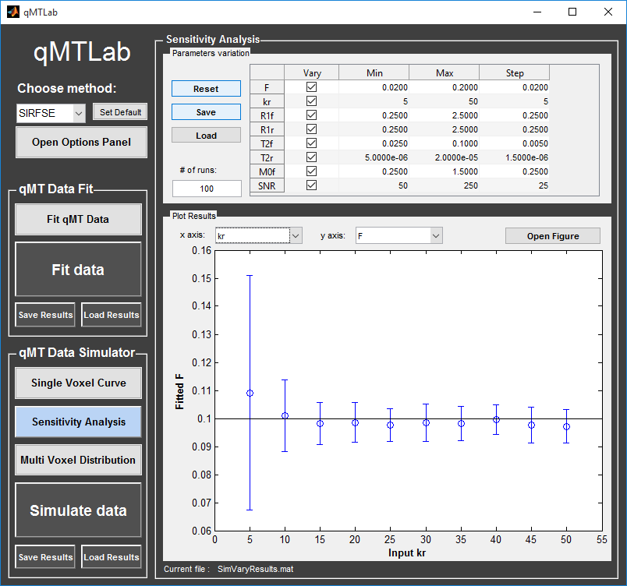

Figure 5 - The *Sensitivity Analysis* interface, showing the results of SIR-FSE simulation.

* 1. Multi Voxel Distribution

The *Multi Voxel Distribution* is a tool to simulate any number of voxels, where any combination of parameters are allowed to be varied simultaneously. You can choose how many voxels to simulate and which parameters are to be normally distributed, with its mean value and variance. The results can be displayed in a number of ways such as distribution histograms, scatter plots of input vs fitted parameters, error histograms, etc.

* + 1. Procedure

1. Select the acquisition method of your qMT data using the ‘Method’ drop-down menu in the *Menu panel*.
2. In the *Menu panel*, click on ‘Multi Voxel Distribution’ to display the interface in the *Main panel*.
3. Using the *Options panel*, define or load your simulation parameters (see section 5.1). The MT parameters defined here are used as the fixed parameters values for parameters that are not selected to be varied.
4. Using the *Options panel*, define or load the protocol you wish to use (see section 5.2).
5. Using the *Options panel*, define or load your fitting options (see section 5.3).
6. In the *Main panel*, use the ‘Parameters distribution’ table to define your distribution settings. Select the parameters that are to be varied by setting a mark in the appropriate checkbox, set the mean and standard deviation values for this parameter under the column ‘Mean’ and ‘Std’ respectively. Set the number of voxels you want to simulate by entering an integer value in the ‘# of voxels’ box. These settings can be saved, retrieved or reset to their initial settings using the ‘Save’, ‘Load’ and ‘Reset’ buttons respectively.
7. Click on ‘Get Parameters’ in the ‘Parameters distribution’ section to generate a set of normally distributed parameters using the current settings. You can look at the distribution in the ‘Plot Results’ section, by choosing ‘Input parameters’ under the ‘Plot type’ dropdown menu. Select the parameters you want to look at with the ‘x axis’ dropdown menu. You can generate a new set of random values by clicking on the ‘Get Parameters’ button again.
8. In the *Menu panel*, click on the big ‘Simulate data’ button. A progress bar will appear to show the progression of the simulation. Clicking ‘Cancel’ in the progress bar window will stop the current simulation.
9. Once the simulation is done, the results are displayed in the ‘Plot Results’ section in the *Main panel*. Using the ‘Plot type’ dropdown menu, choose what plot you want to view. Plot types are defined below.
10. A temporary file (SimRndTempResults) will be saved in the ‘SimResults’ subfolder of the current active method (e.g. qMTLab/SPGR/SimResults/). You can save the current simulation results by clicking ‘Save Results’ in the ‘qMT Data Simulator fit’ section of the *Menu panel*. You can later load it using the ‘Load Results’ button.
    * 1. Plot types

Different plot types are available to analyze your simulation results. Depending on the plot type, available selections under ‘x axis’ and ‘y axis’ dropdown menus will change accordingly.

* *Input parameters*: Histogram of initial input parameters distribution.
* *Fit results*: Histogram of fitted parameters distribution.
* *Input vs. Fit*: Scatter plot of input parameter value vs fitted value.
* *Error*: Histogram of the error distribution. Error is defined as: $Fit-Input$
* *Pct error*: Histogram of the percentage error distribution. Percentage error is defined as: $100×(Fit-Input)/Input$
* *MPE*: Bar graph of the mean percentage error, defined as: $\frac{100}{n}\sum{(\frac{Fit-Input}{Input}})$, where *n* is the number of simulated voxels.
* *RMSE*: Bar graph of the root mean squared error, defined as: $\sqrt{1/n\sum{{\left(Fit-Input\right)}^{2}}}$, where *n* is the number of simulated voxels.
* *NRMSE*: Bar graph of the normalized root mean squared error, defined as $\frac{RMSE}{\max\left(Input\right)-\min\left(Input\right)}$, where *max(Input)* is the maximum value in the input parameter distribution, and *min(Input)* is the minimum value.

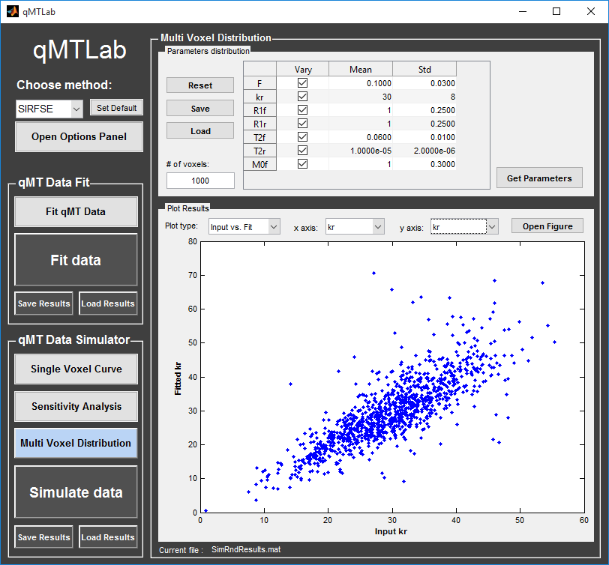

Figure 6 – The *Multi Voxel Distribution* interface.

1. Options panel

Each qMT acquisition method has its own particular options for simulation, protocol and fitting. These options can be modified by using the *Options panel*. The *Options panel* consists of three sub-panels of options: ‘Simulation’, ‘Fitting’ and ‘Protocol’. At the bottom of all these sub-panels you will find buttons to ‘Reset’ the changes you made, ‘Save’ the current settings as a .mat file, ‘Load’ a .mat file of settings, or go back to the ‘Default’ settings.

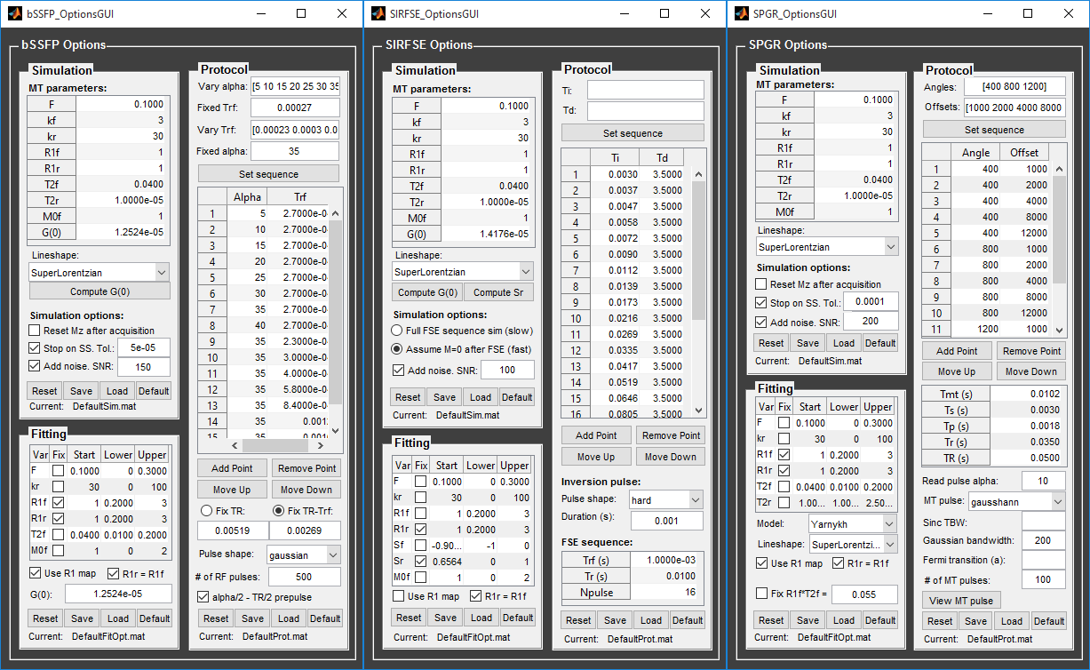

Figure 7 – The *Options panel* interface. Left: bSSFP options, center: SIRFSE options, right: SPGR options.

* 1. Simulation

The ‘Simulation’ panel allows you to define the parameters used for the simulations. Edit the values in the ‘MT parameters’ table to set the physical properties of the model. The MT parameters common to all methods are:

* *F*: Ratio of number of restricted pool to free pool, defined as F = M0r/M0f = kf/kr.
* *kf*: Exchange rate from the free to the restricted pool (note that kf and kr are related to one another via the definition of F. Changing the value of kf will change kr accordingly, and vice versa).
* *kr*: Exchange rate from the restricted to the free pool.
* *R1f*: Longitudinal relaxation rate of the free pool (R1f = 1/T1f)
* *R1r*: Longitudinal relaxation rate of the restricted pool (R1r = 1/T1r)
* *T2f*: Transverse relaxation time of the free pool (T2f = 1/R2f)
* *T2r*: Transverse relaxation time of the restricted pool (T2r = 1/R2r)
* *M0f*: Size of the free pool at equilibrium.
* *Lineshape*: The absorption lineshape of the restricted pool. Available lineshapes are: Gaussian, Lorentzian and SuperLorentzian.

Other MT parameters and simulation options specific to each method are described below.

* + 1. bSSFP
* *G(0)*: bSSFP is an on-resonance method. You can specify the restricted pool absorption value on resonance G(0) in the MT parameters table, or click on the ‘Compute G(0)’ button below the lineshape dropdown menu to compute its value given the current lineshape and T2r.
* *Reset Mz after acquisition*: Checking this box will reset Mzf and Mzr to their equilibrium value M0f and M0r after each data point. Leaving this box unchecked starts the simulation for each data point with the Mzf and Mzr values that was reached at the end of the previous data point. This is the equivalent of setting a delay between each data point acquisition so that magnetization returns to equilibrium, or to acquire each data point successively without delay.
* *Stop on SS.*: Checking this box will tell the simulator to check when steady-state (SS) is reached. If SS is achieved before the maximum number of RF pulses set in the protocol, the simulation will stop there. This should make the simulation time shorter. Leaving this box unchecked will run the simulation up to the number of RF pulses set in the protocol.
* *Tol.*: This is the steady-state tolerance criterion, in the case that *Stop on SS* is selected. If the relative difference between successive pulses readout (|Mn+1-Mn|/Mn) is less than or equal to the tolerance value for five consecutive pulses, then SS is reached.
* *Add noise*: Checking this box will add Gaussian noise to the simulated data.
* *SNR*: The signal to noise ratio used when *Add noise* is selected.
  + 1. SIRFSE
* *G(0)*: SIRFSE is an on-resonance method. You can specify the restricted pool absorption value on resonance G(0) in the MT parameters table, or click on the ‘Compute G(0)’ button below the lineshape dropdown menu to compute its value given the current lineshape and T2r.
* *Compute Sr*: This will perform a simulation of the inversion pulse, using the currently defined inversion pulse settings in the protocol and the G(0) value. The simulated fraction of magnetization after vs before the inversion pulse for the restricted pool (Sr = Mzr+/Mzr-) will be set as the starting value for Sr in the ‘Fitting’ table.
* *Full FSE sequence*: Perform the simulation of all the pulses in the fast spin echo (FSE) readout sequence. This simulation is much slower and should be performed only to test the validity of the M=0 assumption for specific cases.
* *Assume M=0 after FSE*: Skip the simulation of the FSE sequence and assume Mzf = Mzr = 0 after it.
* *Add noise*: Checking this box will add Gaussian noise to the simulated data.
* *SNR*: The signal to noise ratio used when *Add noise* is selected.
  + 1. SPGR
* *Reset Mz after acquisition*: Checking this box will reset Mzf and Mzr to their equilibrium value M0f and M0r after each data point. Leaving this box unchecked starts the simulation for each data point with the Mzf and Mzr values that was reached after the previous data point. This is the equivalent of simulating a delay between each data point acquisition so that magnetization returns to equilibrium, or to acquire each data point successively without delay.
* *Stop on SS.*: Checking this box will tell the simulator to check that steady-state (SS) is reached. If SS is achieved before the maximum number of RF pulses set in the protocol, the simulation will stop there. This should make the simulation time shorter. Leaving this box unchecked will run the simulation up to the number of RF pulses set in the protocol.
* *Tol.*: This is the steady-state tolerance criterion in the case that *Stop on SS* is selected. If the relative difference between successive pulses readout (|Mn+1-Mn|/Mn) is less than or equal to the tolerance value for five consecutive pulses, then SS is reached.
* *Add noise*: Checking this box will add Gaussian noise to the simulated data.
* *SNR*: The signal to noise ratio used when *Add noise* is selected.
  1. Protocol

The ‘Protocol’ panel is where you define all options relating to the acquisition sequence. These options are specific for each method. For all methods, you will find (at the top of the protocol panel) input text fields corresponding to the independent variables. You can enter a Matlab expression defining a vector in these boxes before clicking on ‘Set sequence’ to fill the sequence table automatically. You can then edit the sequence table manually if you need to add/remove or reorder specific points.

\**Important*: The protocol that is used for simulation or data fitting is *as it is defined in the sequence table*. Input text fields at the top of the protocol panel (above the ‘Set sequence’ button) are there only to give a practical way of quickly filling in the sequence table, without having to enter each point values individually.

* + 1. bSSFP

The independent variables for this method are the flip angle (α) and duration (Trf) of the RF pulses. The sequence can be defined in two part: 1- Vary α with a fixed Trf; 2- Vary Trf with a fixed α. From top to bottom, the protocol panel elements are:

* *Vary alpha:* Input text field used to define the flip angles used for the ‘vary α’ part of the sequence.
* *Fixed Trf:* Input text field used to define the fixed Trf value used for the ‘vary α’ part of the sequence.
* *Vary Trf:* Input text field used to define the Trf used for the ‘vary Trf’ part of the sequence.
* *Fixed alpha:* Input text field used to define the fixed α value used for the ‘vary Trf’ part of the sequence.
* *Set sequence*: Click this button to fill the sequence table by evaluating the expressions entered in the fields above. (See important note).
* *Sequence table*: This table contains the values of Alpha and Trf that will be used, in the order they will be used.
* *Add point*: Add an empty row below the selected point. If no point in the sequence table is selected, an empty row is added after the last point.
* *Remove point*: Remove the selected point. If no point in the sequence table is selected the last point of the sequence is removed.
* *Move up:* Move the selected point up in the sequence table.
* *Move down*: Move the selected point down in the sequence table.
* *Fix TR:* Select this options and enter a value in the text box below to set a fixed repetition time.
* *Fix TR-Trf:* Select this options and enter a value in the text box below to set a fixed free precession time (TR-Trf).
* *Pulse shape*: Select the shape of the RF pulses. Available options are: hard, gaussian, gausshann (gaussian pulse with Hanning window), sinc, sinchann (sinc pulse with Hanning window), sincgauss (sinc pulse with gaussian window) and fermi.
* *# of RF pulses*: Enter the number of RF pulses applied before readout.
* *Alpha/2 – TR/2 prepulse*: Perform an α/2 – TR/2 prepulse before each series of RF pulses.
  + 1. SIRFSE

The independent variables for this method are the inversion times (Ti) and the delay times (Td). From top to bottom, the protocol panel elements are:

* *Ti*: Input text field used to define the inversion times.
* *Td*: Input text field used to define the delay times.
* *Set sequence*: Click this button to fill the sequence table by evaluating the expressions entered in the fields above. (See important note).
* *Sequence table*: This table contains the values of Ti and Td that will be used, in the order they will be used.
* *Add point*: Add an empty row below the selected point. If no point in the sequence table is selected, an empty row is added after the last point.
* *Remove point*: Remove the selected point. If no point in the sequence table is selected the last point of the sequence is removed.
* *Move up:* Move the selected point up in the sequence table.
* *Move down*: Move the selected point down in the sequence table.
* *Inversion pulse - Pulse shape*: Select the shape of the inversion pulse. Available options are: hard, gaussian, gausshann (gaussian pulse with Hanning window), sinc, sinchann (sinc pulse with Hanning window), sincgauss (sinc pulse with gaussian window) and fermi.
* *Inversion pulse – Duration:* Enter the duration of the inversion pulse.
* *FSE sequence –* *Trf*: Duration of the pulses in the FSE sequence.
* *FSE sequence –* *Tr*: Delay between the pulses in the FSE sequence.
* *FSE sequence – NPulse:* Number of refocusing pulses in the FSE sequence.
  + 1. SPGR

The independent variables for this method are the MT pulse power (angles) and offset frequencies. From top to bottom, the protocol panel elements are:

* *Angles*: Input text field used to define the MT pulses angles.
* *Offsets*: Input text field used to define the offset frequencies.
* *Set sequence*: Click this button to fill the sequence table by evaluating the expressions entered in the fields above. (See important note).
* *Sequence table*: This table contains the Angles and Offsets values that will be used, in the order they will be used.
* *Add point*: Add an empty row below the selected point. If no point in the sequence table is selected, an empty row is added after the last point.
* *Remove point*: Remove the selected point. If no point in the sequence table is selected the last point of the sequence is removed.
* *Move up:* Move the selected point up in the sequence table.
* *Move down*: Move the selected point down in the sequence table.
* *Tmt*: Duration of the MT pulses.
* *Ts*: Free precession delay between the MT and excitation pulses.
* *Tp*: Duration of the excitation pulse.
* *Tr*: Free precession delay after the excitation pulse, before the next MT pulse.
* *TR*: Repetition time of the whole sequence. Calculated automatically from the above (TR = Tmt+Ts+Tp+Tr). If a value is entered in this field, the Tr field is changed accordingly (Tr = TR-Tmt-Ts-Tp).
* *Read pulse alpha*: Flip angle of the excitation pulse.
* *MT pulse*: Select the shape of the MT pulse. Available options are: hard, gaussian, gausshann (gaussian pulse with Hanning window), sinc, sinchann (sinc pulse with Hanning window), sincgauss (sinc pulse with gaussian window) and fermi.
* *Sinc TBW*: Time-bandwidth product for the sinc MT pulses (applicable to sinc, sincgauss, sinchann MT pulses).
* *Gaussian bandwidth*: Bandwidth of the gaussian MT pulse (applicable to gaussian, gausshann and sincgauss MT pulses).
* *Fermi transition (a)*: ‘a’ parameter (related to the transition width) of the Fermi pulse (applicable to fermi MT pulse).
* *# of MT pulses*: Enter the number of pulses used to achieve steady-state before a readout is made.
* *View MT pulse*: Open a plot of the MT pulse as it is currently defined. In the MT-SPGR method, it is very important that the MT pulse is exactly defined as it was applied in acquisition. Plotting the pulse allows you to check it is correctly defined.
  1. Fitting

The ‘Fitting’ panel is where you define your fit options. For all methods you will find these options in the fitting panel:

* *Fit parameters table*: Using the fit parameters table, you can choose which model parameters are to be held fixed (at the value under the ‘Start’ column) by checking the ‘Fix’ box beside the parameter name. You can constrain the fit range by entering minimum and maximum values in the ‘Lower’ and ‘Upper’ column.
* *Use R1 map*: By checking this box, you tell the fitting algorithm to check for an observed R1 map and use its value to constrain R1f. Checking this box will automatically set the R1f fix box to true in the Fit parameters table. In the case of simulations, if this options is selected, an ‘observed’ R1 value will be simulated by using the MT parameters defined in the ‘Simulation’ panel.
* *R1r = R1f*: By checking this box, you tell the fitting algorithm to fix R1r equal to R1f. Checking this box will automatically set the R1r fix box to true in the Fit parameters table.

Additional options for each methods are described below.

* + 1. bSSFP

*G(0)*: The assumed value of the absorption lineshape of the restricted pool.

* + 1. SIRFSE

No additional options. Note that the ‘Sr’ value in the fit parameters table can be calculated with the ‘Compute Sr’ button in the ‘Simulation’ panel.

* + 1. SPGR
* *Model:* Select the model you want to use for fitting. Available models are: SledPikeRP (Sled & Pike rectangular pulse), SledPikeCW (Sled & Pike continuous wave), Yarkykh (Yarnykh & Yuan) and Ramani. Sled & Pike models will show different options than Yarnykh or Ramani.
* *Load Sf table* (SledPikeRP or SledPikeCW): Choose the pre-computed Sf table to use. The table must correspond to the actual MT pulse parameters, as defined in the ‘Protocol’ panel.
* *Build Sf table* (SledPikeRP or SledPikeCW): Perform the simulation to compute the Sf table by using the actual MT pulse parameters and sequence, as defined in the ‘Protocol’ panel. The simulation will compute Sf values for every combination of unique angles and offsets found in the sequence table, and for 20 linearly space T2f between the ‘lower’ and ‘upper’ values defined in the fit parameter table (see example ??? for details).
* *Fix R1f*T2f* (Yarnykh or Ramani): Check this box and enter a value in the text box to fix the product R1f×T2f to a constant value. This will constrain the fit of T2f (T2f will be fixed by T2f = (R1f×T2f)/R1f).

1. Tutorials
   1. Define a new bSSFP protocol.

Suppose you have a bSSFP acquisition protocol that vary alpha from 10° to 45° by a step of 5° with a fixed Trf duration of 0.3ms followed by 10 variable Trf logarithmically spaced from 0.1ms to 10ms with a fixed alpha of 35° and an additional last point with alpha = 35 and Trf = 25ms. Your sequence uses a fix TR-Trf value of 3ms, and 400 gaussian pulses, with an α/2 – TR/2 prepulse.

* Enter “10:5:45” (without quotes) in the ‘Vary alpha’ input text field.
* Enter “3e-4” (without quotes) in the ‘Fixed Trf’ input text field.
* Enter “logspace(-4,-2,10)” (without quotes) in the ‘Vary Trf’ input text field.
* Enter “35” (without quotes) in the ‘Fixed alpha’ input text field.
* Click on ‘Set sequence’. The sequence table is automatically filled with.
* Click on ‘Add Point’ to add an empty row as the last point in the sequence table.
* Edit the values in this last row to “35” and “0.025” in the alpha and Trf columns respectively.
* Select the ‘Fix TR-Trf’ radio button and enter 0.003 in the text box below.
* Select ‘gaussian’ in the Pulse shape menu.
* Enter 400 in the ‘# of RF pulses’ box.
* Check the alpha/2 – TR/2 checkbox.
* You can now save this protocol for later use by clicking on the ‘Save’ button.
* If you want this to be your default protocol, save it as ‘DefaultProt.mat’, replacing the existing file in the /bSSFP/Parameters folder. This protocol will now be loaded by default each time you launch qMTLab, or when you click on ‘Default’ in the Protocol panel.
  1. Define a new SPGR protocol and compute the ‘Sf table’ for the Sled & Pike models
     1. Defining the protocol

Suppose you have an MT-SPGR protocol that uses three MT pulse power: 400°, 800° and 1200° and offsets of 2000, 4000 and 8000 Hz for each of the three pulse power. MT pulses are Hanning-windowed gaussian of 10ms and bandwidth of 200 Hz, and repetition time is 50ms, with 600 repetition. Excitation pulse angle is 7° with duration 1ms, delay between MT pulse and excitation is 2ms.

* Enter “[400 800 1200]” (without quotes) in the ‘Angles’ input text field.
* Enter “[2000 4000 8000]” (without quotes) in the ‘Offsets’ input text field.
* Click on ‘Set sequence’. The sequence table is automatically filled with.
* Enter these values in the timing table: Tmt = 0.01, Ts = 0.003, Tp = 0.001, TR = 0.05 (Tr is set automatically to (Tr = TR-Tmt-Ts-Tp = 0.0360)
* Enter 7 in the ‘Read pulse alpha’ box.
* Select ‘gausshann’ in the ‘MT pulse’ menu.
* Enter 200 in the ‘Gaussian bandwidth’ box.
* Enter 600 in the ‘# of MT pulses’ box.
* Click on the ‘View MT pulse’ to view the shape of the MT pulse (normalized to 1).
* You can now save this protocol for later use by clicking on the ‘Save’ button.
* If you want this to be your default protocol, save it as ‘DefaultProt.mat’, replacing the existing file in the /SPGR/Parameters folder. This protocol will now be loaded by default each time you launch qMTLab, or when you click on ‘Default’ in the Protocol panel.
  + 1. Computing the Sf table

If you want to use the Sled & Pike CW or RP model for fitting, you will need to compute the ‘Sf table’ that corresponds to your protocol. ‘Sf’ represents the effect of the MT pulse on the free pool as an instant saturation fraction. This effect depends on the MT pulse shape, duration, power, offset and on T2f. Simulating this effect for a range of T2f and MT pulse offset and power in advance allows to fit the data more rapidly by looking up the value in a table. The fitting algorithm will interpolate between precomputed values to fit for T2f. The ‘Compute Sf’ button in the Protocol panel will run the simulation and build the table by using the MT pulse offsets and flip angles that are defined in the Sequence table. Since the table will be used to *interpolate*, and not *extrapolate*, and because actual offsets and power can vary up and down during an experiment due to B1 and B0 inhomogeneities, the program automatically extend the range of offsets and flip angles in the computation of the Sf table. To build the Sf table, first define your protocol as described above, then click on ‘Builf Sf table’. The program will ask you to confirm that you want to compute the Sf table using the current protocol. Click ‘Start’. You will then be asked to save the protocol, as the Sf table will be included inside the protocol file.

* 1. Fitting data using scripts

When you have multiple data sets that you want to fit, and your protocol and fitting options are already set up, you might want to process your files using scripts instead of the GUI. Scripting with qMTLab is very straightforward. You need to load your Protocol.mat, FitOpt.mat and data files, and call the function ‘FitData’. See for example the folder qMTLab/Data/SPGR_demo/, which contains a sample of a single slice brain dataset. A script file ‘FitDemo.m’ shows how to call the function :

%%%%%%%%%%%% FitDemo.m %%%%%%%%%%%%

clear; clc;

Protocol = load('Protocol.mat');

FitOpt = load('FitOpt.mat');

load('MTdata.mat');

load('Mask.mat');

load('B0map.mat');

load('B1map.mat');

load('R1map.mat');

data.MTdata = double(MTdata);

data.Mask = double(Mask);

data.B0map = double(B0map);

data.B1map = double(B1map);

data.R1map = double(R1map);

FitResults = FitData( data, Protocol, FitOpt, 'SPGR', 0);

%%%%%%%%%%%%%%%%%%%%%%%%%%%%%%%

The first argument to FitData is a structure containing fields for MTdata, Mask, B0map, B1map and R1map. The second argument is the Protocol structure, which has been saved previously using the GUI. The third argument is the FitOpt structure, also saved with the GUI (or using the DefaultFitOpt.mat, which should be fine for most cases). The fourth argument is a string defining which qMT method to use (it can be ‘SPGR’, ‘bSSFP’ or ‘SIRFSE’). Finally, the last argument is a flag for the waitbar (0 = no wait bar – progress is displayed a text in the console; 1 = graphical waitbar with cancel button).