NC 2-1-1 I Phone App Checklist

1. Short Name – NC2-1-1; Full Name – United Way’s 2-1-1 of North Carolina
2. Application Description - The North Carolina 2-1-1 app will allow you to search for community resources in North Caroiina. Either use the common searches below or use the search function to find specific resources such as housing authorities, or community health clinics.
3. Keywords – United Way,2-1-1,North Carolina,NC2-1-1,
4. Mission Statement – North Carolina 2-1-1 empowers citizens and communities to solve problems by providings barrier-free access to high-quality information about community resources and volunteer opportunities
5. Website URL - <http://nc211.bowmansystems.com/?option=com_cpx>
6. Phone number to dial – 211
7. Home Screen Layout – Figure 2
8. Home Screen Images -

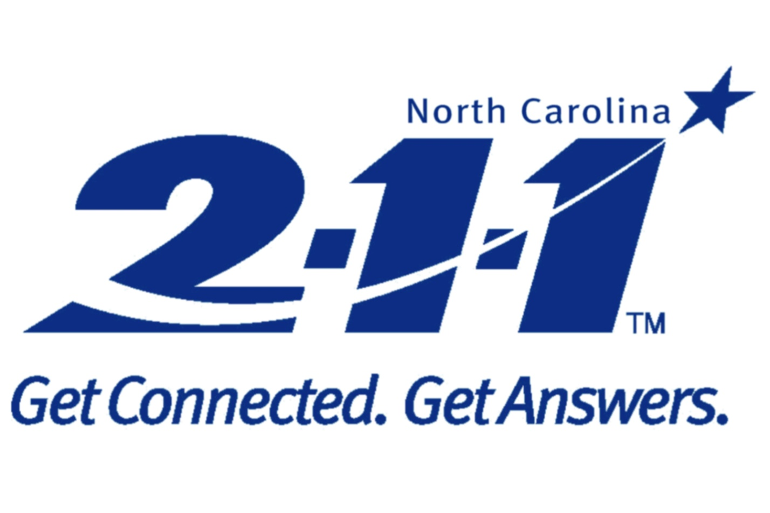

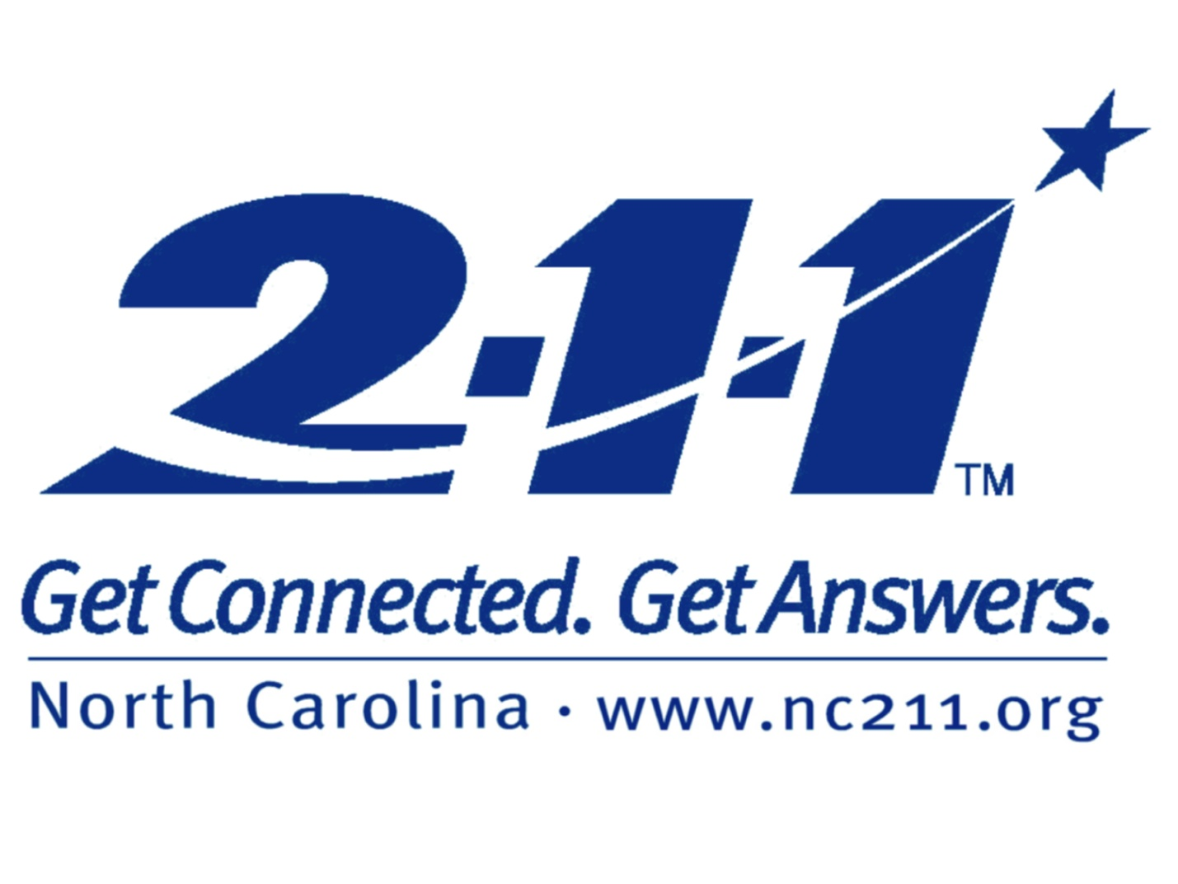

9 – App Icon –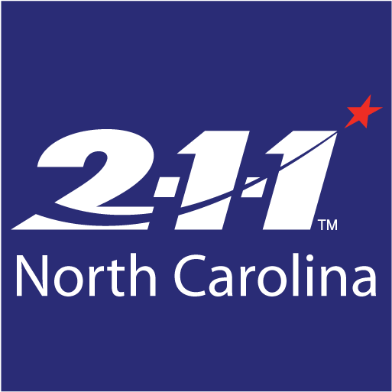

10 – Fee – free

11 – Regions – no restrictions to access