CommunityPoint iPhone® App Checklist

- Application Name
  - Short App Name. 211Brevard This is the name that will appear under the icon on the device.
This can be no longer than 10-11 characters.
Examples: 211Connects, 211SOUTHFL, BreakSpot
  - Full App Name. 211Brevard Community Resource Database This is the name that will appear on the App Store.
It is recommended that this is no longer than 250 characters.
Examples: 211Connects (Tampa Bay), 211SOUTHFLORIDA, Summer BreakSpot Florida
Application Description. This is a paragraph description that you would like to see on the App Store that tells about your community, service, etc. Need to find help in Brevard County, Florida? The 2-1-1 Brevard Community Resource Database lists thousands of health and human services, including food pantries, housing programs, emergency financial assistance, health care, mental health and substance abuse counseling, support for parents and families, disaster services and more.

It is recommended that this is no longer than 700 characters.
See App Store for examples.
- Keywords. Brevard County, Crisis Line, Community Services These are search words that people might type to find your app in the App Store, such as the name of your organization, counties you serve, specific services you offer, etc. According to Apple, “Improper use of keywords is the fourth most common reason for App Store rejections. When you spend the time to come up with well thought out keywords for the audience you’re trying to reach, it increases the likelihood they will find your app on the App Store.” and that one of the most common rejections are for “irrelevant keywords (i.e. keywords not pertaining to the submitted application).”
This can be no longer than 54 characters. Separate keywords by commas.
Example: Tampa Bay,Crisis Hotline,Pinellas County
Bowman will add a standard set of keywords applied to all CommunityPoint apps:
(CommunityPoint,2-1-1,I&R,Information and Referral,211)
- Mission Statement. Providing assistance & referrals in times of emotional, financial and community crisis. This is a sentence or small paragraph that you would like to appear under “Mission” on the information page inside the app.
Please limit this to a sentence or a short paragraph.
See 211Connects or 211SOUTHFL apps for examples.
- Website URL. www.211brevard.orgThis is the website that will be opened when the user taps the “Website” button.
This can be your CommunityPoint site, or your regular website.
Example: http://211tbc.bowmansystems.com/index.php?option=com_cpx
- Phone Numbers. Helpline Specialist: dial 2-1-1 in Brevard County or 321.632.6688; Office: 321.631.9290 List the phone number that will be dialed when the user taps the “Call Helpline Counselor” button,Can we make this ‘call Helpline Specialist’? We don’t use ‘counselor’. as well as any other phone numbers to be shown under “Contact Us” on the information page inside the app.
Example: Call Helpline Counselor: 1-800-555-5555
TTY: 1-800-666-6666, Office: 1-800-777-7777
- Home Screen Layout. We currently have two different choices for the home screen layout. The first option is to have the top button be called “Help Video”. This will open a YouTube video demonstrating how to use the app. The second option is to have the top button be called “Call Helpline Counselor” (or other “Call” text). This will dial the main phone number listed in (6) above. In the second option, a link to view the help video is placed in the information page.
Option 1 Example: See Figure 1 (the 211Connects app).
Option 2 Example: See Figure 2 (the 211SOUTHFL app).
- Home Screen Images. Please supply the two images that will appear above and below the three buttons on this home screen.
They need to be at a high resolution to look good iPhone 4’s.
The top image should be around 512x251 px. The bottom should be around 512x114 px.
See Figure 3 for an example of a top image used by the 211Connects app.
See Figure 4 for an example of a bottom image used by the 211Connects app.
- App Icon. Please supply a 512x512 px icon in 32-bit or 24-bit color .PNG (recommended) or .TIFF file format (files cannot be in JPEG or GIF format). Bowman Systems’ developers will scale the provided icon to various sizes needed. To ensure that the supplied icon will look good in all sizes, please test the 512x512 px icon by scaling it down to 57x57 px and reviewing before sending to Bowman Systems.
Do not try to mimic the styles an icon has on a device (rounded corners, glassy effect, drop shadow, etc.). The icon must have square edges and must contain no transparency.
Do not try to fit many words on the icon. Avoid placing the app name on the icon. When the icon is scaled down to a small size most words will become unreadable.
See Figure 5 for an example of a good icon used by the 211Connects app.
See Figure 6 for an example of a good icon used by the 211SOUTHFL app.
See Figure 7 for an example of an icon that would not scale well and mimics device styles.
See Figure 8 for an example of what the icons will look like on the device.
- Price. What will the price of the app be? It can be free or in $1.00 increments starting with $0.99. Free (per Libby, email 3/21/13
- Regions. Will the app be available for download worldwide or will it be restricted to certain countries? Whatever is most common for other customers. (per Libby, email 3/2113)
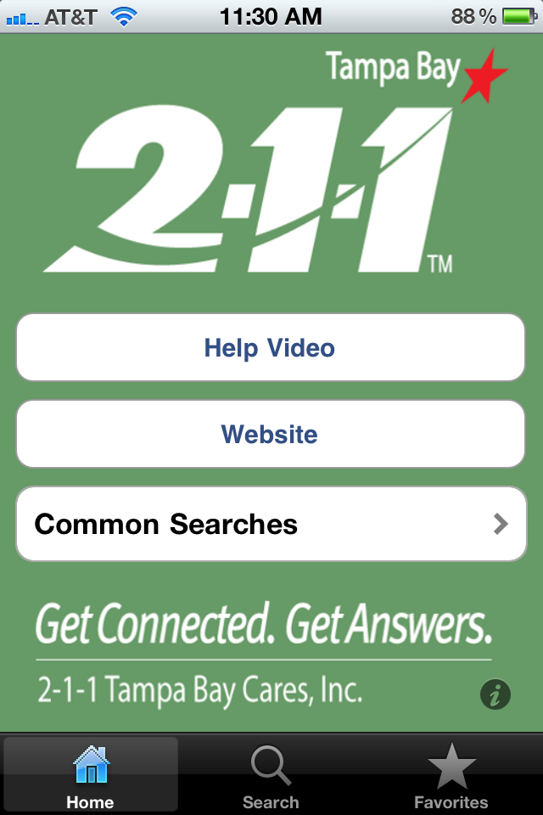
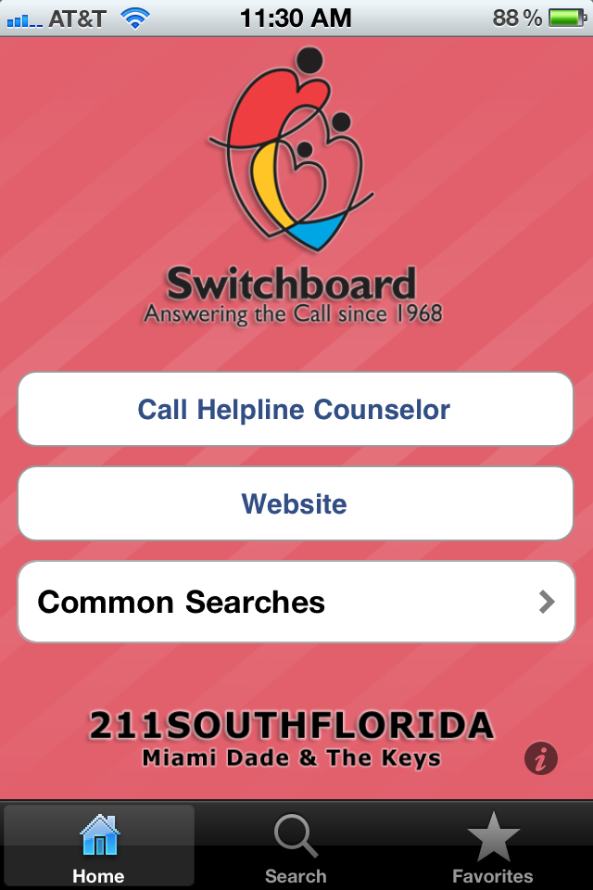
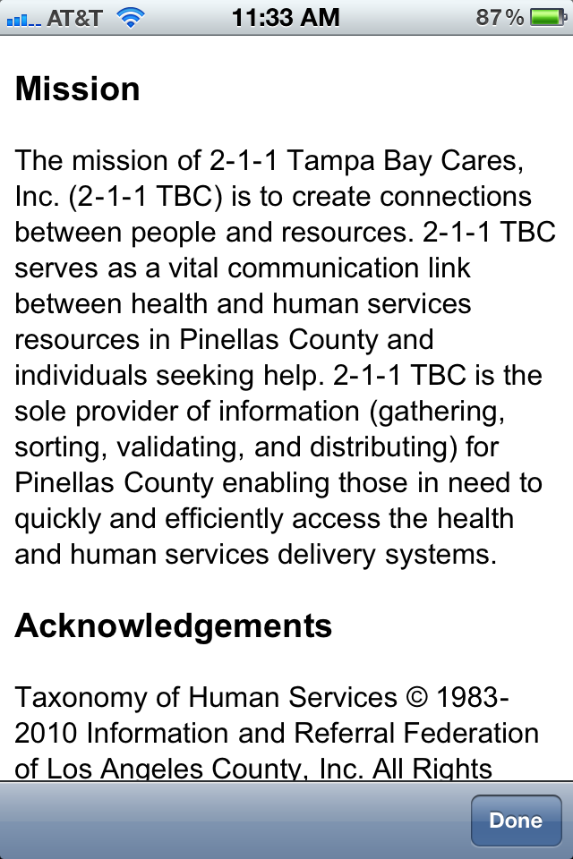
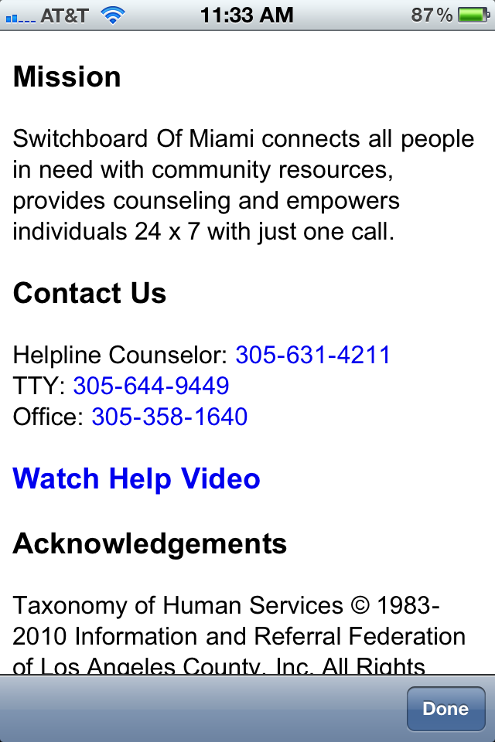
Figure 1. Figure 2.

Figure 3.
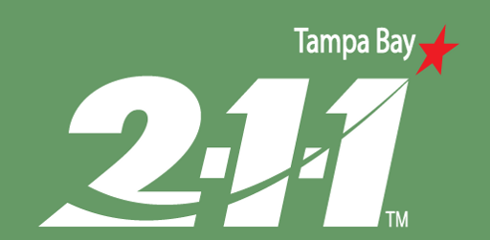

Figure 4.


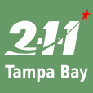

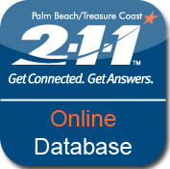
Figure 5. Figure 6. Figure 7.
Figure 8.
