How to Create the Know Your Client Approval Process

This document provides the steps needed to create a Know Your Client approval process. This is an example of using Salesforce.com approval workflow to automate a key financial services process.

It is expected that your company will customize or create your own Know Your Client process based on you specific business processes.

Description
- Financial Advisor creates the Know Your Client form. KYC Approval Status is set to New.
- Financial Advisor fills out the form and adds attachments for actual forms and ID.
- Financial Advisor Submit the Know Your Client form. Approval process sets:
  - Know Your Client Approval Status to “Submitted.”
  - Date Know Your Client Submitted to Today
  - KYC Record Type is changed to "KYC Submitted"
  - Know Your Client form is routed to Lead Financial Advisor for review via email.
- Lead Financial Advisor can approve or reject the Know Your Client via the application or via email.
- Upon Approval/Rejection the approval process:
  - Sets the Know Your Client Approval Status to “Approved”/"Rejected"
  - Sets the Date Know Your Client Approved/Rejected to Today
  - Creates a task for the Financial Advisor review the Know Your Client form in 6 months

Know Your Client AppExchange Package
The Salesforce Know Your Client Package includes:
- Custom object, fields and tabs
- Email template
- Images
- Document for instructions on how to set up a Know Your Client approval process.

Workflow & Approvals Setup
In preparation for creating the approval process we need to make sure we have the tasks and field updates created ahead of time.

Tasks – Part of AppExchange Package
This task is an example of how set a follow up after the Know Your Client form is submitted.

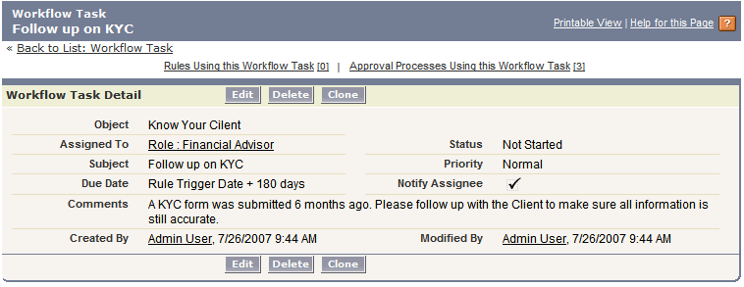
- Create a New Task From Setup -> Workflow & Approvals -> Tasks
- Select Know Your Client as the object. Press Next
- Configure the Task with the following details:
  - Assigned To: Financial Advisor. This is a Role
  - Subject: Follow up on Know Your Client
  - Due Date: Rule Trigger Date plus 180 days
  - Comments: A Know Your Client form was submitted 6 months ago. Please follow up with the Client to make sure all in the information is accurate and determine if a new form is needed.
- Save

Email Alerts
None

Field Updates
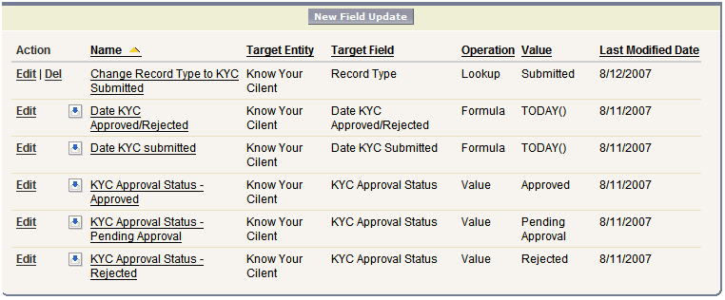

Field Update – Needs To Be Created
- Create a New Field Update From Setup -> Workflow & Approvals -> Field Updates
- Configure the Change Record Type to KYC Submitted Field Update with the following details:
  - Name: Change Record Type to KYC Submitted
  - Description: Change record type from KYC Not Submitted to KYC Submitted on Submit for Approval
  - Object: Know Your Client
  - Field: Record Type
  - Record Type: KYC Submitted
  - Save

Field Updates - Part of AppExchange Package
- Create a New Field Update From Setup -> Workflow & Approvals -> Field Updates
- Configure the Date KYC Approved/Rejected Field Update with the following details:
- Name: Date KYC Approved/Rejected
- Description: Date KYC was approved/rejected
- Object: Know Your Client
- Field: Date KYC Approved/Rejected
- Specify New Field Value: choose to Use a formula to set the new value. Use “TODAY()” as the formula.
- Save
- Repeat for Date KYC Submitted.
- Configure the KYC Approval Status – Approved Field Update with the following details:
- Name: KYC Approval Status - Approved
- Description: Updates KYC Approval Status when the KYC form is approved
- Object: Know Your Client
- Field: KYC Approval Status
- Specify New Field Value: choose to A specific value: Approved
- Save
- Configure the KYC Approval Status – Pending Approval Field Update with the following details:
- Name: KYC Approval Status – Pending Approval
- Description: Updates KYC Approval Status when the KYC form is approved
- Object: Know Your Client
- Field: KYC Approval Status
- Specify New Field Value: choose to A specific value: Pending Approval
- Save
- Configure the KYC Approval Status – Rejected Field Update with the following details:
- Name: KYC Approval Status – Pending Approval
- Description: Updates KYC Approval Status when the KYC form is rejected
- Object: Know Your Client
- Field: KYC Approval Status
- Specify New Field Value: choose to A specific value: Rejected
- Save

Approval Process Detail
One you have setup the Workflow tasks and field updates it is time to configure the approval process.
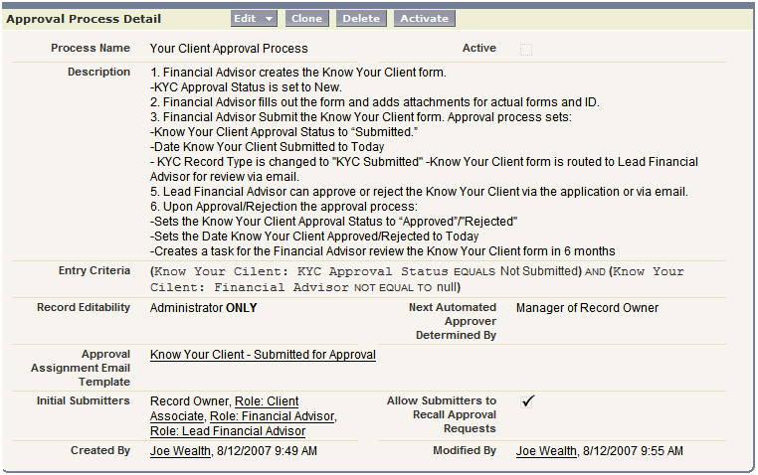

- Create a new approval process from Setup -> Workflow & Approvals -> Approval Processes.
- Manage Approval Process For: Know Your Client
- Create New Approval Process -> Use Standard Wizard

Standard Wizard Steps
- Enter Name and Description
  - Name: Know Your Client Approval Process
  - Description: Basic approval process for Know Your Client.
  - Next
- Specify Criteria for Entering Process
  - KYC Approval Status EQUALS “Not Submitted” AND
  - Financial Advisor NOT EQUAL TO null (null is a blank field)
  - Next
- Specify Approver Field and Record Editability Properties
  - Select Field Used for Automated Approval Routing. Choose Create New Field. Set the label to “Manager”.
  - Record Editability Properties. Select Administrators ONLY can edit records during the approval process.
  - Next
- Select Email Notification Template
  - Choose the “Know Your Client - Submitted for Approval” email template from the Know Your Client folder
  - Approval Assignment Email Return Address is set to “None”
  - Next
- Select Fields to Display on Approval Page Layout
  - <Insert Screen Shot>
  - Security Settings: Allow approvers to access the approval page only from within the Salesforce application. (Recommended)
  - Next
- Specify Initial Submitters
  - Make sure Record Owner, Role: Client Associate, Role: Financial Advisor and Role: Lead Financial Advisor are selected.
  - Check “Allow submitters to recall approval requests.
  - Save

You have just created an approval process. However, you cannot activate this process until you define at least one approval step. Would you like to do that now? Yes, I'd like to create an approval step now. Go.
- Enter Name and Description
- Name: Step1
- Description: Financial Advisor submits Know Your Client for approval.
- Step Number: 1
- Specify Step Criteria. Select “All records should enter this step.” Next
- Select Assigned Approver. Select “Automatically assign using the custom field selected earlier. (Manager)”. Save

You have just created an approval step. You can optionally specify workflow actions to occur upon approval or rejection of this step. Would you like to do that now? No, I'll do this later. Take me to the approval process detail page to review what I've just created.

Initial Submission Actions
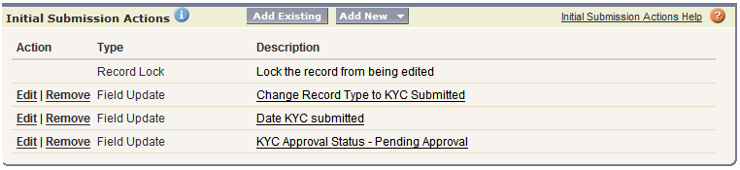

Approval Steps
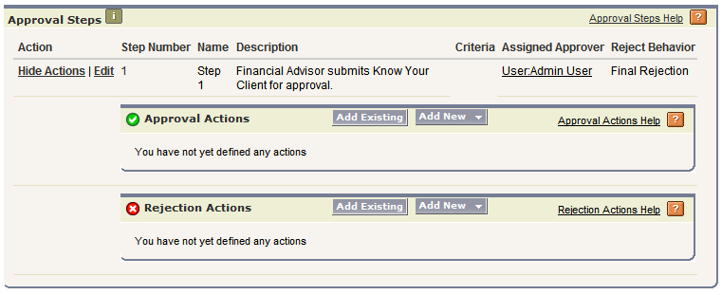

Final Approval Actions
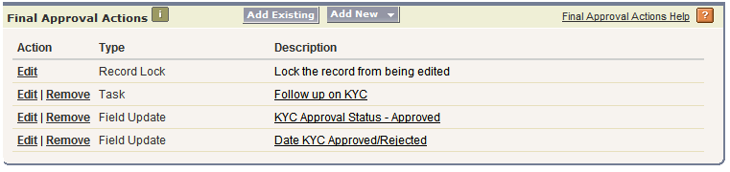

Final Rejection Actions
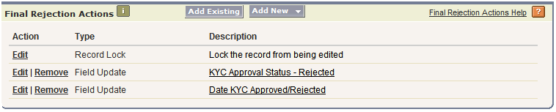

Activate the process

Settings
