**Basic Reading First**

**Bootstrap - Layout(Grid system / align对齐**

<https://v4-alpha.getbootstrap.com/layout/grid/>

**Bootstrap - basics (Boot-CSS)**

<http://getbootstrap.com/css/#forms-control-sizes>

<http://getbootstrap.com/css/>

**Form Controls:**Bootstrap supports the following form controls: **Input, textarea, checkbox, radio, select**

[**https://www.w3schools.com/bootstrap/bootstrap_forms_inputs.asp**](https://www.w3schools.com/bootstrap/bootstrap_forms_inputs.asp)

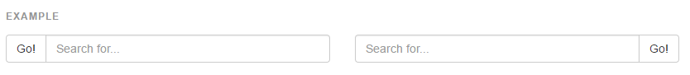

components-input group-**button addons**

<http://getbootstrap.com/components/#input-groups-buttons>

components-**Glyphicons**

<http://getbootstrap.com/components/#glyphicons>

**examples**

<https://www.w3schools.com/bootstrap/tryit.asp?filename=trybs_glyphs&stacked=h>

input group **button color ->limited styles**

<button class=””></button>



Components **- Button group**

http://www.runoob.com/bootstrap/bootstrap-button-groups.html

**Bootstrap Input Sizing**

Components-**input- button size**  
Set the heights of input elements using classes like .input-lg and .input-sm.  
Set the widths of elements using grid column classes like .col-lg-*and .col-sm-*.

<https://www.w3schools.com/bootstrap/bootstrap_forms_sizing.asp>

按钮和input搜索框同高

**Input group 不用form group**

**Dropdown list 代码**

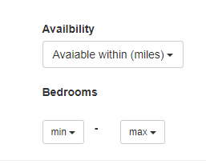

*<div class="col-md-4"><!-- row1 col2 -->*

*<!-- Dropdown: -->*

*<label for="dropdown1">Availbility</label>*

*<div class="dropdown" id="dropdown1">*

*<button class="btn btn-default dropdown-toggle" type="button" data-toggle="dropdown">Avaiable within (miles)*

*<!-- Short Form <button class="btn btn-default dropdown-toggle" type="button" id="dropdownMenu1" data-toggle="dropdown" aria-haspopup="true" aria-expanded="true"> -->*

*<span class="caret"></span></button>*

*<ul class="dropdown-menu" aria-labelledby="dropdownMenu1">*

*<li><a href="#">10</a></li>*

*<li><a href="#">20</a></li>*

*<li><a href="#">30</a></li>*

*<li role="separator" class="divider"></li>*

*<li><a href="#">>30</a></li>*

*</ul>*

*</div>*

*<div class="margin-line1">*

*<label for="">Bedrooms</label>*

*</div>*

*<div class="row margin-line1">*

*<div class="col-md-2">*

*<div class="dropdown btn-group" id="">*

*<button class="btn btn-default dropdown-toggle btn-sm" type="button" data-toggle="dropdown">min*

*<span class="caret"></span></button>*

*<ul class="dropdown-menu dropdown-menu-wid" aria-labelledby="dropdownMenu1">*

*<li><a href="#">10</a></li>*

*<li><a href="#">20</a></li>*

*<li><a href="#">30</a></li>*

*</ul>*

*</div>*

*</div>*

*<div class="col-md-1"><label for="">-</label></div>*

*<div class="col-md-2">*

*<div class="dropdown btn-group" id="">*

*<button class="btn btn-default dropdown-toggle btn-sm" type="button" data-toggle="dropdown">max*

*<span class="caret"></span></button>*

*<ul class="dropdown-menu dropdown-menu-wid" aria-labelledby="dropdownMenu1">*

*<li><a href="#">10</a></li>*

*<li><a href="#">20</a></li>*

*<li><a href="#">30</a></li>*

*</ul>*

*</div>*

*</div>*

*</div>*

*</div><!-- row1 col2 -->*

Components-**button- button size**  
Button Sizes, Bootstrap provides four button sizes:  
https://www.w3schools.com/bootstrap/bootstrap_buttons.asp

*<button type="button" class="btn btn-primary btn-lg">Large</button>*

*<button type="button" class="btn btn-primary btn-md">Medium</button>*

*<button type="button" class="btn btn-primary btn-sm">Small</button>*

*<button type="button" class="btn btn-primary* *btn-xs">XSmall</button>*

div- **居中**

**<head>**

<style>   
 .col-center-block {   
 float: none;   
 display: block;   
 margin-left: auto;   
 margin-right: auto;   
 }   
 </style>  
</head>

**Work Out**

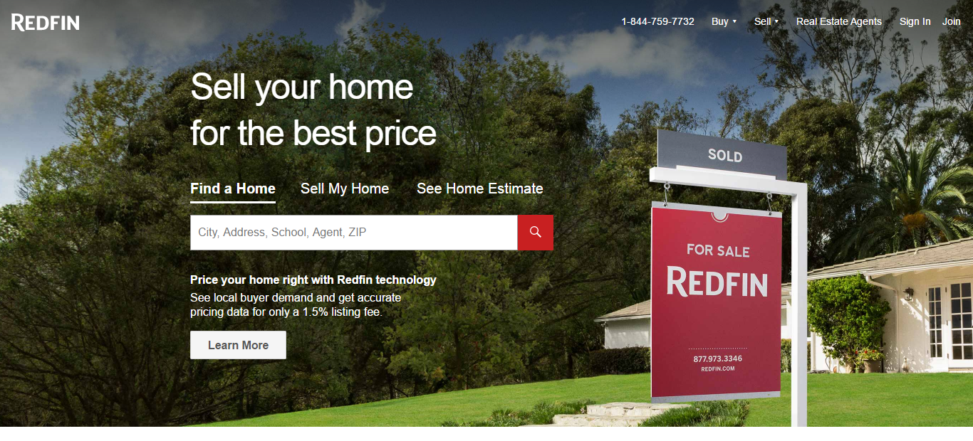

<div class="container">: 左缩进

<div class="col-md-4">content </div> layout

<div class="col-md-8">content </div> layout

*<form method="post">*

*<label for="username">Search</label>*

*<input type="text" name="email" id="email" value="<%= locals.email || '' %>" class="form-control" />*

*<div class="form-group">*

*<label for="password">Search</label>*

*<input type="password" name="password" id="password" class="form-control" />*

*</div>*

*<div class="form-group">*

*<button type="submit" class="btn btn-primary">Sign In</button>*

*<a href="/register" class="btn btn-link">Register</a>*

*</div>*

*</form>*

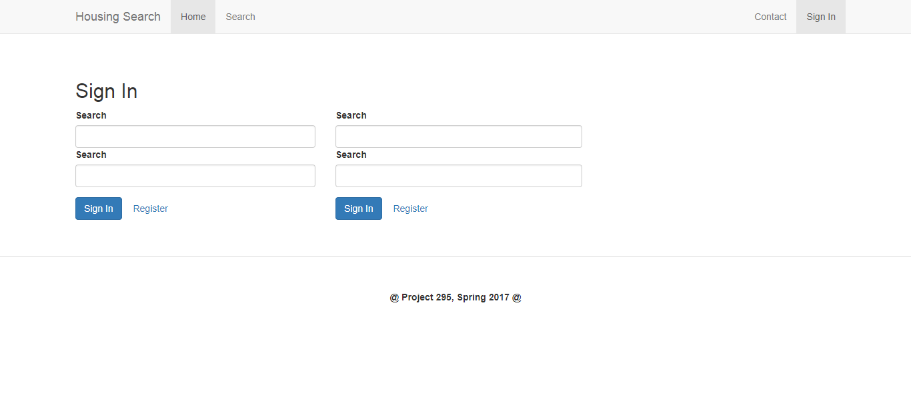

**Component – price bar**

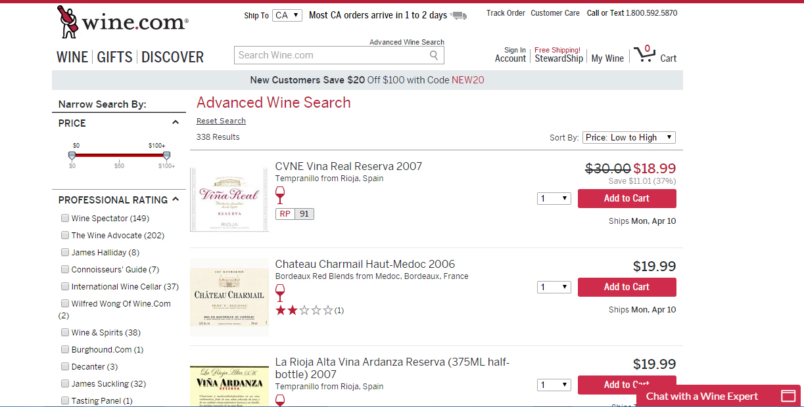

**Component – bootstrap checkbox**

[**https://www.w3schools.com/bootstrap/bootstrap_forms_inputs.asp**](https://www.w3schools.com/bootstrap/bootstrap_forms_inputs.asp)

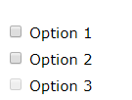

**Component – text**

**<h1> <h2>…<h6>**

**<label>**

**CSS- Div – return 分行作用**

**Div间隔 margin: 一行**margin-left: margin-top

**http://www.divcss5.com/rumen/r128.shtml**

**Div 内部物件居中**

**CSS-width宽度-30percent**

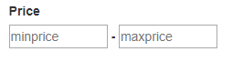

[**http://www.w3school.com.cn/cssref/pr_dim_width.asp**](http://www.w3school.com.cn/cssref/pr_dim_width.asp)

**Component- dropdown 下拉菜单**

[**http://www.runoob.com/bootstrap/bootstrap-dropdown-plugin.html**](http://www.runoob.com/bootstrap/bootstrap-dropdown-plugin.html)

[**http://getbootstrap.com/components/**](http://getbootstrap.com/components/)

**Component- select 选择**

**<select>: not styled in webkit(safari, firefox in IOS)**

[**https://www.w3schools.com/bootstrap/bootstrap_forms_inputs.asp**](https://www.w3schools.com/bootstrap/bootstrap_forms_inputs.asp)

*<!-- Dropdown: -->*

*<label for="dropdown1">Availbility</label>*

*<div class="dropdown" id="dropdown1">*

*<button class="btn btn-default dropdown-toggle" type="button" data-toggle="dropdown">Avaiable within (miles)*

*<!-- Short Form <button class="btn btn-default dropdown-toggle" type="button" id="dropdownMenu1" data-toggle="dropdown" aria-haspopup="true" aria-expanded="true"> -->*

*<span class="caret"></span></button>*

*<ul class="dropdown-menu" aria-labelledby="dropdownMenu1">*

*<li><a href="#">10</a></li>*

*<li><a href="#">20</a></li>*

*<li><a href="#">30</a></li>*

*<li role="separator" class="divider"></li>*

*<li><a href="#">>30</a></li>*

*</ul>*

*</div>*

*<!-- select list: -->*

*<!-- Avoid using <select> elements here as they cannot be fully styled in WebKit browsers. -->*

*<!-- <label for="sel1">Availbility</label>*

*<select class="form-control" id="sel1">*

*<option value="one">10</option>*

*<option value="one">20</option>*

*<option value="one">30</option>*

*<option value="one">40</option>*

*</select> -->*

**Place 2 dropdowns in the same line/row**

[**https://stackoverflow.com/questions/29446555/place-2-dropdowns-in-the-same-line**](https://stackoverflow.com/questions/29446555/place-2-dropdowns-in-the-same-line)

**div class=”btn-group”; div class=”row” <div class="col-md-2"> <div class="dropdown">**

**Component – option**

**Component – tabs**

[**http://getbootstrap.com/components/#nav-tabs**](http://getbootstrap.com/components/#nav-tabs)

**How to integrate bootstrap component**

<https://bootsnipp.com/snippets/e3A7K>



<https://bootsnipp.com/snippets/00WGK>

<https://bootsnipp.com/snippets/featured/bootstrap-pricing-slider-donations>

Page work out

