**CMPE 202 ENTERPRISE SOFTWARE ENGINEERING**

**Personal project: UML Parser**

**Name: Jiongfeng Chen ID: 010830105**

Objective: this program can be used to parse java source code files and then generate the class diagram from the source code input.

Tools used:

1. JavaParser: Used for parsing the *.java files. The website: <https://github.com/javaparser/javaparser>, to use it in this project, library is built in: javaparser-core-2.1.0.jar.

2. yUML: Used for generating the class diagram figure. Source code sent the http request to get the generated figure file. The website : <http://yuml.me/>

IDE and System Environment

1. IDE: Eclipse Mars Mars.1 Release (4.5.1)

2. WINDOWS 8

Manual

uml-parser-test-1

1.put the jar files to appropriate folder as below(folder name can be varied)

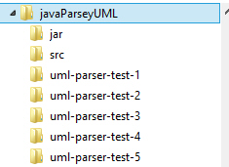

2. open command window run:

java -jar javaParseyUML.jar <classpath> <output file name>

For example:

java -jar javaParseyUML.jar ../uml-parser-test-1 test01-uml.jpg

3.get the generated file (when network is available )

For example:

