Homework #1 Screenshots

John Clark

Java IV

7/22/17

Failed Junit test, caused by binary search bug

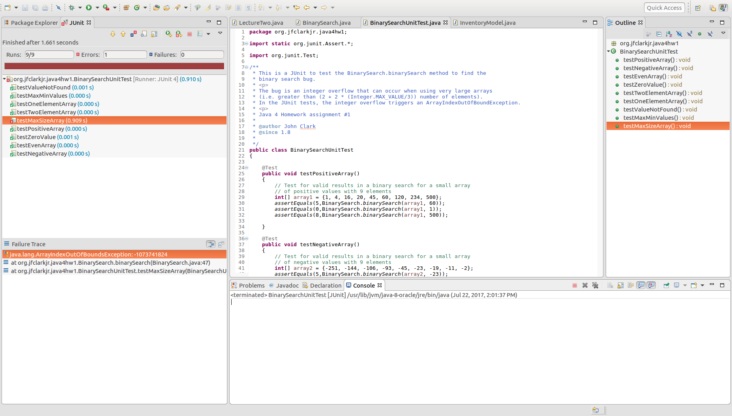

Test passes, after bug is fixed

