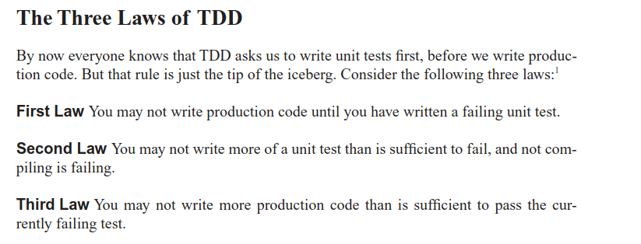Figure 1: Ch. 9 Unit Tests

- Ch. 8 Boundaries: Write “learning tests” for 3rd party libs to verify behavior
- 2. Names/3 Functions/4 Comments/5 Formatting/6 Objects and DS/10 Classes:
  - Remember: You won’t write perfectly the first time, massage and refine!
  - One word per concept, make easily searchable (class: noun, method: verb)
  - Comments: intent, todo, amplify importance… prefer self explanatory code!
  - Read like newspaper and names should tell narrative (also pronounceable)
    - private util methods below public method
  - Do one thing (single responsibility, identify 1 reason why you might change it)
  - One level abstraction
  - Small as possible and then smaller
  - ~45 chars horizontal, files ~200 lines,
  - Do not expose implementation details (expose abstract interfaces)
  - Open for extension, closed for modification. (basically don’t break existing stuff)
  - Dep inversion: depend on abstractions (e.g., don’t inherit concrete implementations)
  - order: public static consts, private static, private instance, rarely public vars!!

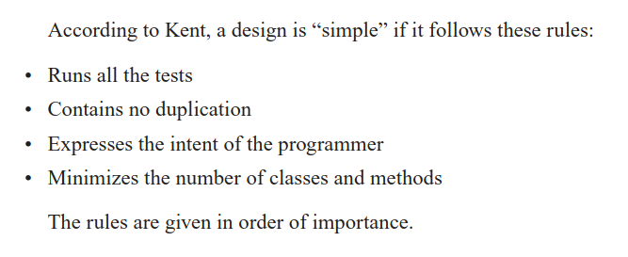Figure 2: Ch. 12 Emergence (Kent Beck)

