Jared Frazier | CSCI 4350 | OLA 4 | Unsupervised Learning with K-Means | Due 2021/11/30

**Introduction**

**Methods**

**Results and Discussion**

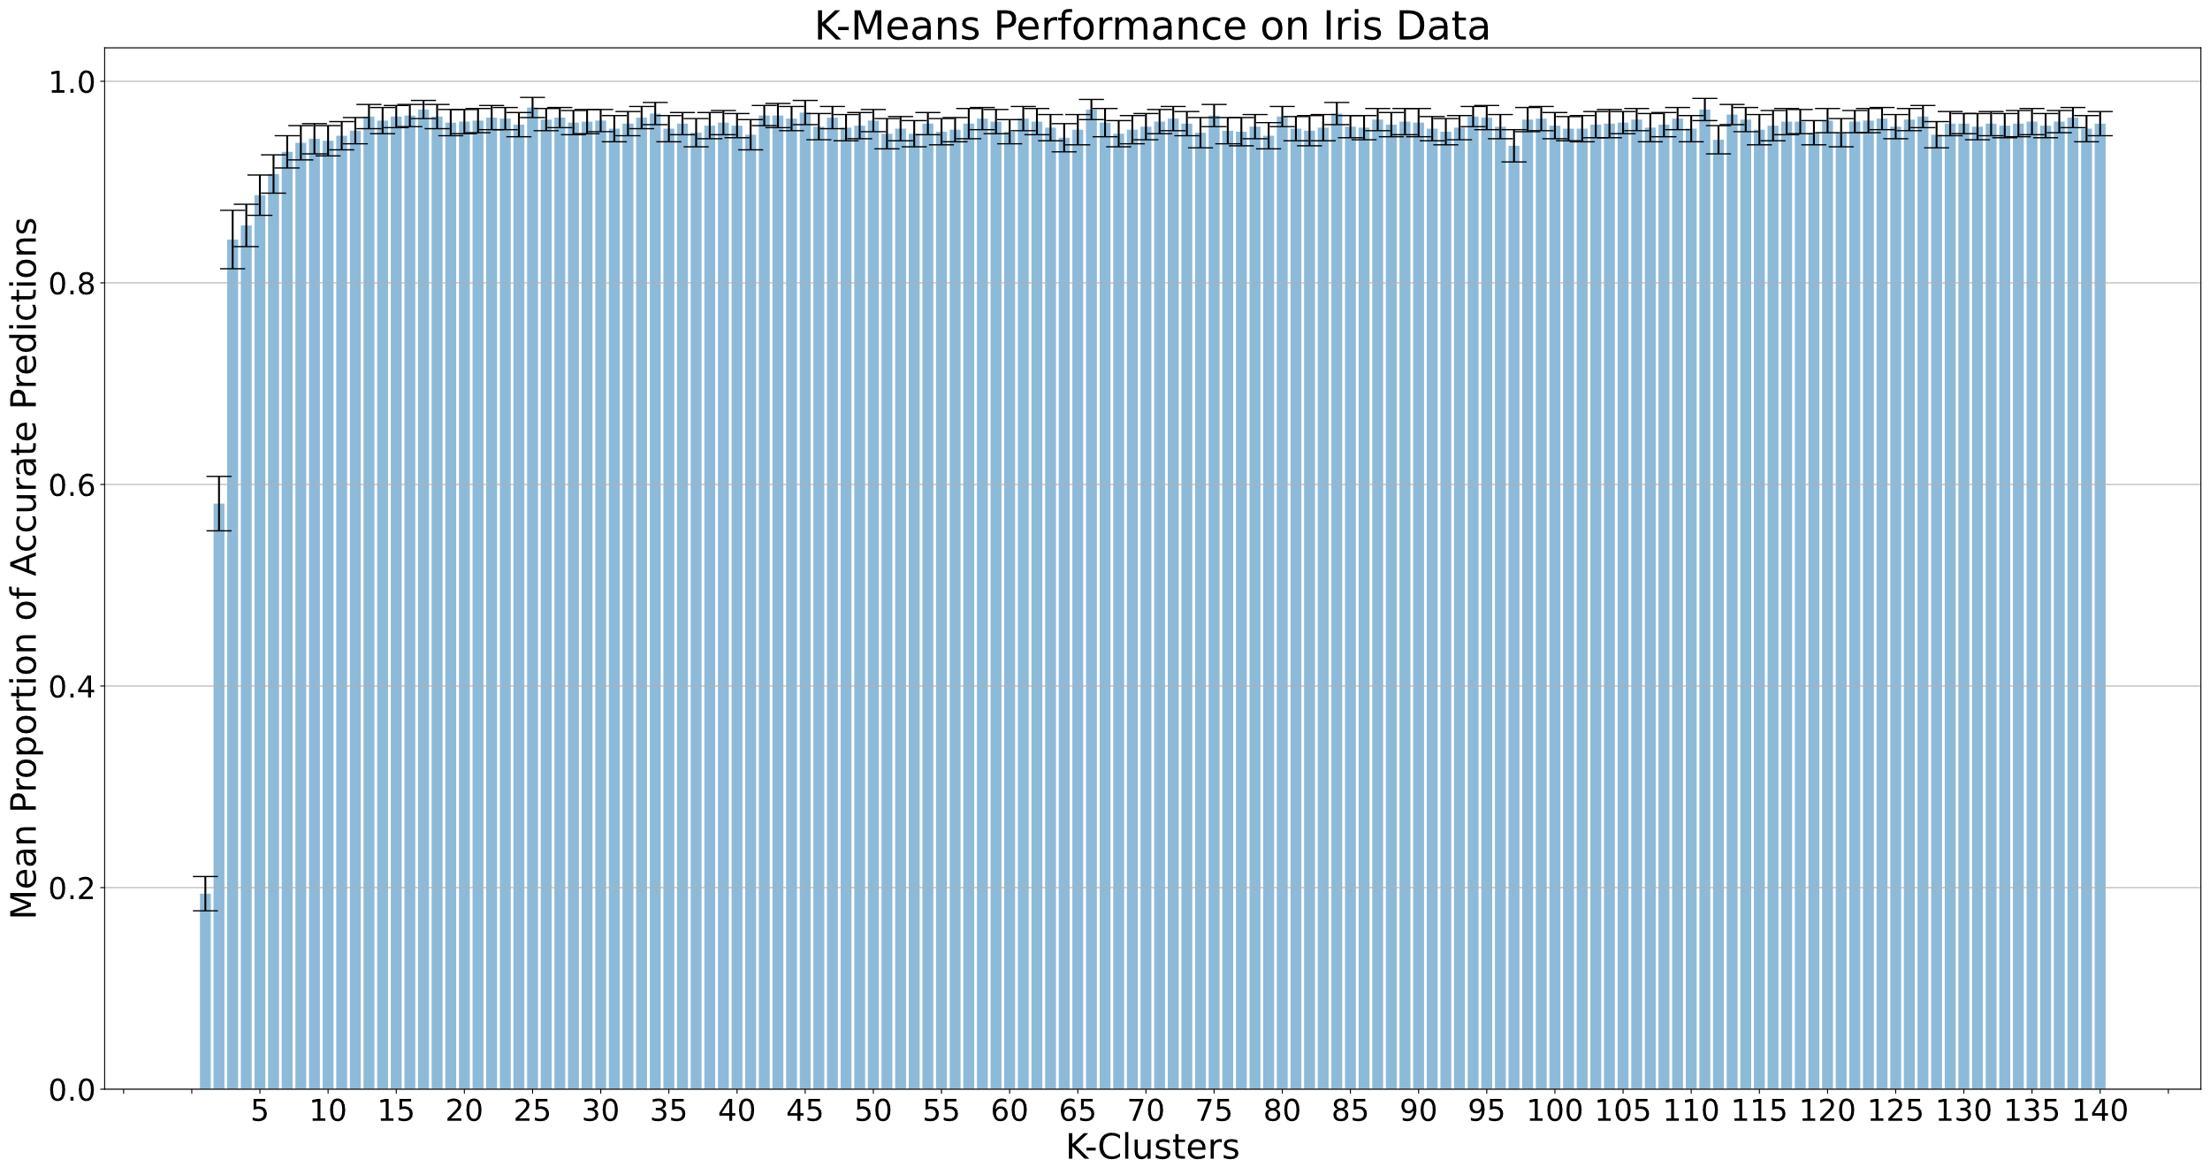

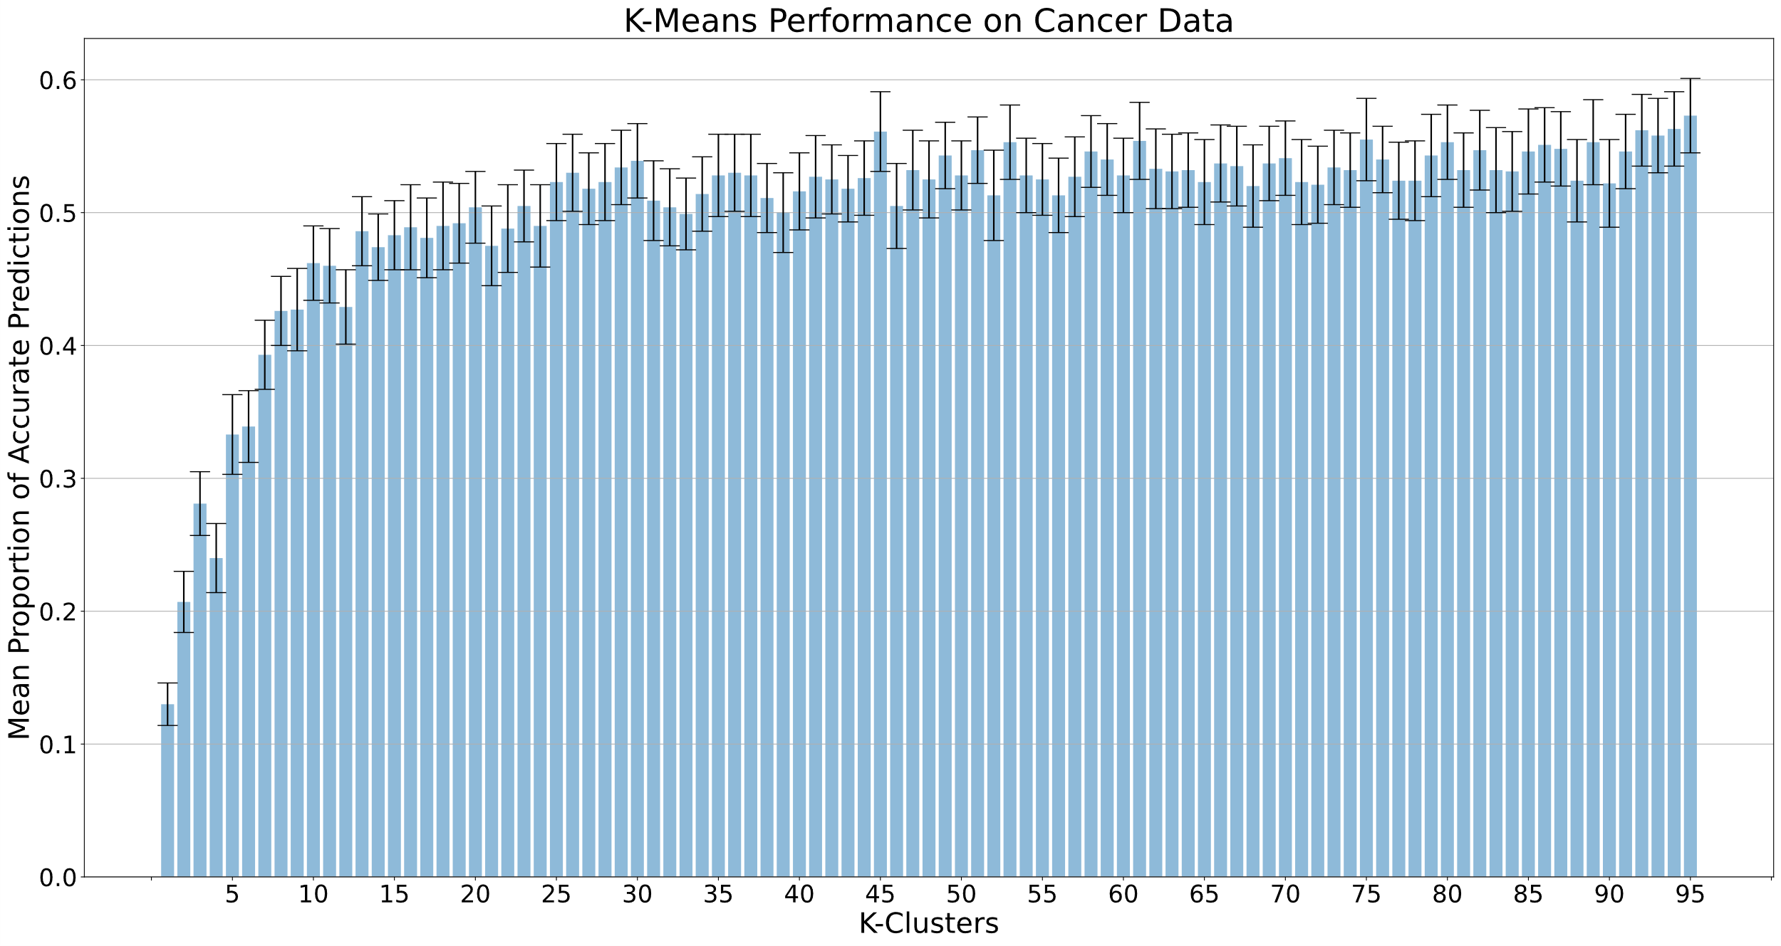

(Cluster, Mean Accuracy, Stderror)

Best Performer Iris**:** 25.0 0.974 0.01

Best Performer Cancer: 95.0 0.573 0.028

**References**