Abstract
Regulatory variation in gene expression can be described by cis and trans genetic components. Here we use RNA-seq data from a panel of Drosophila melanogaster test crosses to compare allelic imbalance (AI) in female head tissue between mated and virgin flies, an environmental change known to affect transcription. Indeed, 3,048 exons (1,610 genes) are differentially expressed in this study. We use a Bayesian model for the detection of AI and control type I error with an intersection test. There are ~200 genes with AI exclusively in mated or virgin flies and on average 34% of genes within a cross, and 54% of all genes across the entire panel show evidence for genetic regulation of transcription. Nearly all differentially regulated genes are affected in cis, with an average of 63% of expression variation explained by the cis effects. trans effects explain 8% of the variance in AI on average and the interaction between cis and trans explains an average of 10% of the total variance in AI. In both environments cis and trans effects are compensatory in their overall effect, with the opposite signs of effects of the allele coupled 63% of the time. There is a negative association between cis and trans effects (85%) across lines. We hypothesize that the gene expression level perturbed by cis-regulatory mutations is compensated through trans-regulatory mechanisms, e.g. trans and cis by trans factors buffering cis-mutations. In addition, when AI is detected in both environments, cis-mated, cis-virgin, and trans-mated-trans-virgin estimates are highly concordant. We conclude that the GRN are robust and that trans buffering explains robustness.

Experimental Design
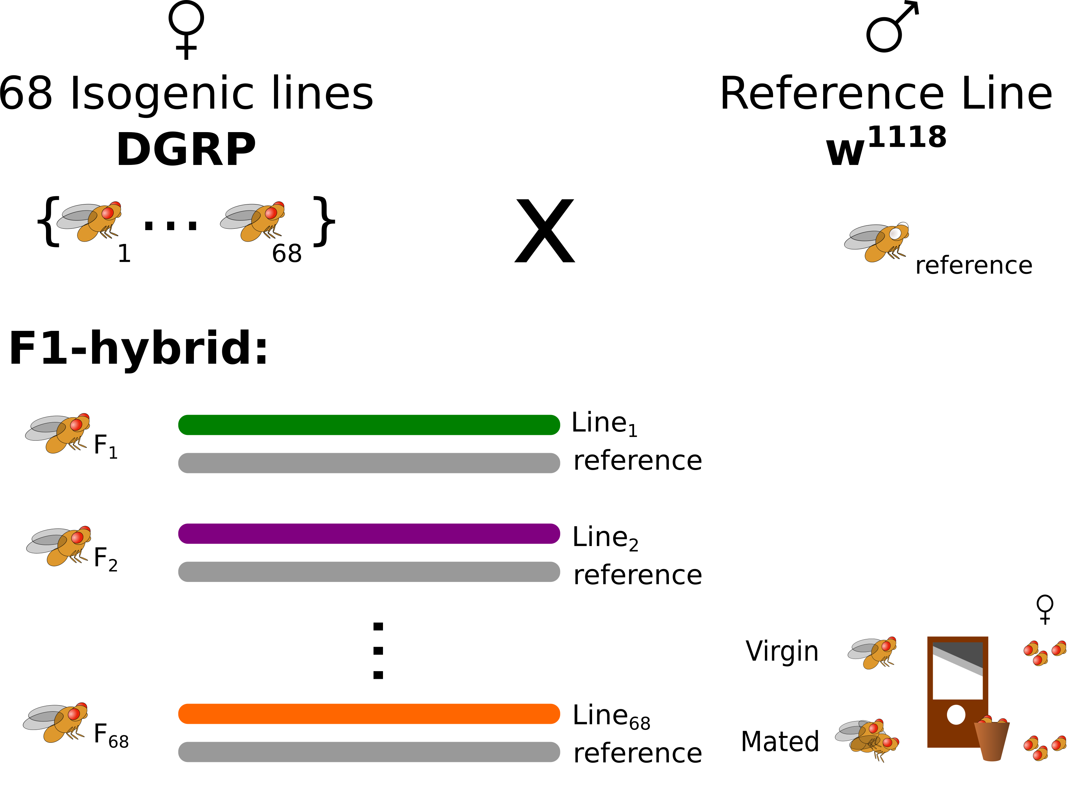
Figure 1. F1-hybrid population design. A hybrid population was created by crossing 68 isogenic lines to a single lab reference strain (w¹¹¹⁸). For a given locus, each individual in the population contains a varying allele (colored), from one of the isogenic lines, and a common allele (gray) from the w¹¹¹⁸ reference strain. Here we use RNA-seq from mated or virgin female heads.

Methods

Allelic Imbalance
We use a Poisson Gamma (PG) model developed by (Leon-Novelo et al. 2014). Under the null hypothesis of no allelic imbalance, H₀: θ = 0.5 compared to the alternative H₁: θ ≠ 0.5. Given that x_{i} and y_{i} are the 'line' and 'reference' allele-specific RNA read counts.
, and

Here μ is the overall mean, β_{i} is the variation of biological replicate (i = 1,..., I), α is the effect of having allelic imbalance, and q is a constant to incorporate mapping bias. If θ is the real proportion of reads from the reference allele then,

When there is no AI (θ = 0.5), therefore α = 1. From previous studies we found that the bias term q is typically between 0.4 to 0.6. To control type I error, we evaluated the posterior using three levels of q (0.4, 0.5, and 0.6) and considered a region to have AI if the credible interval excludes 0.5 for all three levels of q.

Estimation of cis and trans effects
With the reference-cross design, allele-specific read counts can be used to separate cis and trans-effects (Nuzhdin et al. 2012). The expression of varying allele i and reference allele r for genotype j can be expressed as:
varying allele,
reference allele
where μ is the population mean, C_{i} is the cis-effects of allele i, C_{r} is the cis-effects of allele r, and T_{i} and T_{r} are the trans-effects of allele i and r. Using this formulation we can estimate the cis-effects for each varying allele as C_{i} = E_{ij} – E_{rj} + C_{r} and the trans-effects as T_{i} = 2 x (E_{rj} – μ – C_{r}) – T_{r}.

Allelic imbalance is concordant between environments, but differs among genotypes
Figure 2: Distribution of allelic imbalance across environments and genotypes. (A) The distribution of allelic imbalance is similar between virgin (blue) and mated (green) environments. (B) While, the proportion of exons with allelic imbalance (y-axis) varies among F1-hybrids genotypes (x-axis); within a genotype there are differences between virgin (blue) and mated (green) environments.

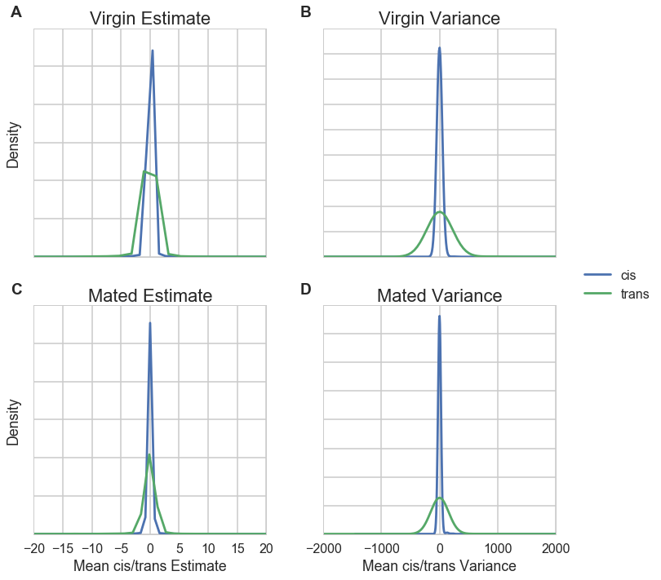
Cis and trans estimates have different distributions and are typically negatively related
Figure 4. Distribution of cis and trans estimates for exons with allelic imbalance. The distribution of trans estimates is wider than cis estimates in both virgin (A) and mated (C) environments. Distribution of the variance for trans estimates is also wider than cis estimates in both virgin (B) and mated (D) environments.

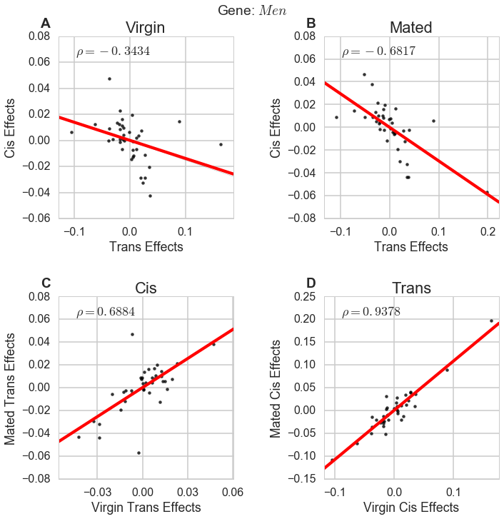
Figure 5. Association of cis and trans estimates for Men. The gene Men was chosen at random. Men is a malate dehydrogenase which is involved in NAD binding. In Men, cis (y-axis) and trans estimates (x-axis) are negatively associated in both environments (A-B; 85% of all exons show negative associations between cis and trans estimates in both environments). In Men, cis and trans estimates are positively associated across environments: virgin environment (y-axis) and mated (y-axis) (C-D; 99% of all exons are positive correlated for both cis and trans estimates across environments with a median correlation of 0.83 for cis and 0.95 for trans). The red line is the regression.

cis-effects account for 63% of variation while trans-effects (cis-by-trans-effects) account for 8% (11%) of the average variance

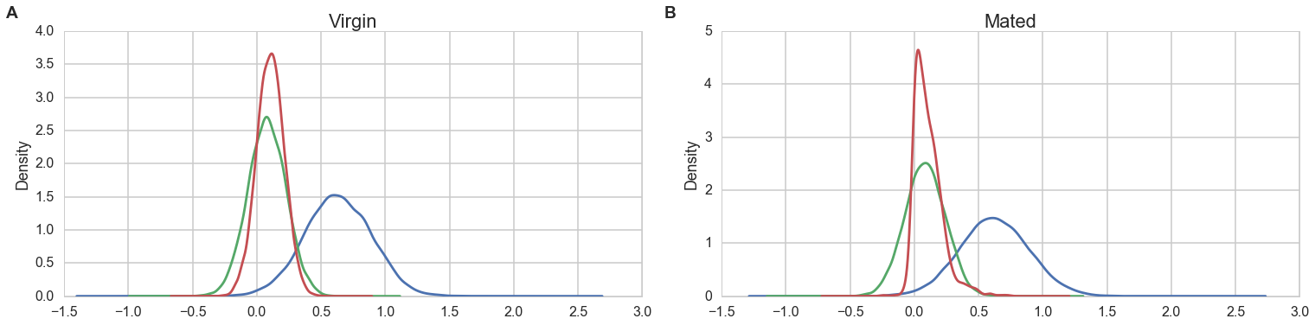
Figure 6. Distribution of the coefficient of determination (R²) from regressing the estimate of allelic imbalance on cis, trans, cis-by-trans estimates. For the model: Y_{ij} = μ + C_{i} + T_{i} + C_{i} x T_{i},where Y is the estimate of allelic imbalance (θ), C_{i} is the estimate of cis-effects, and T_{i} is the estimate of trans-effects for each line i and exon j. R² is an estimate of the contribution of cis, trans, and cis-by-trans interactions to allelic imbalance. Distributions of R² are similar in virgin and mated environments. cis-effects explain at least 45% of the variation in expression for 75% of tested exons. trans-effects explain 8% of the variance on average. The cis-by-trans interaction explains an additional 11% of the variance on average.

