Names:

Math 1120 Polygons Spring 2012

You should all remember Venn Diagrams from last semester, but let’s start by reviewing a bit by looking at the figure below: This is a diagram of triangles, and since each set contains types of triangles, they are all contained within the “triangles” bubble. All equilateral triangles are acute (all angles are 60 degrees!) so they are fully contained in the “acute” bubble. However, isosceles, scalene and other triangles may also be acute sometimes, which is why those bubbles overlap the “acute” bubble. No triangles are both isosceles and scalene, so we show this by making the “isosceles” and “scalene” bubbles have no overlap.

1. Add bubbles for right triangles and obtuse triangles to this figure (hint: you may want to draw bubbles which are concave if you want to fit them into the correct places)

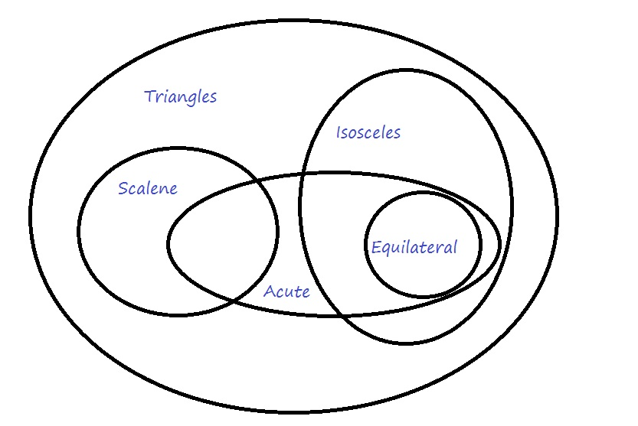

WHY are we suddenly doing Venn Diagrams? (We are supposed to be doing geometry!!) The answer is that they help to demonstrate the relationships between different objects. Using the Venn diagram on the other side of this page, decide if each of the following are true or false. If false, as always, give a **counterexample**.

1. All equilateral triangles are acute triangles (hint: this statement can be re-worded as “the equilateral triangle bubble is fully contained inside of the acute triangles bubble.”)
2. Some isosceles triangles are equilateral.
3. Some scalene triangles are equilateral.
4. Now, we’re going to construct a Venn diagram to help review different types of curves. Remember, we had the following characterizations of curves: connected, simple, closed, polygon, convex and concave. Fill in bubbles, in the appropriate places, for the types of curves not yet included in the diagram.

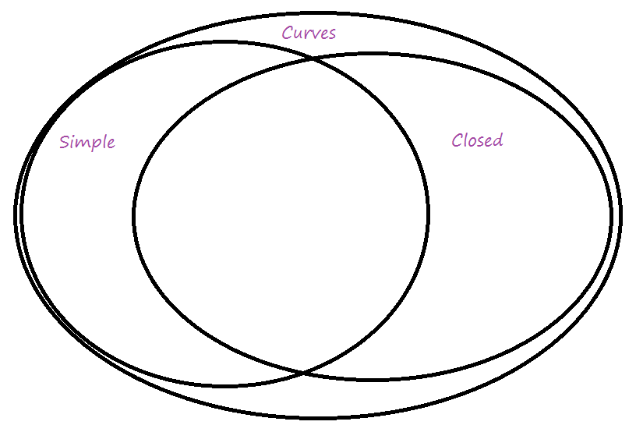

1. Give an example of the following:
2. A simple, closed, concave curve with straight edges.
3. A curve which is not simple and not connected.
4. A convex polygon.
5. A connected curve which is not closed.