Data set: BCI-experiment

Data set provided by Department of Medical Informatics, Institute for Biomedical Engineering, University of Technology Graz. (Gert Pfurtscheller)
Correspondence to Alois Schlögl <alois.schloegl@tugraz.at>
This dataset was recorded from a normal subject (female, 25y) during a feedback session. The subject sat in a relaxing chair with armrests. The task was to control a feedback bar by means of imagery left or right hand movements. The order of left and right cues was random.
The experiment consists of 7 runs with 40 trials each. All runs were conducted on the same day with several minutes break in between. Given are 280 trials of 9s length. The first 2s was quite, at t=2s an acoustic stimulus indicates the beginning of the trial, the trigger channel (#4) went from low to high, and a cross “+” was displayed for 1s; then at t=3s, an arrow (left or right) was displayed as cue. At the same time the subject was asked to move a bar into the direction of a the cue. The feedback was based on AAR parameters of channel #1 (C3) and #3 (C4), the AAR parameters were combined with a discriminant analysis into one output parameter. (similar to [1,2]). The recording was made using a G.tec amplifier and a Ag/AgCl electrodes. Three bipolar EEG channels (anterior ‘+’, posterior ‘-‘) were measured over C3, Cz and C4. The EEG was sampled with 128Hz, it was filtered between 0.5 and 30Hz. The data is not published yet, similar experiments are described in [1-4].
The trials for training and testing were randomly selected. This should prevent any systematic effect due to the feedback.

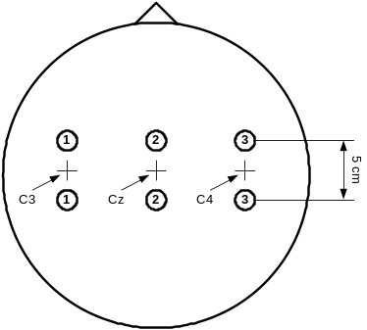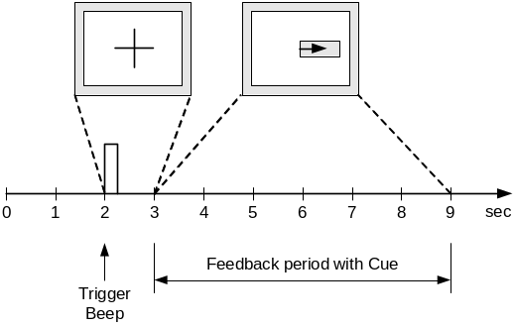
Figure 1: Electrode positions (left) and timing scheme (right).

Format of the data
The data is saved in a Matlab-fileformat. The variable x_train contains 3 EEG channels, 140 trials with 9 seconds each. The variable y_train contains the classlabels ‘1’, ‘2’ for left and right, respectively. x_test contains another set of 140 trials. The cue was presented from t = 3s to 9s. At the same time, the feedback was presented to the subject. Within this period, it should be possible to distinguish the two types of trials.

Requirements and evaluation
The task is to provide an analysis system, that can be used to control a continuous feedback. For this reason, you should provide a continuous value (<0 class “1”, >0 class “2”, 0 non-decisive ) for each time point. The magnitude of the value should reflect the confidence of the classification, the sign indicates the class. Include a description of your analysis system.

Evaluation
There is a close relationship between the error rate and the mutual information [4]. We propose the mutual information because it take also into account the magnitude of the outputs. The criterion will be the ratio between the maximum of the mutual information and the time delay since the cue (t=3s). Only the period between t=4 and t=9s will be considered.

Reference(s):
[1] A. Schlögl, K. Lugger and G. Pfurtscheller (1997) Using Adaptive Autoregressive Parameters for a Brain-Computer-Interface Experiment,
Proceedings of the 19th Annual International Conference if the IEEE Engineering in Medicine and Biology Society ,vol 19 , pp.1533-1535.

[2] C. Neuper, A. Schlögl, G. Pfurtscheller (1999) Enhancement of left-right sensorimotor EEG differences during feedback-regulated motor imagery.
J Clin Neurophysiol. 16(4):373-82.

[3] Pfurtscheller G, Neuper C, Schlögl A, Lugger K. (1998) Separability of EEG signals recorded during right and left motor imagery using adaptive autoregressive parameters. IEEE Trans Rehabil Eng. 6(3):316-25.

[4] Schlögl A., Neuper C. Pfurtscheller G. (2002) Estimating the mutual information of an EEG-based Brain-Computer-Interface, Biomedizinische Technik 47(1-2): 3-8.

