Construya este modelo relacional:

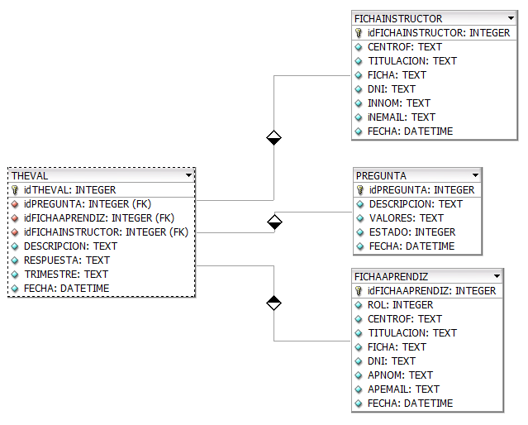

**Database Model plugin_tmp.xml**

|  |
| --- |
| **FICHAAPRENDIZ** |
| |  |  |  |  |  |  |  |  | | --- | --- | --- | --- | --- | --- | --- | --- | | **ColumnName** | **DataType** | **PrimaryKey** | **NotNull** | **Flags** | **Default Value** | **Comment** | **AutoInc** | | **idFICHAAPRENDIZ** | **INTEGER** | PK | NN | UNSIGNED |  |  | AI | | ROL | INTEGER |  |  | UNSIGNED |  | 1=INSTRUCTOR 2=ADMIN |  | | CENTROF | TEXT |  |  |  |  |  |  | | TITULACION | TEXT |  |  |  |  |  |  | | FICHA | TEXT |  |  |  |  |  |  | | DNI | TEXT |  |  |  |  |  |  | | APNOM | TEXT |  |  |  |  |  |  | | APEMAIL | TEXT |  |  |  |  |  |  | | FECHA | DATETIME |  |  |  |  |  |  | |
| |  |  |  | | --- | --- | --- | | **IndexName** | **IndexType** | **Columns** | | PRIMARY | PRIMARY | idFICHAAPRENDIZ | |

|  |
| --- |
| **FICHAINSTRUCTOR** |
| |  |  |  |  |  |  |  |  | | --- | --- | --- | --- | --- | --- | --- | --- | | **ColumnName** | **DataType** | **PrimaryKey** | **NotNull** | **Flags** | **Default Value** | **Comment** | **AutoInc** | | **idFICHAINSTRUCTOR** | **INTEGER** | PK | NN | UNSIGNED |  |  | AI | | CENTROF | TEXT |  |  |  |  | CENTRO DE FORMACION |  | | TITULACION | TEXT |  |  |  |  | PROGRAMA DE FORMACION |  | | FICHA | TEXT |  |  |  |  | FICHA DE FORMACION |  | | DNI | TEXT |  |  |  |  | IDENTIFICACION DEL INSTRUCTOR |  | | INNOM | TEXT |  |  |  |  | NOMBRE DEL INSTRUCTOR |  | | iNEMAIL | TEXT |  |  |  |  | CORREO ELECTRONICO DEL INSTRUCTOR |  | | FECHA | DATETIME |  |  |  |  |  |  | |
| |  |  |  | | --- | --- | --- | | **IndexName** | **IndexType** | **Columns** | | PRIMARY | PRIMARY | idFICHAINSTRUCTOR | |

|  |
| --- |
| **PREGUNTA** |
| |  |  |  |  |  |  |  |  | | --- | --- | --- | --- | --- | --- | --- | --- | | **ColumnName** | **DataType** | **PrimaryKey** | **NotNull** | **Flags** | **Default Value** | **Comment** | **AutoInc** | | **idPREGUNTA** | **INTEGER** | PK | NN | UNSIGNED |  |  | AI | | DESCRIPCION | TEXT |  |  |  |  |  |  | | VALORES | TEXT |  |  |  |  |  |  | | ESTADO | INTEGER |  |  | UNSIGNED |  |  |  | | FECHA | DATETIME |  |  |  |  |  |  | |
| |  |  |  | | --- | --- | --- | | **IndexName** | **IndexType** | **Columns** | | PRIMARY | PRIMARY | idPREGUNTA | |

|  |
| --- |
| **THEVAL** |
| |  |  |  |  |  |  |  |  | | --- | --- | --- | --- | --- | --- | --- | --- | | **ColumnName** | **DataType** | **PrimaryKey** | **NotNull** | **Flags** | **Default Value** | **Comment** | **AutoInc** | | **idTHEVAL** | **INTEGER** | PK | NN | UNSIGNED |  |  | AI | | idPREGUNTA | INTEGER |  | NN | UNSIGNED |  |  |  | | idFICHAAPRENDIZ | INTEGER |  | NN | UNSIGNED |  |  |  | | idFICHAINSTRUCTOR | INTEGER |  | NN | UNSIGNED |  |  |  | | DESCRIPCION | TEXT |  |  |  |  |  |  | | RESPUESTA | TEXT |  |  |  |  |  |  | | TRIMESTRE | TEXT |  |  |  |  |  |  | | FECHA | DATETIME |  |  |  |  |  |  | |
| |  |  |  | | --- | --- | --- | | **IndexName** | **IndexType** | **Columns** | | PRIMARY | PRIMARY | idTHEVAL | | THEVAL_FKIndex1 | Index | idFICHAINSTRUCTOR | | THEVAL_FKIndex2 | Index | idFICHAAPRENDIZ | | THEVAL_FKIndex3 | Index | idPREGUNTA | |

La API por desarrollar debe responder a las siguientes preguntas:

* ¿Qué tipo de usuario es? **/u/1/<email>**
* ¿Puede ingresar? **/u/2/<email>/<pwd>**
* Si es aprendiz, ¿Cuál es su estado? **/u/5/<email>**
* ¿Cuáles son los datos del usuario? **/u/<email>**
* ¿A qué ficha pertenece el aprendiz? **/u/3/<email>**
* ¿Qué fichas tiene a cargo en este momento el instructor?
* ¿Qué instructores dan formación en esa ficha?
* ¿Qué instructores no han sido evaluados en esa ficha por ese aprendiz? **/i/<email>**
* ¿Cuáles son las preguntas de la evaluación? **/p**