[] Design Document

October 28, 2019

Use this Requirements Specification template to document the requirements for your product or service, including priority and approval (Must do).
This document will also serve as a System Design Document (How to) and will include sections detailing system flow, algorithms, staffing plan, software/hardware, and Test Plan
This document contains instructions and examples which are for the benefit of the person writing the document and should be removed before the document is finalized.
To regenerate the TOC, select all (CTL-A) and press F9.
Table of Contents
1. Executive Summary 3
1.1 Project Overview 3
1.2 Purpose and Scope of this Specification 3
2. Product/Service Description 3
2.1 Product Context 3
2.2 User Characteristics 3
2.3 Assumptions 3
2.4 Constraints 3
2.5 Dependencies 4
3. Requirements 4
3.1 Functional Requirements 5
3.2 Security 5
3.2.1 Protection 5
3.2.2 Authorization and Authentication 6
3.3 Portability 6
4. Requirements Confirmation/Stakeholder sign-off 6
5. System Design 6
5.1 Algorithm 6
5.2 System Flow 6
5.3 Software 6
5.4 Hardware 6
5.5 Test Plan 7
5.6 Task List/Gantt Chart 7
5.7 Staffing Plan 7

Executive Summary
The purpose of this project is to create an algorithm to make the robot travel around the class within certain boundaries without going out of bounds and returning to its original starting point. The audience is Professor Gil Eckert.

Product/Service Description
In this project we use a sphero robot which is a self-contained devices which. Uses Bluetooth to interact with it. This particular robot is only used as a toy but the mechanics of the robot itself are used in many other robots. The robot may be driven by anyone regardless of experience.

Assumptions
List any assumptions that affect the requirements, for example, equipment availability, user expertise, etc. For example, a specific operating system is assumed to be available; if the operating system is not available, the Requirements Specification would then have to change accordingly.

Constraints
Describe any items that will constrain the design options, including
- parallel operation with an old system
- audit functions (audit trail, log files, etc.)
- access, management and security
- criticality of the application
- system resource constraints (e.g., limits on disk space or other hardware limitations)
- other design constraints (e.g., design or other standards, such as programming language or framework)

Dependencies
List dependencies that affect the requirements. Examples:
- This new product will require a daily download of data from X,
- Module X needs to be completed before this module can be built.

Requirements

Functional Requirements
In the example below, the requirement numbering has a scheme - BR_LR_0## (BR for Business Requirement, LR for Labor Relations). For small projects simply BR-## would suffice. Keep in mind that if no prefix is used, the traceability matrix may be difficult to create (e.g., no differentiation between '02' as a business requirement vs. a test case)
The following table is an example format for requirements. Choose whatever format works best for your project.
For Example:
Req# | Requirement | Comments | Priority | Date Rvwd | SME Reviewed / Approved
BR_LR_05 | The system should associate a supervisor indicator with each job class. | Business Process = “Maintenance | 3 | 7/13/04 | Bob Dylan, Mick Jagger
BR_LR_08 | The system should handle any number of fees (existing and new) associated with unions. | Business Process = “Changing Dues in the System”  An example of a new fee is an initiation fee. | 2 | 7/13/04 | Bob Dylan, Mick Jagger
BR_LR_10 | The system should capture and maintain job class status (i.e., active or inactive) | Business Process = “Maintenance”  Some job classes are old and are no longer used. However, they still need to be maintained for legal, contract and historical purposes. | 2 | 7/13/04 | Bob Dylan, Mick Jagger
BR_LR_16 | The system should assign the Supervisor Code based on the value in the Job Class table and additional criteria as specified by the clients. | April 2005 – New requirement. It is one of three new requirements from BR_LR_03. | 2
BR_LR_18 | The system should provide the Labor Relations office with the ability to override the system-derived Bargaining Unit code and the Union Code for to-be-determined employee types, including hourly appointments. | April 2005 – New requirement. It is one of three new requirements from BR_LR_04.  5/11/2005 – Priority changed from 2 to 3. | 2  3

Security

Protection
This robot in particular does not have the capability to be hacked or used in a malicious way, the only way to connect to the robot is through Bluetooth which only allows one user to use it at a time.

Authorization and Authentication
Specify the Authorization and Authentication factors. Consider using standard tools such as PubCookie.

Portability
If portability is a requirement, specify attributes of the system that relate to the ease of porting the system to other host machines and/or operating systems. For example,
- Percentage of components with host-dependent code;
- Percentage of code that is host dependent;
- Use of a proven portable language;
- Use of a particular compiler or language subset;
- Use of a particular operating system;
- The need for environment-independence - the product must operate the same regardless of operating systems, networks, development or production environments.

Requirements Confirmation/Stakeholder sign-off
Include documentation of the approval or confirmation of the requirements here. For example:
Meeting Date | Attendees (name and role) | Comments
7/13/07 | Reese Griffin | Confirmed BR_LR_01 – BR_LR_15
04/15/05 | Bob Dylan, Labor Relations SME  Mick Jagger, Labor Relations SME  Ringo Starr, Technical Project Manager | Deferred / Deleted: BR_LR_01 - BR_LR_04, BR_LR_07, BR_LR_12, BR_LR_14, BR_LR_15, BR_LR_06, BR_LR_17

System Design
This section will provide all details concerning the technical design, staffing, coding, and testing the system

Algorithm
Develop and describe here the algorithm that will be used to provide the required performance of your software

System Flow
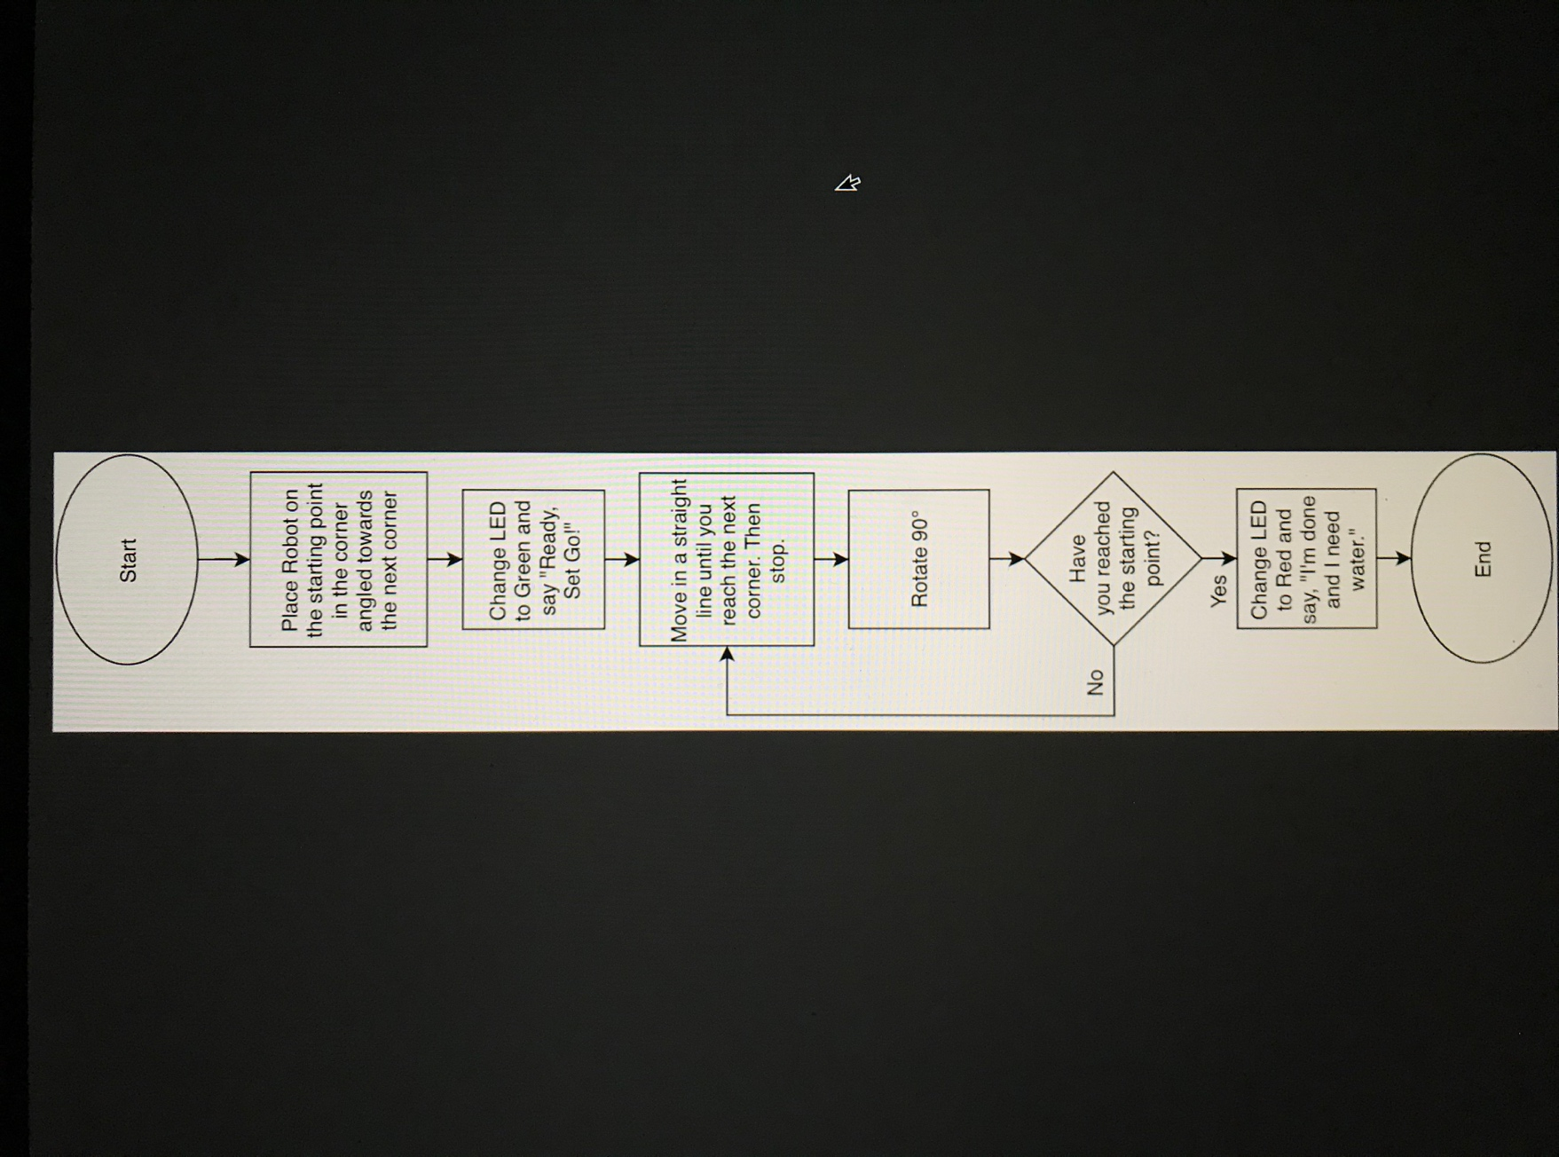

Software
Describe software languages/platforms/api’s used to develop and deploy this application

Hardware
Describe hardware platforms that were used to develop, test and demonstrate this application

Test Plan
Include a test plan showing all unit tests performed for this application, Include test rational, test date, staff member, pass/fail status

Reason for Test Case | Test Date | Expected Output | Observed Output | Staff Name | Pass/Fail

Task List/Gantt Chart
Embed your gantt chart here

Staffing Plan
Insert a chart/table that depicts the roles and responsibilities of each team member that worked on this project

Name | Role | Responsibility | Reports To

