# Project: Analyzing a Market Test

Complete each section. When you are ready, save your file as a PDF document and submit it [here](https://classroom.udacity.com/nanodegrees/nd008/parts/11a7bf4c-2b69-47f3-9aec-108ce847f855/project).

## Step 1: Plan Your Analysis

*To perform the correct analysis, you will need to prepare a data set. (500 word limit)*

*Answer the following questions to help you plan out your analysis:*

1. What is the performance metric you’ll use to evaluate the results of your test?

The performance metric to evaluate the new menu is Gross Margin by Week

1. What is the test period?

The test period is for 12 weeks when the new menu will be implemented in the treatment stores.

And all the required data is:

76 weeks of data:

* 12 weeks for test (2016-04-29 to 2016-07-21)
* 12 weeks for trend (2016-02-05 to 2016-04-28)
* 52 weeks of historical data (2015-02-06 to 2016-02-06)

1. At what level (day, week, month, etc.) should the data be aggregated?

Gross margin and store traffic must be aggregated at weekly level

## Step 2: Clean Up Your Data

*In this step, you should prepare the data for steps 3 and 4. You should aggregate the transaction data to the appropriate level and filter on the appropriate data ranges. You can assume that there is no missing, incomplete, duplicate, or dirty data. You’re ready to move on to the next step when you have weekly transaction data for all stores.*

## Step 3: Match Treatment and Control Units

*In this step, you should create the trend and seasonality variables, and use them along with you other control variable(s) to match two control units to each treatment unit. Note: Calculate the number of transactions per store per week to calculate trend and seasonality.*

*Apart from trend and seasonality...*

1. What control variables should be considered? Note: Only consider variables in the RoundRoastersStore file.

The variables that has been used from the file are:

* Region
* AvgMonthSales
* Sq_Ft

1. What is the correlation between your each potential control variable and your performance metric?

The next plot of means shows there is positive correlation for Region and Avg_MonthSales

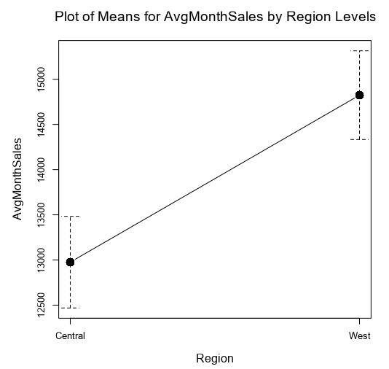

Also, Sq_ft was evaluated with a plot of means using the ranges from interquartile values, and were created three categories small, medium and big. But the plot of means does not show correlation. Then Sq_ft has been discarded as control variable.

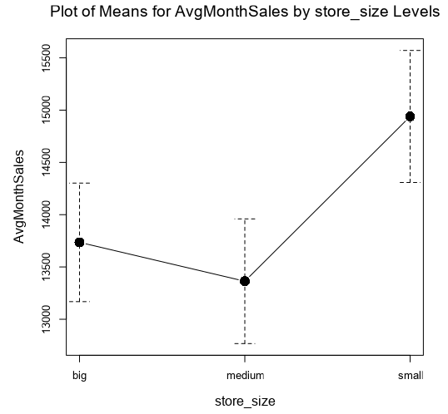

1. What control variables will you use to match treatment and control stores?

* Region
* AvgMonthSales
* Seasonality
* Trend

1. Please fill out the table below with your treatment and control stores pairs:

|  |  |  |
| --- | --- | --- |
| Treatment Store | Control Store 1 | Control Store 2 |
| 1664 | 7162 | 1964 |
| 1675 | 1807 | 7584 |
| 1696 | 1863 | 7334 |
| 1700 | 7037 | 2014 |
| 1712 | 8162 | 7434 |
| 2288 | 2568 | 9081 |
| 2293 | 12686 | 9639 |
| 2301 | 12019 | 9238 |
| 2322 | 3235 | 9388 |
| 2341 | 2572 | 3102 |

## Step 4: Analysis and Writeup

*Conduct your A/B analysis and create a short report outlining your results and recommendations. (250 words limit)*

*Answer these questions. Be sure to include visualizations from your analysis:*

1. What is your recommendation - Should the company roll out the updated menu to all stores?

Yes, there is an increase of gross margin in the test period of 42.3 % with statistically significance of 100 %. Therefore, the new menu should be implemented in all stores.

1. What is the lift from the new menu for West and Central regions (include statistical significance)?

For the Stores in West region has the next lift and statistical significance:

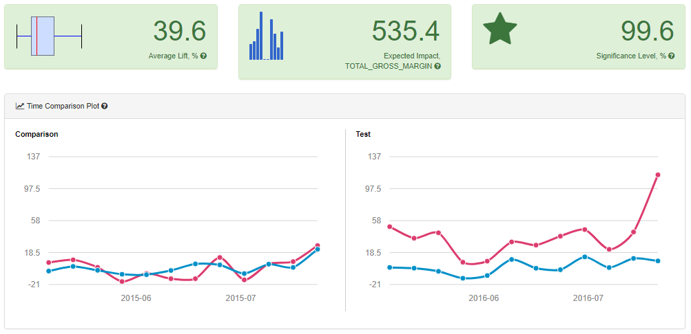

For the Stores in Central region has the next lift and statistical significance:

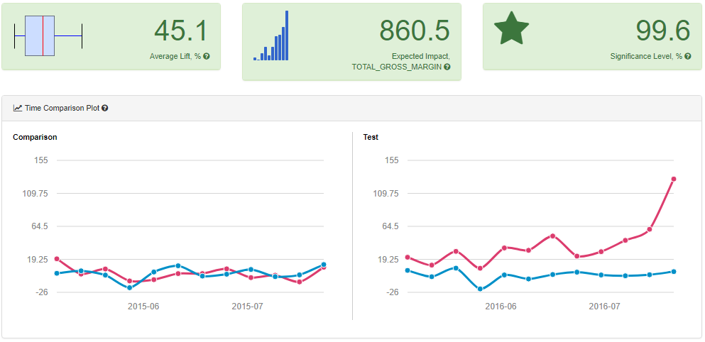

1. What is the lift from the new menu overall?

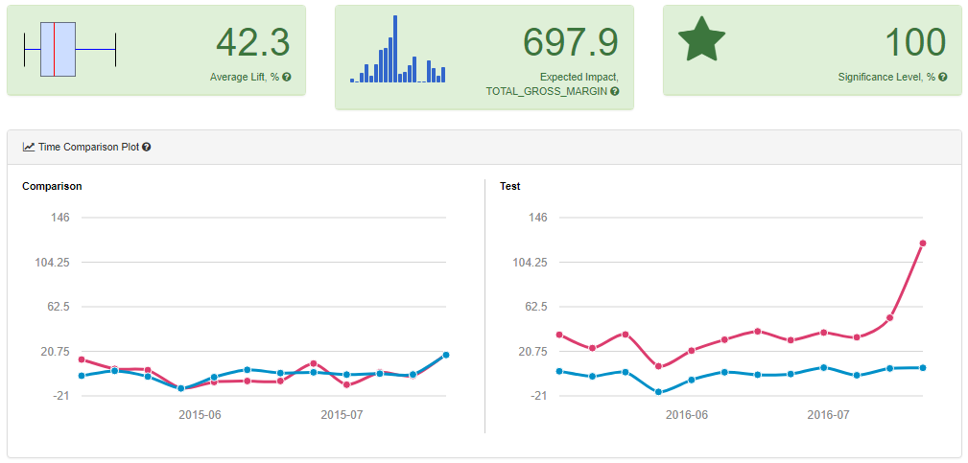

**Alteryx Workflows**

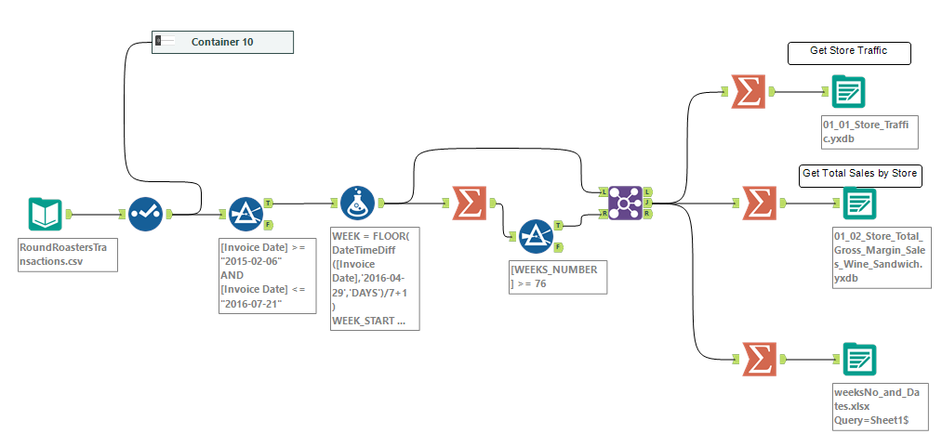

Figure . Data Preparation

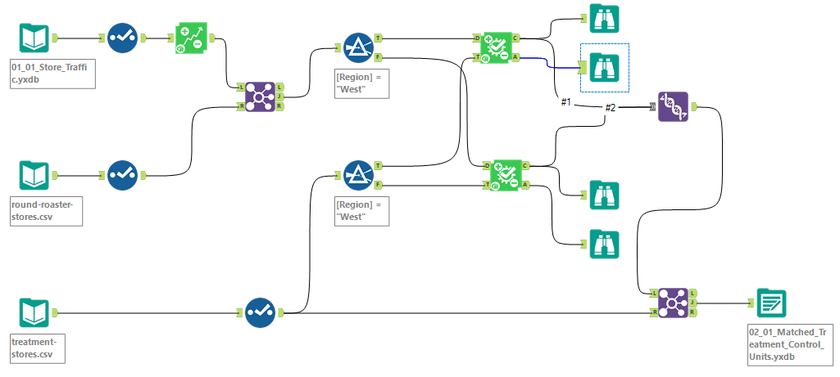

Figure Match Treatment and Control Stores

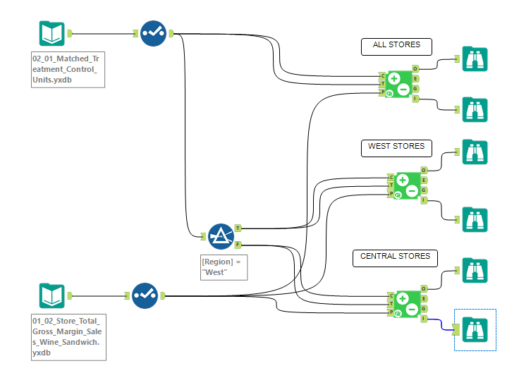

Figure AB Test Analysis