|  |  |  |  |  |
| --- | --- | --- | --- | --- |
|  | Providence | Westerly | New London | Norwich |
| Providence | 0 | 53 | 54 | 48 |
| Westerly | 53 | 0 | 18 | **30** |
| New London | 54 | 18 | 0 | 12 |
| Norwich | 48 | **30** | 12 | 0 |

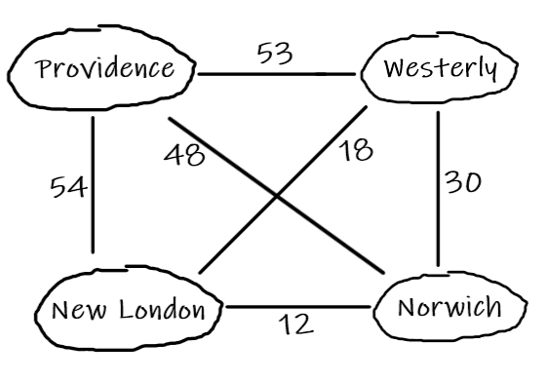



Initial:

|  |  |  |  |  |  |  |  |
| --- | --- | --- | --- | --- | --- | --- | --- |
| A | B | C | D | E | F | G | H |
| 0 | +∞ | +∞ | +∞ | +∞ | +∞ | +∞ | +∞ |

Iteration 1:

|  |  |  |  |  |  |  |  |
| --- | --- | --- | --- | --- | --- | --- | --- |
| A | B | C | D | E | F | G | H |
| 0 | **4** | **7** | **5** | +∞ | +∞ | +∞ | +∞ |

Iteration 2:

|  |  |  |  |  |  |  |  |
| --- | --- | --- | --- | --- | --- | --- | --- |
| A | B | C | D | E | F | G | H |
| 0 | 4 | **6** | 5 | **8** | **8** | **13** | **9** |

Iteration 3:

|  |  |  |  |  |  |  |  |
| --- | --- | --- | --- | --- | --- | --- | --- |
| A | B | C | D | E | F | G | H |
| 0 | 4 | 6 | 5 | 8 | **7** | **12** | 9 |

Iteration 4:

|  |  |  |  |  |  |  |  |
| --- | --- | --- | --- | --- | --- | --- | --- |
| A | B | C | D | E | F | G | H |
| 0 | 4 | 6 | 5 | 8 | 7 | **11** | 9 |

Iteration 5:

|  |  |  |  |  |  |  |  |
| --- | --- | --- | --- | --- | --- | --- | --- |
| A | B | C | D | E | F | G | H |
| 0 | 4 | 6 | 5 | 8 | 7 | 11 | 9 |

No changes

1. M2(i,j) returns the minimum of the distance between vertex i and some vertex k added to the distance between vertex j and the same vertex k. Thus, we can conclude that M2(i,j) is the shortest distance between vertices i and j that has at most 1 intermediate vertex. If M2(i,j) = d, d != ∞, that means that there exists (at least) a path with endpoints i and j such that there is at most 1 intermediate vertex. For Mk(i,j) = d, d != ∞, that means there exists a path with endpoints i and j such that there are at most k intermediate vertices.

Detroit can get a maximum of 77 wins:

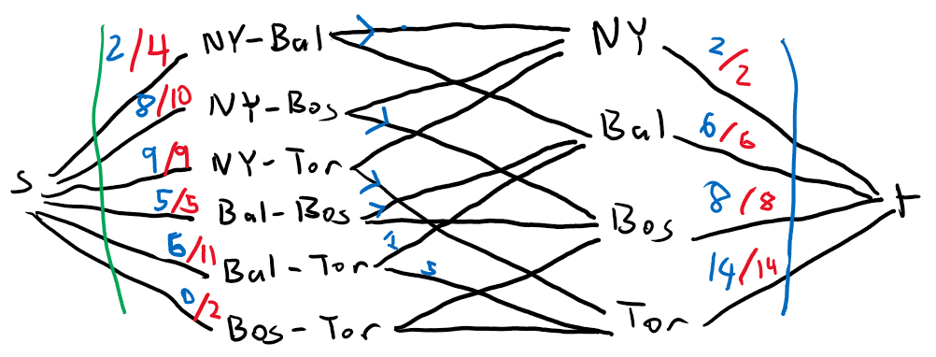

(Blue arrows represent all the flow going in that direction)

Assuming Detroit gets their maximum wins, the above graph represents the matches between the teams not include Detroit’s. The capacity of the green cut represents the number of matches to be played, while the capacity of the blue cut represents the number of wins a team needs to tie with Detroit’s maximum of 77.

Because the capacity of every edge crossing the blue cut has been filled while those of the edges crossing the green cut haven’t, that means that while there are still games left to be played, every team in the best-case would have already reached 77 wins. Since there are still games to be played, a team is guaranteed to get more than 77 wins, making it impossible for Detroit to win.

Toronto can get a maximum of 90 wins:

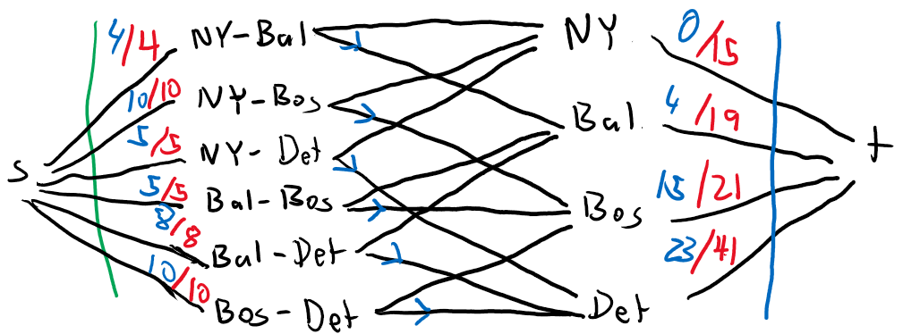

Assuming Toronto gets their maximum wins, the above graph represents the matches between the teams not include Toronto’s. The capacity of the green cut represents the number of matches to be played, while the capacity of the blue cut represents the number of wins a team needs to tie with Toronto’s maximum of 90.

Because the capacities of every edge crossing the green cut was filled before that of any of the edges crossing the blue cut was, that means that it’s possible for every team to end up under 90 wins, meaning Toronto could potentially win still.



Base Case:

All edges across the cut go into the only vertex in set T, that is the sink vertex t. This means that f(χ) = inflow(t). We know |f| = outflow(s) = inflow(t), therefore we can conclude for |T| = 1 that |f| = f(χ).

Assume |f| = f(χ) for |T| = 1,2,...,k. Check if it is true for k+1:

Let y be the flow across cut χ with a start or end point in a vertex vk+1, such that |f| - |y| = f(χ) – z, for some z.

For |y| != 0, vk+1 will have to deposit the extra flow somewhere, meaning it has outflow towards other vertices in T, eventually reaching the sink. Because |f| - |y| is already accounted for, the only additional flow across the cut goes through y. Therefore, z=y and |f| = f(χ) for k+1.

Because of induction, we know that |f| = f(χ) for any |T|.