Purpose of Lab Exercise:

This lab exercise demonstrated the relationship of a lubricant’s absolute viscosity to temperature. It also allowed the student to observe the different behavior between petroleum based lubricants and newer, synthetic lubricants.

To observe the relationship between viscosity and temperature, a Brookfield DV-1 Viscometer was employed to measure the viscosity of several multi-weight lubricants at temperatures ranging from –30°F to 100°F in approximately 10°F increments. The viscosity was recorded and note was also made of any problems observed due to paraffin precipitation or other difficulties in using the apparatus. A plot of the data for each lubricant on common viscosity vs. temperature axes helps shows why/when the use of different weight or formulations of lubricants may be desired to insure proper lubrication in application.

Lab Procedure:

- The manufacturer’s Manual for the Brookfield DV-1 Viscometer was reviewed.

- The viscometer was assembled on the stand and the proper spindles to use in the test and initial rotational speeds were estimated.

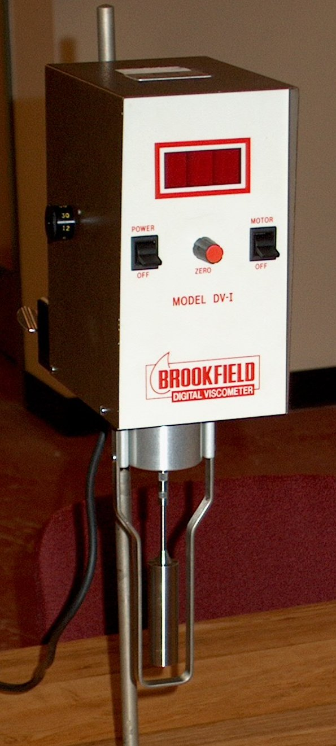

- The samples were retrieved one at a time from the environmental chamber and tested for viscosity at ~10°F intervals from –30°F to 100°F. A thermometer was used to determine the temperature to the nearest °F at each viscosity reading.

- Finally, the apparatus was disassembled, cleaned and returned to storage for future use.

Data & Discussion:

The apparatus reports arbitrary units, which are converted to centiPoise using factors read off an included set of tables, taking into account model, spindle number and rpm:

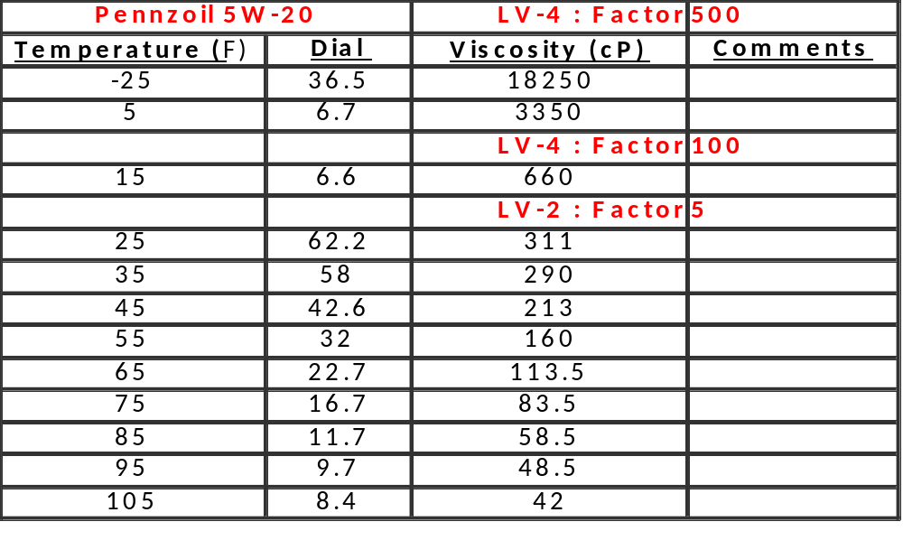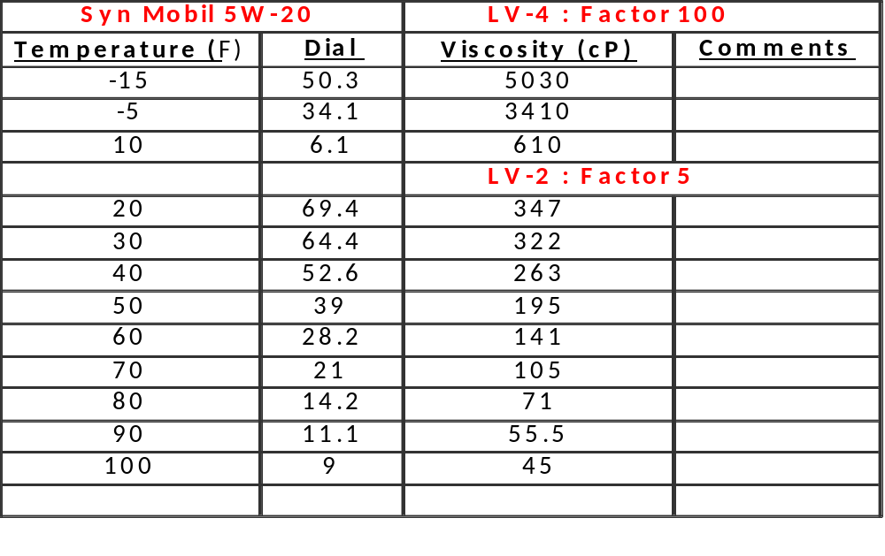
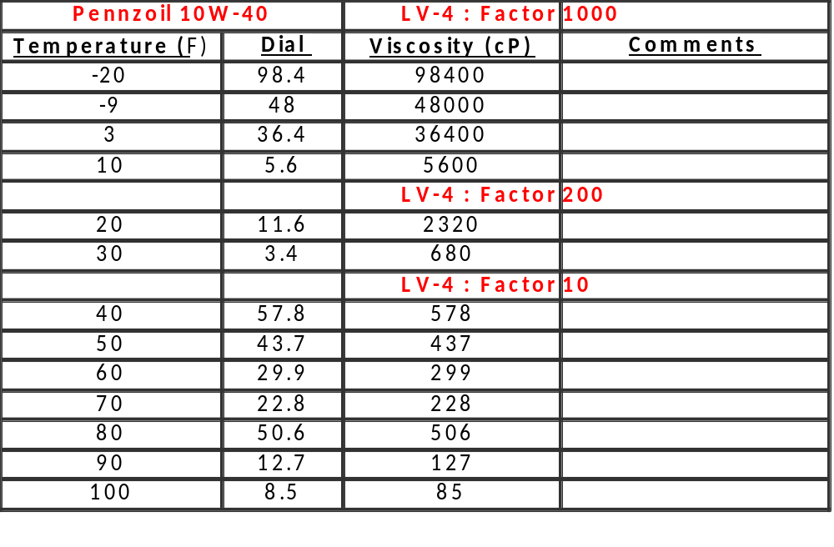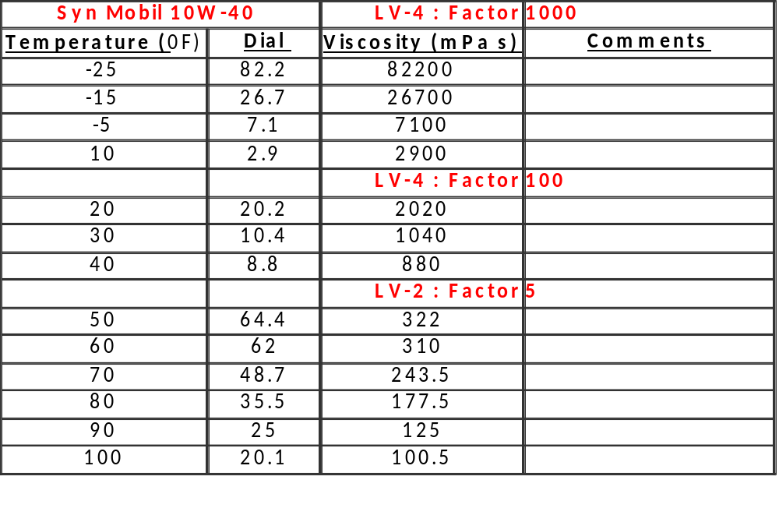

Conclusions & Comments:

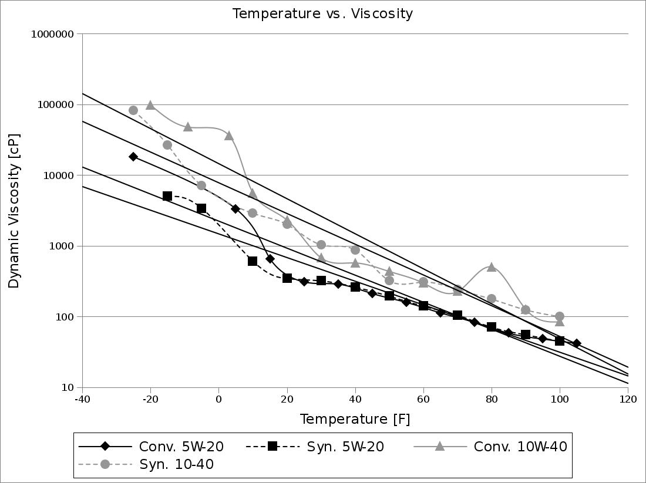

Viscosities were graphed on the same chart with respect to temperature, and fitted with exponential regressions. While these curve fits capture the proper order of magnitude, they do not give the data's nuances justice.

For above-zero temperatures, synthetic and conventional oils act quite similarly to each other, given they have the same weight rating. Also worth noting is that, for our tests, 5W-20 was more consistent than 10W-40 regardless of conventionality.

At lower temperatures, viscosity decreases with respect to temperature increase at a super-exponential rate, particularly for conventional oils. While synthetic oils also exhibited homogeneous behavior at low temperatures, conventional oils tended to "glob"--that is, longer paraffin chains (present in conventional oils but not in synthetics) precipitated and conglomerated at lower temperatures. It is worth noting that this caused the uncertainty of low-temperature viscosity and temperature measurements of conventional oils to be very significant, since neither was even semi-consistent throughout the material.

At low temperatures, these oils are both highly viscous, and not suitable for vehicle lubrication. This is why (at least in part) cars must be plugged in at lower temperatures---that is, the oils must be warmed up to function properly. On the other hand, at medium-level temperatures it is likely worth choosing the lower-weight oil, as the viscosity is significantly lower in these temperature ranges (as can be seen in the chart, noting that viscosity is on a logarithmic scale).

