Purpose of Lab Exercise:

This lab exercise demonstrated the lumped capacitance heat transfer method for transient heat transfer.

Using this method, it is assumed that the resistance to conductive heat transfer within the body is far less than the resistance due to convective and radiative heat transfer from the body to its surroundings. As a result of this assumption, it is also assumed that the temperature distribution within the body is uniform. A metric used to judge the “goodness” of this assumption is the Biot Number (Bi). The closer Bi is to zero, the better is the assumption of lumped capacitance.

To demonstrate this method, an aluminum sphere was heated to between 450°F and 500°F and allowed to free-cool in the lab air. A Type-T thermocouple was embedded in the center of the sphere and the temperature was recorded every 15 seconds using a Campbell 21X Micrologger until the sphere’s temperature fell below 100°F. The analysis shown below compares the results observed to the temperature decay predicted by the theory.

Lab Procedure:

- The aluminum sphere was installed on the support stand as shown.

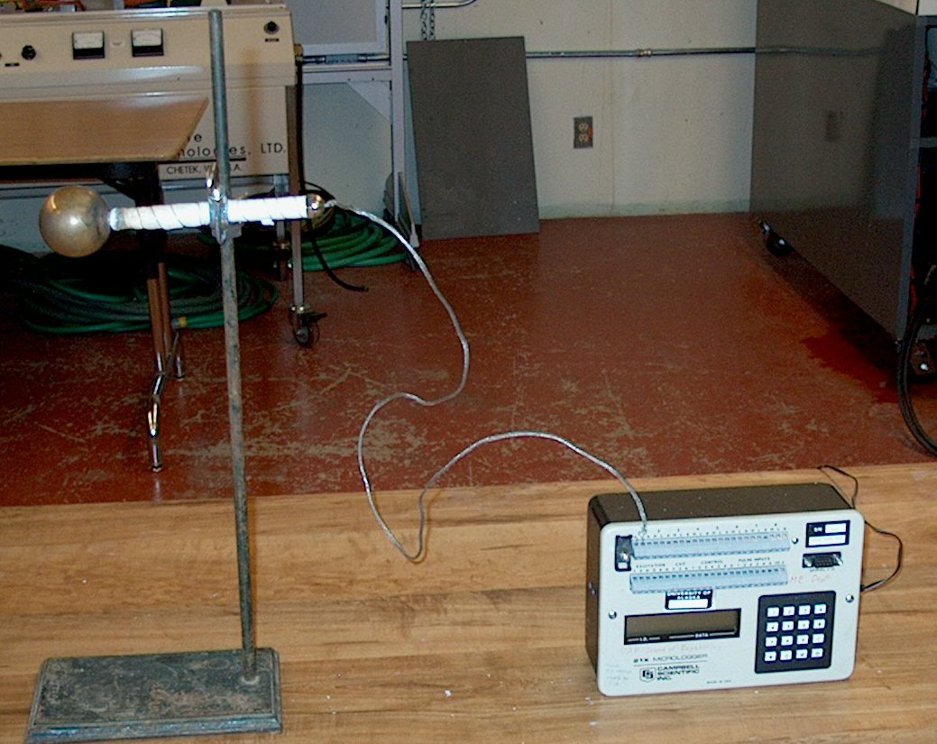

- The Type-T thermocouple leads were connected to the Campbell 21X Micrologger being sure to connect the leads with the correct polarity (more noble metal to positive

- The datalogger was programmed with the program listed below.

- A propane torch was used to heat the sphere to between 450°F and 500°F.

- The sphere was allowed to cool to just below 100°F.

- The data from the datalogger was dumped to a computer file. This file was posted on the class Web site.

- The datalogger was shut OFF and disconnect from the sphere.

Campbell 21X Micrologger Program:

Logger Display | Enter | Purpose
11:11111.11 | *1 | Instructs the logger you are programming Table 1.
01: | 15 | Scan rate of 15 seconds.
01: P | 17 | Program panel (TC Ref.) temperature.
01: | 1 | Storage location for pnl temp is register 1.
02: P | 14 | Program differential TC.
01: | 1 | 1 repetition (1 TC).
02: | 2 | Slow response up to 15mV (suitable to 500°F K & T TC).
03: | 1 | Input channel (TC connection point).
04: | 3 or 1 | 3 for Type-K, 1 for Type-T TC.
05: | 1 | Location (register) for reference temp.
06: | 2 | Storage location (register) for TC temp.
07: | 1D8 | 1.8 conversion factor for °C to °F.
08: | 32 | Scale offset for °C to °F.
03: P | 86 | Set the DO flag.
01: | 10 | Send/store input register data to output registers.
04: P | 70 | Set the sampling for the output registers.
01: | 2 | 2 repetition/data point, the Pnl & TC temp.
02: | 1 | Memory/register location of the Pnl temp.
05: P | *0 | Your program is complete. Compile & run Table 1.
LOG 1 |  | You were successful & program in logging data.
 | *6 | Display input registers.
 | A &/or B | Forward & back between Loc 1 & 2 to read pnl temp and TC temp.

Data & Discussion:

The diameter of the aluminum sphere was measured to be 1.95" by another student with a pair of calipers.

{Discuss the data collected by the logger. Give a brief (~10-20 points) excerpt of the data in organized form.}

{Discuss sub-setting the data for use in this analysis. Show the sub-setted data in organized/table form.}

Calculations & Discussion:

{Calculate the Biot Number and discuss its impact on the applicability of the method.}
{Calculate the convective and radiative contributions to the theoretical cooling of the sphere.}

{Calculate the theoretical temperature vs. time response curve.}

Conclusions & Comments:

{Plot and discuss your theoretical results with an overlay of the sub-setted experimental data.}

