E-Learning Database Management System

Introduction
The purpose of this project was to create an e-learning database management system that can store and organize individual and academic information. Educational institutions need organized systems to manage the large volumes of data they are required to store. Managing records without a database would be time-consuming and difficult to maintain. This database simulates a small, but realistic, college-level e-learning environment. It contains both undergraduate and graduate courses. The system allows instructors to manage course information and assignments while tracking assignment submissions, attendance, enrollment status, and grades. SQL queries also enable the answer to both academic and administrative questions. This database supports complex queries across multiple related tables while demonstrating relational database concepts, ER relationships, primary keys, constraints, and SQL queries.

Database
This e-learning database management system was designed to simulate a college-level online learning environment. The system manages information related to students, instructors, courses, enrollments, attendance, assignments, submissions, and grades. The purpose of the database is to organize academic information efficiently while allowing instructors and administrators to track student performance and course activity.
The system supports both undergraduate and graduate courses across multiple academic departments including Biology, History, Psychology, Mathematics, English, Engineering, Computer Science, Health Science, and Finance. Instructors are assigned to courses based on their department, and graduate-level courses are restricted to instructors with a doctoral title.
Students are stored with identifying and academic information including names, enrollment dates, majors, and grade levels. Students may enroll in multiple courses, and each enrollment record tracks the student’s status as Active, Complete, or Dropped.
Courses contain assignments with due dates and possible point values. Completed assignments are managed through submission records, using submission dates to determine whether the assignment is late. Links are also used to access completed work. The grading system stores assignment scores, percentages, and letter grades.
This database also tracks student attendance in courses using attendance dates and statuses such as Present or Absent. The system can identify students with excessive absences.
This database was designed using relational database concepts with primary keys, foreign keys, and constraints. SQL queries were developed to answer academic and administrative questions, including identifying missing submissions, calculating average grades, analyzing attendance rates, and tracking enrollment trends.

Database Requirements
This database manages several categories of information, including student, instructor, course, enrollment, attendance, assignment, submission, and grade requirements.
Student requirements:
- Student ID
- First Name
- Last Name
- Email Address
- Date of Birth
- Enrollment Date
- Major
- Grade Level
  - Separation between undergraduate and graduate students
Instructor Requirements
- Instructor ID
- Instructor Prefix
- First Name
- Last Name
- Department
- Instructor Email
This system was also required to support instructors teaching multiple courses.
Course Requirements:
- Course ID
- Instructor assignment
- Course name
- Course description
- Credit hours
- Course level
Courses were separated into undergraduate and graduate courses.

Enrollment Requirements
The enrollment system needed to connect students to courses, track enrollment dates, and track enrollment status. Enrollment statuses included active, complete, or dropped. Graduate students were restricted to graduate-level courses related to their major areas.

Attendance Requirements
The attendance system needed to track attendance records for students, Associate attendance with courses, store attendance dates, and record attendance status. Attendance statuses included Present or Absent.

Assignment Requirements
The assignment system needed to connect assignments to courses, store assignment titles, descriptions, due dates, and point values. Each course contained multiple assignments.

Submission Requirements
The submission system needed to connect students to assignment submissions, store submission dates, and store submission links. The system also needed to support missing submissions for academic tracking.

Grade Requirements
The grading system needed to connect grades to submissions, store raw scores, calculate percentage grades, and assign letter grades. Letter grades included the typical grading scale of A, B, C, D, F. These letters were determined by the percentage calculated by dividing the submission score by assignment points.

Entity Relationship Diagram
The ER diagram for this project models the relationships between students, instructors, courses, enrollments, attendance, assignments, submissions, and grades. This is how the system organizes data while maintaining referential integrity throughout the database.
Entities
- Student
- Instructor
- Course
- Enrollment
- Attendance
- Assignment
- Submission
- Grade
The design uses primary keys to identify records and foreign keys to establish relationships between the tables.
Relationships
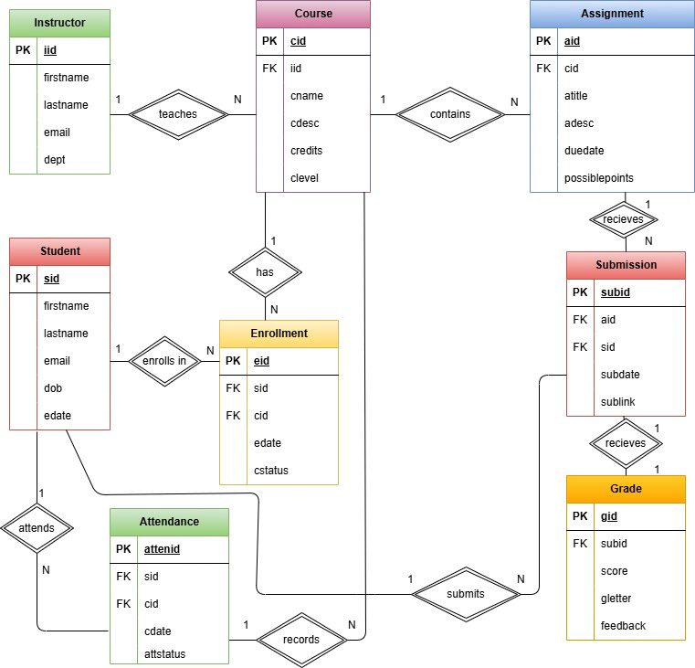
Instructor Course
- An instructor can teach many courses, while each course only has one instructor
- Relationship: 1:N
- Foreign Key: iid in the course table references iid in instructor
Course Assignment
- A course can contain many assignments, while each assignment belongs to one course.
- Relationship: 1:N
- Foreign Key: cid in the assignment table references cid in course
Student Enrollment
- A student can enroll in many courses, and each enrollment record belongs to one student.
- Relationship: 1:N
- Foreign Key: sid in the Enrollment table references sid in Student
Course Enrollment
- A course can contain many enrolled students, while each enrollment record references one course.
- Relationship: 1:N
- Foreign Key: cid in the Enrollment table references cid in Course.
- The Enrollment table is a bridge entity between Student and Course.
Student Attendance
- A student may have many attendance records, while each attendance record belongs to one student.
- Relationship: 1:N
- Foreign Key: sid in the Attendance table references sid in Student.
Course Attendance
- A course contains many attendance records, while each attendance record belongs to one course
- Relationship: 1:N
- Foreign Key: cid in the Attendance table references cid in Course
Student Submission
- A student may submit many assignments, while each submission belongs to one students
- Relationship: 1:N
- Foreign Key: sid in the Submission table references sid in Student.
Assignment Submission
- An assignment may receive many submissions, while each submission belongs to one assignment.
- Relationship: 1:N
- Foreign Key: aid in the Submission table references aid in Assignment
Submission Grade
- Each submission receives one grade, and each grade belongs to one submission.
- Relationship: 1:1
- Foreign Key: subid in the Grade table references subid in Submission
Table Design
Table Creation Order
- Student
- Instructor
- Course
- Enrollment
- Attendance
- Assignment
- Submission
- Grade
Beginning with the student table, following this order pf creation, and ending with the grade table, prevents foreign key errors because referenced tables already exist before dependent tables are created.
Constraints
Used to protect data accuracy. Constraints keep data organized and reduce duplication while still allowing tables to connect via primary and foreign keys.
Primary Keys
- Used to uniquely identify each record.
- sid identifies each student, cid identifies each course, for example.
Foreign Keys
- Connected related tables
NOT NULL
- Used for required values
Unique
- Prevents duplication
Check Constraints
- Only allows certain data
Data Types
- Varchar, date, int, decimal
Table Structure
Course Table
- Stores information about each course offered in the e-learning system.
- Primary Key: cid
- Foreign Key: iid references instructor.iid

Column Description
cid Unique course ID
iid Instructor assigned to the course
cname Course name
cdesc Course description
credits Number of credit hours
clevel Undergraduate or Graduate
Enrollment Table
- Connectys students to courses and tracks each student’s enrollment status
- Primary Key: eid
- Foreign Keys: sid references student(sid), cid references course(cid)
Column Description
eid Unique enrollment ID
sid Student enrolled in the course
cid Course the student is enrolled in
edate Enrollment date for the course
cstatus Enrollment status: Active, Complete, or Dropped

Attendance Table
- Records student attendance for courses.
- Primary Key: attended
- Foreign Keys: sid references student(sid), cid references course(cid)
Column Description
attendid Unique attendance record ID
sid Student connected to the attendance record
cid Course connected to the attendance record
cdate Date attendance was recorded
attstatus Attendance status, such as Present or Absent

Assignment Table
- Stores assignments connected to each course.
- Primary Key: aid
- Foreign Key: cid references course(cid)
Column Description
aid Unique assignment ID
cid Course the assignment belongs to
atitle Assignment title
adesc Assignment description
duedate Assignment due date
possiblepoints Total possible points for the assignment

Submission Table
- Records student assignment submissions
- Primary Key: subid
- Foreign Keys: aid references assignment(aid), sid references student(sid)
Column Description
subid Unique submission ID
aid Assignment being submitted
sid Student who submitted the assignment
subdate Date the assignment was submitted
sublink Link to the submitted assignment

Grade Table
- Stores grading information for each submission.
- Primary Key: gid
- Foreign Key: subid references submission(subid)
Column Description
gid Unique grade ID
subid Submission being graded
score Points received
gradepercent Percentage grade
gletter Letter grade
feedback Optional instructor feedback

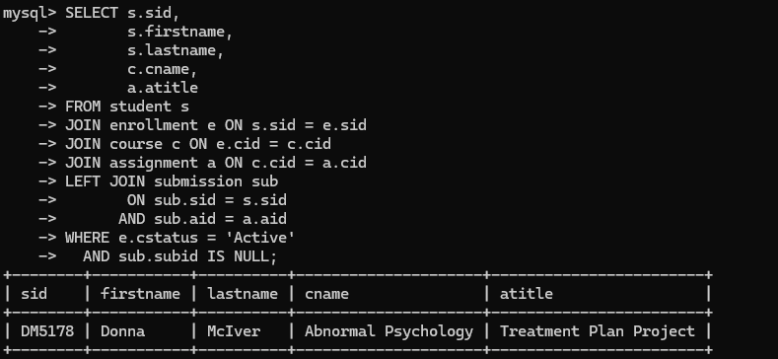
Queries
- This query identifies actively enrolled students who are missing assignments in courses. It joins student, enrollment, course, assignment and submission, using LEFT JOIN to find assignments without matching submissions and WHERE filters for active enrollments.

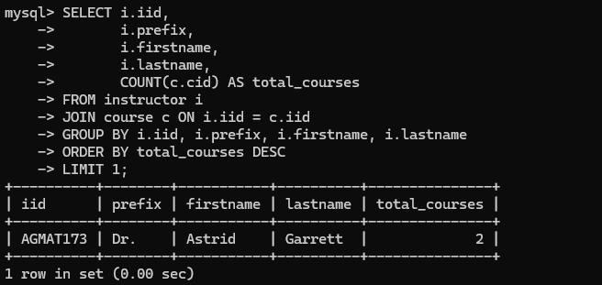
- This query identifies the instructor who teaches the most courses. This query joins the instructor and course tables to determine how many courses each instructor teaches. The COUNT() function counts courses connected to each instructor, while GROUP BY groups the results by instructor information. ORDER BY sorts the instructors from highest to lowest course count, and LIMIT 1 returns only the instructor teaching the most courses.

