E- Learning Database
Database Systems Term Project
Josie Filloon
2026

Introduction
The purpose of this project was to create an e-learning database management system that can store and organize individual and academic information. Educational institutions need organized systems to manage the large volumes of data they are required to store. Managing records without a database would be time-consuming and difficult to maintain. This database simulates a small, but realistic, college-level e-learning environment. It contains both undergraduate and graduate courses. The system allows instructors to manage course information and assignments while tracking assignment submissions, attendance, enrollment status, and grades. SQL queries also enable the answer to both academic and administrative questions. This database supports complex queries across multiple related tables while demonstrating relational database concepts, ER relationships, primary keys, constraints, and SQL queries.
The system supports both undergraduate and graduate courses across multiple academic departments including Biology, History, Psychology, Mathematics, English, Engineering, Computer Science, Health Science, and Finance. Instructors are assigned to courses based on their department, and graduate-level courses are restricted to instructors with a doctoral title.
Students are stored with identifying and academic information including names, enrollment dates, majors, and grade levels. Students may enroll in multiple courses, and each enrollment record tracks the student’s status as Active, Complete, or Dropped.
Courses contain assignments with due dates and points. Completed assignments are managed through submission records, using dates submitted to verify whether the assignment was submitted on time. Links are used to access completed work. The grading system stores assignment scores, percentages, and letter grades.
This database also tracks student attendance in courses using attendance dates and statuses such as Present or Absent. The system can identify students with excessive absences.
This database was designed using relational database concepts with primary keys, foreign keys, and constraints. SQL queries were developed to answer academic and administrative questions, including identifying missing submissions, calculating average grades, analyzing attendance rates, and tracking enrollment trends.

Database Requirements
This database manages student, instructor, course, enrollment, attendance, assignment, submission, and grade requirements.
Student requirements:
- Student ID
- First Name
- Last Name
- Email Address
- Date of Birth
- Enrollment Date
- Major
- Grade Level
  - Separation between undergraduate and graduate students
Instructor Requirements
- Instructor ID
- Instructor Prefix
- First Name
- Last Name
- Department
- Instructor Email
This system was also required to support instructors teaching multiple courses.
Course Requirements:
- Course ID
- Instructor assignment
- Course name
- Course description
- Credit hours
- Course level
Courses were separated into undergraduate and graduate courses.

Enrollment Requirements
The enrollment system needed to connect students to courses, track enrollment dates, and track enrollment status. Enrollment statuses included active, complete, or dropped. Graduate students were restricted to graduate-level courses related to their major areas.

Attendance Requirements
The attendance system needed to track student attendance records, Associate attendance with courses, store attendance dates, and record attendance status. Attendance statuses included Present or Absent.

Assignment Requirements
The assignment system needed to link assignments to courses and store assignment titles, descriptions, due dates, and points. Each course contained multiple assignments.

Submission Requirements
The submission system needed to connect students to assignment submissions, store submission dates, and store submission links. The system also needed to support missing submissions for academic tracking.

Grade Requirements
The grading system needed to connect grades to submissions, store raw scores, calculate percentage grades, and assign letter grades. Letter grades included the typical grading scale of A, B, C, D, F. These letters were determined by the percentage calculated by dividing the submission score by assignment points.

Entity Relationship Diagram
The ER diagram for this project models the relationships between students, instructors, courses, enrollments, attendance, assignments, submissions, and grades. This is how the system organizes data while maintaining referential integrity throughout the database.
Entities
- Student
- Instructor
- Course
- Enrollment
- Attendance
- Assignment
- Submission
- Grade
The design uses primary keys to identify records and foreign keys to establish relationships between the tables.

Relationships
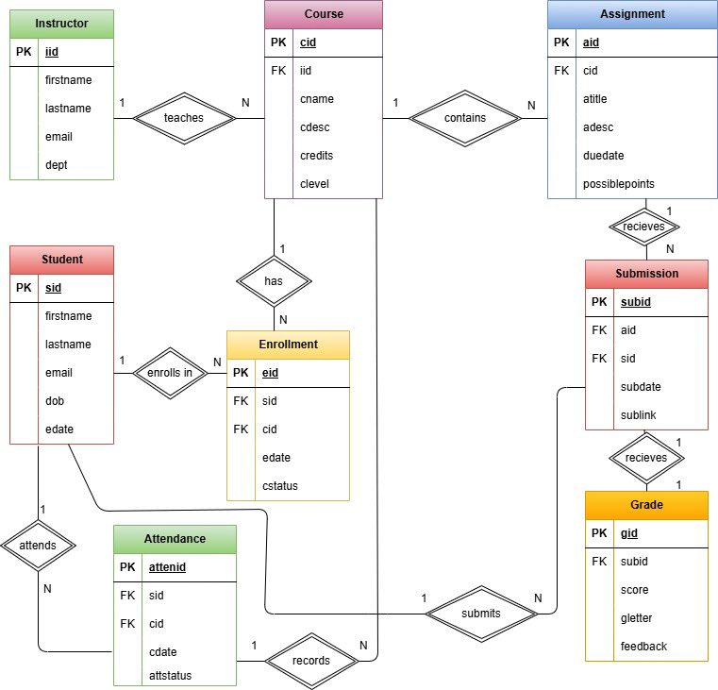
Instructor Course
- An instructor can teach many courses, while each course only has one instructor
- Relationship: 1:N
- Foreign Key: iid in the course table references iid in instructor
Course Assignment
- A course can contain many assignments, while each assignment belongs to one course.
- Relationship: 1:N
- Foreign Key: cid in the assignment table references cid in course
Student Enrollment
- A student can enroll in many courses, and each enrollment record belongs to one student.
- Relationship: 1:N
- Foreign Key: sid in the Enrollment table references sid in Student
Course Enrollment
- A course can contain many enrolled students, while each enrollment record references one course.
- Relationship: 1:N
- Foreign Key: cid in the Enrollment table references cid in Course.
- The Enrollment table is a bridge entity between Student and Course.
Student Attendance
- A student may have many attendance records, while each attendance record belongs to one student.
- Relationship: 1:N
- Foreign Key: sid in the Attendance table references sid in Student.
Course Attendance
- A course contains many attendance records, while each attendance record belongs to one course
- Relationship: 1:N
- Foreign Key: cid in the Attendance table references cid in Course
Student Submission
- A student may submit many assignments, while each submission belongs to one student
- Relationship: 1:N
- Foreign Key: sid in the Submission table references sid in Student.
Assignment Submission
- An assignment may receive many submissions, while each submission belongs to one assignment.
- Relationship: 1:N
- Foreign Key: aid in the Submission table references aid in Assignment
Submission Grade
- Each submission receives one grade, and each grade belongs to one submission.
- Relationship: 1:1
- Foreign Key: subid in the Grade table references subid in Submission

Table Design
Table Creation Order
- Student
- Instructor
- Course
- Enrollment
- Attendance
- Assignment
- Submission
- Grade
Beginning with the student table, following this order of creation, and ending with the grade table, prevents foreign key errors because referenced tables already exist before dependent tables are created.
Constraints
Used to protect data accuracy. Constraints keep data organized and reduce duplication while still allowing tables to connect via primary and foreign keys.
Primary Keys
- Used to uniquely identify each record.
- sid identifies each student, cid identifies each course, for example.
Foreign Keys
- Connected related tables
NOT NULL
- Used for required values
Unique
- Prevents duplication
Check Constraints
- Only allows certain data
Data Types
- Varchar, date, int, decimal

Table Structure
Course Table
- Stores information about each course offered in the e-learning system.
- Primary Key: cid
- Foreign Key: iid references instructor.iid

Column Description
cid Unique course ID
iid Instructor assigned to the course
cname Course name
cdesc Course description
credits Number of credit hours
clevel Undergraduate or Graduate
Enrollment Table
- Connects students to courses and tracks each student’s enrollment status
- Primary Key: eid
- Foreign Keys: sid references student(sid), cid references course(cid)
Column Description
eid Unique enrollment ID
sid Student enrolled in the course
cid Course the student is enrolled in
edate Enrollment date for the course
cstatus Enrollment status: Active, Complete, or Dropped

Attendance Table
- Records student attendance for courses.
- Primary Key: attenid
- Foreign Keys: sid references student(sid), cid references course(cid)
Column Description
attendid Unique attendance record ID
sid Student connected to the attendance record
cid Course connected to the attendance record
cdate Date attendance was recorded
attstatus Attendance status, such as Present or Absent

Assignment Table
- Stores assignments connected to each course.
- Primary Key: aid
- Foreign Key: cid references course(cid)
Column Description
aid Unique assignment ID
cid Course the assignment belongs to
atitle Assignment title
adesc Assignment description
duedate Assignment due date
possiblepoints Total possible points for the assignment

Submission Table
- Records student assignment submissions
- Primary Key: subid
- Foreign Keys: aid references assignment(aid), sid references student(sid)
Column Description
subid Unique submission ID
aid Assignment being submitted
sid Student who submitted the assignment
subdate Date the assignment was submitted
sublink Link to the submitted assignment

Grade Table
- Stores grading information for each submission.
- Primary Key: gid
- Foreign Key: subid references submission(subid)
Column Description
gid Unique grade ID
subid Submission being graded
score Points received
gradepercent Percentage grade
gletter Letter grade

Queries
- Which students are missing assignments in active courses?
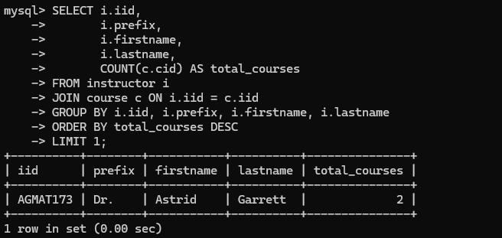
- JOIN connects the student, enrollment, course, assignment, and submission tables
- LEFT JOIN identifies assignments without matching submissions
- WHERE filters for active enrollments only
Result: Identifies actively enrolled students with missing assignment submissions.
Answer: Donna McIver is missing the Treatment Plan Project Assignment in Abnormal Psychology.

- Which Instructor teaches the most courses?
- JOIN connects the instructor and course tables
- COUNT() counts courses taught by each instructor
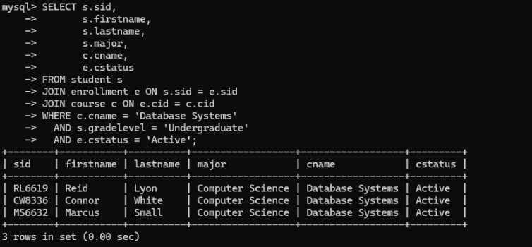
- GROUP BY groups results by instructor
- ORDER BY sorts instructors from highest to lowest course count
- LIMIT 1 returns only the top result
Result: Identifies the instructor teaching the highest number of courses.
Answer: Dr. Astrid Garrett.

- Which active undergraduate students are enrolled in Database Systems?
- JOIN connects the student, enrollment, and course tables
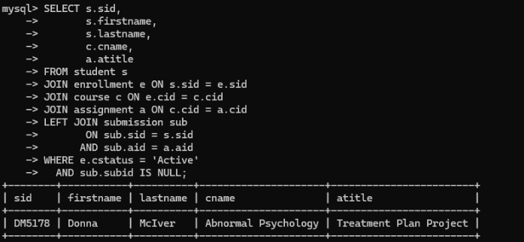
- WHERE filters for Database Systems, undergraduate students, and active enrollments
Result: Identifies active undergraduate students enrolled in Database Systems.
Answer: Reid Lyon, Connor White, and Marcus Small.

- Which students have an average grade below 75%?
- LEFT JOIN connects the student, submission, and grade tables
- AVG() calculates average grade percentages
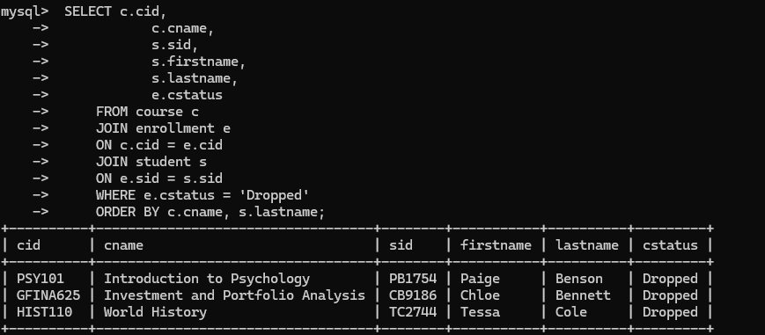
- COALESCE() replaces missing grades with 0
- GROUP BY groups results by student
- HAVING filters averages below 75%
Result: Identifies students with low overall grade averages.
Answer: Chloe Bennett and Tessa Cole have averages below 75% due to missing assignments.

- Which courses have dropped students?
- JOIN connects the course, enrollment, and student tables
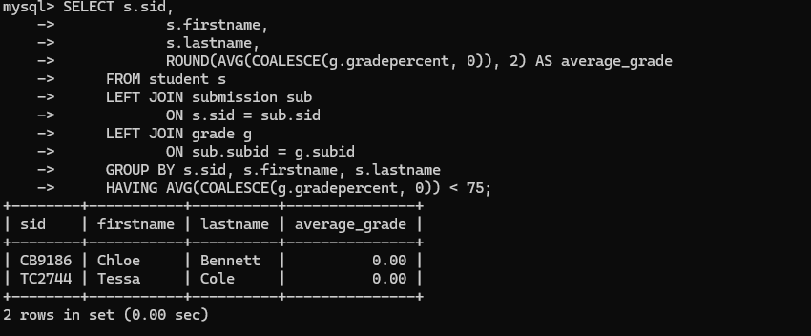
- WHERE filters for dropped enrollment statuses
- ORDER BY sorts by course and student last name
Result: Identifies courses containing dropped enrollments.
Answer: PSY101, GFINA625, and HIST110 have dropped students.

- Which students earned an A in graduate finance courses?
- JOIN connects the student, submission, grade, assignment, and course tables
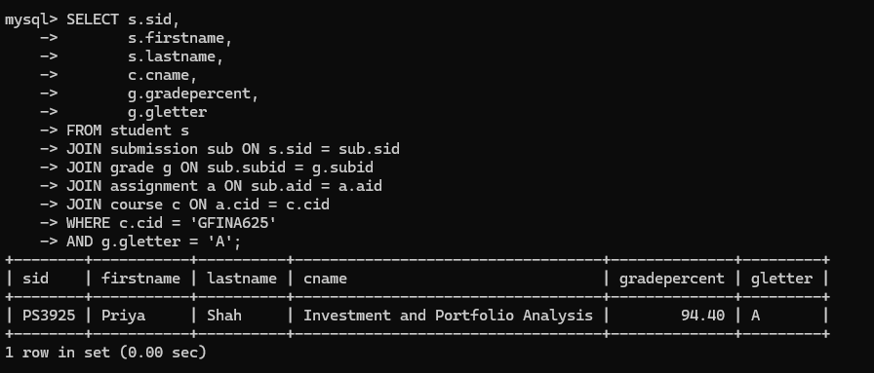
- WHERE filters for GFINA625 and letter grade A
Result: Identifies students earning A grades in graduate finance courses.
Answer: Priya Shah earned a 94.40% average in Investment and Portfolio Analysis.

- Which assignments have the lowest average grades?
- JOIN connects the assignment, course, submission, and grade tables
- AVG() calculates assignment average grades
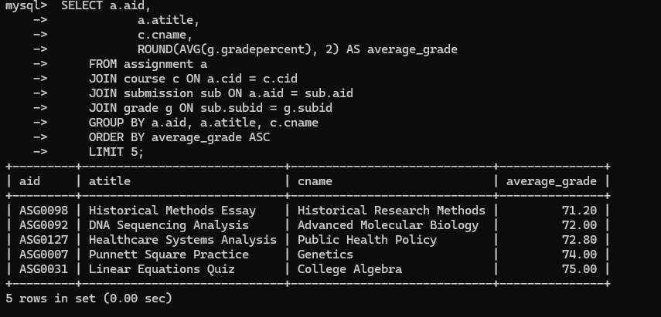
- GROUP BY groups results by assignment
- ORDER BY sorts from lowest to highest average grade
- LIMIT 5 returns the five lowest averages
Result: Identifies assignments with the lowest student performance averages.
Answer: Historical Methods Essay, DNA Sequencing Analysis, Healthcare Systems Analysis, Punnet Square Practice, and Linear Equations Quiz.

- Which undergraduate students are enrolled in only one course?
- JOIN connects the student and enrollment tables
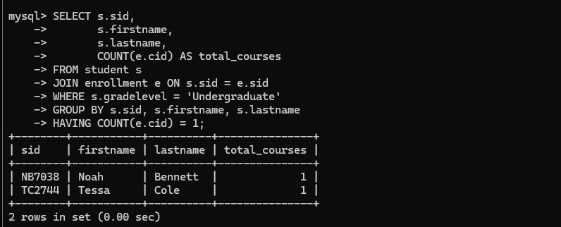
- COUNT() counts the number of courses per student
- GROUP BY groups results by student
- HAVING filters for one course enrollment
Result: Identifies undergraduate students enrolled in exactly one course.
Answer: Noah Bennett and Tessa Cole.

- Which students have received a D or F grade?
- JOIN connects the student, submission, grade, assignment, and course tables
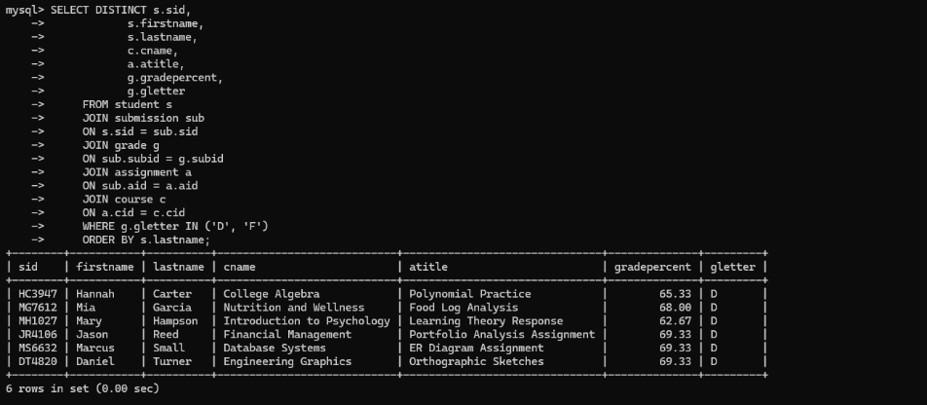
- WHERE filters for letter grades of D or F
- DISTINCT prevents duplicate student records
Result: Identifies students who received low letter grades.
Answer: Hannah Carter, Mia Garcia, Mary Hampson, Jason Reed, Marcus Small, and Daniel Turner.

- Which courses have the lowest attendance rates?
- JOIN connects the course and attendance tables
- SUM() counts present attendance records
- COUNT() counts total attendance records
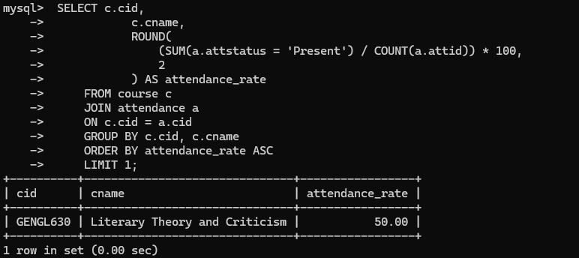
- ROUND() calculates and rounds attendance percentage
- ORDER BY sorts courses from lowest attendance rate to highest
- LIMIT 1 returns the course with the lowest attendance rate
Result: Identifies the course with the lowest attendance percentage.
Answer: Literary Theory and Criticism.

- Which students have perfect grades in a course?
- JOIN connects the student, submission, grade, assignment, and course tables
- AVG() calculates average percentage grade for each student
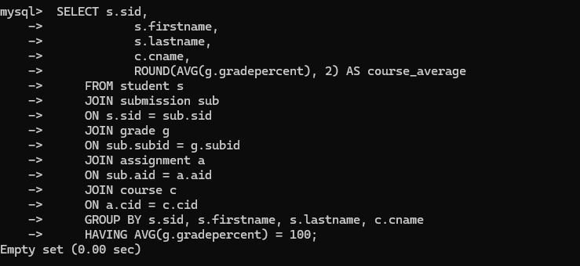
- GROUP BY organizes results by student and course
- HAVING filters for averages equal to 100
Result: Identifies students with perfect course averages.
Answer: The query returned an empty set because no student had a perfect course average.

- Which undergraduate courses have the highest enrollment?
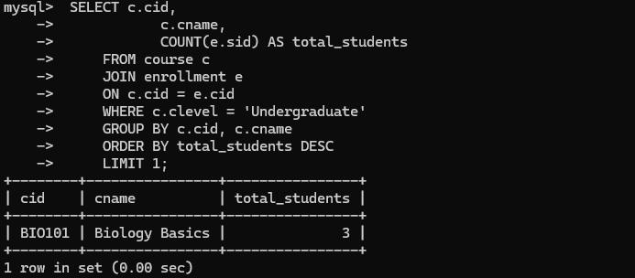
- JOIN connects the course and enrollment tables
- COUNT() counts enrolled students
- GROUP BY groups results by course
- WHERE filters for undergraduate courses only
- LIMIT 1 returns the course with the highest enrollment
Result: Identifies the undergraduate course with the highest enrollment.
Answer: Biology Basics has the highest undergraduate enrollment.

- Which student is enrolled in the most credit hours?
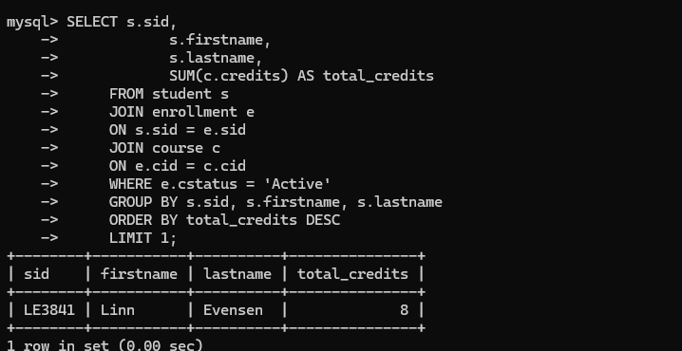
- JOIN connects the student, enrollment, and course tables
- SUM() adds together course credits
- WHERE filters for active enrollments only
- GROUP BY groups results by student
- ORDER BY sorts from highest to lowest total credits
Result: Identifies the student enrolled in the most active credit hours.
Answer: Linn Evensen is enrolled in the most active credit hours.

- Which assignments have missing submissions?
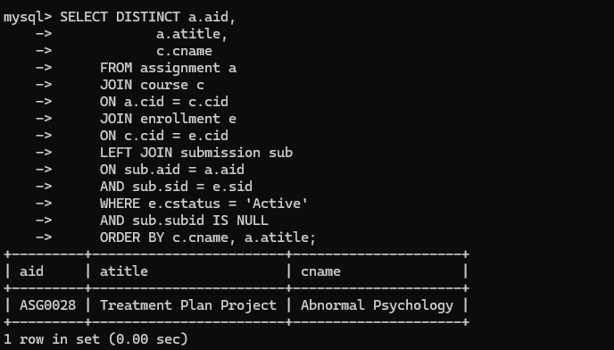
- JOIN connects the assignment, course, enrollment, and submission tables
- LEFT JOIN identifies missing submissions as NULL
- WHERE filters for active enrollments and missing submission records
Result: Identifies assignments with missing student submissions.
Answer: The Treatment Plan Project assignment in Abnormal Psychology has missing submissions.

- Which student has the highest average grade?
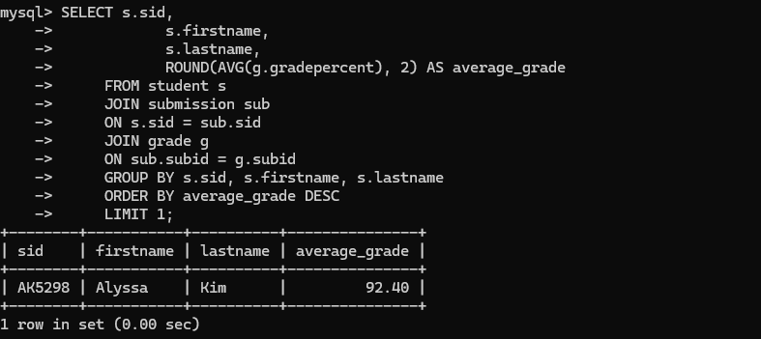
- JOIN connects the student, submission, and grade tables
- AVG() calculates the average percentage grade for each student
- ROUND() formats the result to two decimal places
- GROUP BY groups results by student
- ORDER BY sorts from highest to lowest average grade
Result: Identifies the student with the highest overall average grade.
Answer: Alyssa Kim has the highest overall average grade.

- Which student has the most absences?
- JOIN connects the student and attendance tables
- COUNT() counts absence records
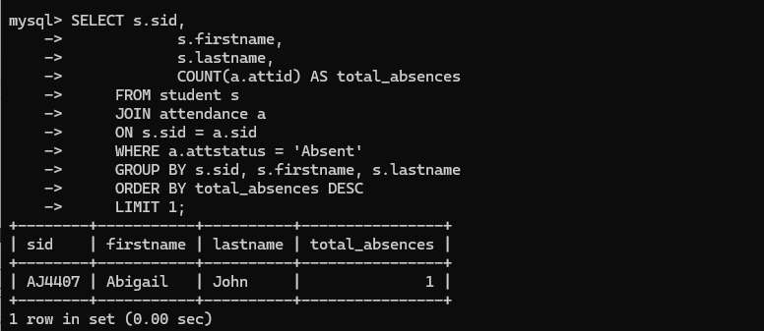
- WHERE filters attendance records marked as Absent
- GROUP BY groups results by student
- ORDER BY sorts from highest to lowest absence count
Result: Identifies the student with the highest number of absences.
Answer: Abigail John has the highest number of absences.

- Which assignments are worth more than 140 points?
- JOIN connects the assignment and course tables
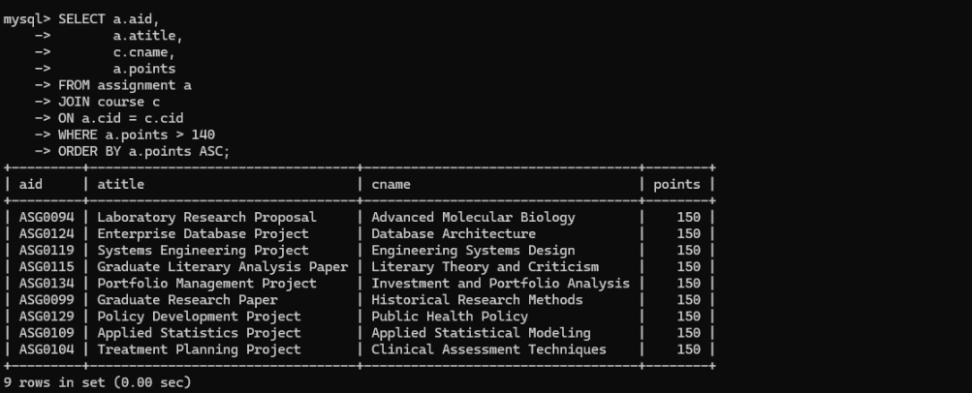
- WHERE filters assignments with points above 140
- ORDER BY sorts assignments by point value
Result: Identifies high-value assignments worth more than 140 points.
Answer: The query returns assignments worth more than 140 points.

- Which assignments are due earliest in the semester?
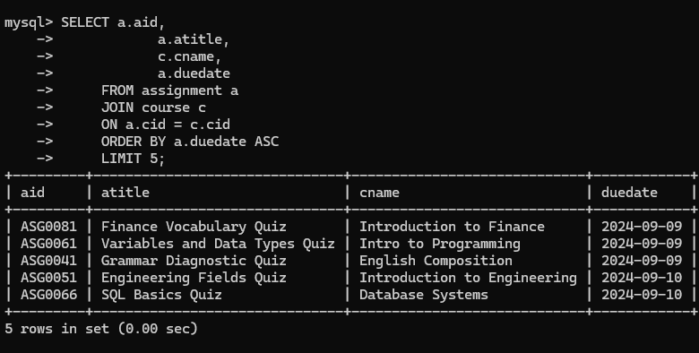
- JOIN connects the assignment and course tables
- ORDER BY sorts assignments by due date from earliest to latest
- LIMIT 5 returns the first five assignments
Result: Identifies the earliest assignments scheduled in the semester.
Answer: The results show the earliest assignments scheduled in the semester.

- Which instructor has the most students across all courses?
- JOIN connects the instructor, course, and enrollment tables
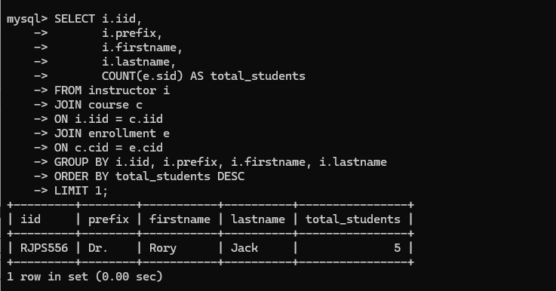
- COUNT() counts enrolled students across courses
- GROUP BY organizes results by instructor
- ORDER BY sorts from highest to lowest student count
- LIMIT 1 returns the instructor with the most students
Result: Identifies the instructor teaching the highest number of students.
Answer: Dr. Rory Jack teaches a total of 5 students.

- Which students have completed at least one course, are currently active in another course, and have an average grade above 85%?
- JOIN connects the student, enrollment, submission, and grade tables
- AVG() calculates average grades
- SUM() counts completed and active enrollments
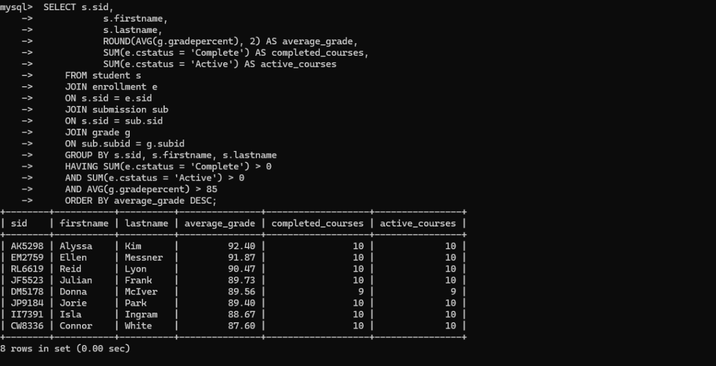
- HAVING filters students who meet all three conditions
Result: Identifies students with completed coursework, active coursework, and an average grade above 85%.
Answer: The results show students with higher scores across both completed and active coursework.

