**California Environmental Protection Agency**

**Central Coast Regional**

**Water Quality Control Board**

**Total Maximum Daily Loads for Turbidity**

**in the**

**Gabilan Creek Watershed,**

**Monterey County California**

**Technical Project Report**

**(11/XX/2019)**

***Prepared November 2019***

***for the Month XX, 2020***

***Central Coast Water Board Meeting***

Adopted by the

California Regional Water Quality Control Board

Central Coast Region

on ______________, 2020

Approved by the

United States Environmental Protection Agency

on ___________________

**CALIFORNIA REGIONAL WATER QUALITY CONTROL BOARD**

**CENTRAL COAST REGION**

895 Aerovista Place, Suite 101, San Luis Obispo, California 93401

Phone • (805) 549-3147

<http://www.waterboards.ca.gov/centralcoast/>

To request copies of this report please contact

Peter Meertens at (805) 549-3869, or by email at:   
Peter.Meertens@waterboards.ca.gov.

Documents also are available at: <https://www.waterboards.ca.gov/centralcoast/water_issues/programs/tmdl/303d_and_tmdl_projects.html>

**STATE OF CALIFORNIA**

GAVIN NEWSOM, Governor

JARED BLUMENFELD, California Secretary for Environmental Protection



**State Water Resources Control Board**

|  |
| --- |
| E. Joaquin Esquivel, Chair |
| Dorene D’Adamo, *Vice Chair* |
| Tam M. Doduc |
| Sean Maguire |
| Laurel Firestone |
| Eileen Sobeck, *Executive Director* |
| Jonathan Bishop, *Chief Deputy Director* |

**California Regional Water Quality Control Board**

**Central Coast Region**

|  |
| --- |
| Dr. Jean-Pierre Wolff, *Chair* |
| Jane Gray, *Vice Chair* |
| Bruce Delgado |
| Dr. Monica S. Hunter |
| Michael Johnston |
| Jeffrey S. Young |

John M. Robertson,Executive Officer

Mathew T. Keeling**,** Assistant Executive Officer

**This report was prepared under the direction of**

Mary Hamilton, Senior Environmental Scientist

Thea Tryon, Supervising Engineering Geologist

**by**

Peter Meertens, Environmental Scientist

**with the assistance of**

Larry Harlan, Environmental Scientist

Steve Saiz, Environmental Scientist

**and support and input provided by**

individuals, agencies, and organizations that have a special interest

in the Gabilan Creek watershed.

# Monitoring Data Analysis

## Analysis of Turbidity Monitoring Data

Turbidity water quality monitoring data was analyzed from 13 monitoring sites in each of the major waterbodies/streams in the Gabilan Creek watershed. The locations of the monitoring sites are shown in Figure 16 and Figure 17 and the site locations are described in Table 14. These monitoring sites are regularly sampled by regional central coast water quality monitoring programs such as the Central Coast Ambient Monitoring Program (CCAMP) and the Cooperative Monitoring Program for Irrigated Agriculture (CMP). The monitoring sites are representative of ambient stream water quality conditions in the watershed. In addition to the regional monitoring programs, some of these sites are also regularly monitored by local organizations such as the City of Salinas for its stormwater program.

The turbidity monitoring data analyzed for the TMDL were obtained from the California Environmental Data Exchange Network (CEDEN) on May 16, 2019 for a monitoring period from 2005 to 2018 (CEDEN, 2019). This dataset covers a longer timeframe and contains more monitoring events than were analyzed for the 2010 303(d) List assessment and which are summarized earlier in the report in Table 1.

**John, we need to add a section with turbidity time series. Mary would like a time series scatter plot of monitoring data. It could be from just a couple of sites and could be from a limited time period. It could also just include ag cmp program data.**

### Impairment Assessment

Waterbodies and sites are assessed for impairments by comparing turbidity monitoring data to the 2010 303(d) turbidity guidelines protective of COLD and WARM aquatic life beneficial uses (refer to Table 12). Impacts to COLD aquatic habitats are based on exceedances of a 25 NTU guideline protective of juvenile salmonids (Sigler et al., 1984) and Impacts to WARM water habitats were based on exceedances of 40 NTU (Shoup, Wahl, 2009). The results are summarized for each site by percent exceedance of the applicable guidelines. Some waterbodies such as Gabilan Creek and the Old Salinas River have both COLD and WARM beneficial uses and waterbodies such as the Reclamation Canal and Tembladero Slough have only WARM. The following are a few key points from the turbidity impairment assessment.

* Monitoring data indicates that all waterbodies assessed in the watershed are impaired for turbidity.
* Alisal Slough, 309ASB, had the site with the lowest percent exceedance with 45% of 157 samples greater than or equal to the WARM water guideline.
* The Reclamation Canal at sites 309ALD and 309JON and the next lowest exceedances at 62% and 56% respectively of the WARM guideline.
* Several sites had exceedance rates of 80% or greater than the COLD guideline including: Gabilan Creek (309GAB), Natividad Creek (309NAD), Old Salinas River Channel (309OLD), Merritt Ditch (309MER), and Santa Rita Creek (309RTA)

Table 12. Turbidity monitoring samples and percent exceedances of 303(d) List guidelines.

| **Waterbody** | **Site Id** | **Number of Samples** | **% ≥ 25 (NTU)** | **% ≥ 40 (NTU)** |
| --- | --- | --- | --- | --- |
| Gabilan Creek | 309GAB | 97 | 92 | 87 |
| Natividad Creek | 309NAD | 168 | 88 | 75 |
| Reclamation Canal Alisal Creek | 309ALG | 158 | n/a | 81 |
| Reclamation Canal | 309ALD | 108 | n/a | 62 |
| Reclamation Canal | 309JON | 163 | n/a | 56 |
| Tembladero Slough | 309TEH | 162 | n/a | 90 |
| Tembladero Slough | 309TEM | 40 | n/a | 78 |
| Tembladero Slough | 309TDW | 181 | n/a | 84 |
| Old Salinas River Channel | 309OLD | 305 | 80 | 70 |
| Alisal Slough | 309ASB | 157 | 65 | 45 |
| Merritt Ditch | 309MER | 162 | 93 | 86 |
| Espinosa Slough | 309ESP | 161 | n/a | 76 |
| Santa Rita Creek | 309RTA | 63 | 90 | 84 |

### Range of Turbidity Levels

In addition to analyzing the exceedances, the turbidity monitoring data are also summarized quartiles (25th, 50th, and 75th percentiles), medians and interquartile ranges for each site (refer to Table 13). The median or 50th percentile is the turbidity level that divides the data into two halves. For example, a value of 114 NTU divides the 162 turbidity samples from site 309TEH on Tembladero Slough in half. In other words, half the samples are greater the 114 NTU and the other half are lower. Median values are also charted in Figure 14. The following are key points from the median turbidity assessment:

* Gabilan Creek (309GAB) and Santa Rita Creek (309RTA) have median turbidities over 200NTU.
* Espinosa Slough (309ESP), Merritt Ditch (309MER), Tembladero Slough (309TDW and 309TEH), and Reclamation Canal/Alisal Creek (309ALG) have median turbidities above 100NTU.
* Alisal Slough (309ASB) and the Reclamation Canal (309ALD and 309JON) had the lowest median turbidities at 57 NTU and 47 NTU respectively.

The data are further summarized in Table 13 by the 25th and 75th percentile NTU values and their interquartile ranges (IQR). For example, the Old Salinas River Channel (309OLD) was sampled 305 times and the 25th percentile value is 33 NTU and the 75th percentile value is 154 NTU. This indicates that 25% of the samples are below 33 NTU and 75% are below 154 NTU. The IQR is the spread between the 25th and 75 percentiles and captures the middle range or the central 50% of turbidity samples. The IQR for the Old Salinas River (309OLD) is 121 NTU. The IQR for all sites are charted in Figure 15. Gabilan Creek (309GAB) and Santa Rita Creek (309RTA) have very high levels at over 800NTU. The lowest IQR is in Alisal Slough at site 309ASB with 53 NTU.

Table 13. Monitoring sites, number of samples analyzed, percentiles, and IQR

| **Waterbody** | **Site Id** | **Number of Samples** | **25th Percentile (NTU)** | **50th Percentile**  **Median (NTU)** | **75th Percentile (NTU)** | **IQR\***  **(NTU)** |
| --- | --- | --- | --- | --- | --- | --- |
| Gabilan Creek | 309GAB | 97 | 90 | 285 | 893 | 804 |
| Natividad Creek | 309NAD | 168 | 40 | 96 | 306 | 266 |
| Reclamation Canal/Alisal Creek | 309ALG | 158 | 47 | 119 | 321 | 274 |
| Reclamation Canal | 309ALD | 108 | 31 | 57 | 133 | 102 |
| Reclamation Canal | 309JON | 163 | 22 | 47 | 145 | 123 |
| Tembladero Slough | 309TEH | 162 | 69 | 114 | 220 | 151 |
| Tembladero Slough | 309TEM | 40 | 45 | 72 | 129 | 83 |
| Tembladero Slough | 309TDW | 181 | 55 | 101 | 170 | 115 |
| Old Salinas River Channel | 309OLD | 305 | 33 | 74 | 154 | 121 |
| Alisal Slough | 309ASB | 157 | 19 | 36 | 71 | 53 |
| Merritt Ditch | 309MER | 162 | 54 | 107 | 214 | 159 |
| Espinosa Slough | 309ESP | 161 | 45 | 108 | 361 | 317 |
| Santa Rita Creek | 309RTA | 63 | 65 | 214 | 900 | 835 |

Note: *Interquartile Range (IQR) = 75th percentile minus 25th percentile

Figure 15. Chart of median turbidity levels for monitoring sites in the Gabilan Creek watershed.

Figure 16. Chart of interquartile ranges for monitoring sites in the Gabilan Creek watershed.

Table 14. Description of monitoring site locations

|  |  |
| --- | --- |
| **Site Id** | **Description of Site Location** |
| 309GAB | Gabilan Creek at Independence Road and East Boranda Road |
| 309NAD | Natividad Creek up stream of Salinas Reclamation Canal |
| 309ALG | Salinas Reclamation Canal at La Guardia |
| 309ALD | Salinas Reclamation Canal at Boronda Road |
| 309JON | Salinas Reclamation Canal at San Jon Road |
| 309TEH | Tembladero Slough at Haro |
| 309TEM | Tembladero Slough at Preston |
| 309TDW | Tembladero Slough at Molera Road |
| 309OLD | Old Salinas River at Monterey Dunes Way |
| 309ASB | Alisal Slough at White Barn |
| 309MER | Merritt Ditch upstream from Highway 183 |
| 309ESP | Espinosa Slough upstream from Alisal Slough |
| 309RTA | Santa Rita Creek at Santa Rita Park |

### Spatial Patterns

Spatial turbidity monitoring data patterns in the Gabilan Creek watershed are mapped in Figure 16 and Figure 17. The map in Figure 16 shows the median turbidity levels of three streams, Gabilan, Natividad, and Alisal Creeks, entering the City of Salinas, and converging at Carr Lake. The streams are channelized in the former lakebed and after they converge to form the Reclamation Canal, which then drains to the west and out of the City. The data indicates that water entering the City is very turbid and is much lower when it leaves in the Reclamation Canal. For example, Gabilan Creek has a median turbidity of 285 NTU just above the City’s urban area and similarly Natividad Creek has a median turbidity of 96 NTU and Alisal Creek has a median turbidity of 119NTU. Downstream of the City and Carr Lake on the Reclamation Canal, site 309ALD has a median turbidity of 57 NTU and 309JON has a median turbidity of 47 NTU.

The Reclamation Canal flows west from the City of Salinas to Tembladero Slough, and the Old Salinas River, which outlets to Moss Landing and ultimately the Pacific Ocean (refer to Figure 17). Several tributaries join this main flow path from the City to the Pacific Ocean including Espinosa Slough and Santa Rita Creek, Merritt Ditch, and Alisal Slough. As previously noted, the median turbidity in the Reclamation Canal is relatively low at 47 NTU at site 309JON. However, the median turbidities of two tributaries entering the main channel are much greater. For example, the median turbidity of Espinosa Slough at site 309ESP is 108 NTU and from Merritt Ditch at site 309MER is 107 NTU. Following the convergence of these two tributaries into the Reclamation Canal and Tembladero Slough the median turbidity levels increase over two-fold from 47 NTU at site 309JON to 114 NTU at site 309TEH on Tembladero Slough. Alisal Slough is a tributary of Tembladero Slough and it has the lowest median turbidity levels of the monitoring sites summarized in the Gabilan watershed at 36 NTU at site 309ASB.

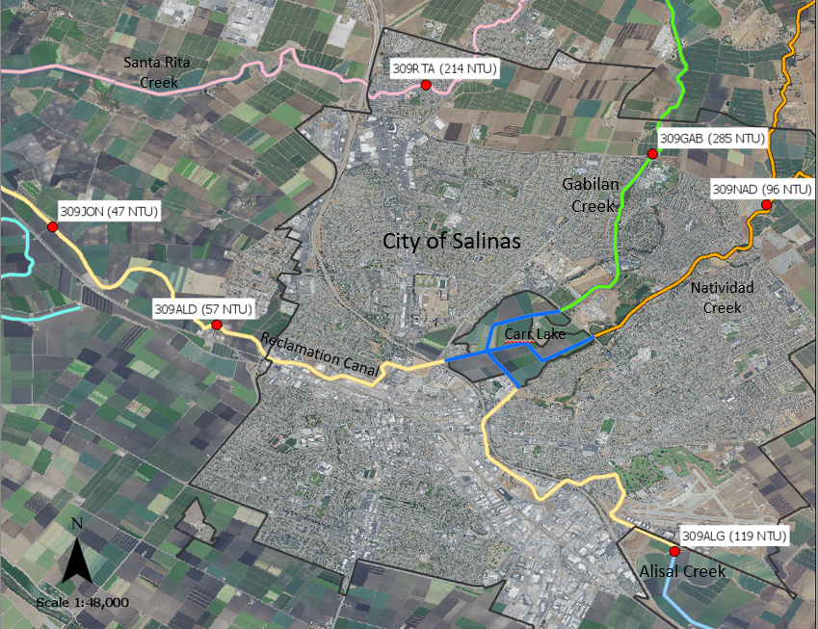

Figure 17. Map of water quality monitoring sites around the City of Salinas and median turbidity levels in parenthesis.

Tembladero has two addition monitoring sites with median turbidities of 72 NTU at site 309TEM and 101 NTU at site 309TDW, which is located just above the intersection with the Old Salinas River. There is one monitoring site analysed on the Old Salinas River, 309OLD, and it has a median turbidity of 74 NTU.

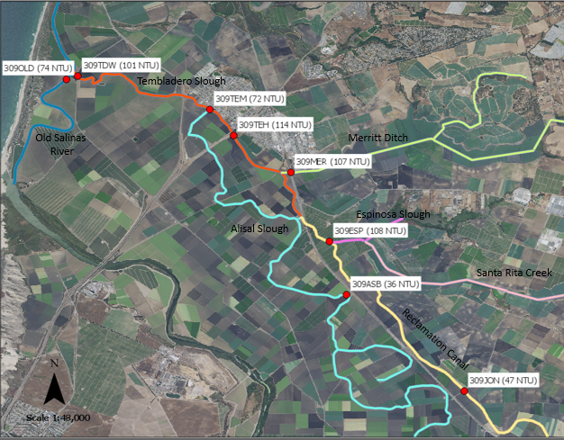

Figure 18. Map of water quality monitoring sites in the lower Gabilan creek watershed and median turbidity levels in parenthesis.

### Seasonal Variation

Turbidity monitoring data for select sites in the Gabilan Creek watershed are summarized by quartiles (25th, 50th, and 75th percentiles for the wet and dry seasons in Table 15. The wet season includes the months of October, November, December, January, February, March, and April and the dry season includes the months of May, June, July, August, and September. The wet and dry season average rainfall patterns in the watershed are described above in section 2.5. The dry season represents a period when there should naturally be no surface water runoff in the watershed and streams should only be supported water that has infiltrated the soil and flows underground into streams.

The wet and dry season turbidity levels are illustrated in Figure 18 and Figure 19. These figures show that at most sites, there are great differences between wet and dry season turbidities. For example, on Alisal Creek the median dry season turbidity is 55 NTU and the Wet season turbidity is 196 NTU. The greatest differences occur between wet and dry season turbidities occurs at 75th percentile level. For example, Santa Rita creek has a 75th percentile dry season turbidity of 214 NTU and a wet season turbidity of 1122 NTU. One exception to this pattern is the Old Salinas River, which has nearly identical dry and wet season turbidity levels at all percentiles. For example, the median dry season turbidity in the Old Salinas River is 75 NTU and the median wet season turbidity is 74 NTU.

Both dry and wet seasons have a wide range of turbidity levels in the watershed, which is reflected in the IQR values. For example, Merritt Ditch has a wet season IQR of 300 NTU and a dry season IQR of 80 NTU. Even the sloughs in the lower watershed have high IQRs. Sloughs are generally stable slow-moving waterbodies and in the summer months the Tembladero Slough has an IQR of 102 NTU at site 309TEH and downstream the Old Salinas River has a dry season IQR of 123 NTU. One site with a low warm season IQR is 309JON on the Reclamation Canal with the difference between the 25th and 75th percentiles of only 26 NTU.

Table 15. Dry and wet season percentiles for streams in the Gabilan Creek watershed.

| **Waterbody**  **(Site Id)** | **Season** | **Number of Samples** | **25th Percentile (NTU)** | **50th Percentile**  **Median (NTU)** | **75th Percentile (NTU)** | **IQR\***  **(NTU)** |
| --- | --- | --- | --- | --- | --- | --- |
| Gabilan Ck. | Dry | 33 | 41 | 190 | 371 | 330 |
| (309GAB) | Wet | 64 | 125 | 386 | 1010 | 885 |
| Natividad Ck. | Dry | 72 | 53 | 106 | 246 | 193 |
| (309NAD) | Wet | 96 | 36 | 88 | 436 | 399 |
| Alisal Ck. | Dry | 67 | 27 | 55 | 157 | 130 |
| (309ALG) | Wet | 91 | 72 | 196 | 612 | 540 |
| Reclamation Canal | Dry | 71 | 17 | 24 | 44 | 26 |
| (309JON) | Wet | 92 | 43 | 102 | 275 | 232 |
| Tembladero S. | Dry | 69 | 57 | 88 | 159 | 102 |
| (309TEH) | Wet | 93 | 84 | 140 | 399 | 315 |
| Old Salinas R. | Dry | 131 | 29 | 75 | 152 | 123 |
| (309OLD) | Wet | 174 | 36 | 74 | 153 | 117 |
| Santa Rita Ck. | Dry | 20 | 51 | 94 | 214 | 163 |
| (309RTA) | Wet | 43 | 78 | 331 | 1122 | 1044 |
| Espinosa S. | Dry | 67 | 13 | 69 | 217 | 204 |
| (309ESP) | Wet | 94 | 65 | 153 | 536 | 471 |
| Merritt Ditch | Dry | 69 | 42 | 76 | 122 | 80 |
| (309MER) | Wet | 93 | 67 | 156 | 367 | 300 |

Note: *Interquartile Range (IQR) = 75th percentile minus 25th percentile

Figure 19. Wet and dry season median turbidity levels of streams in the Gabilan Creek watershed.

Figure 20. Wet and dry season 75th percentile turbidity values in the Gabilan Creek watershed.

# Numeric Targets

This TMDL project sets numeric targets for the turbidity impaired waters to achieve the turbidity water quality objective, the protection of beneficial uses, and the restoration of biological integrity. The targets are based narrative part of the turbidity water quality objective and on the numeric component, which sets levels based on natural turbidity water quality levels. Since this watershed is highly impaired, the turbidity data from reference sites must be used to determine the natural levels for the targets. Turbidity in the watershed has highly impacted aquatic life beneficial uses and in particular aquatic plants and this TMDL sets targets for restoring wetlands.

For comparison, two approaches were used to determine natural conditions from reference sites. One method to develop a hydrogeomorphic model and the second was to use

## Hydrogeomorphic Approach to Reference Conditions

This TMDL uses hydrogeomorphic approach to develops reference levels for impaired waters. Reference conditions are based on the turbidity of reference streams in watersheds with similar hydrogeomorphic characteristics to the impaired streams in the Gabilan Creek watershed. The hydrogeomorphic approach for classifying streams was developed by the U.S. Army Corp of Engineers (ACOE) as part of their approach for assessing the functions of wetlands for the 404 regulatory program. The ACOE is directed under section 404 of the federal Clean Water Act to regulate the discharge of dredged or fill materials in “waters of the United States.” The impaired streams in the watershed meet the criteria for ACOE jurisdictional wetlands. The ACOE hydrogeomorphic approach is used to set chemical, physical, and biological standards of comparison for project sites using the conditions of less disturbed reference sites (ACOE, 1995). The hydrogeomophic classification system is based on the following three factors:

1. geomorphic setting;
2. water source; and
3. hydrodynamics.

Geomorphic setting is the landform of a wetland, its geologic evolution, and its topographic position in the landscape. The geomorphic setting of the lower/impaired sections of the Gabilan Creek watershed is flat alluvial valley landform below coastal foothill mountains.

Water source is the location of water before it enters the wetland. Streams in in the lower watershed are supported naturally in large part by baseflow, which is groundwater entering streams. The watershed is highly modified and has anthropogenic inputs from urban stormwater, agricultural tile drains, and large surface water pumps for example. The watershed has natural intermittent stream flows from upland areas that are carried to the lower valley in the main channels. Surface stormwater runoff occurs after storm events. Runoff is enhanced in the watershed due to impervious surfaces in the developed areas. The lower Gabilan Creek watershed is highly modified, but the predominant natural year-round water source would be baseflow.

Hydrodynamics is the energy level of the water moving in the channels. For example, the level of energy of an isolated wetland is generally lower than a wetland on a river floodplain, and the movement of water in a riverine wetland is generally unidirectional and downstream.

oto Key characteristics include low gradient sloped land and streams, alluvial features, and gaining perennial streams. Regional reference watersheds and monitoring sites are listed in Table 9 and water quality monitoring data are summarized in Table 19, Figure 19, Figure 20, and Figure 21.

Table 16. Central coast reference watersheds and monitoring sites.

| **Reference Watershed** | **Monitoring Site ID(s)** |
| --- | --- |
| Lower Llagas Creek | 305LCS |
| Lower Uvas Creek | 305CAN, 305CAR |
| Watsonville Slough | 305WSA |
| Lower Pajaro River | 305CHI |
| Salsipuedes Creek | 305COR |
| San Juan Creek | 305SJA, 305SJN |
| Elkhorn Slough (Watsonville Creek) | 306WAC |
| Chorro Creek | 310CCC, 310TWB |
| San Luis Obispo Creek | 310PRE, 310SLB |
| Pismo Creek | 310PIS |
| Oso Flaco Creek | 312OFN |
| Orcutt Creek (at Highway 1) | 312ORI |
| Lower San Antonio Creek | 313SAI |
| Santa Lucia Canyon-Santa Ynez River | 314SYN, 314SYF |
| San Miguelito Creek-Santa Ynez River | 314SYL |
| Dos Pueblos Canyon (Devereux Slough) | 315DEV |

Table 17. Turbidity at reference sites.

|  |  |  |  |  |  |
| --- | --- | --- | --- | --- | --- |
| **Station**  **Code** | **Number of Samples** | **25th percentile**  **(NTU)** | **Median**  **(NTU** | **75th percentile**  **(NTU)** | **IQR** |
| 305CAN | 31 | 1.6 | 4.6 | 14.5 | 12.9 |
| 305CAR | 12 | 2.55 | 6.45 | 15.4 | 12.85 |
| 305CHI | 90 | 10.4 | 29.7 | 51.1 | 40.7 |
| 305COR | 72 | 5.4 | 13.2 | 35.2 | 29.8 |
| 305LCS | 64 | 1.4 | 3.6 | 6.2 | 4.8 |
| 305SJA | 72 | 5.6 | 9.0 | 16.1 | 10.5 |
| 305SJN | 11 | 2.1 | 3.2 | 5.1 | 3 |
| 306WAC | 13 | 0 | 1.3 | 5.2 | 5.2 |
| 310CCC | 118 | 0.9 | 1.5 | 2.6 | 1.7 |
| 310PIS | 72 | 0.1 | 2.3 | 6.5 | 6.4 |
| 310PRE | 80 | 7.2 | 9.9 | 13.6 | 6.4 |
| 310SLB | 79 | 0.0 | 0.2 | 1.5 | 1.5 |
| 310TWB | 161 | 0.5 | 1.2 | 2.4 | 1.9 |
| 312OFN | 80 | 4.5 | 8.4 | 20.4 | 15.9 |
| 312ORI | 86 | 7.6 | 11.1 | 29.9 | 22.3 |
| 313SAI | 68 | 0.2 | 2.1 | 9.0 | 8.8 |
| 314SYF | 63 | 1.2 | 4.0 | 7.5 | 6.3 |
| 314SYL | 26 | 0.2 | 1.7 | 3.6 | 3.4 |
| 314SYN | 81 | 0.4 | 1.9 | 5.6 | 5.2 |
| Median | | 1.4 | 3.6 | 7.5 | 6.4 |

|  |  |  |  |  |
| --- | --- | --- | --- | --- |
| **Station**  **Code** | **Number of Samples** | **25th percentile**  **(NTU)** | **Median**  **(NTU** | **75th percentile**  **(NTU)** |
| 305WSA | 52 | 12.7 | 22.2 | 66.4 |
| 315DEV | 10 | 11.0 | 22.6 | 36.5 |
| Median | |  |  |  |

## Dry Season Targets

Species and method identified in Table 16 shall be used to assess whether the sediment toxicity numeric target is achieved. Assessments will be conducted with receiving water(s) sampled at key indicator sites, which will be defined in proper sampling plans with quality assurance and quality controls consistent with SWAMP protocols. Toxicity to invertebrates shall be tested using chronic toxicity test, 10-day sediment exposure with *Hyalella azteca* (USEPA, 2000). It is recommended (not required) that toxicity determinations be based on a comparison of the test organisms’ response to the receiving water sample compared to the control using the Test of Significant Toxicity, also referred to as the TST statistical approach (USEPA 2010; Denton et al., 2011). If a sample is declared “fail” (i.e., toxic), then the target is not met and additional receiving water sample(s) should be collected and evaluated for this specific receiving water to determine the pattern of toxicity and whether a toxicity identification evaluation, also referred to as a TIE, needs to be conducted to determine the causative toxicant(s). If the causative toxicant(s) is already known (e.g., based on land use patterns and similar responses in sub-watersheds) then implementation of management practices, management plans etc. should be examined for effectiveness if already in place, or implemented to reduce the toxicant(s).

Table 18. USEPA Standard Aquatic Toxicity Tests

## USEPA Nutrient Criteria Approach

USEPA Section 304(a) provides a recommended approach for establishing nutrient criteria and for translating the Basin Plan narrative objectives. This approach has been used in TMDLs to establish criteria values for total nitrogen and total phosphorus and it is also recommended for turbidity and chlorophyll a. This approach is described in USEPA’s Technical Guidance Manual for Developing Nutrient Criteria for Rivers and Streams (USEPA, 2000a) and specifically for western states in USEPA’s Ambient Water Quality Criteria Recommendations, Rivers and Streams in Nutrient Ecoregion III (USEPA, 2000b). The criteria produced from this approach is based on reference stream conditions to be used for control discharges of pollutants. Reference conditions are used in this TMDL to identify natural conditions for the calculation of the Basin Plan’s turbidity numeric objective. USEPA defines a reference stream as follows:

*“A reference stream is a least impacted waterbody within an ecoregion that can be monitored to establish a baseline to which other waters can be compared. Reference streams are not necessarily pristine or undisturbed by humans.”*

Since reference conditions are not uniform across the nation nor across any given state due to natural variability, the USEPA has designated ecoregions that denote areas with ecosystems that are generally similar (e.g., physiography, climate, geology, soils, land use, hydrology). California is located in Ecoregion III, for the Xeric west and it has 12 level III sub-ecoregions. The Gabilan Creek watershed and most of the central coast region are in the southern and central California chaparral and oak woodlands sub-region (refer to Figure 20). The primary distinguishing characteristic of this ecoregion is its Mediterranean climate of hot dry summers and cool moist winters, and associated vegetative cover comprising mainly chaparral and oak woodlands; grasslands occur in some lower elevations and patches of pine are found at higher elevations. Most of the California Chaparral and Oak Woodlands ecoregion consists of open low mountains or foothills.

In addition to data analysis by ecoregions, USEPA anticipates that stream type will be use to further characterize data and reduce data variability.

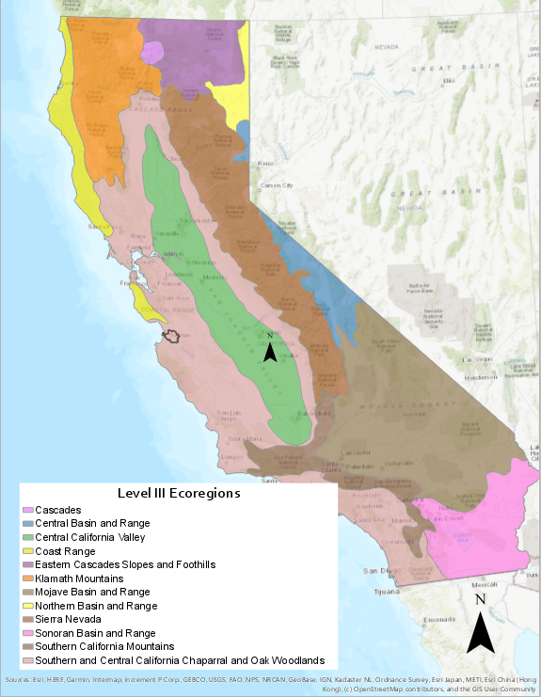

Figure 21. USEPA Level III ecoregions in California

Descriptive Statistical Analysis of Monitoring Data

This USEPA approach describes two ways of calculating a reference condition for nutrients and turbidity. One method is to choose the upper 75th percentile of a reference population of streams. The 75th percentile was chosen by EPA since it is likely associated with minimally impacted conditions, will be protective of designated uses, and provides management flexibility.

USEPA proposed that the 75th percentiles of all nutrient data of these reference stream(s) could be assumed to represent unimpacted reference conditions for each aggregate ecoregion, and also provided a comparison of reference condition for the aggregate ecoregion versus the sub-ecoregions.

Alternatively, when reference streams are not identified, the second method USEPA recommends is to determine the lower 25th percentile of the population of all streams within a region. The 25th percentile of the entire population was chosen by EPA to represent a surrogate for an actual reference population.

The USEPA recommendations are based on medians of all the either 25th and 75th percentile data. For example, if one stream had 300 observations for turbidity over the decade or one year’s time, one median resulted. Each median from each stream was then used in calculating the percentiles for phosphorus for the aggregate nutrient ecoregion/sub-ecoregion (level III ecoregion) by season and year.

In addition to the level III eco-region calculations, staff calculated turbidity reference values for central coast level IV eco-regions.

**Enter results here**

## Sources of Sediment Toxicity

As noted in the Data Analysis Section **Error! Reference source not found.**, sediment toxicity was found throughout the lower Salinas River and Reclamation Canal watersheds. The impaired waterbodies were sampled 159 times from 2006 to 2010 for sediment toxicity and 111 samples or 70% were toxic and staff determined that 13 waterbodies are impaired for sediment toxicity. Some of the monitoring was part of special studies, such as one conducted by the CCWQP, that evaluated the sources of sediment toxicity (refer to Section **Error! Reference source not found.** and Appendix B for a summary of special studies in the watershed). This study indicates that the most likely source of sediment toxicity is pyrethroid pesticides. Other studies in the watershed, such as ones by DPR and Dr. Don Weston further support the conclusion that pyrethroid pesticides are the source of sediment toxicity based on toxicity unit analysis. Toxicity unit analysis is part of TMDL data analysis, Section **Error! Reference source not found.**, and this analysis further supports the linkage between sediment toxicity and pyrethroid pesticides.

# Public Participation

Program staff held several stakeholder meetings during the development of the TMDL. The following is a summary of TMDL meetings and information items:

* January 22, 2015 – Kick-off meeting in Salinas
* March 3, 2015 – CEQA scoping meeting
* April 21, 2015 – Meeting with Grower-Shipper Association of Central California
* December 8, 2015 – Public stakeholder meeting in Salinas

Staff developed an email distribution list to communicate with stakeholders. The distribution list was developed from an existing TMDL distribution list for the watershed.

# References

Bianchi M., Mountjoy D., Jones A. 2009. The Farm Water Quality Plan, Publication *8332*. The Regents of the University of California, Division of Agriculture and Natural Resources

California Environmental Data Exchange Network (CEDEN). 2019. Turbidity data download for the Central Coast Region

California State Water Resources Control Board (SWRCB). 2016. California Regulations Related to Drinking Water, Title 17 and Title 22 of the California Code of Regulations.

City of Salinas (Salinas). 2014. City of Salinas’ 2012-2013 NPDES Annual Report and Stormwater Management Plan Update

Cowardin, L.M., V. Carter, F.C. Golet, E.T. LaRoe. 1979. Classification of Wetlands and Deepwater Habitats of the United States for the United States Department of Interior Fish and Wildlife Service <http://www.fws.gov/wetlands/documents/classification-of-wetlands-and-deepwater-habitats-of-the-united-states.pdf>

Elkhorn Slough Foundation (Elkhorn). 2015. Elkhorn Slough Restoration: Historical Ecology Tools

<http://www.elkhornslough.org/habitat-restoration/historical-ecology-tools.htm>

<http://www.swrcb.ca.gov/rwqcb5/water_issues/tmdl/central_valley_projects/central_valley_pesticides/criteria>

Lloyd, D.S., J.P. Koenings, and J.D. Laperriere. 1987. Effects of Turbidity on Fresh Waters of Alaska, North American Journal of Fisheries Management

Monterey County Water Resources Agency (MCWRA). 2005. Reclamation Ditch Watershed Assessment and Management Strategy: Part A Watershed Assessment

Monterey County Water Resources Agency (MCWRA). 2015. Preliminary Engineering Design Report for Control of Non-Winter Drainage at Carr Lake, Prepared by Balance Hydrologics, Inc.

Murdoch T., Cheo M., and K. O’Laughlin. 1999. The Streamkeeper’s Field Guide, Watershed Inventory and Stream Monitoring Methods.

Rehn, A.C. 2016. Using Multiple Biological and Habitat Condition Indices for Bioassessment of California Streams. SWAMP Technical Memorandum SWAMP-TM-SB-2016-0003

<http://www.waterboards.ca.gov/water_issues/programs/swamp/bioassessment/docs/multiple_indices_tech_memo.pdf>

Shoup, D.E., and D.H. Wahl. 2009. The Effects of Turbidity on Prey Selection by Piscivorous Large Mouth Bass

Sigler, J.W., 1987. Effects of Chronic Turbidity on Density and Growth of Steelheads and Coho Salmon

Sweka, J.A. and K.J. Hartman. 2001a. Influence of Turbidity on Brook Trout Reactive Distance and Foraging Success

Sweka, J.A. and K.J. Hartman. 2001b. Effects of Turbidity on Prey Consumption and Growth in Brook Trout and Implications for Bioenergetics Modeling

Monterey County Agricultural Commissioner (Monterey). 2013. Monterey County Crop Report 2013 <http://ag.co.monterey.ca.us/assets/resources/assets/429/CropReport_2013.pdf>

State Water Resource Control Board (SWRCB), 2004. Water Quality Control Policy for Developing California’s Clean Water Act Section 303(d) list. September 2004

U.S. Army Corp of Engineers (ACOE). 1995. An Approach for Assessing Wetland Functions Using Hydrogeomorphic Classification, Reference Wetlands, and Functional Indices

United States. Census Bureau (Census); 2010 Census Summary; generated by Peter Meertens; using American FactFinder; <http://factfinder2.census.gov>; (9 May 2014).

United State Department of Agriculture Natural Resource Conservation Service 2012. National Conservation Practice Standards

United States Environmental Protection Agency Office of Water (USEPA). 1986. Quality Criteria for Water 1986

United States Environmental Protection Agency Office of Water (USEPA). 2000a. Nutrient Criteria Technical Guidance Manual, Rivers and Streams.

United States Environmental Protection Agency Office of Water (USEPA). 2000b. Ambient Water Quality Criteria Recommendations, Information Supporting the Development of State and Tribal Nutrient Criteria, Rivers and Streams in Nutrient Ecoregion III

United States Environmental Protection Agency Office of Water (USEPA). 2006 Framework for Developing Suspended and Bedded Sediments (Water Quality Criteria

United States Geologic Survey (USGS). 2016 Turbidity, The USGS Water Science School. <http://water.usgs.gov/edu/turbidity.html>

.