The first time you connect the gauge it’ll create an access point.

It needs to be powered through a micro usb plug.

After about a minute you should see “esp8266ap” as an available network.

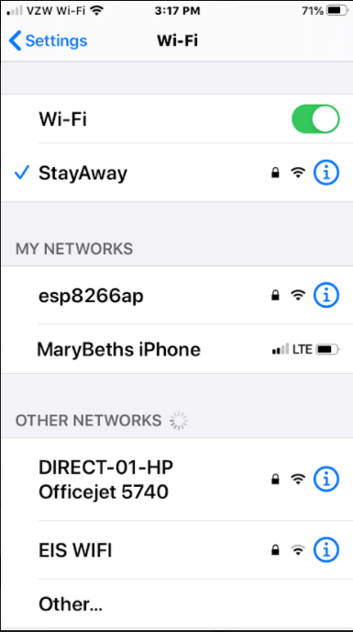

Connect to it and it should present you with a login screen

If it asks for a password use 12345678

You should see the following

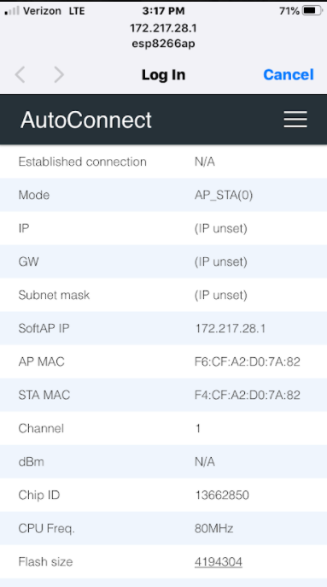

Select the 3 Horizontal bars and you should see the following menu

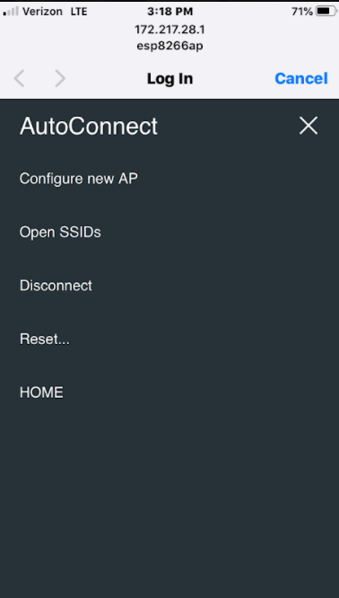

Select Configure New AP and you should see a list of available WiFi networks.

Select the one to use and enter the credentials.

If it successfully connects, you should see the following

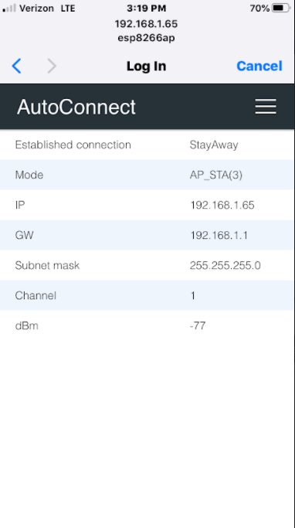

Make note of the IP address (in my case it’s 192.168.1.65)

Open your favorite browser and enter that IP address in the address bar

Or select the 3 horizontal bars, then select HOME

Each time you restart the meter,it SHOULD use this same IP address.

You should see the following

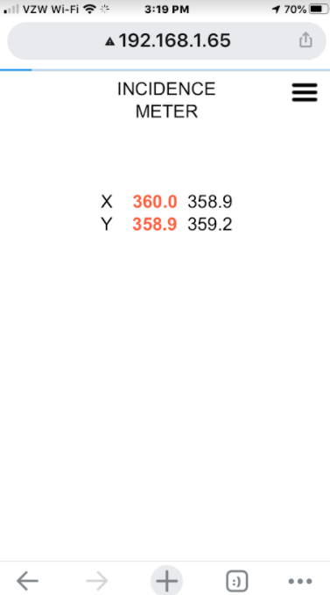

Now each time you power up the throw gauge it should be at that same IP address and all you should need to do is go directly to the web page. If not, look around using 192.168.1.66 or 67 or 64.

(Unchecking the use DHCP option when you enter your credentials allows you to set a static IP address)

The X/Y angle readings of the RED sensor are shown in RED on the left.

The X/Y angle readings of the WHITE sensor are on the right.