FAQ for Managers on the SNSJHO Site

- I just received an e-mail informing me that a new user has registered on the site. I know this individual and would like to upgrade their permissions to Member status. How would I go about doing this?

Go to the People page (Fig. 1), located here. If you are not already logged in, do so now (Fig. 2). There are two methods for granting Member status. The first method is probably the easiest and requires only that you add a New Member to a group (see Question 3). By default a New Member will be granted Member status when added to a user group. The second method does not require adding the user to a user group. First, select the checkbox corresponding to the user(s) of interest. Note that a New User is identified with a green icon. Next, left mouse click the Role button.

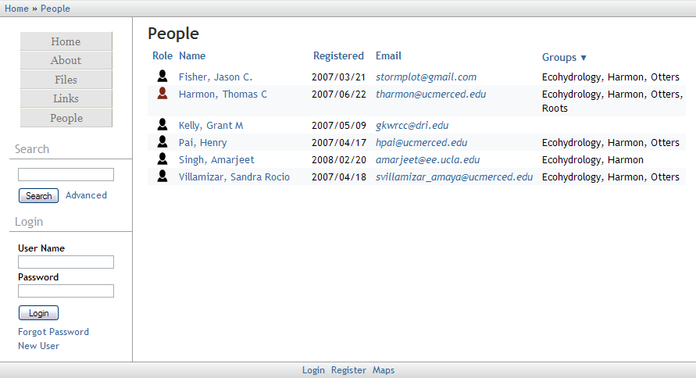
Figure 1: Typical view of People page for an unregister user.

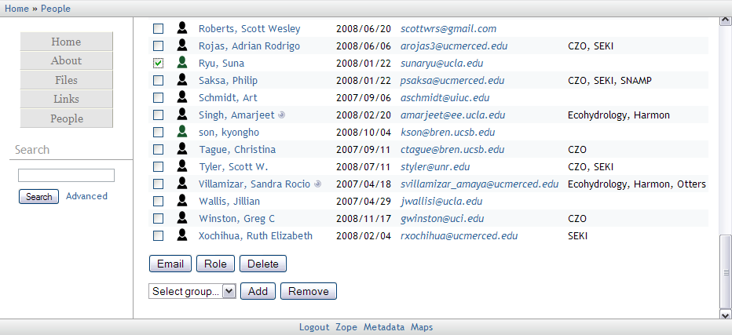
Figure 2: Typical view of the People page for a user with Manager status.

On the Role page select Member from the pull-down menu (Fig. 3). Left mouse click the Change button to finish the procedure.
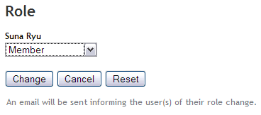
Figure 3: The Role page after selecting Member from the pull-down menu.

- How do I create a new user group?
First visit the People page and log in (see beginning of Question 1 for details). Select the checkbox corresponding to the user(s) you would like to add to the new user group. Left mouse click the Create New Group icon, , located in the upper right-hand corner of the page. On the Add Group page (Fig. 4) enter the name of the new group. The group name will be rejected if already in use. Left mouse click the Add button to finish the procedure. Note that you will automatically become a member of the newly formed group.
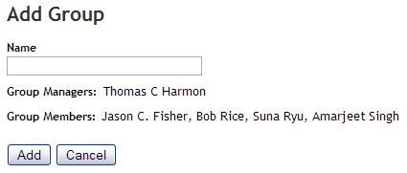
Figure 4: Name the new group on the Add Group page.

- How do I add or remove a user from an existing group?
First, visit the People page and log in (see beginning of Question 1 for details). Select the checkbox(s) corresponding to the user(s) you wish to either add or remove from a group. Next, select a group from the pull down menu (Fig. 5). Left mouse click the Add button to add the user(s) to the group or the Remove button to remove a user(s) from a group. Note that removing all group users will eliminate the group from the site. Also note that by adding a Manager to a group you will be granting them group permissions identical to your own.
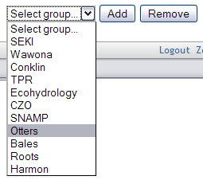
Figure 5: Select a group from the pull-down menu.

- What URL should I give out to my colleagues and use in publications?
The site address (https://eng.ucmerced.edu/snsjho) appears stable, however, things change based on decisions handed down from IT. Therefore, the following URL has been established to supersede any site address changes in the future: http://snsjho.org

- How can I more easily navigate through all the users? For example, I want to add all members of an existing group to a new group I just created.
First, place the mouse curser over the Groups header in the upper-right corner of the People page. A drop down menu will appear (Fig. 6). Select the group of interest. Only members belonging to the select group will appear. Use the checkbox within the upper left-hand corner to select all checkboxes. See Question 3 for adding the selected members to the new group.
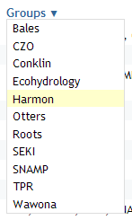
Figure 6: A drop-down menu for group selection.

- A user has left the project and I’d like to remove him/her from the site.
Contact the site administrator (e-mail) for user deletion.

