James Fisher

ANA680

8-11-2024

Week 1 Assignment: Model Roll-up

**Model Comparison**

|  |  |  |  |  |  |
| --- | --- | --- | --- | --- | --- |
|  | True Negatives | False Negatives | True Positives | False Positives | Accuracy |
| Logistic Regression | 114 | 2 | 58 | 1 | 98.29% |
| KNN (k = 5) | 114 | 1 | 59 | 1 | 98.86% |
| SVM (kernel = linear) | 114 | 2 | 58 | 1 | 98.29% |
| SVM (kernel = rbf) | 113 | 2 | 58 | 2 | 97.71% |
| Naïve Bayes | 111 | 1 | 59 | 4 | 97.14% |
| Decision Tree | 111 | 4 | 56 | 4 | 95.43% |
| Random Forest (e=10) | 113 | 2 | 58 | 2 | 97.71% |
| XGBoost | 113 | 2 | 58 | 2 | 97.71% |

**Raw Outputs**

* Logistic Regression

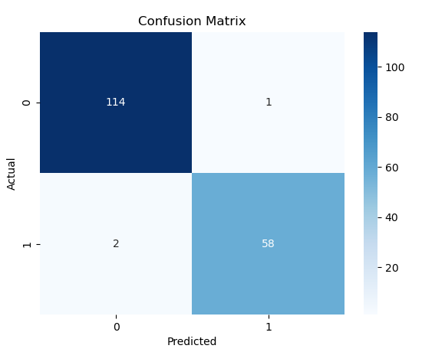



* KNN (k=5)  
  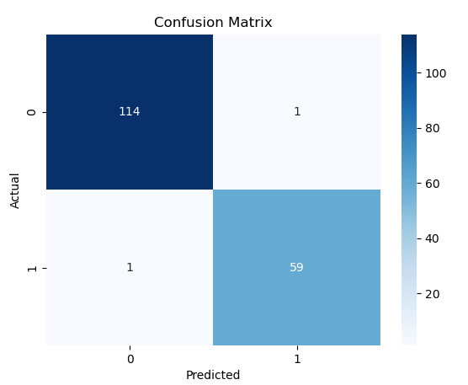  
  
* SVM (kernel = linear)  
  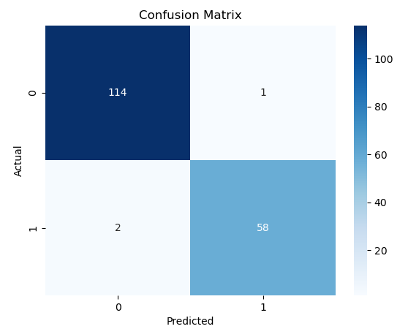  
  
* SVM (kernel = rbf)  
  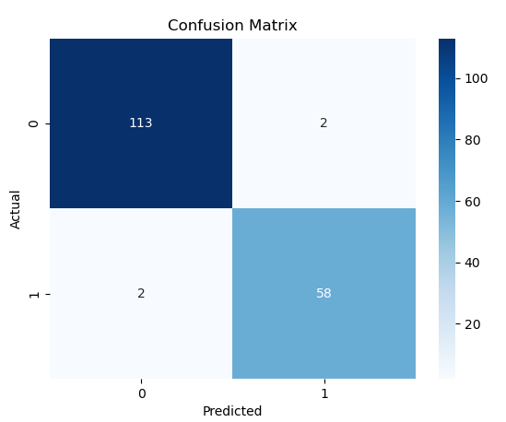  
  
* Naïve Bayes  
  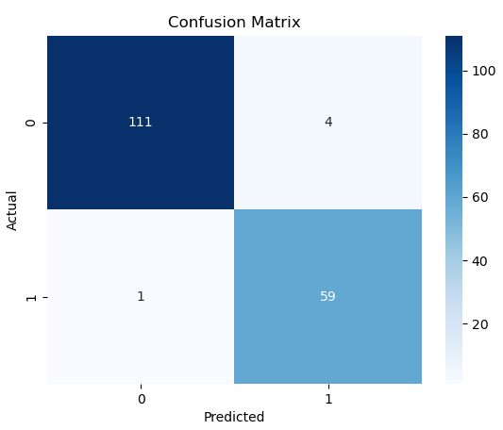  
  
* Decision Tree  
  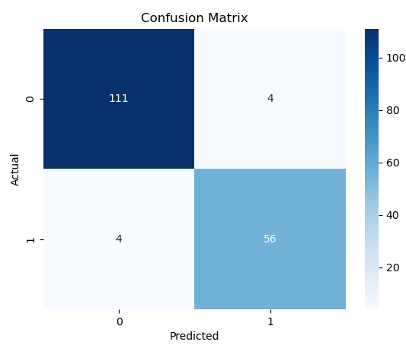  
  
* Random Forest (estimators = 10)  
  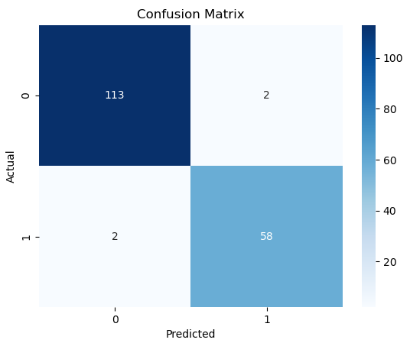  
  
* XGBoost  
  