Julio Jovel

JJovel1

SER316 Assignment 7

Task1

Size:

1. Total lines of code is 22539
2. main.java.memoranda.EventsManager.java with 329 LOC
3. Method 3 is used as the raw or physical lines of code are really what is counted.

Cohesion

1. LCOM 2 is defined as the percentage of methods that do not access a specific attribute averaged over all attributes in the class.
 $LCOM2=1-\frac{sum\left(mA\right)}{m*a}$

  1. Sum(ma) is the sum of the number of methods that access a variable over the attributes of a class
   2. m = number of procedures or methods in the class
   3. a = number of variables or attributes in the class
2. The highest lack of cohesion is in class TaskListImpl.java with a mean of .679 and that is because there are some methods in the class that have nothing to do directly with the class. They could have been moved to a separate class all together.

Complexity

1. Main package has a complexity mean of 1.746 and a standard deviation of 1.547
2. EventsManager has the worst complexity with a 2.5
3. I went into the EventsManager class and went through the getsRepeatableEventsforDate method. Inside of it I was able to move some of the inner workings into a separate method that would do some of the work. I was able to change the complexity from 2.5 to 2.455 with just changing the inside of one single if statement. This is because it is reducing the workload that this method is doing and moving a small section of it to a separate method.

Package Level Coupling

1. Efferent coupling measures the number of data types a class knows about or depends on where as afferent coupling is the number of classes that know the data types of this specific class.
2. The .util package has the worst afferent coupling with a 57
3. The .ui package has the worst efferent coupling with a 49

Worst Quality

I think that the overall class that has the worst quality would be the TaskListImpl class. When you look over most metrics offered it stays near the top of the metric or stays at least above the half way point. Looking at the file itself it is complex to read and it seems as though any changes there would lead you to having to track down a significant amount of lines in other pages.

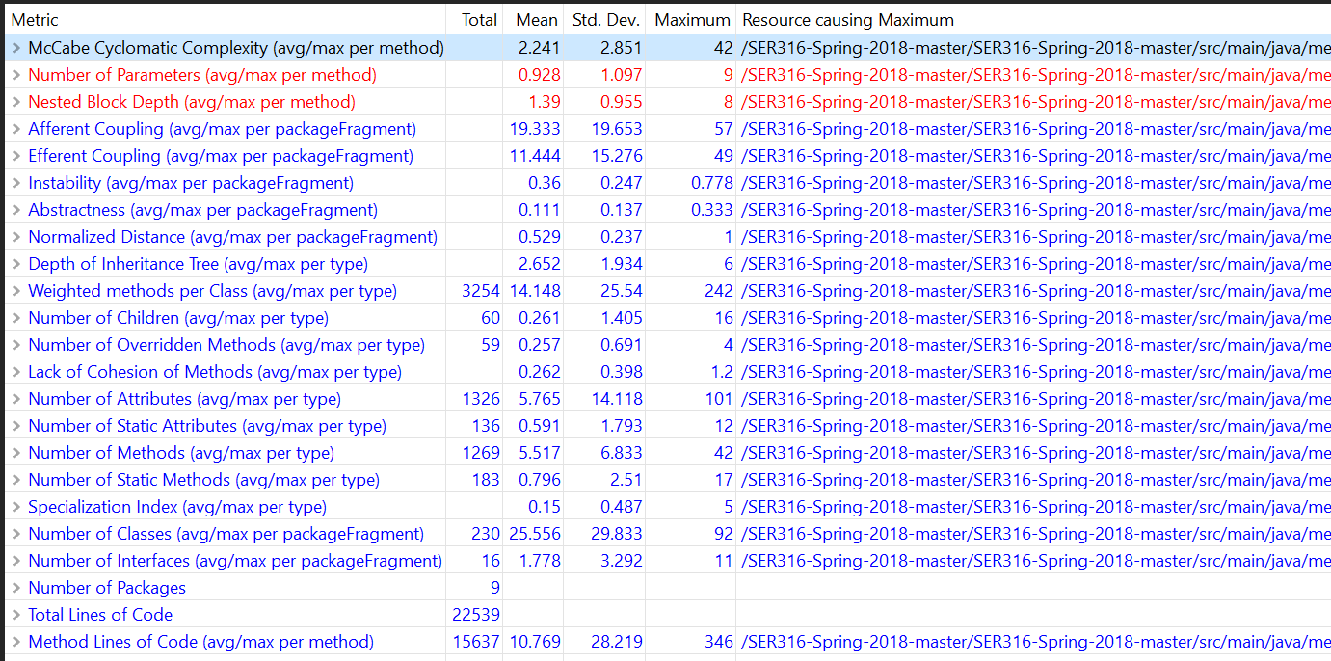

Before Complexity changes

Task 2

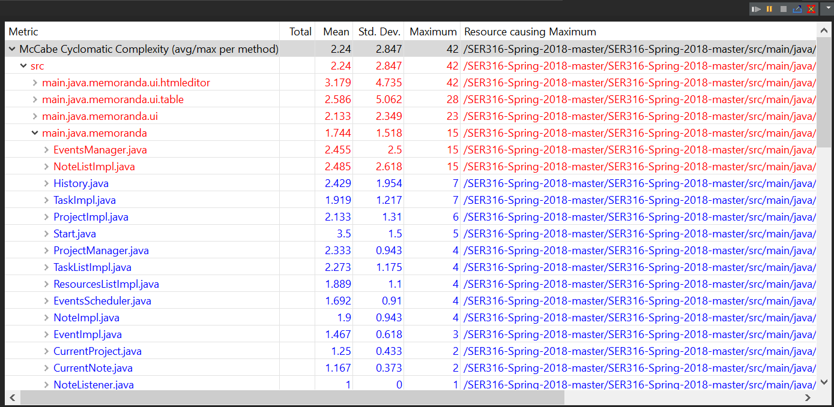

After complexity Changes

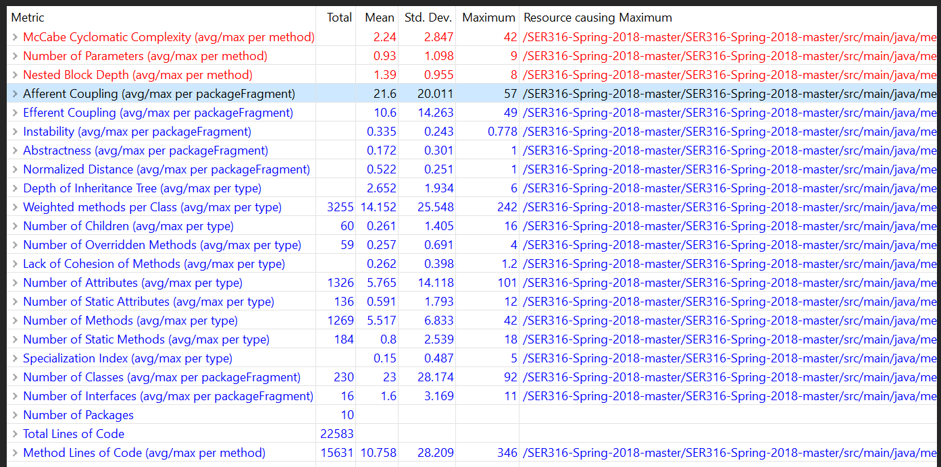

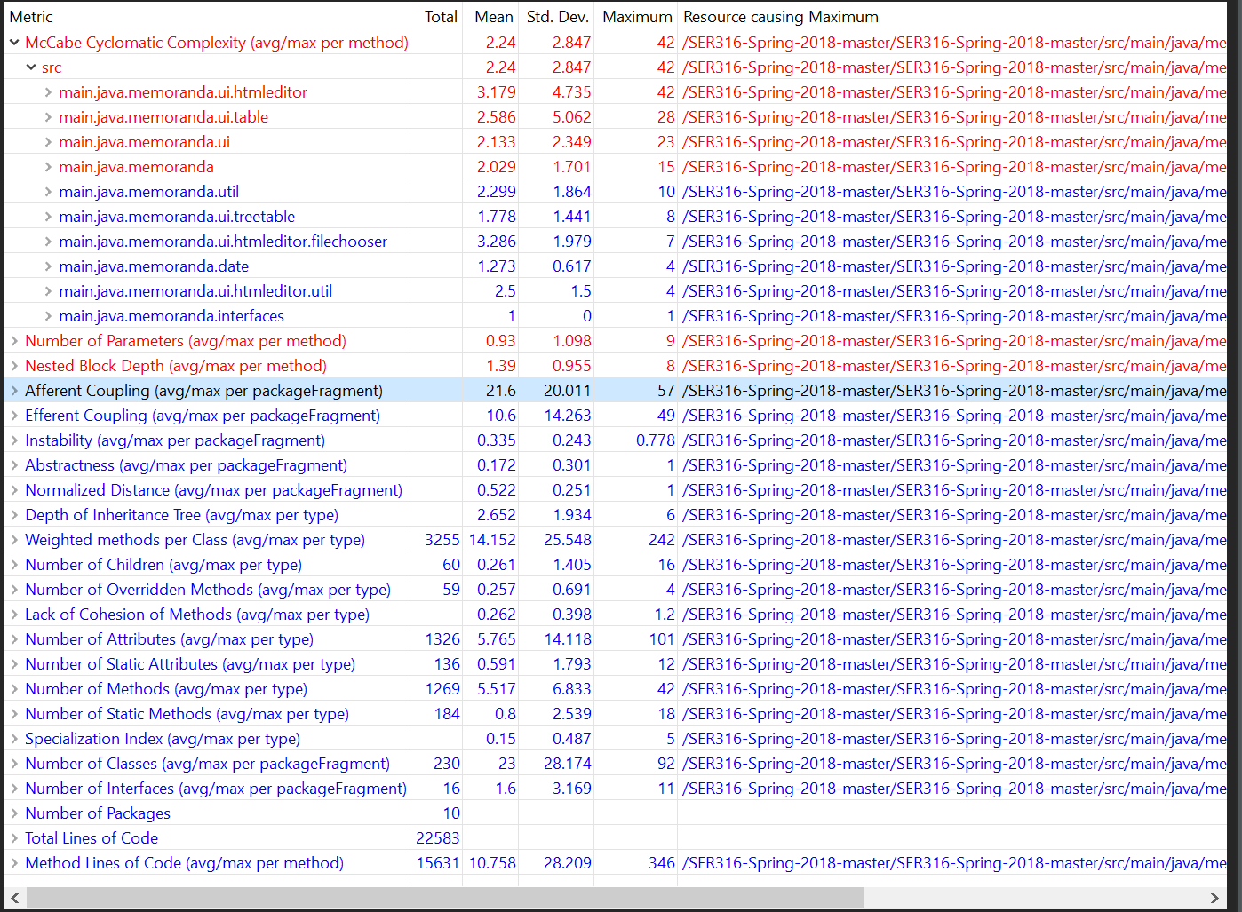

Changes after moving the interfaces over seem to have not made much of a change to the overall complexity but did increase the complexity of the main.java.memoranda package. the complexity of the Nothing seems to have changed for the better. The complexity of the main.java.memoranda seems to have gotten worse maybe because the classes now have to reach outside of their package in order to access the interfaces that it uses.

Task 3

For the code smell within a class I went into the CurrentProject.java class and saw that the method set was unnecessarily long. It was passed in a project as an object and then new objects were made from there and then passed when the initial object could have been passed to the next method that it used. I updated and refactored the code so that the call to notifyListenersBefore()now took the project object as a parameter and then it broke down the necessary parts to what it needed to use. I then finished the original set() method to be able to grab the information it needed. It would be classified as long method.

For the code smell between classes I chose to go into EventsManager.java and excise the Year, Month, and Day classes that were nested and have them be their own classes. Having these nested classes seems to have made it difficult for others to have them readily available as I look through other classes that also use a Year Month and Day nested classes. It seems as though if the classes were out and available then they could have been modified to be used by many more classes instead of repeatedly making up the same classes nested in others with slightly different duties.

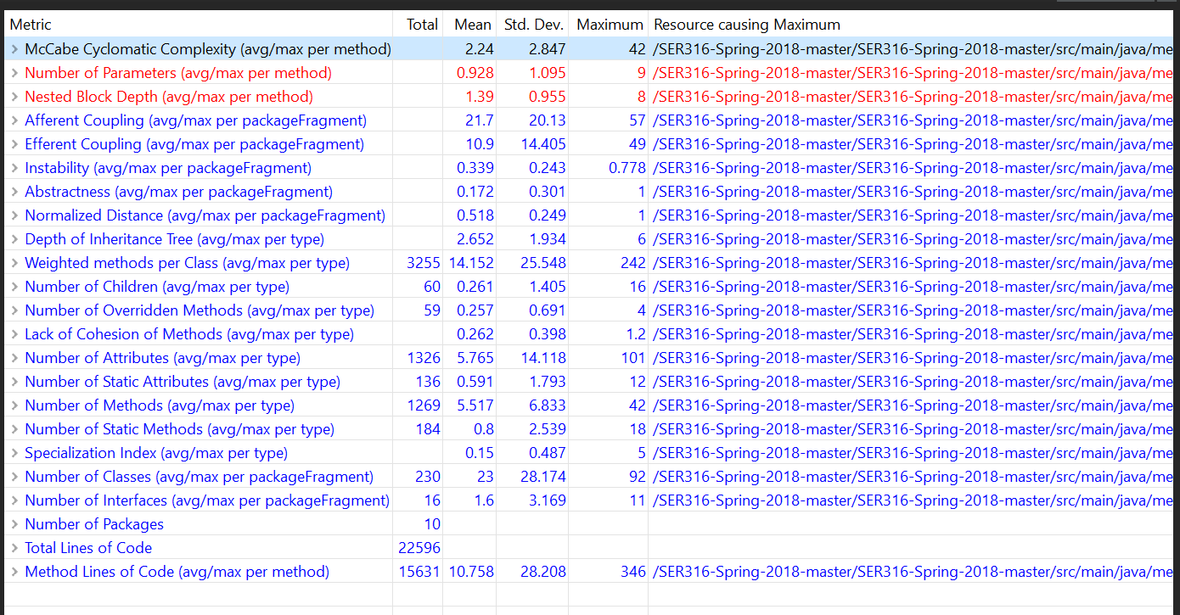

When looking at the metrics, there were minor changes from before and after but im not sure that they were necessarily good or bad. The number of parameters went down slightly from .93 to .928 and that would be because I moved the inner classes to be their own. In doing this though, it increased both the efferent and afferent coupling to 10.9 and 21.7 respectively. I would say that these changes were a wash in terms of helping or degrading the project.