  - INTERNATIONAL WEIGHTLIFTING FEDERATION

Technology and Information System (TIS)

Licensing of TIS Software and Hardware

SUPPLIER PROPOSAL

  - Response to the IWF Request for Proposal dated 28 September 2026
Submission deadline: Saturday, 24 October 2026

Table of Contents
Cover Letter 3
Revision Notes / TODO 4
A. Company 5
A.1 Supplier Eligibility and Responsibilities 5
B. Product 6
B.1 Solution Overview 6
B.2 Profiles 6
B.3 Licence certificate 9
C. Software 10
C.1 Software, Data and Interfaces 10
C.2 Third-party dependencies 11
D. Hardware 13
D.1 Hardware and Field-of-Play Requirements 13
E. Competition functionality 21
E.1 Minimum Functional Requirements – 21
E.2 Timing, Officiating and Outputs 24
F. Security & resilience 40
F.1 Security, Resilience and Business Continuity 40
G. Integration 42
G.1 Interfaces 42
H. Operations 43
H.1 Supplier responsibilities 43
H.2 Event deployment 43
H.3 Support and incidents 44
I. Homologation 45
I.1 Evaluation and Homologation Process 45
I.2 Approval Criteria and Hard Gates 46
J. Commercial 48
J.1 Commercial and Contractual Conditions 48
K. Legal 49
K.1 Licence Conditions, Change Control and Event Deployment 49
K.2 Intellectual property 49
K.3 Mandatory declarations 50
L. Compliance matrix 51
RFP Section 2 51
RFP Section 3 53
RFP Section 4 56
RFP Section 5 61
RFP Section 6 65
RFP Section 7 67
RFP Section 8 69
RFP Section 9 71
RFP Section 10 72
RFP Section 11 73
RFP Section 12 75
RFP Section 13 77
Appendices 77
Appendix A. IWF responsibilities 77

Cover Letter
To: International Weightlifting Federation
Email: iwf@iwf.sport
Subject: IWF TIS RFP - Proposals
Dear Evaluation Committee,
[Supplier] submits this proposal in response to the International Weightlifting Federation's Request for Proposal dated 28 September 2026 for the licensing, supply and operation of complete Technology and Information Systems for weightlifting competitions.
[Supplier] has extensive experience providing sport technology services at international events, including World Championships and the Olympics, including the advanced integration profiles.
This proposal is based on the OTIS commercial offering, which includes the OWLCMS software, Blue Owl refereeing Devices, and the required computers to run a competition. This combination has managed extremely large competitions (5 simultaneous platforms with 1600 athletes) in full compliance with the IWF TCRR. The OWLCMS software has been in use since 2019 in its current form and has been used in over 107 countries. It is the de facto standard for state, national and continental competitions in the Pan-American confederation and regional federations like the Nordic federation. Over 60 kits of Blue Owl refereeing devices have been sold worldwide.
The proposal also specifies the additional computers and devices needed to meet the more advanced integration profiles.
We welcome the opportunity for certification of this offering.
Yours faithfully,
Authorisation | Details
Name | [TO BE COMPLETED]
Title | [TO BE COMPLETED]
Signature | [TO BE COMPLETED]
Date | [TO BE COMPLETED]

Proposal information | Supplier response
Supplier legal name | [TO BE COMPLETED]
Product / solution name | [TO BE COMPLETED]
Exact baseline | [TO BE COMPLETED]
Profiles claimed | [TO BE COMPLETED]
Primary contact | [TO BE COMPLETED]
Email / telephone | [TO BE COMPLETED]
Proposal date | [TO BE COMPLETED]
Document version | Draft 0.1

Revision Notes / TODO
Temporary working notes. Remove this section before final submission.
- .

Company
Legal name, registration, ownership/contact details, experience and references.

Supplier Eligibility and Responsibilities

Minimum supplier requirements

Legally established entity able to contract with IWF
[RFP §8.1] Legally established entity able to contract with IWF.
This proposal is put forward by [Supplier], a duly incorporated corporation under [Country Law]
[To be completed]

Relevant experience delivering competition scoring/results or comparable mission-critical systems
[RFP §8.1] Relevant experience delivering competition scoring/results or comparable mission-critical systems.
[Supplier] has been organizing an annual series of competitions for many years, as well as its own very large scale national championships. Each of these competitions features from 3 to 6 simultaneous platforms, involves up to 1600 athletes, and last between 3 and 9 days. The competitions are streamed and results are available live on the Web.
Furthermore, state-level organizations routinely organize multi-platform events with several hundred participants using the exact same technologies and procedures, so there is a large network of already trained persons available.

Ability to accept end-to-end responsibility for the complete system and declared third-party components.
[RFP §8.1] Ability to accept end-to-end responsibility for the complete system and declared third-party components.
The specific combination of software (OWLCMS) and devices (Blue Owl) presented in this proposal has been used since 2024 at all national events.

Qualified technical, competition-operations and support personnel
[RFP §8.1] Qualified technical, competition-operations and support personnel.
[Supplier] has retainers with technology specialists to install and operate the actual TIS for its very large events, and a large network of people experienced with the system, the devices, and the processes it can draw upon.

International training, event support and incident-response capability
[RFP §8.1] International training, event support and incident-response capability.
[Supplier] is able to provide trainers that would do international training. [Supplier] already monitors its own events at distance with remote intervention capabilities. [Supplier] can create teams of people to be dispatched internationally, as it currently does with technical officials.

Ability to maintain the approved baseline for the license period
[RFP §8.1] Ability to maintain the approved baseline for the license period.
[Supplier] already maintains the exact same baseline for its own very large scale events.

Product
Product name, architecture, supported profiles, capacities, deployment model and limitations.

Solution Overview
This proposal relies on the OTIS kit described at https://blue-owl.nemikor.com/otis.
- The OWLCMS software, used worldwide at the Continental, Regional, National and Local levels. The software has been used in thousands of meets in 107 countries. OWLCMS is fully documented at https://owlcms.jflamy.dev .
- Blue Owl devices. Close to 70 kits of the devices proposed here have been sold. The devices are explicitly designed to work with OWLCMS. Some federations have deployed up to 6 platforms simultaneously with these devices.
- Additional computers and devices required for video processing and external interfaces are included to complement OTIS and meet the requirements of the advanced profiles.
Figure 1 and Figure 2 below provide a visual overview of the solution as proposed.

Profiles

M0 - Core Sport Conformance
[RFP §2.1] Complete sport logic, mandatory FOP controls, screens and official documents.
OWLCMS version 69 and Blue Owl version 3 are fully compliant with the TCRR as of October 2026.

M1 - Licensed Operational Baseline
[RFP §2.1] M0 plus baseline control, audit, interfaces, offline operation, recovery, procedures, training, support and spares.
The system as delivered will meet all the stated requirements. OWLCMS includes a module specifically meant for the creation of external data interfaces. The hardware devices use documented protocols. Baseline control will be according to section K.1.2.

M2 - Major Event & Broadcast
[RFP §2.1] M1 plus applicable VPT, public/live services, broadcast outputs, enhanced monitoring, high availability and full rehearsal.
Video playback uses video-capable equipment that is included in the proposal (laptops with video capture/gaming cards, cameras). OWLCMS has its own standalone VPT capabilities and provides a core set of TV Graphics for broadcasts. OWLCMS replay streams for each lift can be fetched from the replay server once networking access configurations are done.
Furthermore, Supplier can create additional TV graphics for specific event requirements; the actual creation and testing of such items would have to be negotiated with the supplier

M3 - Games & External Integration
[RFP §2.1] M2 plus approved Games/ORIS and programme-specific integrations.
OWLCMS includes a fully documented external interface data format and sample applications that leverage it. All competition data, and every single field-of-play event (weight changes, decisions, etc.) are available for propagation on the Games feeds.
OWLCMS has previously been integrated with Olympic Data Format feeds using that approach.
The interfacing capability is an integral part of the proposal; the actual creation and testing of specific interfaces for specific external formats or events would have to be negotiated with the Supplier.

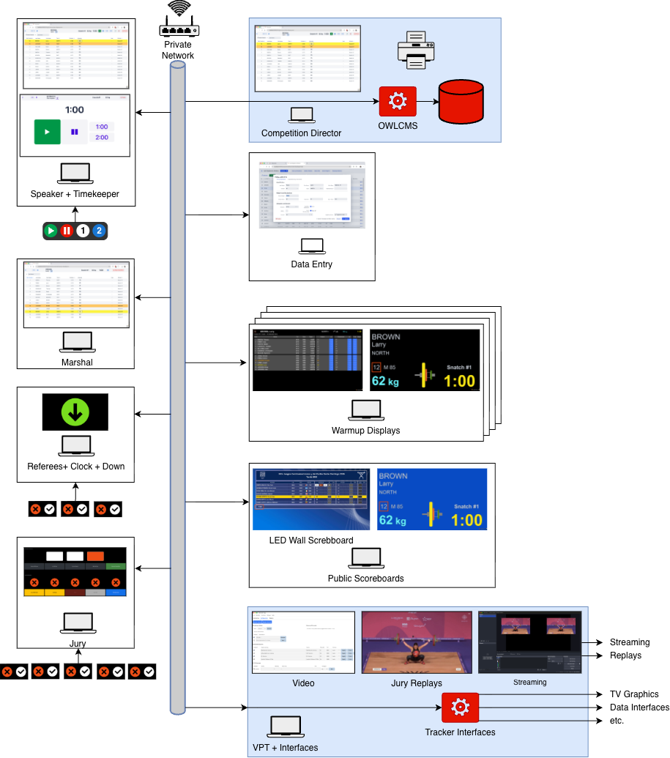
Figure 1: Solution Overview
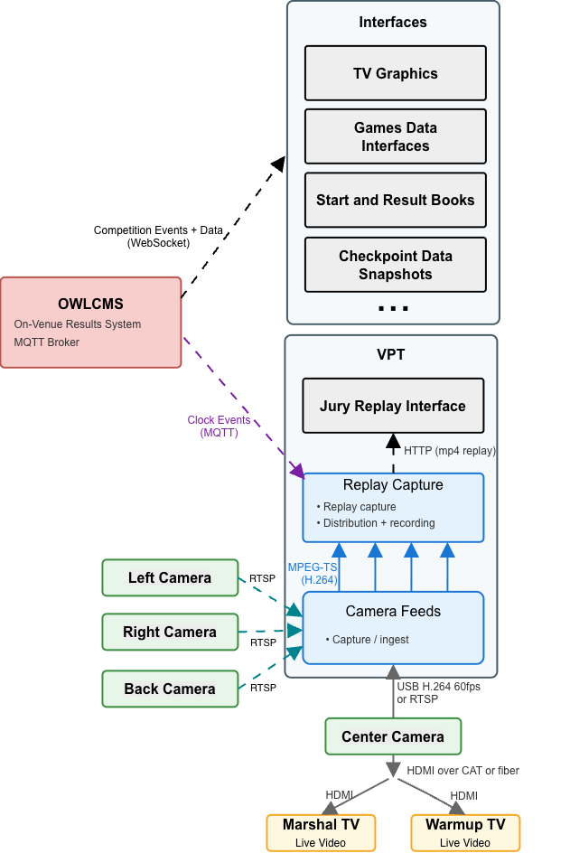
Figure 2: Detail: VPT and Interfaces

MP - Multi-platform Overlay
[RFP §2.1] Simultaneous platform operation with separation and capacity evidence.
OWLCMS has been used in actual competitions with up to 6 platforms simultaneously and 1600 athletes competing, with extremely low computer and network usage.
When running multiple platforms, a single instance of OWLCMS runs them all together, and no integration step for results is required. All results and rankings are available live for all platforms. The normal constraints expressed in TCRR (group B should finish before group A for a given category) should nevertheless be respected so coaches get meaningful information.
The program is verified with a stress test that simulates competition updates as fast as possible in real life, using the entry totals to generate credible lift values. Any competition can be simulated as soon as preliminary registration data is available to confirm expected performance and validate reports

Licence certificate
IWF is expected to issue a license to supplier to confirm certification.
If selected, [Supplier] will provide the following information for such a certificate to be issued.

Supplier and product
[RFP §2.2] The licence certificate shall state the supplier and product.
The supplier of the product shall be [Supplier], who will act as integrator of the OTIS solution and any additional components required to meet the claimed profiles as per requirements.

Exact baseline
[RFP §2.2] The licence certificate shall state the exact baseline.
Any stable version of OWLCMS after version 69 is claimed to meet the current requirements and is fully compliant with TCRR as published at the time of this tender. Any version of the Blue Owl software after version 3.0 meets the requirements. Baseline will be established at acceptance and evolve according to section K.1.2.

Approved profiles and capacities
[RFP §2.2] The licence certificate shall state approved profiles and capacities.
M2 and MP profiles: The system complies with the M2 and MP profiles, up to 6 platforms. For the purpose of this license, the number of participants shall be 1800 or less. There is no intrinsic limitation on the number of participants; this number is given as a safe, previously observed figure with a margin of safety.
M3 profile: Integration capabilities with external systems are intrinsic; actual integration and testing with external systems are not included in this proposal. There are no exclusions preventing IWF from providing the live integration feed to a qualified party.

Interfaces and critical dependencies
[RFP §2.2] The licence certificate shall state interfaces and critical dependencies.
The system has no critical dependencies. All communications use the standard HTTP and MQTT protocols.
The specific MQTT messages used for the devices are fully documented. The physical interfaces for devices are USB and RJ-45 connectors. Only commercially available cabling (CAT-6, USB 2.0, HDMI) is used.
The protocol used to create additional interfaces for Data Exports, TV Graphics, etc. is public and has a published reference implementation.

Limitations and deviations
[RFP §2.2] The licence certificate shall state limitations and deviations.
See section B.3.3 for context on profile M3. No limitations on profiles M0, M1, M2 and MP.

Validity and surveillance conditions
[RFP §2.2] The licence certificate shall state validity and surveillance conditions.
The certificate will be valid for 4 years after date of issuance.

Software
Modules, versions, rule-pack approach, database, interfaces, deployment and update model.

Software, Data and Interfaces

Software

Implement the effective IWF rule pack and support controlled updates
[RFP §6.1] Implement the effective IWF rule pack and support controlled updates.
The solution is tested against the TCRR rules using automated tests. OWLCMS has over 350 automated tests covering rules, reports and program behaviour. Any new release is tested against regressions.

Competition-critical functions shall not depend on unavailable internet, licence-server or payment services.
[RFP §6.1] Competition-critical functions shall not depend on unavailable internet, licence-server or payment services.
Once downloaded, the solution is completely autonomous and works with no internet connection whatsoever

Exact production version, configuration, database schema, rule pack and relevant assets shall be identifiable and reproducible.
[RFP §6.1] Exact production version, configuration, database schema, rule pack and relevant assets shall be identifiable and reproducible.
Releases are created by a fully repeatable automated build process, and under strict version control. This applies both to OWLCMS and the Blue Owl components. All past versions and the source code used to build them are available.

Installation and rollback shall be documented and repeatable
[RFP §6.1] Installation and rollback shall be documented and repeatable.
OWLCMS is launched by a control panel that allows switching between versions. Within a major version, the database can be rolled back if a fix release is unsatisfactory. Fix releases can always read exported prior data so they can be tested independently. Emergency installation of a fix is a matter of seconds once the fix release is downloaded. The OWLCMS program runs on any available Windows, macOS or Linux computer, and the database exports are completely portable, so any available computer can be used for testing.

Automatic updates shall not occur during an event freeze unless approved
[RFP §6.1] Automatic updates shall not occur during an event freeze unless approved.
The system does not perform any type of automatic update. Operating system updates shall be managed by duly authorized personnel according to supplier procedures; they are not under the control of the solution.

Data integrity and authoritative state

Every sporting fact shall have one declared authoritative owner
[RFP §6.2] Every sporting fact shall have one declared authoritative owner.
Any change to the competition state is uniquely attributed to a human actor, to a device input, or to an automated calculation. The audit log reflects this attribution.

Derived screens, feeds, documents and caches shall be traceable to the accepted state
[RFP §6.2] Derived screens, feeds, documents and caches shall be traceable to the accepted state.
All computed results are directly attributable to programmed rules based on the authoritative data.

Corrections shall be authorised, atomic, attributable and propagated
[RFP §6.2] Corrections shall be authorised, atomic, attributable and propagated.
Once the competition has started, all changes are meant to be made using the interactive interfaces or the explicit import features of the programs such that audit traces are kept. Database state that does not correspond to audited actions is evidence of tampering. Should intentional exceptional corrective actions by the supplier requiring database queries or similar be necessary, the corresponding authorizations are expected to be managed separately as part of incident response.

Duplicate, lost, conflicting or out-of-order transactions shall be prevented or detected.
[RFP §6.2] Duplicate, lost, conflicting or out-of-order transactions shall be prevented or detected.
The system applies strict sequencing for all events, whether device-generated or human-generated. Duplicate events are eliminated.
Conflicting updates from technical officials are detected and reported (e.g., competition director and marshal both attempting to correct an error). The marshals cannot accidentally interfere with the data updates resulting from a refereeing decision (the athlete card is closed when a decision is received). Athlete registration information cannot be edited while a session is in progress. Likewise, the features that enable post-session athlete card corrections are blocked until the session is over – during a session only the marshal and director pages can edit the athlete cards.
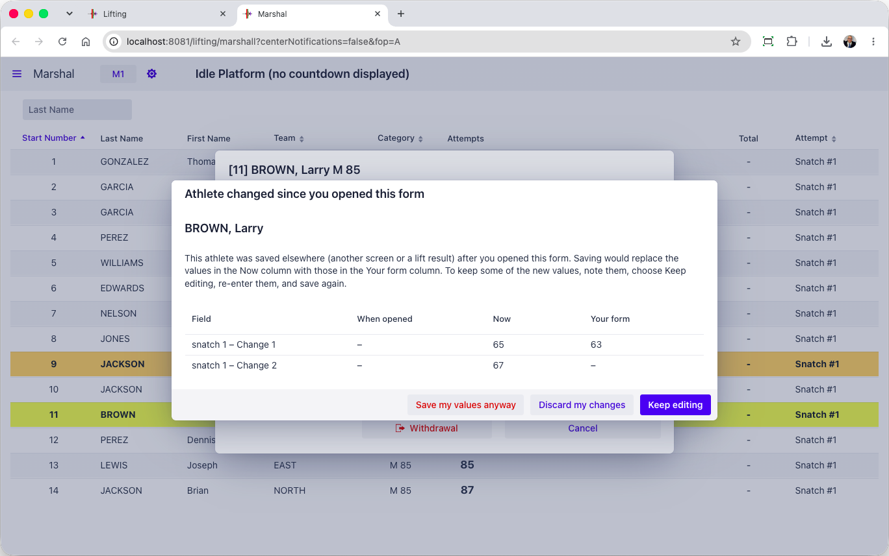

A complete machine-readable event export shall be available to IWF
[RFP §6.2] A complete machine-readable event export shall be available to IWF.
The database export contains all the event data in structured JSON format. The audit logs are also machine-readable.

Third-party dependencies
[RFP §6.4] All third-party software, libraries, services, licences and hardware necessary for operation shall be declared, including version, ownership, support status and cloud/public-internet dependency.
All third-party software, libraries, services, licences and hardware necessary for operation shall be declared, including version, ownership, support status and cloud/public-internet dependency.

OWLCMS dependencies
OWLCMS is written in Java. The full dependencies for OWLCMS are listed in the following files.
- https://github.com/jflamy/owlcms4/blob/dev68/pom.xml
- https://github.com/jflamy/owlcms4/blob/dev68/owlcms/pom.xml
All the dependency files are found in the industry-standard “Maven Central” repository for Java dependencies. Any past version of the software can be recreated because this site contains the full historical record of the libraries. The build process for OWLCMS is entirely automated and repeatable.
The main libraries in use are as follows. All these libraries have been at the core of the program since at least 2019. We have applied all relevant security fixes to these libraries
- The current long-term support version of the Vaadin user interface toolkit; currently version 25.2.7. Vaadin is a Finnish company that has been releasing User Interface kits since the early 2000s. Vaadin is used in industrial-strength applications, mostly in the financial, banking, and governmental sectors, and was chosen for its stability and flexibility.
- Hibernate data access library, version 5.6.15.Final
- H2 relational database, version 2.1.124
- Eclipse Jetty Web Services, version 12.0.4. OWLCMS uses this to provide HTTP services
- Eclipse Paho MQTT library (version 1.2.4). This is used to provide device connections.
- Google Guava library for event distribution (version 33.5.0)
- Apache POI library for generating Excel spreadsheets (Version 4.1.2)
- jxls library for creating templates of Excel files for report generation using Apache POI (version 3.0.0)
- logback library for writing journals and logging information
- The standard libraries for Java (currently version 25 LTS – long-term support)
The libraries outside this list are utilities and do not represent architectural commitments (they can be substituted).
Because of the need to follow browser and mobile device evolution, and to prevent security issues, OWLCMS tracks major versions of the Vaadin library as they are released roughly every year. Updated versions of the software would be made available to IWF accordingly. OWLCMS is stringently tested for backward compatibility with a large automated test suite.

Blue Owl Dependencies
Blue Owl is a Node.js application that connects the refereeing devices to OWLCMS. As such it depends on one main library to interact with the devices.
- The Firmata library johnny-five, version 2.1.0 (https://github.com/rwaldron/johnny-five)

Video Playback Dependencies
- The VPT module delegates all the actual video work to the very widely used FFmpeg software. On Windows the build used is the current stable version 9.0 (https://github.com/BtbN/FFmpeg-Builds/releases/download/latest/ffmpeg-n9.0-latest-win64-gpl-shared-9.0.zip)
- The specific version of FFmpeg used may change in the future depending on what graphics processor is present in the graphics processing laptop, and how device drivers evolve. Using FFmpeg isolates us from the compatibity details.

Hardware
Equipment list, specifications, quantities, spares and lifecycle/support information.

Hardware and Field-of-Play Requirements

Servers / control compute
[RFP §5] Controlled capacity for authoritative state and approved services, with spare/recovery path.
OWLCMS is extremely efficient in memory, input-output and networking. As a reference, the standard OTIS kit has been tested to run 1600 athletes on 6 simultaneous platforms on a 8GB Raspberry Pi5 mini-PC.
Two machines in this proposal qualify as servers, as shown in Figure 1.
- The main station OWLCMS server. This proposal uses a standard 16GB Windows laptop with a SSD disk for running OWLCMS. That station is used by the competition director, and includes Microsoft Office.
- The VPT and Interfaces server. This is a high-end gaming laptop configuration with the capability to run full live video processing for many feeds. The laptop meets the standard for the commercial vMix video software, as a provision for eventual broadcast-level processing.

Operator stations
[RFP §5] Dedicated, role-controlled competition administration and operation positions.
The competition director uses the main station as his operator station. In a multi-platform setup, only one director station will run the OWLCMS software, and the others act as server redundancy.
The other Operator stations are only required to run two browsers as a maximum. The proposed configuration is from the field-tested OTIS kit. Stations are 8GB Raspberry Pi 500s that are cost-effective, easily replaceable, guaranteed to be in production until at least 2036, and designed for use in difficult environments such as classrooms. Operator stations use portable screens that can be replaced if broken.
The USB ports on the operator stations are used to connect the Blue Owl refereeing devices, as shown in Figure 1 above.
Keyboards with numeric pads will be provided for the Marshal and Data entry stations.

Database / storage
[RFP §5] Protected authoritative storage, backup and tested recovery.
A fully relational database called H2 is used. H2 has been used without a single data integrity failure since the initial versions of OWLCMS in 2009, and is extremely quick. The database sizes of a full competition are very small (typically well below 2MB). Furthermore, since OWLCMS preserves the ordering of all events, and the number of data entry operations is very low, there is very little concurrency. The only significant queries are for results production but most of the data fits in main memory for caching.
The actual H2 binary file can be kept and is machine-independent, in addition to the structured JSON exports. The exports is the primary means of backup and snapshot. A readable consistent snapshot can be obtained at any time from the competition director station. The laptop that implements the interfaces can also pull a snapshot on demand, as a quick recovery capability.
In a single platform scenario, the VPT+interface laptop acts the spare for the OWLCMS server.

Referee controls
[RFP §5] Three independent red/white referee control devices.
The Blue Owl referee controls include the two buttons, a visible LED, a sound, and a vibration for warning the referees. Referee controllers are cabled in order to avoid any concern with batteries.
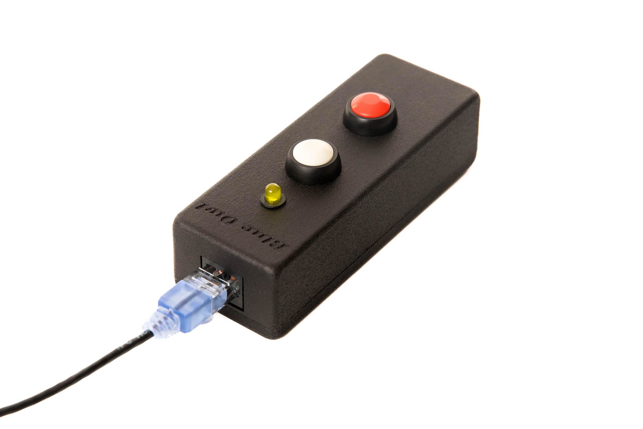

Jury controls
[RFP §5] Individual devices for applicable Jury members plus President controls.
Jury controls for jury members are the same as the referee controls, but without the warning features. Referee controllers can be used as backups for jury controllers (the warnings would simply not be emitted).
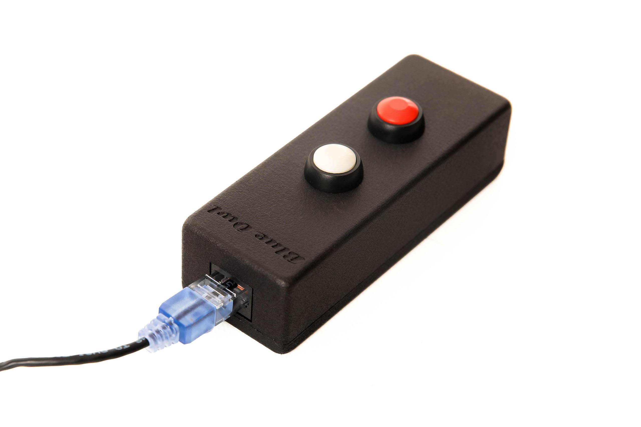
President controls are of two kinds. The solution includes a physical keypad with all the required real-time referee decision display and the required jury member behaviour (green until all decisions visible)
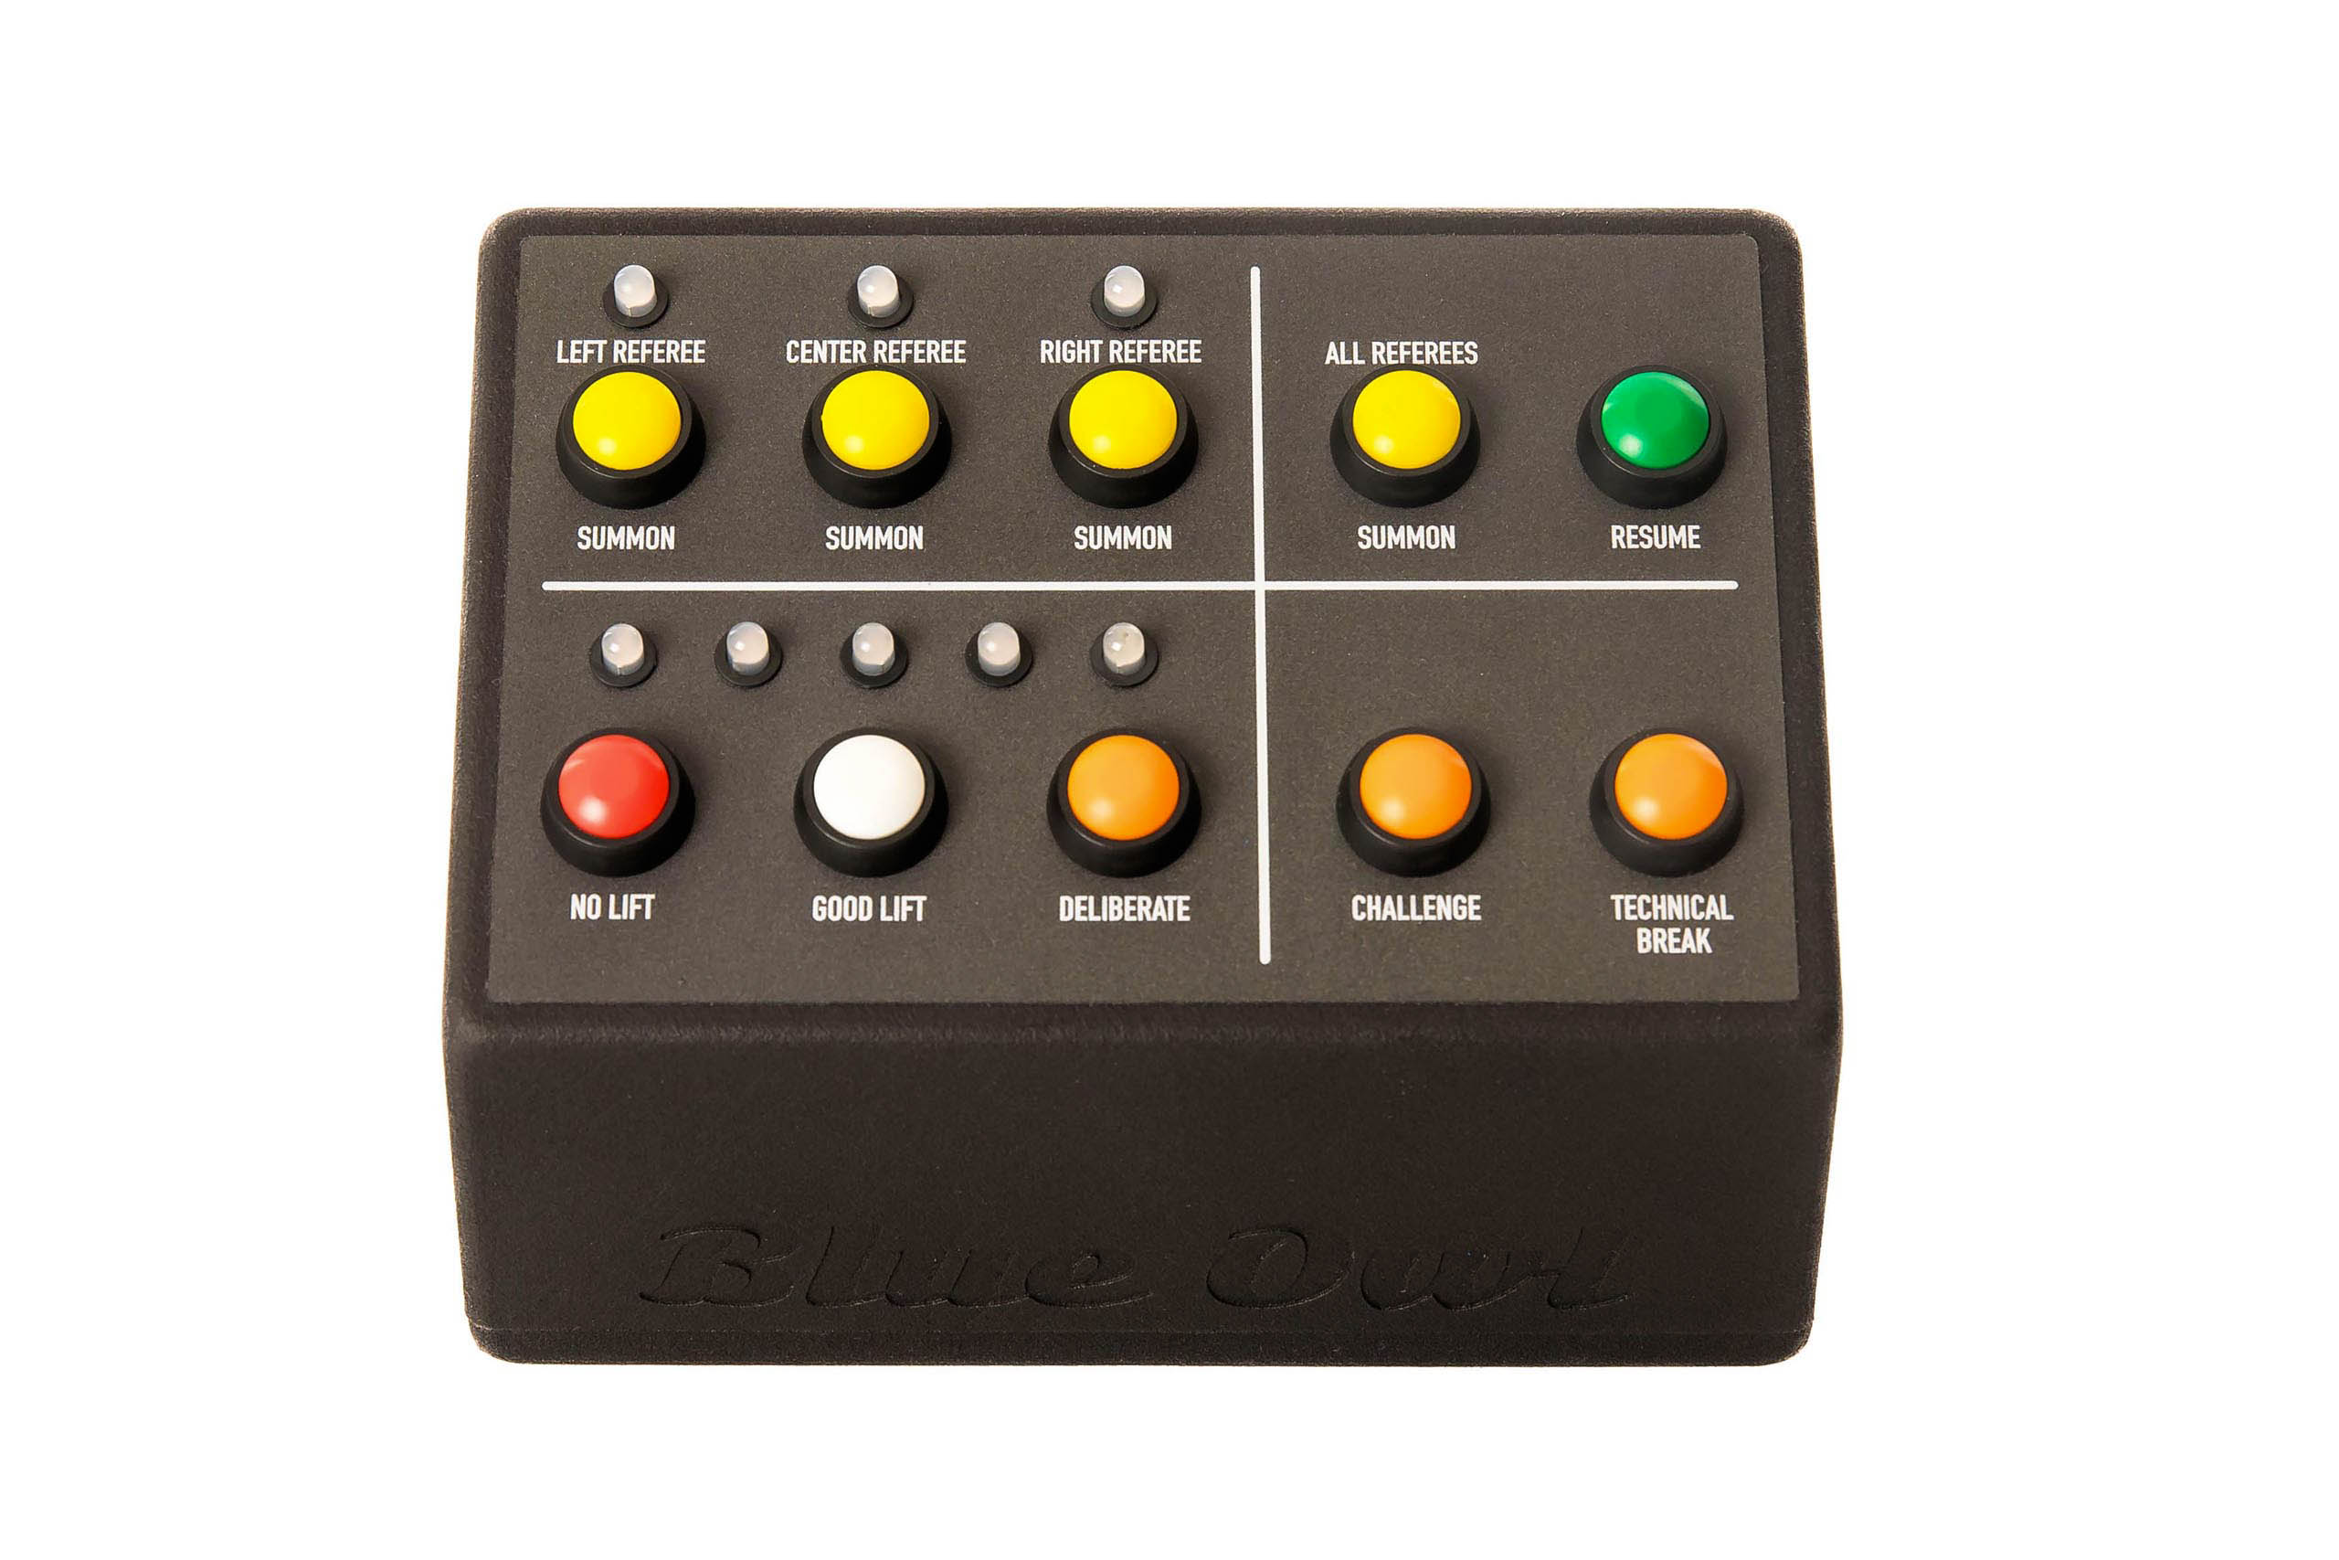
The jury station will also have a tablet-style display that allows the jury president to indicate the reason for lift reversal.

Timing
[RFP §5] Authoritative timer/controller with approved displays and audio.
Timing is done on the main server using the operating system timers. Operating system timing resolution is 1 ms as used. Propagation times of MQTT messages is typically under 10 ms.
Time is displayed on an athlete-facing display, on the attempt boards, and on scoreboards. Each machine with displays attached is synchronized with the OWLCMS computer and receives the millisecond timestamps at which OWLCMS emitted the command. In this way, the propagation delay (even though it is very small) can be compensated.
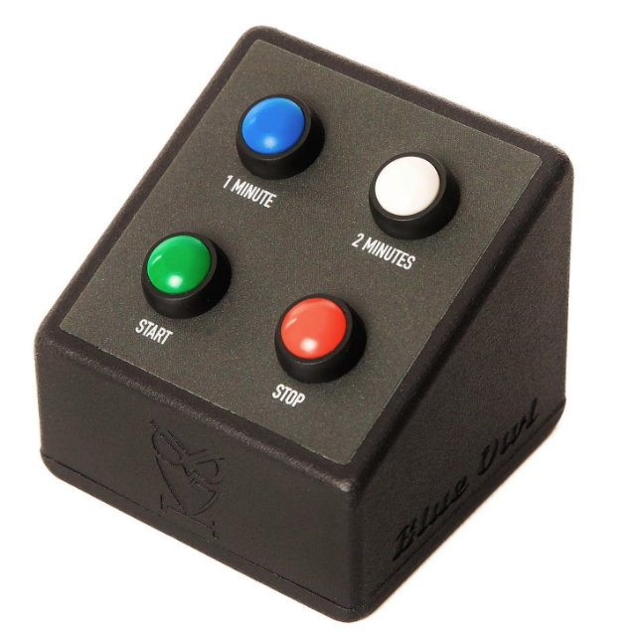
Timer warning and time-over signals are emitted on the down-signal device and logged in the audit log (for example, to determine if the timekeeper stopped the clock before or after the time-over buzzer).
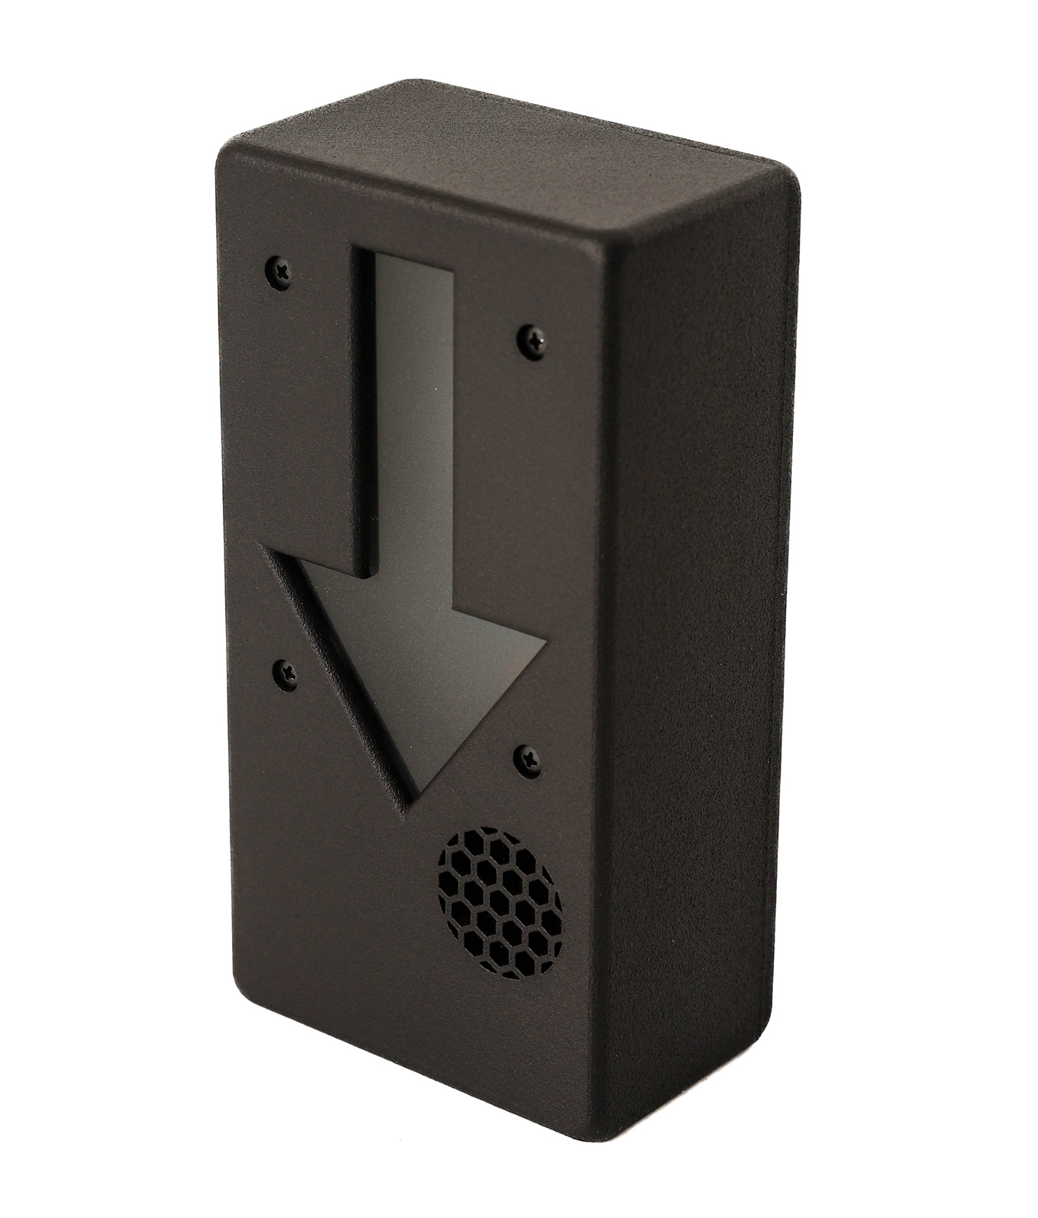

Attempt boards
[RFP §5] Competition and warm-up presentation with mandatory athlete/attempt/weight/clock/decision data.
Attempt boards are standard FullHD or 4K TVs with HDMI inputs. The actual TV screens are to be provided locally and are not part of the certified kit.
As shown in Figure 1, there are two computers running standard web browsers that provide the attempt boards as HDMI outputs. The Vaadin library sends live field of play updates to these browsers over a WebSocket, there is no polling
- The first attempt board output is for the front room and is styled to match the event colour scheme (this is a simple documented action during event setup). A splitter is used to feed one attempt board on each side of the platform.
- The second attempt board output is the normal high-contrast OWLCMS board and is used in all back-room areas (waiting, marshal, warmup).
The kit includes splitters and extenders to reach the typical waiting, marshal and warm-up areas located immediately behind the main platform. Further splitting or extension of the signal to reach multiple attempt boards will use HDMI or SDI equipment obtained locally.
Video connections for the main attempt boards would be as illustrated in Figure 3.
Figure 4 illustrates the back-room connections for attempt boards.
TODO: use pictures that reflect OTIS usage of dual-HDMI computers
TODO: use a more typical backroom layout
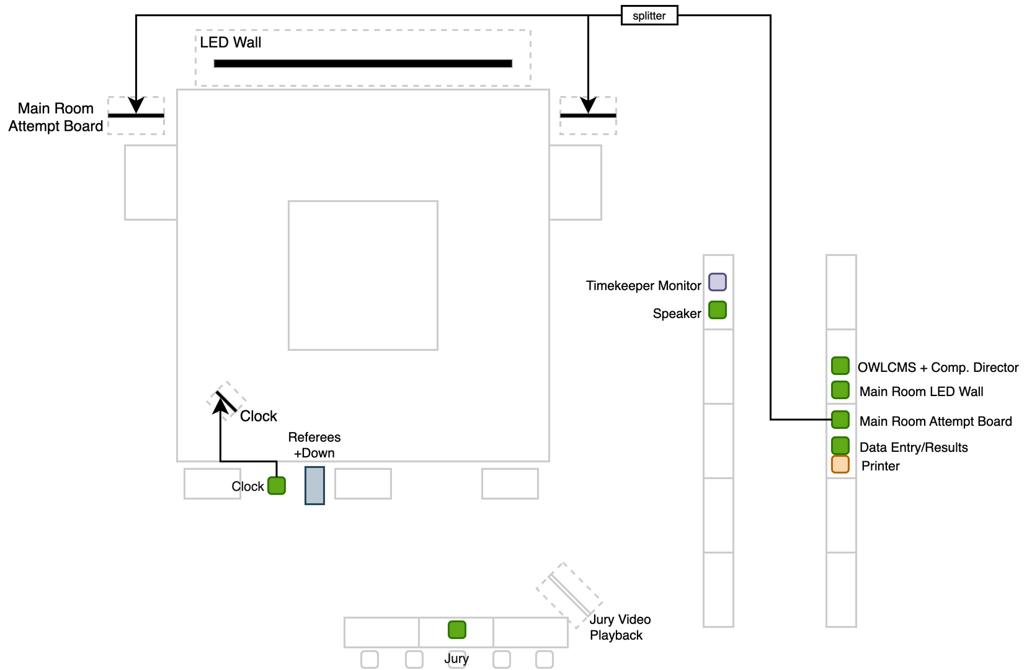
Figure 3: Attempt Board Video Connections
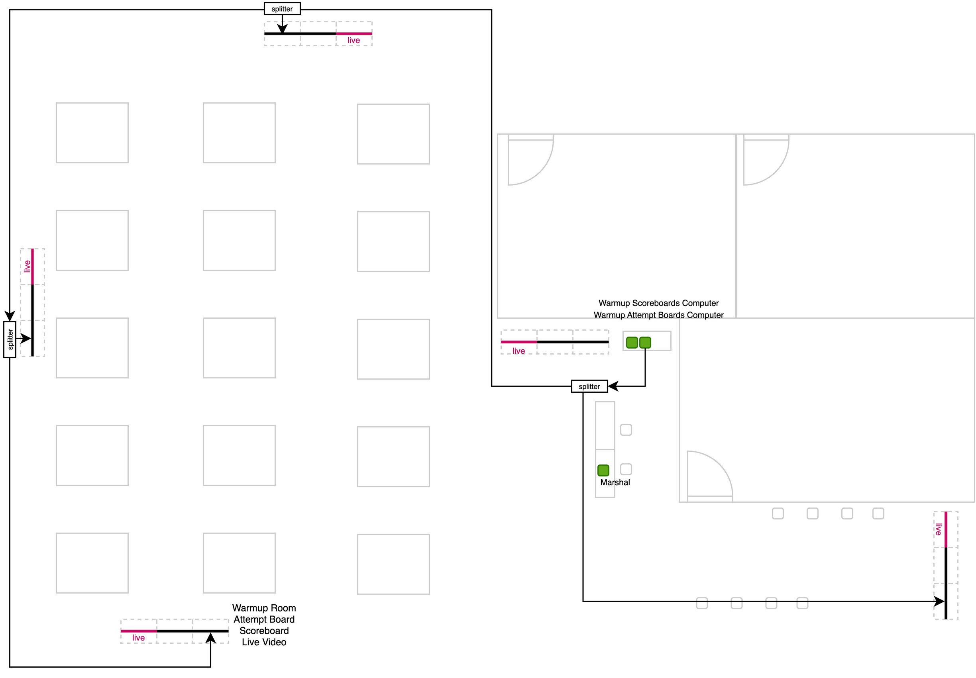
Figure 4: Warmup Room Attempt Board Video Connections

Scoreboards / RTDS
[RFP §5] Real-time competition and warm-up displays with correct ranking and state.
The situation for the scoreboards is the same as for attempt boards. There are two HDMI sources, one for the stage area, one for the back. For the stage area, the signal is assumed to go to a single large LED scoreboard.

VPT
[RFP §5] Approved cameras, recording/replay and Jury output for events requiring VPT.
The VPT system is under the full control of the competition staff, and the TCRR-mandated angles can be displayed in self-service mode by the jury if so required (or provided by the competition director).
As indicated in TCRR, the replay clips are accessible by the venue video team and broadcast teams. Such access will be controlled by networking equipment configurations.
The VPT system relies on four PTZ cameras. Based on our experience in Continental competitions, we propose Tenveo PTZ 60fps cameras. These cameras provide Power-over-Ethernet RTSP video feeds, HDMI, and compressed H.264 USB feeds.
OWLCMS has a VPT module that automatically clips and attributes the replays to the athlete lifting. This module keeps a full indexed archive of all the lifts, at all angles.
The VPT will execute on a high-performance laptop that also meets the requirements for the vMix software. If a client federation wants to add such additional video-processing capabilities, the proposed equipment will be sufficient for them to use their own license on the video-processing laptop.

Network
[RFP §5] Documented, segmented, monitored event network with common time.
The networking configuration is based on switching. Unmanaged switches are sufficient. A minimum of 4 POE (Power-over-Ethernet) ports is necessary to provide power to the networked PTZ cameras. A 16-port switch per platform is provided.
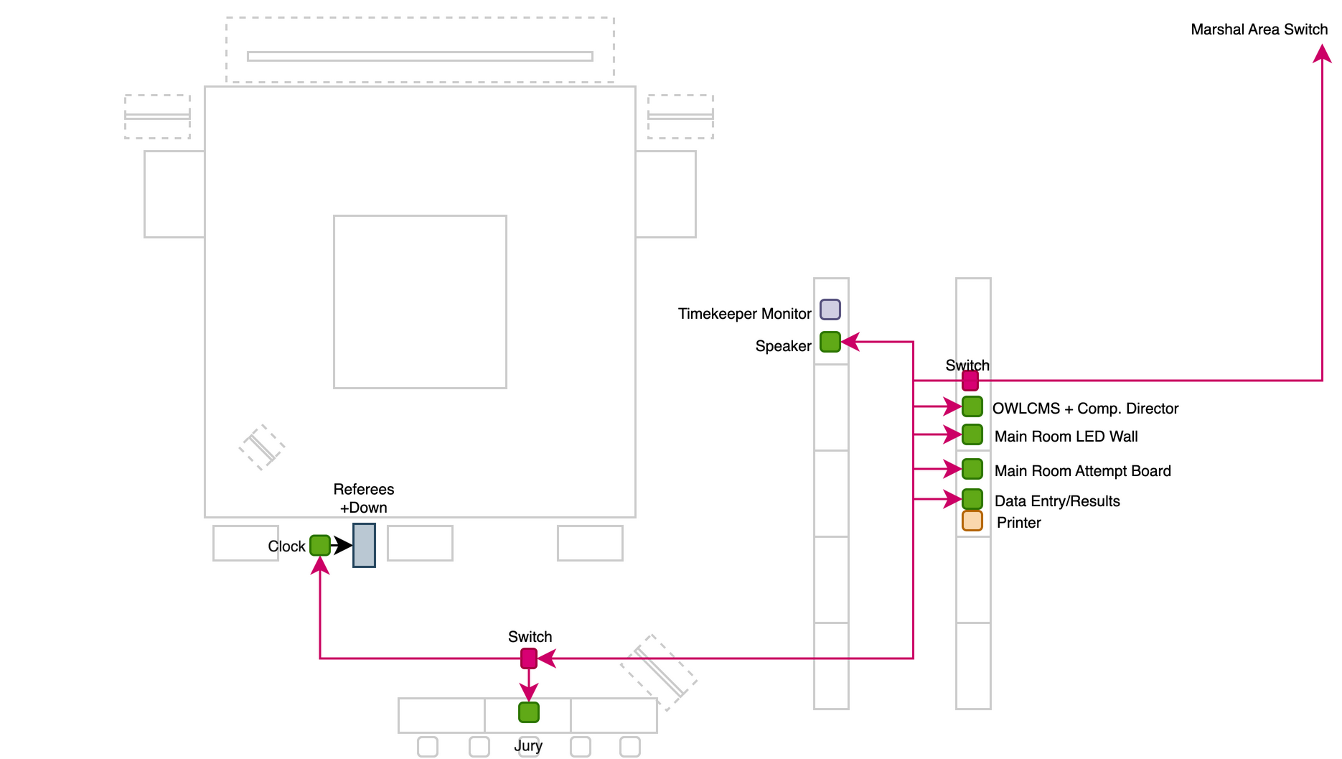
Figure 5: Main Room Networking
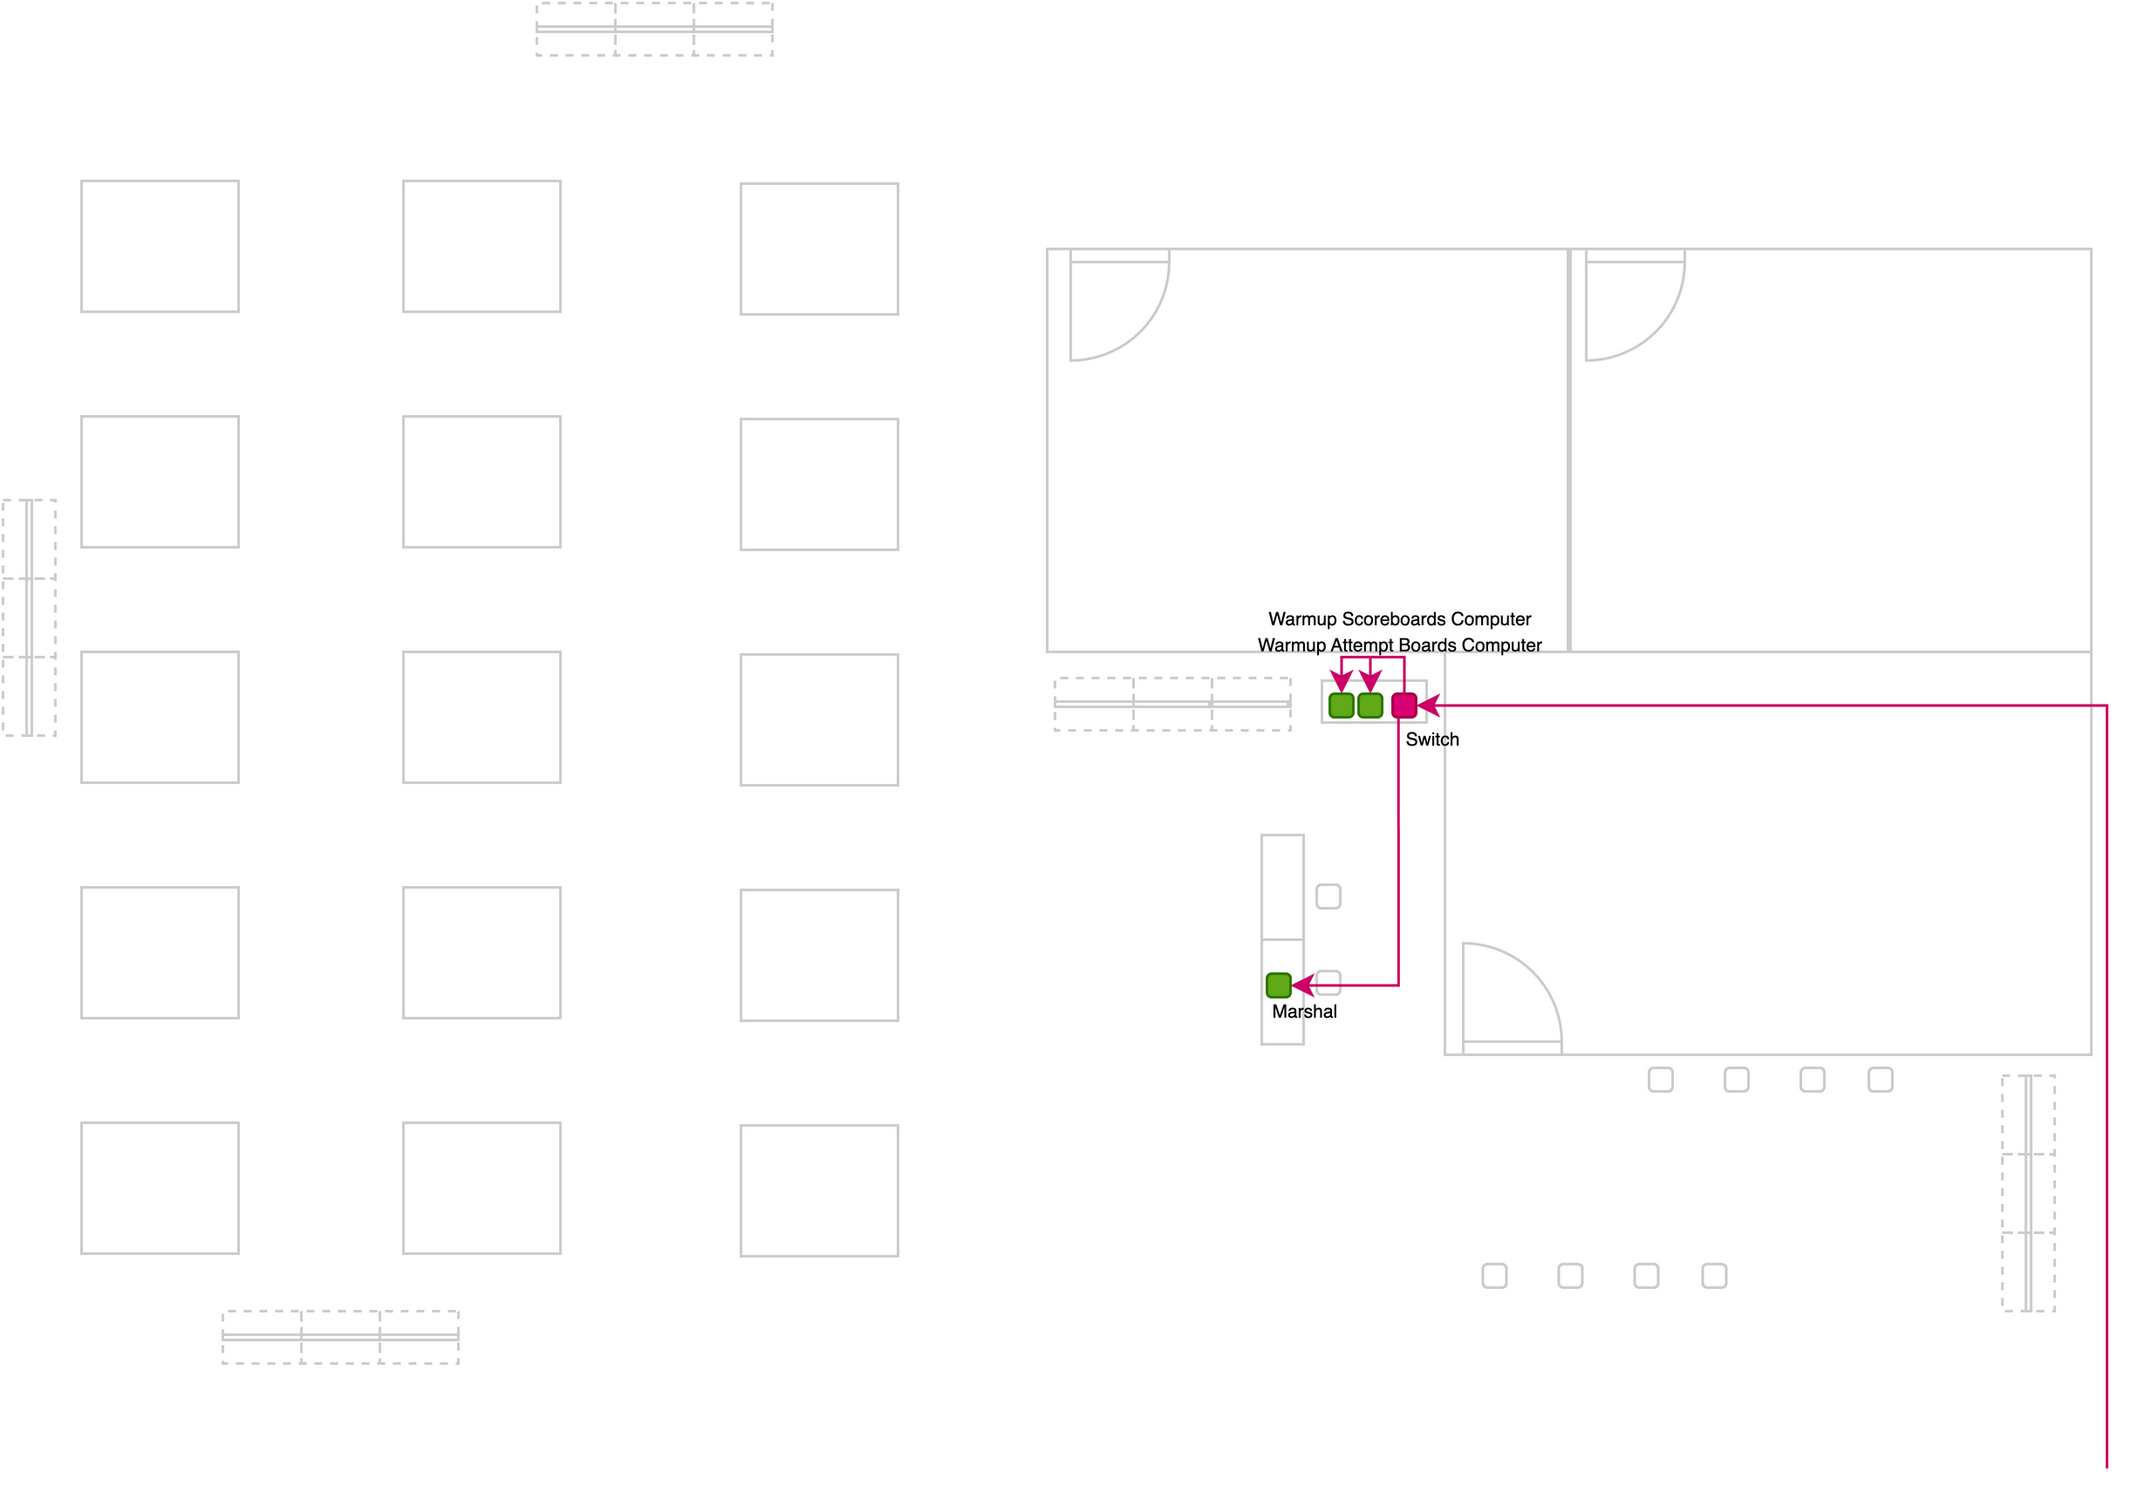
Figure 6: Back-room Networking
All the machines on one platform are connected to a switch on that platform. Use of a switch also ensures that video traffic from the cameras goes directly to the video equipment and does not touch other machines that don’t need it
OWLCMS networking traffic is minimal. The application is routinely used in a cloud configuration with very remote servers and no perceptible delay.
An ASUS router is included. This router is used when an external wired internet connection is available for streaming. WiFi is not normally turned on. If federation personnel request access, it is preferred to loan them a network dongle. This eliminates concerns about illicit WiFi access.

Public / broadcast gateways
[RFP §5] Controlled read-only path from accepted state to approved consumers.
The video laptop will host all the external interfaces. In actual practice, sending information out to a games central is very low usage (and ODF protocols are push only). OWLCMS can also publish to cloud-based scoreboards and other feature, but those are also push only.
In the past, outside broadcasters have used the OVR-provided screen layouts directly. This was accommodated by opening a port on the router to a specifically white-listed address. This capability is generic with the equipment provided.

Printing
[RFP §5] Reliable official documents with fallback.
A Windows laptop with Microsoft Office is used for data entry and report generation to maximize compatibility with whatever printer is made available. OWLCMS produces documents in Excel format. Documents should be exported as PDF in non-editable mode and kept as such for archival.
Start books, Result books, Refereeing schedules and similar sophisticated layouts are produced as PDF.

UPS / protected power
[RFP §5] Protection and approved autonomy for critical equipment.
UPS will be provided to protect the networking switches in the front and back room, so the marshal and competition director can still capture changes and perform timing during a short power outage, relying on the fact that their stations have batteries.
Event organizing committees are expected to provide protection for the rest of the equipment, such as TVs and all other networking and video distribution, if warranted by local conditions.

Monitoring / logging
[RFP §5] Health, service, device, storage, time and stale-state monitoring.
The OWLCMS software has very low memory and disk I/O requirements. Use of the normal operating system indicators is therefore sufficient. Additional technical logging for memory and CPU indicators can be turned on in the technical logs.

Spares / recovery media
[RFP §5] Rapidly deployable replacements for critical equipment families.
All the stations only require the presence of a current browser (Chrome, Edge, Firefox or Safari), and for some of them, the ability to connect a USB device. So essentially any laptop can be used, whether Windows, macOS, Linux. Chromebooks can be used when no USB device is needed.
OWLCMS runs on Windows, macOS,

FOP installation
[RFP §5] Safe, labelled cabling and equipment placement without obstruction or sightline conflicts.
The OTIS kit cabling is fully labelled. As illustrated in Figure 3 to Figure 6, cabling is routed along shared with video distribution, runs under the stage whenever possible, and never crosses paths used by athletes.

Hardware inventory
[RFP §5.1] For each licensed event, the supplier shall maintain make/model, quantity, serial or asset ID, firmware, location, connections, power source, owner, health status, spare path and approved deviations.
The OTIS kit already has a full bill of materials (BOM); Refer to Appendix 1 for the additional components.
.

Competition functionality
Lifecycle, officiating, timing, displays, outputs, results and archive.

Minimum Functional Requirements –
The proposed solution fully complies with TCRR and meets all the requirements. Details are provided for each item.

Data Intake
[RFP §3] Import and validate athlete, federation/NOC, official, event, venue and record data; stable IDs and error reporting.
Registration data is converted to an Excel-style sheet with the athlete identifier, name, and lifting data. The input format handles multiple age groups and supports team allocation. The intake format can be exported, edited offline, and re-ingested without loss of information.
The same applies to schedule changes and referee assignments that can be modified in spreadsheet form until the drafts are considered stable.
All information is stored in a relational database. The program performs validation when loading to ensure integrity.

VFE / Technical Congress
[RFP §3] Corrections, approvals, random lots, grouping, timetable and Technical Official assignments.
The program prints VFE verification sheets that show exactly which athlete is in which category or categories (see section E.2.4.2). This allows the competition director to verify that eligibility rules have been respected, and to know in advance what information will be required at VFE (e.g., which teams need to remove substitute athletes from their roster). The program also prints team membership sheets to verify that all team allocations are correct. Team representatives can sign these sheets to support the VFE process and reduce errors. The TIS team uses these sheets for data capture.
The database includes a list of technical officials and their team assignments. A referee team timetable is uploaded and can be edited interactively. In addition, individual assignment changes can then be made as required (e.g., substituting one referee for another for a given session).

Start publication
[RFP §3] Approved Start List and controlled distribution/versioning.
The solution includes the OWLCMS modules for producing a complete start book. A preliminary version can be published to list participants in each category, with subsequent revisions adding the schedule and the officials’ assignments. There are also spreadsheet formats for the actual schedules and start lists for convenient publishing.
Records are loaded in OWLCMS using a spreadsheet (they are converted from the data made available by the federations).
For convenience, individual documents are available for the competition schedule, for referee assignments, for start lists, etc.

Weigh-in
[RFP §3] Correct timing, bodyweight, first attempts, 20 kg checks, start numbers, signatures and closed snapshot.
OWLCMS produces field-tested weigh-in forms to capture both the weight-on-scale and deducted weight. The form captures all the required signatures. Compliant athlete cards are printed.
During data entry, all applicable rules are checked by the pro, including 20 kg and qualifying totals where applicable. Compliant athlete cards are likewise printed. A special data entry mode is used for quick capture of weigh-in data.
Start numbers are cross-checked at the end of the weigh-in and checked against allocated bib numbers. A speaker introduction sheet for athletes and officials is produced, as are the empty protocols and jury member sheets. The competition director takes a snapshot copy of the database at this point.

Snatch
[RFP §3] Calling order, declarations/changes, 60/120-second timing, referee decisions, records and live outputs.
The system fully complies with the competition flow.
All marshal data entry is immediately handled by the system and all lifting order or requested weights are instantly updated on all displays and scoreboards. Referee decisions and jury reversals are automatically handled, and all scoreboards and attempt boards are immediately updated.
All the normal flow timing decisions are automatic (the clock is automatically set to the right allocated time for each athlete, including on fast sequences of changes). Only explicit loading incidents require the use of the 1:00 or 2:00 reset buttons.
The 20 kg rule is systematically checked and any deviation is explicitly visible to the marshal (including the necessary amounts for corrections).
Records attempted are shown as such, and any record improved is registered in the competition database.

Break
[RFP §3] Controlled Snatch-to-Clean & Jerk transition and synchronized displays.
Transition from the snatch to the clean & jerk break at the end of the snatch is automatic. Jury deliberation or challenge on the very last snatch lift is correctly handled (the snatch is not done until resolution).
Default rules for longer breaks (few athletes) and shorter breaks (large sessions) may be given as part of the event-specific rules. Break durations can also be changed during the meet, at any time before the break start. The break duration can also be set at break time in case of a last minute change.

Clean & Jerk
[RFP §3] Calling order, weight changes, 20 kg enforcement, totals, ranks and records.
See section E.1.5 Snatch; the Clean & Jerk flow is completely automated in the same way.

Review / correction
[RFP §3] STOP, Jury, challenge/VPT where applicable, additional attempts, correction, withdrawal and restart.
The jury can start a deliberation or accept a challenge using a physical jury keypad button or using on the jury control display.
A flashing STOP sign is shown to the athlete on the platform, and all attempt boards and displays indicate the interruption.
Transmission of the jury reversal code to the speaker can be done the traditional way (by the technical controller), or automatically when the jury president chooses the reversal code. In either case, the jury or challenge decision is shown as the speaker announces it.
The system can optionally display jury decisions on the scoreboards and the attempt boards (like IWF has been doing experimentally in its own championships). This is optional as it is not part of TCRR.

Results approval
[RFP §3] Protocol reconciliation, signatures/status, results, classifications and records.
The session protocol sheet is available immediately after the session for signature by the jury president. It contains all results, ranking information and each occurrence of improved records.
Should any correction be required, the athlete card can be adjusted from the results page, with full traceability in the audit log. Errors in registration data (for example, wrong eligibility for a record) can be fixed in the same way, and records re-computed prior to emitting an amended protocol for signature.

Ceremony / publication
[RFP §3] Medallists, public/broadcast outputs, communications and revised outputs.
At the end of a session, a medal sheet is available for the speaker. The medal sheet correctly reports the categories that are actually finished (important when A and B groups from different bodyweight categories are together in the same sessions). Combined category results are also available (showing the ranking for all combined A/B/C… groups)
The system has special purpose scoreboards for ceremonies.
- Public scoreboards are normally styled to match the event colours, and switch content during ceremonies. OWLCMS will automatically switch during introductions. During medal ceremonies, the technical table selects which category is receiving medals so the display switches
- Broadcast-oriented scoreboards are typically visually similar to public scoreboards but styled differently (typically a transparent format is used). If the video producer selects the medal display, it will track what the technical table selects as the current medal ceremony.

Archive
[RFP §3] Final dataset, official outputs, logs, revisions, evidence and machine-readable export.
The full database content is exported in JSON format. This format is suitable for archival – OWLCMS can read archives produced several years ago.
The archived documents also include
- A final result package in Excel format (all categories, best athlete rankings, team points, medals)
- A spreadsheet document with the protocols for all individual sessions
- The full “publication format” results book
- The audit logs

Core sporting logic
The core sporting logic is implemented using what is known technically as a state automaton. This defines all permissible field-of-play events and what the permissible outcome is when each event happens. All human inputs and device inputs are field-of-play events. Likewise, the state automaton issues the updates required on all displays and stations and enforces the rules.
The state automaton relies on a large number of computation rules (points, ranks, timing rules, etc.) There are over 350 automated tests that exercise the core sporting and reporting logic. Any change in the application can therefore be checked to ensure that these rules remain correct.

Snatch followed by Clean & Jerk, maximum three attempts per lift, correct Total calculation.
[RFP §3.1] Snatch followed by Clean & Jerk, maximum three attempts per lift, correct Total calculation.
The database explicitly stores 3 attempts per lift and the associated information. The state automaton enforces the sequence. The total calculation rules are subject to automated tests.

Whole-kilogram weights and applicable minimum starting weights
[RFP §3.1] Whole-kilogram weights and applicable minimum starting weights.
The database explicitly stores 3 integer values for the weights. The 20kg rule is systematically verified on any declaration or weight change. The 20kg rules has its own suite of automated tests.

Correct calling order
[RFP §3.1] Correct calling order, including weight, attempt number, previous-attempt sequence and start number.
The calling order is explicitly programmed to determine the next athlete based on the 4 TCRR criteria.

Permitted weight changes, final-call and consecutive-attempt rules
[RFP §3.1] Permitted weight changes, final-call and consecutive-attempt rules.
The state automaton remembers the athlete for which the clock was last started. It correctly resumes the clock at the correct value when several intervening changes bring back the lifting order to that athlete. The state automaton also determines correctly two-minute situations.
Violations of the late-change delays are signalled to the marshal. The marshal can accept a change that was signed in time but could not be typed in fast enough.
Furthermore, to determine violations when an athlete is moving down but should already have lifted, the system also checks the full correct prior sequence on every lift.

Withdrawals, no-lift/no-Total conditions, disqualification and additional attempts
[RFP §3.1] Withdrawals, no-lift/no-Total conditions, disqualification and additional attempts.
The marshal screen have explicit buttons to mark withdrawals of either the snatch, or of both events. The computation rules correctly register no lifts and compute no totals. The system tracks the reasons for disqualification. If an attempt is given again, the audit trail will show the edition of athlete data to match the changes written on the athlete card.

Material corrections recalculate affected rankings, records and outputs
[RFP §3.1] Material corrections recalculate affected rankings, records and outputs.
Any change to the athlete card data for any athlete causes a recalculation of all affected items. Recalculation of records can be triggered on the records management page. Reports and result books can be regenerated immediately afterwards.

Timing, Officiating and Outputs

Timing

Authoritative electronic countdown in one-second increments, configurable up to at least 15 minutes.
[RFP §4.1] Authoritative electronic countdown in one-second increments, configurable up to at least 15 minutes.
Athlete countdown information is updated at one-second increments on the athlete-facing clock, on all attempt boards, and on scoreboards. Breaks can be configured to any duration.

Automatic 60- and 120-second attempt clocks and applicable introduction/break countdowns
[RFP §4.1] Automatic 60- and 120-second attempt clocks and applicable introduction/break countdowns.
Clock ownership is automatic; no intervention is required to set the clock to 1:00, 2:00 or to the time remaining for the athlete.
The system has break countdowns prior to introduction, prior to first snatch and prior to first clean & jerk. A break management dialog in the user interface does the automatic transition between these countdowns, and also allows overriding the durations are required.

Correct start, stop, restart and STOP behaviour according to the rules
[RFP §4.1] Correct start, stop, restart and STOP behaviour according to the rules.
The timekeeper start, stop and restart behavior is according to TCRR.

All connected displays use the same authoritative time state within the approved tolerance.
[RFP §4.1] All connected displays use the same authoritative time state within the approved tolerance.
Time is kept on the OWLCMS server. All devices are time-synchronized to universal time. When a timer countdown is sent to remote browsers for display, the actual universal time on the server is included so the remote machine can determine how much propagation drift took place and adjust the countdown as needed.

Time corrections are authorised, recorded and auditable
[RFP §4.1] Time corrections are authorised, recorded and auditable.
All machines are configured NTP-synchronized at the operating system level, and an NTP source is configured on the network as part of the system setup. Time drift corrections are logged in the operating system journals. A manual resynchronization should be treated the same as an equipment replacement and logged manually by the competition director, as a procedural requirement beyond the scope of the competition automated logs.

Referee and Jury

Three independent referee control boxes with white/red decisions and required indicators.
[RFP §4.2] Three independent referee control boxes with white/red decisions and required indicators.
Blue Owl referee buttons have visual indicator, sound, and vibration.

Correct majority/Down signal, reminder and reversal-window behaviour
[RFP §4.2] Correct majority/Down signal, reminder and reversal-window behaviour.
Implemented by the state automaton. 3-second reversal window is enforced as per TCRR. Should a late reversal be done using flags, the competition director can easily perform the reversal. See section E.2.3.8 for an example of reversal.

Jury visibility of individual referee decisions before public reveal
[RFP §4.2] Jury visibility of individual referee decisions before public reveal.
Live referee decisions and reversals are shown to the jury both on the keypad and on the jury control screen. See section E.2.3.10 for exame

Support for approved three- and five-member Jury configurations
[RFP §4.2] Support for approved three- and five-member Jury configurations.
Jury size is selectable (3, 5 jury members or no jury)

Individual Jury decision controls and protected independence between members
[RFP §4.2] Individual Jury decision controls and protected independence between members.
Individual jury buttons are provided as per TCRR. Decision protection housings are not currently a TCRR requirement; [Supplier] would provide some acceptable housing after clarification of IWF expectations.

Material decisions and actions are attributable and time-stamped
[RFP §4.2] Material decisions and actions are attributable and time-stamped.
There is a full audit log of every single decision, timestamped to the millisecond, with the originating station or device.

Screens and live presentation
The system is fully compliant with all these items. Details and examples for each item are given.

System health
[RFP §4.3] At minimum, the TIS shall provide System health.
A technical log of the system is constantly updated and can be monitored. This includes technical indicators on the environment, notably CPU and memory usage. The normal operating system gauges can also be used. Note that OWLCMS is typically well under 10% of CPU usage, and under 2GB of memory even for very large events, so the operating system gauges are usually entirely sufficient.

Event setup
[RFP §4.3] At minimum, the TIS shall provide Event setup.
All competition information setup is done using interactive screens. Green is used in the software to indicate common actions.
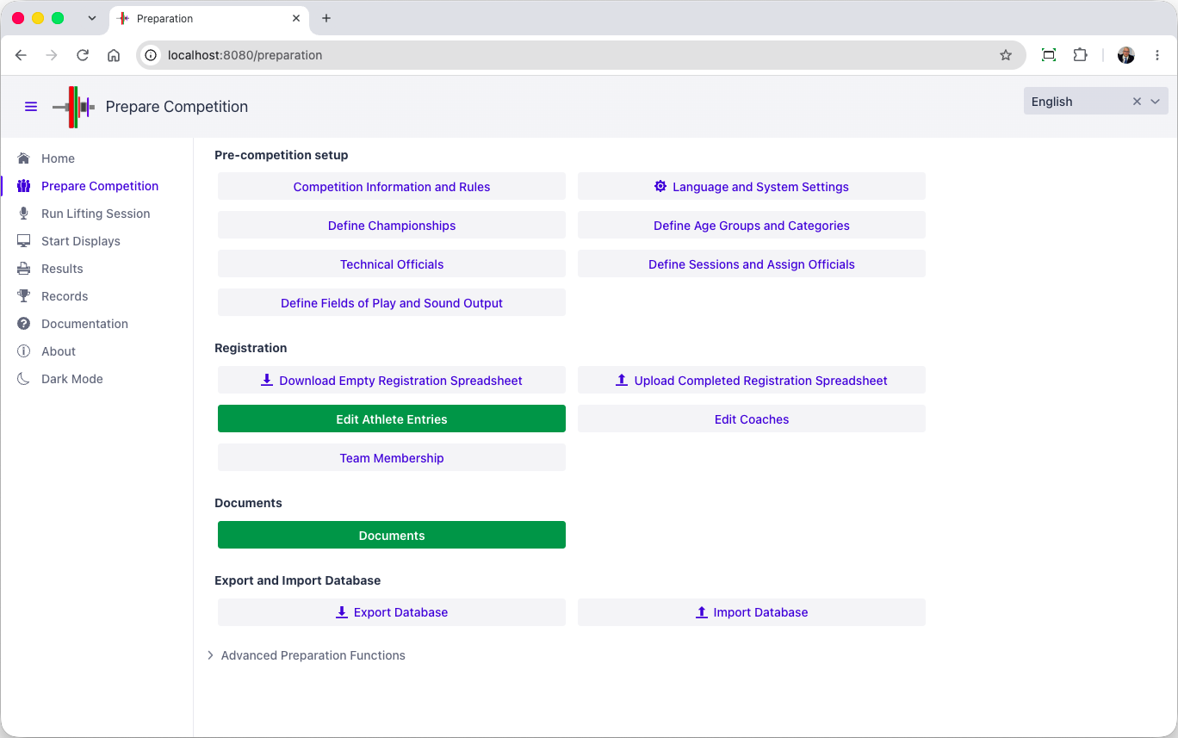

Competition Rules
The first tab concerns competition information and which federation homologates it.
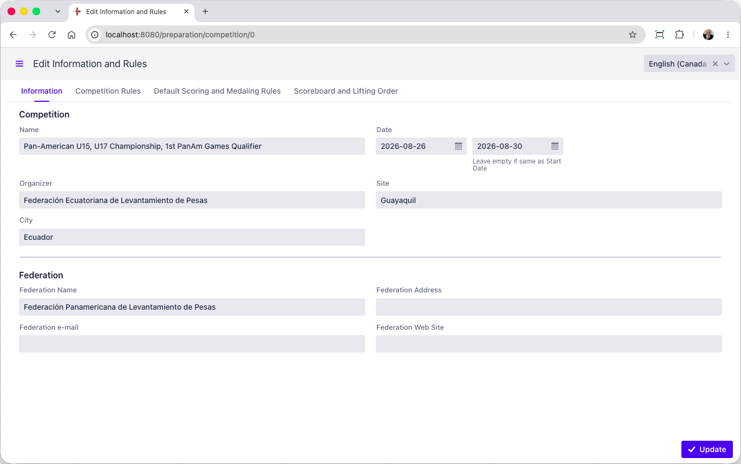
Other Tabs contain the default rules for the meet, for example, what medals are given, how best athletes are determined, how team points are given, etc.
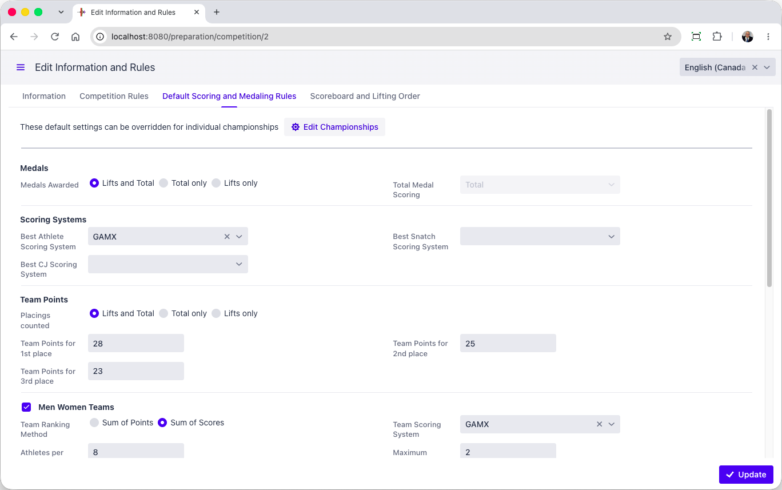
OWLCMS can also be used for local, national, regional and continental championships that have historical variations with full IWF rules. The other tabs include all these options. The defaults comply with TCRR but acquiring organizations would nevertheless be able to use their licenses in different settings.

Lots/groups/timetable
[RFP §4.3] At minimum, the TIS shall provide lots/groups/timetable.
For an IWF event, it is expected that a spreadsheet or CSV format of registration data will be available. This format is then converted to the OWLCMS format that contains the expected information, including athlete identifiers.
The OWLCMS registration format also includes a sheet to define the schedule. In this way, the initial schedule and session assignment can be done in a spreadsheet using whatever means the organisers are comfortable with.
[Supplier] has its own software for creating such initial schedules and session/group assignments
OWLCMS then loads the registration data and validates it. OWLCMS can re-export registration data and adjustments can be made on the export, and re-loaded. Such round-trips can be made until satifsfactory. Once stable the registration data is editable directly in the application.
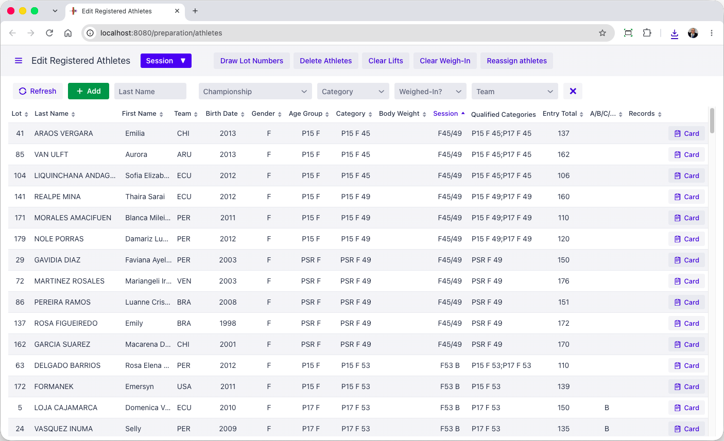
The registration screen allows modification of the allocated session, moving the athlete to another group, adjusting eligibility to multiple age groups as appropriate.
The other tabs on the registration form cover things like record eligibility (in joint jurisdiction championships, not all athletes are eligible to improve all records)
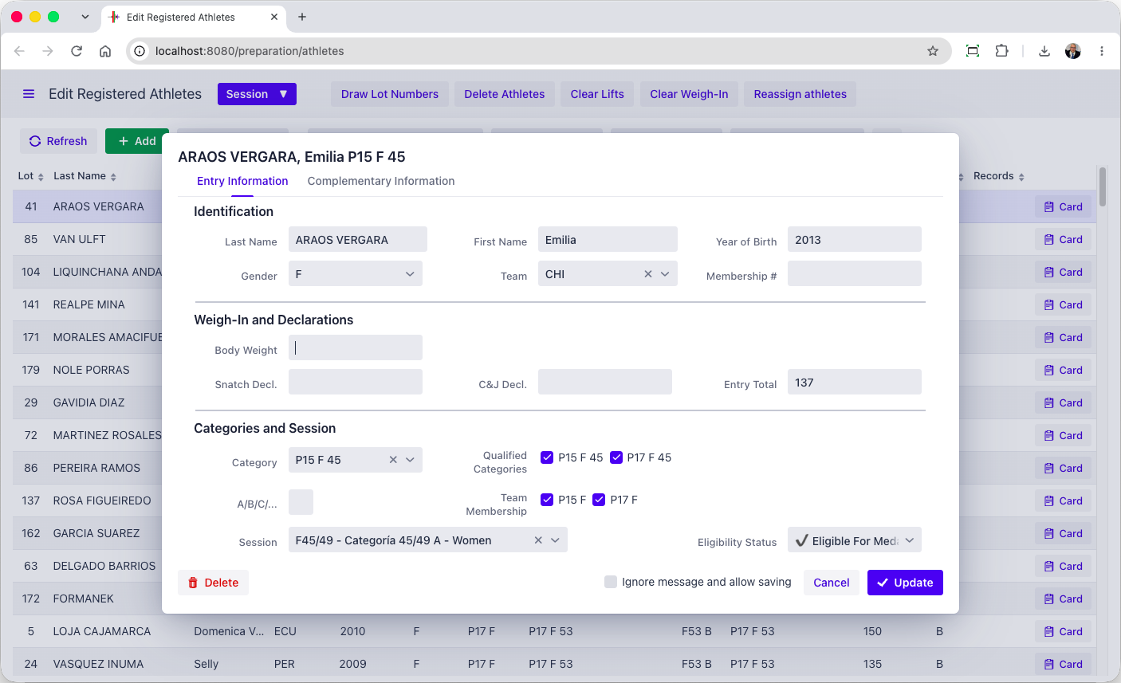
The session timetable is editable.
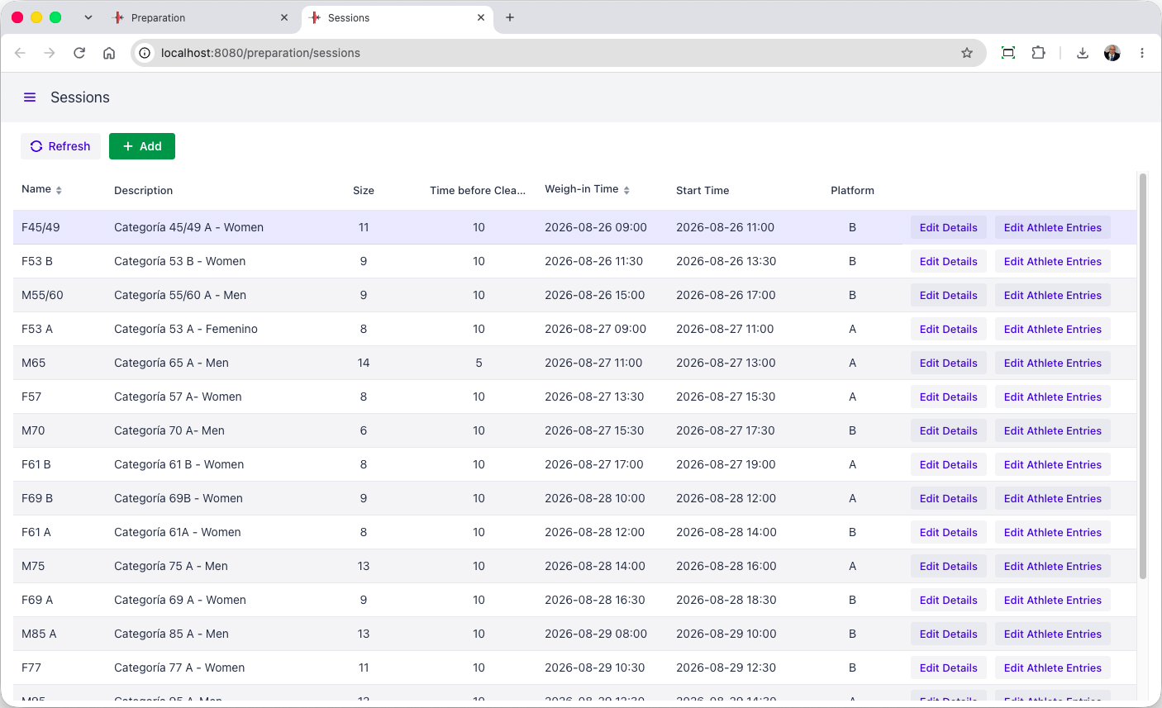

Assignments of Technical Officials
Add Timetable screen herekjjk
Adjustments to individual TO assignments can be done from here after the initial TO teams have been assigned.
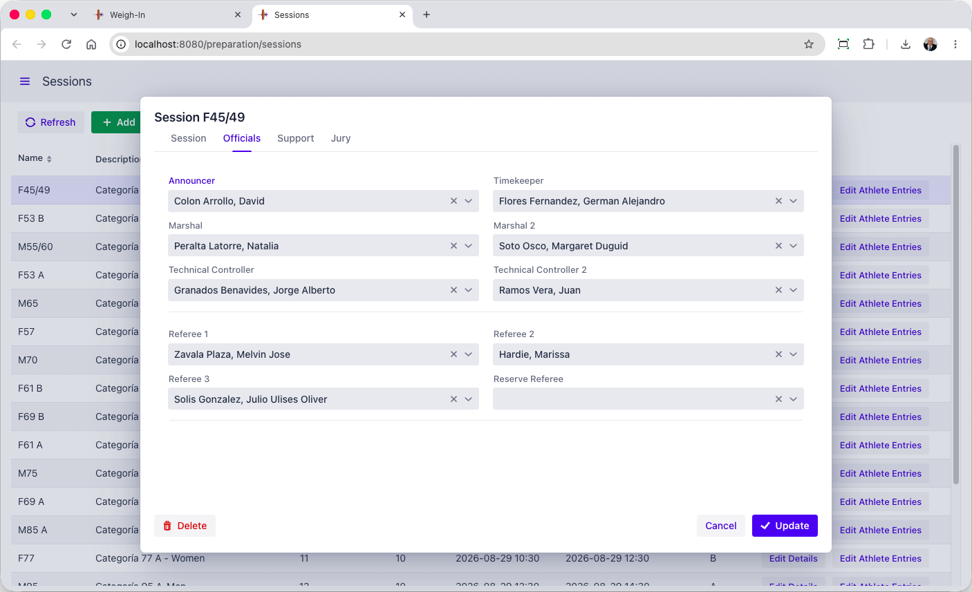

Document Production
After registration and VFE, the relevant documents can be printed, such as the athlete cards and weigh-in forms. Documents are produced in Excel, and can therefore be easily converted to PDF if needed. All the necessary documents are available (see the Documents section further down)
Groups of documents used together can also be created as one set (for example, the weigh-in sheet and the athlete cards), for one or more session (for example, for the next day).
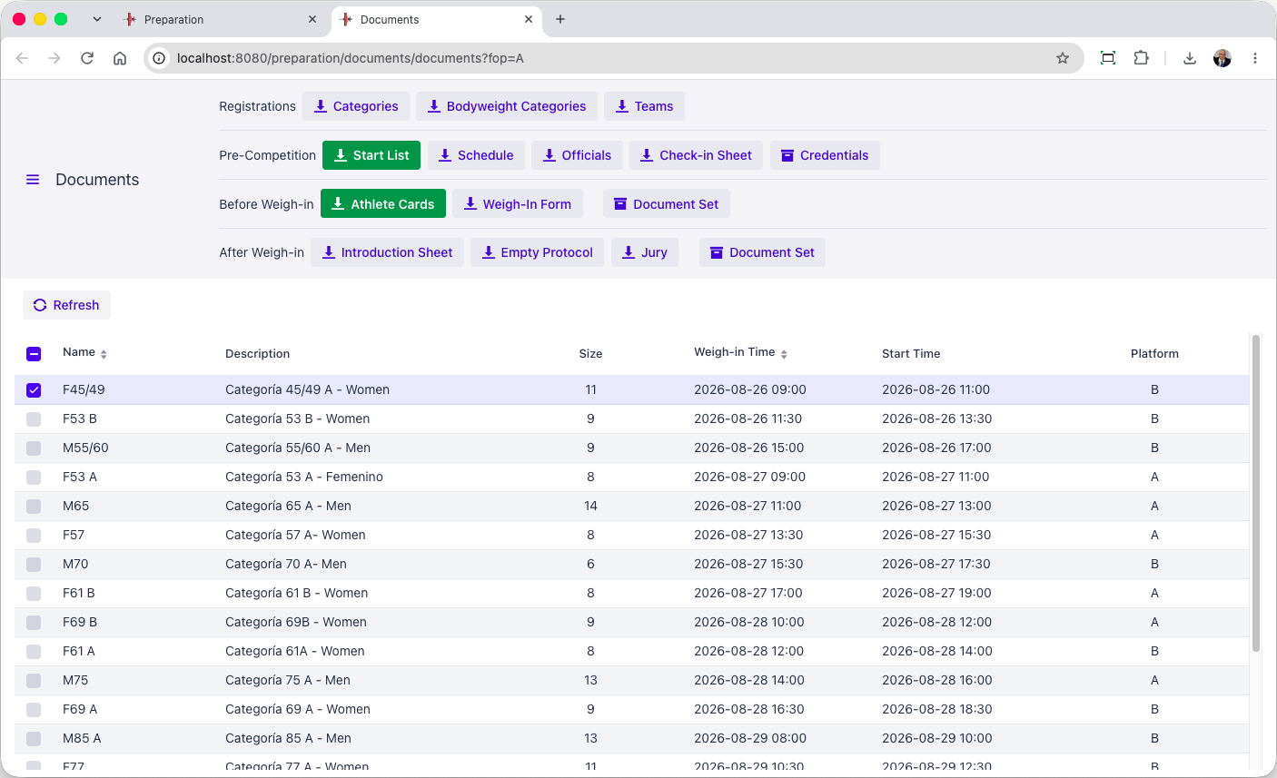

Weigh-in
[RFP §4.3] At minimum, the TIS shall provide Weigh-in.
The weigh-in data entry form is intentionally the same format as the registration form. All relevant checks for the 20 kg rule are applied at data entry, in case they were missed by the weigh-in Tos.
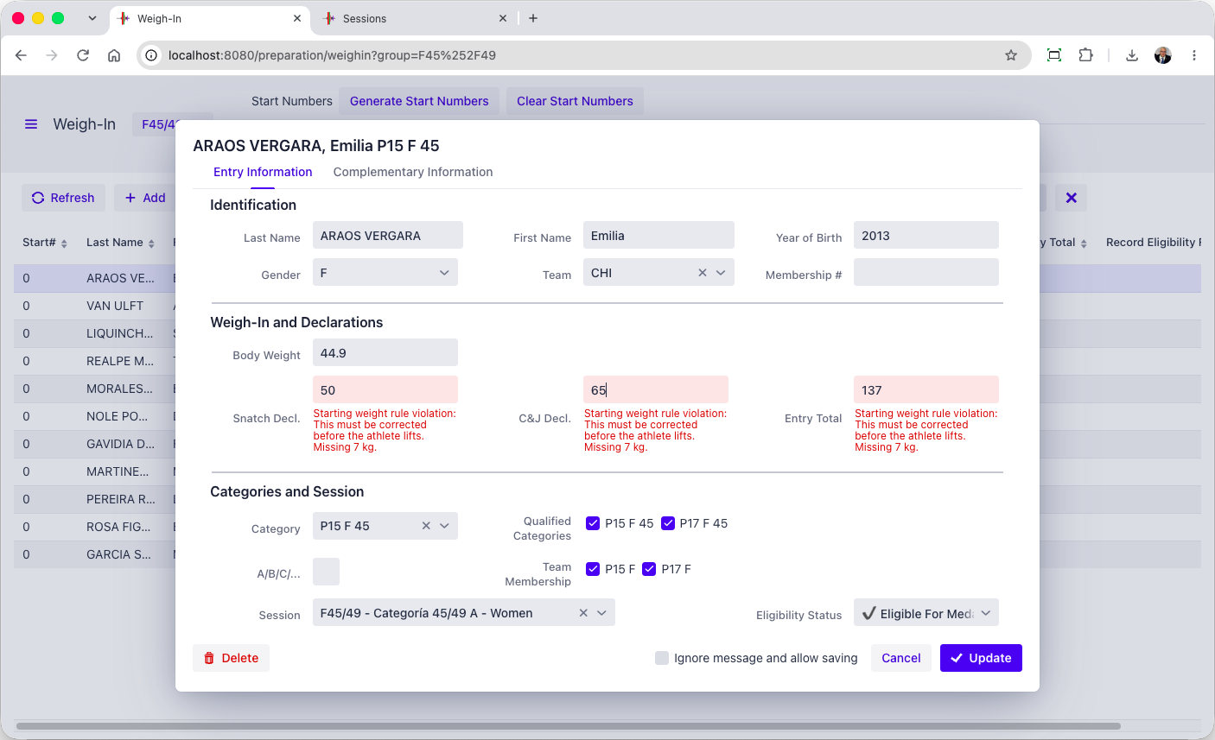
After weigh-in, the page allows the creation of all the relevant forms for the speaker and for the jury.
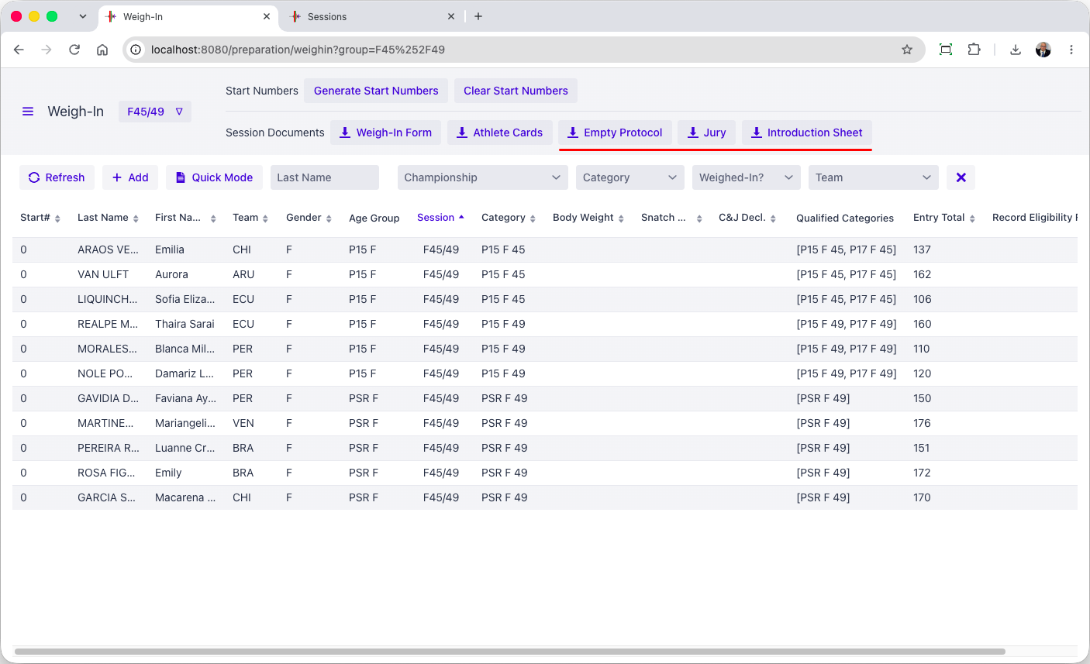

Chief Marshal
[RFP §4.3] At minimum, the TIS shall provide Chief Marshal.
The marshal table has a station that shows all athletes in start order (or lifting order if so preferred). Clicking an athlete brings up a card laid out exactly like the athlete card. Focus is automatically brought to the right cell, so typing the desired value and hitting Enter works immediately for fast data entry.
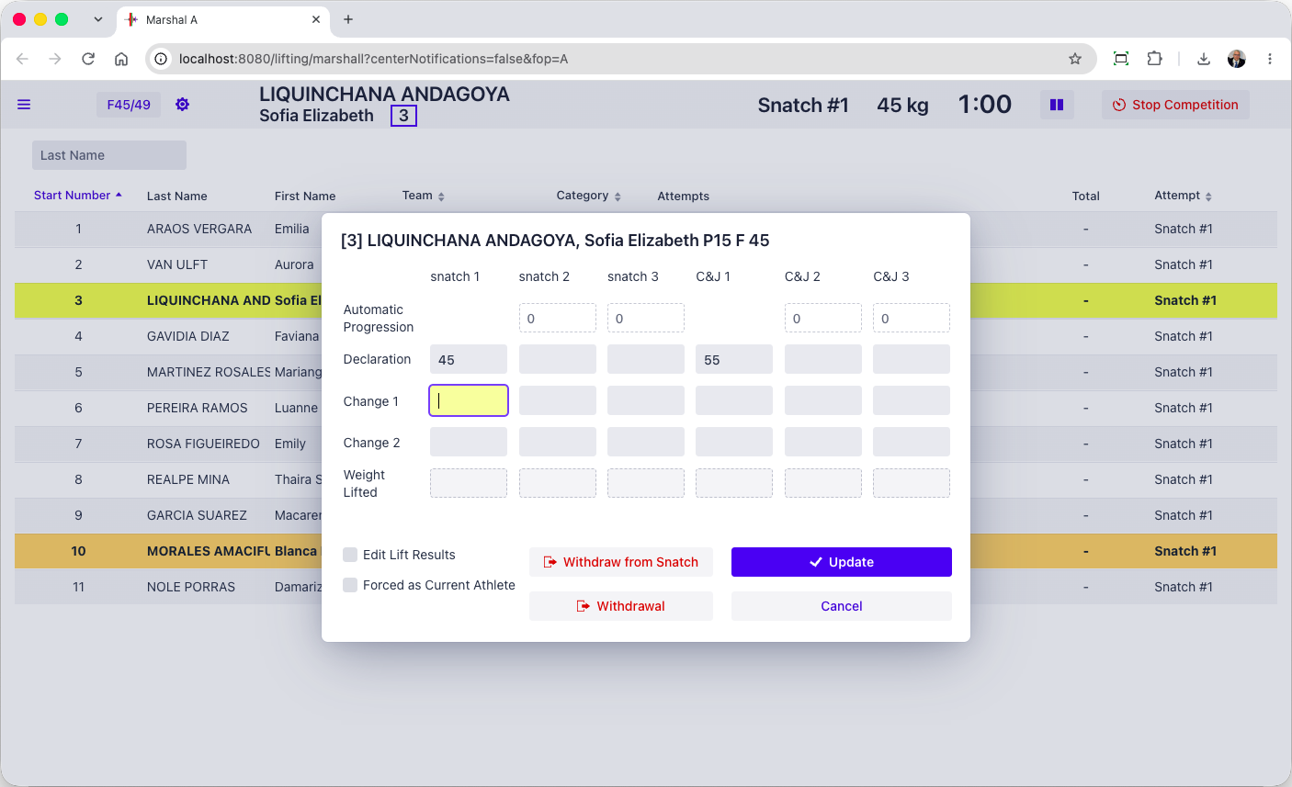
20kg rule violations and late changes are immediately made visible and prevent the card from closing.
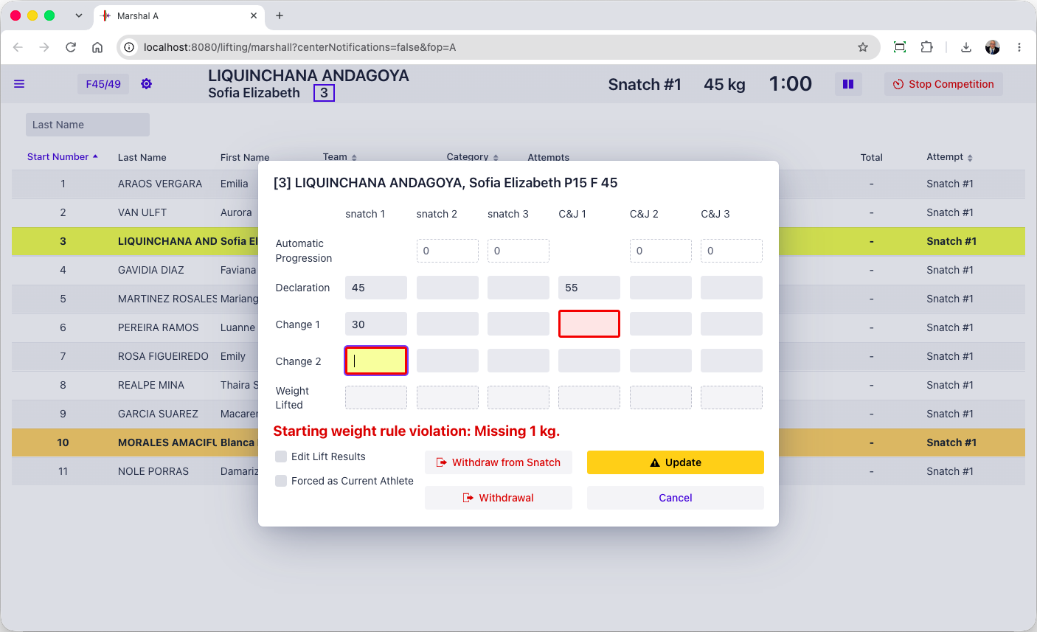

Timekeeper
[RFP §4.3] At minimum, the TIS shall provide Timekeeper.
During the competition a tablet-friendly display is used, that can be used together with the Blue Owl buttons, as preferred.
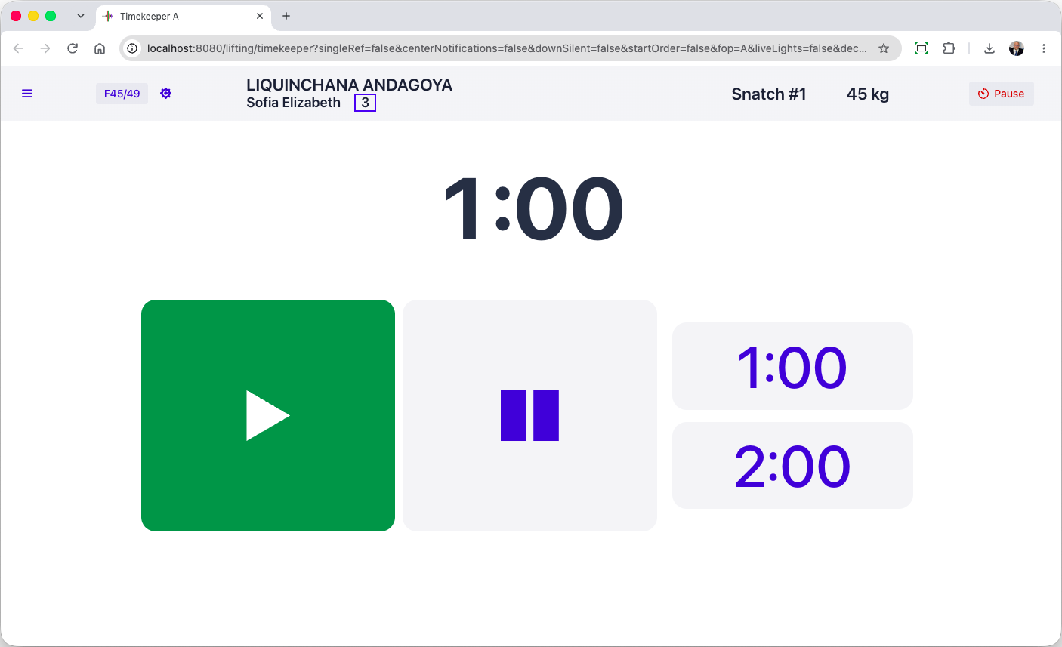
The timekeeper can control the breaks (in addition to the main technical table or the speaker having the same feature depending on the skill and comfort levels). The delay can be set to a clock or duration as relevant for the type of break.
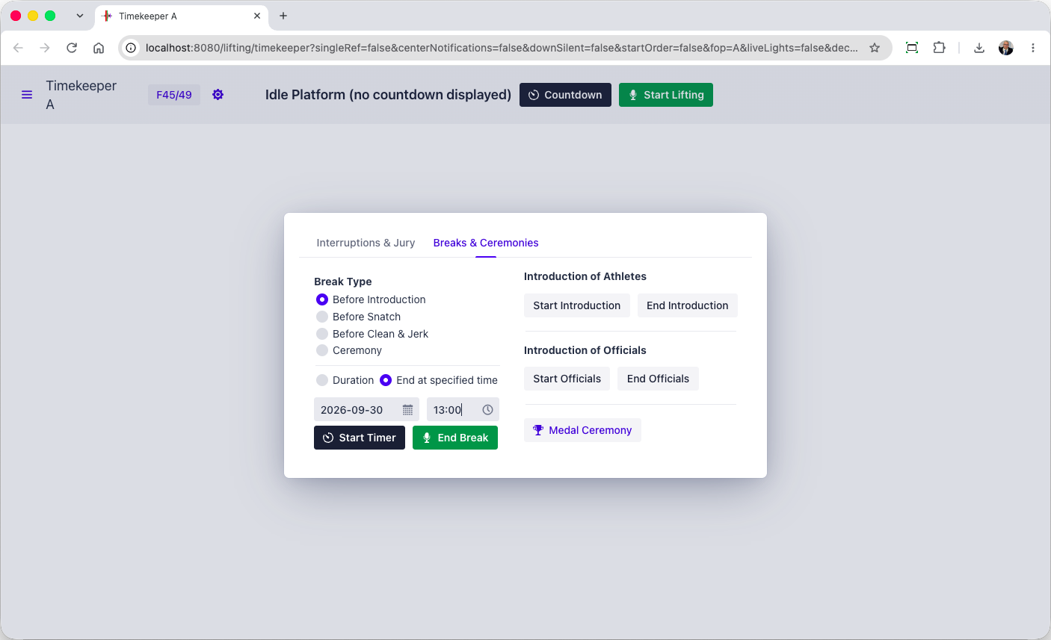

Speaker
In OWLCMS, a speaker page shows athletes in lifting order and displays all relevant notifications. This makes it much easier for the speaker, who does not have to interpret in real time what is shown on the scoreboard.
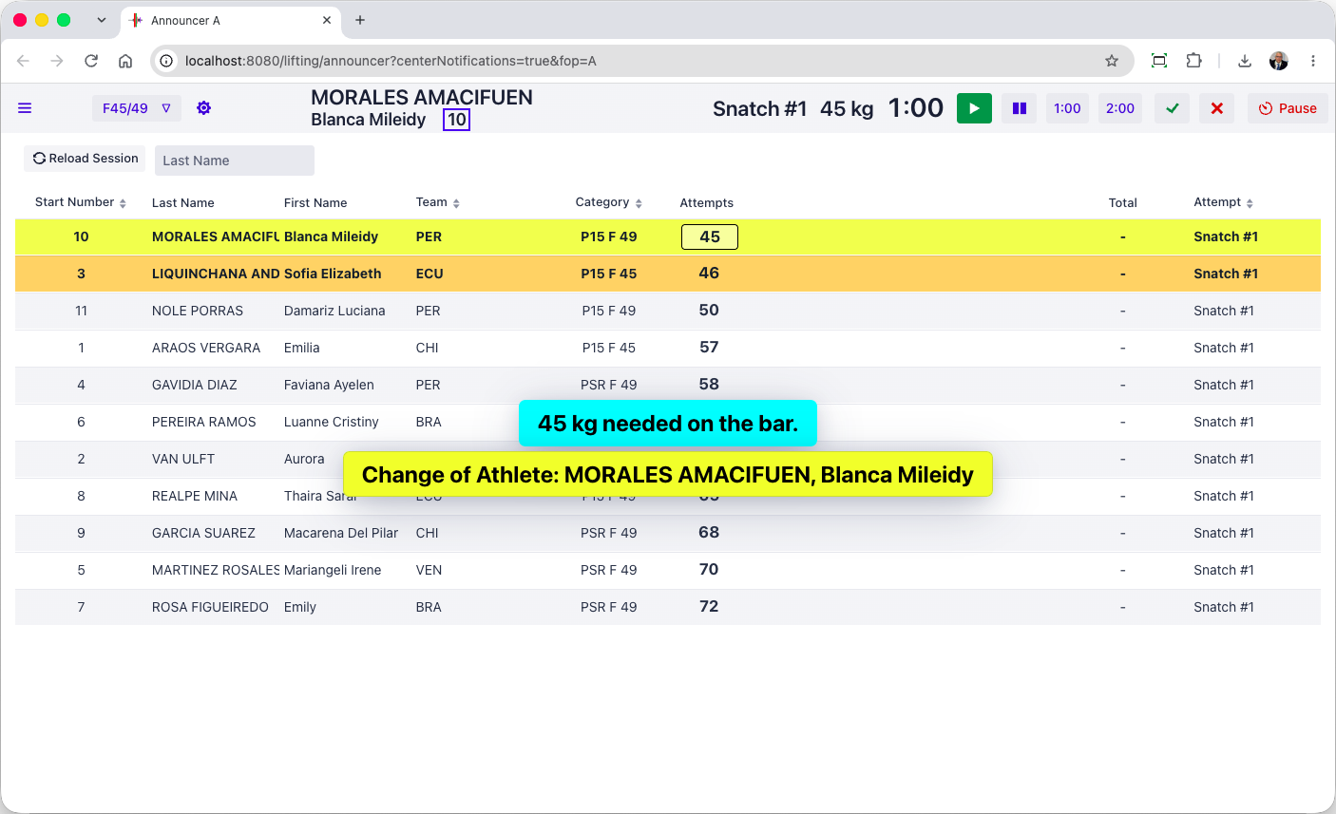

Competition supervisor
[RFP §4.3] At minimum, the TIS shall provide Competition supervisor.
The competition supervisor screen is the as the speaker, with the addition of the decision lights that can be seen live as an option. This is because the switches between sessions, and breaks, and lift overrides after a late referee flag call can all be done from that screen. Depending on competitions, the speaker screen will be made “passive” if the technical table assumes those tasks instead of an ITO1 comfortable with technology.
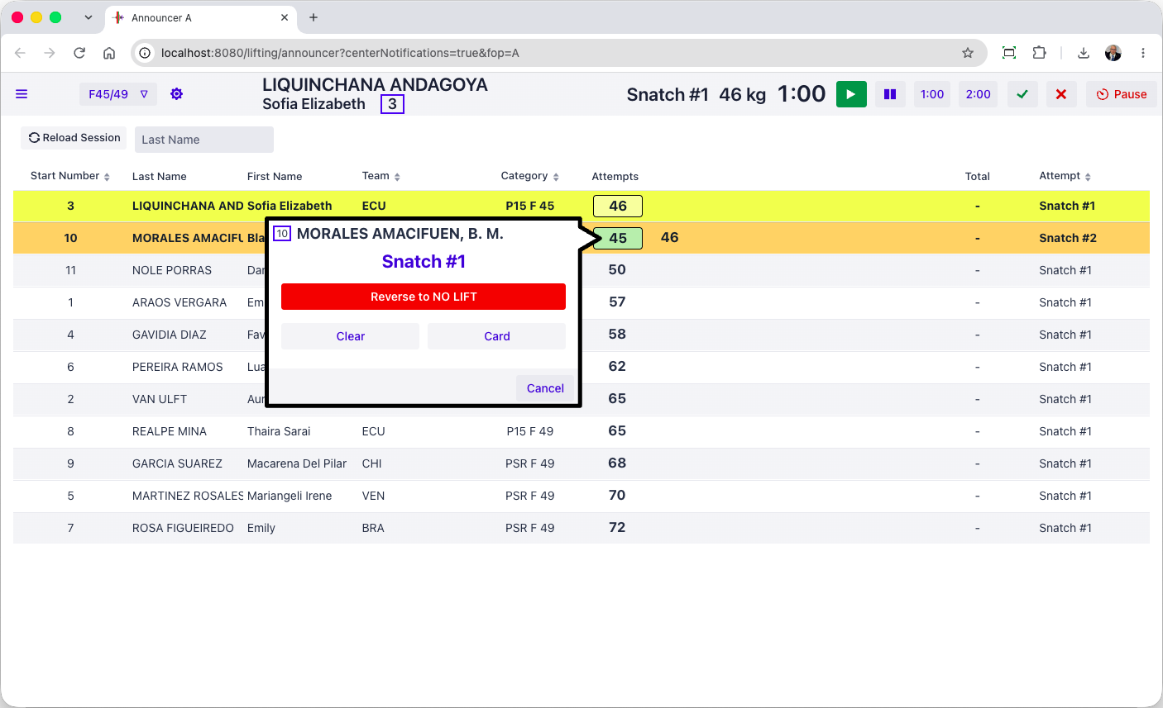
In addition, OWLCMS is launched from a control panel that gives additional options such as viewing the technical log going live. The competition supervisor can watch the competition-level audit log as it is written.
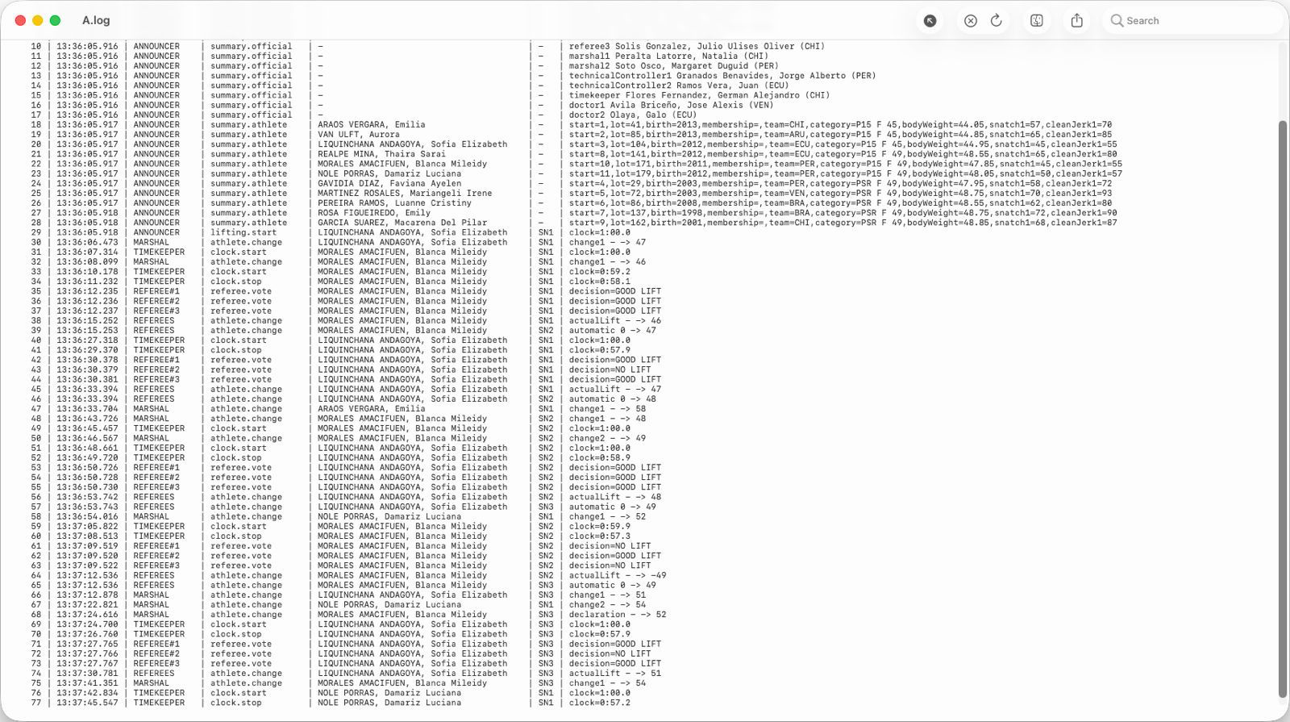

Referee monitoring
[RFP §4.3] At minimum, the TIS shall provide Referee monitoring.
The competition director screen can see the live referee lights, as does the jury. The audit log shows each individual decision, and each weight change from the marshals.

Jury control
[RFP §4.3] At minimum, the TIS shall provide Jury control.
The jury control can be done entirely using a Blue Owl jury control keypad
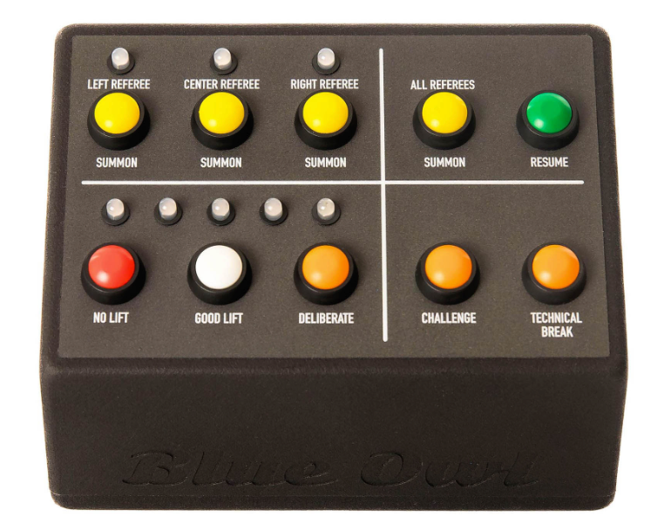
In the context of an IWF meet, it becomes desirable to accelerate the transfer of decisions from the jury to the speaker. To this effect, a tablet-style jury display is available that has the same features as the keypad
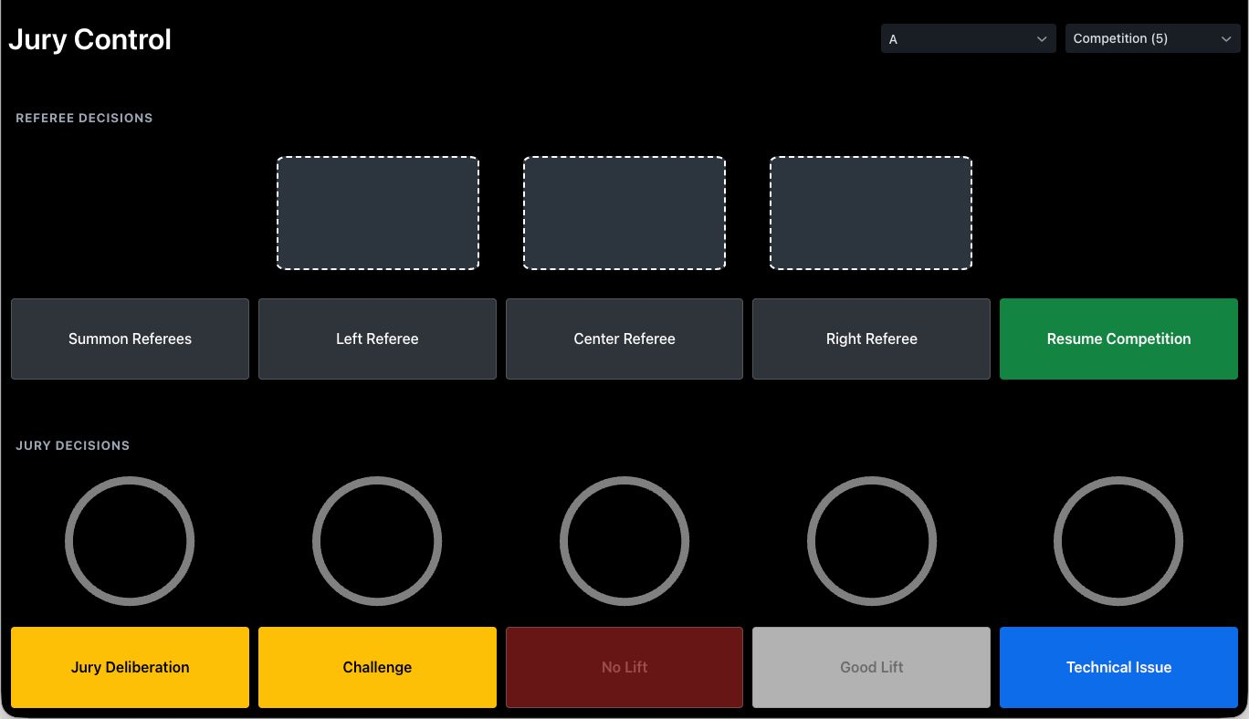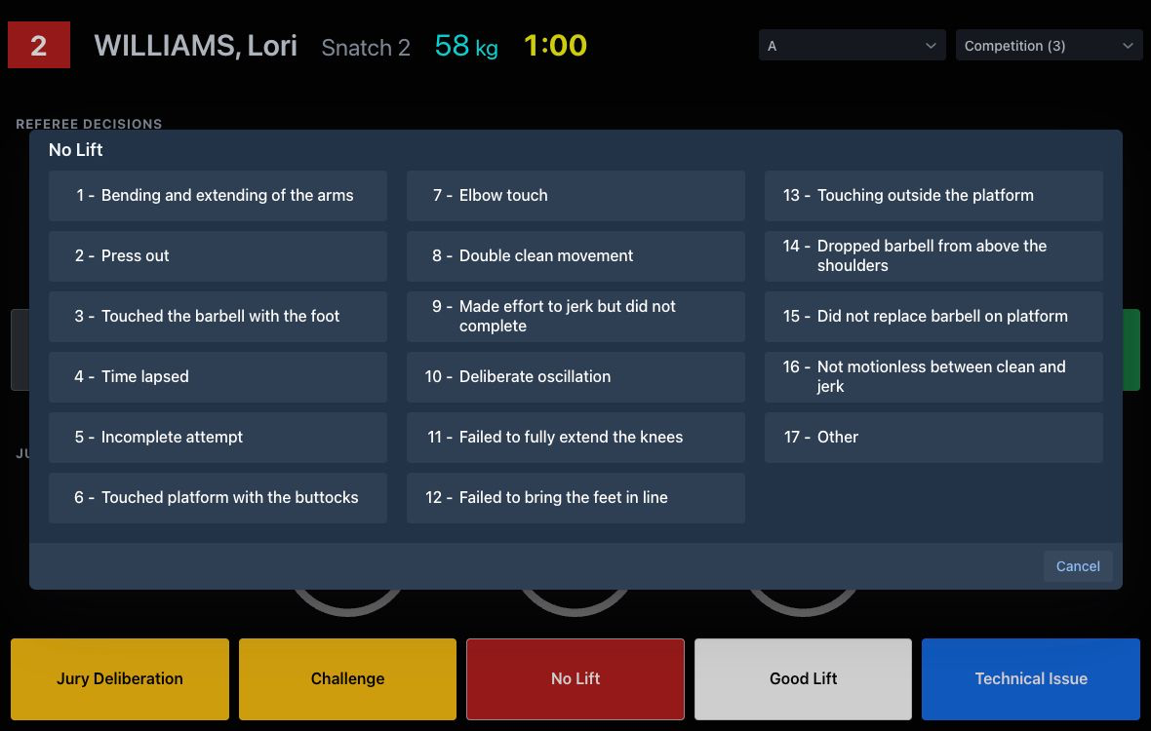
When this is used, the Speaker and Competition Supervisor screens get the reason immediately, and can resume the competition after announcing it.

Attempt boards
[RFP §4.3] At minimum, the TIS shall provide Attempt boards.
Attempt boards show all the information required by TCRR. They can also display the flag of the country. If one or more record attempts take place the attempt boards show it as a rolling banner.
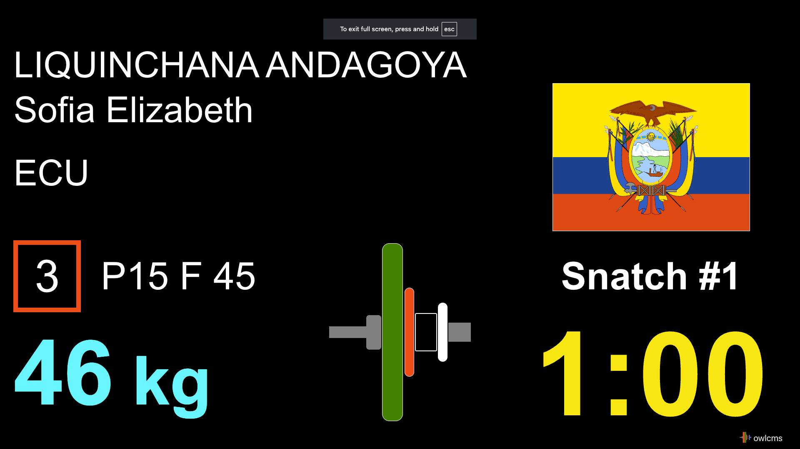

Scoreboards
[RFP §4.3] At minimum, the TIS shall provide Scoreboards.
Scoreboards contain all the requisite information. In addition, the top line contains the current attempt.
The bottom line contains additional information, such as the various championships, rank if successful, jury decisions etc.). This is the warmup room layout, that does not change during ceremonies so coaches can count attempts.
Scoreboard during session with previous leaders

In the main room, styling will be applied as required by the event, and the top row is used as a banner. A row at the bottom carries will carry the clock and other attempt information.
Main Room Scoreboard with previous leaders

Full-fledged video production companies can replace this scoreboard and the TV Graphics by using the extension capabilities provided by OWLCMS. The extension protocol is documented with a reference implementation at https://github.com/owlcms/tracker-core .

RTDS/warm-up
[RFP §4.3] At minimum, the TIS shall provide RTDS/warm-up.
In OWLCMS all the screens are RTDS (Real-time Display System)
When decisions are given, they are shown both on the attempt board and on the scoreboards.
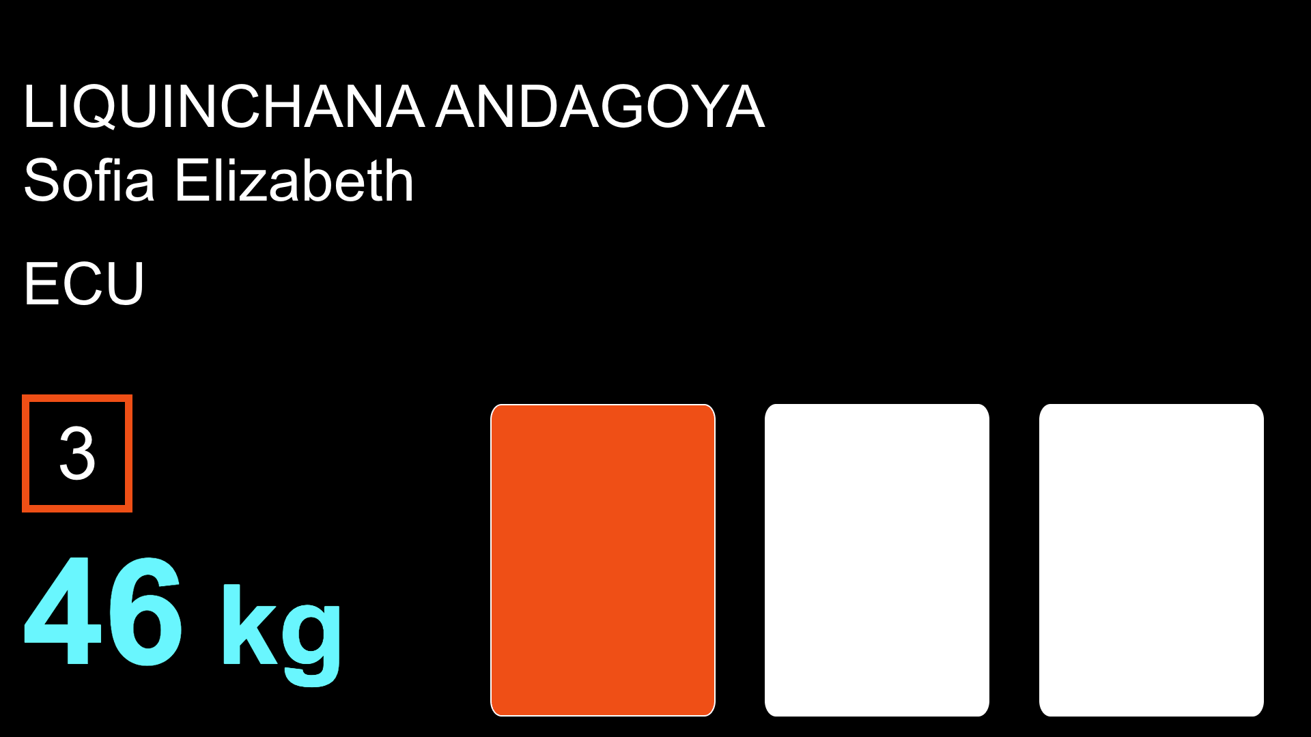
If jury decisions are being shown, these appear as well. The bottom line then shows the athlete under review, whereas the top line shows the athlete getting ready (whose clock is not running).
Jury Decision for current athlete

STOP
[RFP §4.3] At minimum, the TIS shall provide STOP.
During deliberation, challenge, technical issue or other stoppage, the reason is shown
Flashing Stop

Records
[RFP §4.3] At minimum, the TIS shall provide Records.
Record Attempt Attempt Board
Record Attempt Scoreboard

Results
[RFP §4.3] At minimum, the TIS shall provide Results.
End of session rankings with medals

Other approved states
[RFP §4.3] At minimum, the TIS shall provide Other approved states.
OWLCMS can provide additional scoreboards for team competitions, for example, mixed team championships with GAMX scoring.

Official outputs

Start Lists
[RFP §4.4] At minimum, the TIS shall provide Start Lists.
A Start List is provided. Several formats can be provided, depending on whether the competition is on one or more platforms.
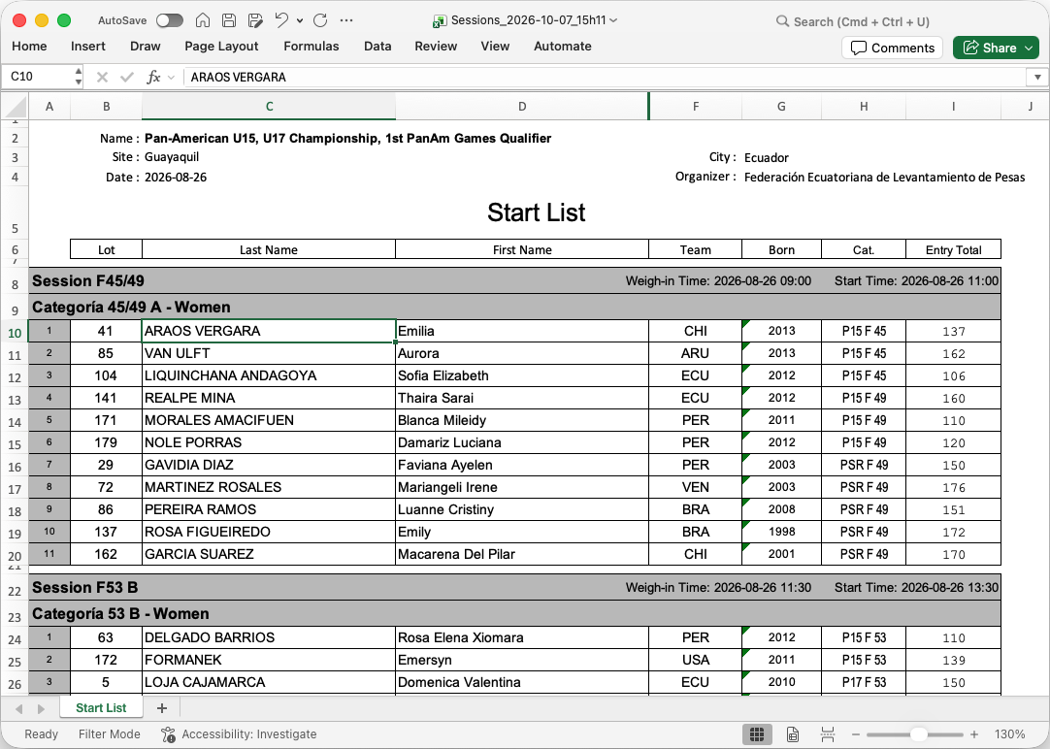

Start List Package
[RFP §4.4] At minimum, the TIS shall provide Start List Package.
The Start List Package is expanded to include documents used at VFE.

VFE Documents
The program provides a VFE form that allows each team to verify that all athletes are registered in the correct category and highlights deviations from rules. In this example, too many athletes are in the same bodyweight category. The sheets can be printed in advance and changes made on this sheet, countersigned by the team delegate.
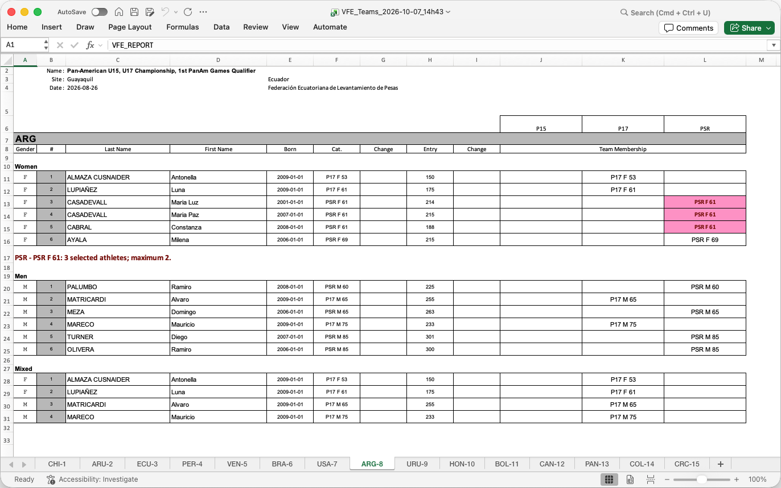

Start Book
OWLCMS can produce a full start book with all required contents, fully formatted.
As examples, technical official teams, a participation summary for a multi-age group championship, a start list for a session, with the records section. All other sections are present (schedule, time tables, full record tables, etc.) and are omitted here for brevity.
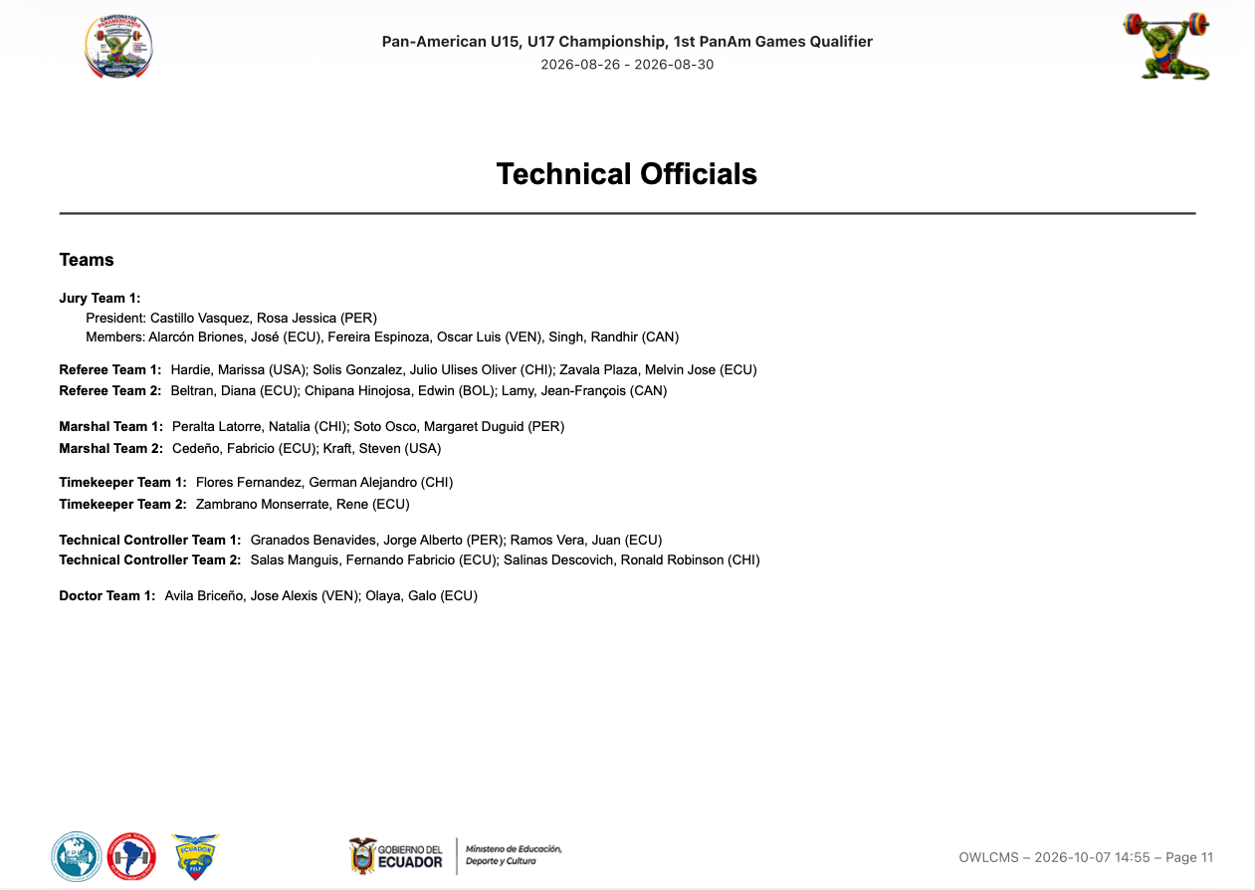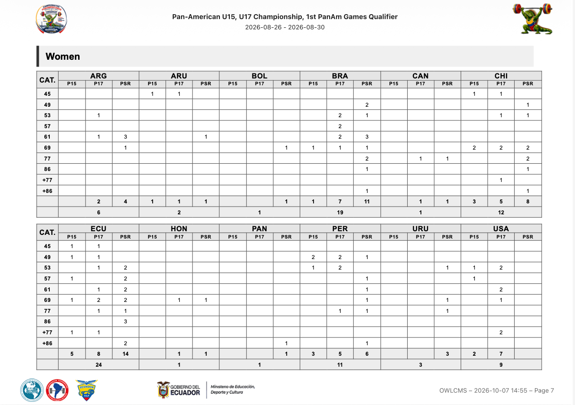
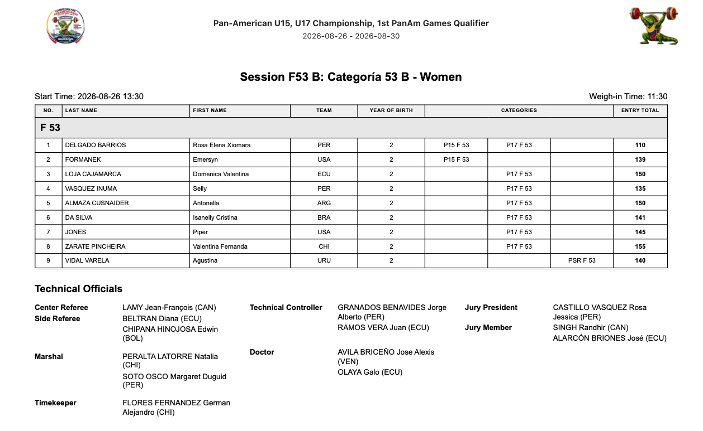
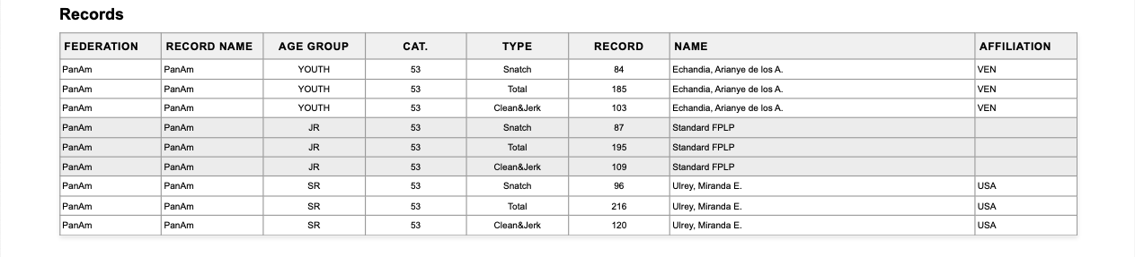

Weigh-in List
[RFP §4.4] At minimum, the TIS shall provide Weigh-in List.
The weigh-in list allows capturing both the weight-on-scale and the adjusted weights. Signature areas for the attending officials are provided
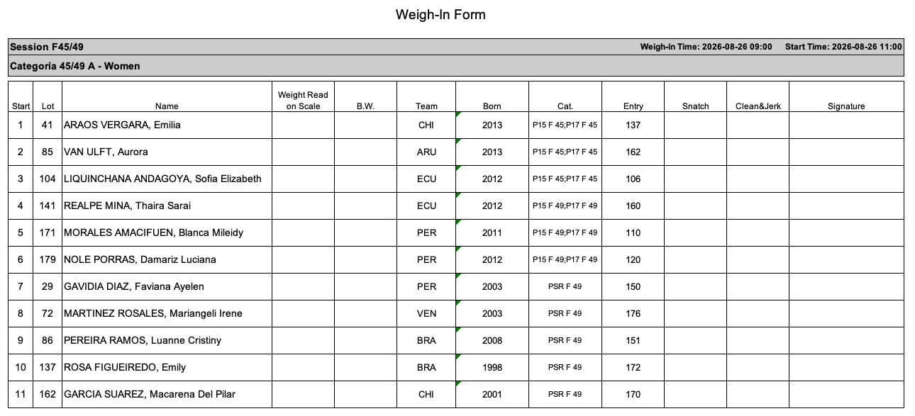

Athlete's Cards
[RFP §4.4] At minimum, the TIS shall provide Athlete's Cards.
Athlete Cards with all the required signature fields are produced.
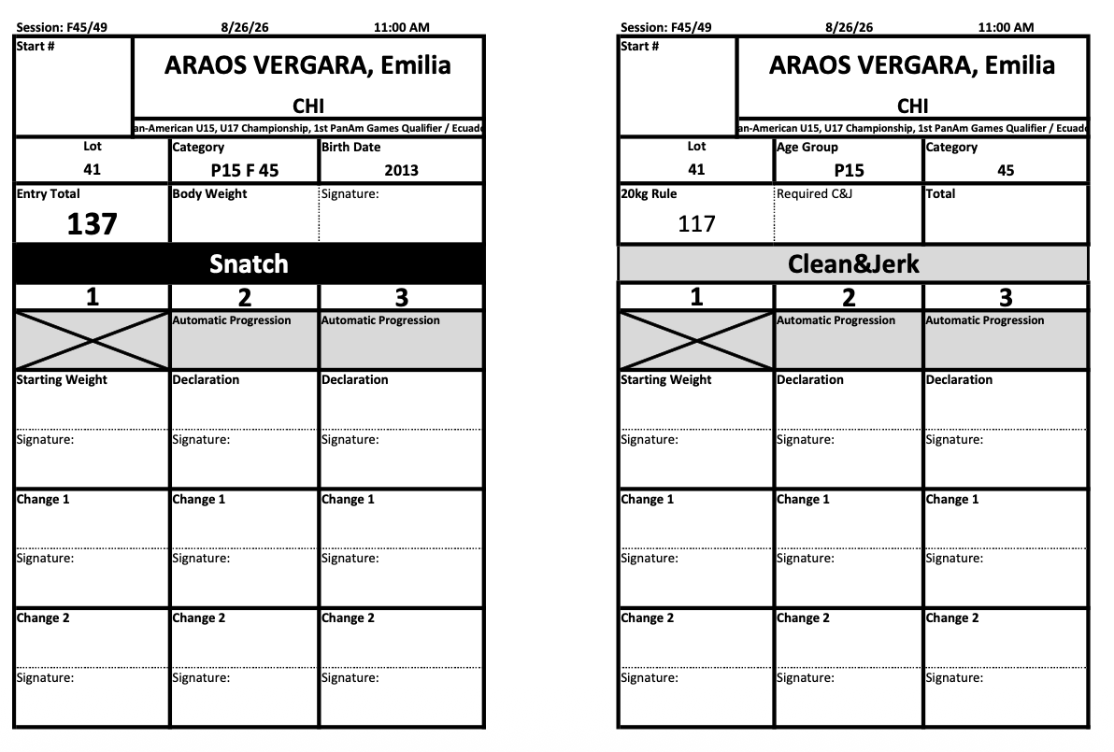

Manual Protocol
[RFP §4.4] At minimum, the TIS shall provide Manual Protocol.
An empty protocol sheet suitable for manual entry is available.
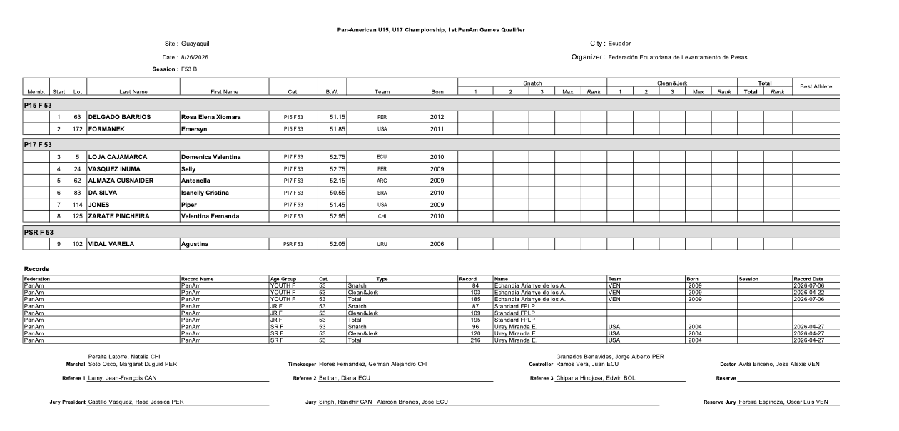

Empty Protocol
[RFP §4.4] At minimum, the TIS shall provide Empty Protocol.
In addition to the manual protocol from section E.2.4.5 the system provides an empty protocol sheet that is typically used by the jury. Bigger text boxes allow capturing the decisions according to the TCRR rules for examinations.
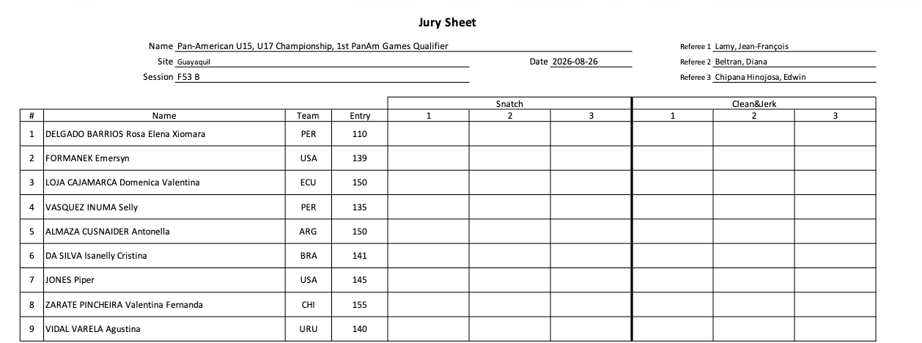
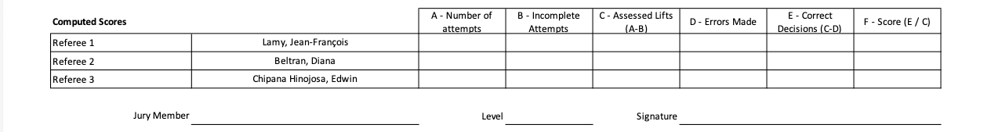

Protocol
[RFP §4.4] At minimum, the TIS shall provide Protocol.
A compliant protocol sheet is provided, including records
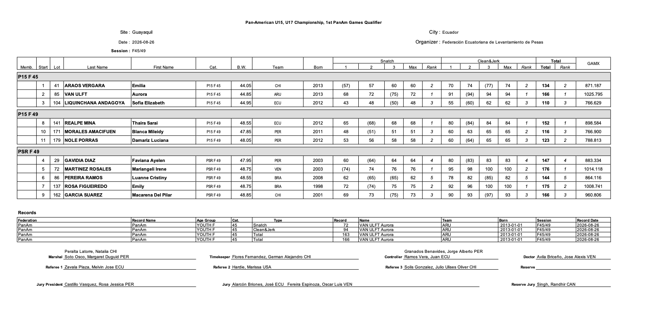

Results
[RFP §4.4] At minimum, the TIS shall provide Results.
Full competition results, per category, are available in several formats.
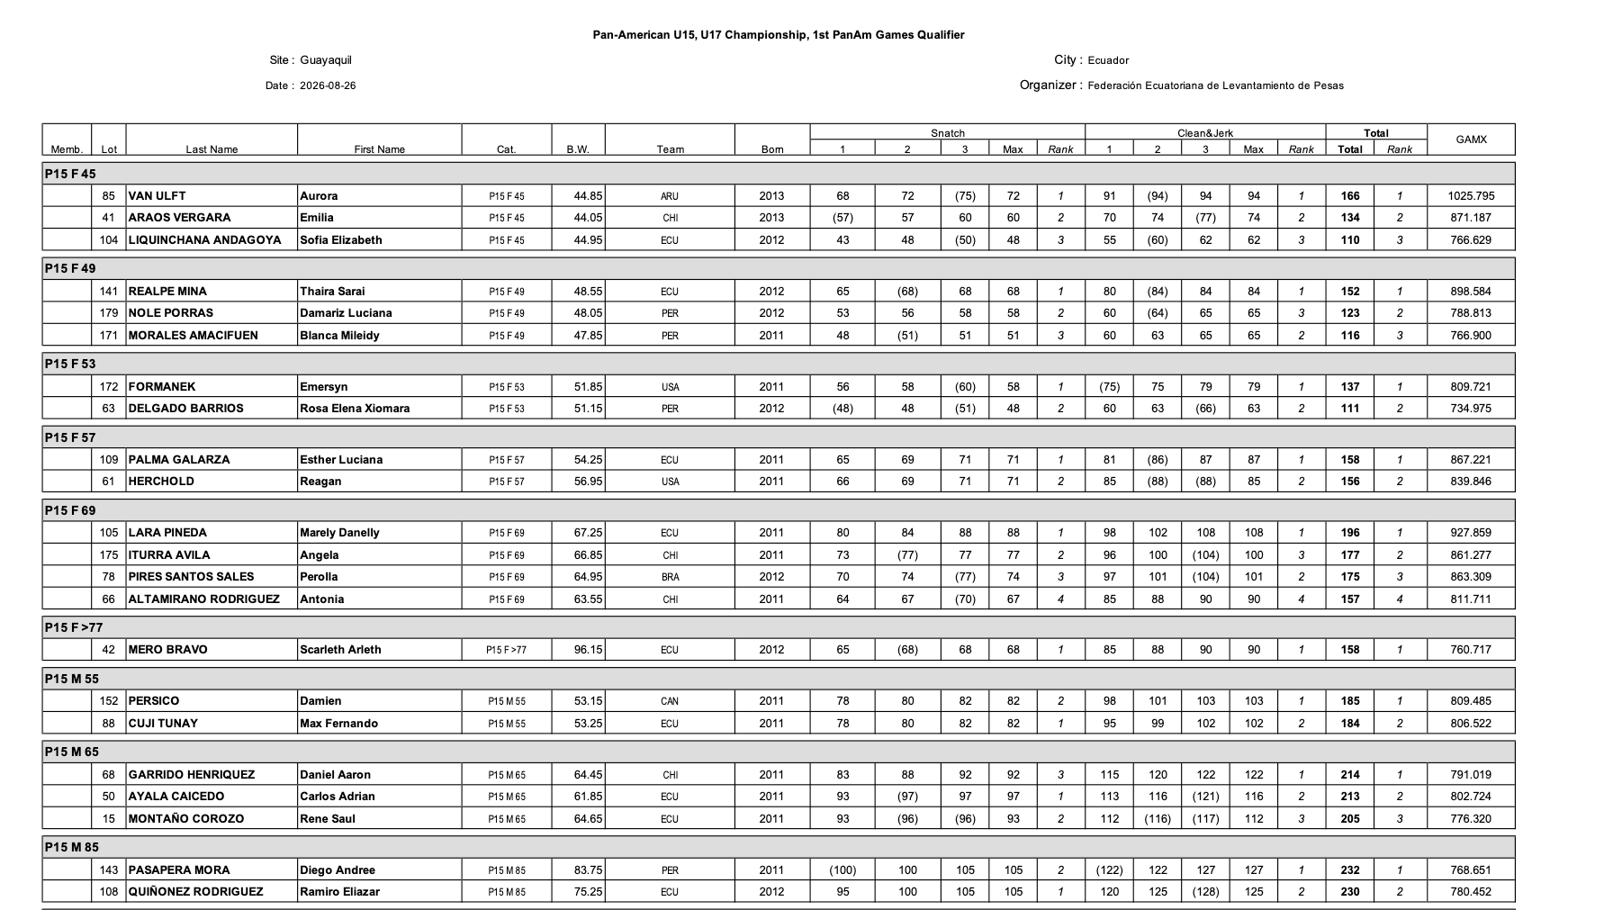
Flat-file formats, such as the one expected by IWF are also supported for easier importing.
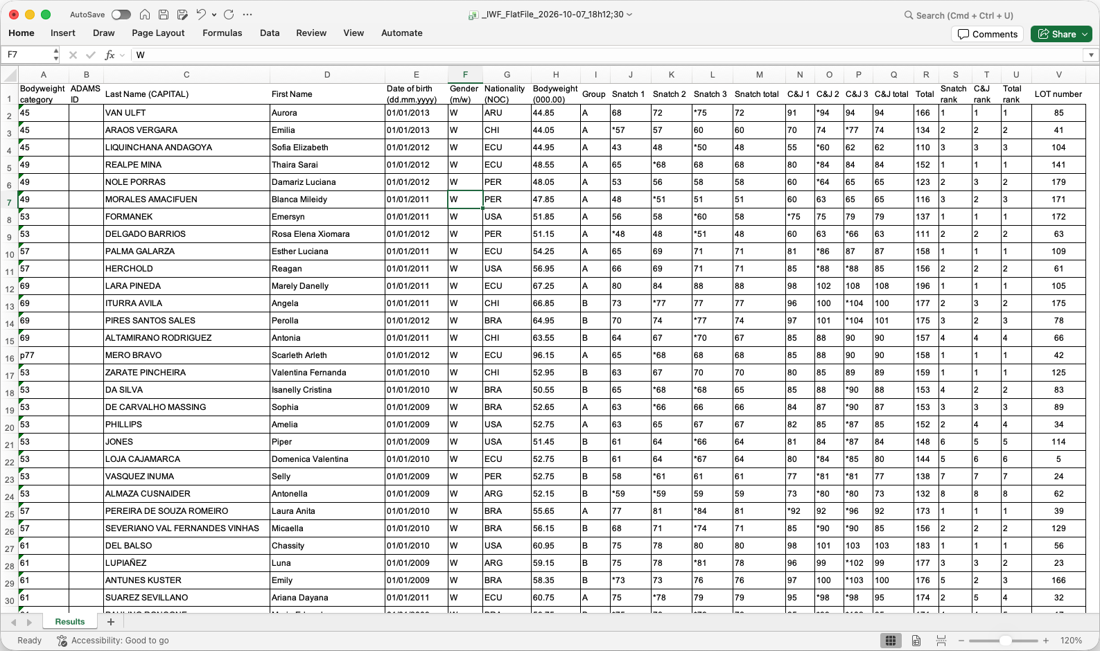

Team Classification/Placing
[RFP §4.4] At minimum, the TIS shall provide Team Classification/Placing.
The final package described in section E.2.4.11 includes a sheet with all the team classification details for IWF points, as well as medal standings. The fully formatted version of these results is present in the Results Book (see section E.2.4.12). In events with multiple concurrent championships, the classification is done per championship.
The following example is for a Youth championship.
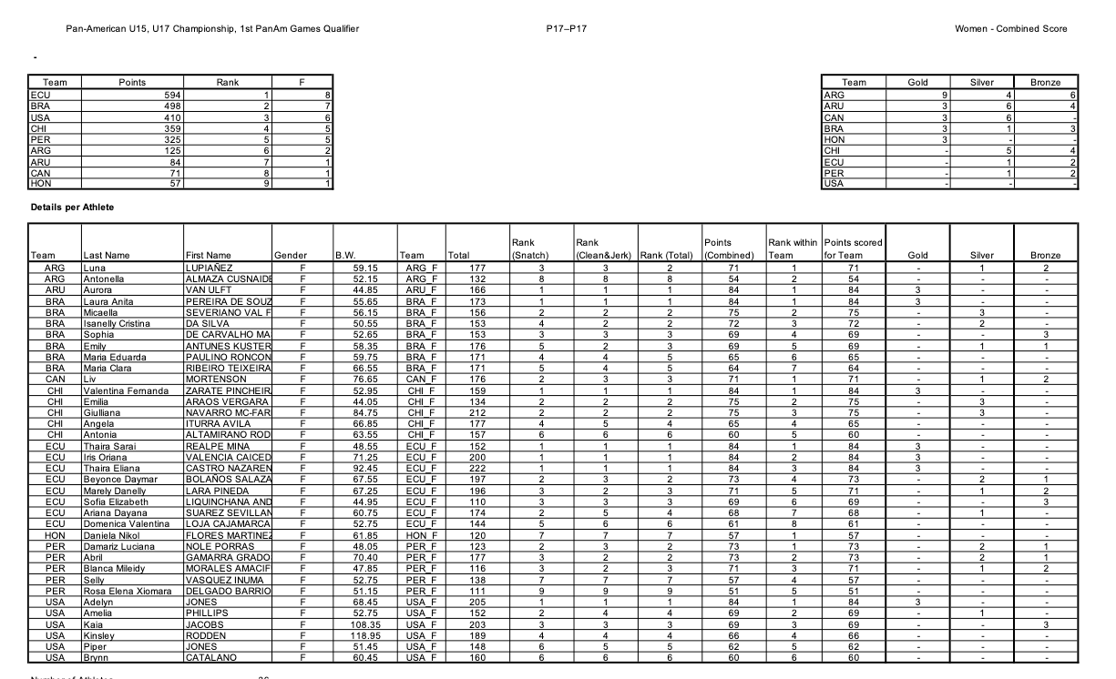
For verification purposes, all the individual athlete statistics are also included

Records
[RFP §4.4] At minimum, the TIS shall provide Records.
Records set during a competition can be visualized directly, for a given age group.
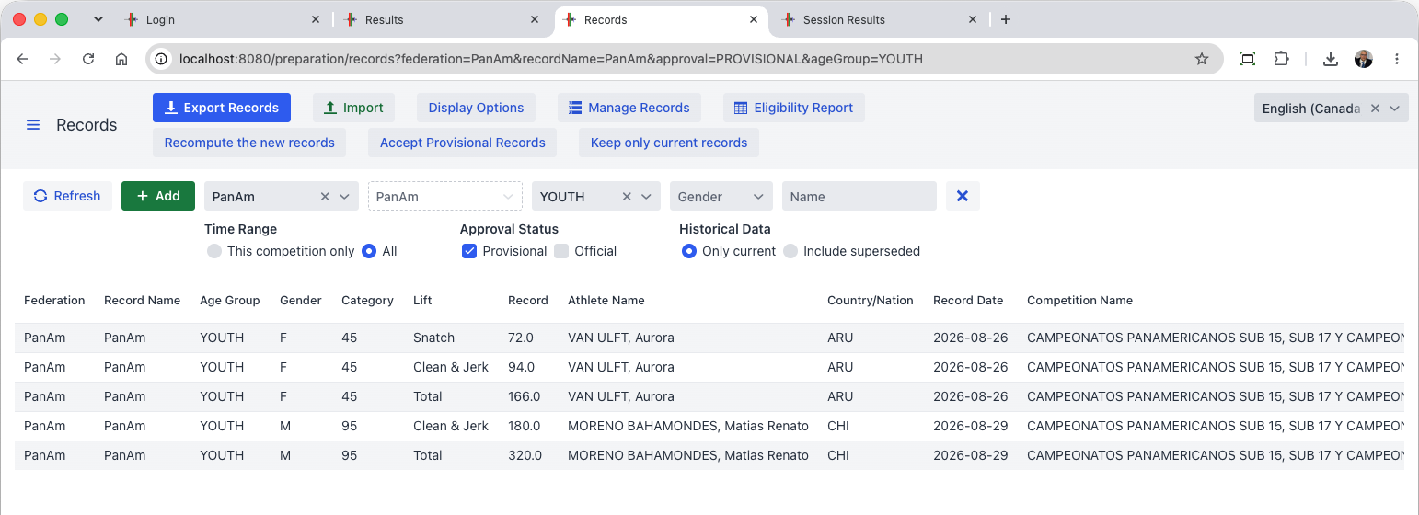
At the end of the competition, records can be exported as required (either only the new records, or an updated list with or without every improvement). Both display-oriented and flat-file formats meant for importing are provided.
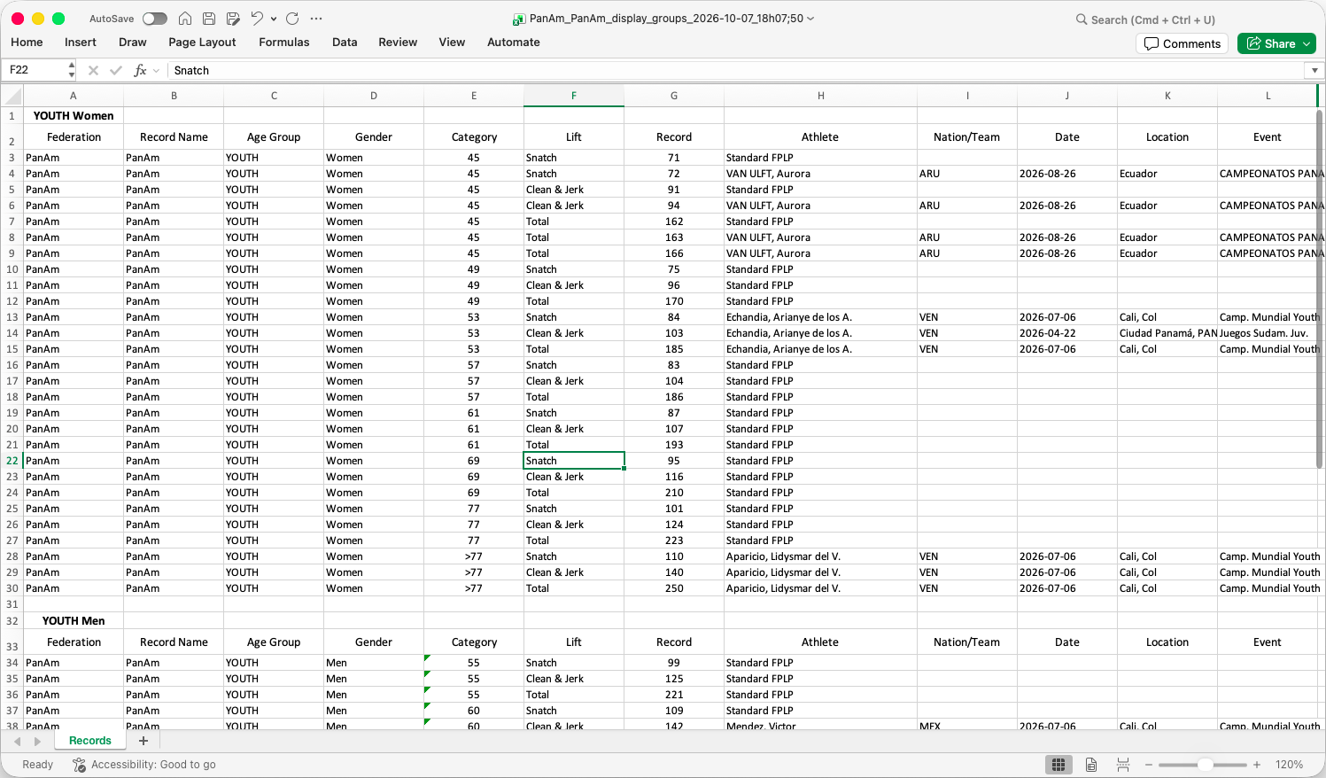

Final Results Package
[RFP §4.4] At minimum, the TIS shall provide Final Results Package.
OWLCMS produces a spreadsheet with all relevant results (per category, best athlete scores, team scores)
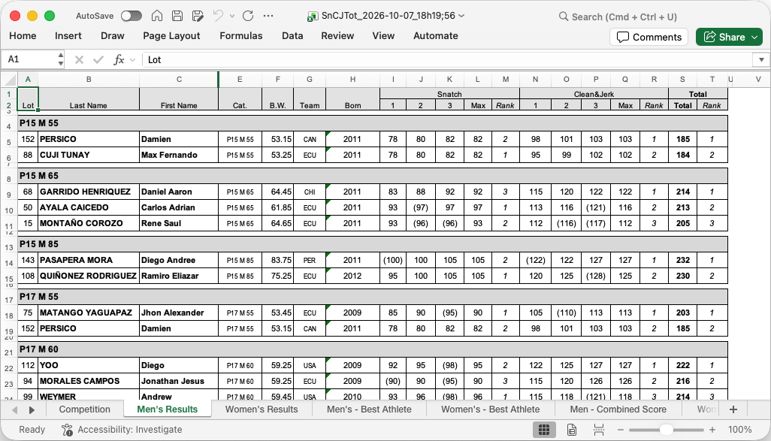

Results Book where applicable
[RFP §4.4] At minimum, the TIS shall provide Results Book where applicable.
A fully formatted results book complete with table of contentsis produced automatically with no human intervention. The following are sample pages.
Medals
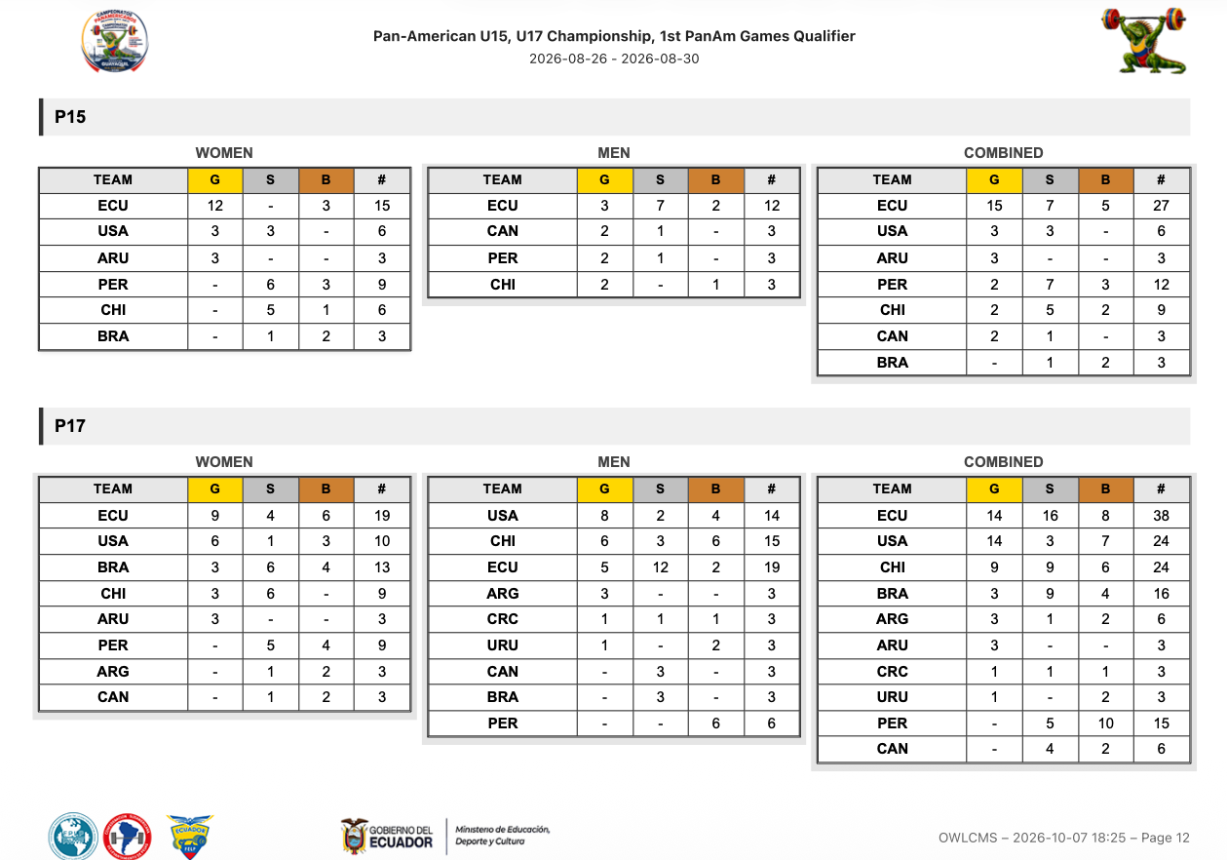
Team Points
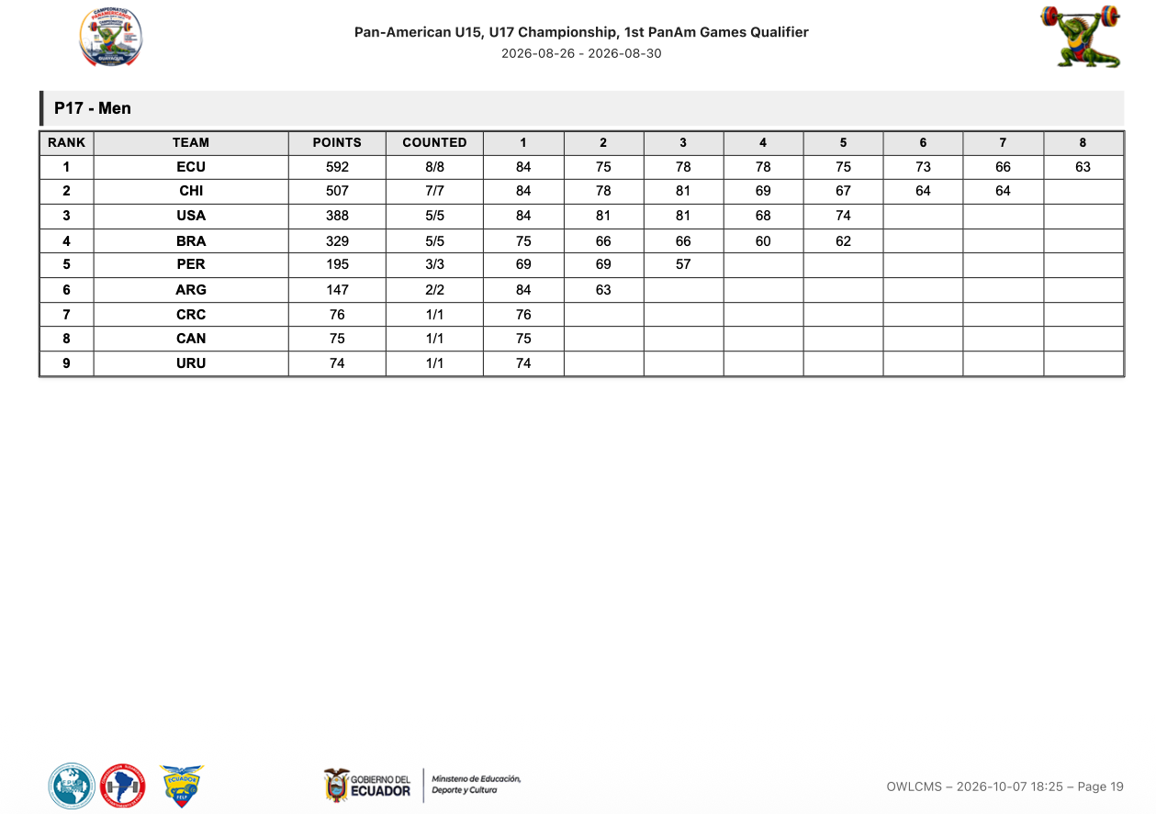
Best Athlete
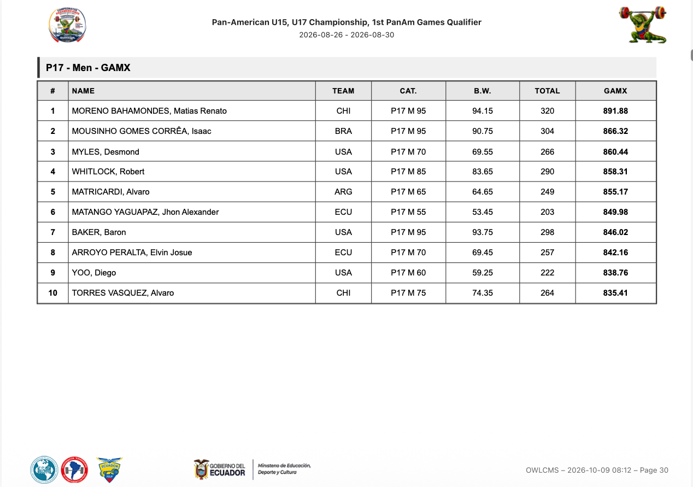
Category Rankings
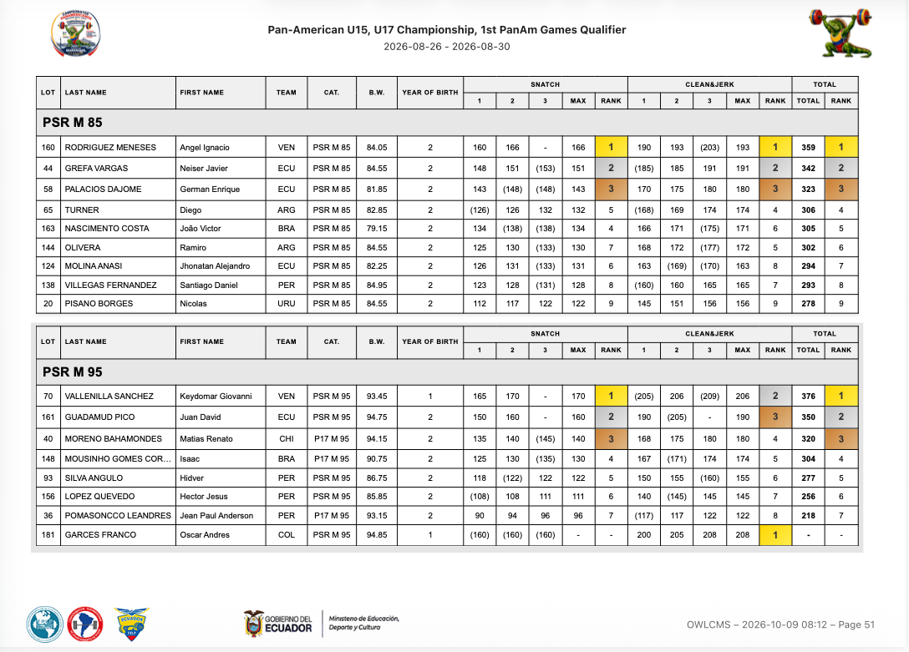
Session Protocols
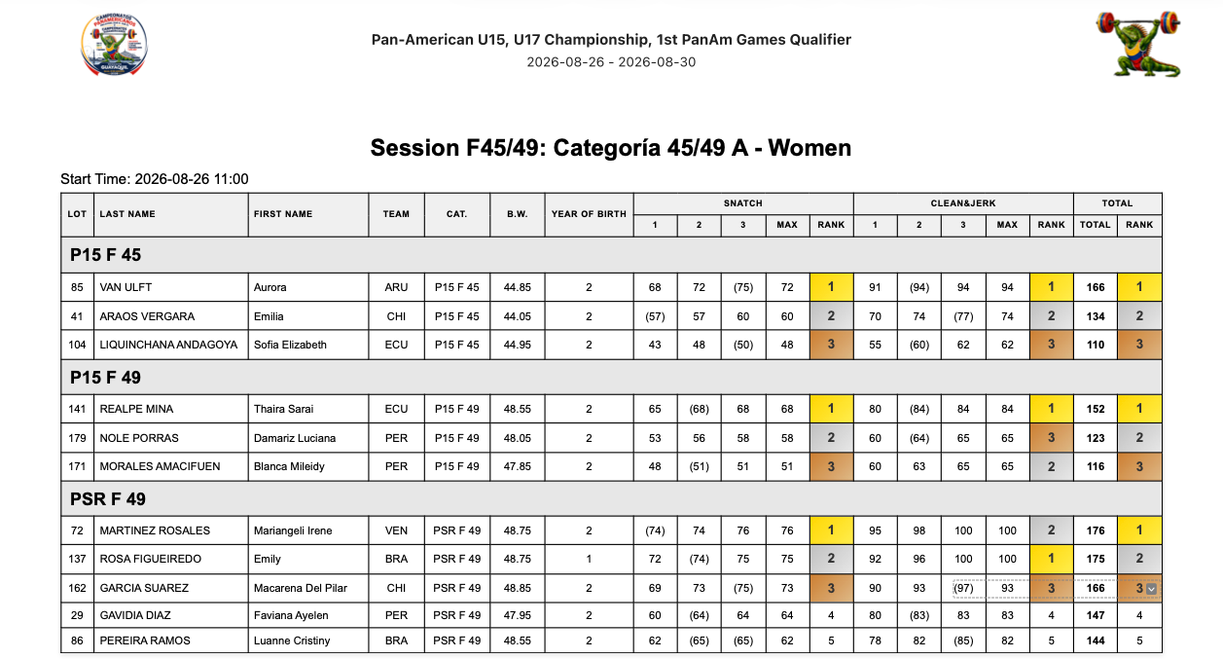
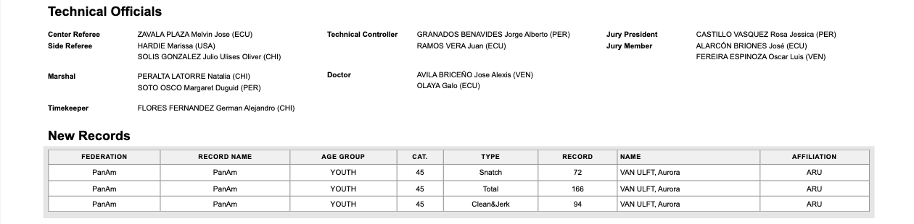

Machine-readable export
[RFP §4.4] At minimum, the TIS shall provide Machine-readable export.
The full database content is available in canonical JSON format, as a snapshot, on demand. The time required to produce is extremely short; this can be triggered at any idle time during the competition.
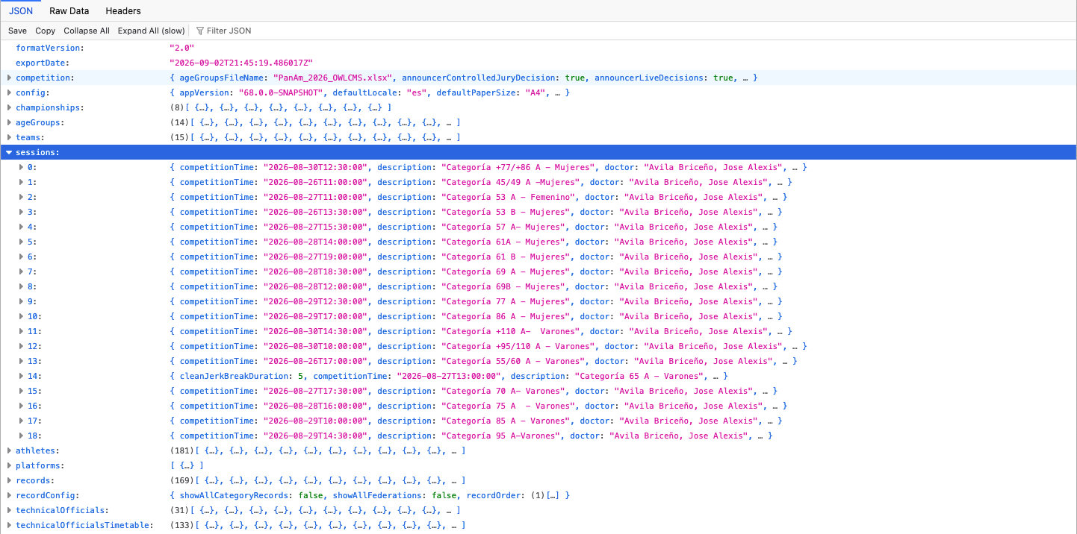
It is also possible to get a SQL-format backup of the H2 database.

Distribution records
[RFP §4.4] At minimum, the TIS shall provide Distribution records.
Distribution of results is entirely under the control of the competition staff. Competition staff is expected to upload official documents to IWF’s document management systems that will control distribution. Production of authoritative exports is however logged in the audit logs.

Final evidence/archive
[RFP §4.4] At minimum, the TIS shall provide Final evidence/archive.
The machine-readable export described in section E.2.4.13 and the audit logs described in F.1.1.5 constitute the source of truth. The export is signed

Security & resilience
Security architecture, access, offline operation, backup, recovery, failover and continuity.

Security, Resilience and Business Continuity

Security

OWLCMS meets all stated requirements.

Least-privilege access by role and device identity.
[RFP §7.1] Least-privilege access by role and device identity.
OWLCMS supports separate logins for every role, and where relevant, separate logins for each role and platform. Devices are identified per platform and authenticated using the MQTT identity of the MQTT interface.

Separation of competition, device, public/display, database and management functions where applicable.
[RFP §7.1] Separation of competition, device, public/display, database and management functions where applicable.
The role structure separates the technical official roles, preparation roles, the competition director, and admin functions.

Protection of credentials, secrets and data in transit/at rest where required.
[RFP §7.1] Protection of credentials, secrets and data in transit/at rest where required.
All credentials or secrets are stored encrypted and transported in encrypted form. They are never written to log files in clear. Account passwords and interface connection passwords use PBKDF2 encryption with HMAC-SHA256.

Controlled remote support, removable media and patch/deployment processes.
[RFP §7.1] Controlled remote support, removable media and patch/deployment processes.
Supplier will install a remote support program on the competition director laptop and on the interface laptop (AnyDesk).
Removable media will be provided by IWF to the competition director, as IWF will keep the files copied to that device.
OWLCMS is always updated from versions built using its repeatable build process, which creates zip files in the official repository. The updated version can be pulled by the OWLCMS launcher if there is internet access; otherwise, another machine can be used to copy the release on removable media and then used to do the updating. The OWLCMS launcher keeps multiple versions side-by-side and maintains a copy of the data for each so that it is always possible to go back to the previous version. The exported files are also systematically tested so that export from a patch version can always be read by a prior version in the same major release cycle.

Tamper-resistant audit sufficient to reconstruct material actions.
[RFP §7.1] Tamper-resistant audit sufficient to reconstruct material actions.
The audit logs include every single modification to the athlete and lifting data, and all events coming from devices (decisions, etc.). All export actions are logged with the checksum of the exported file, for later integrity checks of exported files.
The audit log is a chain of cryptographically signed blocks of log lines. Each block is signed by a private key. Each block's signature also includes the previous block's signature, creating a chain.
Prior to each competition, a cryptographic public-private key pair is generated, along with a public-key fingerprint. The technical delegate or other trusted person takes a picture of the fingerprint. Logs are copied away from the competition computer to a safe location periodically during the meet.
In case of a dispute, the safe logs are copied to a clean machine, and a clean OWLCMS is installed. Each log contains the public key that matches the (undisclosed) private key used to do the signatures. The checker can confirm that each block was signed by the matching private key and that each block was not modified. The technical delegate confirms the public key’s authenticity by comparing its fingerprint with what they photographed.

No public or anonymous path may write authoritative competition state.
[RFP §7.1] No public or anonymous path may write authoritative competition state.
The only writing to the database is done by OWLCMS itself, which owns an exclusive file lock. The database is therefore the source of truth. Exports are cryptographically checksummed, and the checksum is logged in the audits to allow later verifications of integrity.

Offline operation
[RFP §7.2] Core competition, officiating, timing, local displays and local official documents shall remain usable during loss of public internet or cloud connectivity.
The normal mode of operation of OWLCMS in a major competition is completely offline, on a private local area network as shown in Figure 1. Operator stations are normally wired using Ethernet cabling to avoid WiFi interference or foul play.

Backup and recovery

Protected backup copies of data, configuration, rules, assets and audit.
[RFP §7.3] Protected backup copies of data, configuration, rules, assets and audit.
All files that constitute the OWLCMS configuration and rules are stored in a single folder. The cryptographic key is kept separate as it should not leak on backups.
While OWLCMS is running the export format is used to capture snapshots, as it can be produced on demand in a consistent state. The actual binary database file can be backed up when the program is stopped.

Timed restoration demonstrating the approved recovery objective.
[RFP §7.3] Timed restoration demonstrating the approved recovery objective.
Restoration of a saved state from scratch normally takes less than a minute.

Defined promotion, split-brain prevention, failback and reconciliation where redundancy is claimed.
[RFP §7.3] Defined promotion, split-brain prevention, failback and reconciliation where redundancy is claimed.
The system would not operate in tandem. Checkpoint copies would be used.

Cold-start and rollback procedures using controlled recovery media.
[RFP §7.3] Cold-start and rollback procedures using controlled recovery media.
Checkpoint copies of the export format can be obtained on demand, and constitute full rollback points. Restarting the system without a database file creates a minimal empty one that can be immediately loaded from a checkpoint.

Manual continuity
[RFP §7.4] A manual Protocol and rehearsed manual-continuity procedure shall remain available. Staff shall know when to continue, when to STOP and how to reconcile manual records with the electronic state.
A manual Protocol and rehearsed manual-continuity procedure shall remain available. Staff shall know when to continue, when to STOP and how to reconcile manual records with the electronic state.
This is standard operational procedure. A power outage, or a networking mishap can prevent use the system and cause a revert to a “manual cards and flags” mode.
OWLCMS has been tested in such situations before. As soon as the system is restored, someone can simply copy the information as it stands on the cards, even while lifting is going on that platform. As soon as the information has been updated and matches the paper trail, the screens can be turned on for that platform. All the lifting order and such is derived from the authoritative card data as entered.
Writing operational procedures as expected by IWF would take place before deployment.

Monitoring
[RFP §7.5] Actionable monitoring shall cover critical services, devices, timing, storage, network and stale-state conditions, with clear escalation responsibilities.
Actionable monitoring shall cover critical services, devices, timing, storage, network and stale-state conditions, with clear escalation responsibilities.
The actual OTIS kit requires a router and, for each platform, a switch. As part of the certified kit, this constitutes the monitoring boundary. The kit devices are attached directly to these and can be monitored (including remote logins).

Integration
Interfaces, APIs/feeds, public/broadcast and Games/ORIS integrations.

Interfaces
[RFP §6.3] Material interfaces shall document producer/consumer, purpose, version, schema/field mapping, identifiers, status/null rules, sequencing/revision, time source, latency, authentication, acknowledgement, retry/reconnect, monitoring and fallback.
Material interfaces shall document producer/consumer, purpose, version, schema/field mapping, identifiers, status/null rules, sequencing/revision, time source, latency, authentication, acknowledgement, retry/reconnect, monitoring and fallback.

Device Protocol and Authentication
All the devices on the network communicate using MQTT messages to the OWLCMS server; see the specification on-line https://jflamy.github.io/owlcms4/#/100-AdvancedTopics/200-MQTTMessages
Standard MQTT authentication protocols are used (login name and password); crypted MQTT is available, but this is normally only used on cloud-based configurations, which is not the case for the proposed completely-local, closed-network configuration.

Blue Owl USB-MQTT Interface
- Blue Owl devices use the same computing chip that is used on Arduino Uno or Nano, or on Arduino Mega
- The Blue Owl devices use a standard USB 2.0 interface to communicate with the computer that powers them.
- All communications with the computer are done serially on the same USB connection, using the publicly documented Firmata protocol.
- The Blue Owl program speaks Firmata to the devices and relays the information to OWLCMS
  - When a button is pressed on the device, this is immediately propagated by Blue Owl as an MQTT message to OWLCMS
  - Conversely, when OWLCMS issues a command to turn on an LED or buzzer, the Firmata message activates the corresponding ports.
  - Blue Owl itself will attempt reconnections every second in case of disconnection
  - The server detects and reports when a Blue Owl module disconnects and reconnects
  - Each Blue Owl interface keeps complete logs.
- The actual implementation of the software code used by the Blue Owl user interface to perform the interactions is publicly available at https://github.com/nemikor-solutions/blue-owl-core
- Schematics of the Blue Owl devices are included in Annex A.

Direct MQTT Networking
Because the MQTT protocol is documented, any device that can be designed to listen to MQTT can just subscribe to the topics. The VPT modules uses the MQTT messages to know when the clock is started and stopped, as an example. WiFi devices can also act as devices by talking directly to MQTT.

Latency
Latency between the button press and reception of the MQTT message is under XX ms.

Operations
Staffing, training, manuals, event support, escalation and incident response.

Supplier responsibilities

Provide accurate product and hardware baseline
[RFP §8.2] Provide accurate product and hardware baseline.
[To be completed]

Provide complete technical submission and evidence package
[RFP §8.2] Provide complete technical submission and evidence package.
A test environment can be provided to reproduce any claimed feature.

Make the declared system available for IWF testing and demonstrations
[RFP §8.2] Make the declared system available for IWF testing and demonstrations.
A test environment can be provided if supplier is selected.

Correct deficiencies and complete regression testing when required
[RFP §8.2] Correct deficiencies and complete regression testing when required.
Agreed if supplier is selected.

Notify IWF of material product, security, hardware, interface or rule-logic changes
[RFP §8.2] Notify IWF of material product, security, hardware, interface or rule-logic changes.
Agreed.

Maintain qualified support personnel and appropriate spares
[RFP §8.2] Maintain qualified support personnel and appropriate spares.
Agreed.

Protect IWF, athlete and event information and comply with applicable data-protection requirements.
[RFP §8.2] Protect IWF, athlete and event information and comply with applicable data-protection requirements.
The only information that would normally be considered Personal Data under GDPR and similar frameworks is the athlete’s body weight and birth date. The body weight being necessary to the application of rules, it can be construed to fall under the “legitimate interests” clause (and disclosure should be mentioned as part of any consent and risk acceptance form signed by athletes).
Concerning birth date, IWF’s own rules do not require the full birth date to be published, only the birth year. OWLCMS has a setting to only use and show the birth year; we would recommend that this be used in IWF competitions.
The rest of the athlete information and event information is meant to be made public as it is part of public event invitations and included in preliminary participation lists, start books and result books.
In an IWF event, it is expected that an IWF identifier of the athlete will be included in the registration data. OWLCMS treats that identifier as an opaque anonymized foreign identifier.

Event deployment

Only the approved baseline and event configuration may be used
[RFP §12.3] Only the approved baseline and event configuration may be used.
Agreed.

Actual hardware, software, network, power, displays, spares and staffing must match the approved event design.
[RFP §12.3] Actual hardware, software, network, power, displays, spares and staffing must match the approved event design.
Agreed.

Dress rehearsal and failure/recovery test shall be completed before readiness sign-off.
[RFP §12.3] Dress rehearsal and failure/recovery test shall be completed before readiness sign-off.
Agreed.

Substitutions require approved deviation or delta testing before use
[RFP §12.3] Substitutions require approved deviation or delta testing before use.
Agreed. Note that operator stations used by technical officials are only actually dependent on the capability to run a current mainstream browser and on the presence of HDMI ports and USB ports. Any Windows laptop with these features can be substituted in an emergency.

Support and incidents

Defined escalation contacts and event support
[RFP §12.4] Defined escalation contacts and event support.
Competition staff will be provided with that information. Escalation staff will either be directly on site or available remotely.

Critical incidents documented, contained, investigated and reported
[RFP §12.4] Critical incidents documented, contained, investigated and reported.
Supplier will provide an issue reporting environment and ensure follow-up and resolution of incidents.

Serious incidents, unauthorised changes, false evidence, unsupported baselines or material security compromise may lead to restriction, suspension or withdrawal.
[RFP §12.4] Serious incidents, unauthorised changes, false evidence, unsupported baselines or material security compromise may lead to restriction, suspension or withdrawal.
Agreed.

Homologation
Test environment, evidence package, demonstration plan and FAT/SAT readiness.

Evaluation and Homologation Process

Administrative review
[RFP §10] Completeness, eligibility and declarations.
Supplier declares the current information to be correct at the date of submission.

Technical review
[RFP §10] Architecture, functionality, hardware, interfaces, security and resilience.
To be performed by IWF selection committee.

Scope confirmation
[RFP §10] Freeze baseline, profile, capacity, dependencies and test plan.
All claimed capabilities are present in the proposed baseline, in compliance with TCRR as available October 1, 2026.
Baseline will managed according to section K.1.2. Note that the baseline may need to evolve to reflect software modifications due to changes in IWF rules or formal adoption of experimental practices (e.g., display of jury decisions on scoreboards). The baseline may also evolve due to incident resolution or significant supplier upgrades, such as CVE security incident resolutions.

FAT
[RFP §10] Controlled normal, edge, security, capacity and failure testing.
Initial acceptance tests to be formalized if supplier is selected. All capabilities claimed can be demonstrated.

Corrective action
[RFP §10] Resolve deficiencies and provide regression evidence.
Any issue declared will be investigated, and updated official builds will be provided. OWLCMS includes over 350 automated tests to prevent regressions; such tests are run before any release.

Operational validation
[RFP §10] Representative event tempo with operators, officials, displays, feeds and recovery.
OWLCMS includes an automated stress simulation test that allows all required displays to be observed on all platforms as desired. All device interfaces are exercised, and all external feeds are fed.
The stress test proceeds as fast as could possibly be done in real life: a full lift cycle takes about 12 seconds from one decision to the next, including a real clock start and the decision reversal delays. Simulated attempted weights are randomly modified using the audited marshal events (simulating a plausible rate of such changes). Referee decisions are generated using the actual audited referee events as they would be generated by devices, to create a plausible rate of successive attempts.
All the displays, devices, and operator stations, for all platforms, can be opened at once and observed.
It is of course possible to perform the same test manually with human operators.

Homologation decision
[RFP §10] Review requirements, hard gates, evidence and findings.
To be performed by IWF selection committee.

Supplier licence
[RFP §10] Complete legal and operational conditions.
To be defined once supplier is selected.

Event SAT
[RFP §10] Check actual installation against approved baseline.
To be performed by IWF acceptance committee.

Surveillance
[RFP §10] Review incidents, changes, support and expiry.
IWF oversight mechanisms are to be defined.

Evidence
[RFP §10.1] Evidence shall be attributable to a specific baseline and test. Screenshots alone are insufficient where logs, physical inspection or live behaviour are necessary.
Supplier will capture exports and logs as required during testing.

Approval Criteria and Hard Gates

HG-01 Sport rules & result correctness
[RFP §11] Incorrect sporting fact, rank, medal, record or rule-critical transition.
No such incident reported in actual production use.

HG-02 Authoritative state & data integrity
[RFP §11] Split, duplicated, lost or silently overwritten accepted state.
No such incident reported in actual production use.

HG-03 Timing & adjudication safety
[RFP §11] Unsafe or ambiguous timing, decision, Down signal or restart.
No such incident reported in actual production use.

HG-04 Correction & audit
[RFP §11] Unauthorised, partial, untraceable or unreconciled correction.
System includes audit of all modifications.

HG-05 Continuity & recovery
[RFP §11] Uncontrolled loss of competition or unverified recovery.
Actual production occurrences of loss of power or loss of networking do occur regularly in some countries, and OWLCMS has been used in competitions where they occurred. The system has never been observed to lose data. In IWF-scale events, it is always run on battery-protected laptops and/or on a UPS to prevent power spikes. Even if a laptop running on battery suddenly runs out of power, the database's transactional nature prevents data loss.
Recovery is achieved as soon as the system has been updated to catch up with the handwritten athlete cards (or even the manual protocol). A platform can be on outage (local power loss to its networking switch) while others are working, catching up for that platform will allow it to recover, the other platforms are not affected.
As an additional precaution against human error, the competition director would normally trigger a database export after weigh-ins and at each break on each platform. This can also be automated to take place at fixed intervals.

HG-06 Security & least privilege
[RFP §11] Uncontrolled privilege, public write path or material compromise.
The system as proposed to IWF is fully role- and least-privilege-based. The database is in exclusive write mode from the OWLCMS system, and all competition modifications done by the application are logged.

HG-07 Output parity & publication
[RFP §11] Contradictory outputs or untraceable final publication.
No such incident reported in production

HG-08 Baseline reproducibility
[RFP §11] Unknown tested version, missing evidence or irreproducible installation.
All builds are versioned and created from a repeatable procedure that is public. The actual binary files contain version information.

HG-09 FOP readiness & safety
[RFP §11] Missing critical equipment, unsafe installation or unresolved obstruction.
This clause is event-specific, to be completed by the technical delegate of the event.

Decision rules

All applicable mandatory requirements and tests must be disposed of
[RFP §11.1] All applicable mandatory requirements and tests must be disposed of.
Understood as “must be met”. To be completed by IWF evaluation committee.

Applicable TCRR requirements and hard gates must pass
[RFP §11.1] Applicable TCRR requirements and hard gates must pass.
To be completed by IWF evaluation committee.

No open Critical finding may remain
[RFP §11.1] No open Critical finding may remain.
To be completed by IWF evaluation committee.

Traceability from requirement to evidence and test must be complete
[RFP §11.1] Traceability from requirement to evidence and test must be complete.
To be completed by IWF evaluation committee.

Successful FAT, recovery and operational validation are required for the claimed profile.
[RFP §11.1] Successful FAT, recovery and operational validation are required for the claimed profile.
To be completed by IWF evaluation committee.

Partial is not Pass
[RFP §11.1] Partial is not Pass.
To be completed by IWF evaluation committee.

A profile limitation cannot change an IWF sport rule or bypass a hard gate
[RFP §11.1] A profile limitation cannot change an IWF sport rule or bypass a hard gate.
To be completed by IWF evaluation committee.

Commercial
Licence, implementation, equipment, support/maintenance, optional services and recurring charges.

Commercial and Contractual Conditions
The Licensing Fee for the four-year period is US$20,000, payable on an annual basis of US$5,000 per year.

IWF licensing fee
[RFP §13] The Licensing Fee for the four-year period is US$20,000, payable on an annual basis of US$5,000 per year.
US$5,000 per year / US$20,000 total

Licence
[RFP §13] Licence
[TO BE COMPLETED]

Implementation
[RFP §13] Implementation
[TO BE COMPLETED]

Equipment
[RFP §13] Equipment
[TO BE COMPLETED]

Support / maintenance
[RFP §13] Support / maintenance
[TO BE COMPLETED]

Optional services
[RFP §13] Optional services
[TO BE COMPLETED]

Recurring charges
[RFP §13] Recurring charges
[TO BE COMPLETED]

Legal
IP/licensing, warranties, liability, confidentiality, data protection, subcontractors and termination.

Licence Conditions, Change Control and Event Deployment

Licence validity
[RFP §12.1] The IWF licence shall be valid for a four-year period. The certificate shall state supplier, product/baseline, profiles, capacities, limitations, deviations, validity and surveillance conditions.
The IWF licence shall be valid for a four-year period. The final contract shall state the exact licence duration and renewal conditions.

Change control

Editorial / non-functional
[RFP §12.2] Controlled update and review.
Will be treated the same as minor cosmetic

Minor cosmetic
[RFP §12.2] Supplier assessment and IWF notification where applicable.
These are typically typos or simple modification to the layout (spacing, etc.). To be considered minor, operational procedures would not need to be modified.

Significant - OS/database/firmware/interface/security/workflow/hardware
[RFP §12.2] Impact assessment and approved regression/delta test.
Changes in this category will be treated in one of two categories.
- Technical changes (OS/firmware/security/hardware). These are often unavoidable and required by suppliers.
- Functional changes – User interface changes, workflow changes, changes or additions to data sent over interfaces
The difference lies in who assesses impacts and approves the changes.

Major - competition logic/timing/adjudication/records/state/failover
[RFP §12.2] Re-homologation before event use.
Full impact assessment will be done. Such changes are expected if TCRR updates rules.

Emergency security/stability correction
[RFP §12.2] Named approval, backup, rollback, targeted test and retrospective evidence.
It is expected that competition staff will be able to obtain approval as part of the IWF approval chain (e.g. by an on-site technical delegate). As per industry best practices, any emergency remediation will be investigated and a proper corrective fix will be made available under the other clauses of this section.

Intellectual property
[RFP §12.5] IWF shall receive the rights, documentation, exports, interfaces and operational access necessary to use, verify, archive and maintain the approved system and competition records.
The supplier retains its intellectual property except where otherwise agreed. IWF shall receive the rights, documentation, exports, interfaces and operational access necessary to use, verify, archive and maintain the approved system and competition records. Final contractual wording will be agreed with the selected supplier.

Mandatory declarations

Acceptance of the IWF TCRR as the controlling sporting rules
[RFP §9.1] Acceptance of the IWF TCRR as the controlling sporting rules.
Agreed.

Identification of all material limitations and dependencies
[RFP §9.1] Identification of all material limitations and dependencies.
None identified. To be confirmed during acceptance testing.

Ability to reproduce the tested system from controlled installation material
[RFP §9.1] Ability to reproduce the tested system from controlled installation material.
Installation from a compliant kit shall reproduce the tested behaviour.

Offline operation and tested recovery for the claimed profile
[RFP §9.1] Offline operation and tested recovery for the claimed profile.
The system is confirmed to operate without on-line access, and to be recoverable from the described exports.

No automatic licensing mechanism that can interrupt an active competition
[RFP §9.1] No automatic licensing mechanism that can interrupt an active competition.
There are no such automatic licensing mechanisms.

Authorised signatory | Details
Name | [TO BE COMPLETED]
Title | [TO BE COMPLETED]
Signature | [TO BE COMPLETED]
Date | [TO BE COMPLETED]

Compliance matrix
Clear response to this tender and the applicable IWF assessment.

RFP Section 2
Requirement | Compliance | Reference | Justification
2.1 Complete sport logic, mandatory FOP controls, screens and official documents. | Compliant | B.2.1 | OWLCMS and Blue Owl are fully compliant with the TCRR as of October 2026.
2.1-R02 M0 plus baseline control, audit, interfaces, offline operation, recovery, procedures, training, support and spares. | Compliant | B.2.2 | The system as delivered will meet all these requirements. The Tracker element illustrated above provides a fully documented interface for all complementary systems that require one in more advanced profiles.
2.1-R03 M1 plus applicable VPT, public/live services, broadcast outputs, enhanced monitoring, high availability and full rehearsal. | Compliant | B.2.3 | Claimed: Yes. Video playback requires acquisition of additional video-capable equipment (laptops with video capture/gaming cards, cameras). OWLCMS has its own standalone VPT module that would be covered by this proposal. OWLCMS provides a set of TV Graphics for broadcasts, and its replay streams can be used as well. Supplier routinely does event-specific TV Graphics and has used the OWLCMS integration features to do so at large multisport games.
2.1-R04 M2 plus approved Games/ORIS and programme-specific integrations. | Compliant | B.2.4 | Claimed: Yes. Supplier has previously integrated OWLCMS with the ODF (Olympic Data Format) for Games integration in the past (Islamic Solidarity Games 2025). The Tracker module uses the exact same protocol that is available for any external integration. Full access to the competition data and to all competition events is provided over a secure connection, with TLS encryption (wss) supported.  Figure 1: Solution Overview  Figure 2: Detail: VPT and Interfaces
2.1-R05 Simultaneous platform operation with separation and capacity evidence. | Compliant | B.2.5 | Claimed: Yes. OWLCMS has supported up to 6 platforms simultaneously with extremely low computer and network usage and 1600 athletes competing. The program is verified using a stress test designed explicitly for this purpose.  When used in this mode, a single instance of OWLCMS runs all platforms, and no integration step for results is required. TCRR mandates that a lower entry group (e.g., group B) lifts before a higher one (e.g. group A); if this constraint is observed, all live results are correct.
2.2 The licence certificate shall state the supplier and product. | Compliant | B.3.1 | The supplier of the product shall be [Supplier], who will act as integrator of the open-source OWLCMS version, of the Blue Owl OTIS kit to profile MP, and of the necessary additional components required to meet profile M3.
2.2-R02 The licence certificate shall state the exact baseline. | Compliant | B.3.2 | Any stable version of OWLCMS after version 69 is claimed to meet the current requirements and is fully compliant with TCRR as published at the time of this tender. Any version of the Blue Owl software after version 3.0 meets the requirements. Final baseline will be confirmed after acceptance testing.
2.2-R03 The licence certificate shall state approved profiles and capacities. | Compliant | B.3.3 | M2 and MP profiles: The system has been tested to 6 concurrent platforms and 1600 participants, and can be stress-tested on demand. Examples of such very large mixed events include USAW Open 2024, USAW VWS Series 2025 and 2026, IMWA World Championships  M3 profile: [Supplier] integrated the OVR into the Islamic Solidarity Games 2025 central platform using ODF (Olympic Data Format) protocols. [Supplier] will provide interfaces for the protocols used at given major events.
2.2-R04 The licence certificate shall state interfaces and critical dependencies. | Compliant | B.3.4 | The system has no critical dependencies. All communications use the standard HTTP and MQTT protocols.  The specific MQTT messages used for the devices are fully documented.  The protocol used to create additional interfaces for Data Exports, TV Graphics, etc. is public and has a published reference implementation.
2.2-R05 The licence certificate shall state limitations and deviations. | Compliant | B.3.5 | None known.
2.2-R06 The licence certificate shall state validity and surveillance conditions. | Compliant | B.3.6 | Licensing authorizes the use of the TIS equipment and software package; the equipement and software may not be used if the user does not hold such a license.  IWF is expected to acquire TIS equipment and software licences from [Supplier] for IWF use at competitions that are directly under IWF authority.  A Federation licensing the TIS equipment and software package is expected to use it for the competitions that are under its own authority. If the Federation wishes to lend the equipment to another federation, or to a constituent federation (such as a national federation loaning the equipment to a state federation), additional licensing fees may be required by the Supplier.

RFP Section 3
Requirement | Compliance | Reference | Justification
3-R01 Import and validate athlete, federation/NOC, official, event, venue and record data; stable IDs and error reporting. | Compliant | E.1.1 | Data is converted to an Excel-style sheet with the athlete identifier, name, and all registration data. Competition information and dates are stored in the program database (all information is stored in a relational database). The initial schedule is part of the data intake, and an initial assignment of athletes to sessions is done.  The input format handles multiple age groups and supports team allocation. The intake format can be exported, edited off-line, and re-ingested without loss of information. The same applies to schedule changes and referee assignments that can be modified in bulk until stabilized.
3-R02 Corrections, approvals, random lots, grouping, timetable and Technical Official assignments. | Compliant | E.1.2 | The program prints VFE verification sheets that show exactly which athlete is in which category or categories. There are also team membership teams to verify that all team allocations are correct. These sheets can be signed by team representatives to facilitate the VFE process and reduce the number of errors, or used by the TIS team to do the capture and then get them signed.
3-R03 Approved Start List and controlled distribution/versioning. | Compliant | E.1.3 | OWLCMS as proposed is able to produce a fully compliant start book. Preliminary versions can be published to list participants, with subsequent editions adding the schedule and the officials assignments. Once converted to the OWLCMS format, any number of records can be handled. Field-of-play formats are also available (actual session assignments and schedule) for direct use by coaches and technical officials.
3-R04 Correct timing, bodyweight, first attempts, 20 kg checks, start numbers, signatures and closed snapshot. | Compliant | E.1.4 | OWLCMS produces field-tested Weigh-in forms to capture both the weight-on-scale and deducted weight. All applicable rule are checked, including 20 kg and qualifying totals where applicable. The form captures all the required signature. Compliant athlete cards are likewise printed. A special data entry mode is used for quick capture of weigh-in data. A post-weigh-in snapshot of the database is taken. Start numbers are cross-checked at the end of the weigh-in and checked against allocated bib numbers. A speaker introduction sheet for athletes and officials is produced, as are the empty protocols and jury member sheets.
3-R05 Calling order, declarations/changes, 60/120-second timing, referee decisions, records and live outputs. | Compliant | E.1.5 | Full compliance with the competition flow is attained. All marshal data entry is immediately handled by the system and all lifting order or requested weights are instantly updated on all displays and scoreboards. All the normal timing decisions are automatic (the clock is automatically set to the right allocated time for each athlete, including on fast sequences of changes). Only explicit loading incidents require a reset. All attempts are checked against the 20 kg rule and the required changes are explicitly visible to the marshal. Incomplete situations that do not fully restore the 20kg rule are explicitly visible.
3-R06 Controlled Snatch-to-Clean & Jerk transition and synchronized displays. | Compliant | E.1.6 | Default rules for longer breaks (few athletes) and shorter breaks (large sessions) are both available. The session schedule also allows changing the break duration. This can also be done after the session has started (under the assumption the meet director informs all concerned). Transition from the snatch to the clean & jerk break at the end of the snatch is automatic. A jury interruption or challenge on the last requires the time keeper starts the break once the situation has been resolved.
3-R07 Calling order, weight changes, 20 kg enforcement, totals, ranks and records. | Compliant | E.1.7 | The same completely automatic timing and weight change flow as in the snatch takes place.
3-R08 STOP, Jury, challenge/VPT where applicable, additional attempts, correction, withdrawal and restart. | Compliant | E.1.8 | The jury can start a deliberation or accept a challenge using a physical jury keypad button or using a jury tablet. A flashing STOP sign is shown to the athlete on the platform, and all attempt boards and displays indicate the interruption. Transmission of the jury reversal code to the speaker can be done the traditional way (by the technical controller), or automatically when the jury president chooses the reversal code. In either case, the jury or challenge decision is shown as the speaker announces it. The system can optionally display jury decisions on the scoreboards and the attempt boards. This capability is optional because it is not formally described in TCRR.
3-R09 Protocol reconciliation, signatures/status, results, classifications and records. | Compliant | E.1.9 | A session protocol sheet is available immediately after the session that contains all the requisite information and each occurrence of an improved record. This is normally signed by the jury president. After a session, any correction required can be made via the system to ensure an audit trail to match whatever decisions were written on the protocols.
3-R10 Medallists, public/broadcast outputs, communications and revised outputs. | Compliant | E.1.10 | The system distinguishes two types of scoreboards. Public scoreboards are normally styled to match the event colors, and switch content during ceremonies. OWLCMS will automatically switch during introductions. During medal ceremonies, the technical table (or the speaker themselves) can change the display to show the medals. In multi-age or multi-federation championships, this allows correct control of what is shown to the public. If broadcasters elect to use the video layout screens as provided by OWLCMS, the changes are also automatic.
3-R11 Final dataset, official outputs, logs, revisions, evidence and machine-readable export. | Compliant | E.1.11 | The system distinguishes two types of scoreboards. Public scoreboards are normally styled to match the event colors, and switch content during ceremonies. OWLCMS will automatically switch during introductions. During medal ceremonies, the technical table (or the speaker themselves) can change the display to show the medals. In multi-age or multi-federation championships, this allows correct control of what is shown to the public. If broadcasters elect to use the video layout screens as provided by OWLCMS, the changes are also automatic.
3.1-R01 Snatch followed by Clean & Jerk, maximum three attempts per lift, correct Total calculation. | Compliant | E.1.12.1 | Fully compliant with TCRR  Evidence / reference: Explicitly in database schema, automated tests.
3.1-R02 Whole-kilogram weights and applicable minimum starting weights. | Compliant | E.1.12.2 | Fully compliant with TCRR  Evidence / reference: Explicitly in database schema, automated tests.
3.1-R03 Correct calling order, including weight, attempt number, previous-attempt sequence and start number. | Compliant | E.1.12.3 | Fully compliant with TCRR  Evidence / reference: Automated tests for all the change sequences.
3.1-R04 Permitted weight changes, final-call and consecutive-attempt rules. | Compliant | E.1.12.4 | Fully compliant with TCRR  Evidence / reference: Automated tests for all the change sequences and for the two-minute situations. Systematic recalculation of lift order to detect illegal moving down, with automatic tests.
3.1-R05 Withdrawals, no-lift/no-Total conditions, disqualification and additional attempts. | Compliant | E.1.12.5 | Fully compliant with TCRR  Evidence / reference: Automated tests of the total, disqualification and withdrawals.
3.1-R06 Material corrections recalculate affected rankings, records and outputs. | Compliant | E.1.12.6 | Fully compliant with TCRR  Evidence / reference: Any change to the lifting data causes a recalculation of all affected items. Automated tests for the ranking and records calculations.

RFP Section 4
Requirement | Compliance | Reference | Justification
4.1-R01 Authoritative electronic countdown in one-second increments, configurable up to at least 15 minutes. | Compliant | E.2.1.1 | Fully compliant with TCRR  Evidence / reference: Timekeeper controls all break durations, no limit on duration.
4.1-R02 Automatic 60- and 120-second attempt clocks and applicable introduction/break countdowns. | Compliant | E.2.1.2 | Fully compliant with TCRR  Evidence / reference: Clock ownership is automatic, no intervention required to set the clock to 1:00, 2:00 or to the time remaining for the athlete. Transition between countdowns (introduction to snatch for example) is automatic. Can be overridden as required.
4.1-R03 Correct start, stop, restart and STOP behaviour according to the rules. | Compliant | E.2.1.3 | Fully compliant with TCRR  Evidence / reference: As per TCRR
4.1-R04 All connected displays use the same authoritative time state within the approved tolerance. | Compliant | E.2.1.4 | Fully compliant with TCRR  Evidence / reference: Time is kept on the OWLCMS server; when sent to remote devices, actual universal time reference for timer termination so the device can compensate for eventual small clock drift. All devices are time-synchronized.
4.1-R05 Time corrections are authorised, recorded and auditable. | Compliant | E.2.1.5 | Fully compliant with TCRR  Evidence / reference: The displays are NTP-synchronized at the operating system level by default. Verifying time synchronization is part of the technical setup.
4.2-R01 Three independent referee control boxes with white/red decisions and required indicators. | Compliant | E.2.2.1 | Fully compliant with TCRR  Evidence / reference: Nemikor referee buttons have visual indicator, sound, and vibration.
4.2-R02 Correct majority/Down signal, reminder and reversal-window behaviour. | Compliant | E.2.2.2 | Fully compliant with TCRR  Evidence / reference: Implemented by software. Reversal rules are as per TCRR. Manual reversal of a decision following flags can easily be done by the technical table.
4.2-R03 Jury visibility of individual referee decisions before public reveal. | Compliant | E.2.2.3 | Fully compliant with TCRR  Evidence / reference: Live referee decisions and reversal are shown to the jury both on the keypad and on the jury console screen or tablet display if used.
4.2-R04 Support for approved three- and five-member Jury configurations. | Compliant | E.2.2.4 | Fully compliant with TCRR  Evidence / reference: Jury size is selectable,
4.2-R05 Individual Jury decision controls and protected independence between members. | Compliant | E.2.2.5 | Fully compliant with TCRR  Evidence / reference: Individual jury buttons are provided as per TCRR. Decision protection housings are not a TCRR requirement but will be addressed.
4.2-R06 Material decisions and actions are attributable and time-stamped. | Compliant | E.2.2.6 | Fully compliant with TCRR  Evidence / reference: Full audit log of every single decision, timestamped to the millisecond, with the originating station or device.
4.3-R01 At minimum, the TIS shall provide System health. | Compliant | E.2.3.1 | A technical log is always available for detailed technical operations. The memory, disk and networking usage are extremely low, the system gauges confirm this (the system never exceeds 20%, and is usually well below 10, even for extremely large meets).
4.3-R02 At minimum, the TIS shall provide Event setup. | Compliant | E.2.3.2 | All competition information setup is done using interactive screens. Green is used in the software to indicate common actions.
4.3-R04 At minimum, the TIS shall provide lots/groups/timetable. | Compliant | E.2.3.2.2 | Normally an import from a competitions registration system is used to set up the initial schedule and assign athletes assigned to A/B/C… groups. At the scale of IWF events, this is most likely done using output of the registration system in spreadsheet format. This is then converted to fit the documented OWLCMS format (this has now become trivial with human assistance tools). All data exchange formats for OWLCMS are public.  Once this is done all athletes can be edited in the program, and late entries added by hand if needed.  The registration screen allows modification of the allocated session, moving the athlete to another group, adjusting eligibility to multiple age groups as appropriate.  The other tabs on the registration form cover things like record eligibility (in joint jurisdiction championships, not all athletes are eligible to improve all records)  The session timetable is editable.
4.3-R07 At minimum, the TIS shall provide Weigh-in. | Compliant | E.2.3.4 | The weigh-in data entry form is intentionally the same format as the registration form. All relevant checks for the 20 kg rule are applied at data entry, in case they were missed by the weigh-in Tos.  After weigh-in, the page allows the creation of all the relevant forms for the speaker and for the jury.
4.3-R08 At minimum, the TIS shall provide Chief Marshal. | Compliant | E.2.3.5 | The marshal table has a station that shows all athletes (in start order or lifting order as preferred by the TO operating). Clicking on an athlete brings up a card that is laid out exactly as the athlete card, and automatically brings focus to the right cell, such that typing and hitting Enter can be used for fast data entry.  20kg rule violations and late changes are immediately made visible
4.3-R09 At minimum, the TIS shall provide Timekeeper. | Compliant | E.2.3.6 | During the competition a tablet-friendly display is used, that can be used together with the Blue Owl buttons, as preferred.  The timekeeper can control the breaks (in addition to the main technical table or the speaker having the same feature depending on the skill and comfort levels). The delay can be set to a clock or duration as relevant for the type of break.
4.3-R11 At minimum, the TIS shall provide Competition supervisor. | Compliant | E.2.3.8 | The competition supervisor screen is the as the speaker, with the addition of the decision lights that can be seen live as an option. This is because the switches between sessions, and breaks, and lift overrides after a late referee flag call can all be done from that screen. Depending on competitions, the speaker screen will be made “passive” if the technical table assumes those tasks instead of an ITO1 comfortable with technology.  In addition, OWLCMS is launched from a control panel that gives additional options such as viewing the technical log going live. The competition supervisor can watch the competition-level audit log as it is written.
4.3-R12 At minimum, the TIS shall provide Referee monitoring. | Compliant | E.2.3.9 | The competition director screen can see the live referee lights, as does the jury. The audit log shows each individual decision, and each weight change from the marshals.
4.3-R13 At minimum, the TIS shall provide Jury control. | Compliant | E.2.3.10 | The jury control can be done entirely using a Blue Owl jury control keypad  In the context of an IWF meet, it becomes desirable to accelerate the transfer of decisions from the jury to the speaker. To this effect, a tablet-style jury display is available that has the same features as the keypad  When this is used, the Speaker and Competition Supervisor screens get the reason immediately, and can resume the competition after announcing it.
4.3-R14 At minimum, the TIS shall provide Attempt boards. | Compliant | E.2.3.11 | Attempt boards show all the information required by TCRR. They can also display the flag of the country. If one or more record attempts take place the attempt boards show it as a rolling banner.
4.3-R15 At minimum, the TIS shall provide Scoreboards. | Compliant | E.2.3.12 | Scoreboards contain all the requisite information. In addition, the top line contains the current attempt. The bottom line contains additional information, such as the various championships, rank if successful, jury decisions etc.). This is the warmup room layout, that does not change during ceremonies so coaches can count attempts. Scoreboard during session with previous leaders  In the main room, styling will be applied as required by the event, and the top row is used as a banner. A row at the bottom carries will carry the clock and other attempt information. Main Room Scoreboard with previous leaders  Full-fledged video production companies can replace this scoreboard and the TV Graphics by using the extension capabilities provided by OWLCMS. The extension protocol is documented with a reference implementation at https://github.com/owlcms/tracker-core .
4.3-R16 At minimum, the TIS shall provide RTDS/warm-up. | Compliant | E.2.3.13 | In OWLCMS all the screens are RTDS (Real-time Display System)  When decisions are given, they are shown both on the attempt board and on the scoreboards.  If jury decisions are being shown, these appear as well. The bottom line then shows the athlete under review, whereas the top line shows the athlete getting ready (whose clock is not running). Jury Decision for current athlete
4.3-R17 At minimum, the TIS shall provide STOP. | Compliant | E.2.3.14 | During deliberation, challenge, technical issue or other stoppage, the reason is shown  Flashing Stop
4.3-R18 At minimum, the TIS shall provide Records. | Compliant | E.2.3.15 | Record Attempt Attempt Board  Record Attempt Scoreboard
4.3-R19 At minimum, the TIS shall provide Results. | Compliant | E.2.3.16 | End of session rankings with medals
4.3-R20 At minimum, the TIS shall provide Other approved states. | Compliant | E.2.3.17 | [TO BE COMPLETED]
4.4-R01 At minimum, the TIS shall provide Start Lists. | Compliant | E.2.4.1 | [TO BE COMPLETED]
4.4-R02 At minimum, the TIS shall provide Start List Package. | Compliant | E.2.4.2 | [TO BE COMPLETED]
4.4-R03 At minimum, the TIS shall provide Weigh-in List. | Compliant | E.2.4.3 | [TO BE COMPLETED]
4.4-R04 At minimum, the TIS shall provide Athlete's Cards. | Compliant | E.2.4.4 | [TO BE COMPLETED]
4.4-R05 At minimum, the TIS shall provide Empty Protocol. | Compliant | E.2.4.5 | [TO BE COMPLETED]
4.4-R06 At minimum, the TIS shall provide Manual Protocol. | Compliant | E.2.4.6 | [TO BE COMPLETED]
4.4-R07 At minimum, the TIS shall provide Protocol. | Compliant | E.2.4.7 | [TO BE COMPLETED]
4.4-R08 At minimum, the TIS shall provide Results. | Compliant | E.2.4.8 | [TO BE COMPLETED]
4.4-R09 At minimum, the TIS shall provide Team Classification/Placing. | Compliant | E.2.4.9 | [TO BE COMPLETED]
4.4-R10 At minimum, the TIS shall provide Records. | Compliant | E.2.4.10 | [TO BE COMPLETED]
4.4-R11 At minimum, the TIS shall provide Final Results Package. | Compliant | E.2.4.11 | [TO BE COMPLETED]
4.4-R12 At minimum, the TIS shall provide Results Book where applicable. | Compliant | E.2.4.12 | [TO BE COMPLETED]
4.4-R13 At minimum, the TIS shall provide Machine-readable export. | Compliant | E.2.4.13 | [TO BE COMPLETED]
4.4-R14 At minimum, the TIS shall provide Distribution records. | Compliant | E.2.4.14 | [TO BE COMPLETED]
4.4-R15 At minimum, the TIS shall provide Final evidence/archive. | Compliant | E.2.4.15 | Paper, PDF and machine-readable outputs are delivery channels; none may become an undocumented alternative source of sporting truth.  Supplier response [TO BE COMPLETED]

RFP Section 5
Requirement | Compliance | Reference | Justification
5-R01 Controlled capacity for authoritative state and approved services, with spare/recovery path. | Compliant | D.1.1 | One main control computer with 8GB of memory and a 256GB disk is completely sufficient. ARM64 architecture as embodied in a Raspberry Pi5 is is demonstrated to handle 6 platforms with 1600 athletes with competition events taking place as fast as rules allow (stress test) and while providing all the requisite screens and attempt boards.  The proposed configuration includes a spare.  Furthermore computer or laptop running Windows, Linux or macOS can be substituted; the OWLCMS software runs identically on all these platforms, and the machine-readable database exports are readable on all.
5-R02 Dedicated, role-controlled competition administration and operation positions. | Compliant | D.1.2 | Operator stations are only required to run one or two browsers and, for some, the Blue Owl software when devices are connected. As a consequence, any machine with 4GB or more of memory can be used. The proposed configuration uses 8GB Raspberry Pi500 that are easily replaceable, will be available as such for 15 years, and are designed to be used in difficult environments such as classrooms.  Keyboards with numeric pads will be provided for the Marshal and Data entry stations.
5-R03 Protected authoritative storage, backup and tested recovery. | Compliant | D.1.3 | A fully relational database called H2 is used. The volume of data used even in a very large competition is quite small, and H2 is extremely quick. It has been used without a single attributable failure since 2009. The actual H2 binary file can be kept, in addition to the fully machine readable exports.  The readable export is the primary means of backup and snapshot. A readable snapshot can be obtained at any time from the administration or competition director stations, and can also be configured to be obtained on other stations using the tracker protocol.
5-R04 Three independent red/white referee control devices. | Compliant | D.1.4 | The Blue Owl referee controls include the two buttons, a visible LED, a sound, and a vibration for warning the referees. Referee controllers are cabled in order to avoid any concern with batteries.
5-R05 Individual devices for applicable Jury members plus President controls. | Compliant | D.1.5 | Jury controls for jury members are the same as the referee controls, but without the warning features. Referee controllers can be used as backups for jury controllers (the warnings would simply not be emitted).  President controls are of two kinds. The solution includes a physical keypad with all the required real-time referee decision display and the required jury member behaviour (green until all decisions visible)  A complementary tablet display is available in the kit; this enables the jury president to enter the reason for jury reversals.
5-R06 Authoritative timer/controller with approved displays and audio. | Compliant | D.1.6 | Timing is done on the main server using the operating system timers. Operating system timing resolution is 1 ms as used. Propagation times of MQTT messages is under 10 ms.  Time is displayed on the attempt board and on an athlete-facing clock.
5-R07 Competition and warm-up presentation with mandatory athlete/attempt/weight/clock/decision data. | Compliant | D.1.7 | The attempt board is any standard FullHD TV with HDMI inputs. The kit does not include the actual TV screens, that are assumed to be provided locally.  Two computers provide attempt board output. One provides a standard black background output that is replicated on all TVs in the waiting, marshal and warmup areas. The other output is used for the attempt boards in the main room, where some styling (e.g., changing the background color) may have been done.  The kit includes splitters and extenders, assuming an attempt board is present in each of the waiting, marshal, and warm-up rooms, and that these areas are immediately behind the competition stage. Further splitting or extension of the attempt board HDMI signal to reach multiple attempt boards is to be done using equipment and cabling provided locally.  For the main room, it is assumed that two attempt boards are present, one on each side of the stage.
5-R08 Real-time competition and warm-up displays with correct ranking and state. | Compliant | D.1.8 | The situation for the scoreboards is the same as for attempt boards. There are two HDMI sources, one for the stage area, one for the back. For the stage area, the signal is assumed to go to a single large LED scoreboard.
5-R09 Approved cameras, recording/replay and Jury output for events requiring VPT. | Compliant | D.1.9 | The VPT system is under the full control of the competition staff, and the TCRR-mandated angles can be displayed in self-service mode by the jury if so required (or provided by the competition director).  As indicated in TCRR, the replay clips are accessible by the venue video team and broadcast teams. Such access will be controlled by networking equipment configurations.  The VPT system relies on four PTZ cameras. Based on our experience in Continental competitions, we propose Tenveo PTZ 60fps cameras. These cameras provide Power-over-Ethernet RTSP video feeds, HDMI, and compressed H.264 USB feeds.  OWLCMS has a VPT module that automatically clips and attributes the replays to the athlete lifting. This module keeps a full indexed archive of all the lifts, at all angles.  The VPT will execute on a high-performance laptop that also meets the requirements for the vMix software. If a client federation wants to add such additional video-processing capabilities, the proposed equipment will be sufficient for them to use their own license on the video-processing laptop.
5-R10 Documented, segmented, monitored event network with common time. | Compliant | D.1.10 | The networking configuration is based on switching. Unmanaged switches are sufficient. A mininimum of 4 POE (Power-over-Ethernet) ports is necessary to provide power to the networked PTZ cameras. A 16-port switch per platform is provided.  An ASUS WiFi router is included. The router is configured to provide DHCP addresses to all machines in the kit. The only machines whose addresses matter are the main OWLCMS server and the VPT laptop on each platform. These will be set statically. WiFi is not normally used for the competitions, only as a convenience during setup. If federation personnel request access, it is preferred to loan them a network dongle. This eliminates any concern about illicit WiFi access. In the proposed configuration, the number of networking switches is kept to a minimum to prevent illicit connections.  All the machines on one platform are connected to the switch on that platform. Use of a switch also ensures that video traffic from the cameras goes directly to the video equipment and does not touch other machines that don’t need it  OWLCMS networking traffic is minimal. The application is routinely used in a cloud configuration with very remote servers and no perceptible delay.
5-R11 Controlled read-only path from accepted state to approved consumers. | Compliant | D.1.11 | The video laptop will host all the external interfaces. In actual practice, sending information out to a games central is very low usage (and ODF protocols are push only). OWLCMS can also publish to cloud-based scoreboards and other feature, but those are also push only. In the past, outside broadcasters have used the OVR-provided screen layouts directly. This was accommodated by opening a port on the router to a specifically white-listed address. This capability is generic with the equipment provided.
5-R12 Reliable official documents with fallback. | Compliant | D.1.12 | A Windows laptop with Microsoft Office is used for data entry and report generation to maximize compatibility with whatever printer is made available. OWLCMS produces documents in Excel format. Documents should be exported as PDF in non-editable mode and kept as such for archival.  Start books, Result books, Refereeing schedules and similar sophisticated layouts are produced as PDF.
5-R13 Protection and approved autonomy for critical equipment. | Compliant | D.1.13 | A UPS will be provided to protect the main server and the networking switches. The rest of the equipment, such as TVs, will likely go down during power issues, so there is no way to prevent outages other than a full generator (as used in Continental championships held in tropical countries subject to power fluctuations).
5-R14 Health, service, device, storage, time and stale-state monitoring. | Compliant | D.1.14 | The OWLCMS software has very low memory and disk I/O requirements. Use of the normal operating system indicators is therefore sufficient. An administrative function does exist to query more precise runtime information and add it to the technical log, but only ever used during stress tests to confirm correct operation.
5-R15 Rapidly deployable replacements for critical equipment families. | Compliant | D.1.15 | All the stations only require the presence of a current browser (Chrome, Edge, Firefox or Safari), and for some of them, the ability to connect a USB device. So essentially any laptop can be used, whether Windows, macOS, Linux. Chromebooks can be used when no USB device is needed.  OWLCMS runs on Windows, macOS,
5-R16 Safe, labelled cabling and equipment placement without obstruction or sightline conflicts. | Compliant | D.1.16 | [To be completed]
5.1 For each licensed event, the supplier shall maintain make/model, quantity, serial or asset ID, firmware, location, connections, power source, owner, health status, spare path and approved deviations. | Compliant | D.1.17 | For each licensed event, the supplier shall maintain make/model, quantity, serial or asset ID, firmware, location, connections, power source, owner, health status, spare path and approved deviations.  Supplier response [TO BE COMPLETED]

RFP Section 6
Requirement | Compliance | Reference | Justification
6.1-R01 Implement the effective IWF rule pack and support controlled updates. | Compliant | C.1.1.1 | The solution is tested against the TCRR rules using automated tests. Any new release is tested against regressions.
6.1-R02 Competition-critical functions shall not depend on unavailable internet, licence-server or payment services. | Compliant | C.1.1.2 | Once installed, the solution is completely autonomous and works with no internet connection whatsoever
6.1-R03 Exact production version, configuration, database schema, rule pack and relevant assets shall be identifiable and reproducible. | Compliant | C.1.1.3 | Releases are created by a fully repeatable automated build process, and under strict version control. This applies both to OWLCMS and the Blue Owl components. Any past version can be retrieved and matched against its source code.
6.1-R04 Installation and rollback shall be documented and repeatable. | Compliant | C.1.1.4 | Installation and rollback are done with an installation program that allows rollbacks. Within a major version, rollback to a previous version is always possible. Rollback to a prior major version is possible, obviously losing features introduced in that version.
6.1-R05 Automatic updates shall not occur during an event freeze unless approved. | Compliant | C.1.1.5 | The system does not perform any type of automatic update. Operating system updates shall be managed by IWF or event personnel and not part of the product.
6.2-R01 Every sporting fact shall have one declared authoritative owner. | Compliant | C.1.2.1 | Any change to the competition state is uniquely attributed to a human actor, to a device input, or to an automated calculation. The audit log reflects this attribution.
6.2-R02 Derived screens, feeds, documents and caches shall be traceable to the accepted state. | Compliant | C.1.2.2 | All computed results are directly attributable to programmed rules based on the authoritative data.
6.2-R03 Corrections shall be authorised, atomic, attributable and propagated. | Compliant | C.1.2.3 | Once the competition has started, all changes are meant to be made using the interactive interfaces or the explicit import features of the programs such that audit traces are kept. Database state that does not correspond to audited actions is evidence of tampering. Should intentional exceptional corrective actions by the supplier requiring database queries or similar be necessary, the corresponding authorizations are expected to be managed separately as part of incident response.
6.2-R04 Duplicate, lost, conflicting or out-of-order transactions shall be prevented or detected. | Compliant | C.1.2.4 | The system applies strict serialization of transactions. A relational database is used to enforce integrity constraints.
6.2-R05 A complete machine-readable event export shall be available to IWF. | Compliant | C.1.2.5 | The database export contains all the event data. The audit logs are also machine-readable.
6.3 Material interfaces shall document producer/consumer, purpose, version, schema/field mapping, identifiers, status/null rules, sequencing/revision, time source, latency, authentication, acknowledgement, retry/reconnect, monitoring and fallback. | Compliant | G.1 | Material interfaces shall document producer/consumer, purpose, version, schema/field mapping, identifiers, status/null rules, sequencing/revision, time source, latency, authentication, acknowledgement, retry/reconnect, monitoring and fallback.
6.4 All third-party software, libraries, services, licences and hardware necessary for operation shall be declared, including version, ownership, support status and cloud/public-internet dependency. | Compliant | C.2 | All third-party software, libraries, services, licences and hardware necessary for operation shall be declared, including version, ownership, support status and cloud/public-internet dependency.  All dependencies used in OWLCMS and Blue Owl are public and available on public servers.

RFP Section 7
Requirement | Compliance | Reference | Justification
7.1-R01 Least-privilege access by role and device identity. | Compliant | F.1.1.1 | OWLCMS supports separate logins for every role, and where relevant, separate logins for each role and platform. Devices are identified per platform and authenticated using the MQTT identity of the MQTT interface.
7.1-R02 Separation of competition, device, public/display, database and management functions where applicable. | Compliant | F.1.1.2 | The role structure separates the technical official roles, preparation roles, the competition director, and admin functions.
7.1-R03 Protection of credentials, secrets and data in transit/at rest where required. | Compliant | F.1.1.3 | All credentials or secrets are stored encrypted and transported in encrypted form. They are never written to log files in clear. Account passwords use PBKDF2 encryption with HMAC-SHA256. Todo: tracker connection in database needs propping up.
7.1-R04 Controlled remote support, removable media and patch/deployment processes. | Compliant | F.1.1.4 | Security options are in the database or in external configuration files; updating to a fixed version is independent of the options. All future versions of OWLCMS will support the security requirements of IWF.
7.1-R05 Tamper-resistant audit sufficient to reconstruct material actions. | Compliant | F.1.1.5 | The audit log is tamper-resistant and any tampering is detectable (the logger keeps its own copy of the lines and cryptographically signs blocks of lines). The audit logs includes every single modification to the athlete and lifting data,and all events coming from devices (decisions etc.)
7.1-R06 No public or anonymous path may write authoritative competition state. | Compliant | F.1.1.6 | The only writing to the database is done by authenticated users. The database is the only source of written archivals, that are also cryptographically signed.
7.2 Core competition, officiating, timing, local displays and local official documents shall remain usable during loss of public internet or cloud connectivity. | Compliant | F.1.2 | Core competition, officiating, timing, local displays and local official documents shall remain usable during loss of public internet or cloud connectivity.  The normal mode of operation of OWLCMS is completely off-line, on a private local area network, with all key components wired (in particular the refereeing functions).
7.3-R01 Protected backup copies of data, configuration, rules, assets and audit. | Compliant | F.1.3.1 | All files that constitute the OWLCMS state are in a single folder (with the exception of cryptographic key) Any means of backup can be used – normally copying the folder to a removable device or off-site storage.
7.3-R02 Timed restoration demonstrating the approved recovery objective. | Compliant | F.1.3.2 | Restoration of a saved state from scratch normally takes less than a minute.
7.3-R03 Defined promotion, split-brain prevention, failback and reconciliation where redundancy is claimed. | Compliant | F.1.3.3 | The system would not operate in tandem. Checkpoint copies would be used.
7.3-R04 Cold-start and rollback procedures using controlled recovery media. | Compliant | F.1.3.4 | Checkpoint copies of the export format can be obtained on demand, and constitute full rollback points. Restarting the system without a database file creates a minimal empty one that can be immediately loaded from a checkpoint.
7.4 A manual Protocol and rehearsed manual-continuity procedure shall remain available. Staff shall know when to continue, when to STOP and how to reconcile manual records with the electronic state. | Compliant | F.1.4 | A manual Protocol and rehearsed manual-continuity procedure shall remain available. Staff shall know when to continue, when to STOP and how to reconcile manual records with the electronic state.  This is standard operational procedure. A power outage, or a networking mishap can prevent use the system and cause a revert to a “manual cards and flags” mode.  OWLCMS has been tested in such situations before. As soon as the system is restored, someone can simply copy the information as it stands on the cards, even while lifting is going on that platform. As soon as the information has been updated and matches the paper trail, the screens can be turned on for that platform. All the lifting order and such is derived from the authoritative card data as entered.  Writing operational procedures as expected by IWF would take place before deployment.
7.5 Actionable monitoring shall cover critical services, devices, timing, storage, network and stale-state conditions, with clear escalation responsibilities. | Compliant | F.1.5 | Actionable monitoring shall cover critical services, devices, timing, storage, network and stale-state conditions, with clear escalation responsibilities.  The actual OTIS kit requires a router and, for each platform, a switch. As part of the certified kit, this constitutes the monitoring boundary. The kit devices are attached directly to these and can be monitored (including remote logins).

RFP Section 8
Requirement | Compliance | Reference | Justification
8.1-R01 Legally established entity able to contract with IWF. | Compliant | A.1.1.1 | [To be completed]
8.1-R02 Relevant experience delivering competition scoring/results or comparable mission-critical systems. | Compliant | A.1.1.2 | [To be completed]
8.1-R03 Ability to accept end-to-end responsibility for the complete system and declared third-party components. | Compliant | A.1.1.3 | [To be completed]
8.1-R04 Qualified technical, competition-operations and support personnel. | Compliant | A.1.1.4 | [To be completed]
8.1-R05 International training, event support and incident-response capability. | Compliant | A.1.1.5 | [To be completed]
8.1-R06 Ability to maintain the approved baseline for the license period. | Compliant | A.1.1.6 | [To be completed]
8.2-R01 Provide accurate product and hardware baseline. | Compliant | H.1.1 | [To be completed]
8.2-R02 Provide complete technical submission and evidence package. | Compliant | H.1.2 | [To be completed]
8.2-R03 Make the declared system available for IWF testing and demonstrations. | Compliant | H.1.3 | [To be completed]
8.2-R04 Correct deficiencies and complete regression testing when required. | Compliant | H.1.4 | [To be completed]
8.2-R05 Notify IWF of material product, security, hardware, interface or rule-logic changes. | Compliant | H.1.5 | [To be completed]
8.2-R06 Maintain qualified support personnel and appropriate spares. | Compliant | H.1.6 | [To be completed]
8.2-R07 Protect IWF, athlete and event information and comply with applicable data-protection requirements. | Compliant | H.1.7 | [To be completed]

RFP Section 9
Requirement | Compliance | Reference | Justification
9.1-R01 Acceptance of the IWF TCRR as the controlling sporting rules. | Compliant | K.3.1 | [TO BE COMPLETED]
9.1-R02 Identification of all material limitations and dependencies. | Compliant | K.3.2 | [TO BE COMPLETED]
9.1-R03 Ability to reproduce the tested system from controlled installation material. | Compliant | K.3.3 | [TO BE COMPLETED]
9.1-R04 Offline operation and tested recovery for the claimed profile. | Compliant | K.3.4 | [TO BE COMPLETED]
9.1-R05 No automatic licensing mechanism that can interrupt an active competition. | Compliant | K.3.5 | [TO BE COMPLETED]

RFP Section 10
Requirement | Compliance | Reference | Justification
10-S01 Completeness, eligibility and declarations. | Compliant | I.1.1 | [To be completed]
10-S02 Architecture, functionality, hardware, interfaces, security and resilience. | Compliant | I.1.2 | [To be completed]
10-S03 Freeze baseline, profile, capacity, dependencies and test plan. | Compliant | I.1.3 | [To be completed]
10-S04 Controlled normal, edge, security, capacity and failure testing. | Compliant | I.1.4 | [To be completed]
10-S05 Resolve deficiencies and provide regression evidence. | Compliant | I.1.5 | [To be completed]
10-S06 Representative event tempo with operators, officials, displays, feeds and recovery. | Compliant | I.1.6 | [To be completed]
10-S07 Review requirements, hard gates, evidence and findings. | Compliant | I.1.7 | [To be completed]
10-S08 Complete legal and operational conditions. | Compliant | I.1.8 | [To be completed]
10-S09 Check actual installation against approved baseline. | Compliant | I.1.9 | [To be completed]
10-S10 Review incidents, changes, support and expiry. | Compliant | I.1.10 | [To be completed]
10.1 Evidence shall be attributable to a specific baseline and test. Screenshots alone are insufficient where logs, physical inspection or live behaviour are necessary. | Compliant | I.1.11 | Evidence shall be attributable to a specific baseline and test. Screenshots alone are insufficient where logs, physical inspection or live behaviour are necessary.  Supplier response [TO BE COMPLETED]

RFP Section 11
Requirement | Compliance | Reference | Justification
HG-01 Incorrect sporting fact, rank, medal, record or rule-critical transition. | Compliant | I.2.1 | [To be completed]
HG-02 Split, duplicated, lost or silently overwritten accepted state. | Compliant | I.2.2 | [To be completed]
HG-03 Unsafe or ambiguous timing, decision, Down signal or restart. | Compliant | I.2.3 | [To be completed]
HG-04 Unauthorised, partial, untraceable or unreconciled correction. | Compliant | I.2.4 | [To be completed]
HG-05 Uncontrolled loss of competition or unverified recovery. | Compliant | I.2.5 | [To be completed]
HG-06 Uncontrolled privilege, public write path or material compromise. | Compliant | I.2.6 | [To be completed]
HG-07 Contradictory outputs or untraceable final publication. | Compliant | I.2.7 | [To be completed]
HG-08 Unknown tested version, missing evidence or irreproducible installation. | Compliant | I.2.8 | [To be completed]
HG-09 Missing critical equipment, unsafe installation or unresolved obstruction. | Compliant | I.2.9 | [To be completed]
11.1-R01 All applicable mandatory requirements and tests must be disposed of. | Compliant | I.2.10.1 | [To be completed]
11.1-R02 Applicable TCRR requirements and hard gates must pass. | Compliant | I.2.10.2 | [To be completed]
11.1-R03 No open Critical finding may remain. | Compliant | I.2.10.3 | [To be completed]
11.1-R04 Traceability from requirement to evidence and test must be complete. | Compliant | I.2.10.4 | [To be completed]
11.1-R05 Successful FAT, recovery and operational validation are required for the claimed profile. | Compliant | I.2.10.5 | [To be completed]
11.1-R06 Partial is not Pass. | Compliant | I.2.10.6 | [To be completed]
11.1-R07 A profile limitation cannot change an IWF sport rule or bypass a hard gate. | Compliant | I.2.10.7 | [To be completed]

RFP Section 12
Requirement | Compliance | Reference | Justification
12.1 The IWF licence shall be valid for a four-year period. The certificate shall state supplier, product/baseline, profiles, capacities, limitations, deviations, validity and surveillance conditions. | Compliant | K.1.1 | The IWF licence shall be valid for a four-year period. The final contract shall state the exact licence duration and renewal conditions.  Supplier response [TO BE COMPLETED]
12.2-R01 Controlled update and review. | Compliant | K.1.2.1 | [TO BE COMPLETED]
12.2-R02 Supplier assessment and IWF notification where applicable. | Compliant | K.1.2.2 | [TO BE COMPLETED]
12.2-R03 Impact assessment and approved regression/delta test. | Compliant | K.1.2.3 | [TO BE COMPLETED]
12.2-R04 Re-homologation before event use. | Compliant | K.1.2.4 | [TO BE COMPLETED]
12.2-R05 Named approval, backup, rollback, targeted test and retrospective evidence. | Compliant | K.1.2.5 | [TO BE COMPLETED]
12.3-R01 Only the approved baseline and event configuration may be used. | Compliant | H.2.1 | [To be completed]
12.3-R02 Actual hardware, software, network, power, displays, spares and staffing must match the approved event design. | Compliant | H.2.2 | [To be completed]
12.3-R03 Dress rehearsal and failure/recovery test shall be completed before readiness sign-off. | Compliant | H.2.3 | [To be completed]
12.3-R04 Substitutions require approved deviation or delta testing before use. | Compliant | H.2.4 | [To be completed]
12.4-R01 Defined escalation contacts and event support. | Compliant | H.3.1 | [To be completed]
12.4-R02 Critical incidents documented, contained, investigated and reported. | Compliant | H.3.2 | [To be completed]
12.4-R03 Serious incidents, unauthorised changes, false evidence, unsupported baselines or material security compromise may lead to restriction, suspension or withdrawal. | Compliant | H.3.3 | [To be completed]
12.5 IWF shall receive the rights, documentation, exports, interfaces and operational access necessary to use, verify, archive and maintain the approved system and competition records. | Compliant | K.2 | The supplier retains its intellectual property except where otherwise agreed. IWF shall receive the rights, documentation, exports, interfaces and operational access necessary to use, verify, archive and maintain the approved system and competition records. Final contractual wording will be agreed with the selected supplier.  Supplier response [TO BE COMPLETED]

RFP Section 13
Requirement | Compliance | Reference | Justification
13-R01 The Licensing Fee for the four-year period is US$20,000, payable on an annual basis of US$5,000 per year. | Compliant | J.1.1 | US$5,000 per year / US$20,000 total  Assumptions: [TO BE COMPLETED]
13-R02 Licence | Compliant | J.1.2 | [TO BE COMPLETED]  Assumptions: [TO BE COMPLETED]
13-R03 Implementation | Compliant | J.1.3 | [TO BE COMPLETED]  Assumptions: [TO BE COMPLETED]
13-R04 Equipment | Compliant | J.1.4 | [TO BE COMPLETED]  Assumptions: [TO BE COMPLETED]
13-R05 Support / maintenance | Compliant | J.1.5 | [TO BE COMPLETED]  Assumptions: [TO BE COMPLETED]
13-R06 Optional services | Compliant | J.1.6 | [TO BE COMPLETED]  Assumptions: [TO BE COMPLETED]
13-R07 Recurring charges | Compliant | J.1.7 | [TO BE COMPLETED]  Assumptions: [TO BE COMPLETED]

Appendices

Appendix A. IWF responsibilities
The supplier acknowledges the IWF responsibilities stated in section 8.3 of the RFP.
Comments, if any
[TO BE COMPLETED]
DRAFTING NOTE - DELETE BEFORE SUBMISSION
Before PDF export, replace all bracketed text, remove all drafting notes, and check that the proposal remains one coherent package.

