  - INTERNATIONAL WEIGHTLIFTING FEDERATION

Technology and Information System (TIS)

Licensing of TIS Software and Hardware

SUPPLIER PROPOSAL

  - Response to the IWF Request for Proposal dated 28 September 2026
Submission deadline: Saturday, 24 October 2026

Table of Contents
Cover Letter 3
Revision Notes / TODO 4
A. Company 5
A.1 Supplier Eligibility and Responsibilities 5
B. Product 6
B.1 Solution Overview 6
B.2 Profiles 6
B.3 Licence certificate 9
C. Software 10
C.1 Software, Data and Interfaces 10
C.2 Third-party dependencies 11
D. Hardware 13
D.1 Hardware and Field-of-Play Requirements 13
E. Competition functionality 20
E.1 Minimum Functional Requirements – 20
E.2 Timing, Officiating and Outputs 23
F. Security & resilience 59
F.1 Security, Resilience and Business Continuity 59
G. Integration 62
G.1 Interfaces 62
H. Operations 63
H.1 Supplier responsibilities 63
H.2 Event deployment 63
H.3 Support and incidents 64
I. Homologation 65
I.1 Evaluation and Homologation Process 65
I.2 Approval Criteria and Hard Gates 66
J. Commercial 68
J.1 Commercial and Contractual Conditions 68
K. Legal 69
K.1 Licence Conditions, Change Control and Event Deployment 69
K.2 Intellectual property 69
K.3 Mandatory declarations 70
L. Compliance matrix 71
RFP Section 2 71
RFP Section 3 72
RFP Section 4 74
RFP Section 5 77
RFP Section 6 79
RFP Section 7 80
RFP Section 8 81
RFP Section 9 82
RFP Section 10 83
RFP Section 11 84
RFP Section 12 85
RFP Section 13 86
Appendices 86
Appendix A. IWF responsibilities 86

Cover Letter
To: International Weightlifting Federation
Email: iwf@iwf.sport
Subject: IWF TIS RFP - Proposals
Dear Evaluation Committee,
[Supplier] submits this proposal in response to the International Weightlifting Federation's Request for Proposal dated 28 September 2026 for the licensing, supply and operation of complete Technology and Information Systems for weightlifting competitions.
[Supplier] has extensive experience providing sport technology services at international events, including World Championships and the Olympics, including advanced integration profiles.
This proposal is based on the well-established OWLCMS software and Blue Owl refereeing Devices. This combination has been used extensively to manage events at the National, Regional and Continental Levels in full compliance with the IWF TCRR. It is used on a regular basis for extremely large competitions (5 simultaneous platforms with 1600 athletes). The OWLCMS software has been in use since 2019 in its current form and has been used in over 107 countries. Over 60 kits of Blue Owl refereeing devices have been sold worldwide.
We welcome the opportunity for certification of this offering.
Yours faithfully,
Authorisation | Details
Name | [TO BE COMPLETED]
Title | [TO BE COMPLETED]
Signature | [TO BE COMPLETED]
Date | [TO BE COMPLETED]

Proposal information | Supplier response
Supplier legal name | [TO BE COMPLETED]
Product / solution name | [TO BE COMPLETED]
Exact baseline | [TO BE COMPLETED]
Profiles claimed | [TO BE COMPLETED]
Primary contact | [TO BE COMPLETED]
Email / telephone | [TO BE COMPLETED]
Proposal date | [TO BE COMPLETED]
Document version | Draft 0.1

Revision Notes / TODO
Temporary working notes. Remove this section before final submission.
- VPT / Replays are not described as a Competition Functionality
- Screens/capabilities should be added as E.2.2.7
- Equipment – RTSP cameras are most useful – commit to buying a Tenveo for field demo if needed.
- USB distances for Tenveo USB models are acceptable (done before)
- Appendix 1 must include a full list of equipment provided
- Competition supervisor + OWLCMS main laptop especially
- Generic Station Laptops
- Consider using 2 HDMI port “NUC” style PCs
- PoE switch
- Commitment to pre-labelled cabling
- for the technical table
- for the marshal switch
- for the jury switch
- for the router
- HDMI cabling to the clock monitor, appropriate slim discrete extension cord
- Include a flag-label printer for the HDMI links to TVs.

Company
Legal name, registration, ownership/contact details, experience and references.

Supplier Eligibility and Responsibilities

Minimum supplier requirements

Legally established entity able to contract with IWF
[RFP §8.1] Legally established entity able to contract with IWF.
This proposal is put forward by [Supplier], a duly incorporated corporation under [Country Law]
[To be completed]

Relevant experience delivering competition scoring/results or comparable mission-critical systems
[RFP §8.1] Relevant experience delivering competition scoring/results or comparable mission-critical systems.
[Supplier] has been providing similar services to world-class events such as the Asian Games, [To be completed]
[Supplier} provided level M3 (Full on-venue results and full integration with Games central and broadcast-quality TV graphics) for Islamic Solidarity Games in 2025.
[Supplier] has explicit support from the original developer of the OWLCMS software and can leverage a network of extremely experienced competition supervisors with direct experience using the software. These people have managed competitions across 3 to 6 simultaneous platforms, involving up to 1600 athletes and lasting 3 to 9 days.

Ability to accept end-to-end responsibility for the complete system and declared third-party components.
[RFP §8.1] Ability to accept end-to-end responsibility for the complete system and declared third-party components.
[Supplier] has been accepting such responsibility for major events. [Supplier] can fully maintain and fix the declared components.

Qualified technical, competition-operations and support personnel
[RFP §8.1] Qualified technical, competition-operations and support personnel.
[Supplier] has retainers with technology specialists to install and operate the actual TIS for its very large events, and a large network of people experienced with the system, the devices, and the processes it can draw upon.

International training, event support and incident-response capability
[RFP §8.1] International training, event support and incident-response capability.
[Supplier] is able to provide trainers that would do international training. [Supplier] already monitors its own events at distance with remote intervention capabilities. [Supplier] can create teams of people to be dispatched internationally, as it currently does with technical officials.

Ability to maintain the approved baseline for the license period
[RFP §8.1] Ability to maintain the approved baseline for the license period.
[Supplier] already maintains similar baselines for its established activities.

Product
Product name, architecture, supported profiles, capacities, deployment model and limitations.

Solution Overview
This proposal relies on the OTIS kit described at https://blue-owl.nemikor.com/otis.
- The OWLCMS software, used worldwide at the Continental, Regional, National and Local levels. The software has been used in thousands of meets in 107 countries. OWLCMS is fully documented at https://owlcms.jflamy.dev .
- Blue Owl devices. Close to 70 kits of the devices proposed here have been sold. The devices are explicitly designed to work with OWLCMS. Some federations have deployed up to 6 platforms simultaneously with these devices.
- Additional computers and devices required for video processing and external interfaces are included to complement OTIS and meet the requirements of the advanced profiles.
Figure 1 and Figure 2 below provide a visual overview of the solution as proposed.

Profiles

M0 - Core Sport Conformance
[RFP §2.1] Complete sport logic, mandatory FOP controls, screens and official documents.
OWLCMS version 69 and Blue Owl version 3 are fully compliant with the TCRR as of October 2026.

M1 - Licensed Operational Baseline
[RFP §2.1] M0 plus baseline control, audit, interfaces, offline operation, recovery, procedures, training, support and spares.
The system as delivered will meet all the stated requirements. OWLCMS includes a module specifically meant for the creation of external data interfaces. The hardware devices use documented protocols. Baseline control will be according to section K.1.2.

M2 - Major Event & Broadcast
[RFP §2.1] M1 plus applicable VPT, public/live services, broadcast outputs, enhanced monitoring, high availability and full rehearsal.
Video playback uses video-capable equipment that is included in the proposal (laptops with video capture/gaming cards, cameras). OWLCMS has its own standalone VPT capabilities and provides a core set of TV Graphics for broadcasts. OWLCMS replay streams for each lift can be fetched from the replay server once networking access configurations are done.
Furthermore, Supplier can create additional TV graphics for specific event requirements; the actual creation and testing of such items would have to be negotiated with the supplier

M3 - Games & External Integration
[RFP §2.1] M2 plus approved Games/ORIS and programme-specific integrations.
OWLCMS includes a fully documented external interface data format and sample applications that leverage it. All competition data, and every single field-of-play event (weight changes, decisions, etc.) are available for propagation on the Games feeds.
OWLCMS has previously been integrated with Olympic Data Format feeds using that approach.
The interfacing capability is an integral part of the proposal; the actual creation and testing of specific interfaces for specific external formats or events would have to be negotiated with the Supplier.

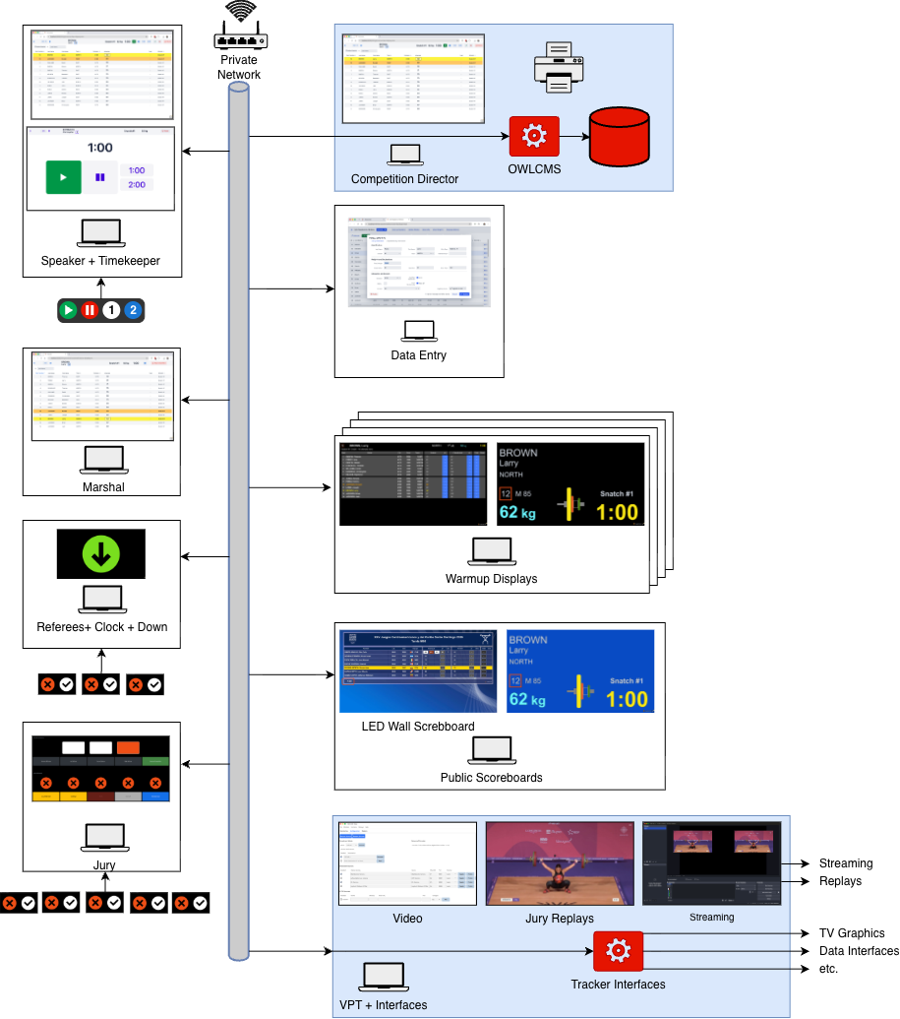
Figure 1: Solution Overview
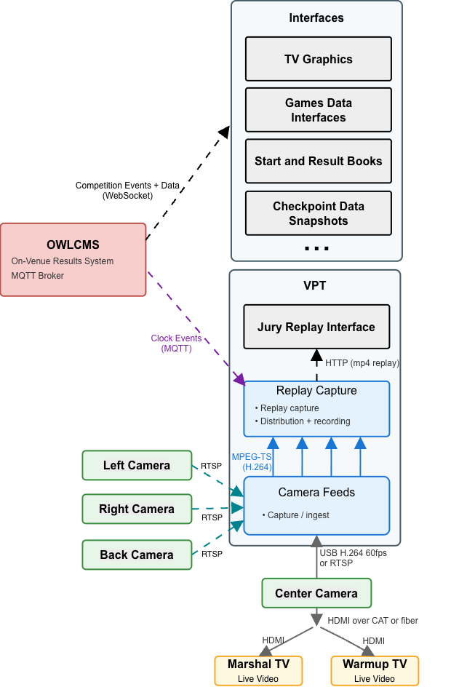
Figure 2: Detail: VPT and Interfaces

MP - Multi-platform Overlay
[RFP §2.1] Simultaneous platform operation with separation and capacity evidence.
OWLCMS has been used in actual competitions with up to 6 platforms simultaneously and 1600 athletes competing, with extremely low computer and network usage.
When running multiple platforms, a single instance of OWLCMS runs them all together, and no integration step for results is required. All results and rankings are available live for all platforms. The normal constraints expressed in TCRR (group B should finish before group A for a given category) should nevertheless be respected so coaches get meaningful information.
The program is verified with a stress test that simulates competition updates as fast as possible in real life, using the entry totals to generate credible lift values. Any competition can be simulated as soon as preliminary registration data is available to confirm expected performance and validate reports

Licence certificate
IWF is expected to issue a license to supplier to confirm certification.
If selected, [Supplier] will provide the following information for such a certificate to be issued.

Supplier and product
[RFP §2.2] The licence certificate shall state the supplier and product.
The supplier of the product shall be [Supplier], who will act as integrator of the OTIS solution and any additional components required to meet the claimed profiles as per requirements.

Exact baseline
[RFP §2.2] The licence certificate shall state the exact baseline.
Any stable version of OWLCMS after version 69 is claimed to meet the current requirements and is fully compliant with TCRR as published at the time of this tender. Any version of the Blue Owl software after version 3.0 meets the requirements. Baseline will be established at acceptance and evolve according to section K.1.2.

Approved profiles and capacities
[RFP §2.2] The licence certificate shall state approved profiles and capacities.
M2 and MP profiles: The system complies with the M2 and MP profiles, up to 6 platforms. For the purpose of this license, the number of participants shall be 1800 or less. There is no intrinsic limitation on the number of participants; this number is given as a safe, previously observed figure with a margin of safety.
M3 profile: Integration capabilities with external systems are intrinsic; actual integration and testing with external systems are not included in this proposal. There are no exclusions preventing IWF from providing the live integration feed to a qualified party.

Interfaces and critical dependencies
[RFP §2.2] The licence certificate shall state interfaces and critical dependencies.
The system has no critical dependencies. All communications use the standard HTTP and MQTT protocols.
The specific MQTT messages used for the devices are fully documented. The physical interfaces for devices are USB and RJ-45 connectors. Only commercially available cabling (CAT-6, USB 2.0, HDMI) is used.
The protocol used to create additional interfaces for Data Exports, TV Graphics, etc. is public and has a published reference implementation.

Limitations and deviations
[RFP §2.2] The licence certificate shall state limitations and deviations.
See section B.3.3 for context on profile M3. No limitations on profiles M0, M1, M2 and MP.

Validity and surveillance conditions
[RFP §2.2] The licence certificate shall state validity and surveillance conditions.
The certificate will be valid for 4 years after date of issuance.

Software
Modules, versions, rule-pack approach, database, interfaces, deployment and update model.

Software, Data and Interfaces

Software

Implement the effective IWF rule pack and support controlled updates
[RFP §6.1] Implement the effective IWF rule pack and support controlled updates.
The solution is tested against the TCRR rules using automated tests. OWLCMS has over 350 automated tests covering rules, reports and program behaviour. Any new release is tested against regressions.

Competition-critical functions shall not depend on unavailable internet, licence-server or payment services.
[RFP §6.1] Competition-critical functions shall not depend on unavailable internet, licence-server or payment services.
Once downloaded, the solution is completely autonomous and works with no internet connection whatsoever

Exact production version, configuration, database schema, rule pack and relevant assets shall be identifiable and reproducible.
[RFP §6.1] Exact production version, configuration, database schema, rule pack and relevant assets shall be identifiable and reproducible.
Releases are created by a fully repeatable automated build process, and under strict version control. This applies both to OWLCMS and the Blue Owl components. All past versions and the source code used to build them are available.

Installation and rollback shall be documented and repeatable
[RFP §6.1] Installation and rollback shall be documented and repeatable.
OWLCMS is launched by a control panel that allows switching between versions. Within a major version, the database can be rolled back if a fix release is unsatisfactory. Fix releases can always read exported prior data so they can be tested independently. Emergency installation of a fix is a matter of seconds once the fix release is downloaded. The OWLCMS program runs on any available Windows, macOS or Linux computer, and the database exports are completely portable, so any available computer can be used for testing.

Automatic updates shall not occur during an event freeze unless approved
[RFP §6.1] Automatic updates shall not occur during an event freeze unless approved.
The system does not perform any type of automatic update. Operating system updates shall be managed by duly authorized personnel according to supplier procedures; they are not under the control of the solution.

Data integrity and authoritative state

Every sporting fact shall have one declared authoritative owner
[RFP §6.2] Every sporting fact shall have one declared authoritative owner.
Any change to the competition state is uniquely attributed to a human actor, to a device input, or to an automated calculation. The audit log reflects this attribution.

Derived screens, feeds, documents and caches shall be traceable to the accepted state
[RFP §6.2] Derived screens, feeds, documents and caches shall be traceable to the accepted state.
All computed results are directly attributable to programmed rules based on the authoritative data.

Corrections shall be authorised, atomic, attributable and propagated
[RFP §6.2] Corrections shall be authorised, atomic, attributable and propagated.
Once the competition has started, all changes are meant to be made using the interactive interfaces or the explicit import features of the programs such that audit traces are kept. Database state that does not correspond to audited actions is evidence of tampering. Should intentional exceptional corrective actions by the supplier requiring database queries or similar be necessary, the corresponding authorizations are expected to be managed separately as part of incident response.

Duplicate, lost, conflicting or out-of-order transactions shall be prevented or detected.
[RFP §6.2] Duplicate, lost, conflicting or out-of-order transactions shall be prevented or detected.
The system applies strict sequencing for all events, whether device-generated or human-generated. Duplicate events are eliminated.
Conflicting updates from technical officials are detected and reported (e.g., competition supervisor and marshal both attempting to correct an error). The marshals cannot accidentally interfere with the data updates resulting from a refereeing decision (the athlete card is closed when a decision is received). Athlete registration information cannot be edited while a session is in progress. Likewise, the features that enable post-session athlete card corrections are blocked until the session is over – during a session only the marshal and director pages can edit the athlete cards.
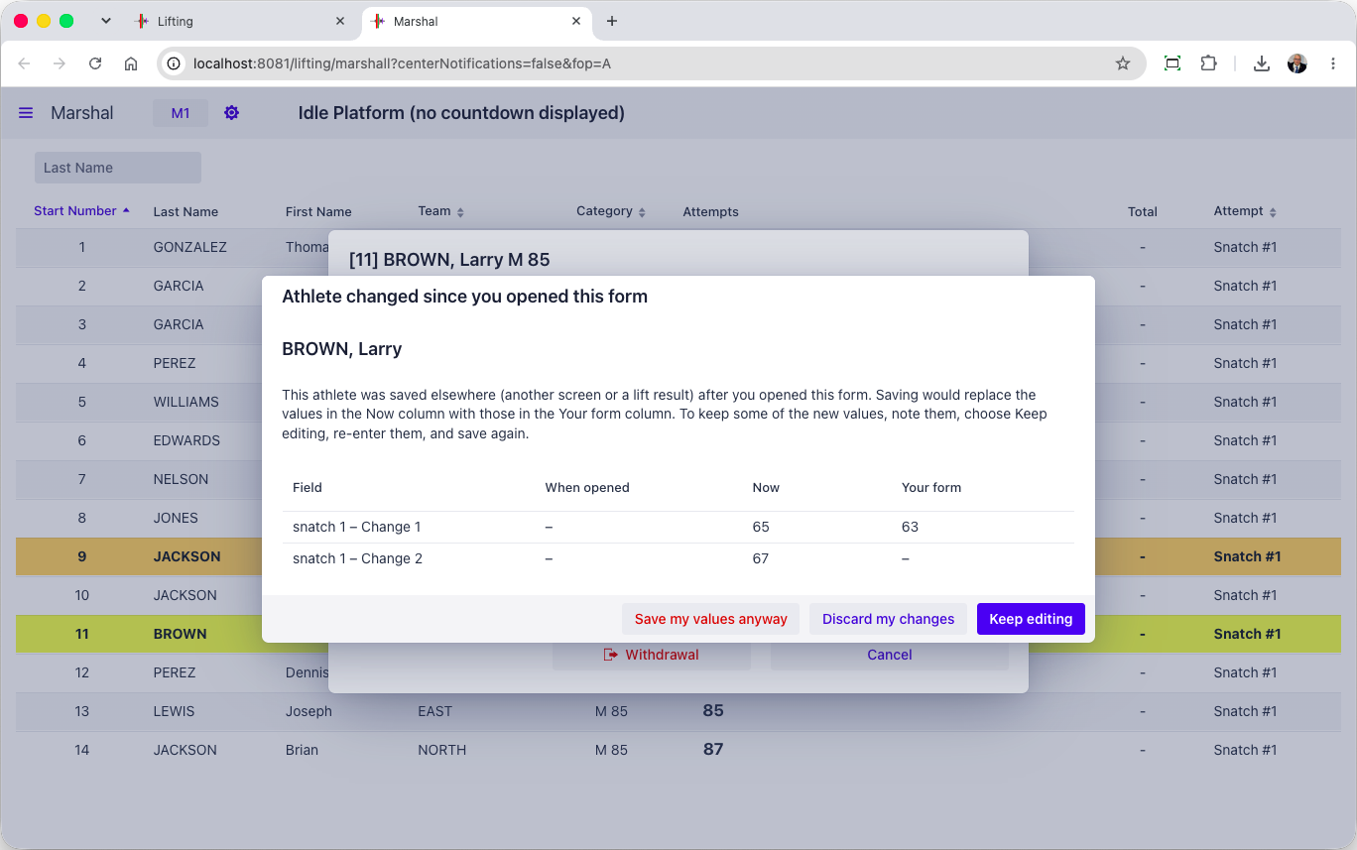

A complete machine-readable event export shall be available to IWF
[RFP §6.2] A complete machine-readable event export shall be available to IWF.
The database export contains all the event data in structured JSON format. The audit logs are also machine-readable.

Third-party dependencies
[RFP §6.4] All third-party software, libraries, services, licences and hardware necessary for operation shall be declared, including version, ownership, support status and cloud/public-internet dependency.
All third-party software, libraries, services, licences and hardware necessary for operation shall be declared, including version, ownership, support status and cloud/public-internet dependency.

OWLCMS dependencies
OWLCMS is written in Java. The full dependencies for OWLCMS are listed in the following files.
- https://github.com/jflamy/owlcms4/blob/dev68/pom.xml
- https://github.com/jflamy/owlcms4/blob/dev68/owlcms/pom.xml
All the dependency files are found in the industry-standard “Maven Central” repository for Java dependencies. Any past version of the software can be recreated because this site contains the full historical record of the libraries. The build process for OWLCMS is entirely automated and repeatable.
The main libraries in use are as follows. All these libraries have been at the core of the program since at least 2019. We have applied all relevant security fixes to these libraries
- The current long-term support version of the Vaadin user interface toolkit; currently version 25.2.7. Vaadin is a Finnish company that has been releasing User Interface kits since the early 2000s. Vaadin is used in industrial-strength applications, mostly in the financial, banking, and governmental sectors, and was chosen for its stability and flexibility.
- Hibernate data access library, version 5.6.15.Final
- H2 relational database, version 2.1.124
- Eclipse Jetty Web Services, version 12.0.4. OWLCMS uses this to provide HTTP services
- Eclipse Paho MQTT library (version 1.2.4). This is used to provide device connections.
- Google Guava library for event distribution (version 33.5.0)
- Apache POI library for generating Excel spreadsheets (Version 4.1.2)
- jxls library for creating templates of Excel files for report generation using Apache POI (version 3.0.0)
- logback library for writing journals and logging information
- The standard libraries for Java (currently version 25 LTS – long-term support)
The libraries outside this list are utilities and do not represent architectural commitments (they can be substituted).
Because of the need to follow browser and mobile device evolution, and to prevent security issues, OWLCMS tracks major versions of the Vaadin library as they are released roughly every year. Updated versions of the software would be made available to IWF accordingly. OWLCMS is stringently tested for backward compatibility with a large automated test suite.

Blue Owl Dependencies
Blue Owl is a Node.js application that connects the refereeing devices to OWLCMS. As such it depends on one main library to interact with the devices.
- The Firmata library johnny-five, version 2.1.0 (https://github.com/rwaldron/johnny-five)

Video Playback Dependencies
- The VPT module delegates all the actual video work to the very widely used FFmpeg software. On Windows the build used is the current stable version 9.0 (https://github.com/BtbN/FFmpeg-Builds/releases/download/latest/ffmpeg-n9.0-latest-win64-gpl-shared-9.0.zip)
- The specific version of FFmpeg used may change in the future depending on what graphics processor is present in the graphics processing laptop, and how device drivers evolve. Using FFmpeg isolates us from the compatibity details.

Hardware
Equipment list, specifications, quantities, spares and lifecycle/support information.

Hardware and Field-of-Play Requirements

Servers / control compute
[RFP §5] Controlled capacity for authoritative state and approved services, with spare/recovery path.
OWLCMS is extremely efficient in memory, input-output and networking. As a reference, the standard OTIS kit has been tested to run 1600 athletes on 6 simultaneous platforms on a 8GB Raspberry Pi5 mini-PC.
Two machines in this proposal qualify as servers, as shown in Figure 1.
- The main station OWLCMS server. This proposal uses a standard 16GB Windows laptop with a SSD disk for running OWLCMS. That station is used by the competition supervisor, and includes Microsoft Office.
- The VPT and Interfaces server. This is a high-end gaming laptop configuration with the capability to run full live video processing for many feeds. The laptop meets the standard for the commercial vMix video software, as a provision for eventual broadcast-level processing.

Operator stations
[RFP §5] Dedicated, role-controlled competition administration and operation positions.
The competition supervisor uses the main station as his operator station. In a multi-platform setup, only one director station will run the OWLCMS software, and the others act as server redundancy.
The other Operator stations are only required to run two browsers as a maximum. The proposed configuration is from the field-tested OTIS kit. Stations are 8GB Raspberry Pi 500s that are cost-effective, easily replaceable, guaranteed to be in production until at least 2036, and designed for use in difficult environments such as classrooms. Operator stations use portable screens that can be replaced if broken.
The USB ports on the operator stations are used to connect the Blue Owl refereeing devices, as shown in Figure 1 above.
Keyboards with numeric pads will be provided for the Marshal and Data entry stations.

Database / storage
[RFP §5] Protected authoritative storage, backup and tested recovery.
A fully relational database called H2 is used. H2 has been used without a single data integrity failure since the initial versions of OWLCMS in 2009, and is extremely quick. The database sizes of a full competition are very small (typically well below 2MB). Furthermore, since OWLCMS preserves the ordering of all events, and the number of data entry operations is very low, there is very little concurrency. The only significant queries are for results production but most of the data fits in main memory for caching.
The actual H2 binary file can be kept and is machine-independent, in addition to the structured JSON exports. The exports is the primary means of backup and snapshot. A readable consistent snapshot can be obtained at any time from the competition supervisor station. The laptop that implements the interfaces can also pull a snapshot on demand, as a quick recovery capability.
In a single platform scenario, the VPT+interface laptop acts the spare for the OWLCMS server.

Referee controls
[RFP §5] Three independent red/white referee control devices.
The Blue Owl referee controls include the two buttons, a visible LED, a sound, and a vibration for warning the referees. Referee controllers are cabled in order to avoid any concern with batteries.
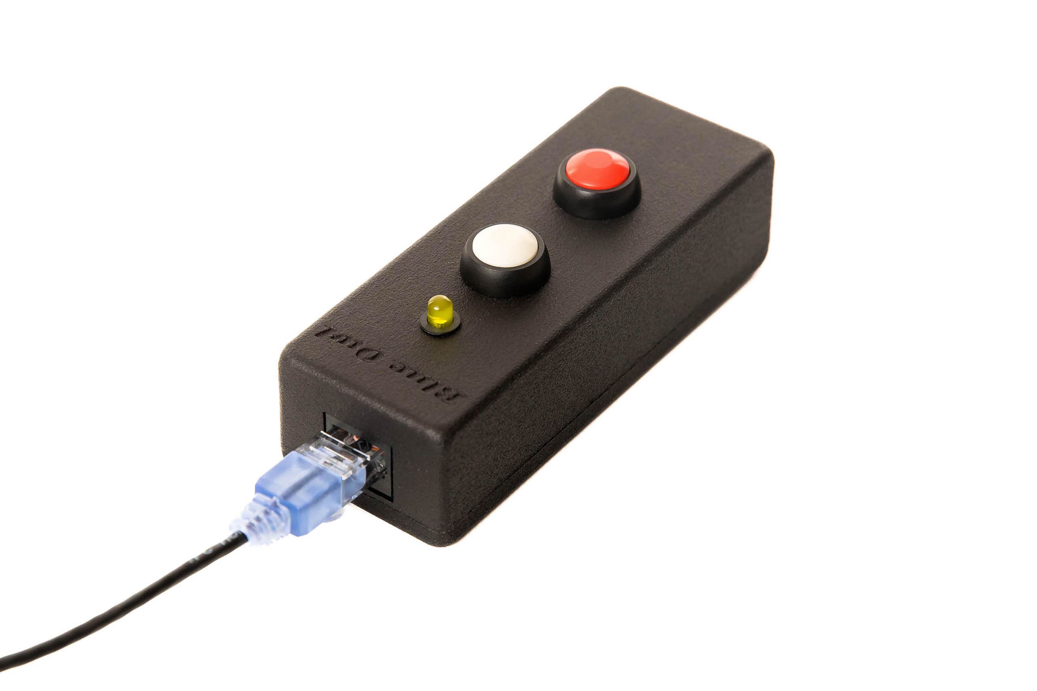

Jury controls
[RFP §5] Individual devices for applicable Jury members plus President controls.
Jury controls for jury members are the same as the referee controls, but without the warning features. Referee controllers can be used as backups for jury controllers (the warnings would simply not be emitted).
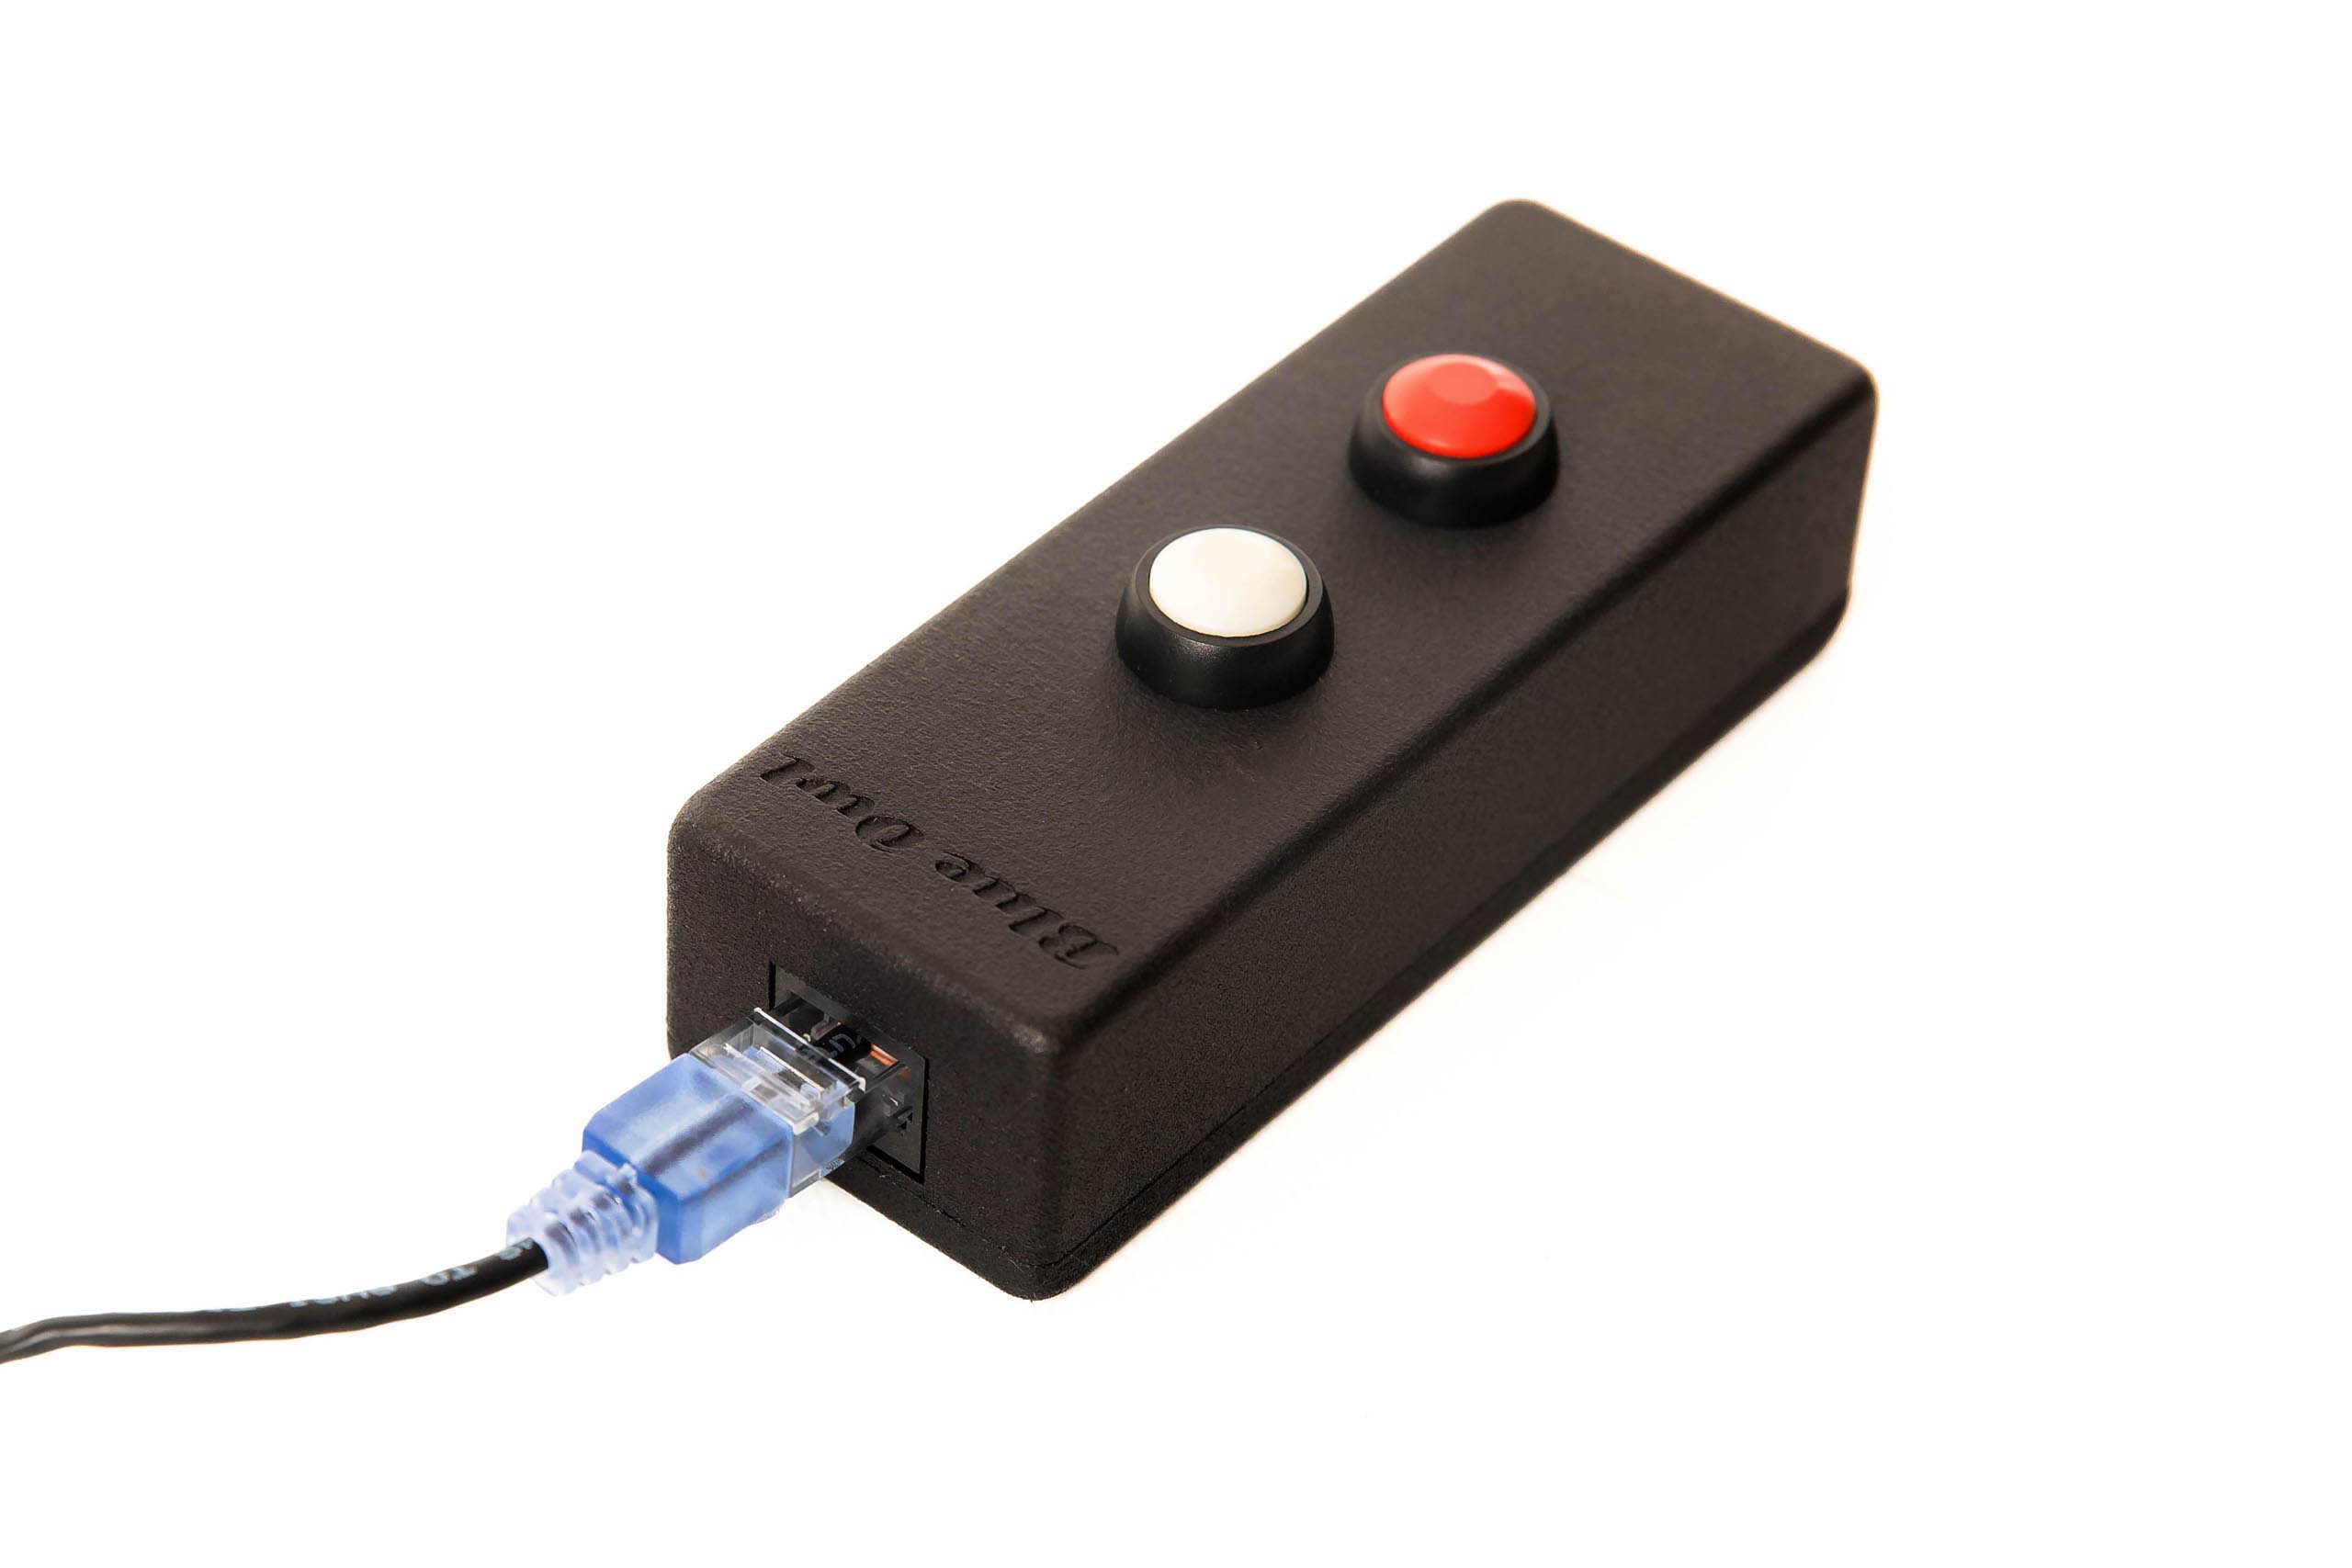
President controls are of two kinds. The solution includes a physical keypad with all the required real-time referee decision display and the required jury member behaviour (green until all decisions visible)
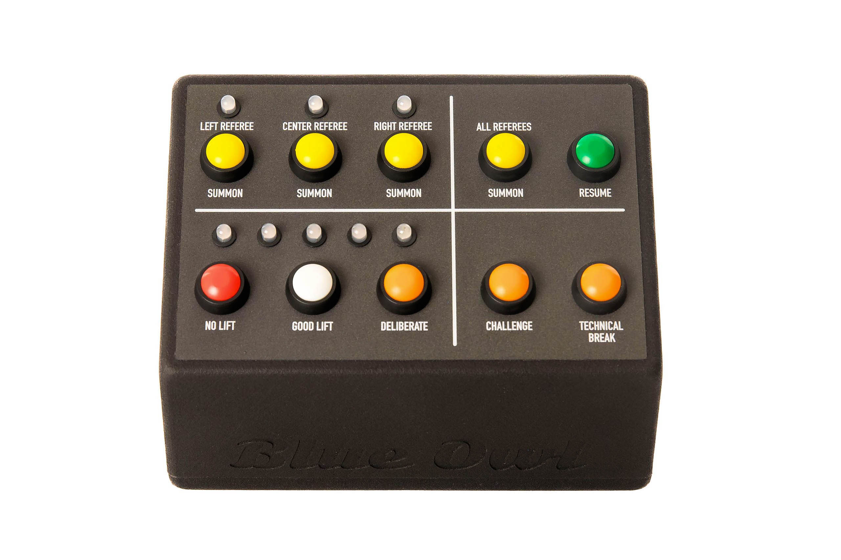
The jury station will also have a tablet-style display that allows the jury president to indicate the reason for lift reversal.

Timing
[RFP §5] Authoritative timer/controller with approved displays and audio.
Timing is done on the main server using the operating system timers. Operating system timing resolution is 1 ms as used. Propagation times of MQTT messages is typically under 10 ms.
Time is displayed on an athlete-facing display, on the attempt boards, and on scoreboards. Each machine with displays attached is synchronized with the OWLCMS computer and receives the millisecond timestamps at which OWLCMS emitted the command. In this way, the propagation delay (even though it is very small) can be compensated.
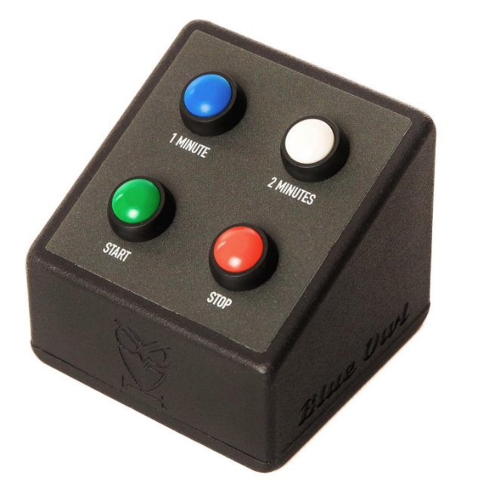
Timer warning and time-over signals are emitted on the down-signal device and logged in the audit log (for example, to determine if the timekeeper stopped the clock before or after the time-over buzzer).
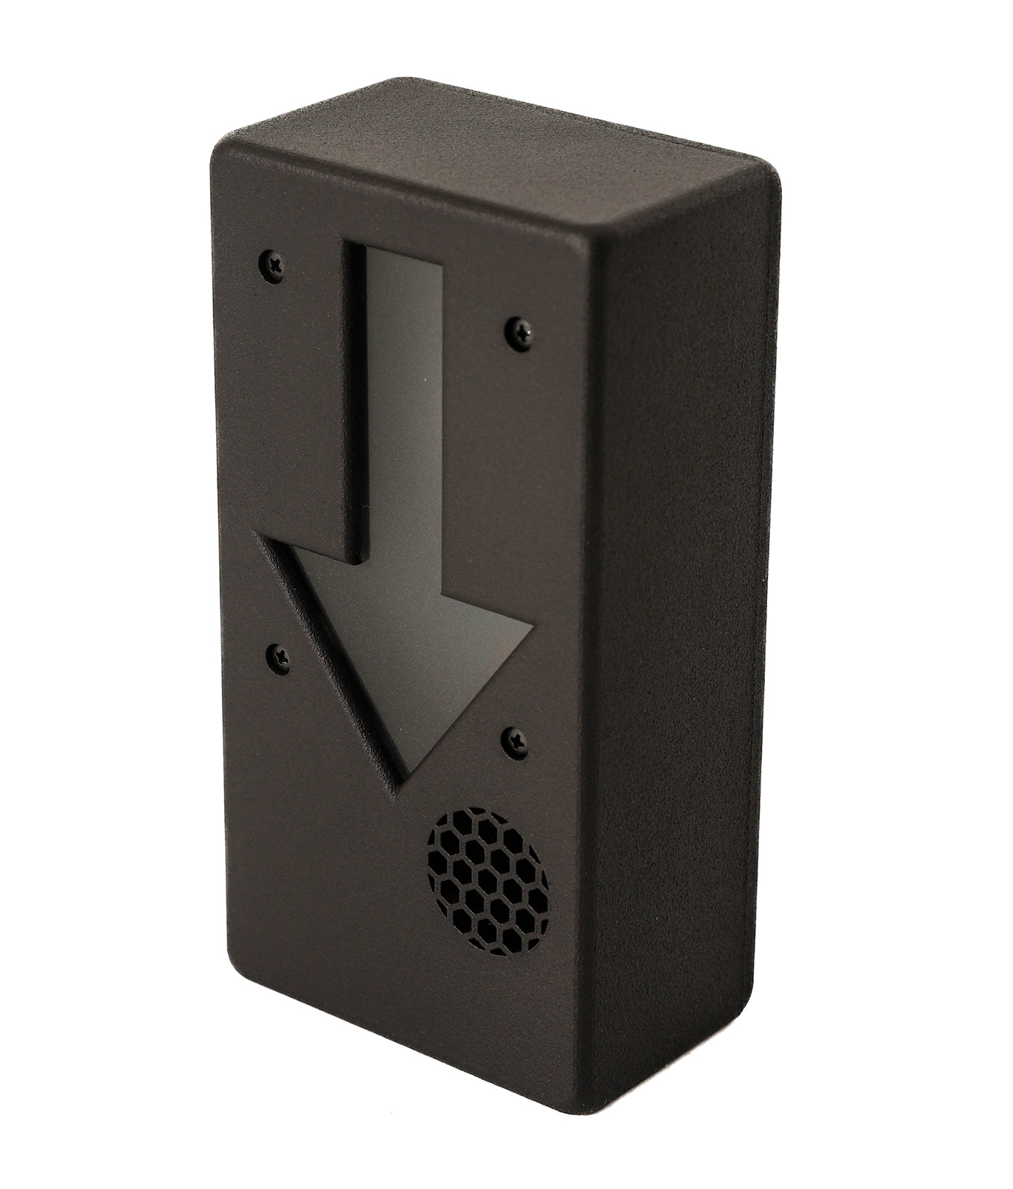

Attempt boards
[RFP §5] Competition and warm-up presentation with mandatory athlete/attempt/weight/clock/decision data.
Attempt boards are standard FullHD or 4K TVs with HDMI inputs. The actual TV screens are to be provided locally and are not part of the certified kit.
As shown in Figure 1, there are two computers running standard web browsers that provide the attempt boards as HDMI outputs. The Vaadin library sends live field of play updates to these browsers over a WebSocket, there is no polling
- The first attempt board output is for the front room and is styled to match the event colour scheme (this is a simple documented action during event setup). A splitter is used to feed one attempt board on each side of the platform.
- The second attempt board output is the normal high-contrast OWLCMS board and is used in all back-room areas (waiting, marshal, warmup).
The kit includes splitters and extenders to reach the typical waiting, marshal and warm-up areas located immediately behind the main platform. Further splitting or extension of the signal to reach multiple attempt boards will use HDMI or SDI equipment obtained locally.
Scoreboard and attempt board connections for the main room would be as illustrated in Figure 3. Figure 4 illustrates the back-room connections for scoreboards and attempt boards.
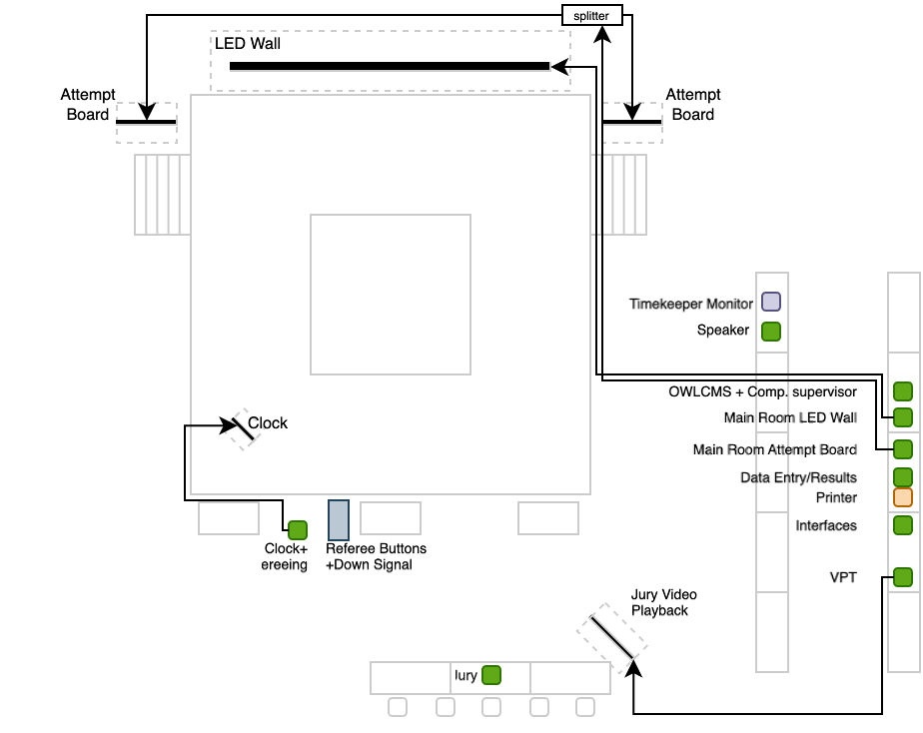
Figure 3: Main Room Scoreboard/RTDS Connections
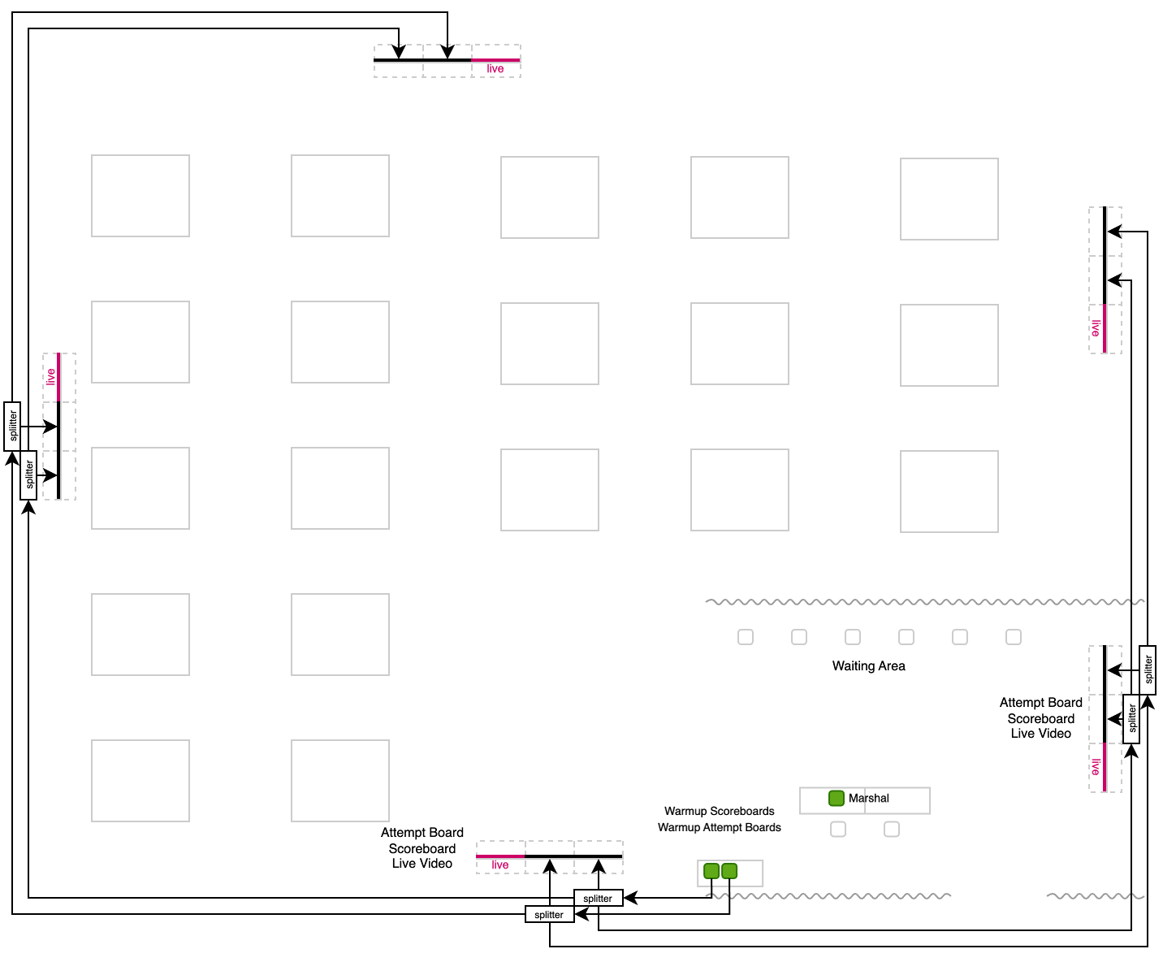
Figure 4: Warmup Room Scoreboards/RTDS Connections

Scoreboards / RTDS
[RFP §5] Real-time competition and warm-up displays with correct ranking and state.
The situation for the scoreboards is the same as for attempt boards. There are two HDMI sources, one for the stage area, one for the back. For the stage area, the video signal is assumed to go to a single large LED scoreboard.
Refer to Figure 3 and Figure 4 for details.

VPT
[RFP §5] Approved cameras, recording/replay and Jury output for events requiring VPT.
The VPT system is under the full control of the competition staff, and the TCRR-mandated angles can be displayed in self-service mode by the jury if so required (or provided by the competition supervisor).
As indicated in TCRR, the replay clips are accessible by the venue video team and broadcast teams. Such access will be controlled by networking equipment configurations.
The VPT system relies on four PTZ cameras. Based on our experience in Continental competitions, we propose Tenveo PTZ 60fps cameras. These cameras provide Power-over-Ethernet RTSP video feeds, HDMI, and compressed H.264 USB feeds.
OWLCMS has a VPT module that automatically clips and attributes the replays to the athlete lifting. This module keeps a full indexed archive of all the lifts, at all angles.
The VPT will execute on a high-performance laptop that also meets the requirements for the vMix software. If a client federation wants to add such additional video-processing capabilities, the proposed equipment will be sufficient for them to use their own license on the video-processing laptop.

Network
[RFP §5] Documented, segmented, monitored event network with common time.
The networking configuration is based on switching. The only specificity is that a minimum of 4 POE (Power-over-Ethernet) ports is necessary for VPT Cameras. Connectivity for VPT cameras is presented separately in section [To be Completed].
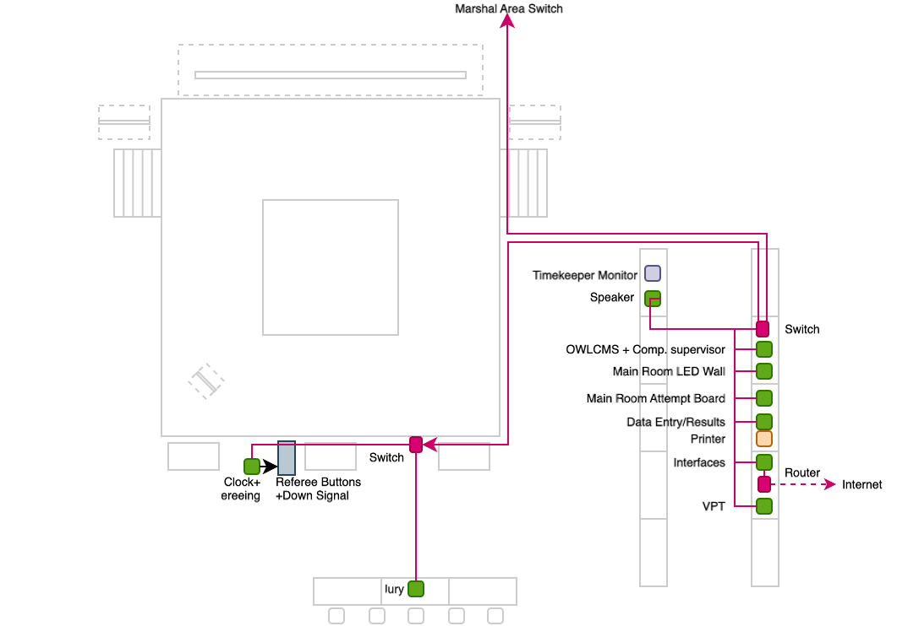
Figure 5: Main Room Networking
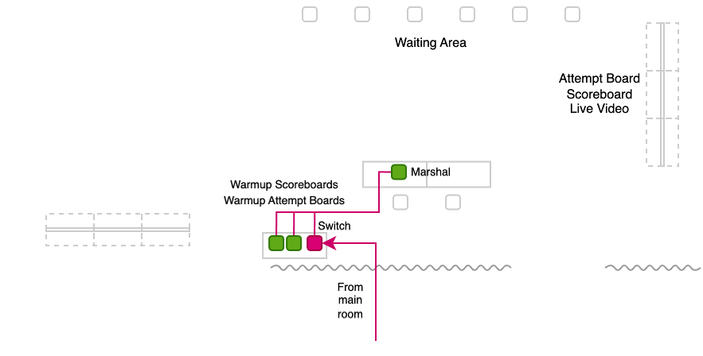
Figure 6: Back-room Networking
All the machines on a given platform are connected to a switch on that platform. OWLCMS networking traffic is minimal. The application is routinely used in a cloud configuration with very remote servers and no perceptible delay.
In secured installations, only the Interfaces computer is connected to the outside world, and the competition computers are not on WiFi.

Public / broadcast gateways
[RFP §5] Controlled read-only path from accepted state to approved consumers.
Production of broadcast-quality TV Graphics takes place on a specific laptop with the required graphical capabilities.
In most circumstances, the same laptop will be able to handle the external interfaces – sending information out to Games Central is very low usage (and ODF protocols are push-only). Adding a second laptop for event-specific interfaces does not change the proposed solution in any meaningful way.
At an M2 event, a broadcaster may judge that the OWLCMS scoreboards and lower-thirds are sufficient and request an external connection to access them. OWLCMS already has built-in restrictions for such access once connectivity from a specific address has been whitelisted and established at the networking level.

Printing
[RFP §5] Reliable official documents with fallback.
A Windows laptop with Microsoft Office is used for data entry and report generation to maximize compatibility with whatever printer the event organizing committee provides. OWLCMS produces documents in Excel format. For archival, export to PDF in read-only mode can be performed by the competition staff.
Start books, Result books, Refereeing schedules and similar layouts are produced directly as PDF. For M3 events, the production of these documents is typically customized specifically for the event.

UPS / protected power
[RFP §5] Protection and approved autonomy for critical equipment.
UPSes will protect the networking switches in the front and back room so the marshal and competition supervisor can still capture changes and perform timing during a short power outage, relying on their laptop batteries.
When local conditions include frequent brownouts, it is expected that events will provide external full site power protection (e.g., generators)

Monitoring / logging
[RFP §5] Health, service, device, storage, time and stale-state monitoring.
The OWLCMS software has very low memory and disk I/O requirements. A dedicated log captures the memory and CPU usage from the program runtime every 30s. I/O and networking are tracked by the normal operating system utilities.

Spares / recovery media
[RFP §5] Rapidly deployable replacements for critical equipment families.
In the proposed configuration, all operator stations are standard Windows laptops with a minimal standardized configuration that can be substituted at any time.
The special configuration machines are the Competition (better CPU, Microsoft Office) and the machines doing video processing (VPT or TV Graphics) with a sufficiently powerful GPU.

FOP installation
[RFP §5] Safe, labelled cabling and equipment placement without obstruction or sightline conflicts.
Networking cables coming into the 3 switches (main table, refereeing switch and marshal switch) will be pre-labelled with their origin. Cables that cannot be pre-labelled will be labeled on-site (e.g., the cable from the main room to the marshal area).
As illustrated in Figure 3 to Figure 6, cabling is routed along or under the stage whenever possible.

Hardware inventory
[RFP §5.1] For each licensed event, the supplier shall maintain make/model, quantity, serial or asset ID, firmware, location, connections, power source, owner, health status, spare path and approved deviations.
Refer to Appendix 1 for the list of components.
.

Competition functionality
Lifecycle, officiating, timing, displays, outputs, results and archive.

Minimum Functional Requirements –
The proposed solution fully complies with TCRR and meets all the RFP requirements. Details are provided for each item.
Sections E.2.3 and E.2.4 provide concrete examples of the application screens and outputs.

Data Intake
[RFP §3] Import and validate athlete, federation/NOC, official, event, venue and record data; stable IDs and error reporting.
Registration data is converted to an Excel-style sheet with the athlete identifier, name, and lifting data. The input format handles multiple age groups and supports team allocation. The intake format can be exported, edited offline, and re-ingested without loss of information.
The same applies to schedule changes and referee assignments that can be modified in spreadsheet form until the drafts are considered stable.
All information is stored in a relational database. The program performs validation when loading to ensure integrity.

VFE / Technical Congress
[RFP §3] Corrections, approvals, random lots, grouping, timetable and Technical Official assignments.
The program prints VFE verification sheets that show exactly which athlete is in which category or categories (see section E.2.4.2). This allows the competition supervisor to verify that eligibility rules have been respected, and to know in advance what information will be required at VFE (e.g., which teams need to remove substitute athletes from their roster). The program also prints team membership sheets to verify that all team allocations are correct. Team representatives can sign these sheets to support the VFE process and reduce errors. The TIS team uses these sheets for data capture.
The database includes a list of technical officials and their team assignments. The uploaded referee team timetable can be edited interactively. In addition, individual assignment changes can then be made as required (e.g., substituting one referee for another for a given session). See Section E.2.3.2.3.

Start publication
[RFP §3] Approved Start List and controlled distribution/versioning.
Fully formatted start books are produced. See section E.2.4.2.2 for examples. A preliminary version can list participants in each category, with subsequent revisions adding the schedule and officials’ assignments. There are also spreadsheet formats for the actual schedules and start lists for convenient publishing.
Records are loaded in OWLCMS using a spreadsheet (they are converted from the data made available by the federations).
For convenience, individual documents are available for the competition schedule, for referee assignments, for start lists, etc.

Weigh-in
[RFP §3] Correct timing, bodyweight, first attempts, 20 kg checks, start numbers, signatures and closed snapshot.
OWLCMS produces field-tested weigh-in forms to capture both the weight-on-scale and deducted weight. The form captures all the required signatures. See section E.2.3.4 for screens and E.2.4.3 for documents. Compliant athlete cards are printed (see E.2.4.4)
During data entry, all applicable rules are checked by the pro, including 20 kg and qualifying totals where applicable. A special data entry mode is used for quick capture of weigh-in data.
Start numbers are assigned by the program at the end of weigh-in so they can be checked against distributed bibs. The program produces a speaker introduction sheet for athletes and officials, as well as empty protocols and jury member sheets.
The competition supervisor takes a snapshot backup copy of the database at this point.

Snatch
[RFP §3] Calling order, declarations/changes, 60/120-second timing, referee decisions, records and live outputs.
The system fully complies with the competition flow.
All marshal data entry is immediately handled by the system and all lifting order or requested weights are instantly updated on all displays and scoreboards. Referee decisions and jury reversals are automatically handled, and all scoreboards and attempt boards are immediately updated.
All the normal flow timing decisions are automatic (the clock is automatically set to the right allocated time for each athlete, including on fast sequences of changes). Only explicit loading incidents require the use of the 1:00 or 2:00 reset buttons.
The 20 kg rule is systematically checked and any deviation is explicitly visible to the marshal (including the necessary amounts for corrections). See section E.2.3.5.
Records attempted are shown as such (see section E.2.3.15), and any record improved is registered in the competition database.

Break
[RFP §3] Controlled Snatch-to-Clean & Jerk transition and synchronized displays.
Transition from the snatch to the clean & jerk break at the end of the snatch is automatic. Jury deliberation or challenge on the very last snatch lift is correctly handled (the snatch is not done until resolution).
Default rules for longer breaks (few athletes) and shorter breaks (large sessions) may be given as part of the event-specific rules. Break durations can also be changed during the meet, at any time before the break start. Break duration can also be set at break time in case of a last-minute change.

Clean & Jerk
[RFP §3] Calling order, weight changes, 20 kg enforcement, totals, ranks and records.
See section E.1.5 Snatch; the Clean & Jerk flow is completely automated in the same way.

Review / correction
[RFP §3] STOP, Jury, challenge/VPT where applicable, additional attempts, correction, withdrawal and restart.
The jury can start a deliberation or accept a challenge using a physical jury keypad button or using on the jury control display. A flashing STOP sign is shown to the athlete on the platform, and all attempt boards and displays indicate the interruption. Transmission of the jury reversal code to the speaker can be done the traditional way (by the technical controller), or automatically when the jury president chooses the reversal code. In either case, the jury or challenge decision is shown as the speaker announces it. See section E.2.3.10.
The system can optionally display jury decisions on the scoreboards and the attempt boards (like IWF has been doing experimentally in its own championships). This is optional as it is not part of TCRR.

Results approval
[RFP §3] Protocol reconciliation, signatures/status, results, classifications and records.
The session protocol sheet is available immediately after the session for signature by the jury president. It contains all results, ranking information and each occurrence of improved records.
Should any correction be required, the athlete card can be adjusted from the results page, with full traceability in the audit log. Errors in registration data (for example, wrong eligibility for a record) can be fixed in the same way, and records re-computed prior to emitting an amended protocol for signature.

Ceremony / publication
[RFP §3] Medallists, public/broadcast outputs, communications and revised outputs.
At the end of a session, a medal sheet is available for the speaker. The medal sheet correctly reports the categories that are actually finished (important when A and B groups from different bodyweight categories are together in the same sessions). Combined category results are also available (showing the ranking for all combined A/B/C… groups)
The system has special purpose scoreboards for ceremonies.
- Public scoreboards are styled to match the event colours. They automatically switch to a start list during introductions. During medal ceremonies, the technical table selects which category is receiving medals so the display switches accordingly. See section E.2.3.16.
- Broadcast-oriented scoreboards are typically visually similar to public scoreboards but styled differently (typically a transparent format is used). If the video producer selects the medal display, it will track what the technical table selects as the current medal ceremony.

Archive
[RFP §3] Final dataset, official outputs, logs, revisions, evidence and machine-readable export.
The full database content is exported in JSON format. This format is suitable for archival – OWLCMS can read archives produced several years ago.
The archived documents should also include
- A “final result package” in Excel format (all categories, best athlete rankings, team points, medals)
- A spreadsheet document with the protocol content for all individual sessions
- The full “publication format” formatted PDF results book
- The audit logs

Core sporting logic
The core sporting logic is implemented using a state automaton. This technique defines all permissible field-of-play events and what the permissible outcomes are when a given event happens. All human inputs and device inputs are such field-of-play events. Likewise, the state automaton issues the user interface updates required on all displays, stations and devices.
The state automaton relies on a large number of computation rules (regulations, order, points and ranks, timing rules, etc.) OWLCMS includes over 350 automated tests that exercise the core sporting and reporting logic. Any change in the application can therefore be checked to ensure that these rules have not been unintentionally affected.

Snatch followed by Clean & Jerk, maximum three attempts per lift, correct Total calculation.
[RFP §3.1] Snatch followed by Clean & Jerk, maximum three attempts per lift, correct Total calculation.
The database explicitly stores 3 attempts per lift and the associated information. The state automaton enforces the sequence. The total calculations comply with TCRR rules are subject to automated tests.

Whole-kilogram weights and applicable minimum starting weights
[RFP §3.1] Whole-kilogram weights and applicable minimum starting weights.
The database explicitly stores 3 integer values for the weights. The 20kg rule is systematically verified on any declaration or weight change. The 20kg rules have their own suite of automated tests.

Correct calling order
[RFP §3.1] Correct calling order, including weight, attempt number, previous-attempt sequence and start number.
The calling order is explicitly programmed to determine the next athlete based on the 4 TCRR criteria. These rules have their own automated tests.

Permitted weight changes, final-call and consecutive-attempt rules
[RFP §3.1] Permitted weight changes, final-call and consecutive-attempt rules.
The state automaton remembers the athlete for which the clock was last started. It correctly resumes the clock at the correct remaining time value when several intervening changes bring back the lifting order to that athlete. The state automaton also determines correctly two-minute situations. The correct “1 minute only” rule is applied when the same athlete lifts twice in succession, but the clock has started on another athlete
Violations of the late-change delays are signalled to the marshal. The marshal can accept a change that, in their opinion, was signed in time but could not be typed in fast enough.
The system will also systematically detect and report violations when an athlete is moving down but should already have lifted. In order to do so, the system recomputes the full prior lifting order as it should have taken place, on every weight change.

Withdrawals, no-lift/no-Total conditions, disqualification and additional attempts
[RFP §3.1] Withdrawals, no-lift/no-Total conditions, disqualification and additional attempts.
The marshal screen has explicit buttons to declare withdrawals of either the snatch or both events. The computation rules correctly register failed lifts and compute no totals for bomb-outs. If an athlete is disqualified, the reason can be captured.
If an attempt is given again, and this results in the same athlete card field being rewritten, the audit trail will show the edition of athlete data. This can then be compared with the manual edits done on the athlete card.

Material corrections recalculate affected rankings, records and outputs
[RFP §3.1] Material corrections recalculate affected rankings, records and outputs.
Any change to the athlete card data for any athlete causes a recalculation of all affected ranks. Recalculation of records can be triggered on the records management page if there is a change posterior to the actual lift. Reports and result books can be regenerated on demand.

Timing, Officiating and Outputs

Timing

Authoritative electronic countdown in one-second increments, configurable up to at least 15 minutes.
[RFP §4.1] Authoritative electronic countdown in one-second increments, configurable up to at least 15 minutes.
Athlete countdown information is updated at one-second increments on the athlete-facing clock, on all attempt boards, and on scoreboards. Breaks can be set to any duration.

Automatic 60- and 120-second attempt clocks and applicable introduction/break countdowns
[RFP §4.1] Automatic 60- and 120-second attempt clocks and applicable introduction/break countdowns.
Clock ownership is automatic; no intervention is required to set the clock to 1:00, 2:00 or to the time remaining for the athlete.
The system has break countdowns prior to introduction, prior to first snatch and prior to first clean & jerk. A break management dialog in the user interface does the automatic transition between these countdowns, and also allows overriding the durations are required.

Correct start, stop, restart and STOP behaviour according to the rules
[RFP §4.1] Correct start, stop, restart and STOP behaviour according to the rules.
The timekeeper start, stop and restart behavior is according to TCRR.

All connected displays use the same authoritative time state within the approved tolerance.
[RFP §4.1] All connected displays use the same authoritative time state within the approved tolerance.
Time is kept on the OWLCMS server. All devices are time-synchronized to universal time. When a timer countdown is sent to remote browsers for display, the actual universal time on the server is included so the remote machine can determine how much propagation drift took place and adjust the countdown as needed.

Time corrections are authorised, recorded and auditable
[RFP §4.1] Time corrections are authorised, recorded and auditable.
All machines are configured NTP-synchronized at the operating system level, and an NTP source is configured on the network as part of the system setup. Time drift corrections are logged in the operating system journals. A manual resynchronization should be treated the same as an equipment replacement and logged manually by the competition supervisor, as a procedural requirement beyond the scope of the competition automated logs.

Referee and Jury

Three independent referee control boxes with white/red decisions and required indicators.
[RFP §4.2] Three independent referee control boxes with white/red decisions and required indicators.
Blue Owl referee buttons have visual indicator, sound, and vibration.

Correct majority/Down signal, reminder and reversal-window behaviour
[RFP §4.2] Correct majority/Down signal, reminder and reversal-window behaviour.
Implemented by the state automaton. 3-second reversal window is enforced as per TCRR. Should a late reversal be done using flags, the competition supervisor can easily perform the reversal. See section E.2.3.8 for an example of reversal.

Jury visibility of individual referee decisions before public reveal
[RFP §4.2] Jury visibility of individual referee decisions before public reveal.
Live referee decisions and reversals are shown to the jury both on the keypad and on the jury control screen. See section E.2.3.10 for exame

Support for approved three- and five-member Jury configurations
[RFP §4.2] Support for approved three- and five-member Jury configurations.
Jury size is selectable (3, 5 jury members or no jury)

Individual Jury decision controls and protected independence between members
[RFP §4.2] Individual Jury decision controls and protected independence between members.
Individual jury buttons are provided as per TCRR. Decision protection housings are not currently a TCRR requirement; [Supplier] would provide some acceptable housing after clarification of IWF expectations.

Material decisions and actions are attributable and time-stamped
[RFP §4.2] Material decisions and actions are attributable and time-stamped.
There is a full audit log of every single decision, timestamped to the millisecond, with the originating station or device.

Replays
To be added – Video Replay Capabilities

Screens and live presentation
The system is fully compliant with all these items. Details and examples for each item are given.

System health
[RFP §4.3] At minimum, the TIS shall provide System health.
A technical log of the system is constantly updated and can be monitored. This includes technical indicators on the environment, notably CPU and memory usage. The normal operating system gauges can also be used. Note that OWLCMS is typically well under 10% of CPU usage, and under 2GB of memory even for very large events, so the operating system gauges are usually entirely sufficient.

Event setup
[RFP §4.3] At minimum, the TIS shall provide Event setup.
All competition information setup is done using interactive screens. Green is used in the software to indicate common actions.
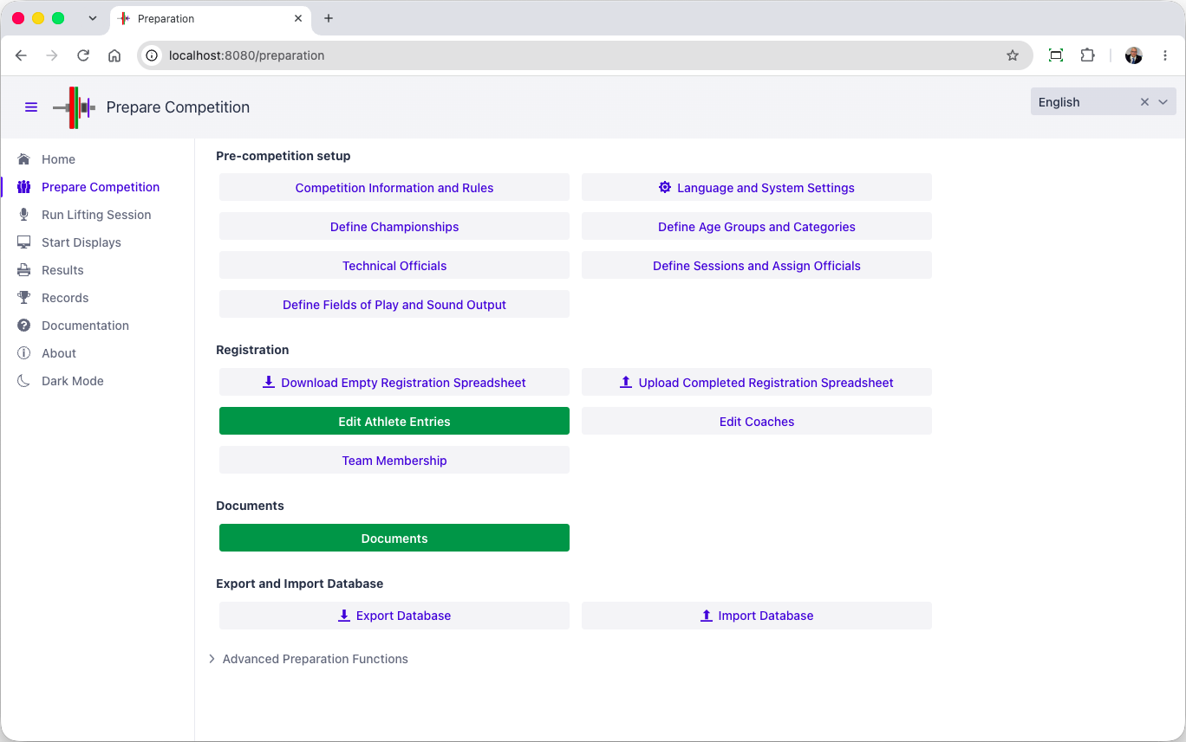

Competition Rules
The first tab concerns competition information and which federation homologates it.
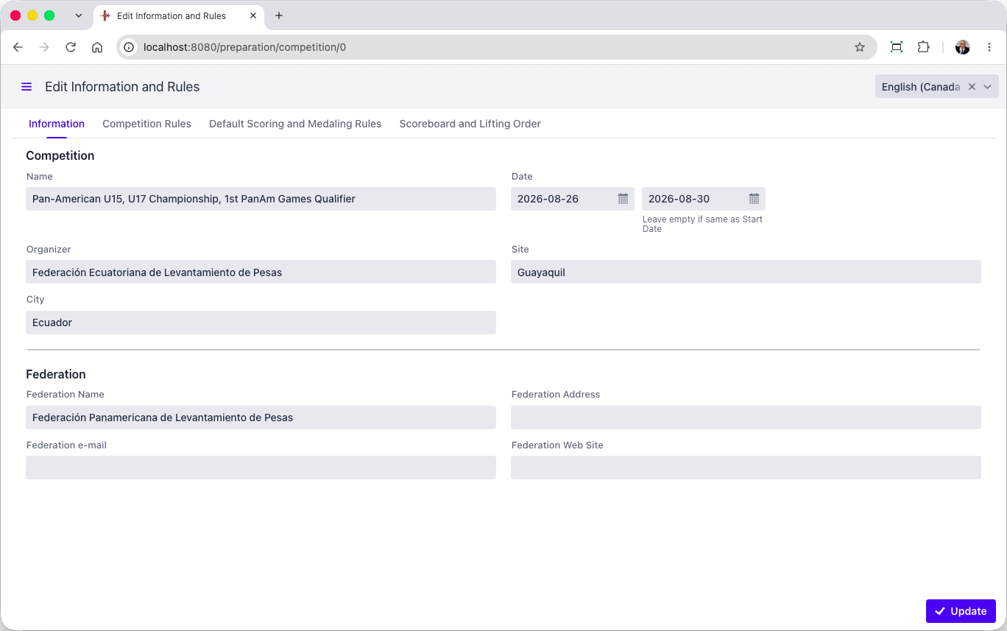
OWLCMS can manage multiple age group championships simultaneously, each with the appropriate medal rules, best athlete awards and team awards. OWLCMS supports mixed teams and the use of scores.
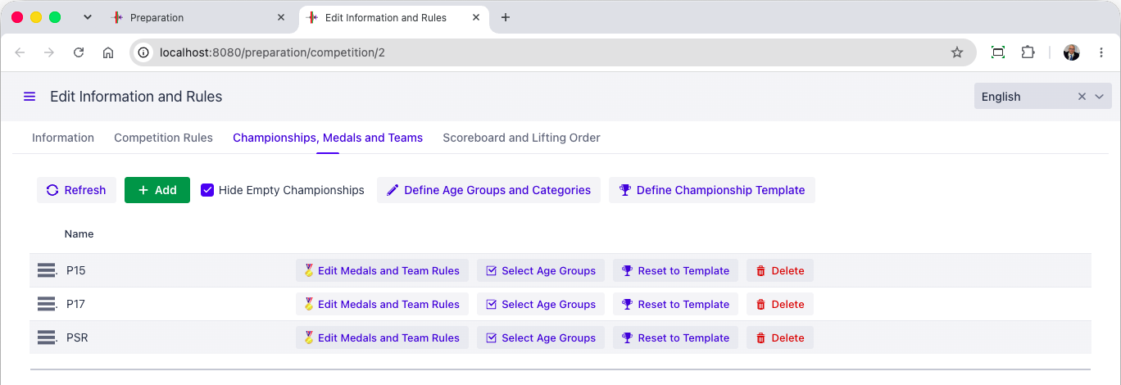
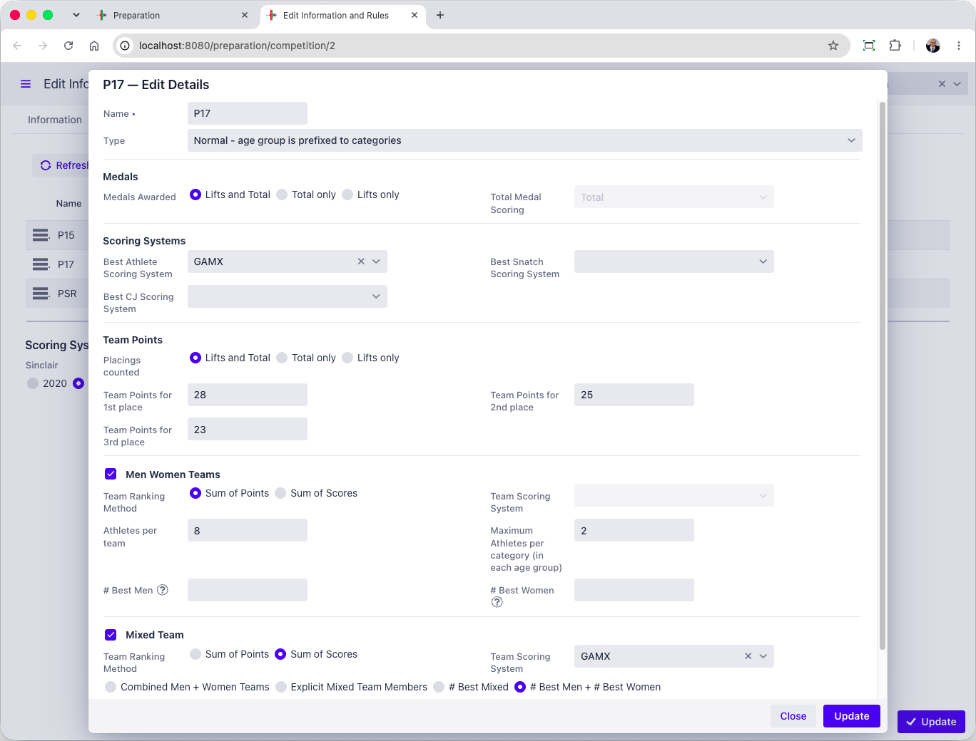

Lots/groups/timetable
[RFP §4.3] At minimum, the TIS shall provide lots/groups/timetable.
For an IWF event, it is expected that a spreadsheet or CSV format of registration data will be available. This format is then converted to the OWLCMS format that contains the expected information, including athlete identifiers.
The OWLCMS registration format also includes a sheet to define the schedule. In this way, the initial schedule and session assignment can be done in a spreadsheet using whatever means the organisers are comfortable with.
[Supplier] has its own software for creating such initial schedules and session/group assignments
OWLCMS then loads the registration data and validates it. OWLCMS can re-export registration data and adjustments can be made on the export, and re-loaded. Such round-trips can be made until satifsfactory. Once stable the registration data is editable directly in the application.
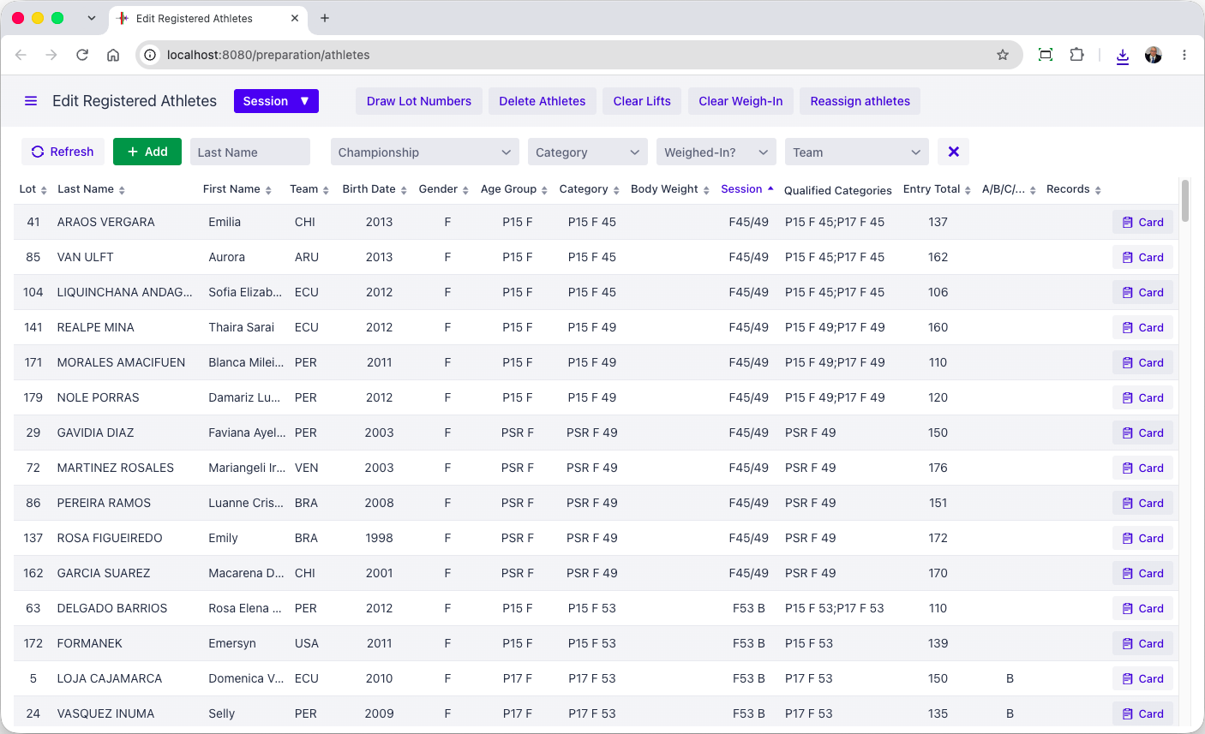
The registration screen allows modification of the allocated session, moving the athlete to another group, adjusting eligibility to multiple age groups as appropriate.
The other tabs on the registration form cover things like record eligibility (in joint jurisdiction championships, not all athletes are eligible to improve all records)
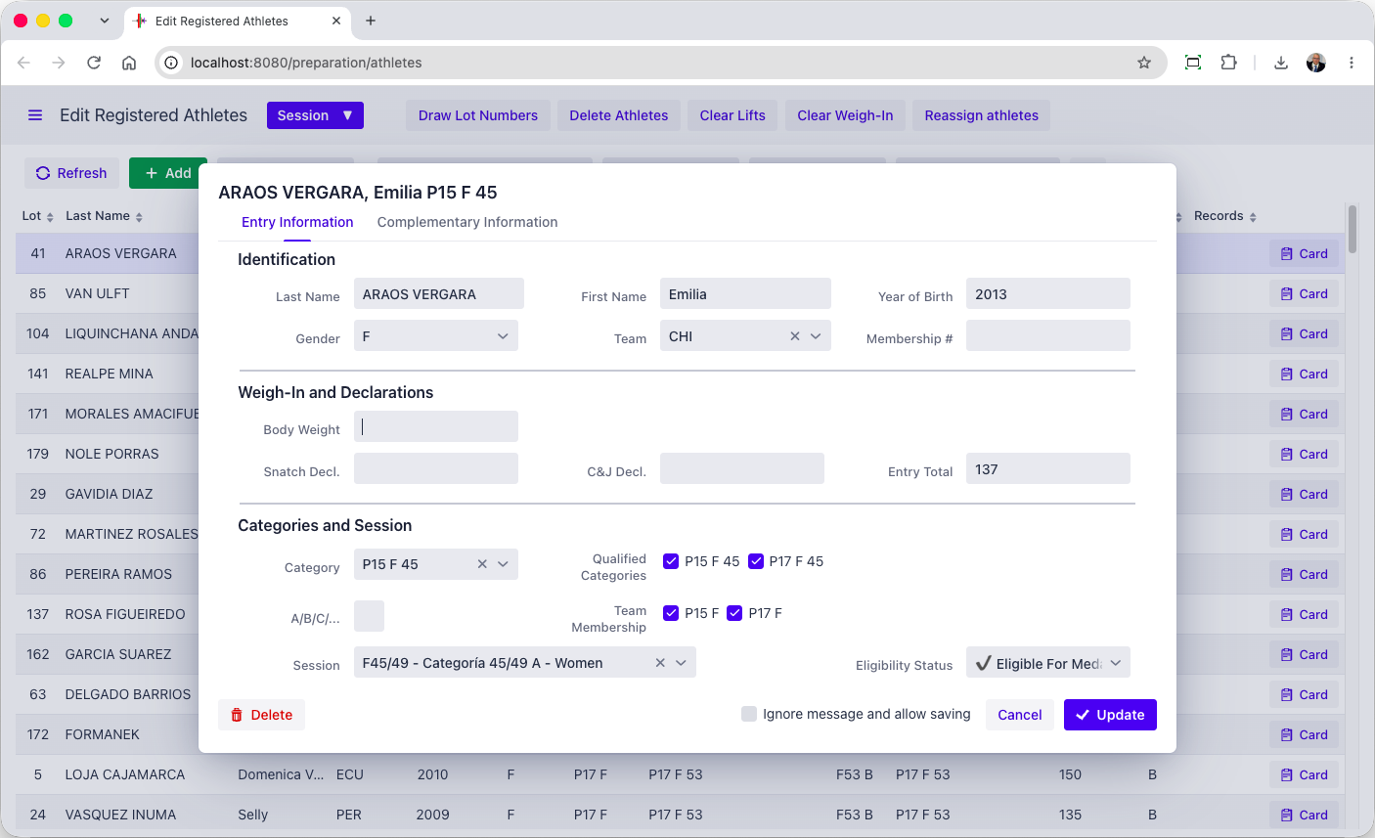
The session timetable is editable.
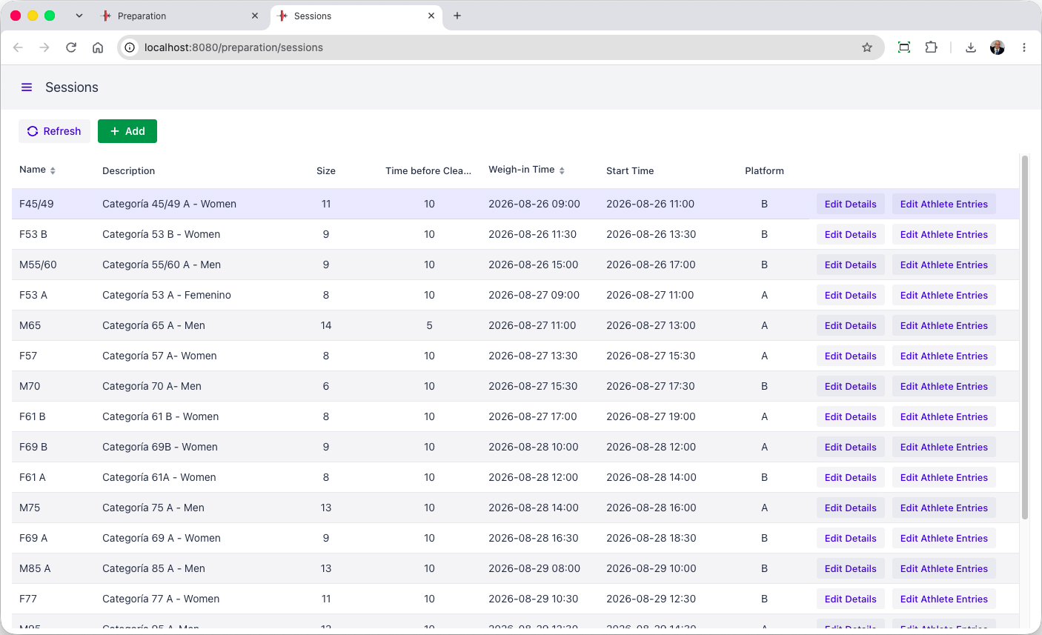

Technical Official Assignments and Timetable
OWLCMS can load a timetable prepared as a spreadsheet, and once loaded, edit it for adjustments. The program will then generate the individual assignments for each team, performing the appropriate rotations with each team as per usual practices,
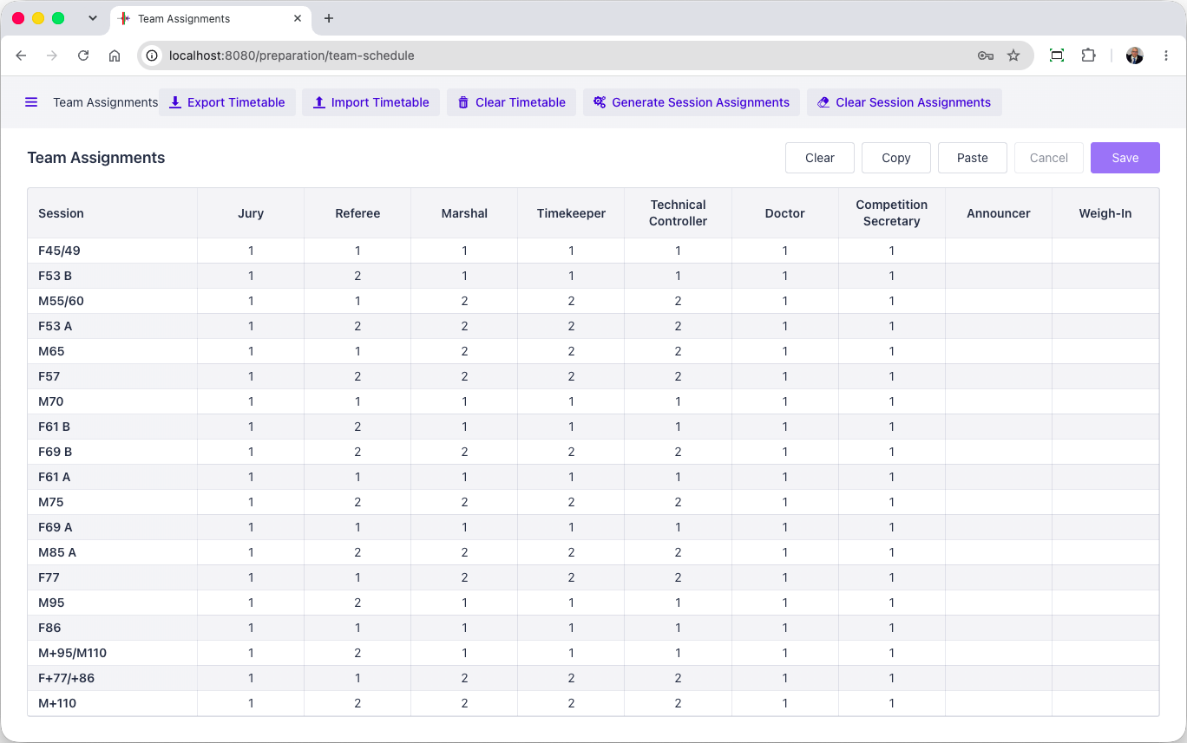
The Sessions page can then be used to adjust individual assignments, e.g., when one official needs to be substituted, etc.
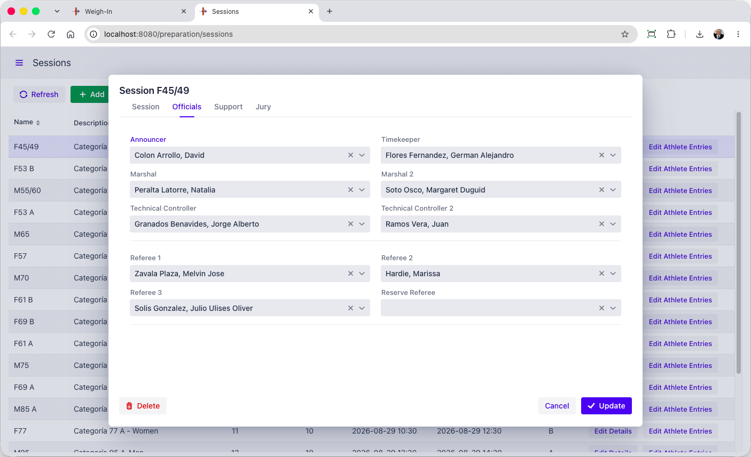

Document Production
After registration and VFE, the relevant documents can be printed, such as the athlete cards and weigh-in forms. Documents are produced in Excel, and can therefore be easily converted to PDF if needed. All the necessary documents are available (see the Documents section further down)
Groups of documents used together can also be created as one set (for example, the weigh-in sheet and the athlete cards), for one or more session (for example, for the next day).
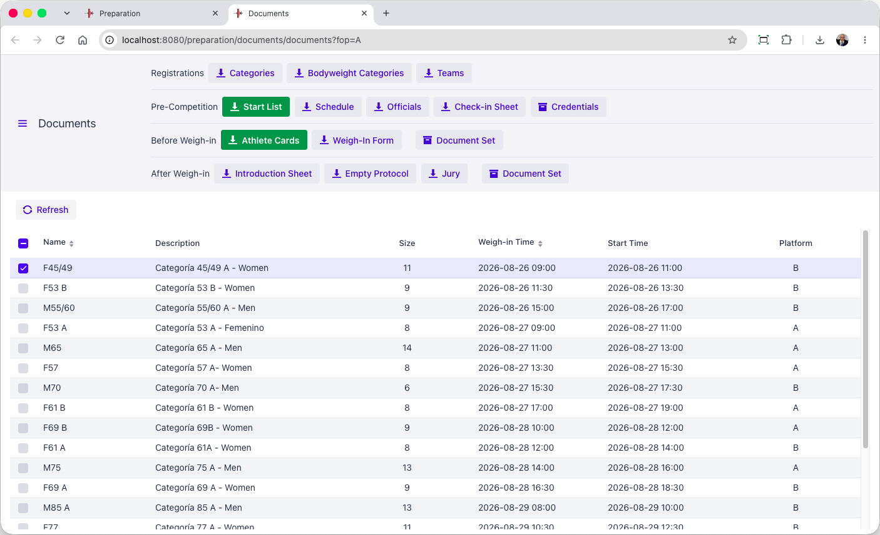

Weigh-in
[RFP §4.3] At minimum, the TIS shall provide Weigh-in.
The weigh-in data entry form is intentionally the same format as the registration form. All relevant checks for the 20 kg rule are applied at data entry in case the weigh-in TOs missed them.
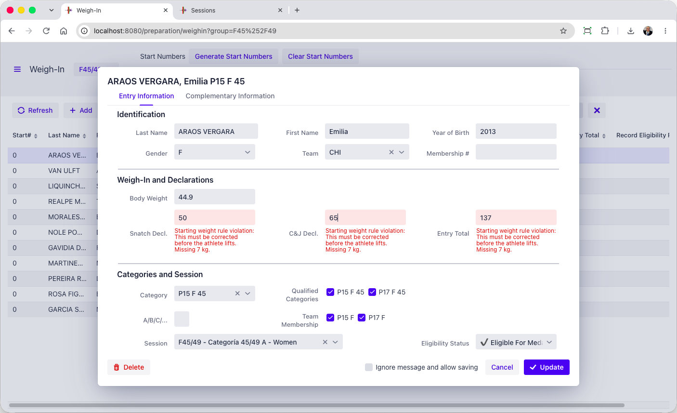
After weigh-in, the page allows creation of all relevant documents for the speaker (an introduction sheet) and the jury (jury protocol sheets)
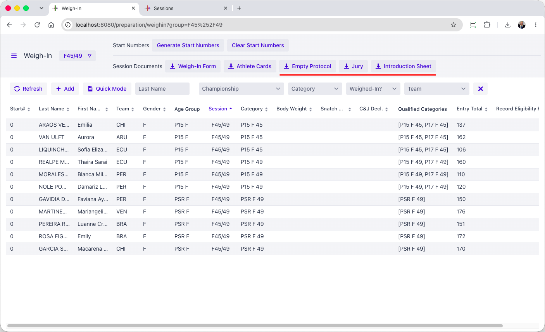

Chief Marshal
[RFP §4.3] At minimum, the TIS shall provide Chief Marshal.
The marshal screen shows all athletes in start order by default (this can be changed to lifting order if the operator of the station prefers). Clicking an athlete brings up the athlete card. The layout is identical to the paper card for easy comparisons. Focus is automatically brought to the right cell, so typing the desired value and hitting Enter works immediately for fast data entry.
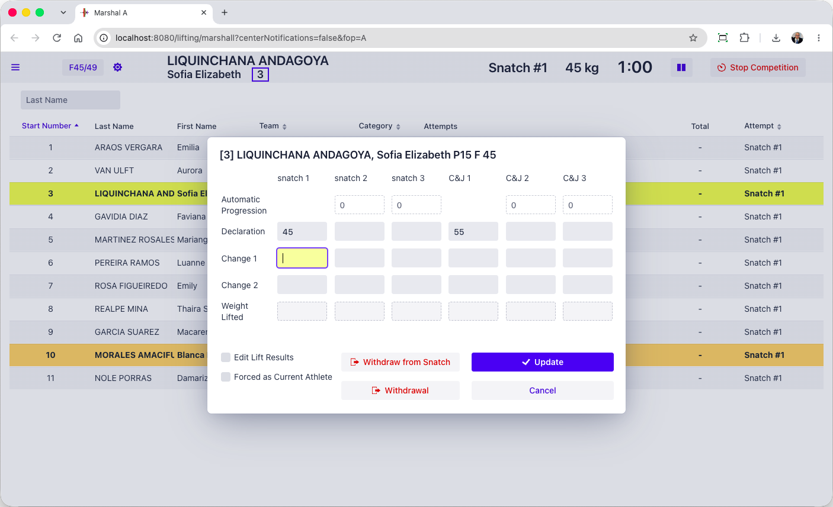
Violations such as 20kg rule violations or late changes are immediately made visible and prevent the card from closing. When the card was signed on time and the delay came from data entry, the operator can accept the change.
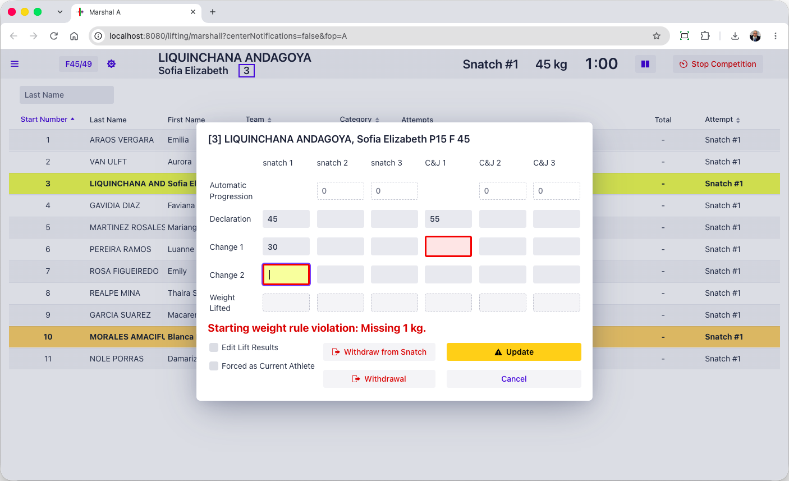

Timekeeper
[RFP §4.3] At minimum, the TIS shall provide Timekeeper.
During the competition a tablet-friendly display is used, that can be used together with the Blue Owl buttons, as preferred.
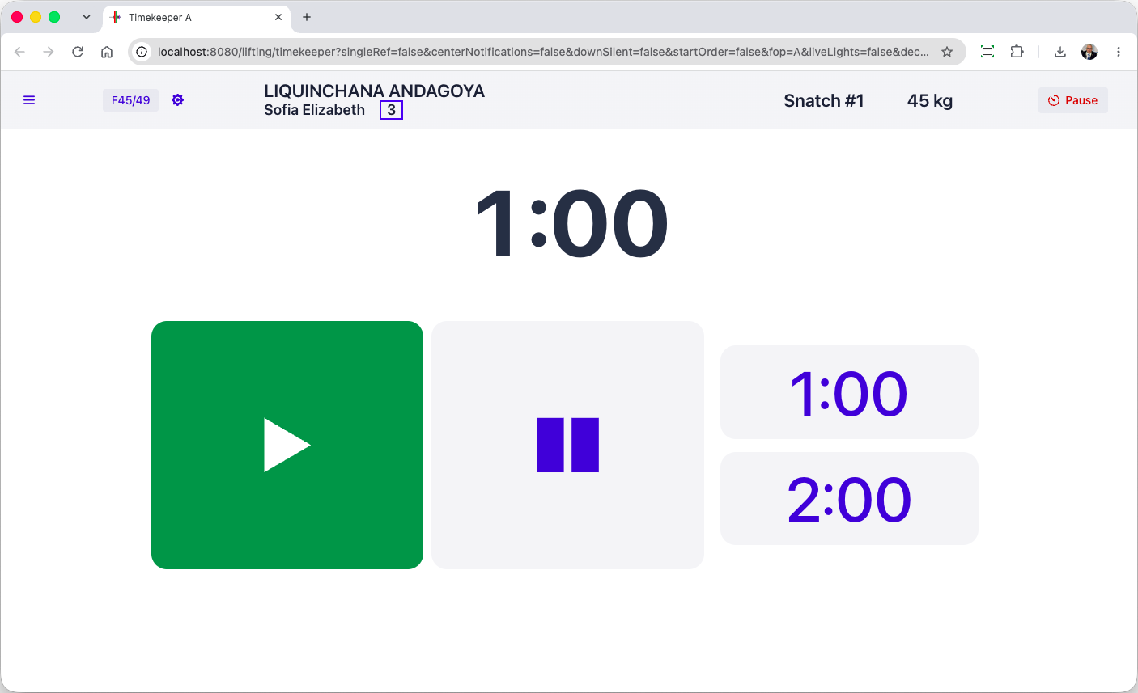
The timekeeper can set the break durations to arbitrary values as required by TCRR. In actual practice, this is typically handled by the competition supervisor (see section E.2.3.8)
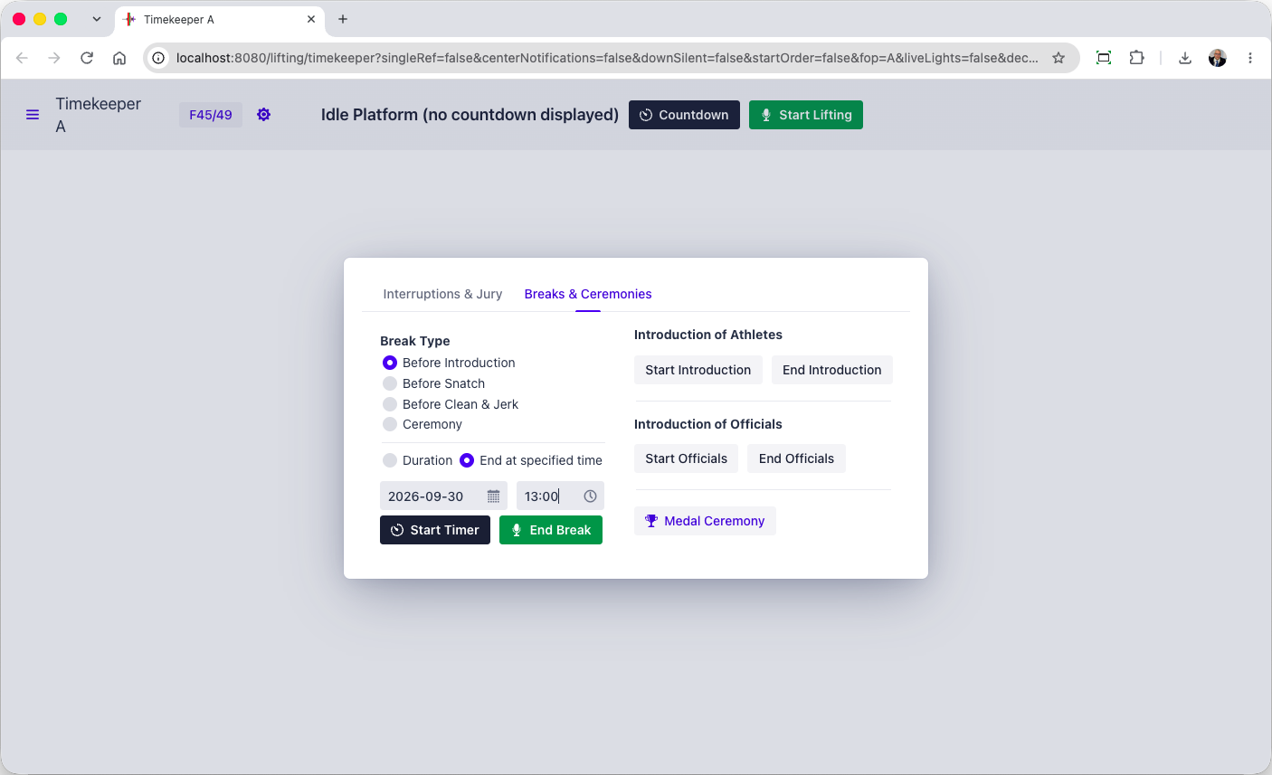

Speaker
In OWLCMS, a speaker page shows athletes in lifting order and displays all relevant notifications. This makes it much easier for the speaker, who does not have to interpret in real time what is shown on the scoreboard.
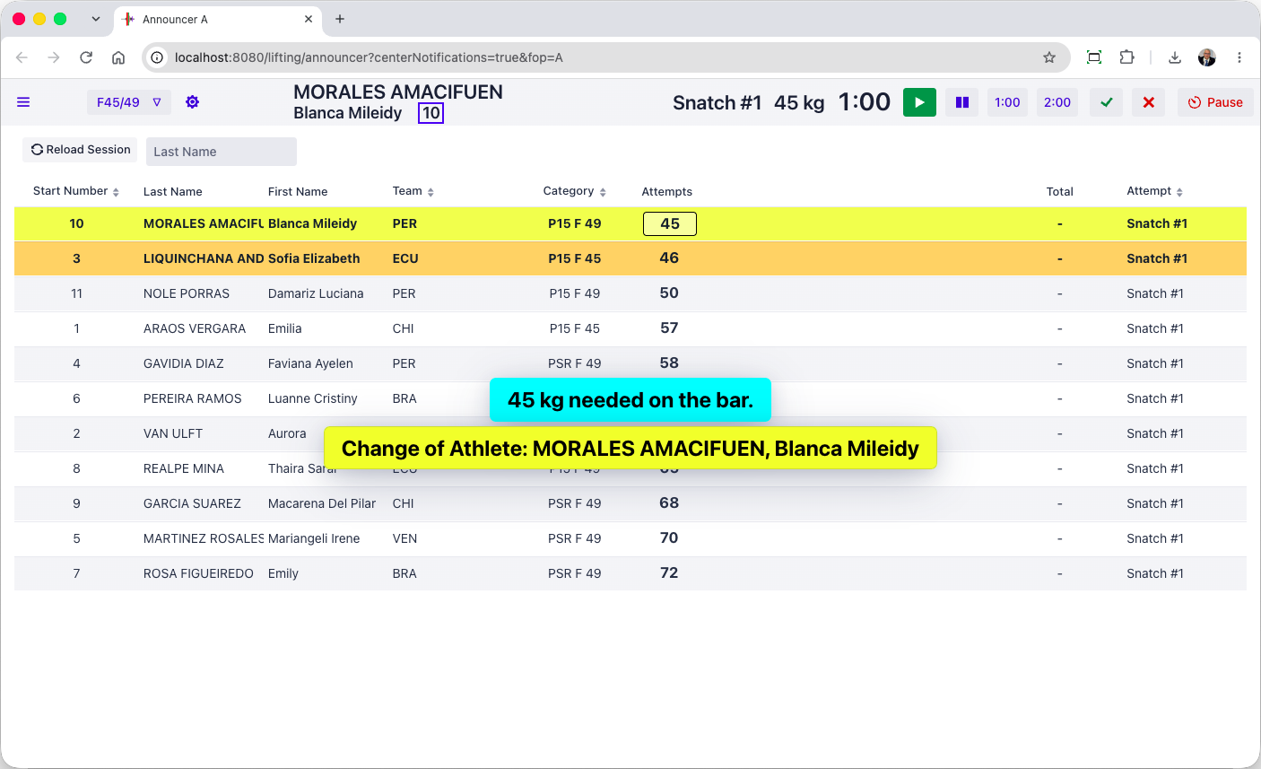

Competition supervisor
[RFP §4.3] At minimum, the TIS shall provide Competition supervisor.
The competition supervisor screen is the as the speaker, with the addition of the decision lights that can be seen live as an option. This is because the switches between sessions, and breaks, and lift overrides after a late referee flag call can all be done from that screen. Depending on competitions, the speaker screen will be made “passive” if the technical table assumes those tasks instead of an ITO1 comfortable with technology.
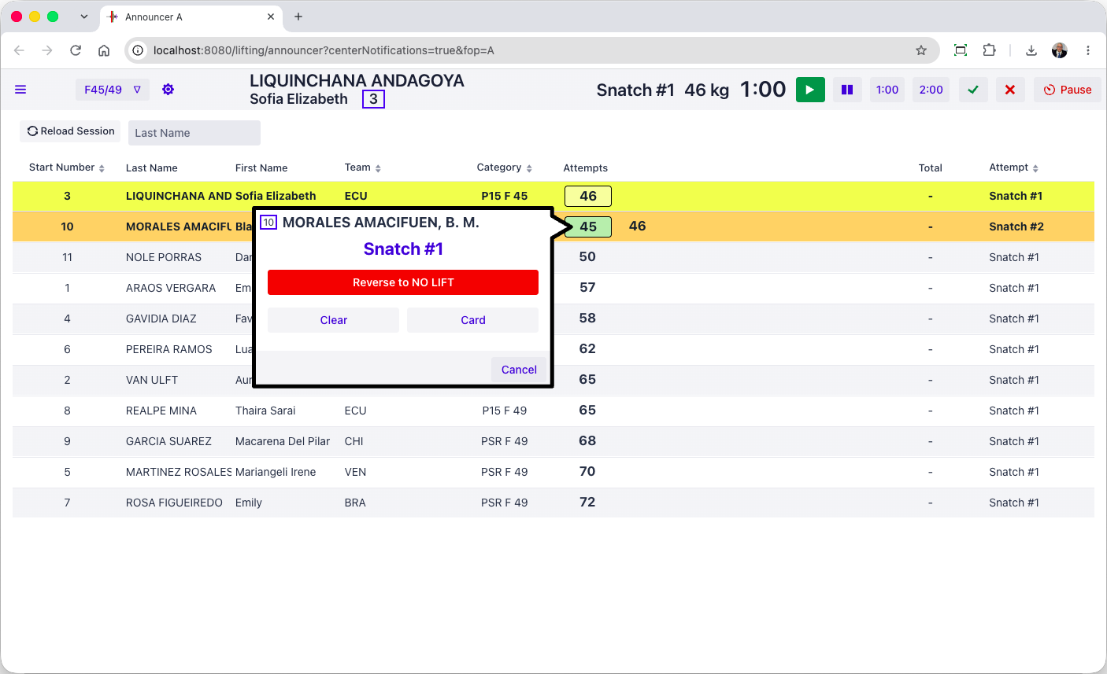
The competition supervisor can watch the competition-level audit log as it is written.
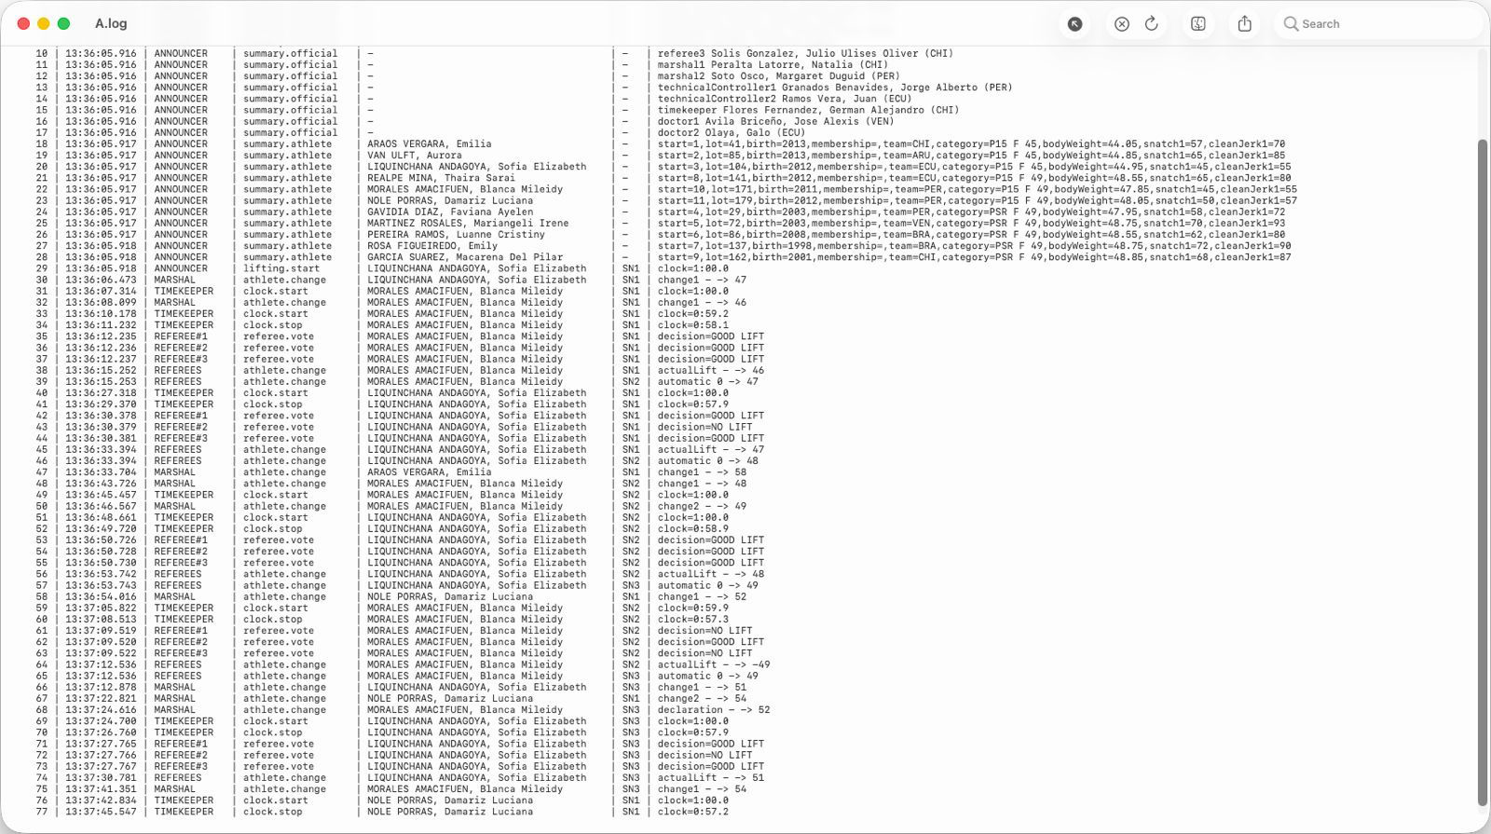
There are two additional technical logs that can be watched. There is a specific log for application health indicators (memory and CPU usage etc.). There is also a full technical logs that traces the internal application events and all the transitions of the competition state automaton, for all platforms, in real time. Program exceptions, if any, are visible in this technical log.

Referee monitoring
[RFP §4.3] At minimum, the TIS shall provide Referee monitoring.
The competition supervisor screen can see the live referee lights, as does the jury. The audit log shown in section E.2.3.9traces each individual decision and each weight change from the marshals.

Jury control
[RFP §4.3] At minimum, the TIS shall provide Jury control.
The jury control can be done entirely using a Blue Owl jury control keypad
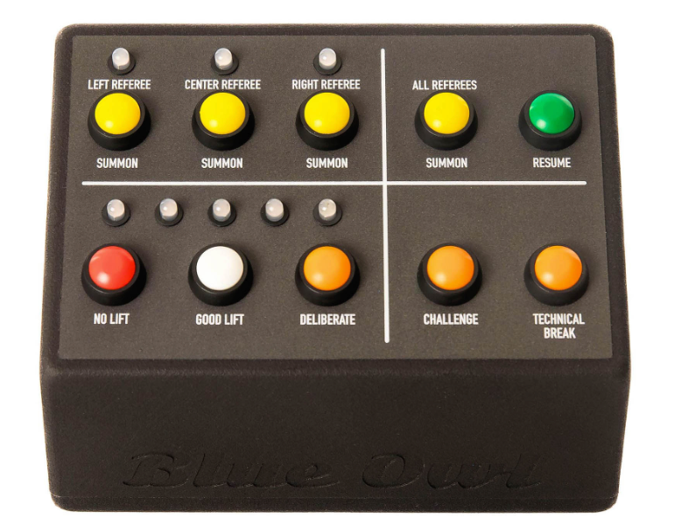
In the context of an IWF meet, it becomes desirable to accelerate the transfer of decisions from the jury to the speaker. To this effect, a tablet-style jury display is available that has the same features as the keypad
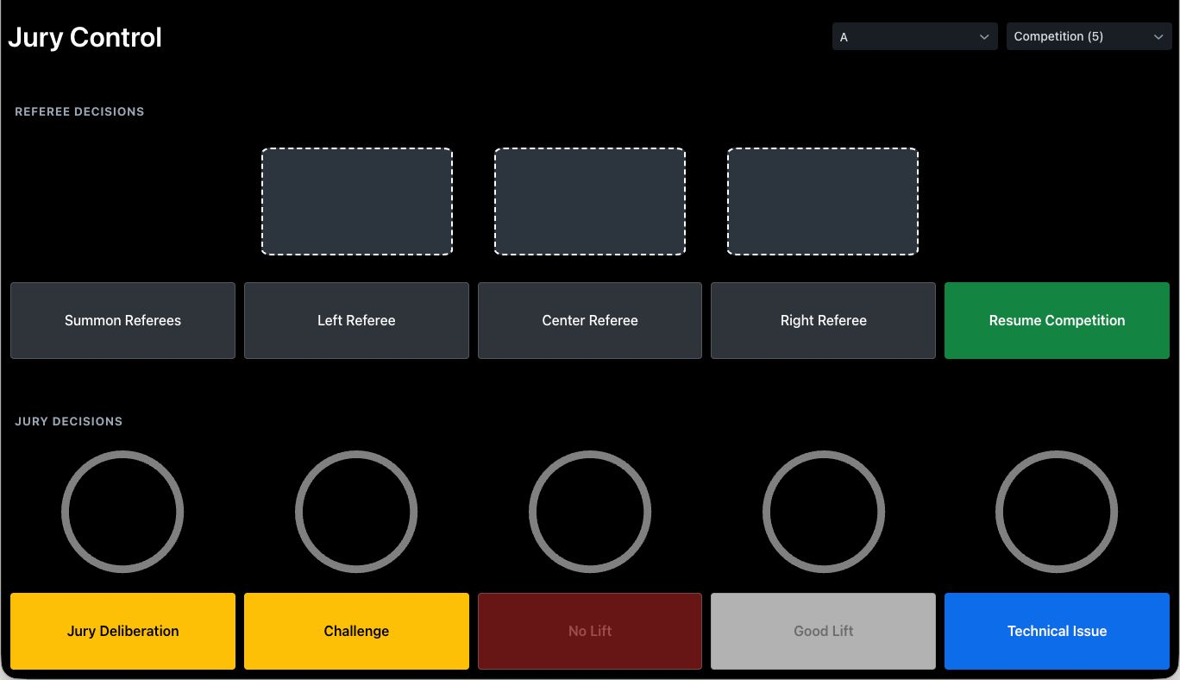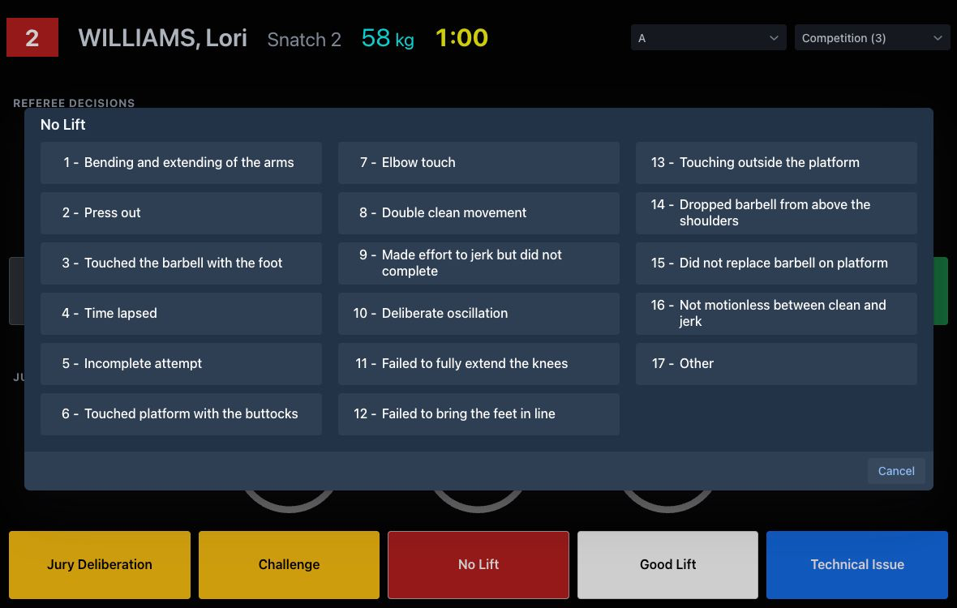
When this is used, the Speaker and Competition Supervisor screens get the reason immediately, and can resume the competition after announcing it.

Attempt boards
[RFP §4.3] At minimum, the TIS shall provide Attempt boards.
Attempt boards show all the information required by TCRR. They can also display the flag of the country. If one or more record attempts take place the attempt boards show it as a rolling banner.
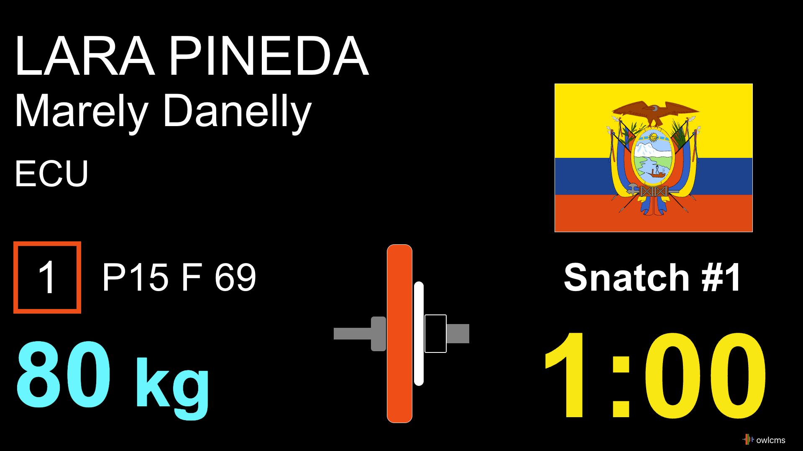

Scoreboards
[RFP §4.3] At minimum, the TIS shall provide Scoreboards.
Scoreboards contain all the requisite information.
This is the warm-up room layout, which does not change during ceremonies so coaches can count attempts. The top line contains all the current attempt information. The bottom line contains additional information, such as the various age groups an athlete is competing in, rank if successful, jury decisions, etc.
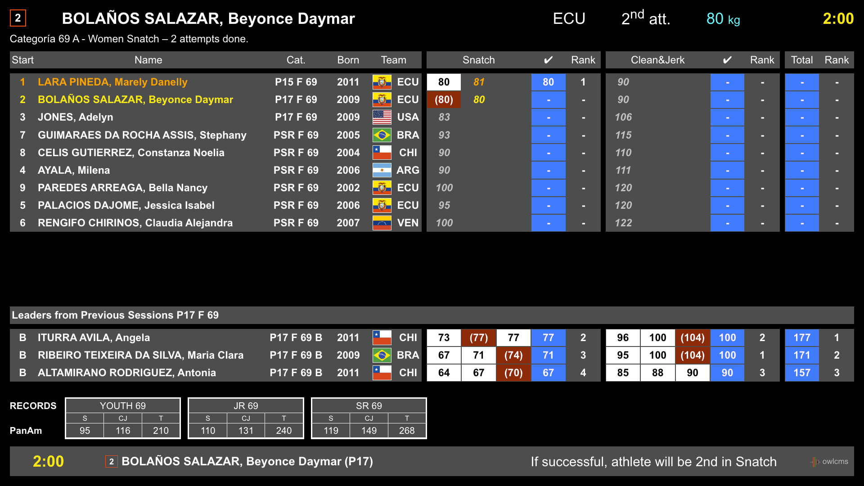

In the main room, styling will be applied as defined by the event, and the top row is used as a banner.
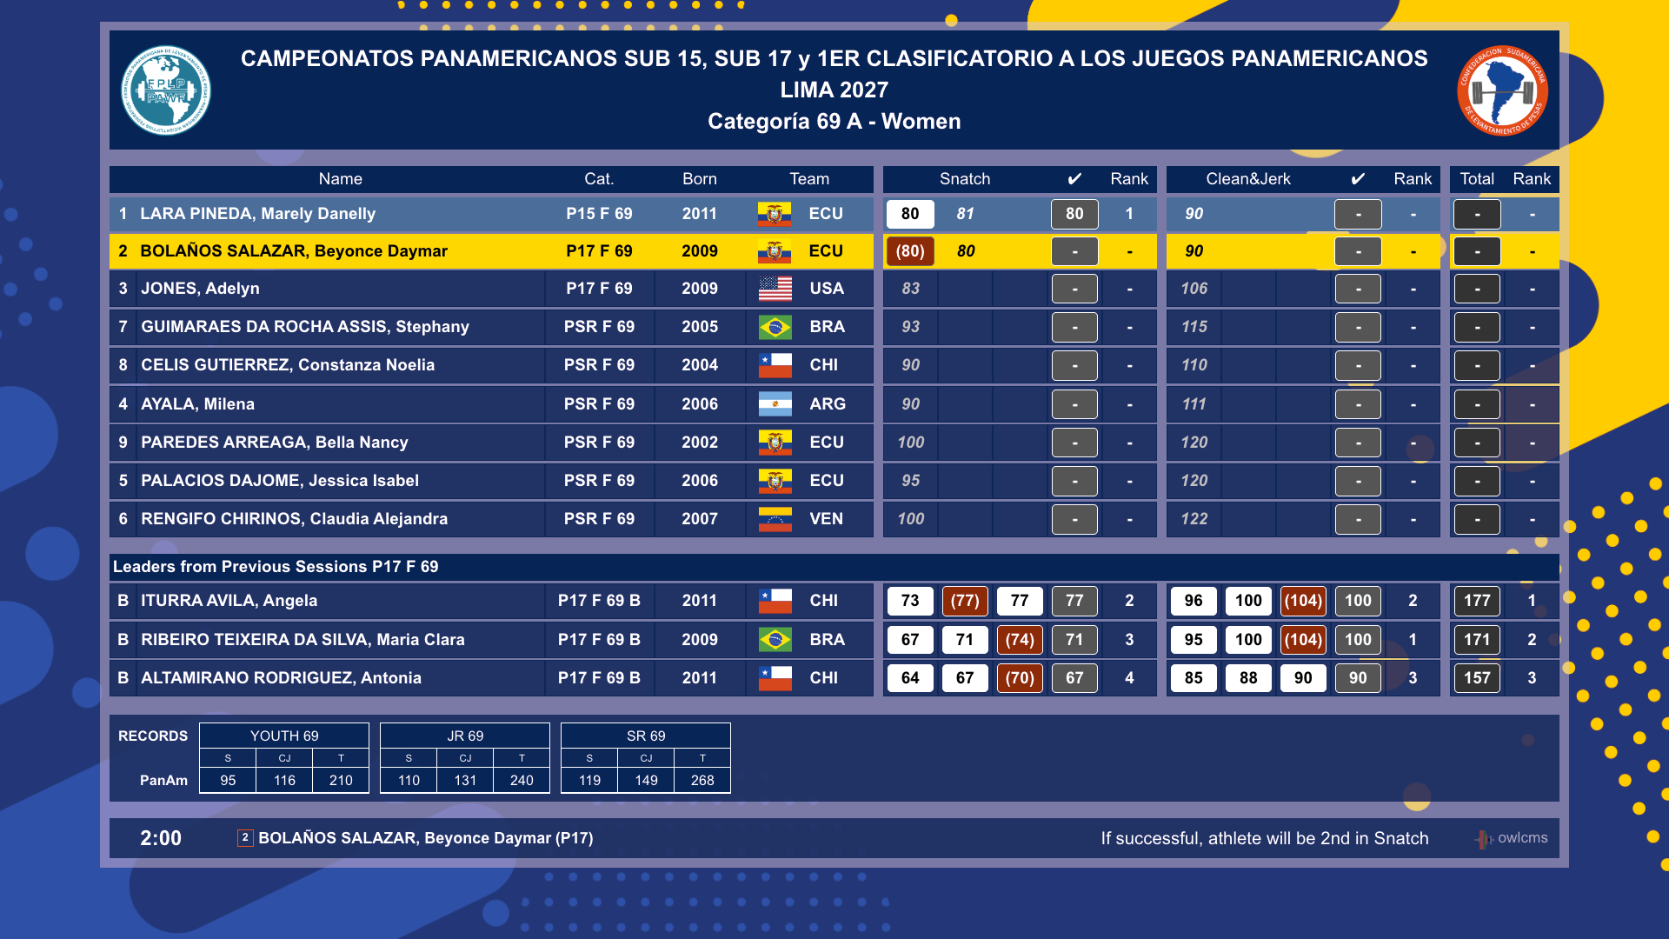
Jury Decisions are shown at the bottom if this optional feature is enabled (as it is not currently officially in TCRR)
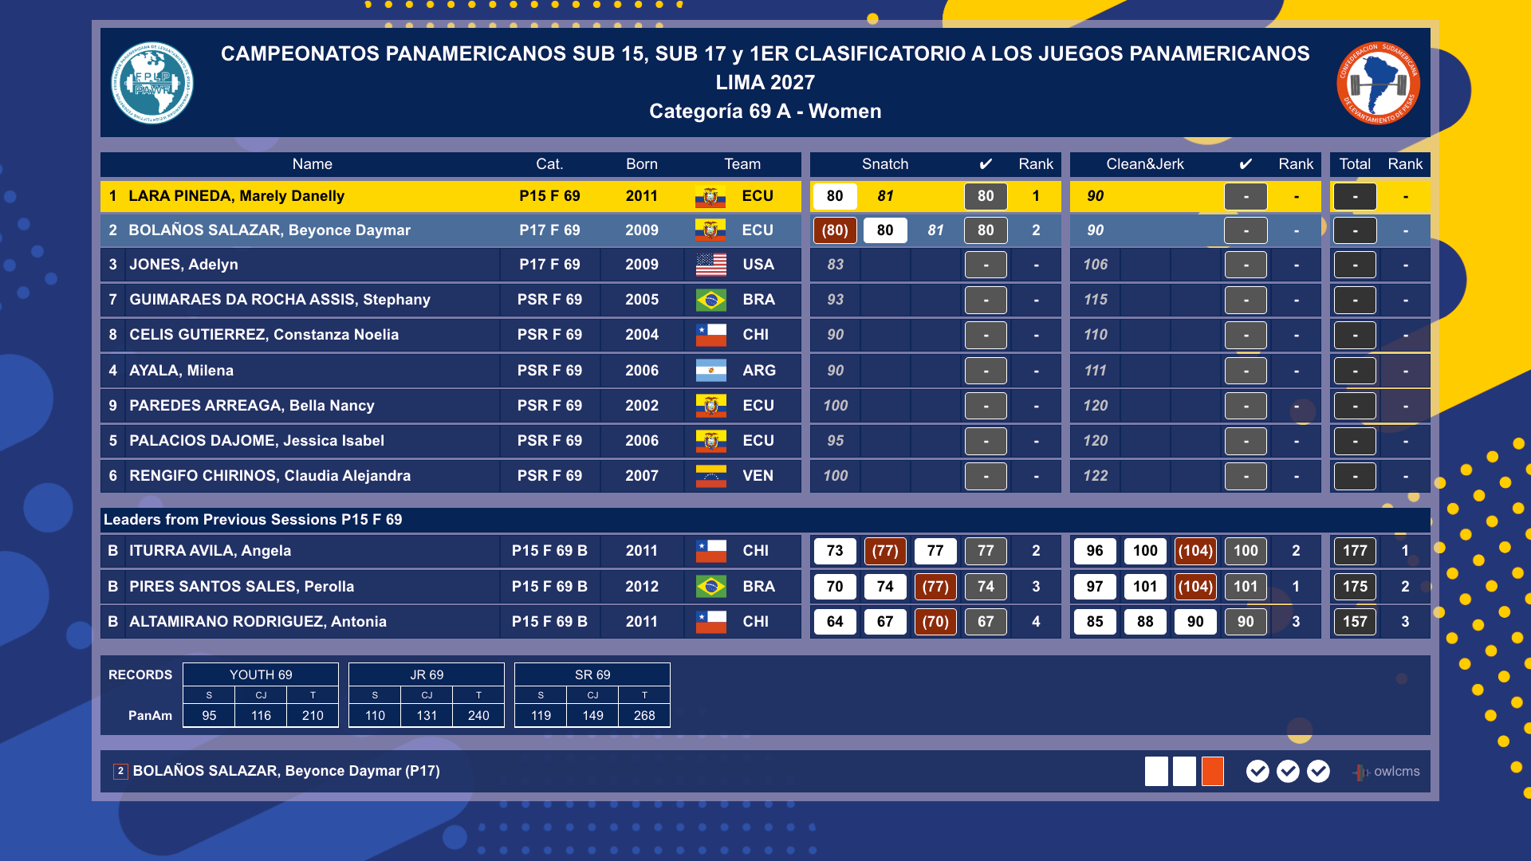Full-fledged video production companies can replace this scoreboard and the TV Graphics by using the extension capabilities provided by OWLCMS. The extension protocol is documented with a reference implementation at https://github.com/owlcms/tracker-core .

RTDS/warm-up
[RFP §4.3] At minimum, the TIS shall provide RTDS/warm-up.
In OWLCMS all the screens provide RTDS capabilities (Real-time Display System)
When decisions are given, they are shown both on the attempt board and on the scoreboards (as shown in section E.2.3.12.
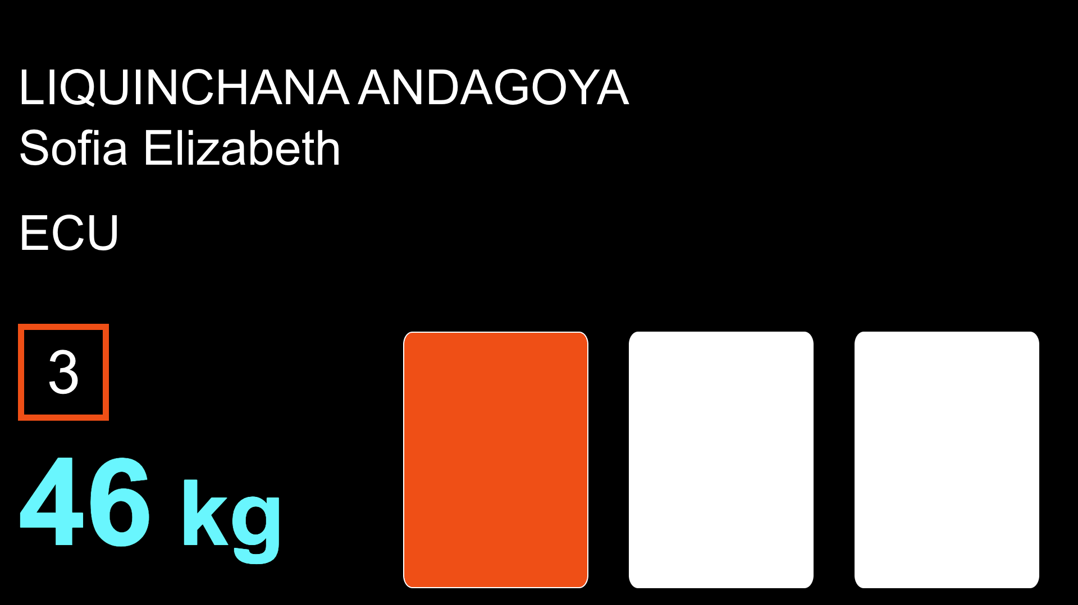
Jury decisions (3 or 5) can also be shown on warm-up and/or public attempt boards if so desired. This allows coaches to see the jury vote as they may not be in a position to view the main scoreboard.
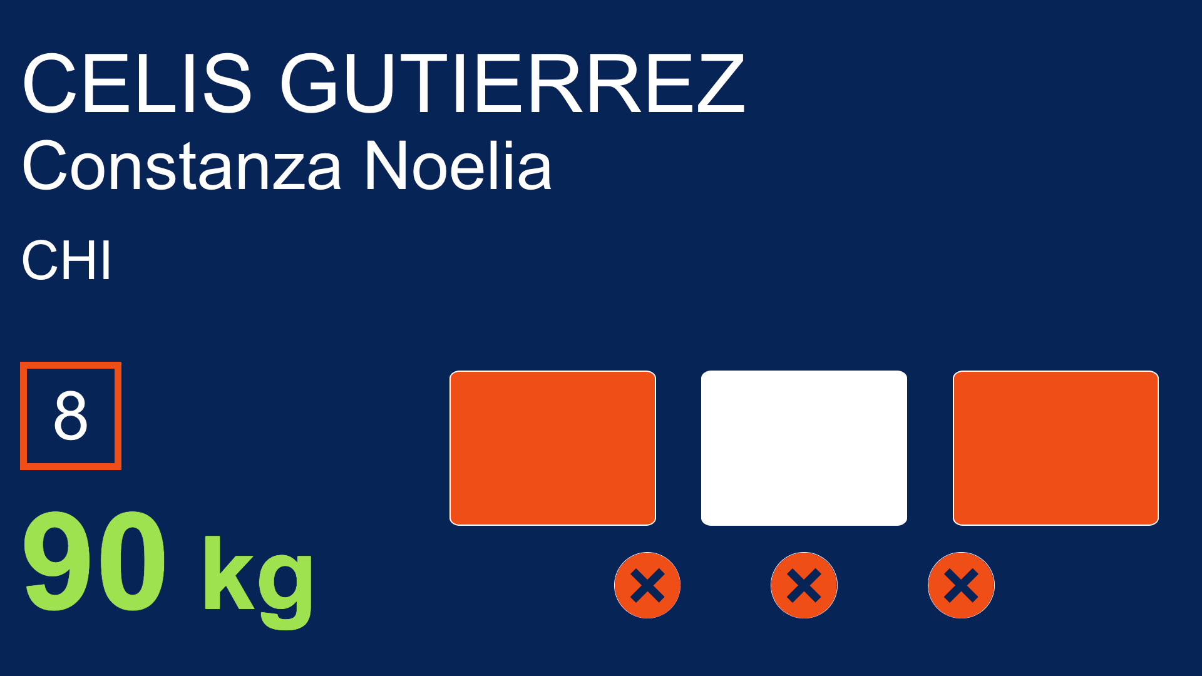

STOP
[RFP §4.3] At minimum, the TIS shall provide STOP.
The jury (section E.2.3.10) and the competition supervisor (section E.2.3.8) can stop the competition at any time. In addition, the marshal can also trigger a competition stop to sort out lift order issues using a button at the top right of their station screen (section E.2.3.5).
During deliberation, challenge, technical issues, or other stoppages, the attempt board shows the reason for the break, and the athlete-facing clock display shows a flashing stop.


Records
[RFP §4.3] At minimum, the TIS shall provide Records.
If there is a record attempt, the speaker and supervisor screens show the details of what is being attempted and what records are being improved.
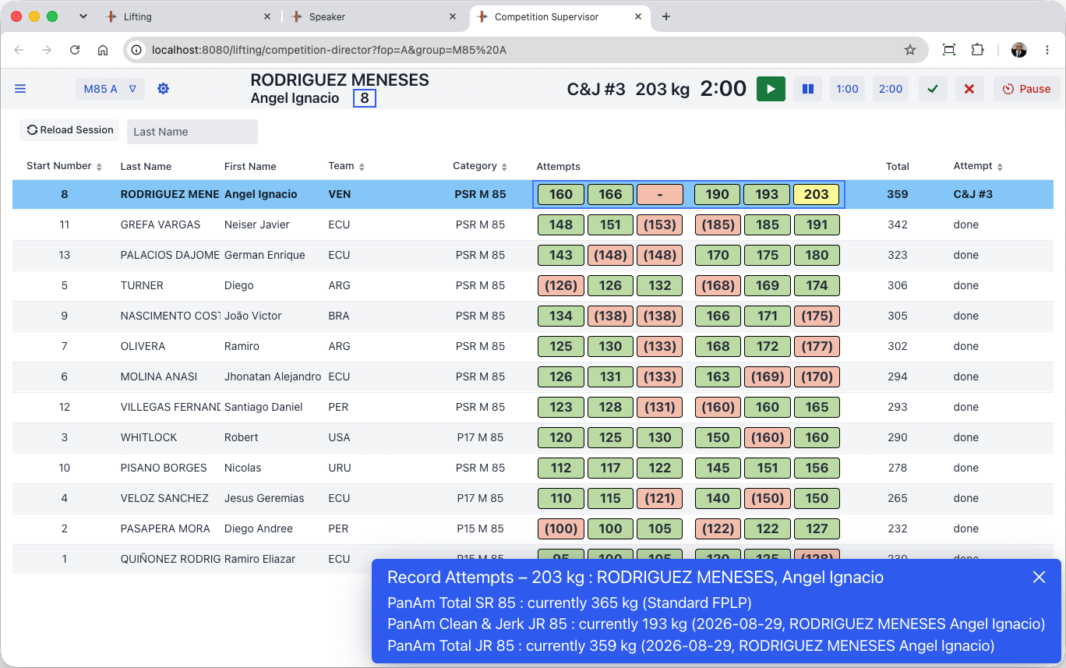
The records attempted are visible on the scoreboards
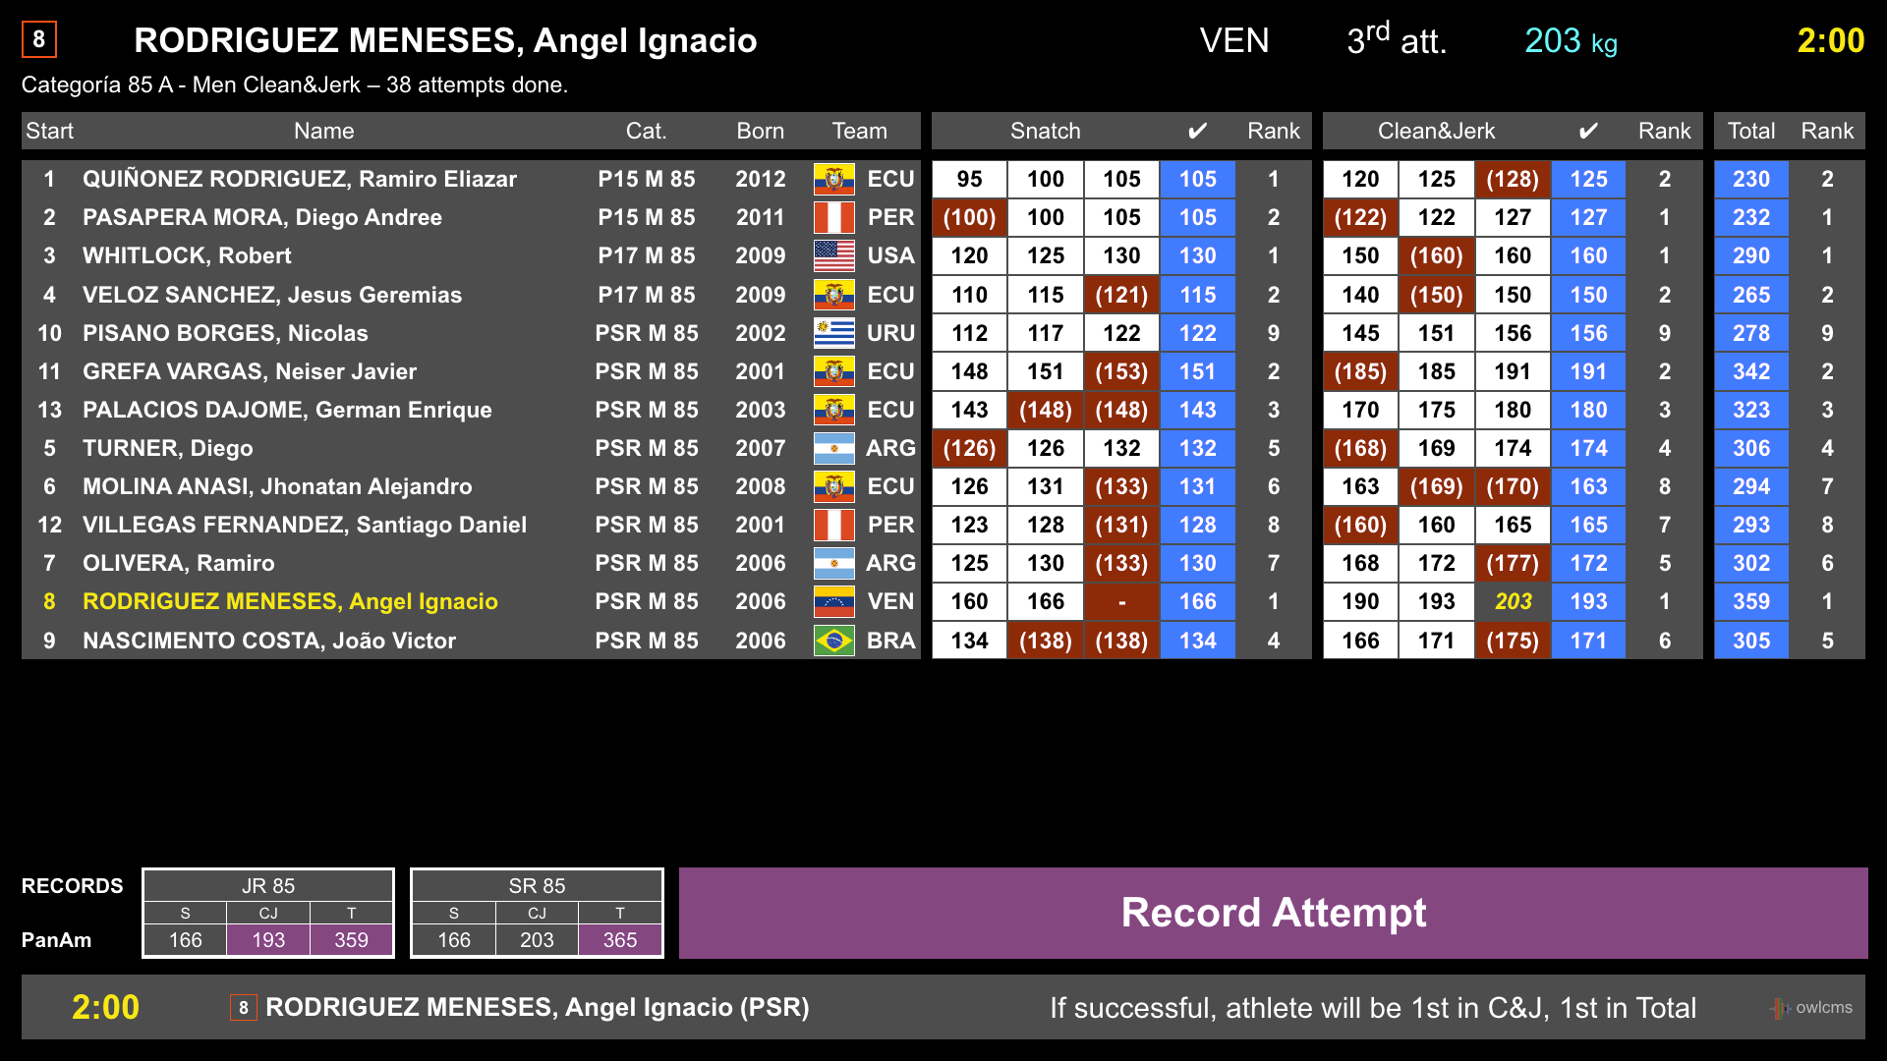
The attempt boards show a scrolling ticker of all the records being attempted. Successful records are highlighted.
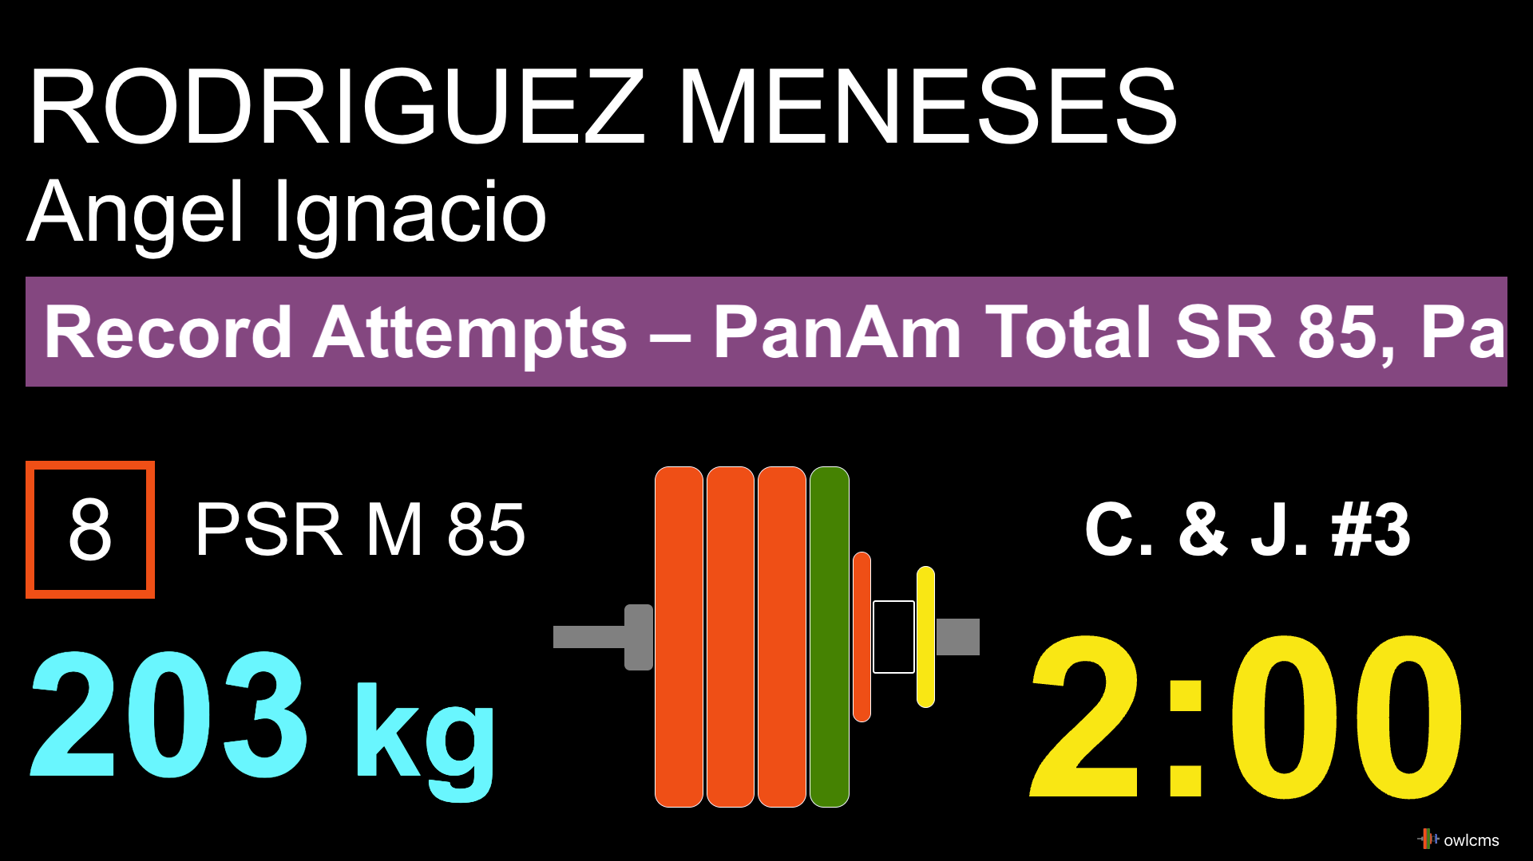

Results
[RFP §4.3] At minimum, the TIS shall provide Results.
Official results are of course available in a variety of formats, refer to sections E.2.4.7 and E.2.4.8
Scoreboards with medals or rankings are available. When there are mixed A and B groups in the same sessions, the system correctly determines which categories are actually done. The competition director can select to show all categories in the championships, or show one category at a time.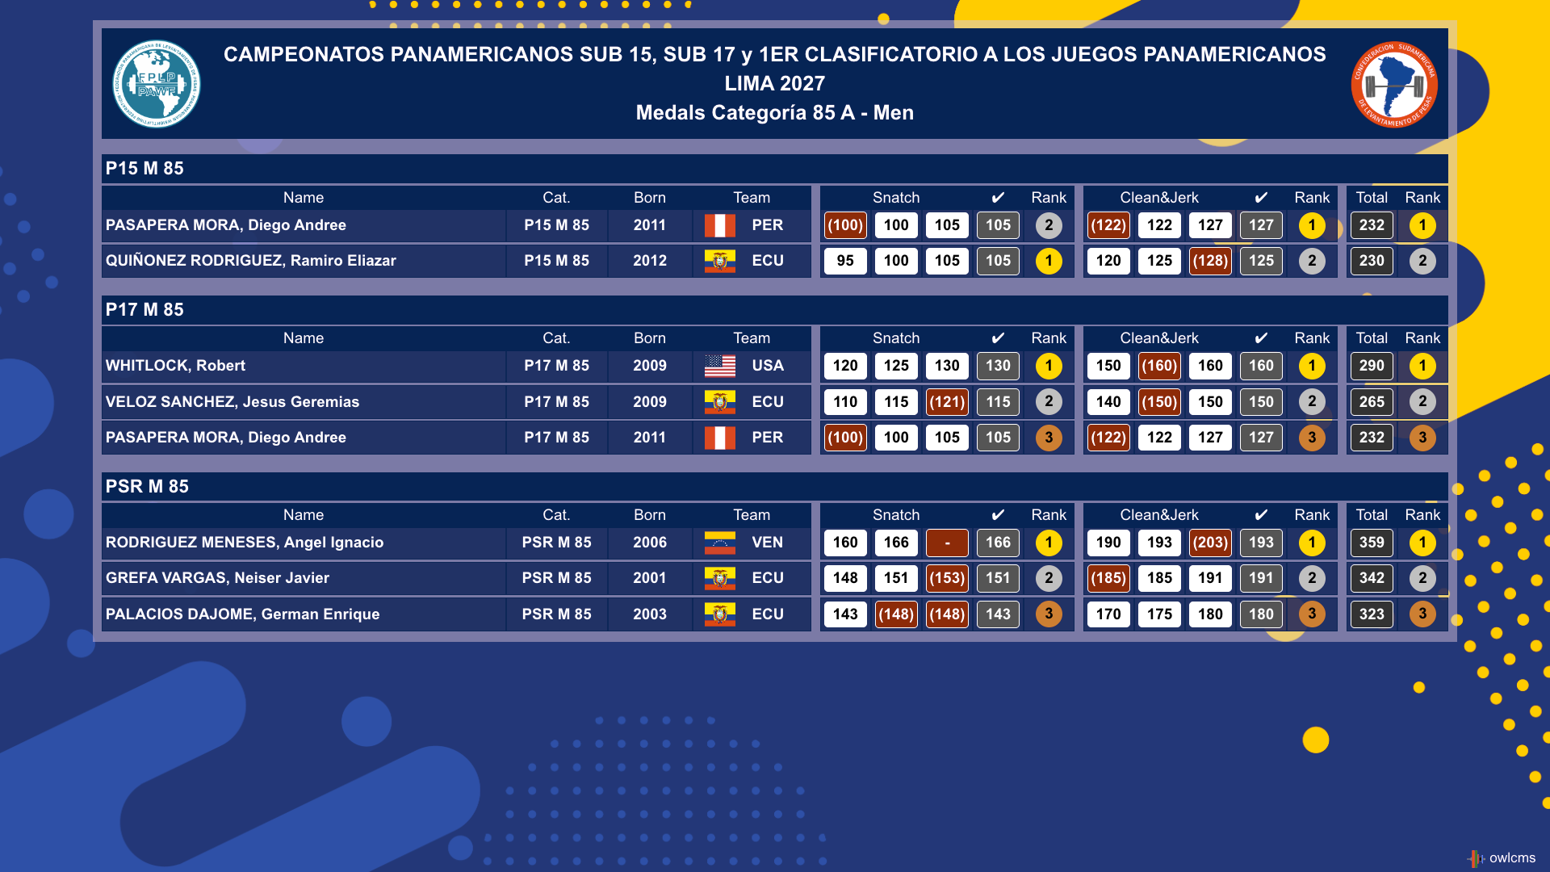
An end-of-session medal report is available. The medal report shows the medals in the order expected by the speaker.
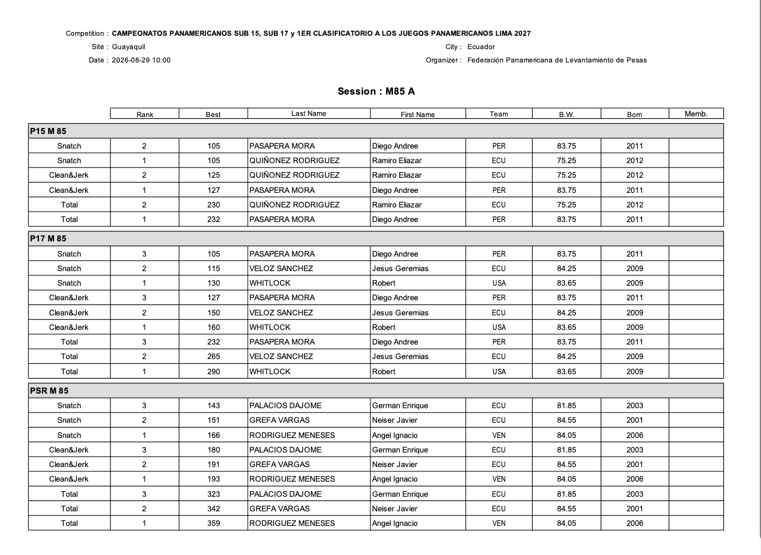

Other approved states
[RFP §4.3] Other approved states.

Introduction Scoreboards
OWLCMS provides a scoreboard to be shown during the introduction of athletes.

Streaming-oriented Lower-Third display
In order to support large events that stream on the Internet, OWLCMS includes a video overlay for the bottom of the screen (aka “Lower-Third”) that can be customized with the event logo. This is in effect a mini attempt board. It shows the currently requested weight, the time on the clock and the referee decisions. The background is transparent so it can be overlaid on top of the camera feed.


Streaming-oriented Scoreboards
All scoreboards shown to the public on the LED walls can be used for streaming. The difference is that there is a transparent background. For example, a “rankings” scoreboard that can be used during the meet to show what medals are being earned.
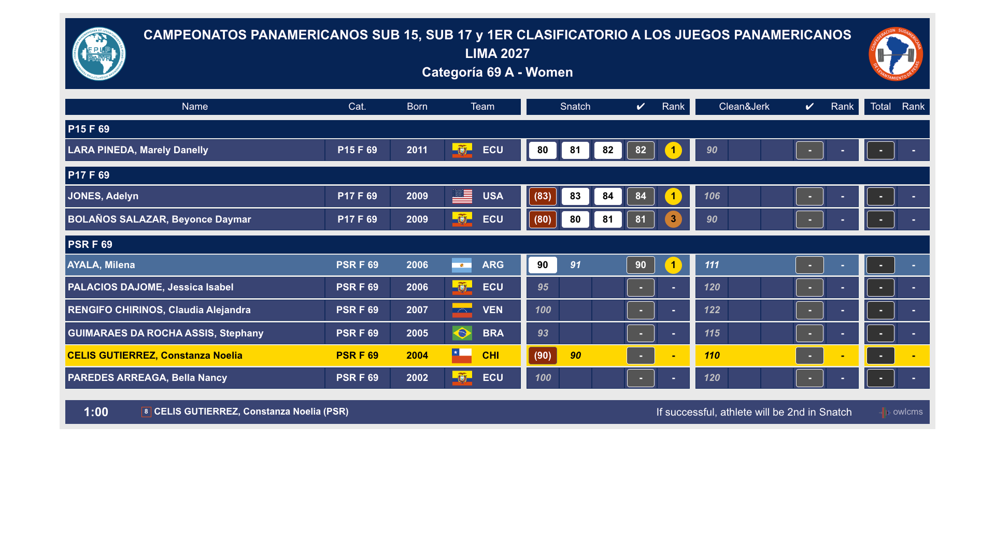

Team Rankings
OWLCMS can provide additional scoreboards for team competitions, for example. The teams scoreboard can handle multiple championships, and can handle new team competition formats such as mixed teams using GAMX scoring.
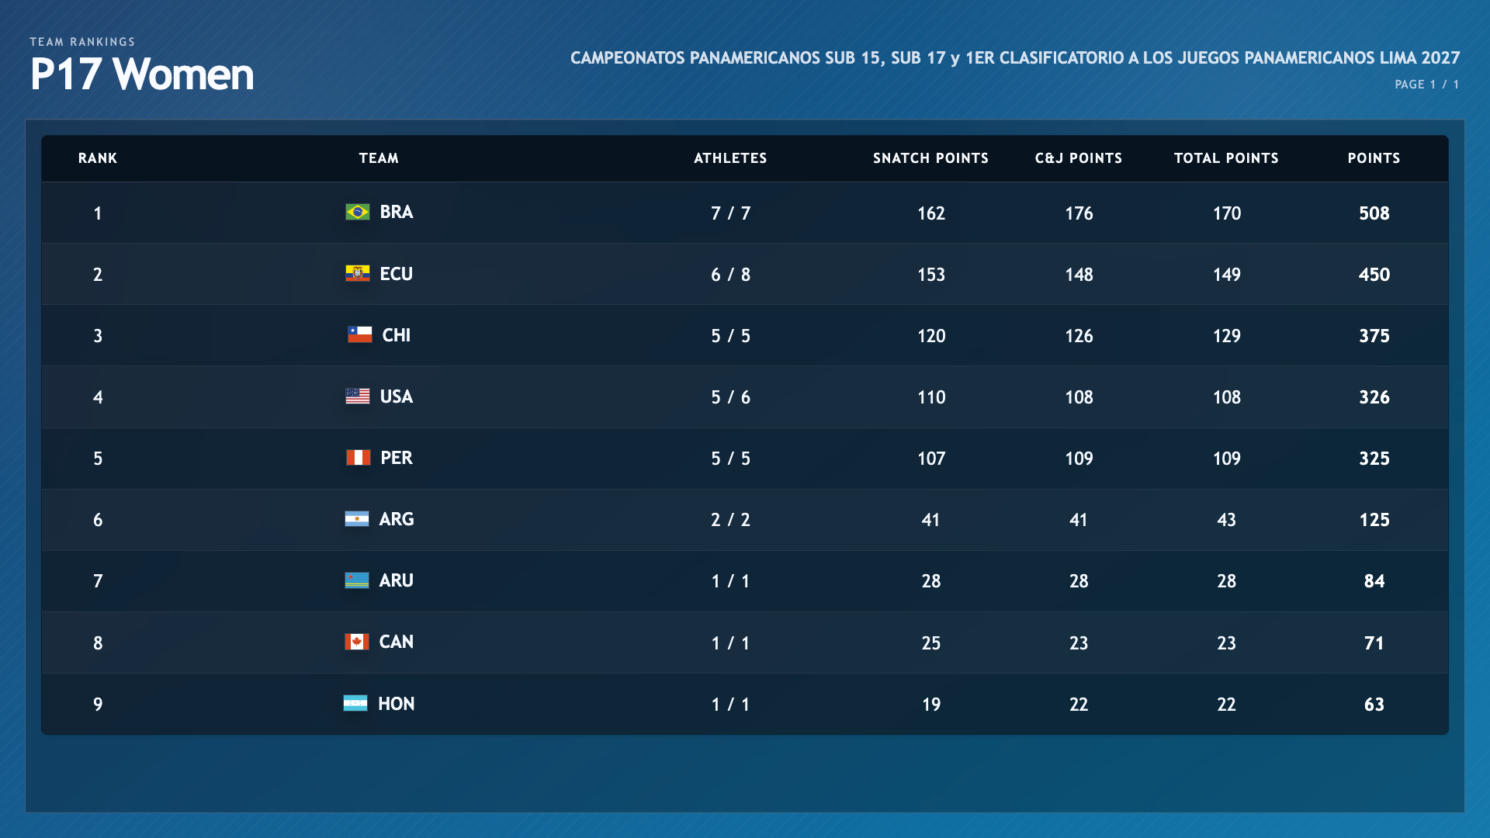

Official outputs

Start Lists
[RFP §4.4] At minimum, the TIS shall provide Start Lists.
A Start List is provided. Several formats are available, depending on whether the competition is on one or more platforms.
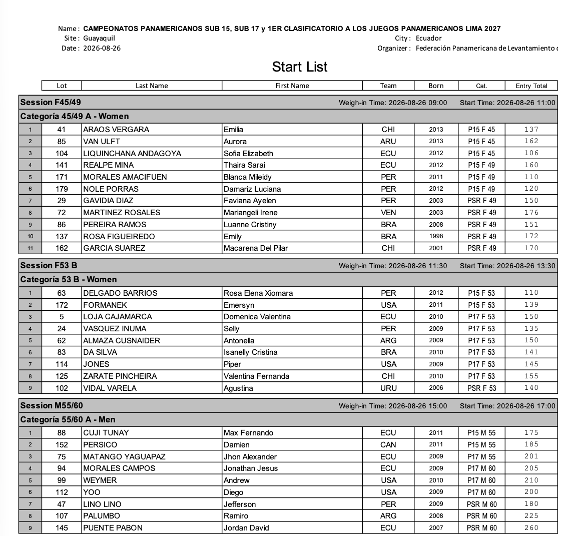

Start List Package
[RFP §4.4] At minimum, the TIS shall provide Start List Package.
All the documents listed in section 3.4.4 of the TCRR are available.

VFE Documents
The Start List Package is expanded to include documents useful at VFE.
The program provides a VFE form that lets each team verify that all athletes are registered in the correct category and highlights rule deviations. The sheets can be printed in advance and updated during VFE and then countersigned by the team manager.
In this example, too many athletes are in the same bodyweight category, and this would require the team to correct the entry or retire an athlete.
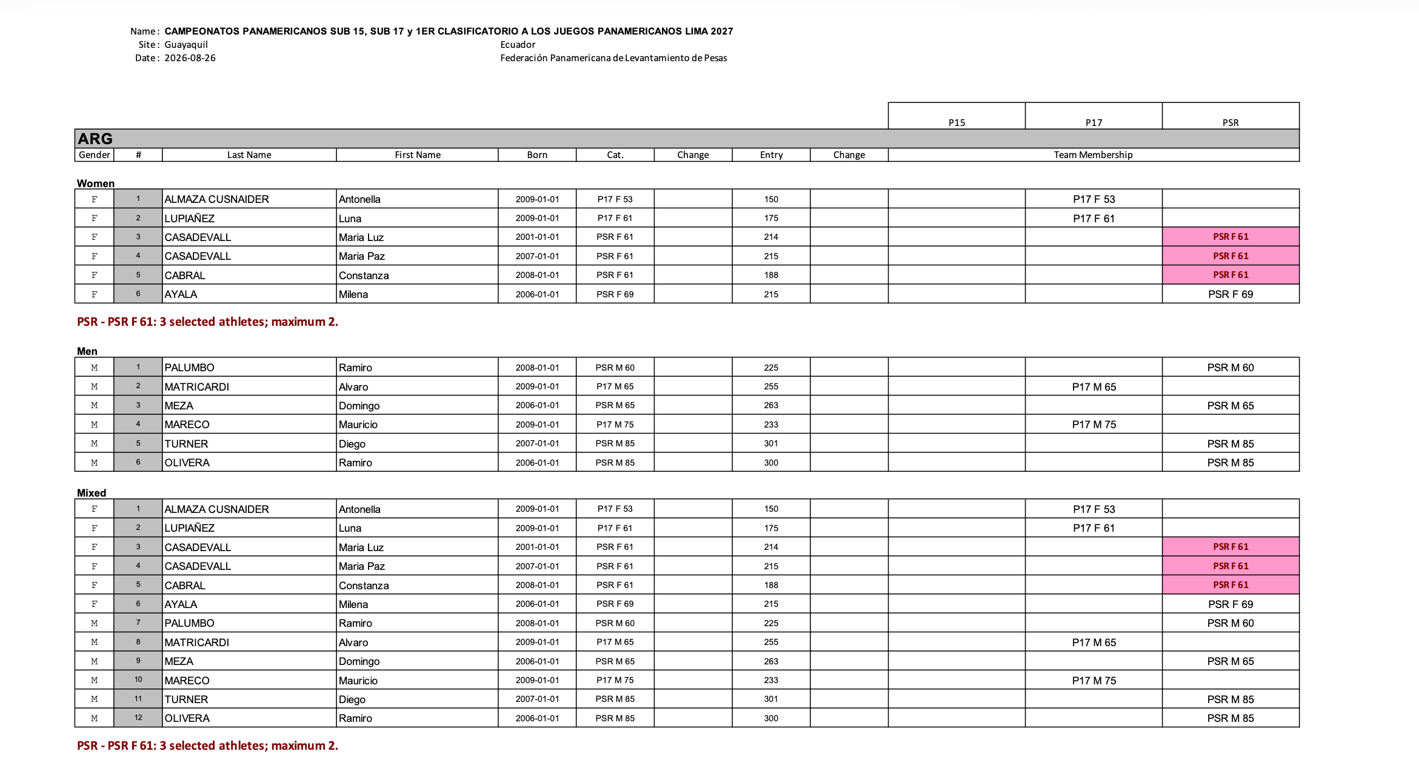

Start Book
OWLCMS produces a start book with all required contents, fully formatted. In the following figures, we show a sample of pages.

Schedule
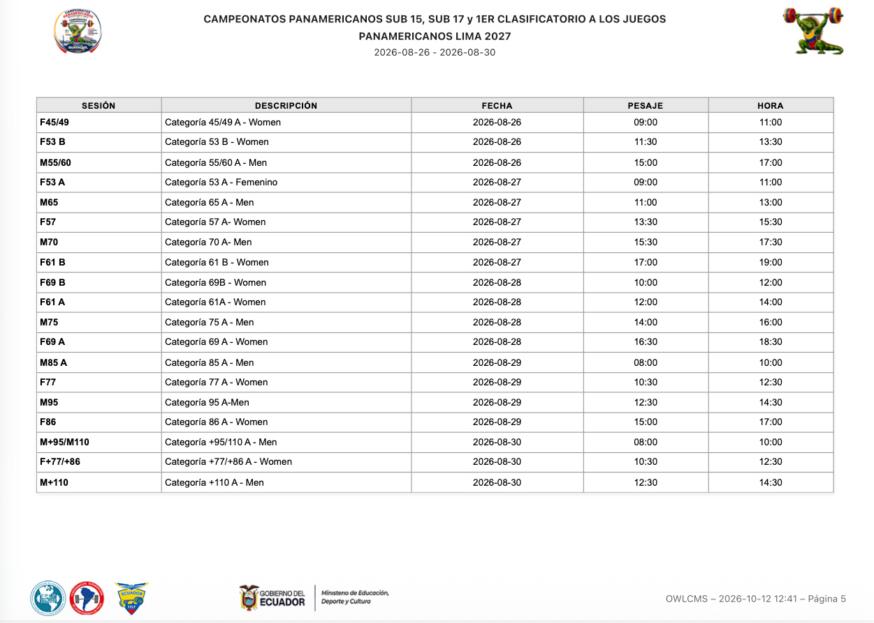

Summary of Participants

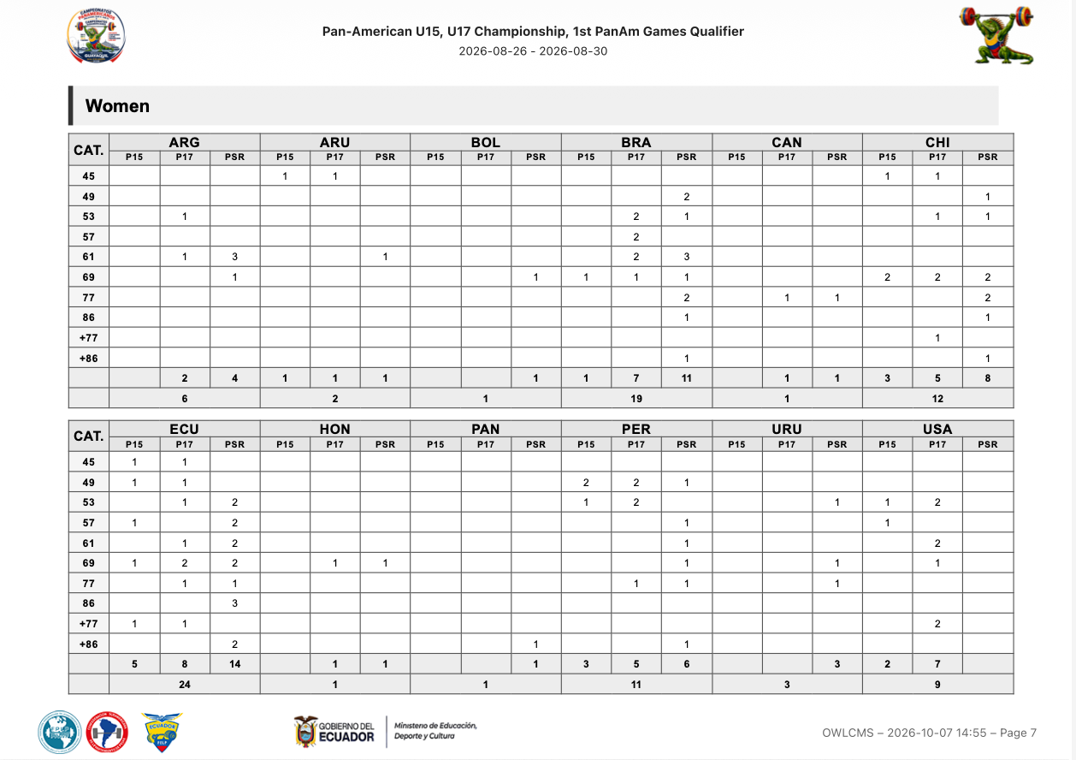

Technical Officials

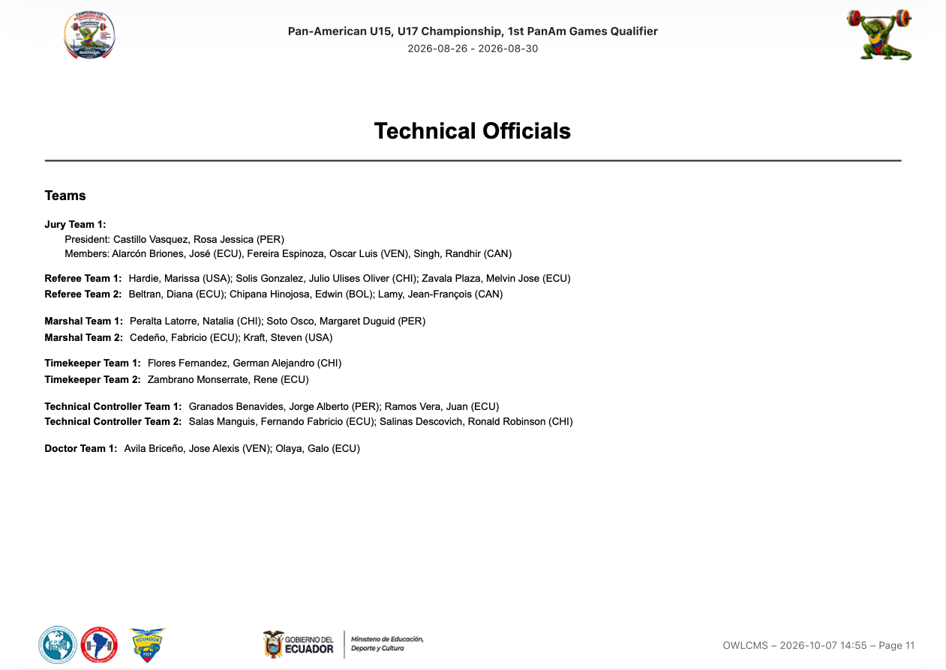

Technical Officials Teams Timetable

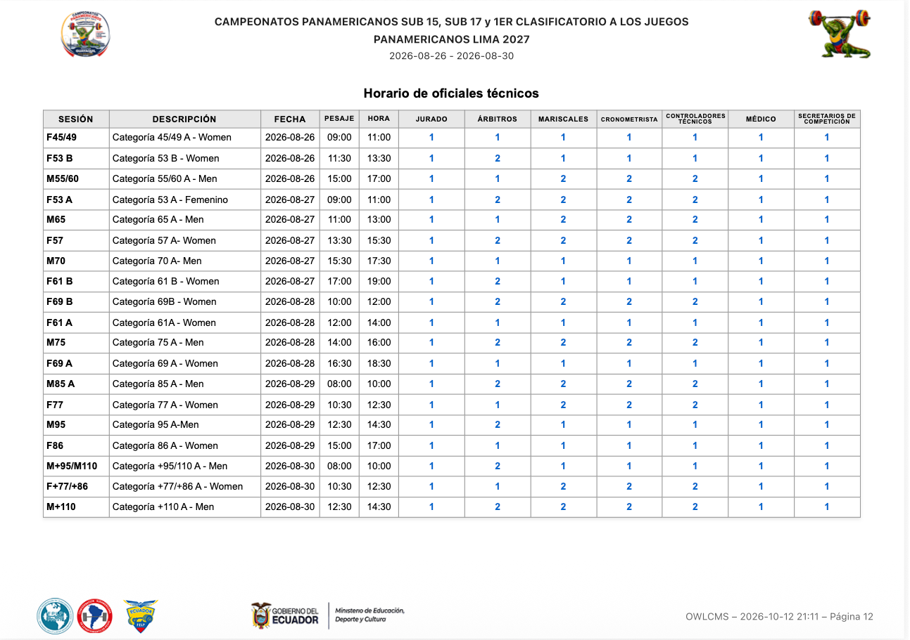

Session Start List

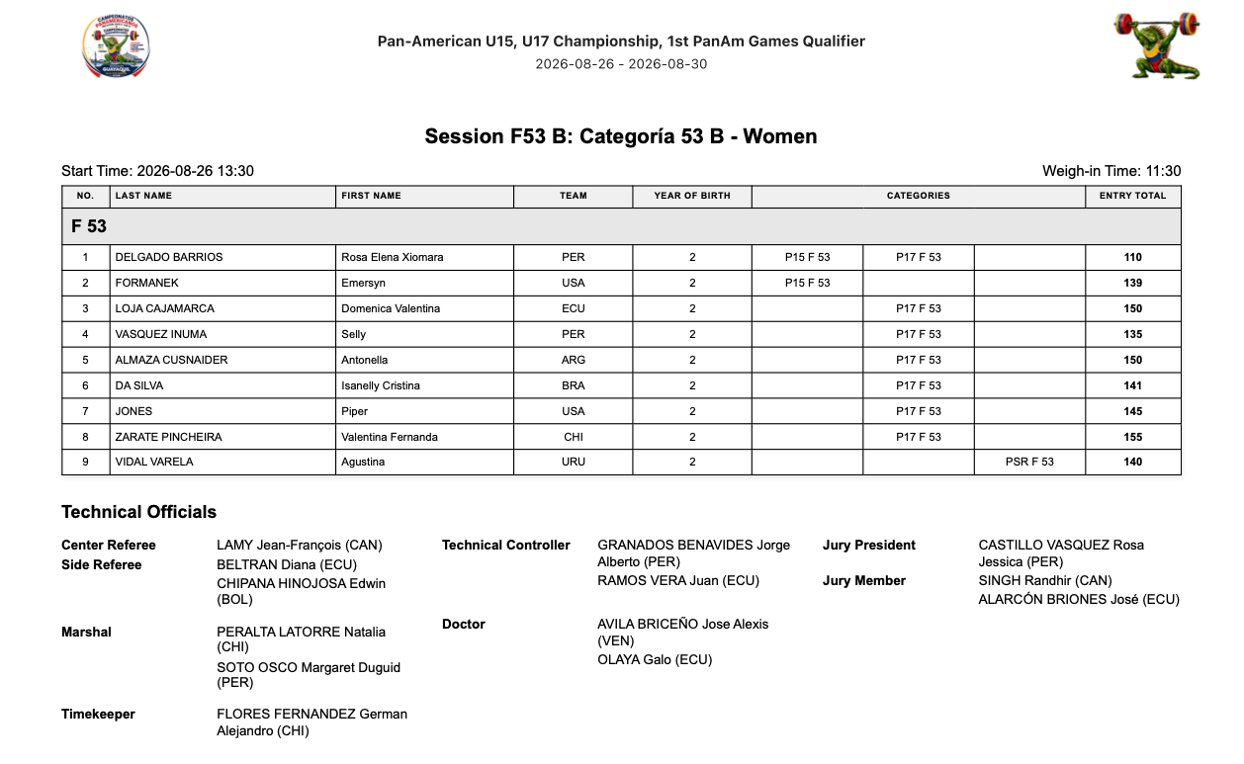
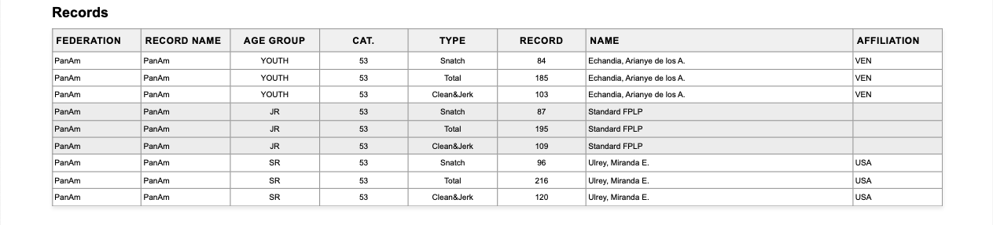

Records
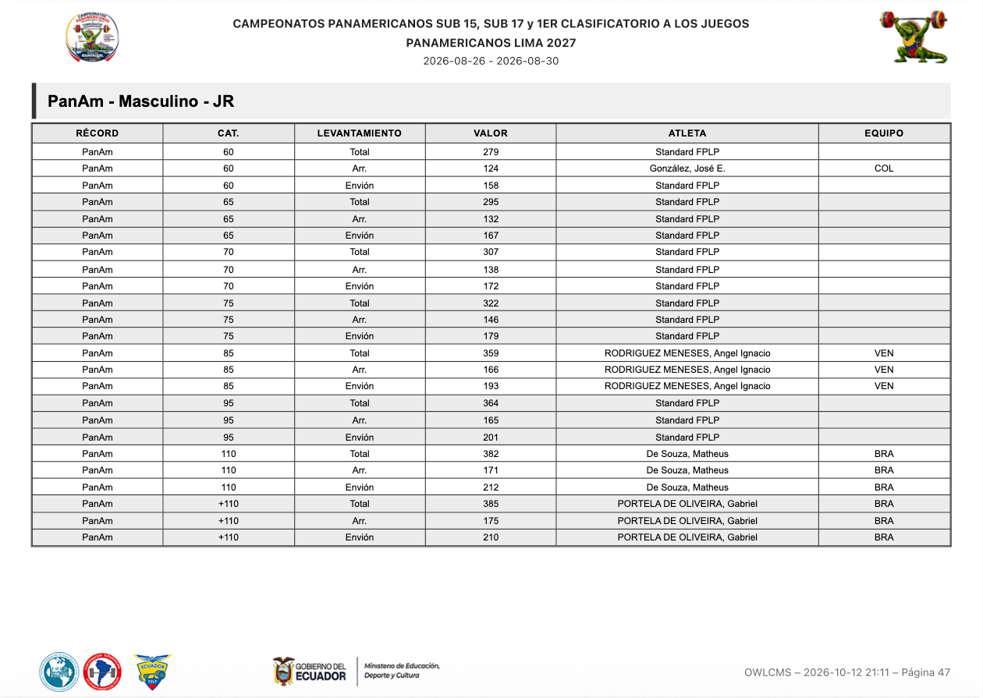

Weigh-in List
[RFP §4.4] At minimum, the TIS shall provide Weigh-in List.
The weigh-in list allows capturing both the weight-on-scale and the adjusted weights. Signature areas for the attending officials are provided
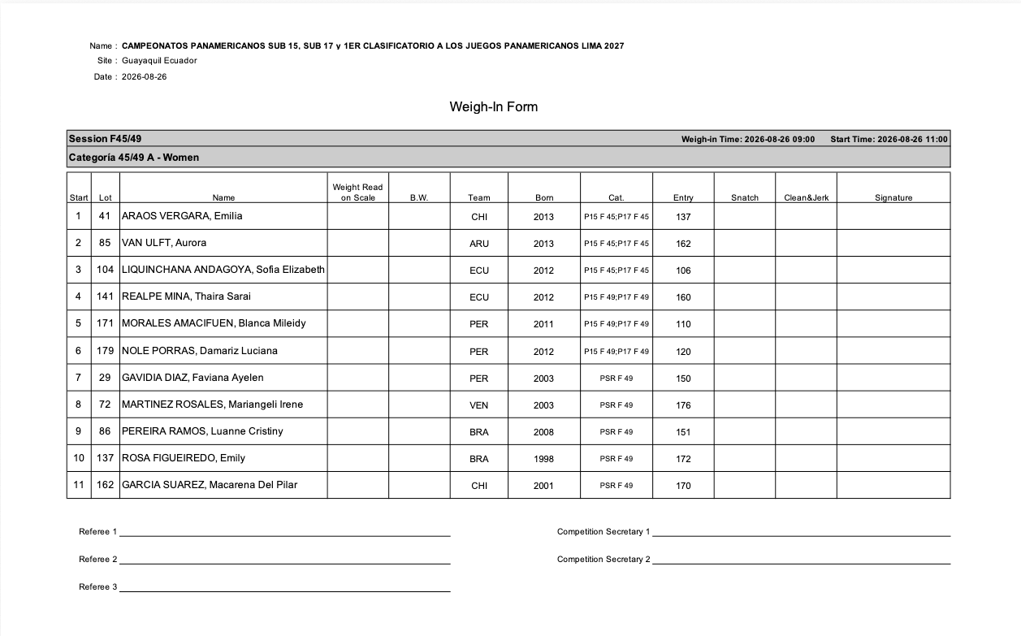

Athlete's Cards
[RFP §4.4] At minimum, the TIS shall provide Athlete's Cards.
Athlete Cards with all the required signature fields are provided.
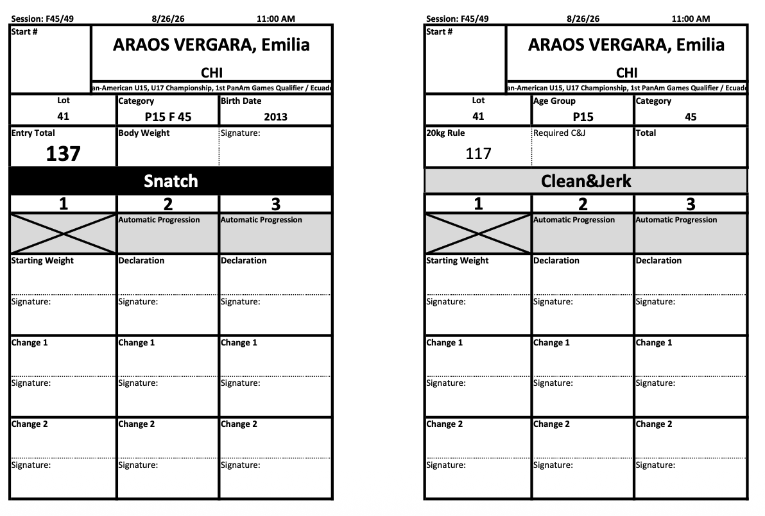

Manual Protocol
[RFP §4.4] At minimum, the TIS shall provide Manual Protocol.
An empty protocol sheet suitable for manual entry is available.
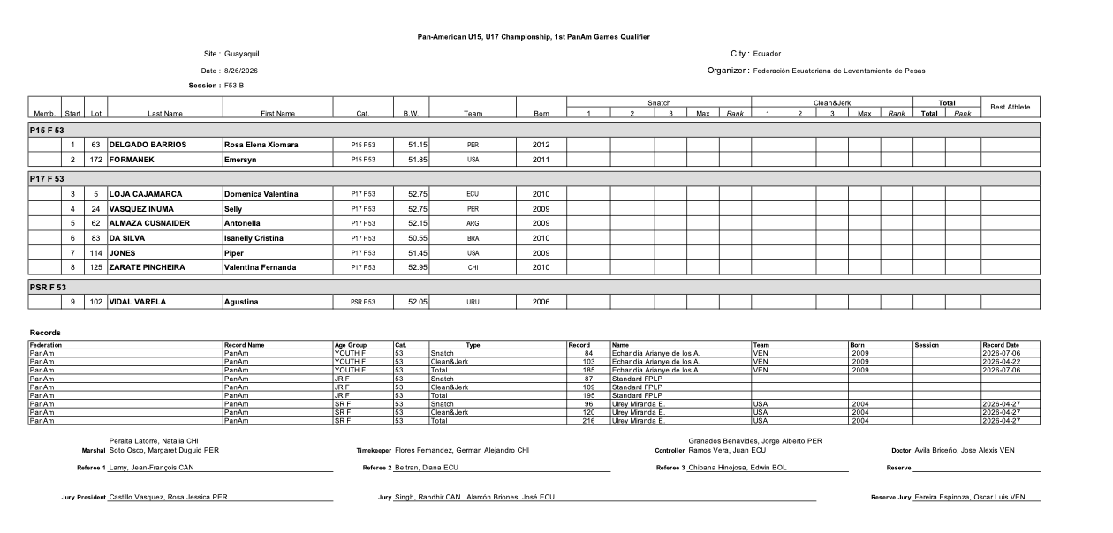

Empty Protocol
[RFP §4.4] At minimum, the TIS shall provide Empty Protocol.
In addition to the manual protocol from section E.2.4.5 the system provides an empty jury protocol sheet. Bigger text boxes allow capturing the decisions according to the TCRR rules for examinations, and the calculation section for exams can optionally be included.
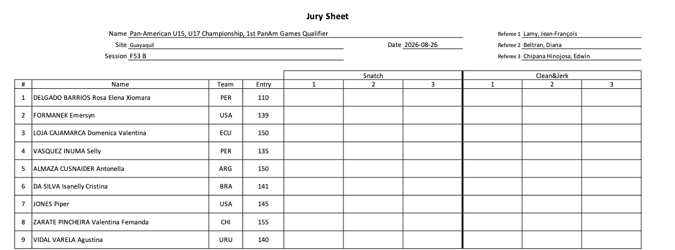
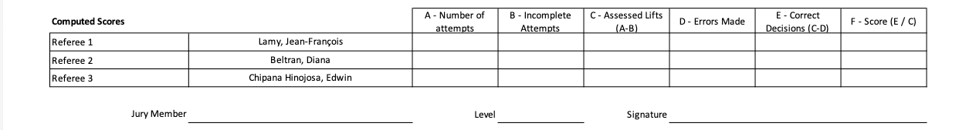

Protocol
[RFP §4.4] At minimum, the TIS shall provide Protocol.
A session-end protocol sheet is provided, including record improvements
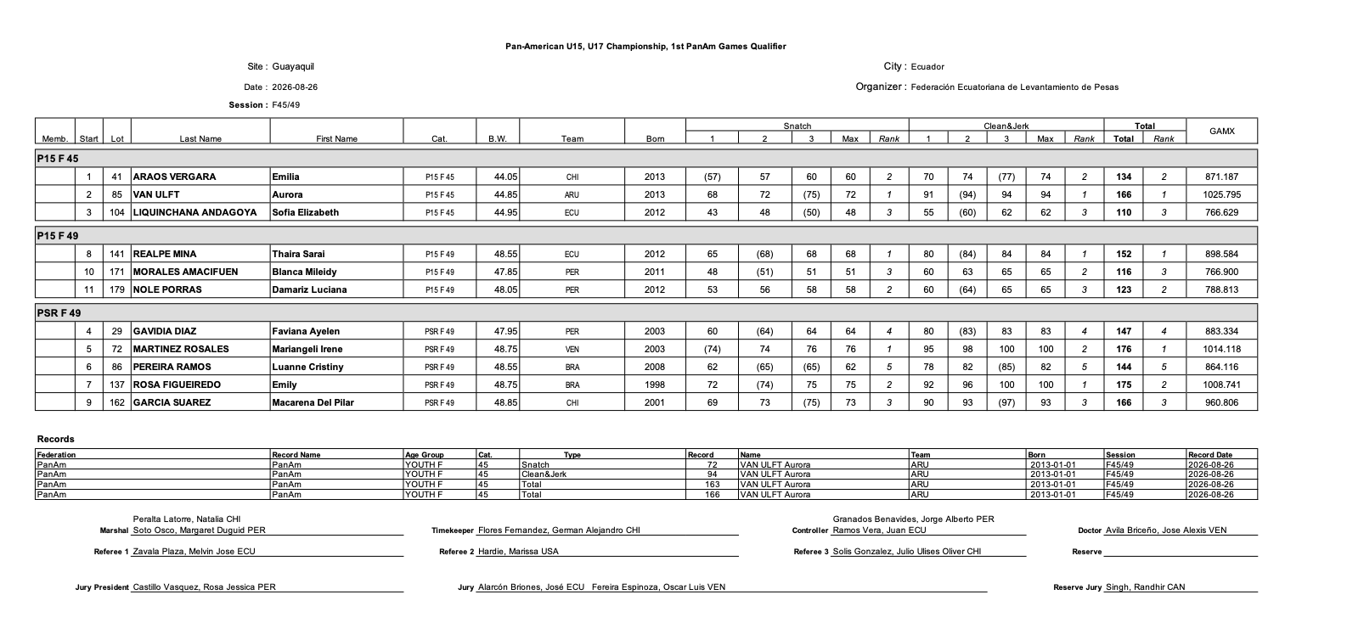

Results
[RFP §4.4] At minimum, the TIS shall provide Results.
Full competition results, per category, are available in several formats. For example, a category-per-category output in Excel format.
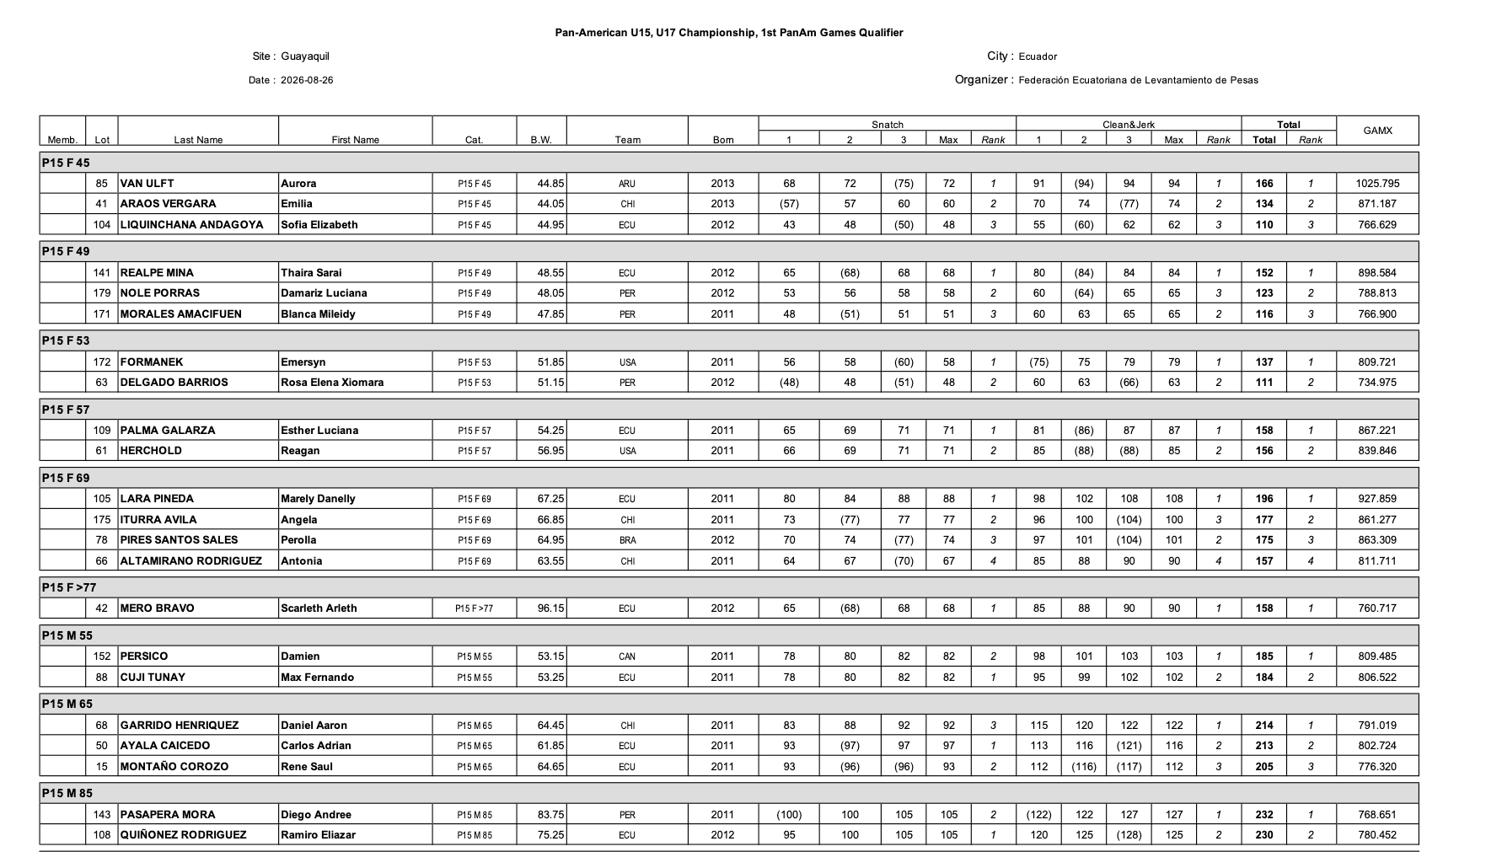
Flat-file formats, such as the one expected by IWF are also supported for easier importing.
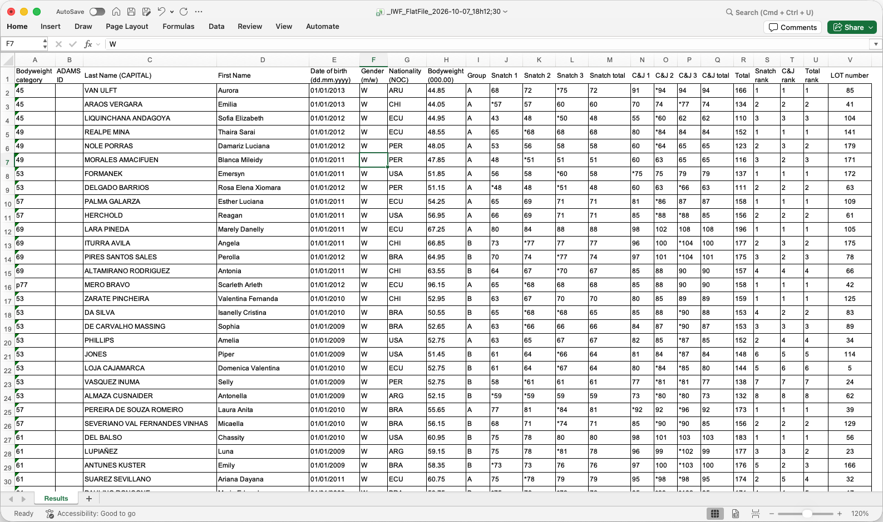

Team Classification/Placing
[RFP §4.4] At minimum, the TIS shall provide Team Classification/Placing.
The Excel-format final package described in section E.2.4.11 includes a sheet with all the team classification details for IWF points, as well as medal standings.
The following example is for a Youth championship. A fully formatted version of the team classifications and medal standings is present in Results Book (see section E.2.4.12)
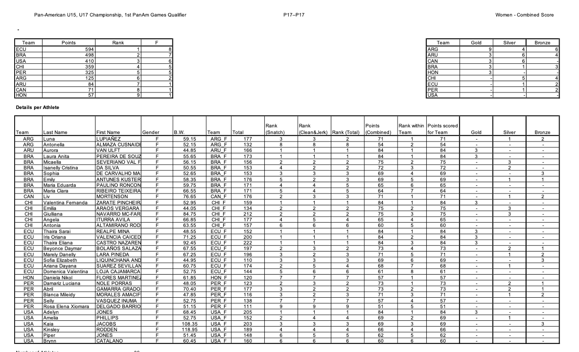
For verification purposes, all the individual athlete statistics are also included

Records
[RFP §4.4] At minimum, the TIS shall provide Records.
Records improved during a competition can be visualized directly, for a given age group.
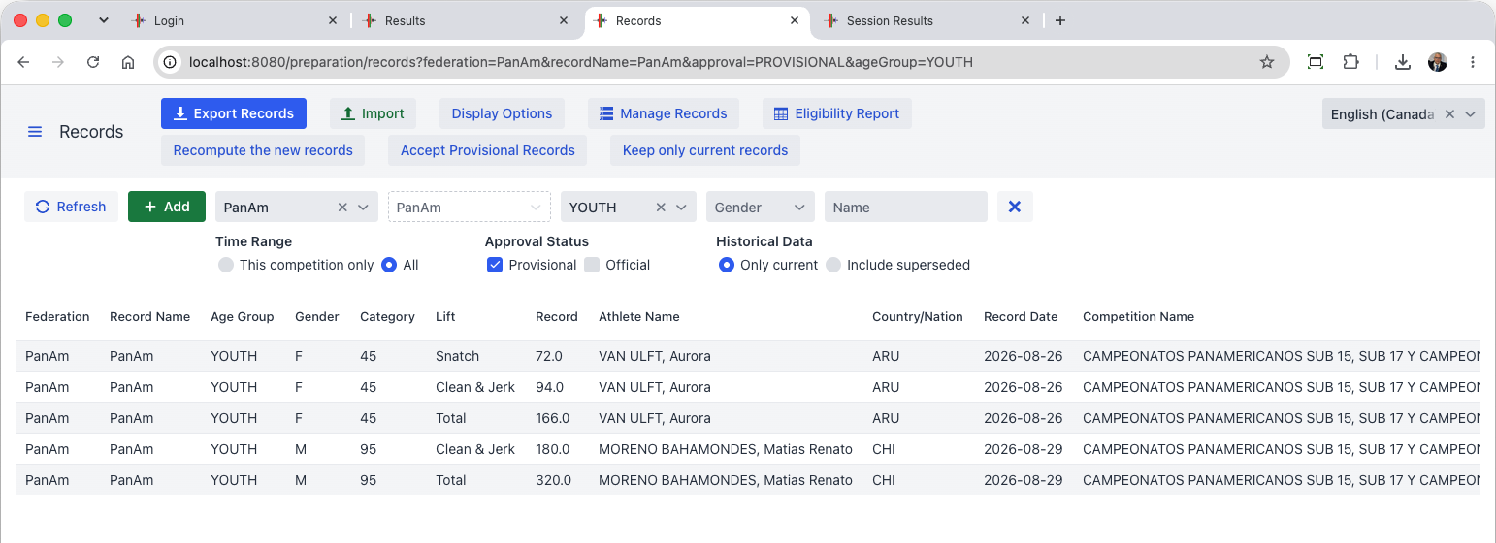
An arbitrary number of record files can be loaded; the system can export records in the same format it reads. Records that are loaded are shown in the Start Book (see Section E.2.4.2.2.6)
The registration data for each athlete determines who is eligible for what records (for example, a Mexican athlete is eligible for PanAmerican and World Records, but not for the South American ones; OWLCMS handles this automatically).
If a missing record file was not loaded at the start of the competition (or if an error is found), it is possible to reload the record files and recompute the records set during the competition. New protocol sheets can then be emitted and signed as authentic by the jury presidents concerned.
At the end of the competition, records can be exported as required. There are both display- and import-oriented formats.
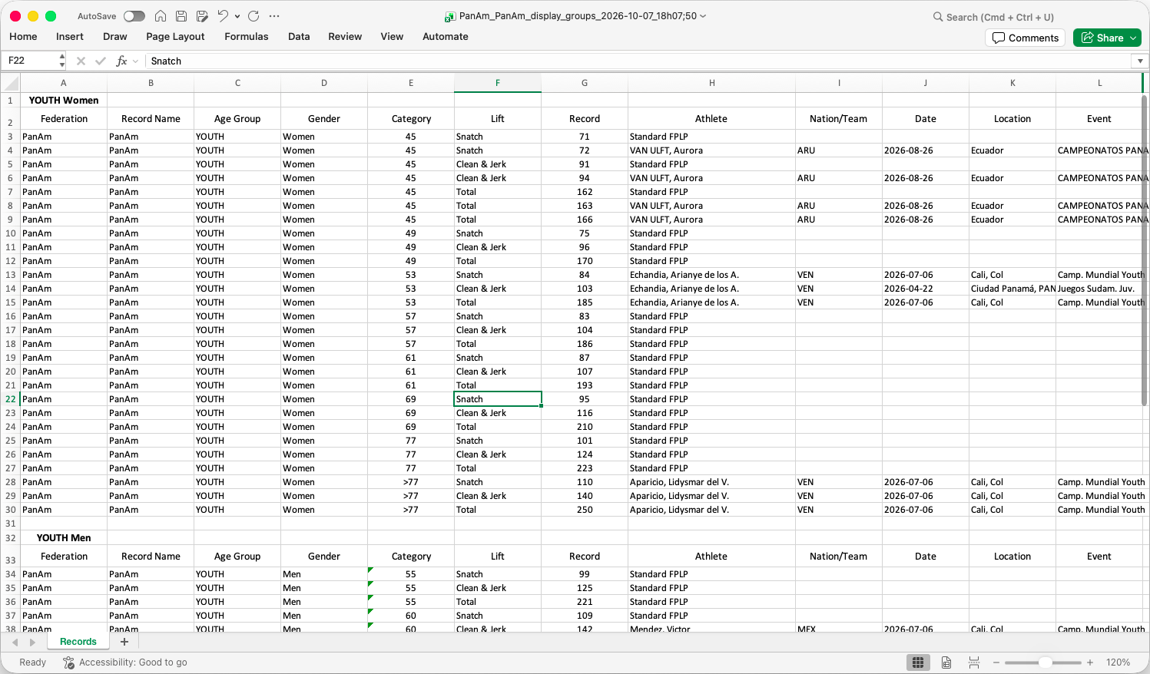

Final Results Package
[RFP §4.4] At minimum, the TIS shall provide Final Results Package.
OWLCMS produces a spreadsheet with all relevant results (per category, best athlete scores, team scores)
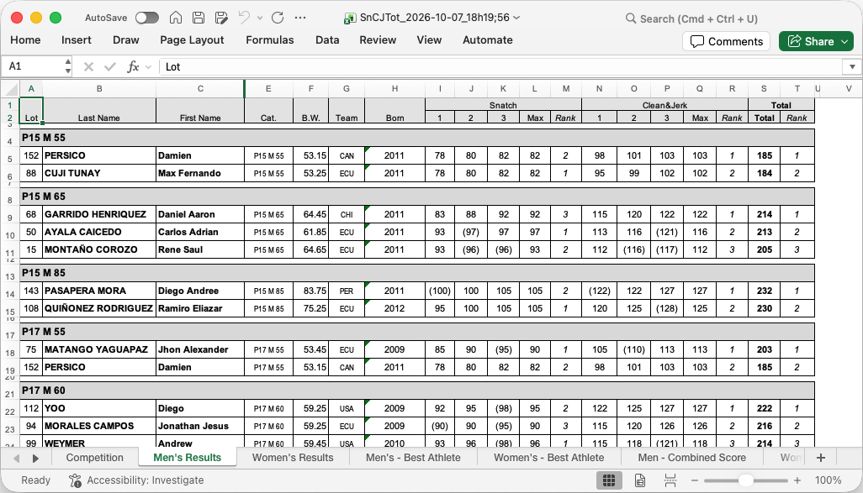

Results Book where applicable
[RFP §4.4] At minimum, the TIS shall provide Results Book where applicable.
A fully formatted results book, complete with a table of contents, is produced automatically with no human intervention. The following are sample pages.

Medals
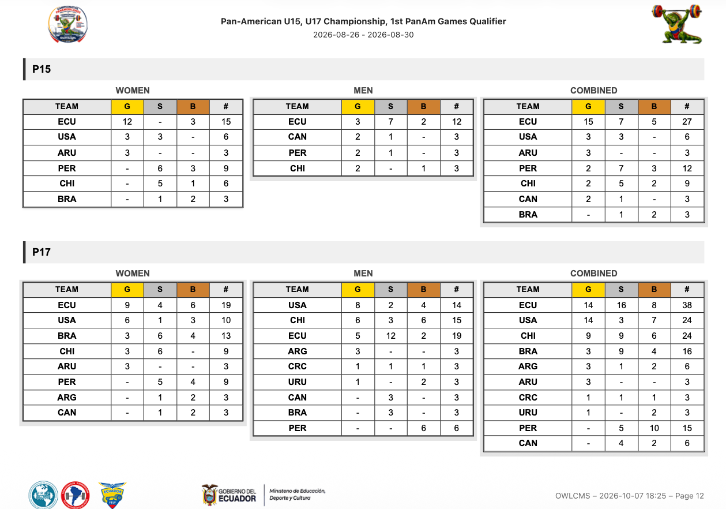

Team Points
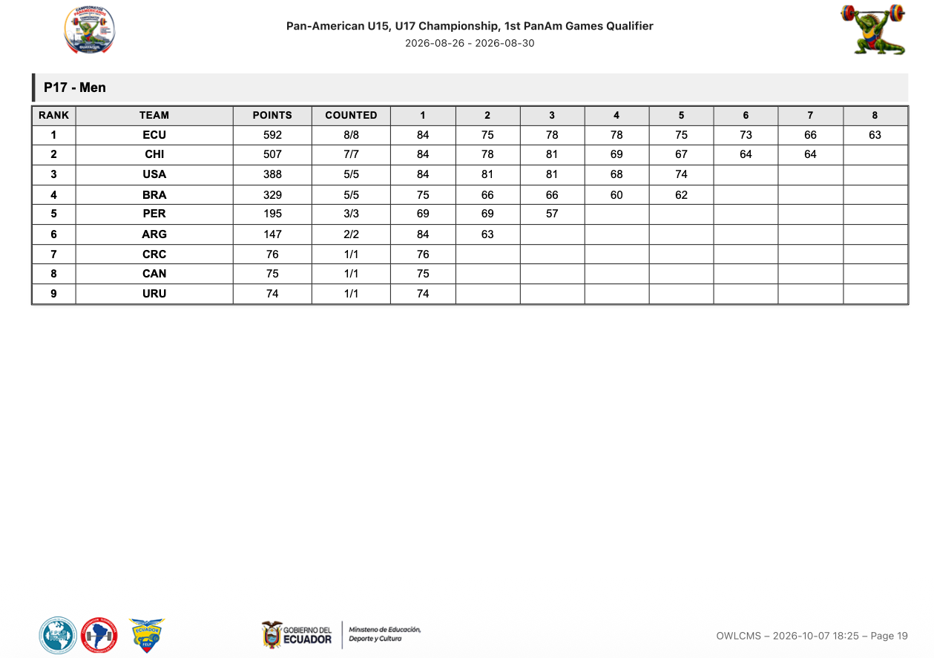

Best Athlete
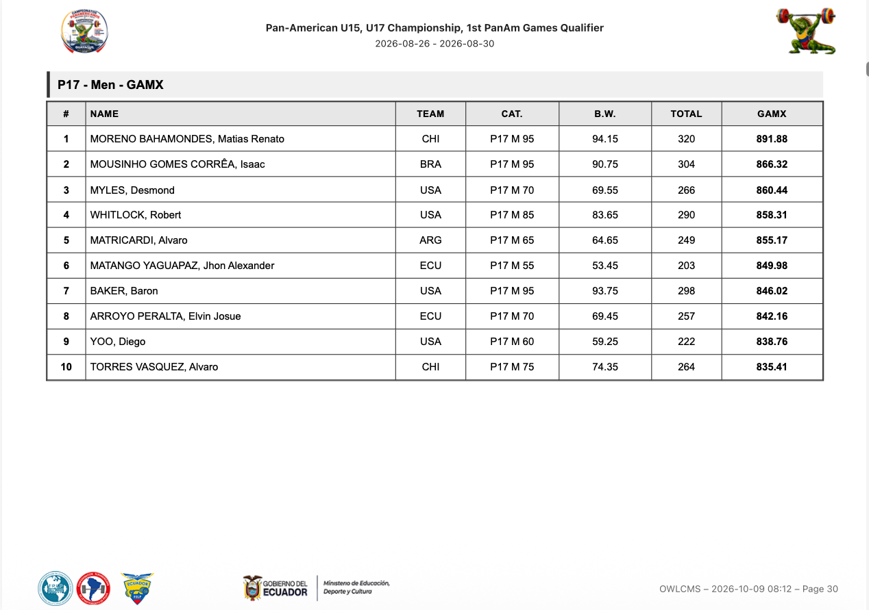

Category Rankings
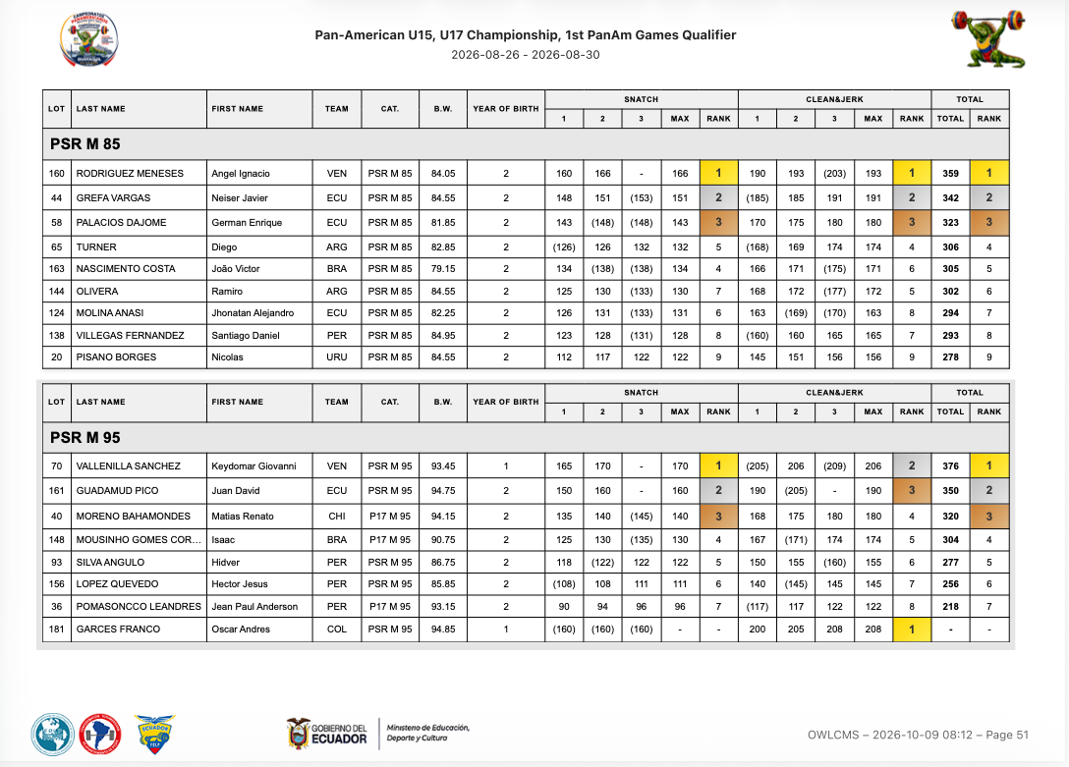

Session Protocols
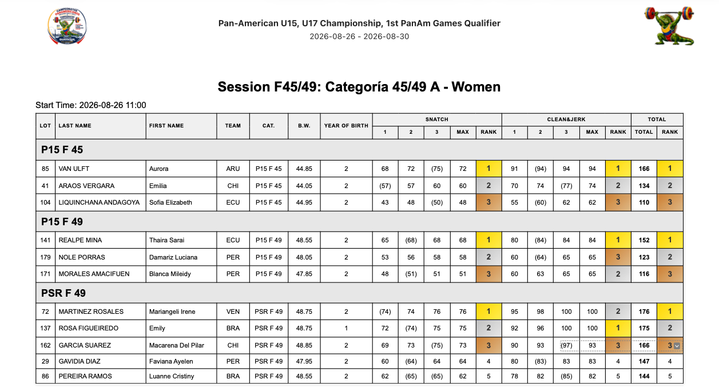
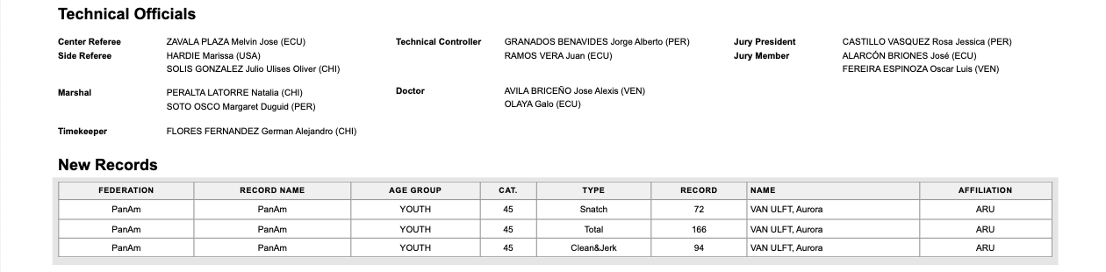

Machine-readable export
[RFP §4.4] At minimum, the TIS shall provide Machine-readable export.
The full database content is available on demand in normalized JSON format. The time required to produce is extremely short and the data is consistent; such a snapshot export can be triggered at any idle time during the competition.
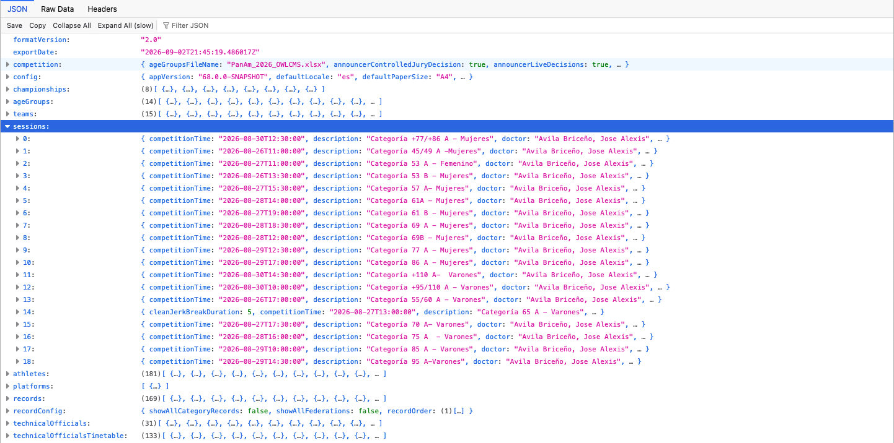
The competition supervisor typically triggers such exports at meaningful times (after a weigh-in, at Clean&Jerk break, or at the end of a session). The backups can also include a sealed version of the audit log, ready to be saved off-site.
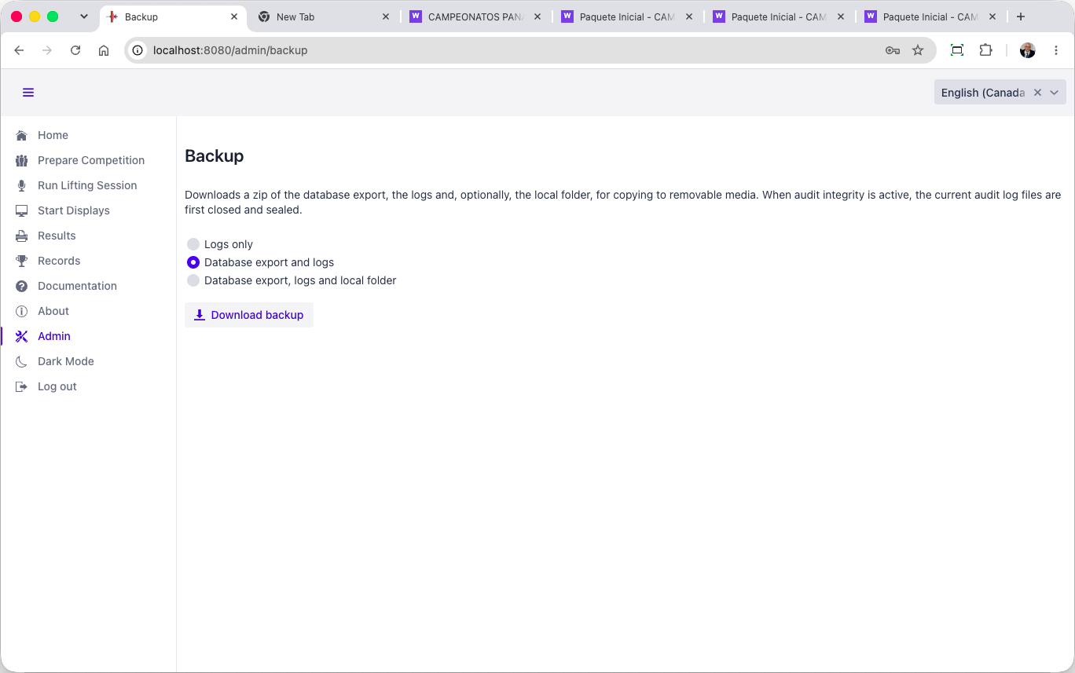

Distribution records
[RFP §4.4] At minimum, the TIS shall provide Distribution records.
Distribution of results is entirely under the control of the competition staff. Competition staff is expected to upload official documents to IWF’s document management systems that will then control distribution. Production of authoritative exports is logged in the audit logs.

Final evidence/archive
[RFP §4.4] At minimum, the TIS shall provide Final evidence/archive.
The machine-readable export described in section E.2.4.13 and the audit logs described in F.1.1.5 constitute the source of truth. A SHA-256 checksum of the export is logged in the audit log so the time of production in the export can be cross-checked with that written in the log.

Security & resilience
Security architecture, access, offline operation, backup, recovery, failover and continuity.

Security, Resilience and Business Continuity

Security
OWLCMS meets all stated requirements.

Least-privilege access by role and device identity.
[RFP §7.1] Least-privilege access by role and device identity.
OWLCMS supports separate logins for every role, and where relevant, separate logins for each role and platform. Devices are identified per platform and authenticated using the MQTT identity of the MQTT interface.

Separation of competition, device, public/display, database and management functions where applicable.
[RFP §7.1] Separation of competition, device, public/display, database and management functions where applicable.
The role structure separates the technical official roles, preparation roles, the competition supervisor, and admin functions.

Protection of credentials, secrets and data in transit/at rest where required.
[RFP §7.1] Protection of credentials, secrets and data in transit/at rest where required.
All credentials or secrets are stored encrypted and transported in encrypted form. They are never written to log files in clear. Account passwords and interface connection passwords use PBKDF2 encryption with HMAC-SHA256.

Controlled remote support, removable media and patch/deployment processes.
[RFP §7.1] Controlled remote support, removable media and patch/deployment processes.
Supplier will install a remote support program on the competition supervisor laptop and on the interface laptop (AnyDesk). Access to the competition system will be granted explicitly by the competition supervisor.
IWF will provide removable media to the competition supervisor, and IWF will keep the files copied on that device.
OWLCMS and Blue Owl are distributed as installation packages created using automated, repeatable processes. Both packages follow strict version control rules.
So as a rule, when a fix is required, an installation package is made available for the fixed version. The fixed package is installed alongside the old version, and data is imported (the OWLCMS launch process supports this). If the test is conclusive, the new version continues to be used; otherwise, the prior version is used again.
There are situations where a fix is extremely simple (adjusting a configuration file or a template). In such cases, the corrective fix may be simply applied in the correct location. But the supplier will generally avoid such processes.

Tamper-resistant audit sufficient to reconstruct material actions.
[RFP §7.1] Tamper-resistant audit sufficient to reconstruct material actions.
The audit logs include every single modification to the athlete and lifting data, and all events coming from devices (decisions, etc.). All export actions are logged with the checksum of the exported file, for later integrity checks of exported files.
The audit log is a chain of cryptographically signed blocks of log lines. Each block is signed by a private key. Each block's signature also includes the previous block's signature, creating a chain.
Prior to each competition, a cryptographic public-private key pair is generated, along with a public-key fingerprint. The technical delegate or other trusted person takes a picture of the fingerprint. Logs are copied away from the competition computer to a safe location periodically during the meet.
In case of a dispute, the safe logs are copied to a clean machine, and a clean OWLCMS is installed. Each log contains the public key that matches the (undisclosed) private key used to do the signatures. The checker can confirm that each block was signed by the matching private key and that each block was not modified. The technical delegate confirms the public key’s authenticity by comparing its fingerprint with what they photographed.

No public or anonymous path may write authoritative competition state.
[RFP §7.1] No public or anonymous path may write authoritative competition state.
The only writing to the database is done by OWLCMS itself, which owns an exclusive file lock. The database is therefore the source of truth. Exports are cryptographically checksummed, and the checksum is logged in the audits to allow later verification of integrity.

Offline operation
[RFP §7.2] Core competition, officiating, timing, local displays and local official documents shall remain usable during loss of public internet or cloud connectivity.
The normal mode of operation of OWLCMS in a major competition is completely offline, on a private local area network as shown in Figure 1. Operator stations are normally wired using Ethernet cabling to avoid WiFi interference or foul play.

Backup and recovery

Protected backup copies of data, configuration, rules, assets and audit.
[RFP §7.3] Protected backup copies of data, configuration, rules, assets and audit.
All files that constitute the OWLCMS configuration and rules can be backed up as a single zipped folder. This zip is copied remotely by the competition supervisor. This
The cryptographic key is preserved separately, as a matter of principle.
While OWLCMS is running, it uses the JSON export format for snapshots, which can be produced on demand. Copying the actual binary database is possible when OWLCMS is stopped.

Timed restoration demonstrating the approved recovery objective.
[RFP §7.3] Timed restoration demonstrating the approved recovery objective.
Restoration of a saved state from scratch normally takes less than a minute.

Defined promotion, split-brain prevention, failback and reconciliation where redundancy is claimed.
[RFP §7.3] Defined promotion, split-brain prevention, failback and reconciliation where redundancy is claimed.
The system would not operate in tandem. Checkpoint copies would be used.

Cold-start and rollback procedures using controlled recovery media.
[RFP §7.3] Cold-start and rollback procedures using controlled recovery media.
Checkpoint copies of the export format can be obtained on demand, and constitute full rollback points. Restarting the system without a database file creates a minimal empty one that can be immediately loaded from a checkpoint.

Manual continuity
[RFP §7.4] A manual Protocol and rehearsed manual-continuity procedure shall remain available. Staff shall know when to continue, when to STOP and how to reconcile manual records with the electronic state.
A manual Protocol and rehearsed manual-continuity procedure shall remain available. Staff shall know when to continue, when to STOP and how to reconcile manual records with the electronic state.
This is standard operational procedure. A power outage, or a networking mishap can prevent use the system and cause a revert to a “manual cards and flags” mode.
OWLCMS has been tested in such situations before. As soon as the system is restored, someone can simply copy the information as it stands on the cards, even while lifting is going on that platform. As soon as the information has been updated and matches the paper trail, the screens can be turned on for that platform. All the lifting order and such is derived from the authoritative card data as entered.
Writing operational procedures as expected by IWF would take place before deployment.

Monitoring
[RFP §7.5] Actionable monitoring shall cover critical services, devices, timing, storage, network and stale-state conditions, with clear escalation responsibilities.
Actionable monitoring shall cover critical services, devices, timing, storage, network and stale-state conditions, with clear escalation responsibilities.
The actual OTIS kit requires a router and, for each platform, a switch. As part of the certified kit, this constitutes the monitoring boundary. The kit devices are attached directly to these and can be monitored (including remote logins).

Integration
Interfaces, APIs/feeds, public/broadcast and Games/ORIS integrations.

Interfaces
[RFP §6.3] Material interfaces shall document producer/consumer, purpose, version, schema/field mapping, identifiers, status/null rules, sequencing/revision, time source, latency, authentication, acknowledgement, retry/reconnect, monitoring and fallback.
Material interfaces shall document producer/consumer, purpose, version, schema/field mapping, identifiers, status/null rules, sequencing/revision, time source, latency, authentication, acknowledgement, retry/reconnect, monitoring and fallback.

Device Protocol and Authentication
All the devices on the network communicate using MQTT messages to the OWLCMS server; see the specification on-line https://jflamy.github.io/owlcms4/#/100-AdvancedTopics/200-MQTTMessages
Standard MQTT authentication protocols are used (login name and password); crypted MQTT is available, but this is normally only used on cloud-based configurations, which is not the case for the proposed completely-local, closed-network configuration.

Blue Owl USB-MQTT Interface
- Blue Owl devices use the same computing chip that is used on Arduino Uno or Nano, or on Arduino Mega
- The Blue Owl devices use a standard USB 2.0 interface to communicate with the computer that powers them.
- All communications with the computer are done serially on the same USB connection, using the publicly documented Firmata protocol.
- The Blue Owl program speaks Firmata to the devices and relays the information to OWLCMS
  - When a button is pressed on the device, this is immediately propagated by Blue Owl as an MQTT message to OWLCMS
  - Conversely, when OWLCMS issues a command to turn on an LED or buzzer, the Firmata message activates the corresponding ports.
  - Blue Owl itself will attempt reconnections every second in case of disconnection
  - The server detects and reports when a Blue Owl module disconnects and reconnects
  - Each Blue Owl interface keeps complete logs.
- The actual implementation of the software code used by the Blue Owl user interface to perform the interactions is publicly available at https://github.com/nemikor-solutions/blue-owl-core
- Schematics of the Blue Owl devices are included in Annex A.

Direct MQTT Networking
Because the MQTT protocol is documented, any device that can be designed to listen to MQTT can just subscribe to the topics. The VPT modules uses the MQTT messages to know when the clock is started and stopped, as an example. WiFi devices can also act as devices by talking directly to MQTT.

Latency
Latency between the button press and reception of the MQTT message is under XX ms.

Operations
Staffing, training, manuals, event support, escalation and incident response.

Supplier responsibilities

Provide accurate product and hardware baseline
[RFP §8.2] Provide accurate product and hardware baseline.
[To be completed]

Provide complete technical submission and evidence package
[RFP §8.2] Provide complete technical submission and evidence package.
A test environment can be provided to reproduce any claimed feature.

Make the declared system available for IWF testing and demonstrations
[RFP §8.2] Make the declared system available for IWF testing and demonstrations.
A test environment can be provided if supplier is selected.

Correct deficiencies and complete regression testing when required
[RFP §8.2] Correct deficiencies and complete regression testing when required.
Agreed if supplier is selected.

Notify IWF of material product, security, hardware, interface or rule-logic changes
[RFP §8.2] Notify IWF of material product, security, hardware, interface or rule-logic changes.
Agreed.

Maintain qualified support personnel and appropriate spares
[RFP §8.2] Maintain qualified support personnel and appropriate spares.
Agreed.

Protect IWF, athlete and event information and comply with applicable data-protection requirements.
[RFP §8.2] Protect IWF, athlete and event information and comply with applicable data-protection requirements.
The only information that would normally be considered Personal Data under GDPR and similar frameworks is the athlete’s body weight and birth date. The body weight being necessary to the application of rules, it can be construed to fall under the “legitimate interests” clause (and disclosure should be mentioned as part of any consent and risk acceptance form signed by athletes).
Concerning birth date, IWF’s own rules do not require the full birth date to be published, only the birth year. OWLCMS has a setting to only use and show the birth year; we would recommend that this be used in IWF competitions.
The rest of the athlete information and event information is meant to be made public as it is part of public event invitations and included in preliminary participation lists, start books and result books.
In an IWF event, it is expected that an IWF identifier of the athlete will be included in the registration data. OWLCMS treats that identifier as an opaque anonymized foreign identifier.

Event deployment

Only the approved baseline and event configuration may be used
[RFP §12.3] Only the approved baseline and event configuration may be used.
Agreed.

Actual hardware, software, network, power, displays, spares and staffing must match the approved event design.
[RFP §12.3] Actual hardware, software, network, power, displays, spares and staffing must match the approved event design.
Agreed.

Dress rehearsal and failure/recovery test shall be completed before readiness sign-off.
[RFP §12.3] Dress rehearsal and failure/recovery test shall be completed before readiness sign-off.
Agreed.

Substitutions require approved deviation or delta testing before use
[RFP §12.3] Substitutions require approved deviation or delta testing before use.
Agreed. Note that operator stations used by technical officials are only actually dependent on the capability to run a current mainstream browser and on the presence of HDMI ports and USB ports. Any Windows laptop with these features can be substituted in an emergency.

Support and incidents

Defined escalation contacts and event support
[RFP §12.4] Defined escalation contacts and event support.
Competition staff will be provided with that information. Escalation staff will either be directly on site or available remotely.

Critical incidents documented, contained, investigated and reported
[RFP §12.4] Critical incidents documented, contained, investigated and reported.
Supplier will provide an issue reporting environment and ensure follow-up and resolution of incidents.

Serious incidents, unauthorised changes, false evidence, unsupported baselines or material security compromise may lead to restriction, suspension or withdrawal.
[RFP §12.4] Serious incidents, unauthorised changes, false evidence, unsupported baselines or material security compromise may lead to restriction, suspension or withdrawal.
Agreed.

Homologation
Test environment, evidence package, demonstration plan and FAT/SAT readiness.

Evaluation and Homologation Process

Administrative review
[RFP §10] Completeness, eligibility and declarations.
Supplier declares the current information to be correct at the date of submission.

Technical review
[RFP §10] Architecture, functionality, hardware, interfaces, security and resilience.
To be performed by IWF selection committee.

Scope confirmation
[RFP §10] Freeze baseline, profile, capacity, dependencies and test plan.
All claimed capabilities are present in the proposed baseline, in compliance with TCRR as available October 1, 2026.
Baseline will managed according to section K.1.2. Note that the baseline may need to evolve to reflect software modifications due to changes in IWF rules or formal adoption of experimental practices (e.g., display of jury decisions on scoreboards). The baseline may also evolve due to incident resolution or significant supplier upgrades, such as CVE security incident resolutions.

FAT
[RFP §10] Controlled normal, edge, security, capacity and failure testing.
Initial acceptance tests to be formalized if supplier is selected. All capabilities claimed can be demonstrated.

Corrective action
[RFP §10] Resolve deficiencies and provide regression evidence.
Any issue declared will be investigated, and updated official builds will be provided. OWLCMS includes over 350 automated tests to prevent regressions; such tests are run before any release.

Operational validation
[RFP §10] Representative event tempo with operators, officials, displays, feeds and recovery.
OWLCMS includes an automated stress simulation test that allows all required displays to be observed on all platforms as desired. All device interfaces are exercised, and all external feeds are fed.
The stress test proceeds as fast as could possibly be done in real life: a full lift cycle takes about 12 seconds from one decision to the next, including a real clock start and the decision reversal delays. Simulated attempted weights are randomly modified using the audited marshal events (simulating a plausible rate of such changes). Referee decisions are generated using the actual audited referee events as they would be generated by devices, to create a plausible rate of successive attempts.
All the displays, devices, and operator stations, for all platforms, can be opened at once and observed.
It is of course possible to perform the same test manually with human operators.

Homologation decision
[RFP §10] Review requirements, hard gates, evidence and findings.
To be performed by IWF selection committee.

Supplier licence
[RFP §10] Complete legal and operational conditions.
To be defined once supplier is selected.

Event SAT
[RFP §10] Check actual installation against approved baseline.
To be performed by IWF acceptance committee.

Surveillance
[RFP §10] Review incidents, changes, support and expiry.
IWF oversight mechanisms are to be defined.

Evidence
[RFP §10.1] Evidence shall be attributable to a specific baseline and test. Screenshots alone are insufficient where logs, physical inspection or live behaviour are necessary.
Supplier will capture exports and logs as required during testing.

Approval Criteria and Hard Gates

HG-01 Sport rules & result correctness
[RFP §11] Incorrect sporting fact, rank, medal, record or rule-critical transition.
No such incident reported in actual production use.

HG-02 Authoritative state & data integrity
[RFP §11] Split, duplicated, lost or silently overwritten accepted state.
No such incident reported in actual production use.

HG-03 Timing & adjudication safety
[RFP §11] Unsafe or ambiguous timing, decision, Down signal or restart.
No such incident reported in actual production use.

HG-04 Correction & audit
[RFP §11] Unauthorised, partial, untraceable or unreconciled correction.
System includes an audit trail of all modifications made to data, and all access is role-based.

HG-05 Continuity & recovery
[RFP §11] Uncontrolled loss of competition or unverified recovery.
Actual production occurrences of loss of power or loss of networking do occur regularly in some countries, and OWLCMS has been used in competitions where they occurred. The system has never been observed to lose data. In IWF-scale events, it is always run on battery-protected laptops and/or on a UPS to prevent power spikes. Even if a laptop running on battery suddenly runs out of power, the database's transactional nature prevents data loss.
Recovery is achieved as soon as the system has been updated to catch up with the handwritten athlete cards (or even the manual protocol). A platform can be on outage (local power loss to its networking switch) while others are working, catching up for that platform will allow it to recover, the other platforms are not affected.
As an additional precaution against human error, the competition supervisor would normally trigger a database export after weigh-ins and at each break on each platform. This can also be automated to take place at fixed intervals.

HG-06 Security & least privilege
[RFP §11] Uncontrolled privilege, public write path or material compromise.
The system as proposed to IWF is fully role- and least-privilege-based. The database is in exclusive write mode from the OWLCMS system, and all competition modifications done by the application are logged.

HG-07 Output parity & publication
[RFP §11] Contradictory outputs or untraceable final publication.
No such incident reported in production

HG-08 Baseline reproducibility
[RFP §11] Unknown tested version, missing evidence or irreproducible installation.
All builds are versioned and created from a repeatable procedure that is public. The actual binary files contain version information.

HG-09 FOP readiness & safety
[RFP §11] Missing critical equipment, unsafe installation or unresolved obstruction.
This clause is event-specific, to be completed by the technical delegate of the event.

Decision rules

All applicable mandatory requirements and tests must be disposed of
[RFP §11.1] All applicable mandatory requirements and tests must be disposed of.
Understood as “must be met”. To be completed by IWF evaluation committee.

Applicable TCRR requirements and hard gates must pass
[RFP §11.1] Applicable TCRR requirements and hard gates must pass.
To be completed by IWF evaluation committee.

No open Critical finding may remain
[RFP §11.1] No open Critical finding may remain.
To be completed by IWF evaluation committee.

Traceability from requirement to evidence and test must be complete
[RFP §11.1] Traceability from requirement to evidence and test must be complete.
To be completed by IWF evaluation committee.

Successful FAT, recovery and operational validation are required for the claimed profile.
[RFP §11.1] Successful FAT, recovery and operational validation are required for the claimed profile.
To be completed by IWF evaluation committee.

Partial is not Pass
[RFP §11.1] Partial is not Pass.
To be completed by IWF evaluation committee.

A profile limitation cannot change an IWF sport rule or bypass a hard gate
[RFP §11.1] A profile limitation cannot change an IWF sport rule or bypass a hard gate.
To be completed by IWF evaluation committee.

Commercial
Licence, implementation, equipment, support/maintenance, optional services and recurring charges.

Commercial and Contractual Conditions
The Licensing Fee for the four-year period is US$20,000, payable on an annual basis of US$5,000 per year.

IWF licensing fee
[RFP §13] The Licensing Fee for the four-year period is US$20,000, payable on an annual basis of US$5,000 per year.
US$5,000 per year / US$20,000 total

Licence
[RFP §13] Licence
[TO BE COMPLETED]

Implementation
[RFP §13] Implementation
[TO BE COMPLETED]

Equipment
[RFP §13] Equipment
[TO BE COMPLETED]

Support / maintenance
[RFP §13] Support / maintenance
[TO BE COMPLETED]

Optional services
[RFP §13] Optional services
[TO BE COMPLETED]

Recurring charges
[RFP §13] Recurring charges
[TO BE COMPLETED]

Legal
IP/licensing, warranties, liability, confidentiality, data protection, subcontractors and termination.

Licence Conditions, Change Control and Event Deployment

Licence validity
[RFP §12.1] The IWF licence shall be valid for a four-year period. The certificate shall state supplier, product/baseline, profiles, capacities, limitations, deviations, validity and surveillance conditions.
The IWF licence shall be valid for a four-year period. The final contract shall state the exact licence duration and renewal conditions.

Change control

Editorial / non-functional
[RFP §12.2] Controlled update and review.
Will be treated the same as minor cosmetic

Minor cosmetic
[RFP §12.2] Supplier assessment and IWF notification where applicable.
These are typically typos or simple modification to the layout (spacing, etc.). To be considered minor, operational procedures would not need to be modified.

Significant - OS/database/firmware/interface/security/workflow/hardware
[RFP §12.2] Impact assessment and approved regression/delta test.
Changes in this category will be treated in one of two categories.
- Technical changes (OS/firmware/security/hardware). These are often unavoidable and required by suppliers.
- Functional changes – User interface changes, workflow changes, changes or additions to data sent over interfaces
The difference lies in who assesses impacts and approves the changes.

Major - competition logic/timing/adjudication/records/state/failover
[RFP §12.2] Re-homologation before event use.
Full impact assessment will be done. Such changes are expected if TCRR updates rules.

Emergency security/stability correction
[RFP §12.2] Named approval, backup, rollback, targeted test and retrospective evidence.
It is expected that competition staff will be able to obtain approval as part of the IWF approval chain (e.g. by an on-site technical delegate). As per industry best practices, any emergency remediation will be investigated and a proper corrective fix will be made available under the other clauses of this section.

Intellectual property
[RFP §12.5] IWF shall receive the rights, documentation, exports, interfaces and operational access necessary to use, verify, archive and maintain the approved system and competition records.
The supplier retains its intellectual property except where otherwise agreed. IWF shall receive the rights, documentation, exports, interfaces and operational access necessary to use, verify, archive and maintain the approved system and competition records. Final contractual wording will be agreed with the selected supplier.

Mandatory declarations

Acceptance of the IWF TCRR as the controlling sporting rules
[RFP §9.1] Acceptance of the IWF TCRR as the controlling sporting rules.
Agreed.

Identification of all material limitations and dependencies
[RFP §9.1] Identification of all material limitations and dependencies.
None identified. To be confirmed during acceptance testing.

Ability to reproduce the tested system from controlled installation material
[RFP §9.1] Ability to reproduce the tested system from controlled installation material.
Installation from a compliant kit shall reproduce the tested behaviour.

Offline operation and tested recovery for the claimed profile
[RFP §9.1] Offline operation and tested recovery for the claimed profile.
The system is confirmed to operate without on-line access, and to be recoverable from the described exports.

No automatic licensing mechanism that can interrupt an active competition
[RFP §9.1] No automatic licensing mechanism that can interrupt an active competition.
There are no such automatic licensing mechanisms.

Authorised signatory | Details
Name | [TO BE COMPLETED]
Title | [TO BE COMPLETED]
Signature | [TO BE COMPLETED]
Date | [TO BE COMPLETED]

Compliance matrix
Clear response to this tender and the applicable IWF assessment.

RFP Section 2
Requirement | Compliance | Reference | Justification
2.1 M0: sport logic, FOP controls, screens, documents. | Compliant | B.2.1 | OWLCMS 69 and Blue Owl 3 are fully compliant with the TCRR.
2.1-R02 M1: control, audit, interfaces, offline, recovery, support. | Compliant | B.2.2 | The delivered system meets all requirements, with documented interfaces and baseline control per K.1.2.
2.1-R03 M2: VPT, live/broadcast outputs, monitoring, HA, rehearsal. | Compliant | B.2.3 | Standalone VPT, a replay server and core TV graphics are included.
2.1-R04 M3: Games/ORIS and programme integrations. | Compliant | B.2.4 | A documented data feed, already used for ODF, supports integrations; event-specific work is negotiable.
2.1-R05 MP: simultaneous platforms with capacity evidence. | Compliant | B.2.5 | One OWLCMS instance has run 6 platforms and 1600 athletes, and capacity is verified by stress test.
2.2 Certificate states supplier and product. | Compliant | B.3.1 | [Supplier] is the supplier and acts as OTIS integrator.
2.2-R02 Certificate states exact baseline. | Compliant | B.3.2 | The baseline is OWLCMS 69+ and Blue Owl 3.0+, fixed at acceptance.
2.2-R03 Certificate states profiles and capacities. | Compliant | B.3.3 | M2 and MP are supported up to 6 platforms and 1800 participants; M3 integration is negotiable.
2.2-R04 Certificate states interfaces and dependencies. | Compliant | B.3.4 | There are no critical dependencies; only standard HTTP/MQTT and documented device protocols are used.
2.2-R05 Certificate states limitations and deviations. | Compliant | B.3.5 | There are no limitations for M0, M1, M2 and MP; M3 is described in B.3.3.
2.2-R06 Certificate states validity and surveillance. | Compliant | B.3.6 | The certificate is valid for 4 years from issuance.

RFP Section 3
Requirement | Compliance | Reference | Justification
3-R01 Import and validate entry, official and record data. | Compliant | E.1.1 | Spreadsheet imports are validated and can be round-tripped before loading into a relational database.
3-R02 Corrections, lots, groups, timetable, TO assignments. | Compliant | E.1.2 | VFE and team verification sheets are printed, and the referee timetable is editable.
3-R03 Approved, versioned Start List distribution. | Compliant | E.1.3 | A start book is produced with incremental revisions, plus schedule and start list exports.
3-R04 Weigh-in: bodyweight, first attempts, 20 kg, signatures. | Compliant | E.1.4 | Weigh-in forms and athlete cards are produced, 20 kg rules are checked, and a snapshot is taken.
3-R05 Snatch flow: order, changes, timing, decisions, records. | Compliant | E.1.5 | Lifting order, clock, decisions, 20 kg checks and records are handled automatically.
3-R06 Controlled snatch to C&J transition. | Compliant | E.1.6 | The transition is automatic and break durations are configurable at any time.
3-R07 C&J flow: order, changes, totals, ranks, records. | Compliant | E.1.7 | The Clean & Jerk is automated exactly like the Snatch (E.1.5).
3-R08 STOP, Jury, challenge, corrections, restart. | Compliant | E.1.8 | The jury uses a keypad or screen, STOP flashes on all displays, and reversals reach the speaker.
3-R09 Protocol, results, classifications and records. | Compliant | E.1.9 | The protocol is ready at session end, and corrections are audited with records recalculated.
3-R10 Medallists, public/broadcast and revised outputs. | Compliant | E.1.10 | Medal sheets, ceremony scoreboards and broadcast-styled displays are provided.
3-R11 Final dataset, logs, evidence, machine-readable export. | Compliant | E.1.11 | The archive includes the JSON export, results package, protocols, results book and audit logs.
3.1-R01 Snatch then C&J, three attempts, correct Total. | Compliant | E.1.12.1 | The state machine enforces the sequence, and Total calculation is covered by automated tests.
3.1-R02 Whole-kg weights and minimum starting weights. | Compliant | E.1.12.2 | Weights are stored as integers, and the 20 kg rule is checked on every change and tested.
3.1-R03 Correct calling order. | Compliant | E.1.12.3 | The calling order implements all four TCRR criteria.
3.1-R04 Weight change, final-call, consecutive-attempt rules. | Compliant | E.1.12.4 | The clock resumes correctly, late changes are flagged, and the prior sequence is verified.
3.1-R05 Withdrawals, no-lift/no-Total, DQ, extra attempts. | Compliant | E.1.12.5 | Withdrawals, no-Totals and DQ reasons are recorded, and re-attempts are audited.
3.1-R06 Corrections recalculate rankings, records, outputs. | Compliant | E.1.12.6 | Any card change triggers recalculation, and reports regenerate immediately.

RFP Section 4
Requirement | Compliance | Reference | Justification
4.1-R01 Authoritative 1-second countdown up to 15 minutes. | Compliant | E.2.1.1 | All clocks update every second, and breaks can have any duration.
4.1-R02 Automatic 60/120-second and break countdowns. | Compliant | E.2.1.2 | Attempt clocks are set automatically, and break countdowns are managed with overrides.
4.1-R03 Correct start, stop, restart and STOP behaviour. | Compliant | E.2.1.3 | Start, stop and restart follow the TCRR.
4.1-R04 All displays share one authoritative time. | Compliant | E.2.1.4 | Time is kept on the server, and displays compensate for propagation drift.
4.1-R05 Time corrections authorised and auditable. | Compliant | E.2.1.5 | All machines are NTP-synchronized, and corrections are logged by the operating system.
4.2-R01 Three referee boxes with decisions and indicators. | Compliant | E.2.2.1 | Blue Owl buttons provide light, sound and vibration.
4.2-R02 Correct Down signal, reminder, reversal window. | Compliant | E.2.2.2 | The state machine enforces the TCRR 3-second reversal window.
4.2-R03 Jury sees referee decisions before public reveal. | Compliant | E.2.2.3 | Live decisions are shown on the jury keypad and jury screen.
4.2-R04 Three- and five-member Jury support. | Compliant | E.2.2.4 | Jury size is selectable: 3, 5 or none.
4.2-R05 Independent individual Jury controls. | Compliant | E.2.2.5 | Individual jury buttons are provided; housings will follow IWF clarification.
4.2-R06 Decisions attributable and time-stamped. | Compliant | E.2.2.6 | Every decision is logged to the millisecond with its originating device.
4.3-R01 System health view. | Compliant | E.2.3.1 | A live technical log reports CPU and memory use.
4.3-R02 Event setup view. | Compliant | E.2.3.2 | All setup is done through interactive screens.
4.3-R04 Lots, groups and timetable view. | Compliant | E.2.3.2.2 | Registration and schedule are imported from spreadsheets, round-tripped, then edited in the application.
4.3-R07 Weigh-in view. | Compliant | E.2.3.4 | Weigh-in entry mirrors registration, applies 20 kg checks, and produces speaker and jury forms.
4.3-R08 Chief Marshal view. | Compliant | E.2.3.5 | The marshal screen mirrors the athlete card for fast entry, and violations block closing.
4.3-R09 Timekeeper view. | Compliant | E.2.3.6 | The timekeeper uses a tablet display or Blue Owl buttons and can control breaks.
4.3-R11 Competition supervisor view. | Compliant | E.2.3.8 | The supervisor uses the speaker screen with live lights and can watch the audit log.
4.3-R12 Referee monitoring view. | Compliant | E.2.3.9 | Referee lights are visible live, and each decision is in the audit log.
4.3-R13 Jury control view. | Compliant | E.2.3.10 | The jury uses a Blue Owl keypad or tablet, and the reason is sent to the speaker.
4.3-R14 Attempt boards. | Compliant | E.2.3.11 | Attempt boards show TCRR content, the country flag and a record-attempt banner.
4.3-R15 Scoreboards. | Compliant | E.2.3.12 | Warm-up and main-room layouts are provided and are extensible via tracker-core.
4.3-R16 RTDS and warm-up displays. | Compliant | E.2.3.13 | All screens are real-time, including referee and jury decisions.
4.3-R17 STOP display. | Compliant | E.2.3.14 | A flashing STOP is shown with the reason.
4.3-R18 Records display. | Compliant | E.2.3.15 | Record attempts are shown on attempt boards and scoreboards.
4.3-R19 Results display. | Compliant | E.2.3.16 | End-of-session rankings are shown with medals.
4.3-R20 Other approved states. | Compliant | E.2.3.17 | Team scoreboards, such as GAMX mixed teams, are available.
4.4-R01 Start Lists. | Compliant | E.2.4.1 | Start lists are provided for single- and multi-platform events.
4.4-R02 Start List Package. | Compliant | E.2.4.2 | The package also includes VFE documents.
4.4-R03 Weigh-in List. | Compliant | E.2.4.3 | The list captures scale and adjusted weights, with signature areas.
4.4-R04 Athlete's Cards. | Compliant | E.2.4.4 | Athlete cards include all signature fields.
4.4-R06 Manual Protocol. | Compliant | E.2.4.5 | An empty manual-entry protocol is provided.
4.4-R07 Empty Protocol. | Compliant | E.2.4.6 | A jury protocol with space for decisions is provided.
4.4 Protocol. | Compliant | E.2.4.7 | A compliant protocol, including records, is provided.
4.4-R08 Results. | Compliant | E.2.4.8 | Per-category results are available, including the IWF flat-file format.
4.4-R09 Team Classification/Placing. | Compliant | E.2.4.9 | IWF team points and medal standings are produced per championship.
4.4-R10 Records. | Compliant | E.2.4.10 | Records are viewable live and exportable as new or updated lists.
4.4-R11 Final Results Package. | Compliant | E.2.4.11 | A spreadsheet contains category, best-athlete and team results.
4.4-R12 Results Book. | Compliant | E.2.4.12 | A formatted results book with table of contents is generated automatically.
4.4-R13 Machine-readable export. | Compliant | E.2.4.13 | A JSON snapshot is available on demand, plus an SQL backup.
4.4-R14 Distribution records. | Compliant | E.2.4.14 | Distribution is controlled by staff, and exports are recorded in the audit log.
4.4-R15 Final evidence/archive. | Compliant | E.2.4.15 | The signed JSON export and audit logs form the archive.

RFP Section 5
Requirement | Compliance | Reference | Justification
5-R01 Server capacity with spare and recovery path. | Compliant | D.1.1 | OWLCMS needs few resources and runs on a server laptop, with the VPT laptop as second server.
5-R02 Dedicated role-controlled operator positions. | Compliant | D.1.2 | The director uses a laptop, operators use Raspberry Pi 500 stations, and keypads are supplied.
5-R03 Protected storage, backup and tested recovery. | Compliant | D.1.3 | The H2 database is backed up by on-demand JSON snapshots, and the VPT laptop is the spare.
5-R04 Three independent referee devices. | Compliant | D.1.4 | Wired Blue Owl controls provide LED, sound and vibration.
5-R05 Jury member devices and President controls. | Compliant | D.1.5 | Jury members have buttons, and the President has a keypad and a reversal-reason tablet.
5-R06 Authoritative timer with displays and audio. | Compliant | D.1.6 | The server times to 1 ms, displays compensate drift, and signals are audited.
5-R07 Competition and warm-up attempt boards. | Compliant | D.1.7 | Two browser HDMI outputs feed the boards through included splitters and extenders.
5-R08 Real-time competition and warm-up scoreboards. | Compliant | D.1.8 | Stage and back-room HDMI sources feed the scoreboards, as for attempt boards.
5-R09 Cameras, replay and Jury output for VPT. | Compliant | D.1.9 | Four PTZ cameras feed automatic per-lift clips that the jury can replay.
5-R10 Segmented, monitored network with common time. | Compliant | D.1.10 | Each platform has a PoE switch, a router is included, and WiFi is off.
5-R11 Read-only path to approved consumers. | Compliant | D.1.11 | The interface laptop pushes feeds out, and inbound access is whitelisted.
5-R12 Reliable official documents with fallback. | Compliant | D.1.12 | Documents are produced as Excel and PDF from an Office laptop.
5-R13 Power protection for critical equipment. | Compliant | D.1.13 | Switches are on UPS, and the stations run on battery.
5-R14 Health, device, storage and time monitoring. | Compliant | D.1.14 | Operating system indicators suffice, with optional CPU and memory logging.
5-R15 Rapid replacement of critical equipment. | Compliant | D.1.15 | Any laptop with a current browser can replace a station.
5-R16 Safe, labelled, unobstructive cabling. | Compliant | D.1.16 | Cabling is labelled, runs under the stage, and avoids athlete paths.
5.1 Per-event equipment register. | Compliant | D.1.17 | A full bill of materials for the OTIS kit is provided (Appendix 1).

RFP Section 6
Requirement | Compliance | Reference | Justification
6.1-R01 Implement IWF rule pack with controlled updates. | Compliant | C.1.1.1 | Over 350 automated tests check rules and prevent regressions.
6.1-R02 No dependency on internet or licence servers. | Compliant | C.1.1.2 | The system runs fully offline.
6.1-R03 Reproducible version, config, schema and assets. | Compliant | C.1.1.3 | Releases come from repeatable automated builds under version control.
6.1-R04 Documented, repeatable install and rollback. | Compliant | C.1.1.4 | The control panel switches versions, and the database can be rolled back in seconds.
6.1-R05 No automatic updates during event freeze. | Compliant | C.1.1.5 | The system never updates itself, and OS updates follow procedures.
6.2-R01 One authoritative owner per sporting fact. | Compliant | C.1.2.1 | Every change is attributed in the audit log.
6.2-R02 Outputs traceable to accepted state. | Compliant | C.1.2.2 | All results are derived by rules from authoritative data.
6.2-R03 Authorised, atomic, attributable corrections. | Compliant | C.1.2.3 | Changes go through audited interfaces, so unaudited state reveals tampering.
6.2-R04 Prevent or detect bad transaction sequencing. | Compliant | C.1.2.4 | Events are strictly sequenced, duplicates removed, and conflicts detected and locked out.
6.2-R05 Complete machine-readable export. | Compliant | C.1.2.5 | The JSON export and audit logs are machine-readable.
6.3 Documented material interfaces. | Compliant | G.1 | Material interfaces shall document producer/consumer, purpose, version, schema/field mapping, identifiers, status/null rules, sequencing/revision, time source, latency, authentication, acknowledgement, retry/reconnect, monitoring and fallback.
6.4 Declared third-party dependencies. | Compliant | C.2 | All third-party software, libraries, services, licences and hardware necessary for operation shall be declared, including version, ownership, support status and cloud/public-internet dependency.

RFP Section 7
Requirement | Compliance | Reference | Justification
7.1-R01 Least-privilege access by role and device. | Compliant | F.1.1.1 | Logins are per role and platform, and devices are identified by MQTT identity.
7.1-R02 Separation of functions. | Compliant | F.1.1.2 | Official, preparation, director and admin roles are separated.
7.1-R03 Protected credentials and data. | Compliant | F.1.1.3 | Secrets are encrypted, and passwords use PBKDF2 with HMAC-SHA256.
7.1-R04 Controlled remote support, media and patching. | Compliant | F.1.1.4 | Support uses AnyDesk, media come from IWF, and versions run side by side for rollback.
7.1-R05 Tamper-resistant audit. | Compliant | F.1.1.5 | Log blocks are signed and chained, exports are checksummed, and keys are verified by fingerprint.
7.1-R06 No public write path to competition state. | Compliant | F.1.1.6 | Only OWLCMS writes to the locked database, and exports are checksummed.
7.2 Operation without internet or cloud. | Compliant | F.1.2 | The system normally runs fully offline on a wired private network.
7.3-R01 Protected backups of data, config and audit. | Compliant | F.1.3.1 | Configuration is in one folder, the key is kept separate, and snapshots are on demand.
7.3-R02 Timed restoration within objective. | Compliant | F.1.3.2 | A full restore takes under a minute.
7.3-R03 Failover controls where redundancy claimed. | Compliant | F.1.3.3 | Systems do not run in tandem; checkpoint copies are used instead.
7.3-R04 Cold-start and rollback procedures. | Compliant | F.1.3.4 | Export checkpoints serve as full rollback points.
7.4 Rehearsed manual-continuity procedure. | Compliant | F.1.4 | Fallback to cards and flags is tested, and the system resyncs from the cards.
7.5 Actionable monitoring with escalation. | Compliant | F.1.5 | The router and switches form the monitored boundary of the kit.

RFP Section 8
Requirement | Compliance | Reference | Justification
8.1-R01 Legal entity able to contract with IWF. | Compliant | A.1.1.1 | [Supplier] is a duly incorporated corporation under [Country Law]. [To be completed]
8.1-R02 Relevant mission-critical delivery experience. | Compliant | A.1.1.2 | [Supplier] runs annual multi-platform events of up to 1600 athletes, streamed live.
8.1-R03 End-to-end system responsibility. | Compliant | A.1.1.3 | The same OWLCMS and Blue Owl combination has been used nationally since 2024.
8.1-R04 Qualified technical and support personnel. | Compliant | A.1.1.4 | [Supplier] retains specialists and can draw on a large trained network.
8.1-R05 International training, support and incident response. | Compliant | A.1.1.5 | [Supplier] provides international trainers, remote monitoring and deployable teams.
8.1-R06 Maintain baseline for licence period. | Compliant | A.1.1.6 | [Supplier] already maintains this baseline for its own large events.
8.2-R01 Accurate product and hardware baseline. | Compliant | H.1.1 | [To be completed]
8.2-R02 Complete technical submission and evidence. | Compliant | H.1.2 | A test environment can reproduce any claimed feature.
8.2-R03 System available for IWF testing. | Compliant | H.1.3 | A test environment will be provided if selected.
8.2-R04 Correct deficiencies with regression testing. | Compliant | H.1.4 | Agreed if selected.
8.2-R05 Notify IWF of material changes. | Compliant | H.1.5 | Agreed.
8.2-R06 Maintain support personnel and spares. | Compliant | H.1.6 | Agreed.
8.2-R07 Protect data and meet data-protection rules. | Compliant | H.1.7 | Personal data is minimal, birth year alone can be used, and IWF IDs are treated as opaque.

RFP Section 9
Requirement | Compliance | Reference | Justification
9.1-R01 Accept IWF TCRR as controlling rules. | Compliant | K.3.1 | Agreed.
9.1-R02 Identify material limitations and dependencies. | Compliant | K.3.2 | None have been identified; this will be confirmed at acceptance.
9.1-R03 Reproducible installation from controlled material. | Compliant | K.3.3 | Installing from a compliant kit reproduces the tested behaviour.
9.1-R04 Offline operation and tested recovery. | Compliant | K.3.4 | The system runs offline and recovers from exports.
9.1-R05 No licensing mechanism that can interrupt competition. | Compliant | K.3.5 | There is no such mechanism.

RFP Section 10
Requirement | Compliance | Reference | Justification
10-S01 Completeness, eligibility and declarations. | Compliant | I.1.1 | The information is declared correct at the submission date.
10-S02 Technical evaluation. | Compliant | I.1.2 | This is performed by the IWF selection committee.
10-S03 Freeze baseline, profile and test plan. | Compliant | I.1.3 | All capabilities are in the baseline, which is managed per K.1.2.
10-S04 Controlled acceptance testing. | Compliant | I.1.4 | Tests will be formalized if selected, and all claims can be demonstrated.
10-S05 Resolve deficiencies with regression evidence. | Compliant | I.1.5 | Fixed official builds are provided, backed by over 350 regression tests.
10-S06 Representative event-tempo test. | Compliant | I.1.6 | An automated real-tempo stress test exercises all displays, devices and feeds.
10-S07 Review gates, evidence and findings. | Compliant | I.1.7 | This is performed by the IWF selection committee.
10-S08 Legal and operational conditions. | Compliant | I.1.8 | These will be defined once a supplier is selected.
10-S09 Installation matches approved baseline. | Compliant | I.1.9 | This is performed by the IWF acceptance committee.
10-S10 Review incidents, changes, support, expiry. | Compliant | I.1.10 | IWF oversight mechanisms are to be defined.
10.1 Evidence tied to baseline and test. | Compliant | I.1.11 | Exports and logs will be captured during testing.

RFP Section 11
Requirement | Compliance | Reference | Justification
HG-01 Incorrect sporting fact or rule transition. | Compliant | I.2.1 | No such incident has been reported in production use.
HG-02 Split, lost or overwritten state. | Compliant | I.2.2 | No such incident has been reported in production use.
HG-03 Unsafe timing, decision or restart. | Compliant | I.2.3 | No such incident has been reported in production use.
HG-04 Untraceable or unauthorised correction. | Compliant | I.2.4 | All modifications are audited.
HG-05 Uncontrolled loss or unverified recovery. | Compliant | I.2.5 | No data loss has been observed, platforms recover independently, and exports are taken regularly.
HG-06 Uncontrolled privilege or public write path. | Compliant | I.2.6 | Roles are least-privilege, database writes are exclusive, and all changes are logged.
HG-07 Contradictory or untraceable outputs. | Compliant | I.2.7 | No such incident has been reported in production use.
HG-08 Unknown version or irreproducible install. | Compliant | I.2.8 | Binaries are versioned and built by a public, repeatable procedure.
HG-09 Missing equipment or unsafe installation. | Compliant | I.2.9 | This is event-specific and is completed by the technical delegate.
11.1-R01 All mandatory requirements disposed of. | Compliant | I.2.10.1 | This is understood as "must be met" and is evaluated by IWF.
11.1-R02 TCRR requirements and hard gates pass. | Compliant | I.2.10.2 | This is evaluated by the IWF evaluation committee.
11.1-R03 No open Critical finding. | Compliant | I.2.10.3 | This is evaluated by the IWF evaluation committee.
11.1-R04 Complete requirement-to-test traceability. | Compliant | I.2.10.4 | This is evaluated by the IWF evaluation committee.
11.1-R05 Successful FAT, recovery and validation. | Compliant | I.2.10.5 | This is evaluated by the IWF evaluation committee.
11.1-R06 Partial is not Pass. | Compliant | I.2.10.6 | This is evaluated by the IWF evaluation committee.
11.1-R07 Profiles cannot override rules or gates. | Compliant | I.2.10.7 | This is evaluated by the IWF evaluation committee.

RFP Section 12
Requirement | Compliance | Reference | Justification
12.1 Four-year licence with certificate contents. | Compliant | K.1.1 | The licence runs four years, with duration and renewal set in the final contract.
12.2-R01 Editorial changes: controlled update and review. | Compliant | K.1.2.1 | Editorial changes are treated as minor cosmetic changes.
12.2-R02 Minor cosmetic changes: supplier assessment, IWF notice. | Compliant | K.1.2.2 | These cover typos and layout only, with no procedure changes.
12.2-R03 Significant changes: impact assessment and delta test. | Compliant | K.1.2.3 | Changes are technical or functional, which determines who approves them.
12.2-R04 Major logic/timing changes: re-homologation. | Compliant | K.1.2.4 | A full impact assessment is done, typically for TCRR rule changes.
12.2-R05 Emergency fixes: approval, rollback, retrospective evidence. | Compliant | K.1.2.5 | On-site IWF approval is obtained, and a proper corrective fix follows.
12.3-R01 Only approved baseline and configuration. | Compliant | H.2.1 | Agreed.
12.3-R02 Event setup matches approved design. | Compliant | H.2.2 | Agreed.
12.3-R03 Dress rehearsal and recovery test before sign-off. | Compliant | H.2.3 | Agreed.
12.3-R04 Substitutions need approval or delta test. | Compliant | H.2.4 | Agreed; any laptop with a browser, HDMI and USB can substitute.
12.4-R01 Escalation contacts and event support. | Compliant | H.3.1 | Contacts are provided, with escalation staff on site or remote.
12.4-R02 Critical incidents handled and reported. | Compliant | H.3.2 | Incidents are tracked and followed to resolution.
12.4-R03 Serious breaches may lead to suspension. | Compliant | H.3.3 | Agreed.
12.5 IWF rights, documentation and access. | Compliant | K.2 | These rights are granted; the supplier keeps its IP, with wording per contract.

RFP Section 13
Requirement | Compliance | Reference | Justification
13-R01 US$20,000 licence fee over four years. | Compliant | J.1.1 | The fee is US$5,000 per year.
13-R02 Licence. | Compliant | J.1.2 | [TO BE COMPLETED]
13-R03 Implementation. | Compliant | J.1.3 | [TO BE COMPLETED]
13-R04 Equipment. | Compliant | J.1.4 | [TO BE COMPLETED]
13-R05 Support / maintenance. | Compliant | J.1.5 | [TO BE COMPLETED]
13-R06 Optional services. | Compliant | J.1.6 | [TO BE COMPLETED]
13-R07 Recurring charges. | Compliant | J.1.7 | [TO BE COMPLETED]

Appendices

Appendix A. IWF responsibilities
The supplier acknowledges the IWF responsibilities stated in section 8.3 of the RFP.

