test

Jared Flater

5/15/2019

## phyloseq-class experiment-level object  
## otu_table() OTU Table: [ 43630 taxa and 288 samples ]  
## sample_data() Sample Data: [ 288 samples by 13 sample variables ]  
## tax_table() Taxonomy Table: [ 43630 taxa by 6 taxonomic ranks ]  
## phy_tree() Phylogenetic Tree: [ 43630 tips and 43628 internal nodes ]

## phyloseq-class experiment-level object  
## otu_table() OTU Table: [ 28211 taxa and 288 samples ]  
## sample_data() Sample Data: [ 288 samples by 13 sample variables ]  
## tax_table() Taxonomy Table: [ 28211 taxa by 6 taxonomic ranks ]  
## phy_tree() Phylogenetic Tree: [ 28211 tips and 28209 internal nodes ]

## phyloseq-class experiment-level object  
## otu_table() OTU Table: [ 15007 taxa and 244 samples ]  
## sample_data() Sample Data: [ 244 samples by 13 sample variables ]  
## tax_table() Taxonomy Table: [ 15007 taxa by 6 taxonomic ranks ]  
## phy_tree() Phylogenetic Tree: [ 15007 tips and 15005 internal nodes ]

# too big, need smaller tree, use a phyloseq object with tree added and then only use one phyla  
TopNOTUs = names(sort(taxa_sums(inc_rare), TRUE)[1:1500])  
inc10 <- prune_taxa(TopNOTUs, inc_rare) %>%  
 filter_taxa(function(x) sum(x) >= 3, T) %>%  
 transform_sample_counts(function(x) x / sum(x)) %>%  
 tax_glom(taxrank = "Genus")  
  
t1 <- phy_tree(inc10)  
data <- psmelt(inc10)

cast.data <- data %>%   
 group_by(OTU, treatment) %>%   
 summarise_at('Abundance', mean) %>%   
 dcast(OTU ~ treatment) %>%  
 column_to_rownames("OTU")

## Using Abundance as value column: use value.var to override.

head(cast.data)

## Alfalfa CompAlfa Compost Control  
## Otu00001 0.16208619 0.17274439 0.202800938 0.207236707  
## Otu00002 0.05256299 0.04751765 0.052215065 0.074286351  
## Otu00004 0.04298169 0.04089566 0.045522328 0.066633781  
## Otu00005 0.03025220 0.02712367 0.031846047 0.038647796  
## Otu00008 0.02790432 0.01620257 0.004238235 0.005272172  
## Otu00009 0.01575423 0.02348085 0.029262593 0.012777291

tax <- data.frame(tax_table(inc10)) %>%  
 rownames_to_column(var = "label")  
head(tax)

## label Kingdom Phylum Class  
## 1 Otu00001 Bacteria Acidobacteria Acidobacteria_Gp6  
## 2 Otu00009 Bacteria Proteobacteria Gammaproteobacteria  
## 3 Otu00011 Bacteria Proteobacteria Gammaproteobacteria  
## 4 Otu00064 Bacteria Proteobacteria Gammaproteobacteria  
## 5 Otu00329 Bacteria Proteobacteria Gammaproteobacteria  
## 6 Otu00047 Bacteria Proteobacteria Gammaproteobacteria  
## Order Family  
## 1 Gp6 Gp6_unclassified  
## 2 Gammaproteobacteria_unclassified Gammaproteobacteria_unclassified  
## 3 Xanthomonadales Sinobacteraceae  
## 4 Pseudomonadales Pseudomonadaceae  
## 5 Pseudomonadales Pseudomonadaceae  
## 6 Xanthomonadales Xanthomonadaceae  
## Genus  
## 1 Gp6_unclassified  
## 2 Gammaproteobacteria_unclassified  
## 3 Steroidobacter  
## 4 Pseudomonas  
## 5 Cellvibrio  
## 6 Lysobacter

ggtree(t1)

## Found more than one class "phylo" in cache; using the first, from namespace 'phyloseq'

## Also defined by 'tidytree'

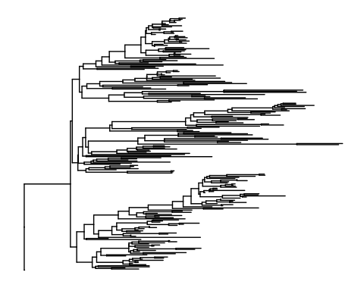

p <- ggtree(t1) %<+% tax +  
 geom_tiplab(aes(label=Genus))

## Found more than one class "phylo" in cache; using the first, from namespace 'phyloseq'  
## Also defined by 'tidytree'

p

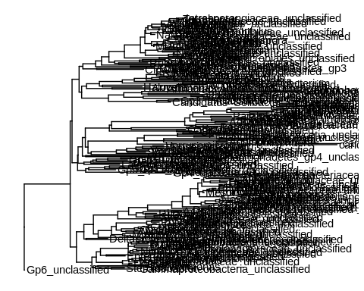

d2 = dplyr::mutate(tax, newlab = paste(Phylum, Genus, sep='|'))  
head(d2)

## label Kingdom Phylum Class  
## 1 Otu00001 Bacteria Acidobacteria Acidobacteria_Gp6  
## 2 Otu00009 Bacteria Proteobacteria Gammaproteobacteria  
## 3 Otu00011 Bacteria Proteobacteria Gammaproteobacteria  
## 4 Otu00064 Bacteria Proteobacteria Gammaproteobacteria  
## 5 Otu00329 Bacteria Proteobacteria Gammaproteobacteria  
## 6 Otu00047 Bacteria Proteobacteria Gammaproteobacteria  
## Order Family  
## 1 Gp6 Gp6_unclassified  
## 2 Gammaproteobacteria_unclassified Gammaproteobacteria_unclassified  
## 3 Xanthomonadales Sinobacteraceae  
## 4 Pseudomonadales Pseudomonadaceae  
## 5 Pseudomonadales Pseudomonadaceae  
## 6 Xanthomonadales Xanthomonadaceae  
## Genus  
## 1 Gp6_unclassified  
## 2 Gammaproteobacteria_unclassified  
## 3 Steroidobacter  
## 4 Pseudomonas  
## 5 Cellvibrio  
## 6 Lysobacter  
## newlab  
## 1 Acidobacteria|Gp6_unclassified  
## 2 Proteobacteria|Gammaproteobacteria_unclassified  
## 3 Proteobacteria|Steroidobacter  
## 4 Proteobacteria|Pseudomonas  
## 5 Proteobacteria|Cellvibrio  
## 6 Proteobacteria|Lysobacter

p <- ggtree(t1) %<+% d2 +  
 geom_tiplab(aes(label=newlab), size=2, align=TRUE, linesize=.5) + theme_tree()

## Found more than one class "phylo" in cache; using the first, from namespace 'phyloseq'

## Also defined by 'tidytree'

## Warning: Duplicated aesthetics after name standardisation: size

p

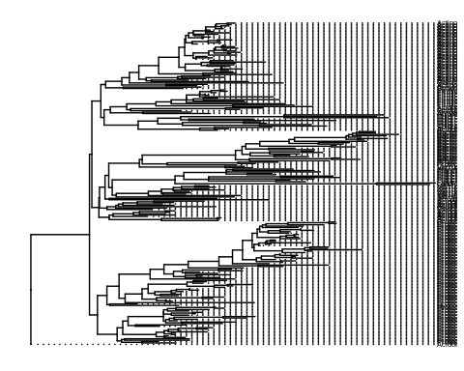

final_p <- p %>%  
 gheatmap(cast.data, offset=.7, width=0.1, font.size = 3, colnames=T, colnames_angle=-45, hjust=0) %>%  
 scale_x_ggtree()  
plot(final_p)

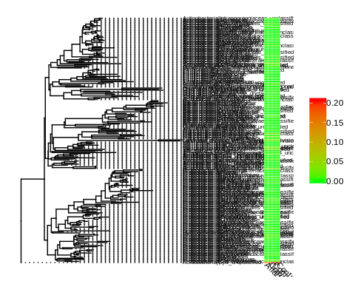

png("../Figures/abundance_tree.png",height=15,width=10,units='in',res=600)  
plot(final_p)  
dev.off()

## png   
## 2