Untitled

Jared Flater

10/8/2020

library(tidyverse)

## ── Attaching packages ───────────────────────────────────────────────────────────────────────────────────────────────────────── tidyverse 1.3.0 ──

## ✓ ggplot2 3.3.2 ✓ purrr 0.3.4  
## ✓ tibble 3.0.3 ✓ dplyr 1.0.2  
## ✓ tidyr 1.1.2 ✓ stringr 1.4.0  
## ✓ readr 1.4.0 ✓ forcats 0.5.0

## ── Conflicts ──────────────────────────────────────────────────────────────────────────────────────────────────────────── tidyverse_conflicts() ──  
## x dplyr::filter() masks stats::filter()  
## x dplyr::lag() masks stats::lag()

library(phyloseq)  
library(phylosmith)

# Worle soil

This data now includes bacterial communities from soil samples from the WOR rainfall experiment.

soil <- subset_samples(worle, matrix == c("soil"))  
head(sample_data(soil))

## unique_id experiment matrix treatment plot sample_day  
## P1-s1-d1-b P1-s1-d1-b Worle_Rainfall soil no_manure_strip 1 Baseline  
## P1-s1-d1-t0 P1-s1-d1-t0 Worle_Rainfall soil no_manure_strip 1 T000  
## P1-s1-d1-t14 P1-s1-d1-t14 Worle_Rainfall soil no_manure_strip 1 T014  
## P1-s1-d1-t2 P1-s1-d1-t2 Worle_Rainfall soil no_manure_strip 1 T002  
## P1-s1-d2-t2 P1-s1-d2-t2 Worle_Rainfall soil no_manure_strip 1 T002  
## P1-s1-d1-t21 P1-s1-d1-t21 Worle_Rainfall soil no_manure_strip 1 T021  
## depth in_plot_location block strip manure_treatment soil_type  
## P1-s1-d1-b 1 s1 1 Y N crop  
## P1-s1-d1-t0 1 s1 1 Y N crop  
## P1-s1-d1-t14 1 s1 1 Y N crop  
## P1-s1-d1-t2 1 s1 1 Y N crop  
## P1-s1-d2-t2 2 s1 1 Y N crop  
## P1-s1-d1-t21 1 s1 1 Y N crop

# Are bacterial communities in soil from strip different from crop?

Look at all baseline samples, before manure was applied. Depth is a strong driver of clustering. Seperate into two datasets by depth, S1 and S2.

s1 <- subset_samples(soil, depth == 1)  
s2 <- subset_samples(soil, depth == 2)

Visualize if samples from crop are different from prairie. Select baseline samples and plot PCoA ordinations.

s1plot <- s1 %>%  
 subset_samples(sample_day == c("Baseline")) %>%  
 pcoa_phyloseq(c('soil_type'), circle = TRUE)  
s2plot <- s2 %>%  
 subset_samples(sample_day == c("Baseline")) %>%  
 pcoa_phyloseq(c('soil_type'), circle = TRUE)  
s1plot

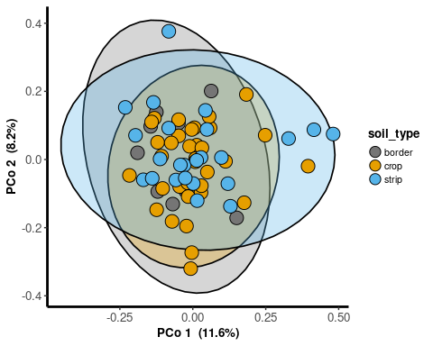

s2plot

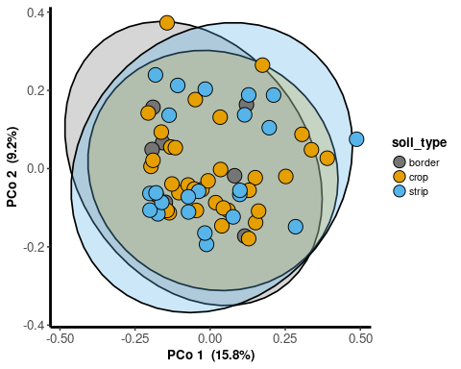 Rarefied and mintax 10

d1rmintax10 <- subset_samples(soil, depth == 1 & sample_day == c("Baseline")) %>%  
 rarefy_even_depth(sample.size = 10000, rngseed = 1231, replace = T) %>%  
 filter_taxa(function(x) sum(x) >= 10, T) %>%  
 pcoa_phyloseq(c('soil_type'), circle = TRUE)

## `set.seed(1231)` was used to initialize repeatable random subsampling.

## Please record this for your records so others can reproduce.

## Try `set.seed(1231); .Random.seed` for the full vector

## ...

## 32 samples removedbecause they contained fewer reads than `sample.size`.

## Up to first five removed samples are:

## P1-s3-d1-bP1-s6-d1-bP1-s9-d1-bP2-s2-d1-bP2-s6-d1-b

## ...

## 74006OTUs were removed because they are no longer   
## present in any sample after random subsampling

## ...

d2rmintax10 <- subset_samples(soil, depth == 2 & sample_day == c("Baseline")) %>%  
 rarefy_even_depth(sample.size = 10000, rngseed = 1231, replace = T) %>%  
 filter_taxa(function(x) sum(x) >= 10, T) %>%  
 pcoa_phyloseq(c('soil_type'), circle = TRUE)

## `set.seed(1231)` was used to initialize repeatable random subsampling.

## Please record this for your records so others can reproduce.

## Try `set.seed(1231); .Random.seed` for the full vector

## ...

## 13 samples removedbecause they contained fewer reads than `sample.size`.

## Up to first five removed samples are:

## P1-s4-d2-bP1-s5-d2-bP1-s6-d2-bP2-s3-d2-bP2-s4-d2-b

## ...

## 69113OTUs were removed because they are no longer   
## present in any sample after random subsampling

## ...

d1rmintax10

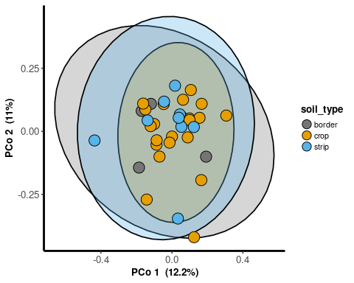

d2rmintax10

