**Black Jack Game API**

This program produces a game of Black Jack. There are three buttons and card images that appear on the screen, with a full functional game. This version of the game does not include Jokers or a bidding system.

The base of this file is set up so we can create different card games with the same deck of cards. Method would probably need to be added into the Hand class for different rules of different games

Below you will find a table of the methods provided for you along with the functionality, return type, and which class file to find them in.

|  |  |  |  |  |
| --- | --- | --- | --- | --- |
| Method Name | Return Type | Args | Class File | Desc |
| settingUpTable() | **GridPane** | **GridPane gp** | **BlackJack** | **Creates scene, adds items to the pane, and binds properties** |
| startGame() | **void** | **N/A** | **BlackJack** | **Gets the game ready to play. Shuffles deck, and deals out cards, and shows the card images on the pane** |
| getWinner() | **void** | **N/A** | **BlackJack** | **Stop the game before tallying scores. Displays winner in messageBox** |
| dealTopCard() | **Card** | **N/A** | **DeckOCards** | **This is used in combination with takeCard(). Pops the top card off of the deck of cards.** |
| takeCard() | **Card** | **Card card** | **Hand** | **This is in combination with dealTopCard(). The card is pushed onto the hand from the deck. CardValue is added to the player’s total. Aces are evaluated in algor** |
| getCardImg() | **Image** | **N/A** | **Card** | **This displays the face card on the scene.** |

**Tons of pictures in a “card” folder, one for each card, plus a few images of the card back**

**All Class files do NOT modify. These are objects for the scene included to make project work:  
Hand.java Card.java DeckOCards.java**

**BlackJack.java – This is the actual API. Do NOT change anything here  
BlackJack_Demo.java – This is an example program executing the game.**

**BlackJack_Template.java – This file inherits from our API.   
 Follow the /*TODO*/ comments to find out how to make this game.**

**Example Results on the next page**

**Initial Launch:**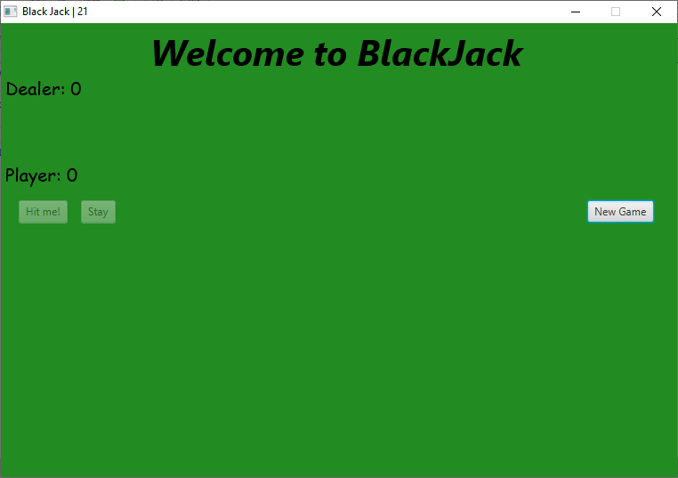

**Pressing new Game:**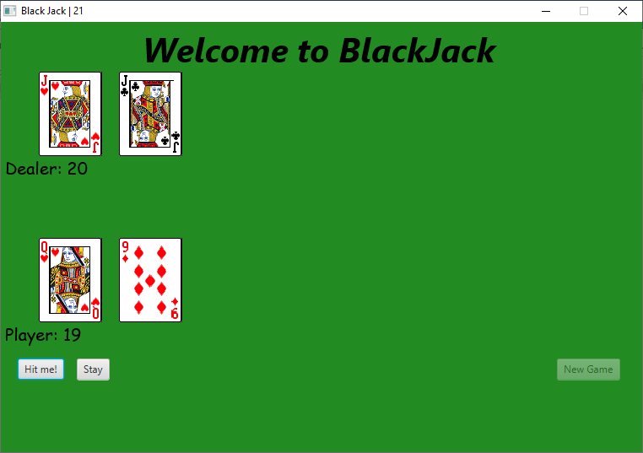

**Finished Game (Bad & Good ending)**