Resource Guide

* Application that will display listings of service sites and the services they offer concurrently with their locations displayed on an interactive map.
  + Useful for people who require those services to find and access them.
  + Convenient web interface to make information as accessible as possible.
* RDE provides table of services and locations that provide those services.
* List locations that provide a selected service.
* Interactive map using geocoding to display location of service providers.
* Target End Users:
  + PLWHA (People Living With HIV/AIDS)
  + People at risk of HIV
* Goal: Give End Users a way to find locations which offer the services they need.

## Requirements

* Has to be responsive: works on mobile and desktop browsers.
* Use Angular.js
* Provide a link to Google Maps for directions for each location.
* Basic Search: type any keyword
  + Matches services & locations
  + Results: all locations matched by keyword, all locations that serve services matched by keyword, and also display which services were matched by keyword
* Advanced search: add filters:
  + Text search by location / agency name
  + Text search by service
    - Auto-completion & suggestions
* Search results / sites display: Each location is a card. Click on the card, you get a detailed display (new view). Click on the address, link to the map.
  + In desktop, the map is visible all the time (see mockup below).
  + In mobile, the map is only available as a new view that you get from a link on the detailed display view.
* Click on map should show you full listing.
* Click on location in search results should bring you to the pin on the map.

## Reach Goals

* Tag services and locations with certain terms and use them to create a universal search.
* Store My Favorite Location / Favorites list. Use client-side storage, no user accounts.
* Admin interface to manage services and locations.
* Display distances from user’s current location.
* Add drilldown to region or grantee
* Additional filter options:
  + Radial search (within 10mi, 50mi, etc.)
  + Predefined area search (zip code, city, etc.)
* ADA Compliance

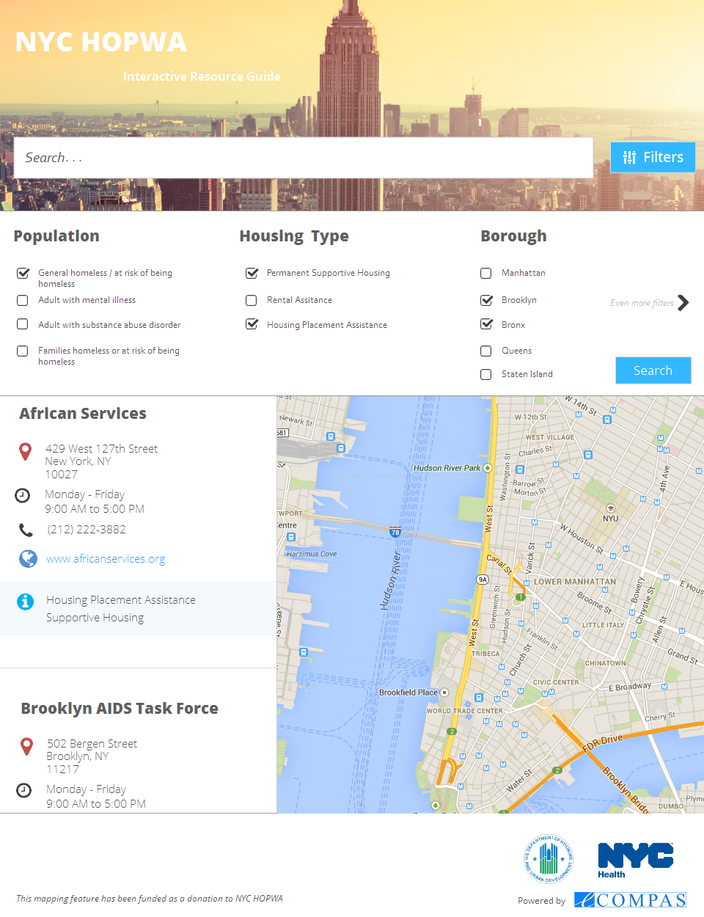

# Basic tables

Providers (organization, ABCD Healthcare)

Locations (providers can have multiple locations/sites/offices)

Services (many-to-many relationship with Locations)

# Minutes

Send after every weekly meeting. Please include:

* Dates
* Attendees
* Summary of What We talked about.
* Action Steps & Who will do them.

# Contact

Send all emails to [capstone@e-compas.com](mailto:capstone@e-compas.com)