Players Table:
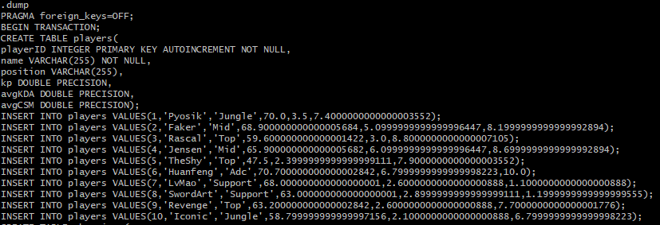
Champions Table:
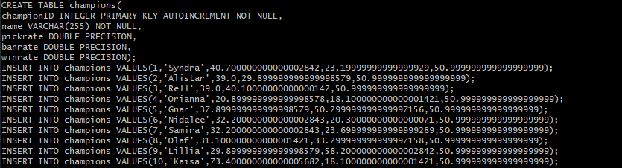
Designers Table: There are only 6 designers that exist currently.

Teams Table:
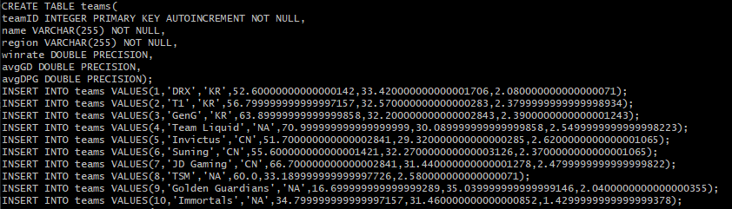
Tournaments Table:
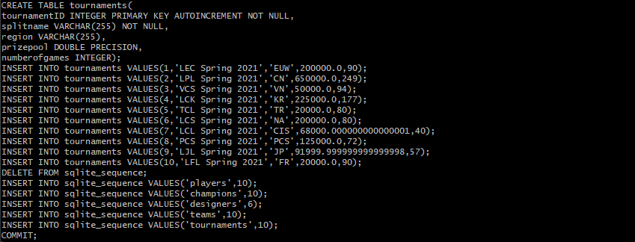

Queries:
- Which player has a KDA greater than 4?
SELECT * FROM Players
WHERE avgKDA > 4

- What position has the highest CS per minute (CSM)
SELECT position FROM Players
WHERE MAX(AvgCSM) As MaxCSM FROM Players

- How many junglers are there with over 50% KP?
SELECT COUNT(name) AS 50KPJG FROM Players
WHERE (position = ‘Jungler’ AND kp > 50)

- What champion has the highest pick rate?
SELECT name FROM Champions
WHERE MAX(pickrate) As MaxPR

- What champion has the highest ban rate?
SELECT name FROM Champions
WHERE MAX(banrate) As MaxBR

- Which teams have over 2 average dragons per game (DPG)?
SELECT name FROM Teams
WHERE avgDPG > 2

- Which region has the shortest games?
SELECT region FROM Teams
WHERE MIN(avgGD) AS minGD

- Change the name of T1 to SKT T1
UPDATE Teams SET name = ‘SKT T1’
WHERE name = ‘T1’

- What tournament as the highest prize pool?
SELECT splitname FROM Tournaments
WHERE MAX(prizepool) AS MAXPP

- How many tournaments were held in the KR region?
SELECT Count(name) as numKRTourneys FROM Tournaments
WHERE region = ‘KR’

