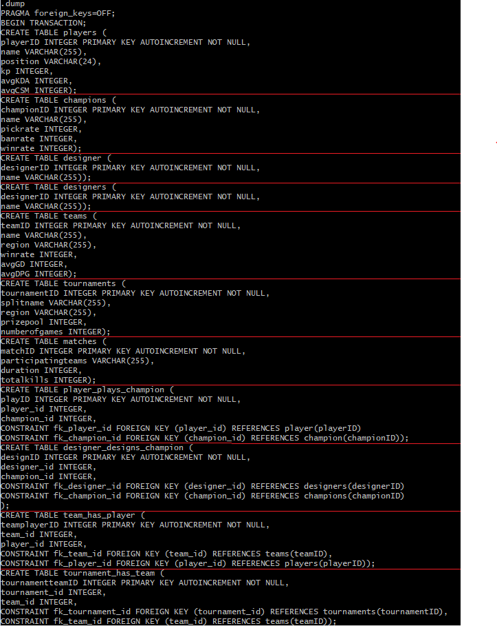

|  |  |
| --- | --- |
| Players: This entity holds the person’s statistics | |
| playerID (int) | Player entity’s autoincremented primary key |
| name (varchar) | Person’s in-game name |
| position (varchar) | Lane that the person plays |
| avgKDA (int) | Average kills/deaths/assists ratio |
| avgCSM (int) | Average creep score per minute |
| kp (int) | Average Kill participation |

|  |  |
| --- | --- |
| Champions: This entity holds the character’s pre/post game statistics | |
| championID (int) | Champion entity’s autoincremented primary key |
| name (varchar) | Name of the character |
| pick rate (int) | Number of games played in / Total games |
| ban rate (int) | Number of games banned / Total games |
| win rate (int) | Number of wins / Total games |

|  |  |
| --- | --- |
| Teams: This entity holds the team’s details | |
| teamID (int) | Team entity’s autoincremented primary key |
| Name (varchar) | Name of organization |
| Region (varchar) | Region the team plays in |
| win rate (int) | Number of wins / Total games |
| avgDPM (int) | Sum of dragons per game/ Total games |
| avgGD (int) | Sum of duration of games / Total games |

|  |  |
| --- | --- |
| Tournaments: This entity holds the tournament’s details | |
| tournamentID (int) | Tournament entity’s autoincremented primary key |
| splitname (varchar) | Name of the tournament with the split its played in |
| Region (varchar) | Region the tournament is held in |
| Numberofgames (int) | Total number of matches played |
| Prizepool (int) | Total amount of money to be won |

|  |  |
| --- | --- |
| Match: This entity holds the match’s details | |
| matchID (int) | Match entity’s autoincremented primary key |
| Participatingteams (varchar) | Name of teams that played in this match |
| Duration (int) | The total time of the game |
| Kills (int) | Total accumulated kills per team |

|  |  |
| --- | --- |
| Designer: This entity holds the creator of the champion’s details | |
| designerID (int) | Designer entity’s autoincremented primary key |
| name (varchar) | Name of the creator |

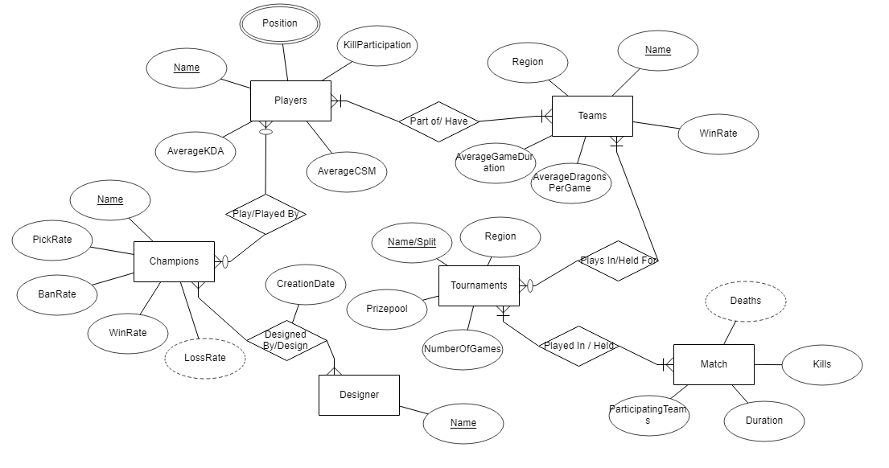

|  |  |  |
| --- | --- | --- |
| Relationship Tables | | |
| player_plays_champion | Many to Many | playid: Surrogate key |
| player_id: foreign key related to playerID |
| champion_id: foreign key related to championID |
| designer_designs_champion | Many to Many | designid: Surrogate key |
| designer_id: foreign key related to designerID |
| champion_id: foreign key related to championID |
| team_has_player | Many to Many | teamplayerid: Surrogate key |
| team_id: foreign key related to teamID |
| player_id: foreign key related to playerID |
| tournament_has_team | Many to Many | tournamentteamid: Surrogate key |
| tournament_id: foreign key related to tournamentID |
| team_id: foreign key related to teamID |
| tournament_holds_match | Many to Many | tournamentmatchid: Surrogate key |
| tournament_id: foreign key related to tournamentID |
| match_id: foreign key related to matchID |