**Code Startup:**

1. Open Netbeans IDE
2. Open lab5 project
3. If this window pops up, click the “Resolve Problems…” button, then locate where the “sqlite-jdbc-3.30.1.jar” file is. The problem should then be fixed.
4. Source code is located in ..\lab5\lab5\src

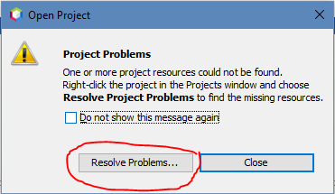

**Interface Text:**

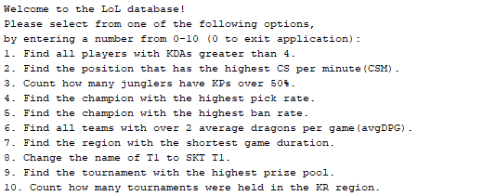

**Query Number 1:**



**Query Number 2:**



**Query Number 3:**



**Query Number 4:**



**Query Number 5:**



**Query Number 6:**

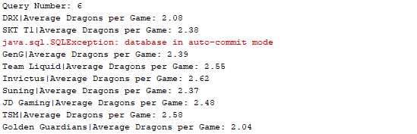

**Query Number 7:**



**Query Number 8:**



**Query Number 9:**



**Query Number 10:**



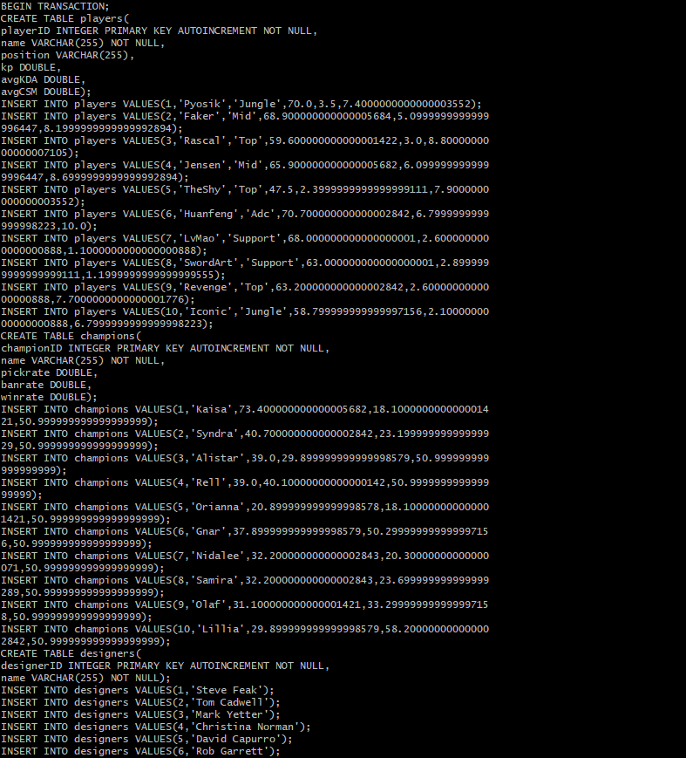**LoL Database dump:**

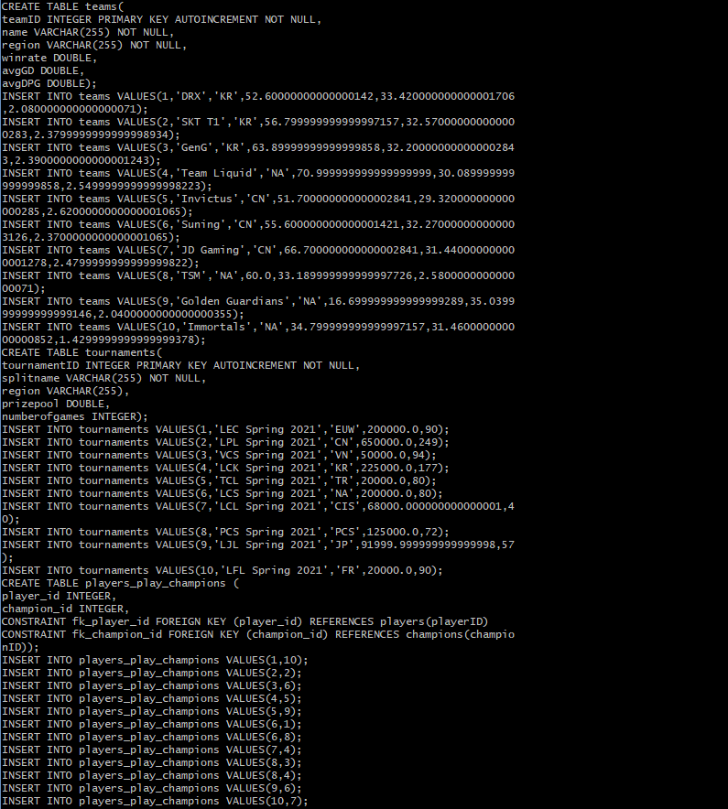

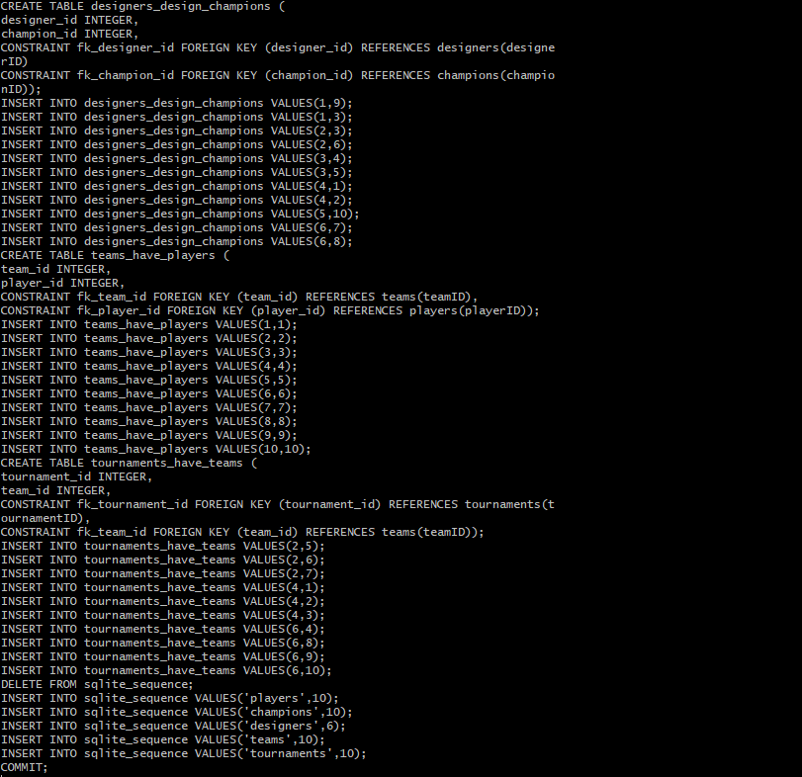

Changes Made from Previous Labs:

1. Removed Matches entity
2. Added many-to-many relationship connections in their respective relationship tables
3. Changed table names to be more uniform (plural instead of some singular)
4. Updated query list to match new tables