**Python Installation**

Revision 2017/06/22b

Contributors: sunyoupan; stevenryder

1. **Install 7-Zip (to work with .gz compressed files)**

Download from <http://www.7-zip.org/download.html> (64-bit Windows x64)

* <http://www.7-zip.org/a/7z1700-x64.exe>

1. **Install Notepad++ (to edit python code files)**

Download from <https://notepad-plus-plus.org/>

* <https://notepad-plus-plus.org/repository/7.x/7.4.2/npp.7.4.2.Installer.x64.exe>

1. **Install Python 64bit for Windows**

Download Python 64bit (3.6.2rc1) from <https://www.python.org/downloads/windows/>

* <https://www.python.org/ftp/python/3.6.2/python-3.6.2rc1-amd64.exe>

During installation, select “Add Python 3.6 to PATH” to allow scripts to run from any CMD window.

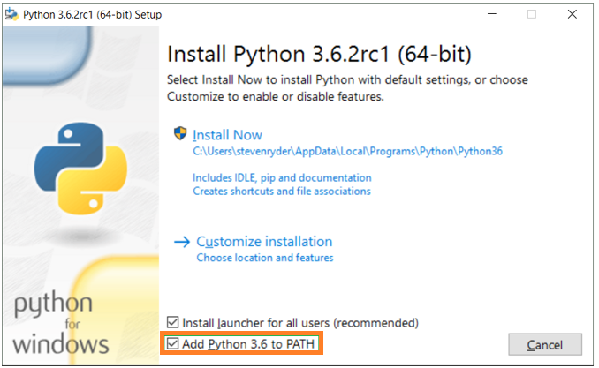

1. **Verify the installation**

Run CMD.exe

Type “phython”

His should then open a Python console.

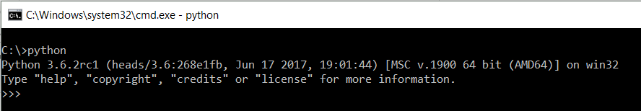

1. **Install Python Package “Requests” (*HTTP for Humans*)**

Download version 0.10.6 from <https://pypi.python.org/pypi/requests/0.10.6#downloads>

Use 7-Zip to extract files from “requests-0.10.6.tar.gz”

* Suggested location: “C:\mytools\Python\requests-0.10.6”

Run “python setup.py install”

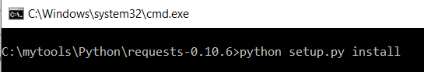

Post installation, the message should show a “Finished” message.

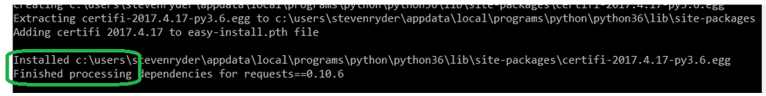

1. **Download QCloud SDK (example) from Github**

Open <https://github.com/QcloudApi/qcloudapi-sdk-python> and download ZIP.

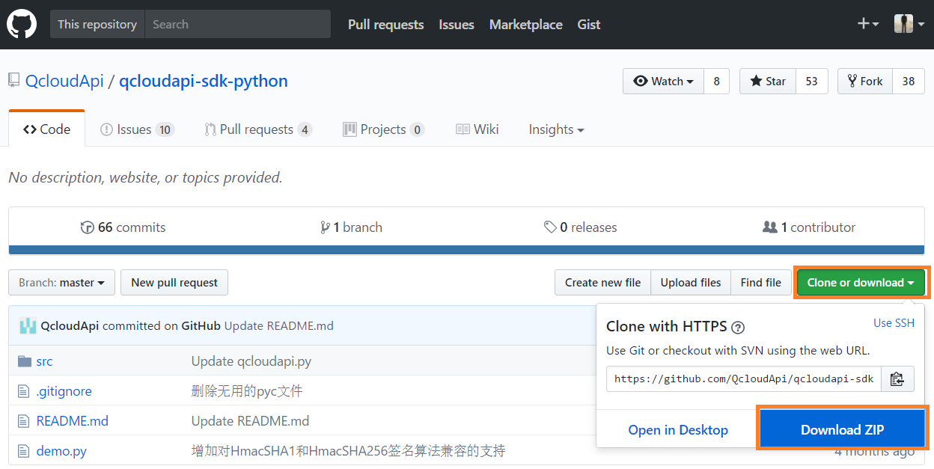

Extract the ZIP file to a local folder such as “c:\mytools\TencentCloudAPI\qcloudapi-sdk-python-master”

* A single demo file “demo.py” exists (this needs modifying before it will work with your account)