John C. Flournoy b_WCEN_EPISODICTOT % Tue Jul 26 16:33:23 2022
Hemisphere | Parcel Label | Estimate [95% CI] | Location
Left | DorsAttn Post 6 | -0.032 [-0.058, -0.006] | 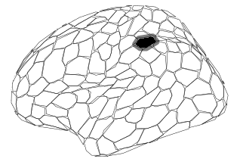
Left | DorsAttn Post 12 | -0.029 [-0.049, -0.008] | 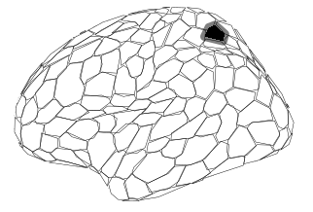
Left | SalVentAttn ParOper 3 | -0.042 [-0.069, -0.016] | 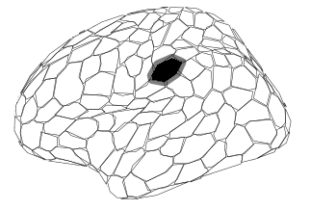
Left | SalVentAttn FrOperIns 5 | -0.044 [-0.072, -0.015] | 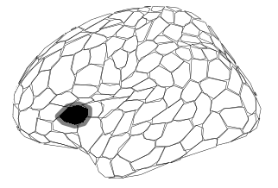
Left | SalVentAttn Med 2 | -0.035 [-0.061, -0.008] | 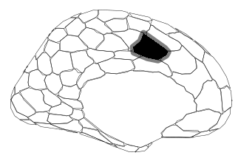
Left | Default PFC 16 | 0.047 [ 0.022, 0.073] | 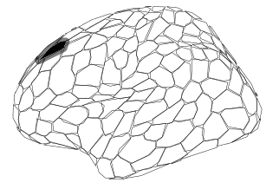
Left | Default PFC 19 | 0.031 [ 0.010, 0.052] | 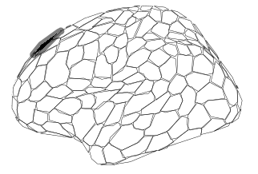
Left | Default PFC 21 | 0.029 [ 0.007, 0.052] | 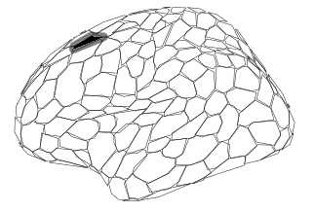
Left | Default PFC 22 | 0.038 [ 0.015, 0.062] | 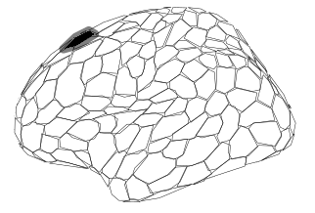
Left | Default pCunPCC 7 | 0.061 [ 0.030, 0.091] | 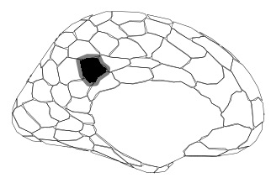
Left | Default pCunPCC 8 | 0.060 [ 0.030, 0.090] | 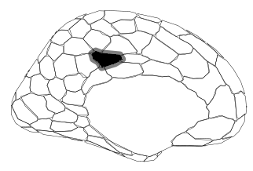
Left | Default pCunPCC 10 | 0.036 [ 0.008, 0.062] | 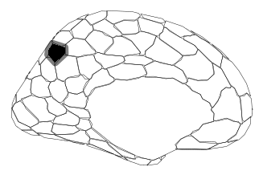
Right | SalVentAttn FrOperIns 5 | -0.039 [-0.070, -0.010] | 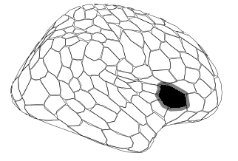
Right | SalVentAttn Med 2 | -0.042 [-0.068, -0.016] | 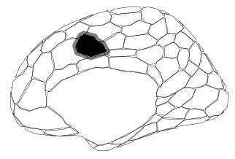
Right | Cont Temp 1 | 0.034 [ 0.010, 0.059] | 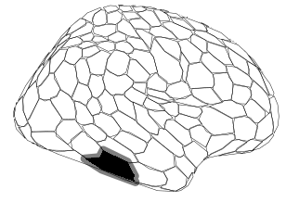
Right | Default PFCdPFCm 10 | 0.031 [ 0.007, 0.056] | 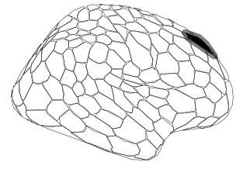
Right | Default PFCdPFCm 12 | 0.040 [ 0.017, 0.063] | 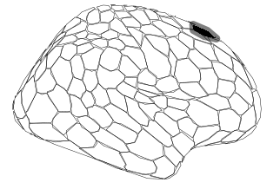
Right | Default pCunPCC 6 | 0.060 [ 0.029, 0.091] | 