John C. Flournoy b_WCEN_PANASNEG % Tue Jul 26 16:33:24 2022
Hemisphere | Parcel Label | Estimate [95% CI] | Location
Left | DorsAttn Post 5 | -0.023 [-0.039, -0.007] | 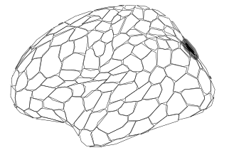
Left | Cont PFCl 2 | -0.015 [-0.028, -0.003] | 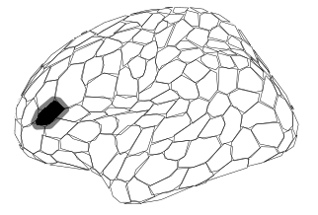
Left | Cont PFCl 6 | -0.014 [-0.025, -0.003] | 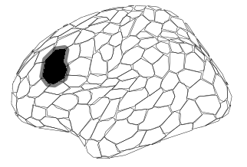
Right | DorsAttn Post 3 | -0.015 [-0.029, -0.002] | 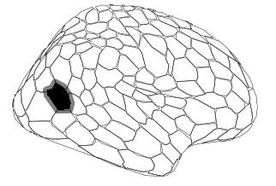
Right | Cont PFCl 2 | -0.014 [-0.025, -0.003] | 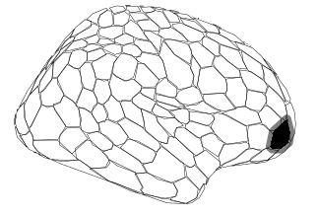
Right | Cont PFCl 4 | -0.016 [-0.030, -0.003] | 