John C. Flournoy bsp_meWCEN_BRAINWB_SE-GAD7 % Tue Jul 26 16:33:24 2022
Hemisphere | Parcel Label | Estimate [95% CI] | Location
Left | Limbic OFC 3 | -0.019 [-0.034, -0.004] | 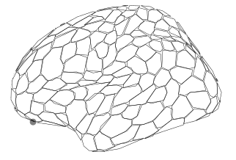
Left | Default PFC 24 | -0.014 [-0.024, -0.003] | 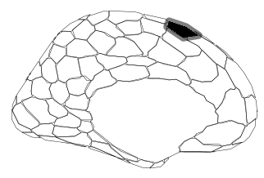
Right | SalVentAttn Med 5 | 0.016 [ 0.002, 0.030] | 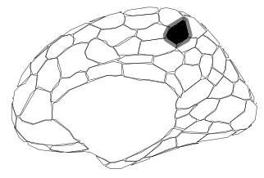
Right | Limbic OFC 1 | -0.037 [-0.063, -0.011] | 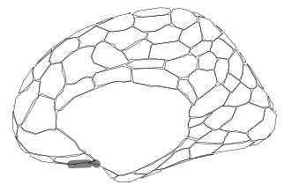
Right | Limbic OFC 2 | -0.029 [-0.052, -0.006] | 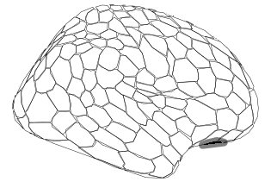
Right | Default pCunPCC 1 | 0.013 [ 0.003, 0.023] | 