John C. Flournoy bsp_meWCEN_BRAINWB_SE-PHQ9 % Tue Jun 14 23:32:33 2022
Hemisphere | Parcel Label | Estimate [99.988% CI] | Location
Right | SomMot 22 | -0.025 [-0.060, 0.007] | 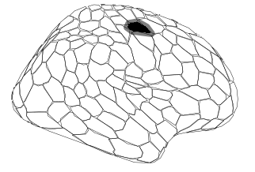
Right | SomMot 29 | -0.013 [-0.035, 0.007] | 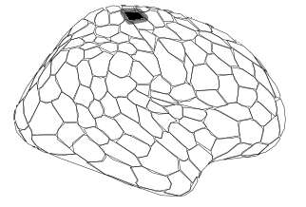
Right | SalVentAttn FrOperIns 6 | 0.017 [-0.013, 0.045] | 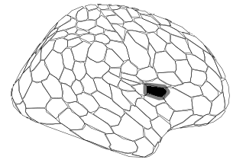
Right | Cont PFCl 11 | 0.016 [-0.010, 0.042] | 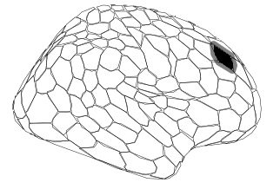
Right | Default pCunPCC 1 | 0.013 [-0.007, 0.035] | 