John C. Flournoy b_TIMECENTER % Tue Jul 26 16:09:16 2022 [1] “——————————————————————————————————————————Parcel Label Estimate [95% CI] Location ———— ——————- ————————- ——————————————————————-Vis 3 -0.028 [-0.046, -0.009] 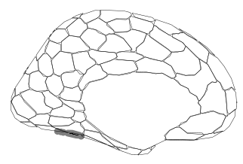 SomMot 27 -0.025 [-0.041, -0.009] 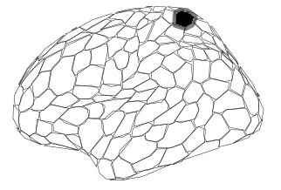 Cont Par 1 -0.024 [-0.042, -0.006] 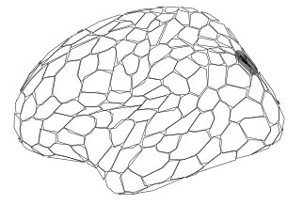 Vis 10 -0.038 [-0.060, -0.015] 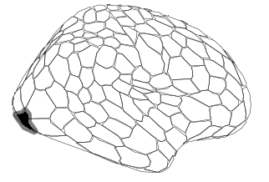 Vis 16 -0.027 [-0.048, -0.006] 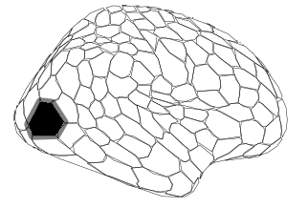 Vis 24 -0.032 [-0.057, -0.007] 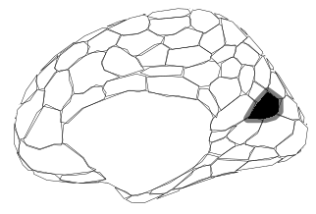 Cont PFCl 6 -0.031 [-0.055, -0.007] 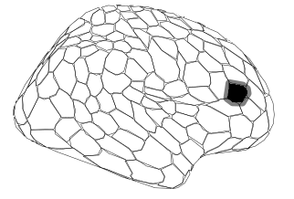 Default Par 2 -0.025 [-0.044, -0.006] 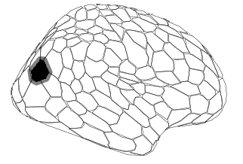 Default pCunPCC 4 -0.037 [-0.058, -0.016] 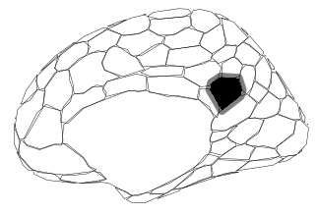 ——————————————————————————————————————————” attr(,“class”) [1] “knit_asis” attr(,“knit_cacheable”) [1] NA

