John C. Flournoy b_WCEN_SLEEPDUR % Tue Jul 26 16:09:17 2022 [1] “——————————————————————————————————————————Parcel Label Estimate [95% CI] Location ———— ——————- ————————- ——————————————————————-SomMot 13 -0.094 [-0.165, -0.022] 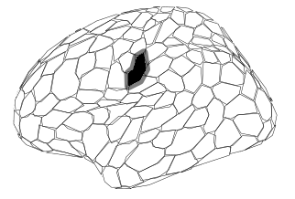 SomMot 14 -0.166 [-0.255, -0.075] 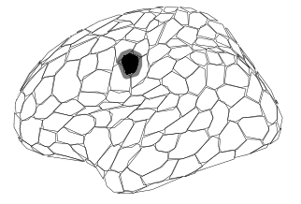 SalVentAttn Med 6 -0.095 [-0.167, -0.022] 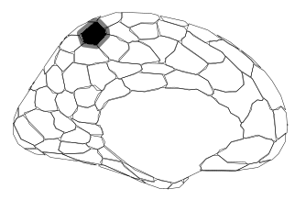 Vis 25 -0.092 [-0.171, -0.016] 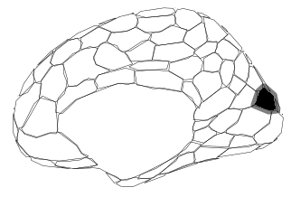 SomMot 32 -0.071 [-0.132, -0.013] 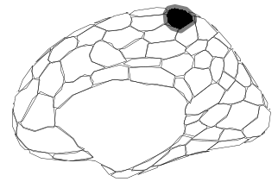 Cont PFCl 1 0.081 [ 0.017, 0.147] 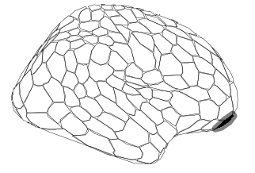 Cont PFCl 3 0.070 [ 0.011, 0.130] 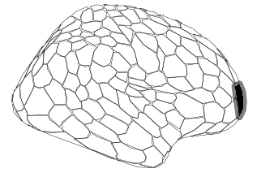 Default Temp 8 -0.113 [-0.192, -0.033] 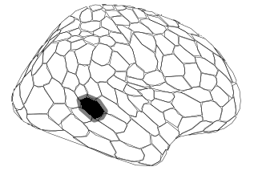 Default PFCv 2 0.099 [ 0.031, 0.167] 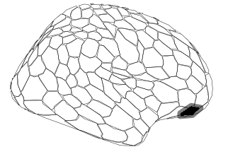 ——————————————————————————————————————————” attr(,“class”) [1] “knit_asis” attr(,“knit_cacheable”) [1] NA

