John C. Flournoy b_WCEN_CHRONICSEV % Tue Jul 26 16:09:17 2022 [1] “——————————————————————————————————————————Parcel Label Estimate [95% CI] Location ———— ——————– ———————– ——————————————————————–Vis 24 0.124 [ 0.031, 0.220] 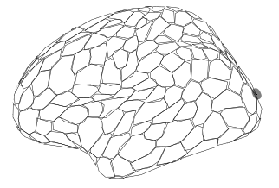 DorsAttn Post 13 0.135 [ 0.025, 0.250] 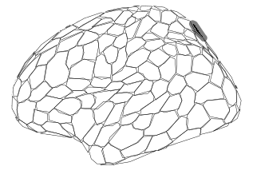 Default PFC 16 0.137 [ 0.028, 0.248] 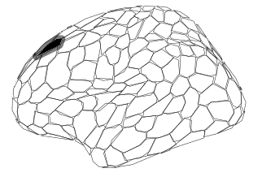 Default PFC 21 0.139 [ 0.040, 0.235] 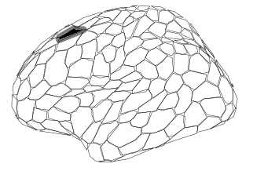 Default PFC 22 0.141 [ 0.038, 0.247] 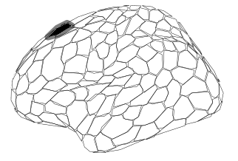 Default pCunPCC 6 0.168 [ 0.032, 0.306] 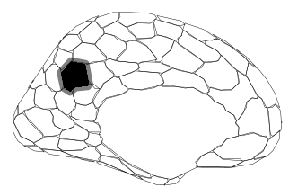 Default pCunPCC 10 0.148 [ 0.032, 0.265] 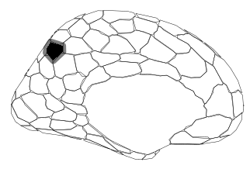 Default pCunPCC 5 0.167 [ 0.028, 0.308] 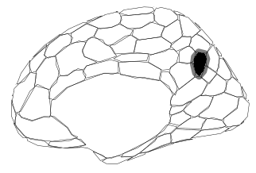 ——————————————————————————————————————————” attr(,“class”) [1] “knit_asis” attr(,“knit_cacheable”) [1] NA

