**Senior Project Proposal – Design Phase**

**Student:** Jonathan Flum

**Degree and Major:** Bachelor of Arts in Applied Computing, Business Concentration

**Project Advisor:** Prof. O’Neill

**Expected Graduation Date:** Spring 2023

**Project Title:** Cognitive Trainer for Computer Science Professionals

**Problem Statement**

Within the realm of systems programming and development, computer science professionals are regularly faced with intangible technical challenges that require accurate and decisive resolution—an analytical skill that is traditionally not exercised until it must be applied, often with varying success. To these ends, research has shown that routine engagement of activities which stimulate critical thinking can lead to “intelligence training,” increasing one’s ability to more quickly and precisely apply their knowledge at higher-orders of cognizance/ domains of Bloom’s taxonomy.

**Project Description**

The “Cognitive Trainer for Computer Science Professionals” is one such proposed application to facilitate thought and ability development of this nature, requiring minimal time commitment, with the additional benefit of taking place in a zero-stakes environment.

**Problem Analysis**

When presented with high risk and/or time-constrained situations, proficient computer science professionals should ideally be able to perform with the same efficiency and accuracy as they otherwise would without such challenges or limitations. However, one’s ability to think critically (e.g., at the ‘Analyzing’ and ‘Evaluating’ domains of Bloom’s taxonomy) is often hindered when faced with external, situational dilemmas, especially those that are of a nonroutine nature. Problem resolution that takes place under stress is an analytical skill that is often underdeveloped and for the computer science professional, lapses in judgement and indecisiveness can have detrimental effects on the welfare of society. A case study conducted by Leveson and Turner (1993), exemplifies the potential for extreme harm in this regard.

To that extent, professionals wishing to develop their ability to apply knowledge at higher-orders of cognizance can engage in brief, routine stimuli of activities that require critical thinking. By creating a program that utilizes basic information the user has already mastered (such as colors, numbers, and shapes), new knowledge is not required to be assimilated; rather, the application isolates the way known information is analyzed and evaluated. Facilitating complex thought and ability development of this nature will allow the user to conduct brain plasticity training with direct correlations to problem solving (e.g., the application, analysis, and evaluation of compound data and information) (Green & Bavelier, 2008). Similar to the phenomena of how solving crossword puzzles can lead to an increased vocabulary, this project aims to improve the user’s ability to accurately and decisively resolve technical challenges.

**Lo-Res Prototype**

Provided the information contained within Figure 1, the following is an example question and response that require higher-level applications of basic knowledge. This, as well as subsequent queries, will need to be correctly answered within a user-adjustable, limited time frame, commensurate with the problem’s complexity.

Q: What shape is written on tile 3? What is the number’s color of the orange circle?

A: triangle blue

**Figure 1**

*Prototype display of a randomly generated information set*

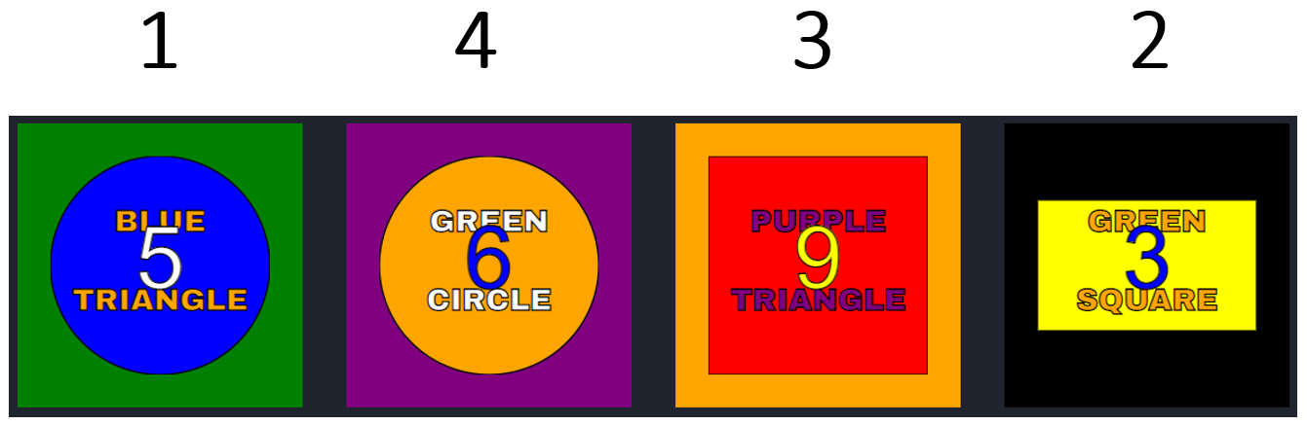

*Note.* Colors, numbers, and shapes presented as complex data, requiring analysis and evaluation when the user is presented a question/specification.

**Proposed Implementation**

**Languages.** C#, C++

**Technologies.** VS Code, Unity, Inkscape, GIMP, Cafetera

**Target platform.** Web-based, hosted via GitHub Pages

**Personal Motivation**

Generally speaking, while I would consider myself an effective programmer, I’m not particularly efficient in terms of speed, especially under high pressure. In other words, it’s not often that I can’t get the job done provided little to no constraint of time, however as a means for self-improvement, coding proficiency, and situational adaptability, being able to do so more quickly, without sacrificing quality, is a personal goal to those ends. The premise of this project was rooted in this observation, and proposes a utility to mitigate these types of shortfalls, either academically or professionally, which I suspect others face as well. As a prospective future educator, the scope of this project also lends itself to analyses of instructional methodology/ efficacy and psychology of the learner.

**Future Research Efforts**

The anticipated end state deliverable for this project will be a publicly accessible web site containing the application as described above and detailed in the corresponding Requirements Document. Possible extensions of the program include: a user account mechanism that allows for performance tracking over time, metric comparisons with other users (or groups of users), and administration functionality suitable for potential academic or professional implementations. In addition, perhaps during graduate studies, a controlled experiment should be conducted comparing the academic performance of students within a specific course of study who engage in a prescribed use of the program versus those who do not. This will be necessary in order to either substantiate or invalidate its effect on neuroplasticity in its current state, prior to subsequent revision or iteration.

**Schedule**

|  |  |  |  |  |
| --- | --- | --- | --- | --- |
| **Item** | **Description** | **ECD** | **STATUS** | **Comments** |
| 1. | **Plan** |  |  |  |
| 1.1 | Draft Proposal | 02/28/22 | Complete | Deliverable |
| 1.2 | Draft Proposal and Requirements | 03/31/22 | Complete | Deliverable |
| 1.3 | Completed Proposal and Requirements | 04/12/22 | Complete | Deliverable; fork Sr. Project Repo and add documents, update readme |
|  |  |  |  |  |
| 2 | **Build** |  |  |  |
| 2.1 | User Interface | Fall 2022 | Not Started | Input/output considerations |
| 2.2 | Data/Objects | Fall 2022 | Not Started | Primary class for information sets |
| 2.3 | Graphic Design | Fall 2022 | Not Started | Display formatting, responsiveness |
| 2.4 | Functional Loop | Fall 2022 | Not Started | Cradle-to-grave sequence |
| 2.5 | “Significant Progress” | Fall 2022 | Not Started | Deliverable; current state of above |
|  |  |  |  |  |
| 3 | **Test** |  |  |  |
| 3.1 | Create Test Plan | Fall 2022 | Not Started | Deliverable; partially identified in FRD, user task/process oriented |
| 3.2 | Test & Document | Fall 2022 | Not Started | Generate specification punch list and order by priority |
| 3.3 | Clear backlog | Fall 2022 | Not Started | Finalize any outstanding product implementations |
|  |  |  |  |  |
| 4 | **Deploy** |  |  |  |
| 4.1 | Package and deliver | Spring 2023 | Not Started | Deliverable; host application on GitHub Pages |
| 4.2 | Evaluate | Spring 2023 | Not Started | Identify lessons learned, best practices, extendibility, etc. |
| 4.3 | Defense Documentation | Spring 2023 | Not Started | Deliverable; Final Report |
| 4.4 | Project Presentation | Spring 2023 | Not Started | Deliverable |

**References**

Green, C. S., & Bavelier, D. (2008). Exercising your brain: A review of human brain plasticity and training-induced learning. *Psychology and Aging*, *23*(4), 692–701. https://doi.org/10.1037/a0014345

Leveson, N., & Turner, C. (1993). An investigation of the Therac-25 accidents. *Computer*, *26*(7), 18–41. https://doi.org/10.1109/mc.1993.274940