     |       Licensed  Partner


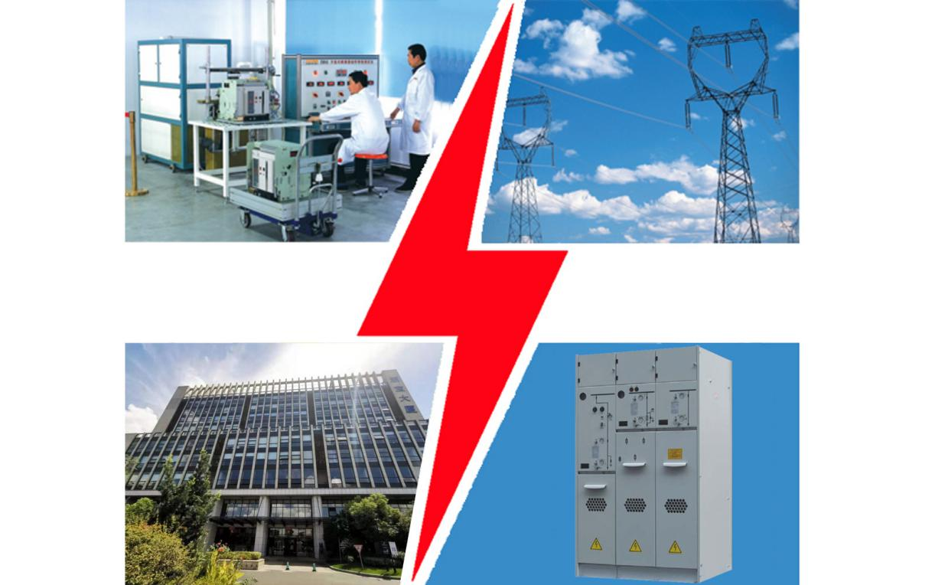

ZHEBAO ELECTRICAL 2019 PRODUCTS CATALOGUE

Zhebao Company PROFILE ... P01  Certificates and Awards ... P15  R/D and Cooperations ... P17  Advanced Equipments ... P18  Exhibitions and Interactions ... P19  Successful Operating Projects ... P20 |  | Products:  HV MV LV Switchgears ... P03  Siemens ABB Schneider Products ... P07  Prefabricated Substations ... P09  MCC, Power Distribution Boxes ... P10  MV HV VCB, SF6 LBS & Others ... P11  ACB MCCB RCCB & Components ... P14


浙宝电气（杭州）集团有限公司
Zhebao Electrical (Hangzhou) Group Co., Ltd.
www.cn-electric.net



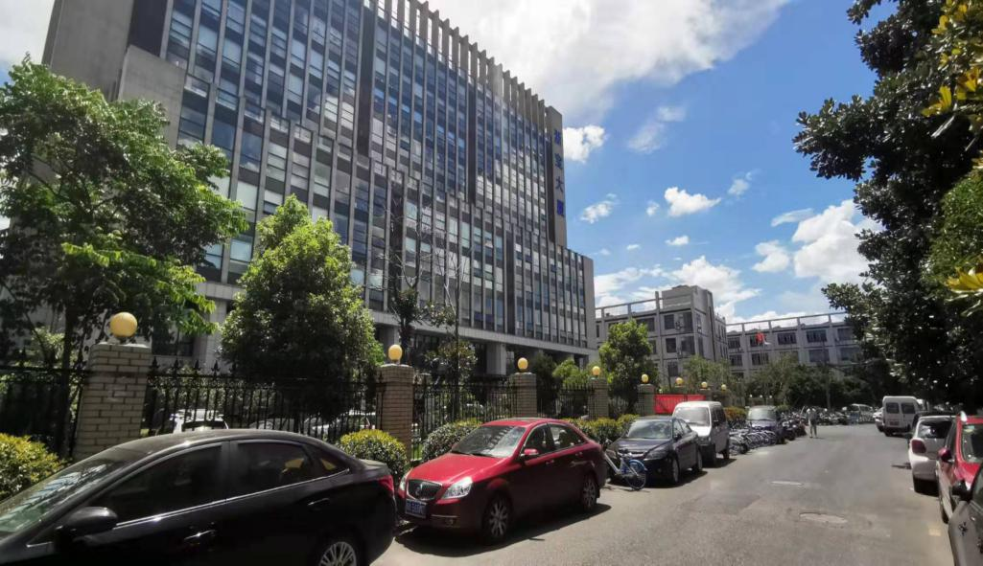 |  | 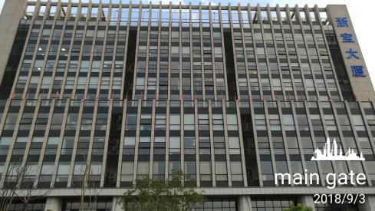
 |  | Main Gate
 |  | 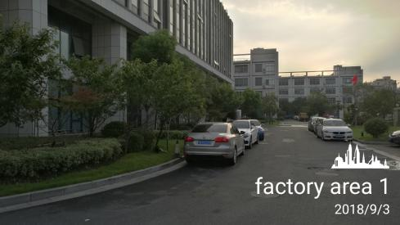
Over View |  | Factory Area 1
 | 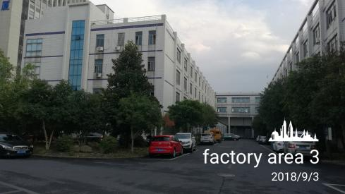 | 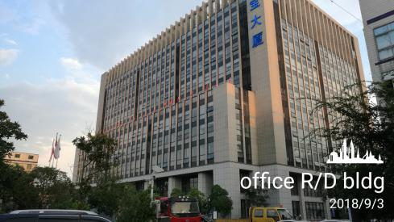
Factory Area 2 | Factory Area 3 | Office RD & Incubation Park
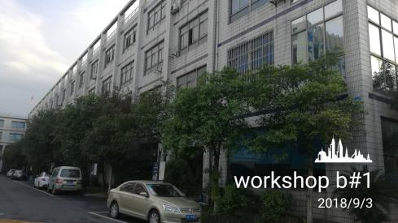 | 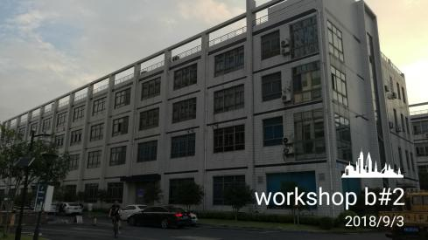 | 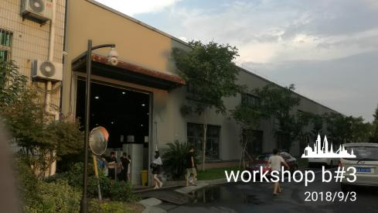
Workshop Building #1 | Workshop Building #2 | Workshop Building #3
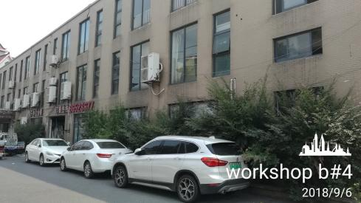 | 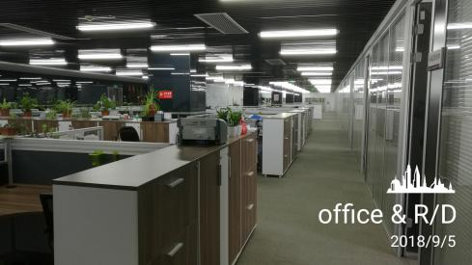 | 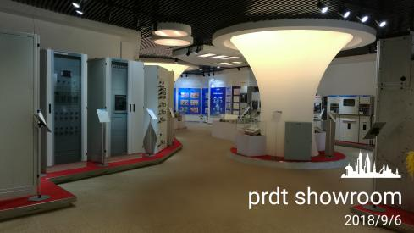
Workshop Building #4 | Office R/D Center | Product Showroom
Zhebao Electrical PROFILE:
● Specialized in electric switchgear design and manufacturing since May 22, 1993;
● Office area 6880 sqm (74,056 sq ft), Workshop area 41500 sqm (446,702 sq ft), Hi tech Industrial Incubation Park 35,000sqm (eqv 376,700 sq ft);
● Employees total 560, senior engineer 5, engineer R/D 15, senior technician 80, workers 168, QA/QC 39, after-sale service 36;
● Annual revenue RMB 480 million (USD70 million);
● China national patent 25, China invention patent 2;
● Siemens / ABB / Schneider licensed partner since Sep 2002;
● ISO9001, ISO14001, OHSAS18001, GB/T50430, ISO10012, ERP; CE, CCC, CQC.

[ Company profile ]
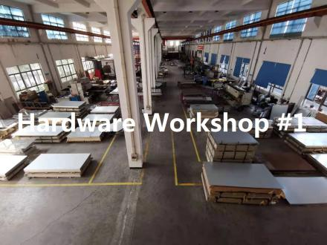 |  | 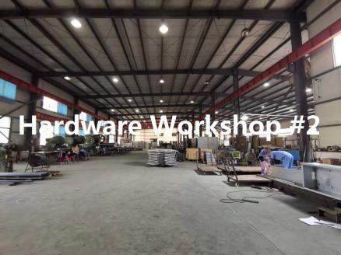 |  | 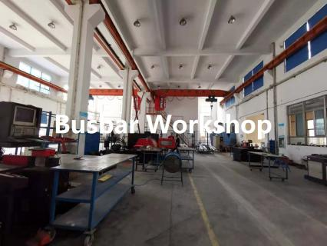
 | 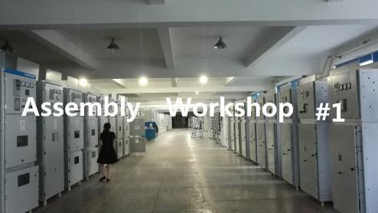 |  | 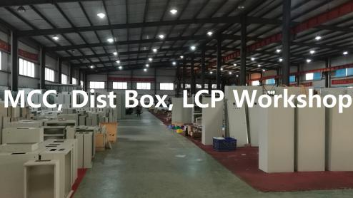
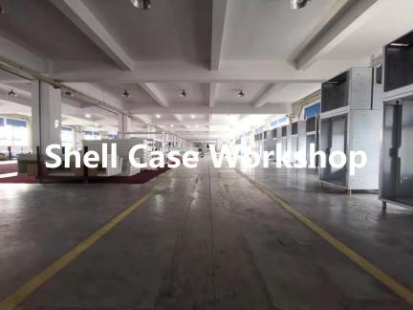 |  | 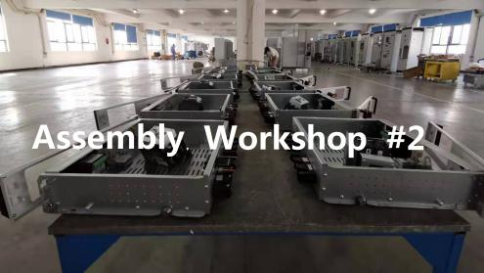 |  | 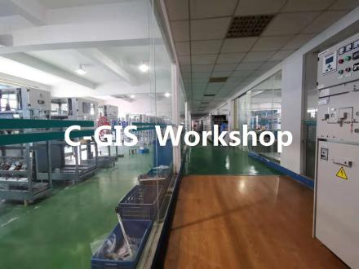
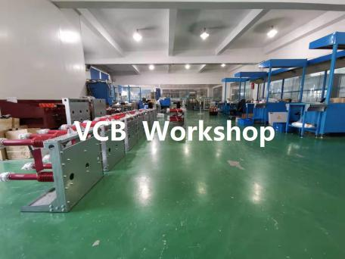 |  | 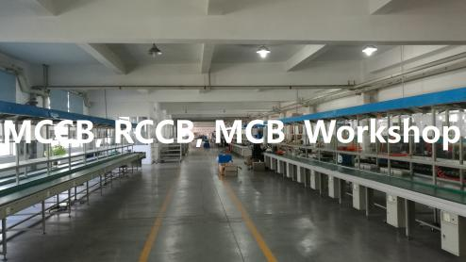 |  | 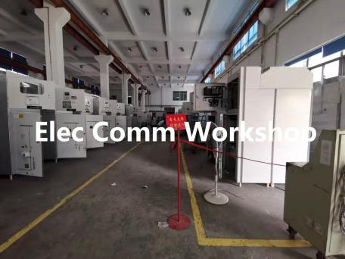
Main products and services:
● High, Medium and Low Voltage Switchgears below 40.5kV, SF6 GIS, RMU,
● Siemens ABB Schneider Co-operated Switchboards and Panels,
● Prefabricated Transformer Substations,
● Low-voltage Distribution Boxes, MCC, LCS etc,
● SF6 Load Switch, Vacuum Circuit Breaker, Switching Components ACB MCCB MCB RCCB etc.,
● Electrical facility installation, testing, repairing and maintenance.
Management certifications:
● Sep 1998, ISO9001 QMS, quality management system;
● Sep 2002, ISO14001 EMS, environmental management system;
● Dec 2012, (ISO45001) OHSAS18001, occupational health and safety assessment series;
● Jul 2018, GB/T50430, professional contract and Construction QMS;
● Mar 2005, ISO10012 IMT, inspection measurement and test system.
● Jan 2006, ERP, enterprise resource planning system.
Product certifications and standards:
● 2003year, low-voltage switchgears, China CCC compulsory certifications;
● 2005year, high-voltage (MV) switchgears, China CQC certificates;
● Aug 2012, high (MV) & low voltage (LV) switchgears, CE certificates.
● IEC standards, China GB standards.
Page 01 < > Page 02

[ Products > HV MV LV Switchgears ]

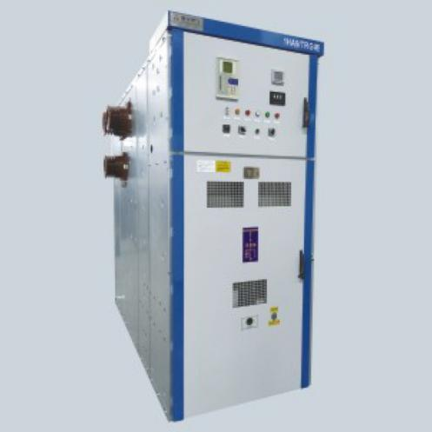 | 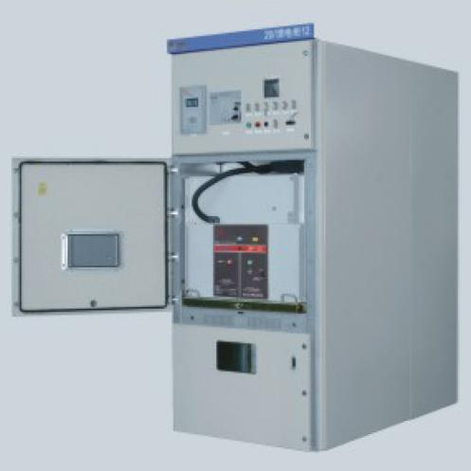 | 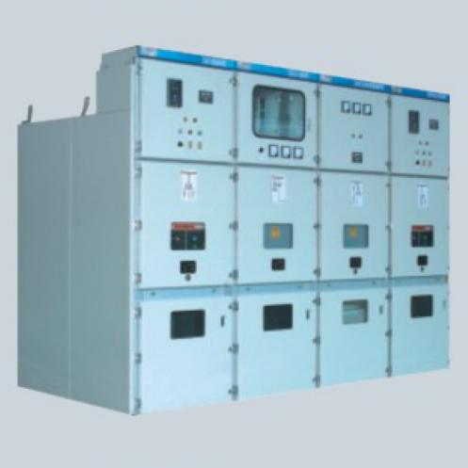
● Model: KYN61A-40.5  ● Name: AC armored removable metal enclosed switchgear  ● Rated frequency: AC 50Hz / 60Hz;  ● Rated voltage (Ue): 40.5kV;  ● Power frequency withstand voltage (1min): 95kV;  ● Rated impulse withstand voltage (Ump): 185kV;  ● Rated current: 1250A 1600A 2000A;  ● Short time withstand current Icw (4s): 25kA 31.5kA;  ● Short circuit drop-out current: 25kA 31.5kA;  ● Short circuit making curnt: 63kA 80kA;  ● Protection Degree: IP40, door open 2x;  ● Standard: IEC62271-200;  ● Dimension: 2450H *1200/ 1400W *2800D (mm) | ● Model: KYN28A-24, ZBS-24  ● Name: AC armored removable metal enclosed switchgear  ● Rated frequency: AC 50Hz / 60Hz;  ● Rated voltage (Ue): 24kV;  ● Power frequency withstand voltage (1min): 65/79kV;  ● Rated impulse withstand voltage (Uimp): 125/145kV;  ● Rated current (Ir): 630A 1250A 1600A 2000A 2500A 3150A 4000A;  ● Short time withstand current (Icw) (4s): 25kA 31.5kA 40kA;  ● Short circuit drop-out current: 25kA 31.5kA 40kA;  ● Protect Degree: IP40, door open IP2x;  ● Standard: IEC62271-200;  ● Dimension: 2380H *800/1000/1100W *1900/2250D (mm) | ● Model: KYN28A-12, GZS1-12  ● Name: AC armored removable metal enclosed switchgear  ● Rated frequency: AC 50Hz / 60Hz;  ● Rated voltage (Ue): 12kV;  ● Power frequency withstand voltage (1min): 42/48kV;  ● Rated impulse withstand voltage (Uimp): 75/85kV;  ● Rated current (Ir): 630A 1250A 1600A 2000A 2500A 3150A 4000A;  ● Short time withstand current (Icw) (4s): 25kA 31.5kA 40kA;  ● Short circuit drop-out current: 25kA 31.5kA 40kA;  ● Protect Degree: IP40, door open IP2x;  ● Standard: IEC62271-200;  ● Dimension: 2260H *650/800/1000W *1450/1610D (mm)
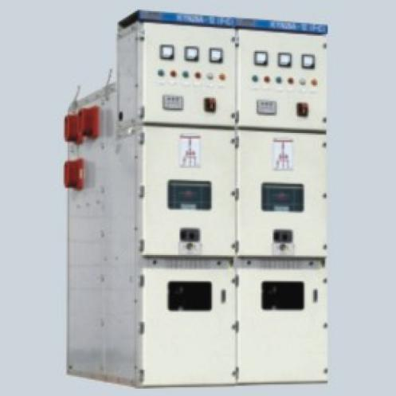 | 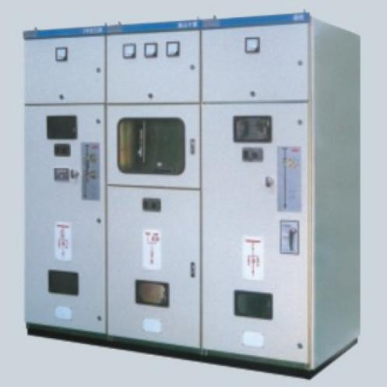 | 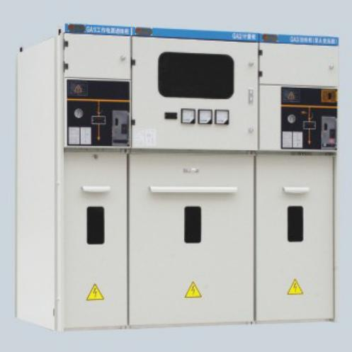
● Model: KYN28A-12(F-C)  ● Name: AC armored removable metal enclosed switchgear  ● Rated frequency: AC 50Hz / 60Hz;  ● Rated voltage (Ue): 12kV;  ● Power frequency withstand voltage (1min): 42kV;  ● Rated impulse withstand voltage (Uimp): 75kV;  ● Rated current (Ir): 630A 1250A 1600A 2000A 2500A 3150A;  ● Short time withstand current (Icw) (4s): 25kA 31.5kA 40kA;  ● Short circuit drop-out current: 25kA 31.5kA 40kA;  ● Protect Degree: IP40, door open IP2x;  ● Standard: IEC62271-200;  ● Dimension: 2240H *650W *1500D (mm) | ● Model: HXGN17-12  ● Name: AC metal clad Ring Main Unit switchgear  ● Rated frequency: AC 50Hz / 60Hz;  ● Rated voltage (Ue): 12kV;  ● Power frequency withstand voltage (1min): 42/48kV;  ● Rated impulse withstand voltage (Uimp): 75/85kV;  ● Rated current (Ir): 630A;  ● Short time withstand current (Icw) (4s): 20kA;  ● Short circuit drop-out current: 25kA 31.5kA;  ● Protect Degree: IP40, door open IP2x;  ● Standard: IEC62271-200;  ● Dimension: 1950H *400/ 700W *900D (mm) | ● Model: XGN15-12  ● Name: AC metal enclosed RMU  ● Scheme options: load switch panel, LBS - fuse combined apparatus, CB panel, metering, cable cabinet;  ● Rated voltage (Ue): 12kV;  ● Power freq withstand volt(1min): 42kV;  ● Rated impulse withstand voltage (Uimp): 75kV;  ● Rated current (Ir): 630A (load switch panel), 125A (LS-Fuse combined);  ● Short time withstand current (Icw) (4s): 20kA;  ● Short circuit drop-out current: 31.5kA (combined panel, CB panel);  ● Rated transfer current: 1700A (comb);  ● Dimension: for LS & Comb 1600H *375(500)W *960D (mm), for VCB Metering 750W
Page 03

[ Products > HV MV LV Switchgears ]

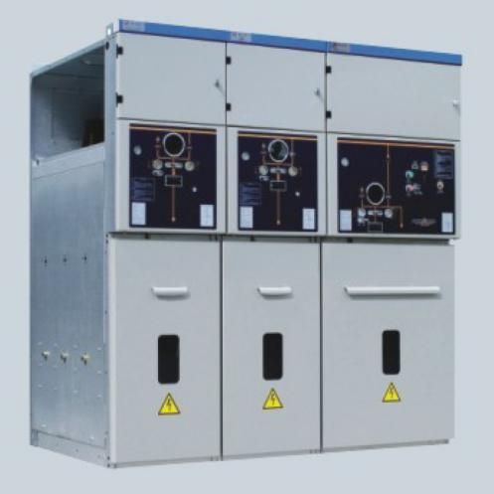 | 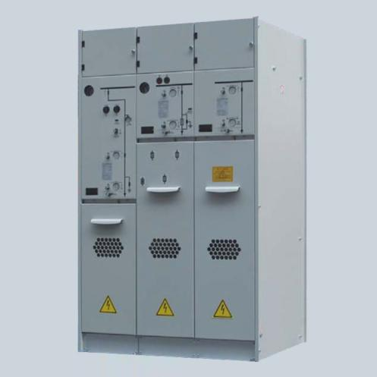 | 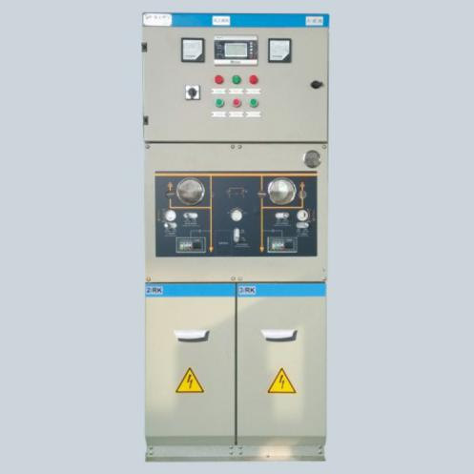
● Model: ZBF-24A (XGN15-24)  ● Name: AC metal enclosed RMU  ● Scheme options: load switch panel ZBF-24/AR, load switch - fuse combined apparatus -24/AT, Vacuum CB panel -24/AV;  ● Rated voltage (Ue): 24kV, 12kV(for plateau);  ● Rated current (Ir): 630A ;  ● Short time withstand current (Icw) (4s): 20kA;  ● Short circuit drop-out current: 20kA (combined panel, CB panel);  ● Rated transfer current: 1400A (comb);  ● Sulfur hexafluoride SF6 as insulation and arc interrupter;  ● 3.0mm SS full sealed cabinet;  ● Visible window on interlock;  ● Dimension: for LS & Comb 1800H *500W *1000D (mm), for VCB panel 750W | ● Model: ZBF-12 (24)  ● Name: AC gas insulated metal enclosed switchgear RMU (compact)  ● Rated voltage (Ue): 12kV 24KV;  ● Rated current (Ir): 630A ;  ● Short time withstand current (Icw) (4s): 20kA;  ● Sulfur hexafluoride SF6 as insulation and arc interrupter;  ● 3.0mm SS full sealed cabinet;  ● Visible indicator on interlock;  ● Compact design, for outdoor cable branch box or sub section post (SSP)  ● Protect Degree: SF6 enclosure IP67, shell IP4x;  ● Standard: IEC62271-200;  ● Dimension: 1200H *325W *785D (mm) per unit | ● Model: ZBF-12 (24) /DPS  ● Name: AC gas insulated metal enclosed switchgear RMU (duplicate power supply switching)  ● Rated voltage (Ue): 12kV 24KV;  ● Rated current (Ir): 630A ;  ● Short time withstand current (Icw) (4s): 20kA;  ● Sulfur hexafluoride SF6 as insulation and arc interrupter;  ● 3.0mm SS full sealed cabinet;  ● Visible window on interlock;  ● Single hole operation three position load switch (Close1 - Open - Close2)  ● Protect Degree: SF6 enclosure IP67, shell IP4x;  ● Standard: IEC62271-200;  ● Dimension: manual, power-driven 1600H *650W *785D (mm) manual, power-driven, auto 2000H *650W *785D
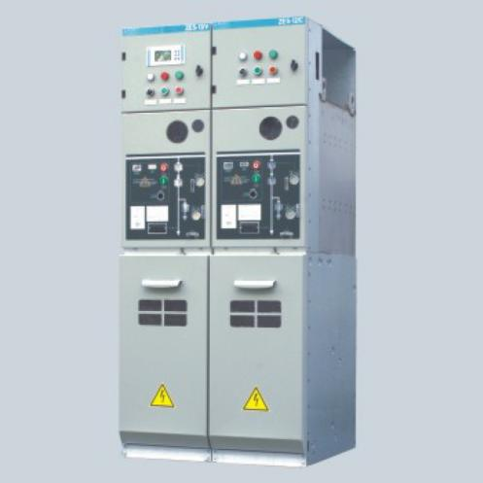 | 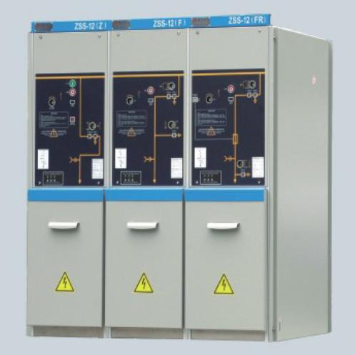 | 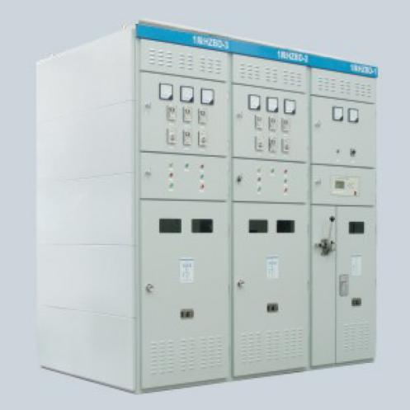
● Model: ZES-12  ● Name: AC Environmental GIS metal enclosed switchgear, RMU  ● Scheme options: VCB panel, Vacuum load break switch panel;  ● Rated voltage (Ue): 12kV;  ● Rated power freq withstand voltage (1min): 42/48kV;  ● Rated current (Ir): 250A / 630A;  ● Short time withstand current (Icw): main circuit 20kA/2s, 25kA/4s;  ● Short circuit drop-out current: 20kA/ 25kA (VCB panel);  ● Rated transfer current: 2200A (for T);  ● Protect Degree: IP67, shell IP4x;  ● Annual leakage: 0.1%;  ● Dimension: 1700H *375W *780D (mm) | ● Model: ZSS-12  ● Name: AC solid insulated metal enclosed switchgear, RMU  ● Scheme options: vacuum load switch panel ZSS-12(F), load switch - fuse combined ZSS-12(FR), Vacuum CB panel ZSS-12(Z);  ● Rated voltage (Ue): 12kV;  ● Rated current (Ir): 630A (load switch panel, VCB panel), 1250A (LS-Fuse combined panel);  ● Short time withstand current (Icw) (4s): 20kA;  ● Short circuit drop-out current: 31.5kA (combined panel), 20kA (VCB panel);  ● Rated take over current: 3150A (LS-fuse combined panel);  ● Protect Degree: IP40, door open IP2x;  ● Standard: IEC62271-200;  ● Dimension: 1200H *420W *860D (mm) | ● Model: HGBZ-12  ● Name: HV parallel Capacitor Reactive Power Compensation Device  ● Rated frequency: 50Hz;  ● Rated voltage: 3.6kV~ 12kV;  ● Rated capacity: 2*8000 kvar;  ● Hi-freq rectifying modulazation structure;  ● Microcomputer auto monitoring system;  ● Remote control, measuring, signalling and adjustment;  ● Protect Degree: IP30/ IP41;  ● Standard: IEC62271-200;  ● Dimension: control cabinet 2200H *800W *600D (mm), battery cabinet 2200H *800W *600D
Page 04

[ Products > HV MV LV Switchgears ]

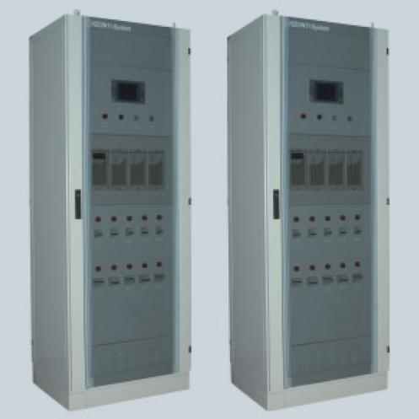 | 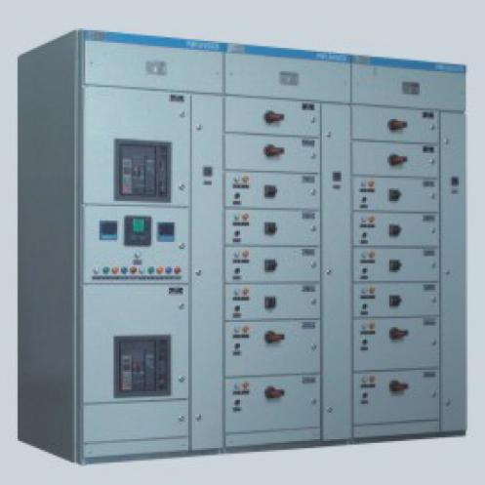 | 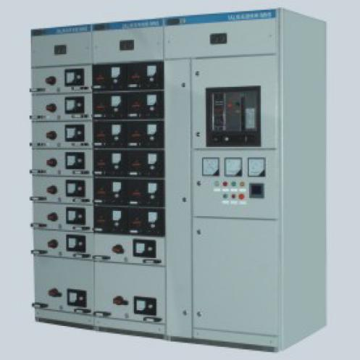
● Model: HZDW  ● Name: Intelligent Hi-frequency DC power cabinet  ● Rated frequency: 50Hz;  ● Rated input voltage: AC 220V / AC380V;  ● Rated output voltage: DC 220V / DC110V;  ● Rated battery capacity: 20Ah 38Ah 50Ah 65Ah 100Ah 150Ah 200Ah 300Ah;  ● High frequency rectifying modulazation structure;  ● Microcomputer automatic monitoring system;  ● Remote control, measuring, signalling and adjustment;  ● Protect Degree: IP30/ IP41;  ● Standard: IEC61439-1:2011;  ● Dimension: control cabinet 2200H *800W *600D (mm), battery cabinet 2200H *800W *600D | ● Model: GCD (HYDS)  ● Name: AC low voltage fixed partition switchgear  ● Rated frequency: AC 50Hz / 60Hz;  ● Rated voltage (Ue): 400V/ 690V;  ● Rated insulation voltage(Ui): 1000V;  ● Horizontal Busbar Rated current (Ir): 4000A;  ● Vertical Bus Rated current (Ir): 4000A;  ● Horizontal Busbar Short time withstand current (Icw) (4s): 30kA 50kA 85kA;  ● Vertical Bus Short time withstand current (Icw) (4s): 30kA 50kA 85kA;  ● Functional units: fixed partition type;  ● Protect Degree: IP20~ IP54;  ● Standard: IEC61439-1:2011;  ● Dimension: 2200H *600/ 800/ 900/ / 1200/ 1500W *600/ 800/ 1000D (mm) | ● Model: MNS (MNX)  ● Name: AC low voltage drawable switchgear  ● Rated frequency: AC 50Hz / 60Hz;  ● Rated voltage (Ue): 400V/ 690V;  ● Rated insulation voltage(Ui): 1000V;  ● Horizontal Busbar Rated current (Ir): 2940A;  ● Vertical Bus Rated current (Ir): 1000A;  ● Horizontal Busbar Short time withstand current (Icw) (1s): 100kA;  ● Vertical Bus Short time withstand current (Icw) (4s): 90kA 130kA;  ● Functional units: module type;  ● Protect Degree: IP20~ IP54;  ● Standard: IEC61439-1:2011;  ● Dimension: 2200H *400-1200W *600-1000D (mm)
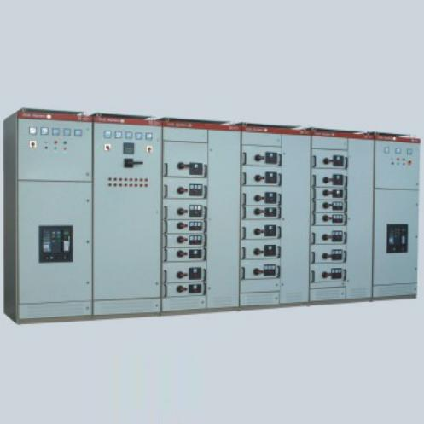 | 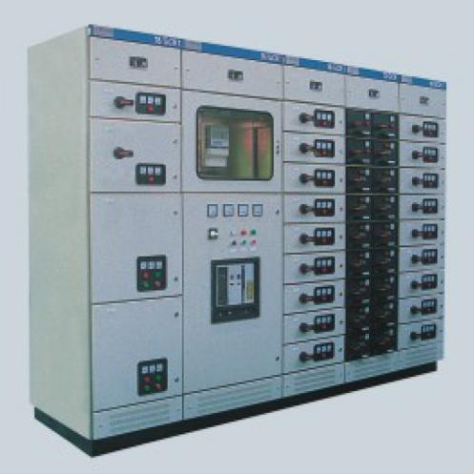 | 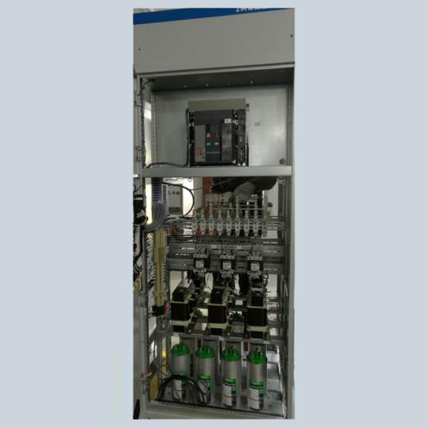
● Model: GCS  ● Name: AC low voltage withdrawable switchgear  ● Rated frequency: AC 50Hz / 60Hz;  ● Rated voltage (Ue): 400V/ 690V;  ● Rated insulation voltage(Ui): 1000V;  ● Horizontal Busbar Rated current (Ir): 6300A or lower;  ● Vertical Bus Rated current (Ir): 1500A;  ● Horizontal Busbar Short time withstand current (Icw) (1s): 30kA 50kA 100kA;  ● Vertical Bus Short time withstand current (Icw) (4s): 30kA 50kA 85kA;  ● Functional units: drawable type;  ● Protect Degree: IP20~ IP54;  ● Standard: IEC61439-1:2011;  ● Dimension: 2200H *400/ 600/ 800/ 1000W * 600/ 800/ 1000D (mm) | ● Model: GCK  ● Name: AC low voltage withdrawable switchgear  ● Rated frequency: AC 50Hz / 60Hz;  ● Rated voltage (Ue): 400V/ 690V;  ● Rated insulation voltage(Ui): 1000V;  ● Horizontal Busbar Rated current (Ir): 1250-6300A;  ● Vertical Bus Rated current (Ir): 1200A;  ● Horizontal Busbar Short time withstand current (Icw) (1s): 30kA 50, 80, 100kA;  ● Vertical Bus Short time withstand current (Icw) (1s): 30kA 50kA 80kA;  ● Functional units: drawable type;  ● Protect Degree: IP20~ IP40;  ● Standard: IEC61439-1:2011;  ● Dimension: 2200H *600/ 800/ 1000/ 1200W * 800/ 1000D (mm) | ● Model: HDB  ● Name: HDB low voltage reactive power compensation device
Page 05

[ Products > HV MV LV Switchgears ]

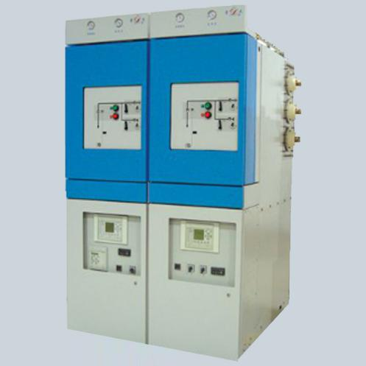 | 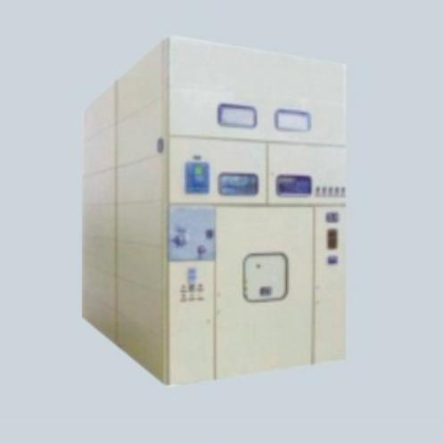 | 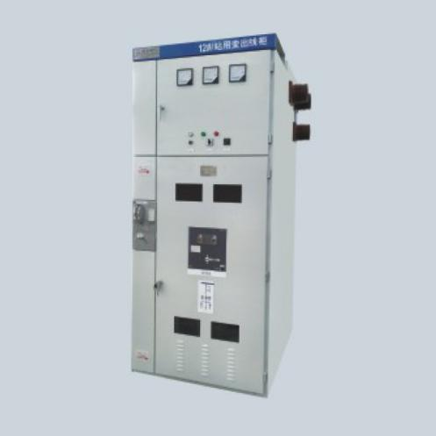
● Model: XGN80-40.5 (compact GIS)  ● Name: AC gas insulated metal enclosed switchgear RMU (GIS)  ● Rated voltage (Ue): 40.5kV 33KV;  ● Rated current (Ir): 1250A 2000A ;  ● Short time withstand current (Icw) (3s): 31.5kA;  ● Sulfur hexafluoride SF6 as insulation and arc interrupter;  ● SS full sealed cabinet; Primary active parts all in protective gas cubicle;  ● Visible indicator on interlock;  ● Compact design, for outdoor cable branch box or sub section post (SSP)  ● Protect Degree: SF6 enclosure IP67, shell IP4x;  ● Standard: IEC62271-200;  ● Dimension: 2300H *600/800W *1500/1760D (mm) per panel unit | ● Model: XGN17-40.5  ● Name: AC Box type metal enclosed switchgear | ● Model: XGN66-12  ● Name: AC MV vacuum circuit breaker switchgear
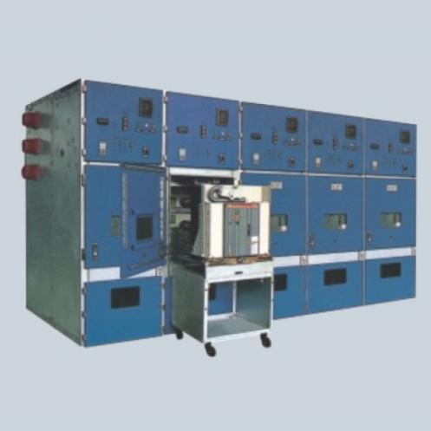 | 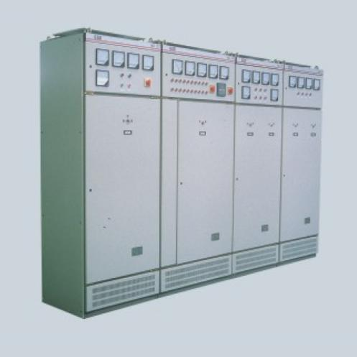 | 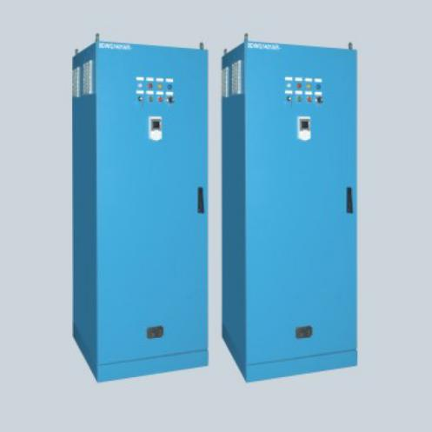
● Model: KYN44-12kV  ● Name: AC metal enclosed central positioned switchgear | ● Model: GGD  ● Name: AC low voltage power distribution switchgear | ● Model: FCC  ● Name: Frequency conversion control device specialized for nuclear power

Page 06




[ Products > Siemens ABB Schneider Products ]

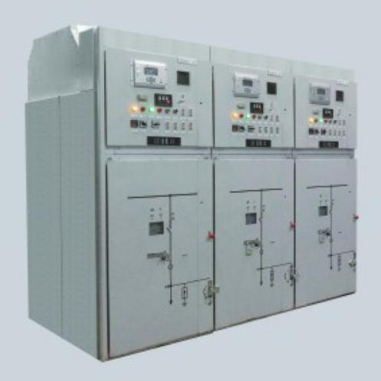 | 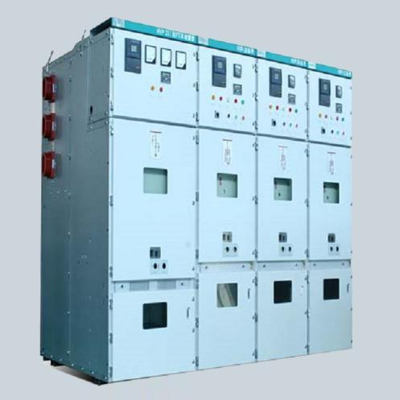 | 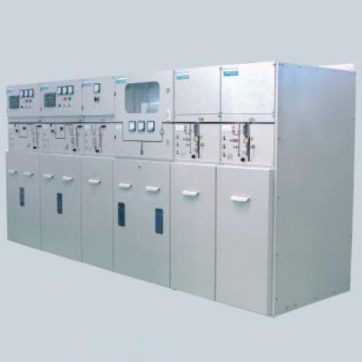
● Model: Siemens NXAirS LP  ● Name: AC medium voltage metal enclosed switchgear  ● Rated voltage (Ue): 12kV;  ● Power frequency withstand voltage (1min): 42/48kV;  ● Rated impulse withstand voltage (Uimp): 75/85kV;  ● Rated busbar current (Ir): 4000A;  ● Short time withstand current (Icw) (4s): 40kA;  ● Short circuit drop-out current: 40kA;  ● Short circuit making current (4s): 100kA;  ● Peak withstand current: 100kA;  ● Protect Degree: IP40, door open IP2x;  ● Standard: IEC62271-200;  ● Dimension: ≦2500A 2200H *800W *1350D (mm) ≧3150A 2300*1000*1450 | ● Model: Siemens 8BK81-12  ● Name: AC medium voltage metal enclosed withdrawable switchgear  ● Rated voltage (Ue): 12kV;  ● Power frequency withstand voltage (1min): 42/48kV for VCB, 32/42kV for F-C;  ● Rated impulse withstand voltage (Uimp): 75/85kV for VCB, 60/75 for F-C;  ● Rated busbar current (Ir): 4000A;  ● Short time withstand current (Icw): 63kA/3s for VCB, 4kA/4s for F-C;  ● Short circuit drop-out c (F-C): 50kA;  ● Short circuit making current (F-C): 100kA;  ● Peak withstand current: 160kA/ 10kA;  ● Protect Degree: IP4X, door open IP2x;  ● Standard: IEC62271-200;  ● Dimension: (VCB) 2200H *800 / 1000W *1800D (mm) ,(F-C) 2200H*500 / 650W*1800D | ● Model: SIEMENS SIMOSEC  ● Name: AC MV metal enclosed switchgear  ● Scheme options: load switch panel, LBS-fuse combined apparatus, CB panel, metering, cable cabinet;  ● Rated voltage (Ue): 12kV, 24kV;  ● Power frequency withstand voltage (1min): 42kV, 65kV;  ● Rated impulse withstand voltage (Uimp): 75kV, 125kV;  ● Rated current (Ir): 630A (load switch panel), 125A (LS-Fuse combined);  ● Short time withstand current (Icw): 25kA(1s), 20kA(3s);  ● Short circuit drop-out current: 31.5kA (combined panel, CB panel);  ● Rated transfer current: 1150A (comb);  ● Dimension: for LS and Comb 1700H *375(500)W *1000D (mm), for VCB & metering 1700H *750W *1000D
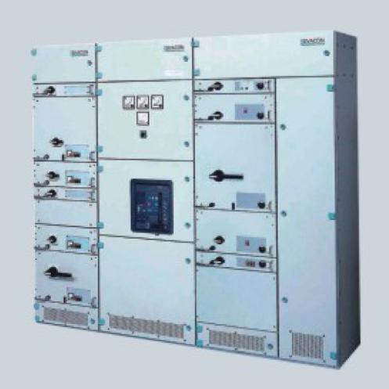 | 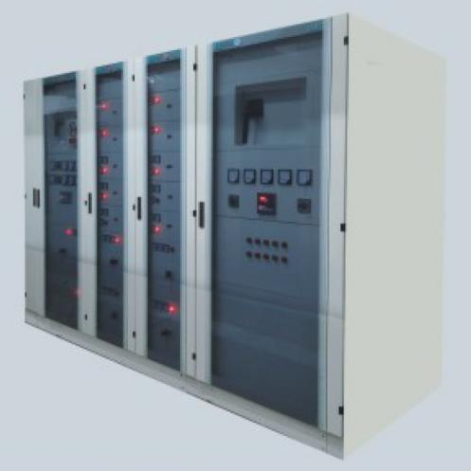 | 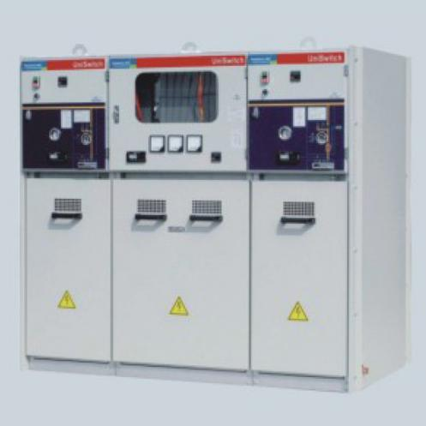
● Model: SIEMENS Sivacon 8PT  ● Name: AC low voltage switchgear  ● Rated frequency: AC 50Hz / 60Hz;  ● Rated voltage (Ue): 400V/ 690V;  ● Rated insulation voltage(Ui): 1000V;  ● Horizontal Busbar Rated current (Ir): 7000A;  ● Vertical Bus Rated current (Ir): 2000A;  ● Horizontal Busbar Short time withstand current (Icw): 150kA(1s), 120kA(3s);  ● Vertical Bus Short time withstand current (Icw): 65kA(1s), 50kA(3s);  ● Functional units: withdrawble type/ (fixed partition type);  ● Protect Degree: IP30/31/40/41/42/54;  ● Standard: IEC 61439-1 & 2;  ● Dimension: 2200/ 2300/ 2600H *400/ 600/ 800/ 1200W *600/ 800/ 1000/ 1200D (mm) | ● Model: SIEMENS Sikus  ● Name: AC low voltage fixed partition type switchgear  ● Rated frequency: AC 50Hz / 60Hz;  ● Rated voltage (Ue): 400V;  ● Rated insulation voltage(Ui): 690V;  ● Horizontal Busbar Rated current (Ir): 6400A;  ● Vertical Bus Rated current (Ir): 3200A;  ● Horizontal Busbar Short time withstand current (Icw): 100kA(1s);  ● Vertical Bus Short time withstand current (Icw): 100kA(1s);  ● Functional units: fixed partition type;  ● Protect Degree: IP30/ IP41;  ● Standard: IEC 61439-1 & 2;  ● Dimension: 2200/ 2300H *700/ 1000W *600/ 800/ 1000D (mm) | ● Model: ABB UniSwitch  ● Name: AC interval metal enclosed switchgear  ● Scheme options: load switch panel, load switch - fuse combined, CB panel, metering, cable cabinet;  ● Rated voltage (Ue): 12kV;  ● Power freq withstand volt(1min): 42kV;  ● Rated impulse withstand voltage (Uimp): 75kV;  ● Rated current (Ir): 630A (load switch panel), 125A (LS-Fuse combined);  ● Short time withstand current (Icw) (4s): 25kA;  ● Short circuit drop-out current: 31.5kA (combined panel, CB panel);  ● Rated transfer current: 1700A (comb);  ● Dimension: for LS and Comb 1635(1885)H *375(500)W *1000D (mm), for VCB 1885H *650W *1000D
Page 07




[ Products > Siemens ABB Schneider Products ]

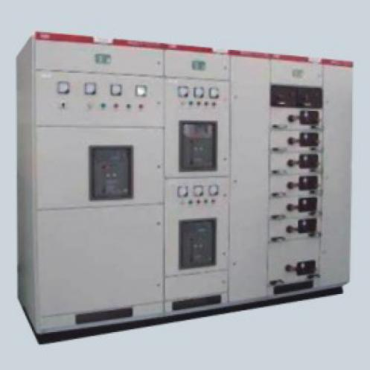 | 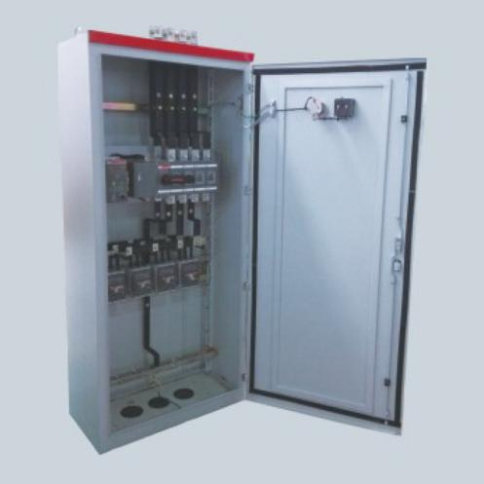 | 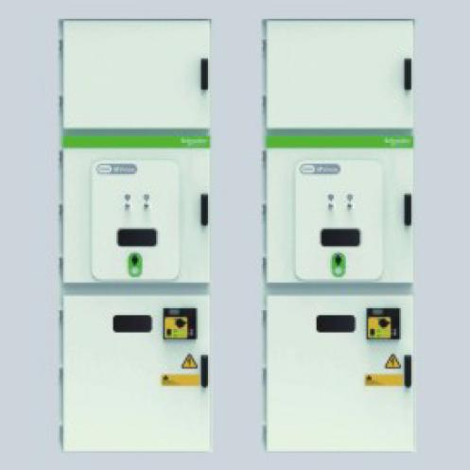
● Model: ABB MNS2.0  ● Name: AC low voltage withdrawable switchgear  ● Rated frequency: AC 50Hz / 60Hz;  ● Rated voltage (Ue): 400V;  ● Rated insulation voltage(Ui): 690V;  ● Horizontal Busbar Rated current (Ir): 6300A;  ● Vertical Bus Rated current (Ir): 2000A;  ● Horizontal Busbar Short time withstand current (Icw) (4s): 100kA;  ● Vertical Bus Short time withstand current (Icw) (4s): 80kA;  ● Functional units: withdrawable;  ● Protect Degree: IP30~ IP54;  ● Standard: IEC 61439-1 & 2;  ● Dimension: 2200H *400/ 600/ 800/ 1000/ 1200W *800/ 1000/ 1200D (mm) | ● Model: ABB MNS-E/S  ● Name: AC low voltage power distribution box  ● Rated frequency: AC 50Hz / 60Hz;  ● Rated voltage (Ue): 380V;  ● Rated insulation voltage(Ui): 400V;  ● Rated current (Ir): 250A;  ● Short time withstand c (Icw): 6kA(1s);  ● Standardized design, compact structure and versatility;  ● Opening angle of the cabinet is 180 degrees;  ● Eelectrical mounting plate can be detachable separately;  ● Protect Degree: IP30;  ● Standard: IEC 61439-1 & 2;  ● Dimension: 1000/ 950 (differ 50mm)...600/ 550H *900/ 850 (differ 50mm)...500/ 450W *300/ 275 (differ 25mm)... 200/ 175D (mm) | ↑ Schneider MVnex Metal Enclosed Switchgear  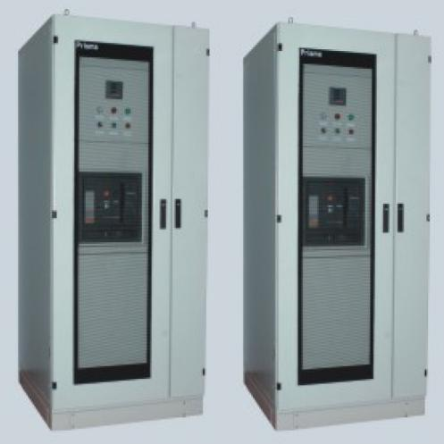  ↑ Schneider Prisma LV Switchgear
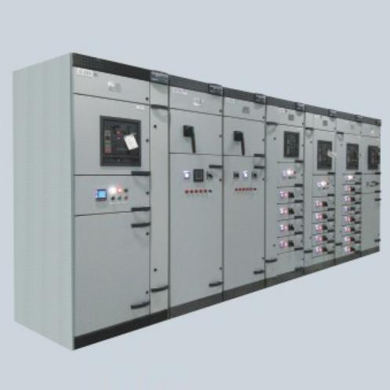 | 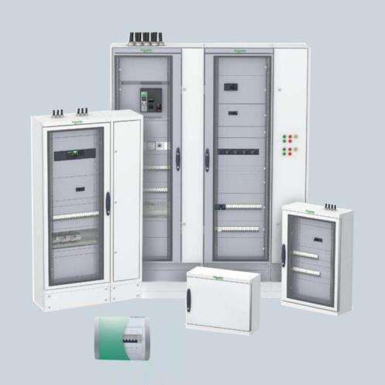 | 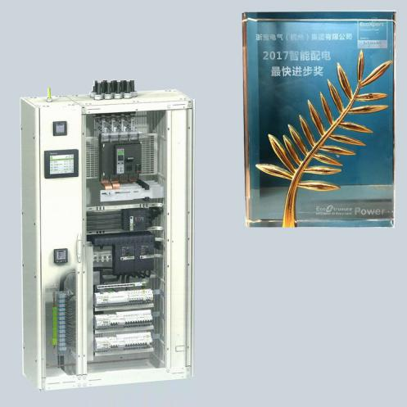
● Model: Schneider Blokset  ● Name: AC low voltage switchgear  ● Rated frequency: AC 50Hz / 60Hz;  ● Rated voltage (Ue): 400V/ 690V;  ● Rated insulation voltage(Ui): 1000V;  ● Horizontal Busbar Rated c (Ir): 7000A;  ● Vertical Bus Rated current (Ir): 3200A;  ● Horizontal Busbar Short time withstand c (Icw) (4s): 30kA 50kA 85kA 100kA;  ● Vertical Bus Short time withstand current (Icw) (4s): 30kA 50kA 85kA;  ● Functional units: withdrawble/ fixed;  ● Protect Degree: IP20~ IP54;  ● Internal arcing protect IEC61641: 85kA 0.4s  ● Standard: IEC 61439-1 & 2;  ● Dimension: 2200H *500/ 600/ 700/ 800/ 900/ 1000/ 1100/ 1200/ 1300W *400/ 600/ 1000D (mm) | ● Model: SCHNEIDER Prisma iPM WM  ● Name: AC low voltage power distribution box  ● Rated frequency: AC 50Hz / 60Hz;  ● Rated voltage (Ue): 380V;  ● Rated insulation voltage(Ui): 400V;  ● Rated current (Ir): 250A;  ● Short time withstand current (Icw): 6kA(1s);  ● Standardized design, compact structure and versatility;  ● Modular design;  ● Protect Degree: IP30;  ● Standard: IEC 61439-1 & 2;  ● Dimension: 1300/ 1100/ 900/ 700/ 500/ 300H *600W *235D (mm) | SMART PANELS Intelligent power distribution system & FacilityMost Platform  ● Electrical assets management  ** electrical equipment status real-time monitoring, electrical asset configuration information display  ** circuit breaker aging assessment analysis, providing fault diagnosis and Recovery Guidance for electrical assets.  ** through mobile terminal APP, fast access to the QR code on cabinet door and interactive alarm management can be realized.  ** preventive maintenance guidance plan, flexible and simple network configuration.  ● Power quality management  ● Energy efficiency management
Page 08

[ Products > Substations ]

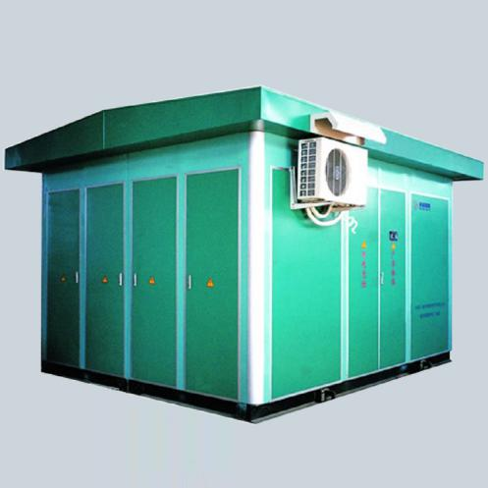 | 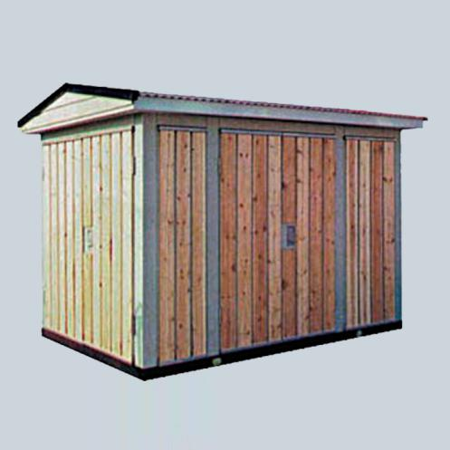 | 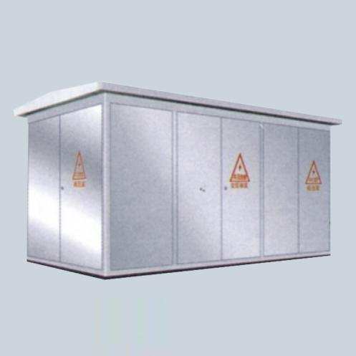
● Model: YBM27-40.5/12kV  ● Name: intelligent prefabricated transformer substation | ● Model: YBM27-12/0.4kV  ● Name: transformer substation with wooden decor enclosure | ● Model: YBM27-12/0.4kV  ● Name: transformer substation with stainless steel enclosure
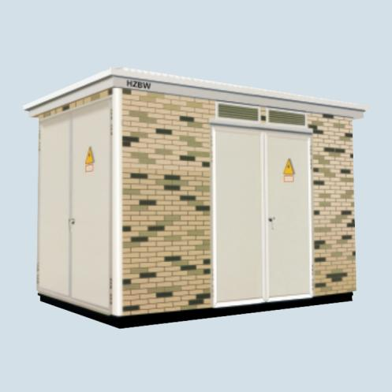 | 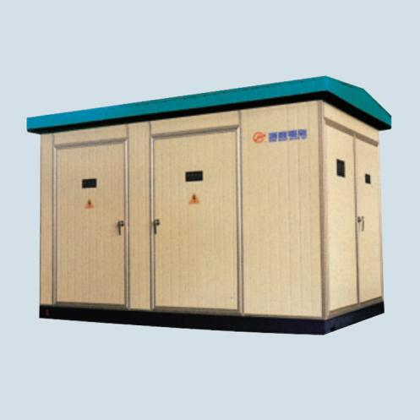 | 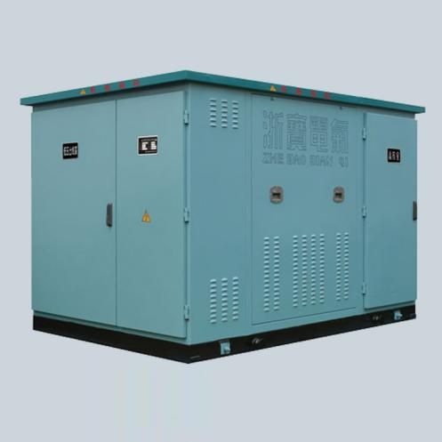
● Model: YBM27-12/0.4kV  ● Name: transformer substation with non-metal decor enclosure | ● Model: YBM27-12/0.4kV  ● Name: transformer substation with sandwich board enclosure | ● Model: YBM27-12/0.4kV  ● Name: intelligent prefabricated transformer substation
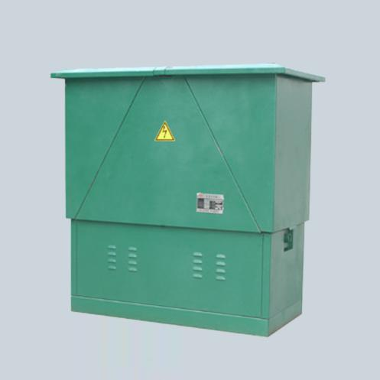 | 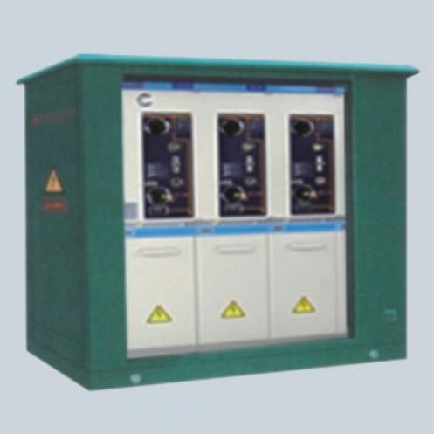
● Model: DFW-12kV  ● Name: outdoor cable distribution branch box | ● Model: XGW-12kV  ● Name: outdoor RMU sub section post

Page 09

[ Products > MCC, LCP, Power Distribution Boxes ]

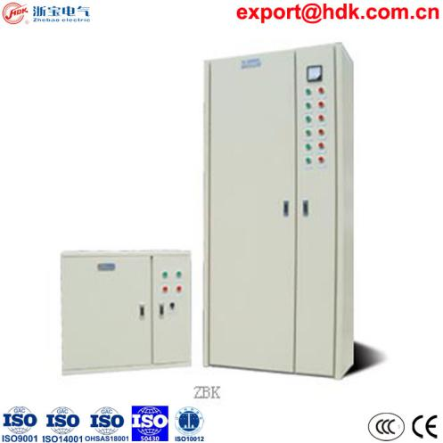 | 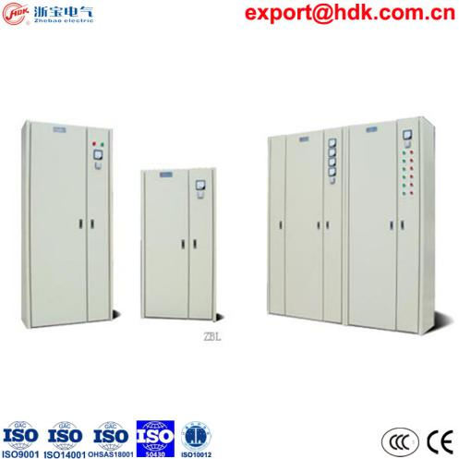 | 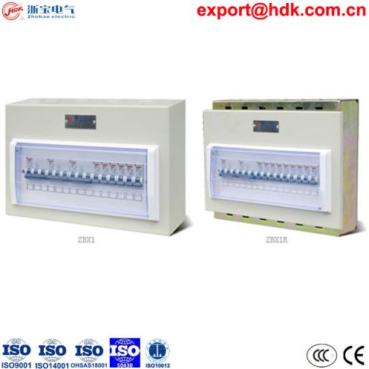
● Model: ZBK6  ● Name: safety extinguishing control box | ● Model: ZBL  ● Name: motive electricity cabinet | ● Model: ZBX1  ● Name: ZBX1 general terminal distribution box
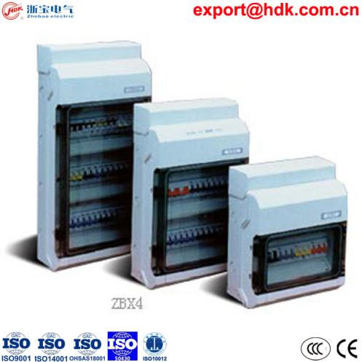 | 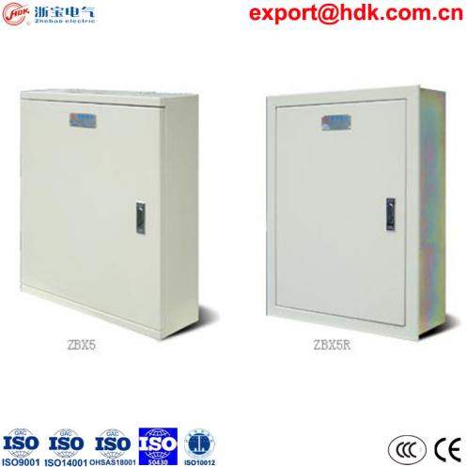 | 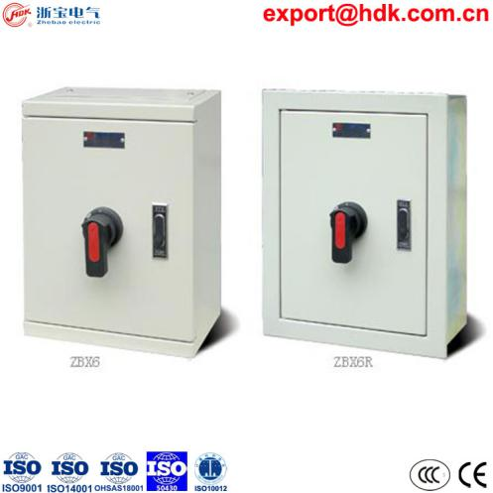
● Model: ZBX4  ● Name: ZBX4 high protection terminal box | ● Model: ZBX5  ● Name: ZBX5 ribs type distribution box | ● Model: ZBX6  ● Name: ZBX6 power switch box
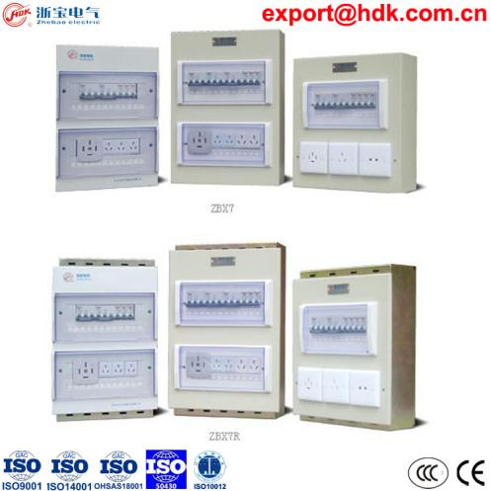 | 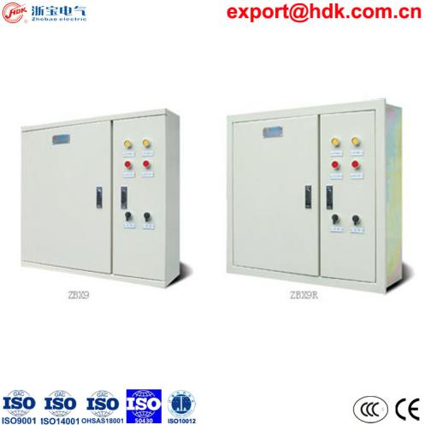 | 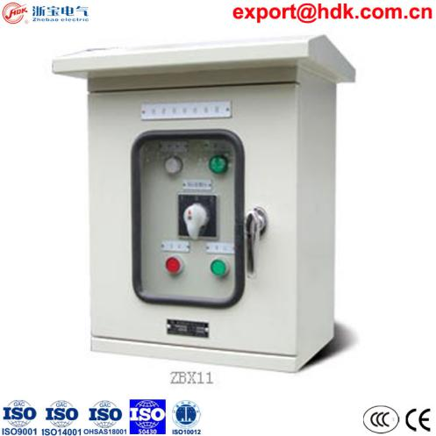
● Model: ZBX7  ● Name: ZBX7 outlet socket box | ● Model: ZBX9  ● Name: ZBX9 dual power switching box | ● Model: ZBX11  ● Name: ZBX11 rain proof distribution box

Page 10

[ Products > MV HV VCB, SF6 LBS & OTHERS ]

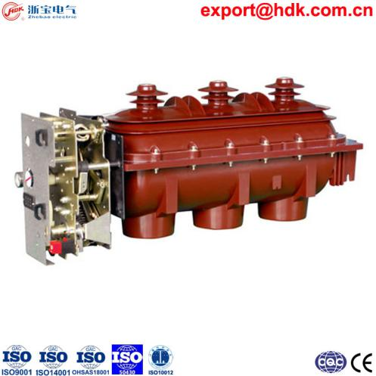 | 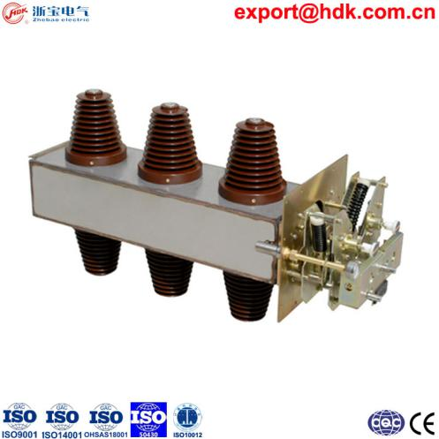 | 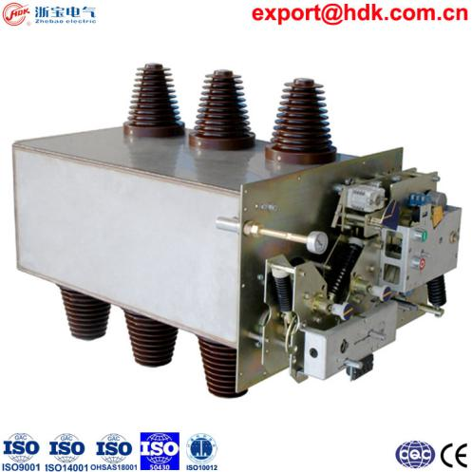
● Model: ZBF(R)N-12D  ● Name: Indoor HV SF6 load switch  ● Rated voltage Ur: 12kV  ● Rated power frequency withstand voltage Ud (1min) : 42/48kV  ● Rated impulse withstand voltage: 75/85kV  ● Rated short circuit making current Ima: expected 31.5kA for fuse comb  ● Life time load switch / disconnecting switch: 5000times  ● Life time earthing switch: 2000times  ● Leakage percentage per year: ≦0.5% | ● Model: ZBF(R)N-24D  ● Name: Indoor HV SF6 LBS-Fuse Combination  ● Rated voltage Ur: 24kV  ● Rated power frequency withstand voltage Ud (1min) : 65/79kV  ● Rated impulse withstand voltage: 125/145kV  ● Rated short circuit making current Ima: 50kA  ● Life time load switch / disconnecting switch: 5000/2000times  ● Life time earthing switch: 2000times  ● Leakage percentage per year: ≦0.1% | ● Model: ZBFV-24D  ● Name: Indoor HV SF6 VCB Earthing Combination  ● Rated voltage Ur: 24kV  ● Rated power frequency withstand voltage Ud (1min) : 65/79kV  ● Rated impulse withstand voltage: 125/145kV  ● Rated short circuit making current Ima: 50kA  ● Rated short circuit drop out current Isc: 20kA  ● Life time load switch / disconnecting switch: 2000times  ● Life time earthing switch: 2000times  ● Life time VCB: 10000times  ● Leakage percentage per year: ≦0.1%
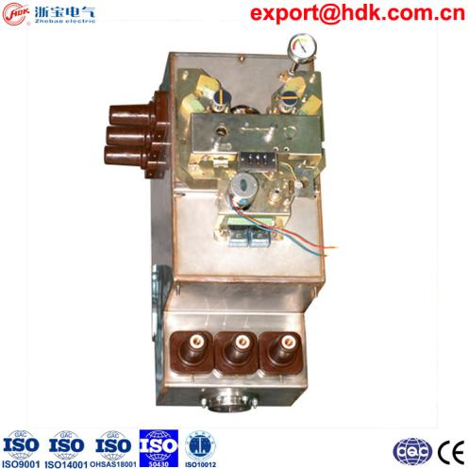 | 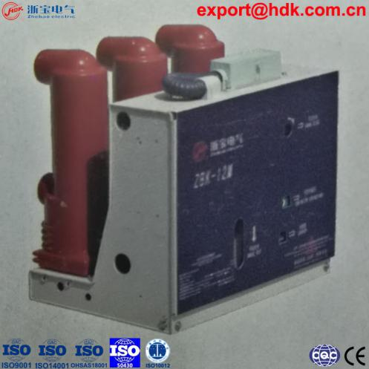 | 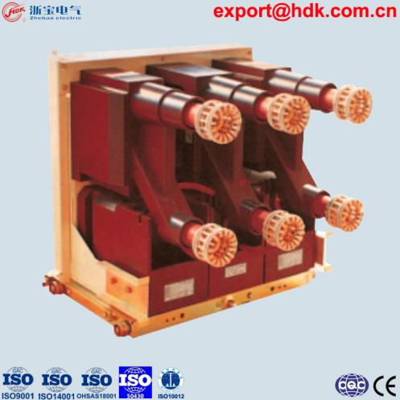
● Model: ZBF12~24kV Central Assy  ● Name: SF6 Co-cubicle Central Assembly for compact gas insulated cabinet | ● Model: ZBK-12  ● Name: AC High Voltage Fast Vacuum Circuit Breaker (FVCB)  ● Rated voltage (Ue): 12kV;  ● Power frequency withstand voltage (1min): 42kV;  ● Rated impulse withstand voltage (Uimp): 75kV;  ● Rated current (Ir): 630A 1250A 1600A;  ● Short time withstand current (Icw) (4s): 25kA 31.5kA;  ● Short circuit drop-out c: 25kA 31.5kA;  ● Phase spacing: 150/ 210/ 275mm;  ● Install mode: trolley, fixed;  ● Embedded pole column;  ● Permanent magnetic operating mechanism 30k times;  ● Closing time ≦10ms, open ≦3ms;  ● Applicable for flexible power supply;  ● Standard: IEC62271-100, IEC60694 | ● Name: VCB for KYN28-12 MV Switchgear
Page 11

[ Products > MV HV VCB, SF6 LBS & OTHERS ]

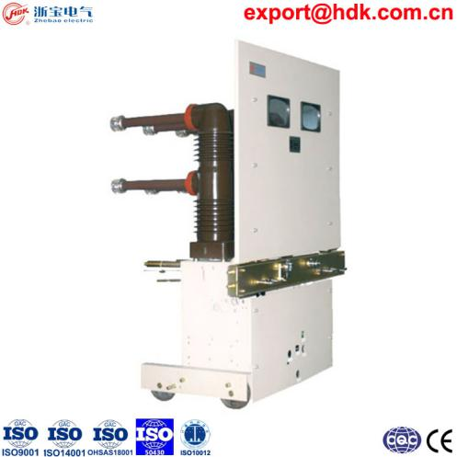 | 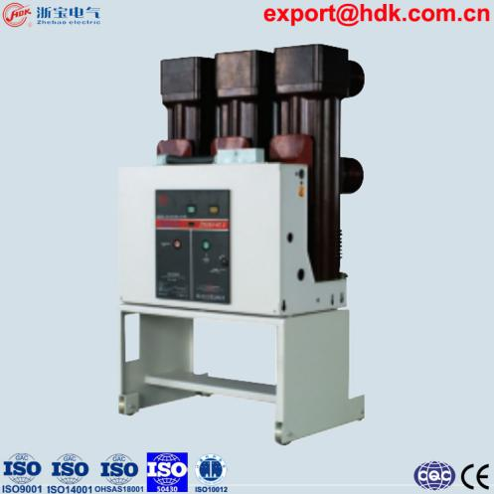 | 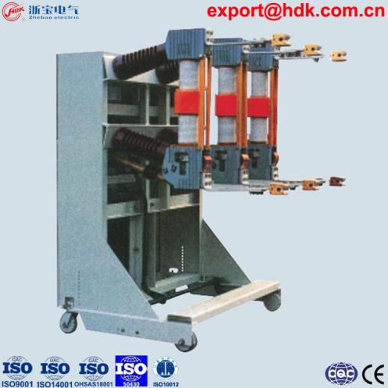
● Model: ZBP-40.5  ● Name: AC High Voltage Embedded Pole Vacuum Circuit Breaker (VCB)  ● Rated frequency: AC 50Hz / 60Hz;  ● Rated voltage (Ue): 40.5kV;  ● Power frequency withstand voltage (1min): 95kV;  ● Rated impulse withstand voltage (Uimp): 185kV;  ● Rated current (Ir): 630A 1250A 1600A 2000A 2500A;  ● Short time withstand current (Icw) (4s): 25kA 31.5kA ;  ● Short circuit drop-out current: 25kA 31.5kA ;  ● Phase spacing: 275/ 280/ 300mm;  ● Install mode: trolley, fixed;  ● Embedded pole column;  ● Spring operating mechanism 20k time;  ● Standard: IEC62271-100, IEC60694 | ● Model: ZN85A-40.5  ● Name: AC High Voltage Vacuum Circuit Breaker (VCB)  ● Rated frequency: AC 50Hz / 60Hz;  ● Rated voltage (Ue): 40.5kV;  ● Power frequency withstand voltage (1min): 95kV;  ● Rated impulse withstand voltage (Uimp): 185kV;  ● Rated current (Ir): 630A 1250A 1600A 2000A 2500A;  ● Short time withstand current (Icw) (4s): 25kA 31.5kA ;  ● Short circuit drop-out current: 25kA 31.5kA ;  ● Phase spacing: 280/ 300mm;  ● Install mode: trolley, fixed;  ● Common insulating tube structure;  ● Spring operating mechanism 10k time;  ● Standard: IEC62271-100, IEC60694 | ZN23C-40.5kV indoor HV VCB  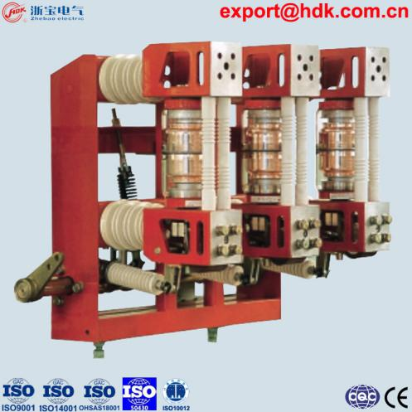  ZN28A-12kV indoor HV VCB
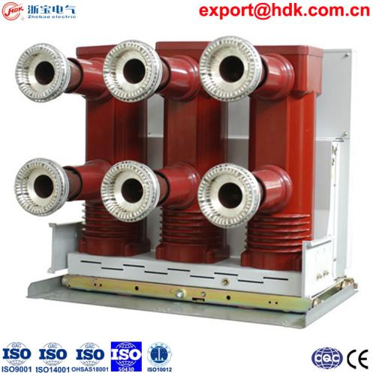 | 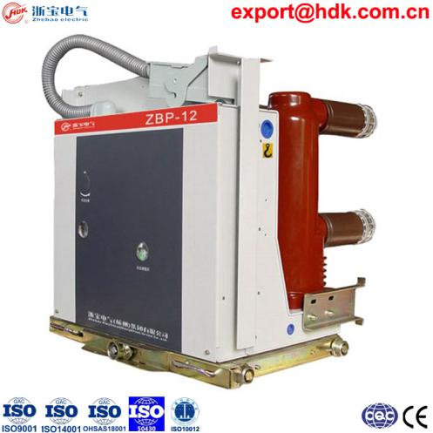 | 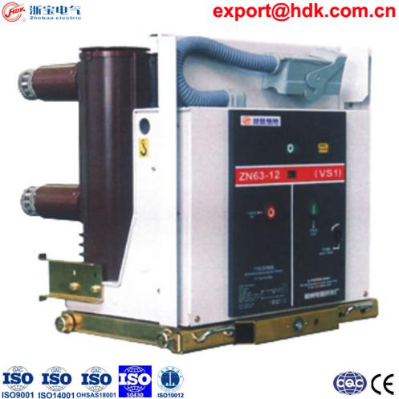
● Model: ZBP-24  ● Name: AC High Voltage Vacuum Circuit Breaker (VCB)  ● Rated frequency: AC 50Hz / 60Hz;  ● Rated voltage (Ue): 24kV;  ● Power frequency withstand voltage (1min): 65kV;  ● Rated impulse withstand voltage (Uimp): 125kV;  ● Rated current (Ir): 630A 1250A 1600A 2000A 2500A;  ● Short time withstand current (Icw) (4s): 20kA 25kA 31.5kA ;  ● Short circuit drop-out current: 20kA 25kA 31.5kA ;  ● Phase spacing: 210/ 275mm;  ● Install mode: trolley, fixed;  ● Embedded pole column;  ● Spring operating mechanism 30k time;  ● Standard: IEC62271-100, IEC60694 | ● Model: ZBP-12  ● Name: AC High Voltage Vacuum Circuit Breaker (VCB)  ● Rated frequency: AC 50Hz / 60Hz;  ● Rated voltage (Ue): 12kV;  ● Power frequency withstand voltage (1min): 42kV;  ● Rated impulse withstand voltage (Uimp): 75kV;  ● Rated current (Ir): 630A 1250A 1600A 2000A 2500A 3150A 4000A;  ● Short time withstand current (Icw) (4s): 25kA 31.5kA 40kA;  ● Short circuit drop-out current: 25kA 31.5kA 40kA;  ● Phase spacing: 150/ 210/ 275mm;  ● Install mode: trolley, fixed;  ● Embedded pole column;  ● Spring operating mechanism 30k time;  ● Standard: IEC62271-100, IEC60694 | ● Model: ZN63A-12 (VS1), (24kV avl)  ● Name: AC High Voltage Vacuum Circuit Breaker (VCB)  ● Rated frequency: AC 50Hz / 60Hz;  ● Rated voltage (Ue): 12kV;  ● Power frequency withstand voltage (1min): 42kV;  ● Rated impulse withstand voltage (Uimp): 75kV;  ● Rated current (Ir): 630A 1250A 1600A 2000A 2500A 3150A 4000A;  ● Short time withstand current (Icw) (4s): 25kA 31.5kA 40kA;  ● Short circuit drop-out current: 25kA 31.5kA 40kA;  ● Phase spacing: 150/ 210/ 275mm;  ● Install mode: trolley, fixed;  ● Common insulating tube structure;  ● Spring operating mechanism 10k time;  ● Standard: IEC62271-100, IEC60694
Page 12

[ Products > MV HV VCB, SF6 LBS & OTHERS ]

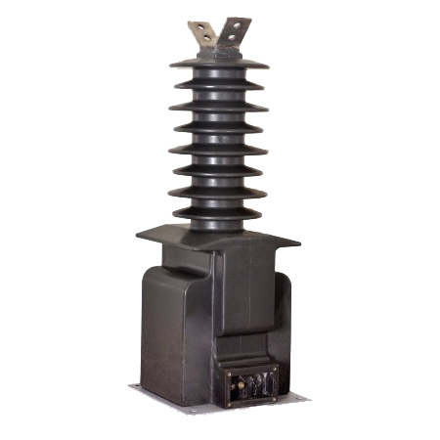 | 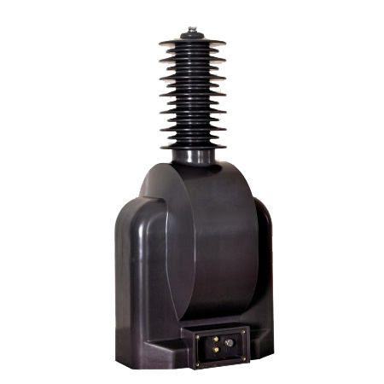 | 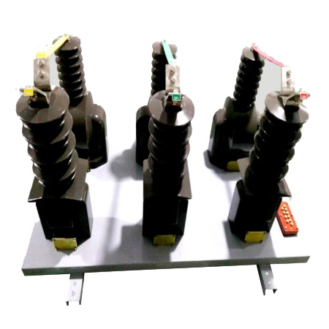
● Model: LZZW-35kV  ● Name: Outdoor Current Transformer, (CT)  ● Rated insulation: 40.5/95/185kV;  ● Rated Secondary current: 5A; | ● Model: JDZX-35kV  ● Name: Outdoor Voltage Transformer, Power Transformer (VT, PT)  ● Rated insulation: 40.5/95/200kV;  ● Voltage Ratio: 33000/√3/110/√3/110√3, 35000/√3/100/√3/100/3; | ● Model: JLSZY-35kV  ● Name: Outdoor CT VT combined instrument transformers (w/ metering)  ● Current Ratio: 400-800-1200/5A;  ● Voltage Ratio: 33kV/3，110V/3;
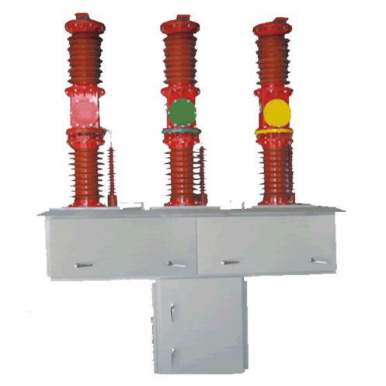 | 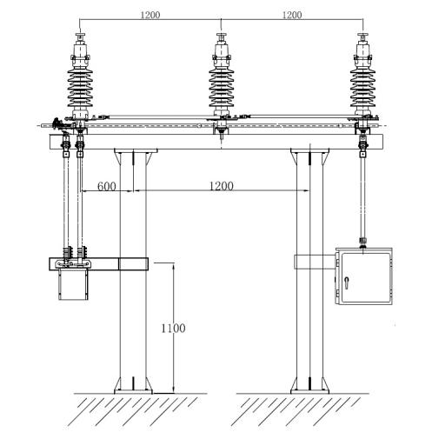 | 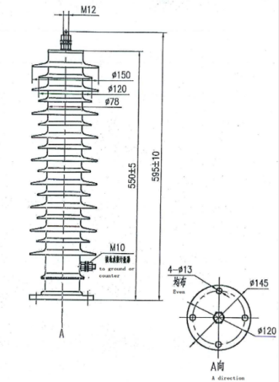
● Model: ZW7-40.5kV  ● Name: Outdoor High Voltage Vacuum Circuit Breaker (HV VCB)  ● Rated current: 630A, up to 1600A;  ● Short circuit breaking current: 20kA/25kA/31.5kA; | ● Model: GW4-40.5kV  ● Name: Outdoor High Voltage Disconnect Switch with Earth Switch  ● Rated current: 630A, up to 1600A;  ● Short circuit breaking current: 20kA/25kA/31.5kA; | ● Model: YH10WZ-45  ● Name: Outdoor Gapless Metal Oxide Surge Arrestor (SA)  ● Rated frequency: AC 50Hz / 60Hz;  ● Square wave capacity: 600A
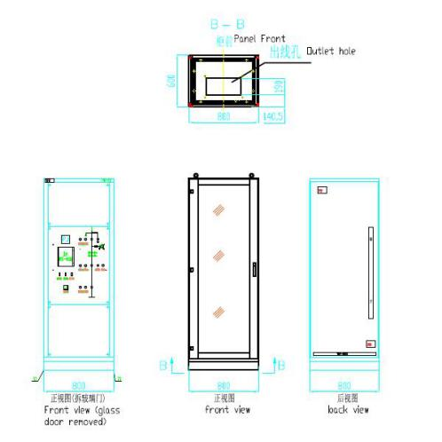 | 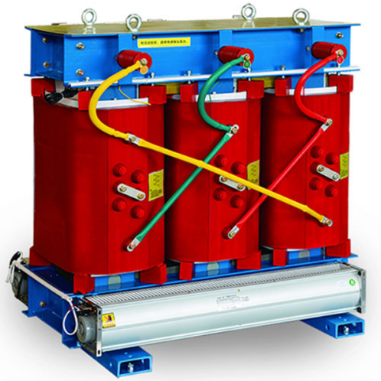 | 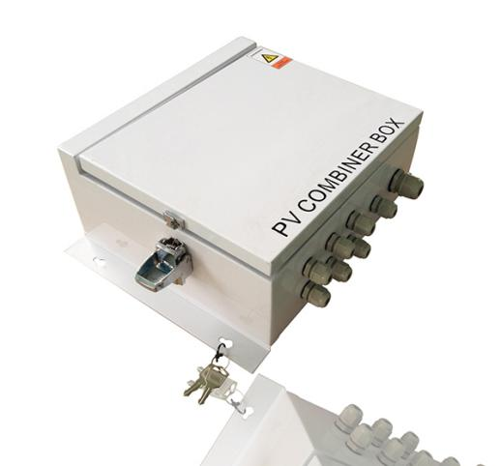
● Model: PK-10  ● Name: Feeder Protection and Control Panel with Metering  ● Auxiliary supply: 110V DC,  ● Cubicle lighting/heating rated: 230V AC | ● Model: SCB10  ● Name: Indoor Dry Type Cast Resin DISTRIBUTION TRANSFORMER (TR)  ● Capacity: 30--3150KVA | ● Model: V-CD  ● Name: Intelligent PhotoVoltaic Lightning Protection DC Combiner Box (Solar Energy PV Combiner)  ● Max Input Voltage: DC1000V;  ● Circuit Current: 10A;
Page 13
[ Products > ACB MCB MCCB RCCB & Components ]

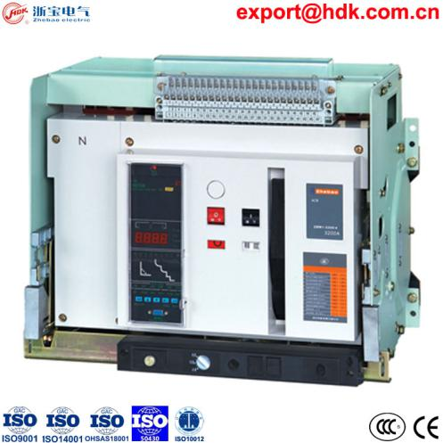 | 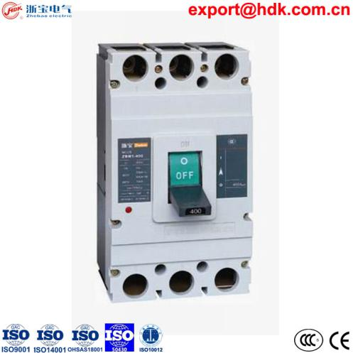 | 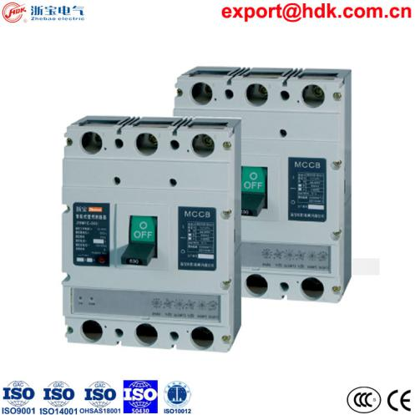
● Model: ZBW1, ZBW2  ● Name: ZBW1 Intelligent LV Air Circuit Breaker (ACB)  ZBW2 Intelligent LV Air Circuit Breaker | ● Model: ZBM1, ZBM3  ● Name: ZBM1 MCCB (molded case circuit breaker)  ZBM1L, ZBM3L Residual MCCB | ● Model: ZBM1E, ZBM3E  ● Name: ZBM1E electronic MCCB
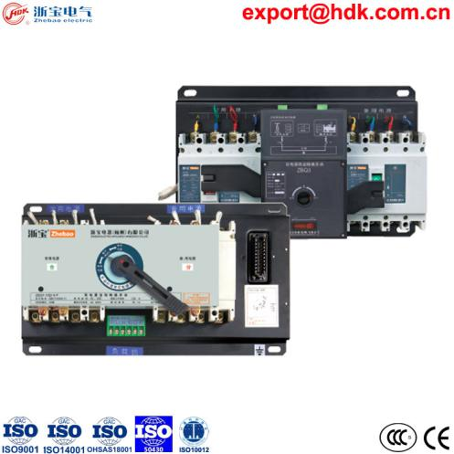 | 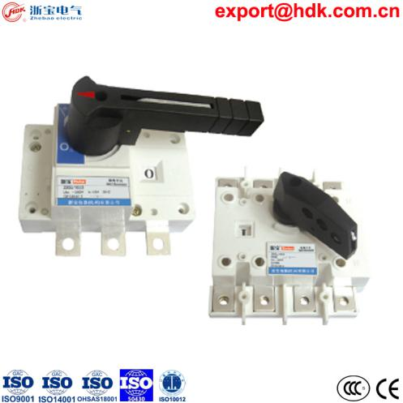 | 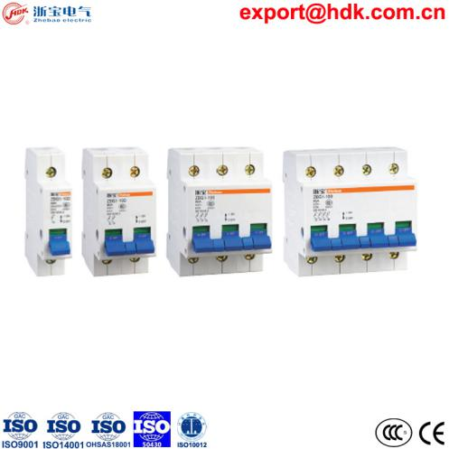
● Model: ZBQ  ● Name: ZBQ Dual-power automatic switch | ● Model: ZBG  ● Name: ZBG isolator switch | ● Model: ZBG1  ● Name: ZBG1-100 miniture isolator switch
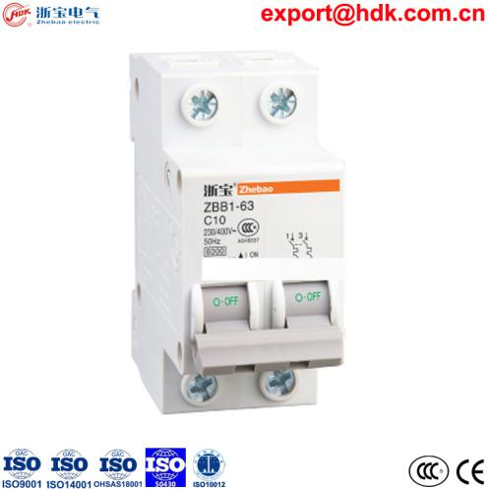 | 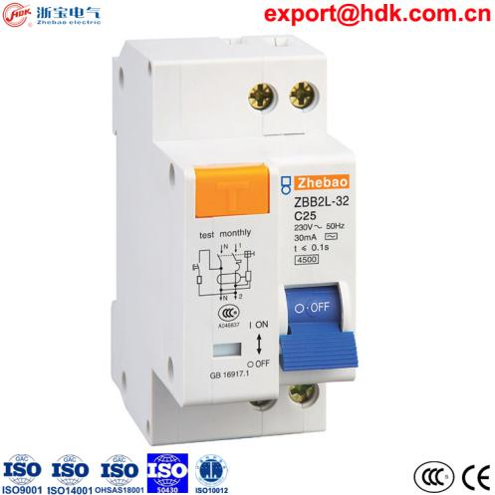 | 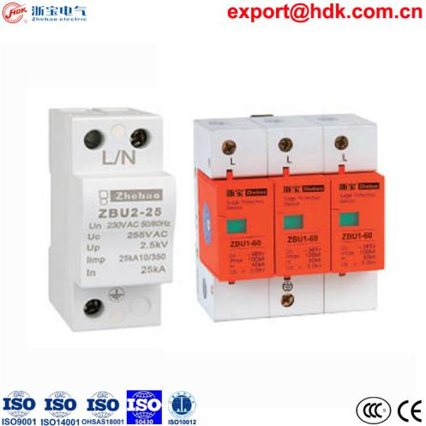
● Model: ZBB1  ● Name: ZBB1 MCB | ● Model: ZBB2  ● Name: ZBB2x RCCB (Residual Current actuated Circuit Breaker) | ● Model: ZBU1, ZBU2  ● Name: ZBU surge protector

Page 14

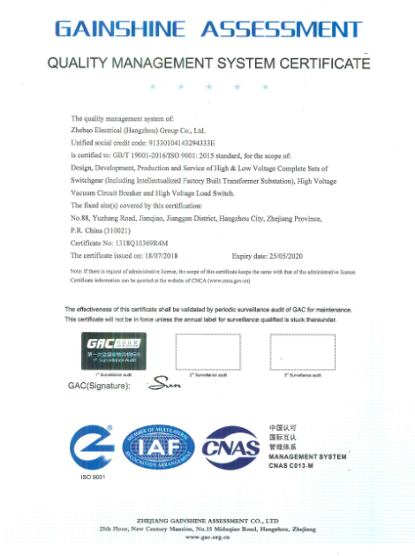 | 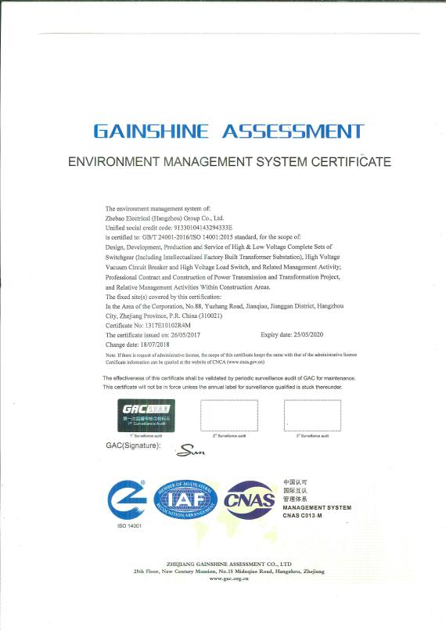 | 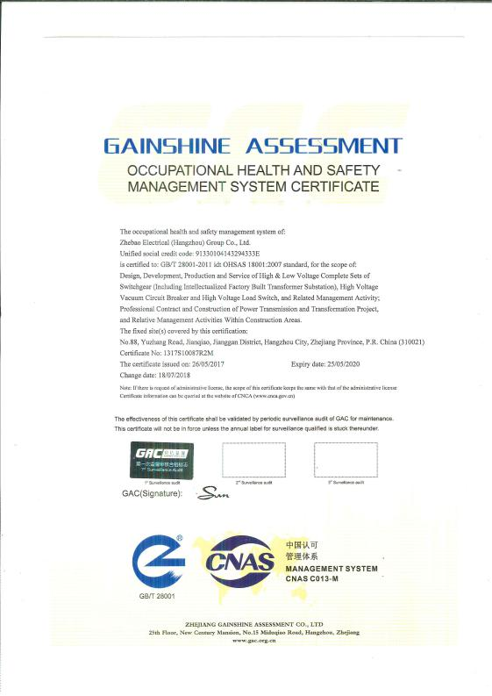
ISO9001 QMS | ISO14001 EMS | (ISO45001) OHSAS18001
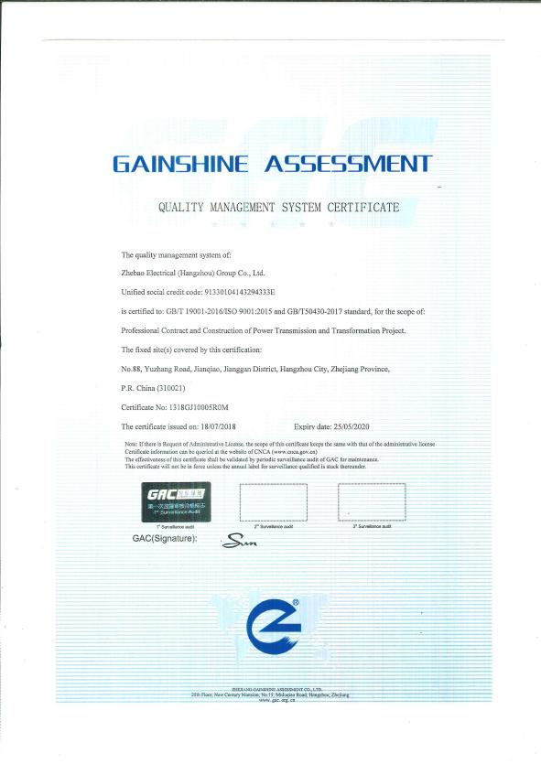 | 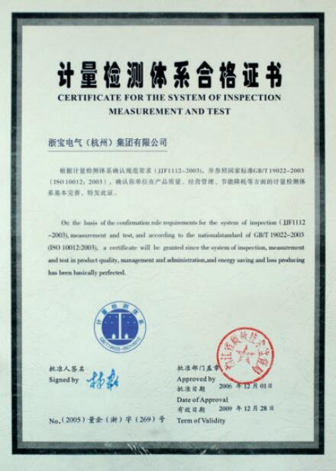
GB/T50430 Construction QMS | ISO10012 IMT measurement
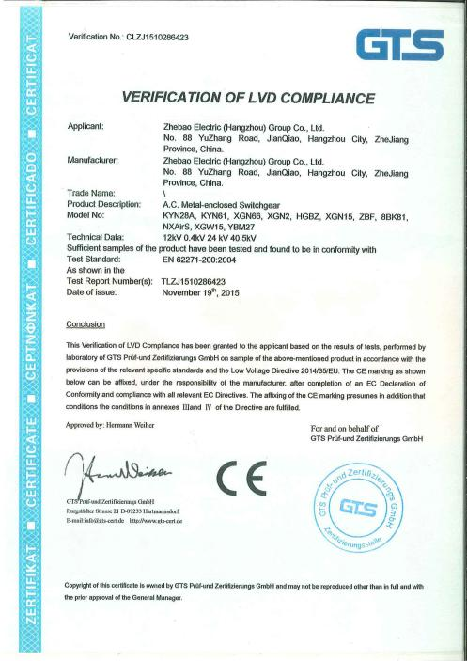 | 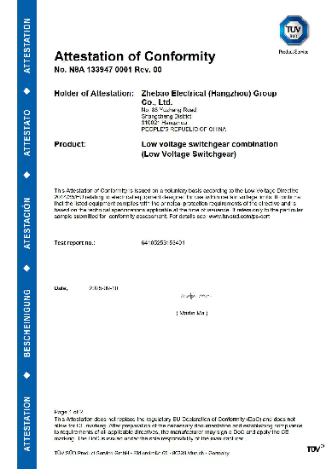
CE for HV MV Switchgears | CE for LV Switchgears (TUV)
[ Certificates and Awards ] Page 15
 | 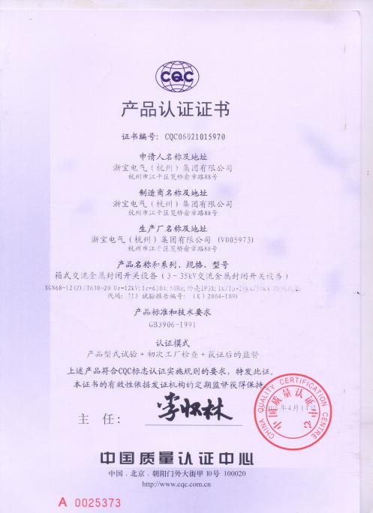 | 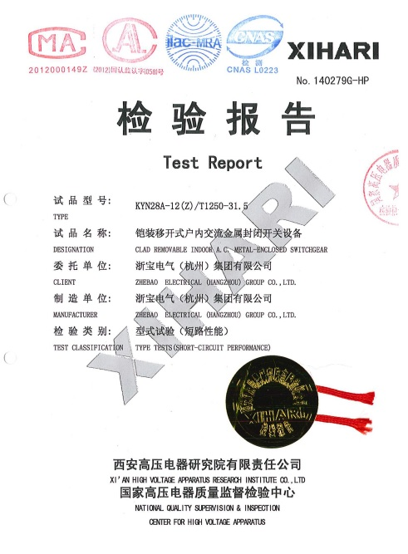
CCC for LV Switchgears | CQC for HV MV Switchboards | Type Test Report
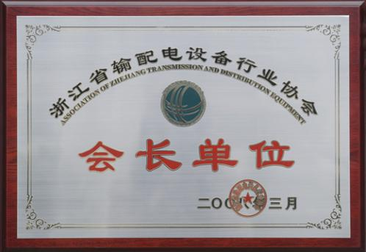 | 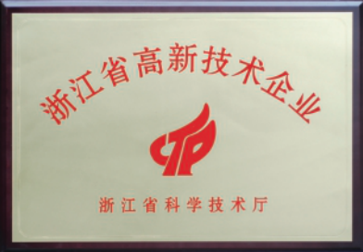 | 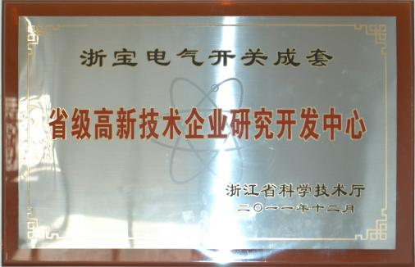
Chairman of Provincial Power Transmission and Distribution Equipment Association | Provincial Hi-new  Technology Enterprise | Provincial Hi-new Technology Research and Developing Center
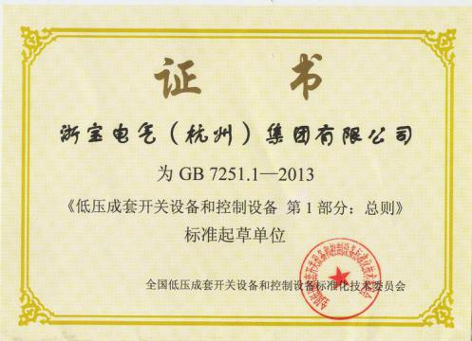 | 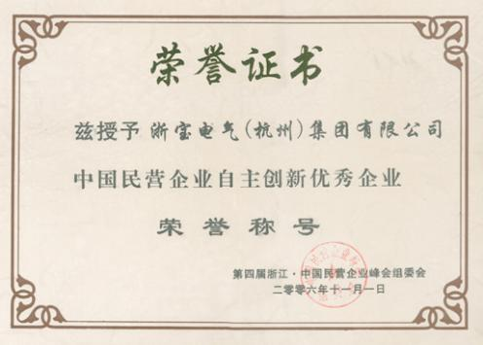 | 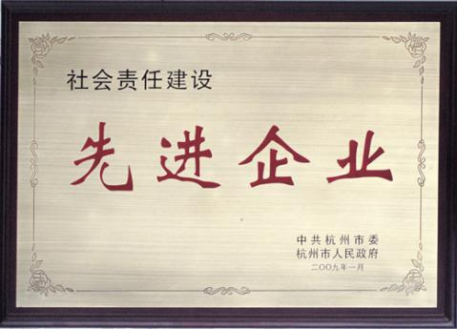
Participation on China national and industry standards formulation and revision | Private Company Self Innovation Excellent Enterprise | Corporate Social Reliability Excellent Enterprise

[ Certificates and Awards ] Page 16
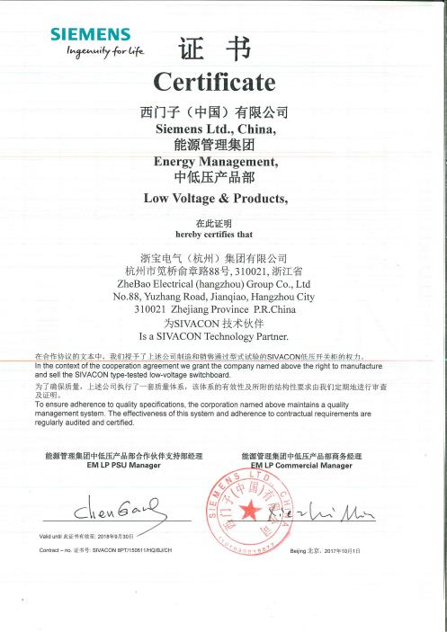 | 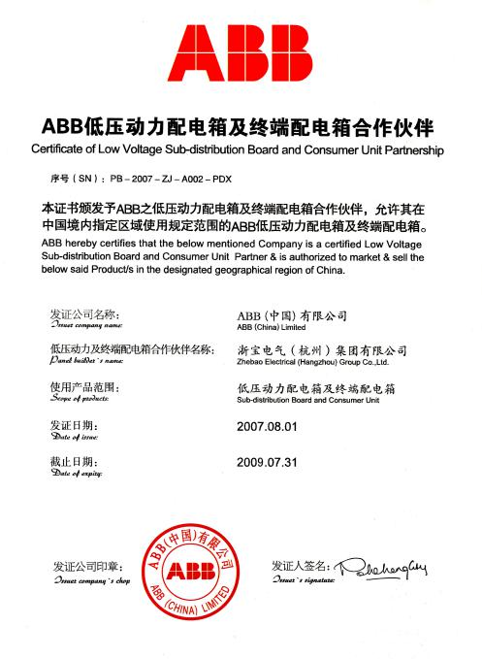 | 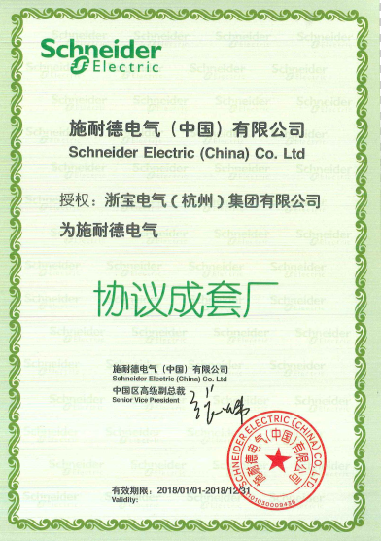
Siemens License Certificate | ABB Cooperation Authorization | Schneider Authorization
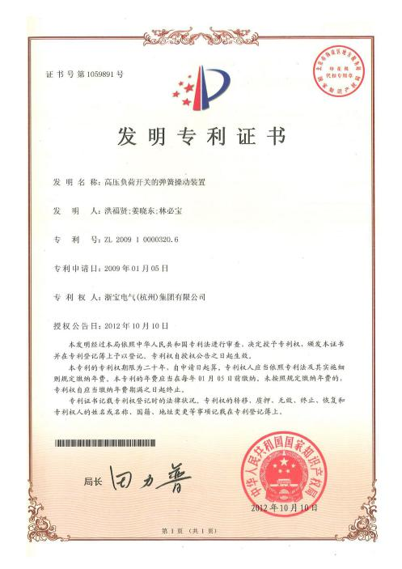 | 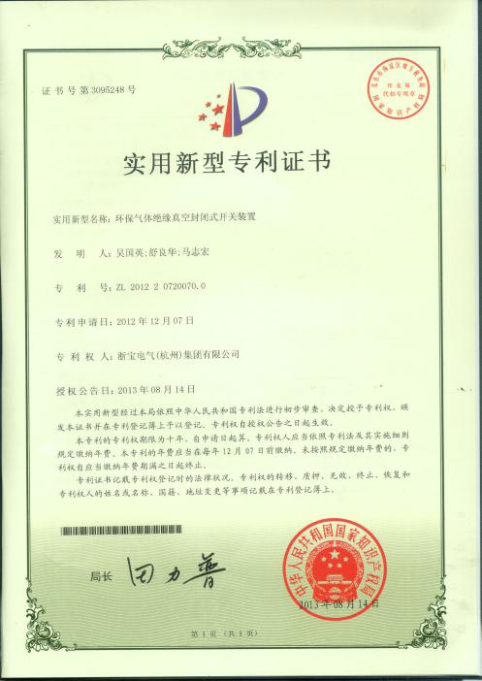 | 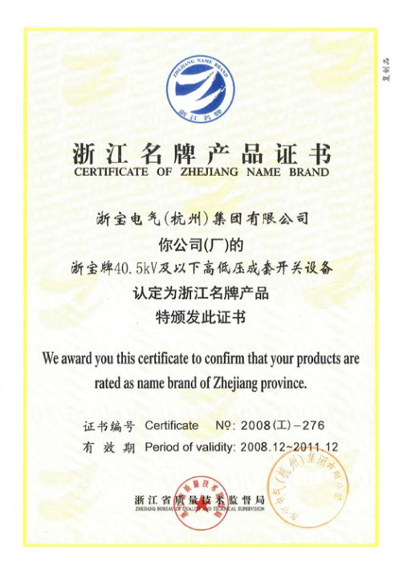
China Invention Patent | China Patent | Provincial Famous Brand

 |  | 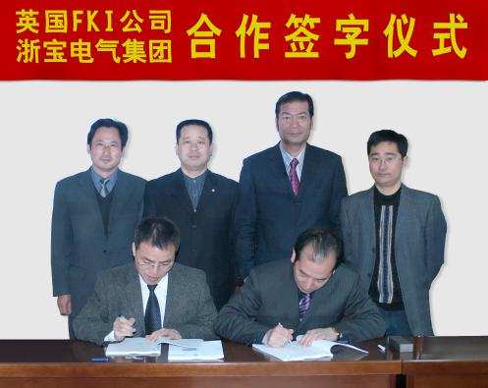
Signing Ceremony with Siemens on LV Switchboards | Signing Ceremony with Siemens on SF6 GIS MV Switchboards | Signing Ceremony with British FKI Switchgear

[ R/D and Cooperations ] Page 17
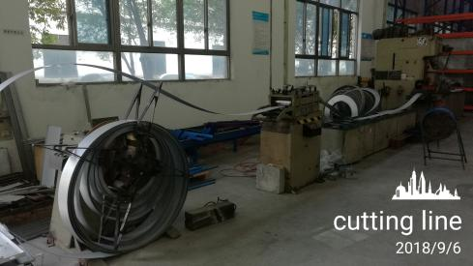 | 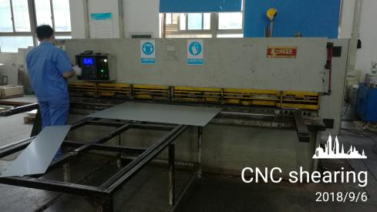 |  | 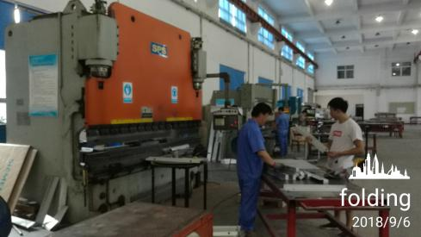
Precision cutting line | CNC shearing machine |  | CNC bending machine
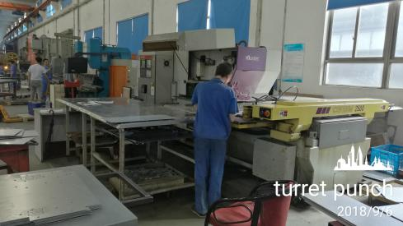 | 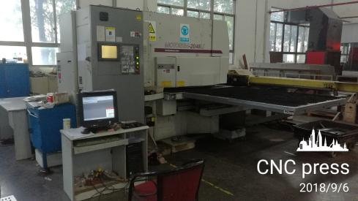
Japanese Muratec CNC multi-station turret punch | Japanese Motorum High precision CNC press |  | CNC Busbar Processing Machine
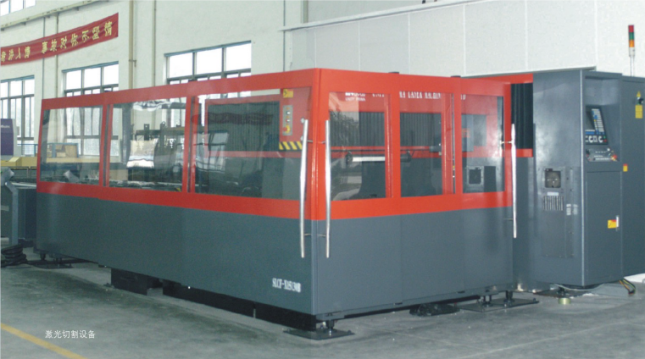
Laser cutting machine |  | Vacuum helium leakage detector
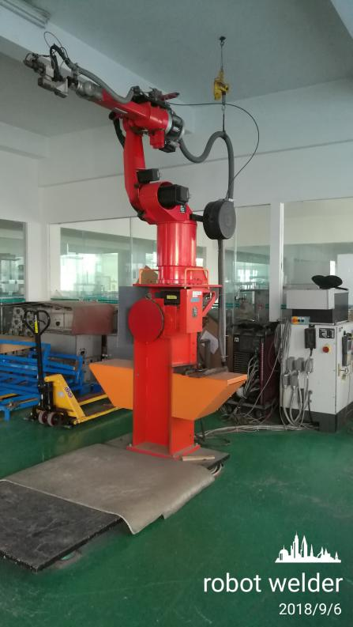 | 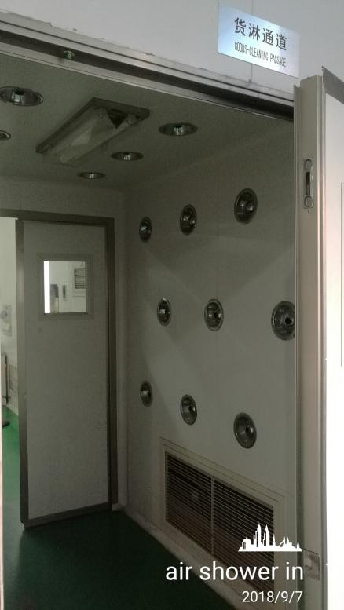 |  | 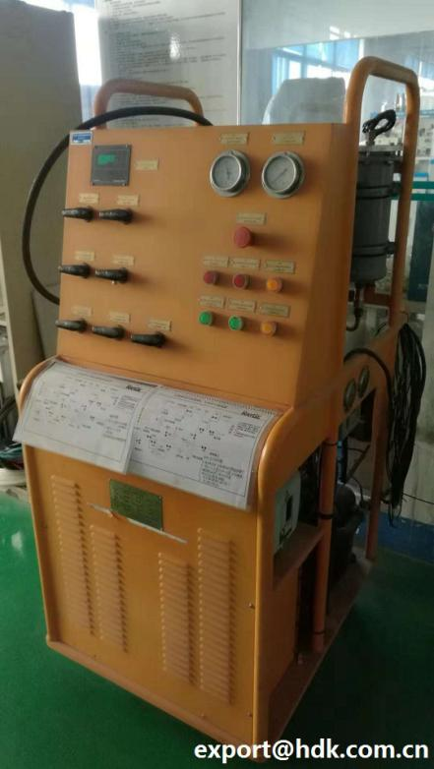
Robot welding machine | Air shower entrance |  | SF6 extracting & charging machine

[ Advanced Equipments ] Page 18
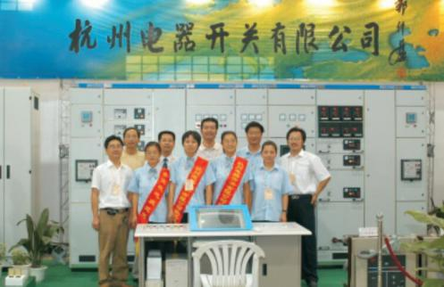 |  | 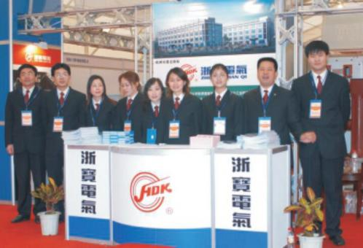 |  | 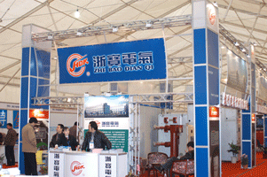
2003 Zhejiang Electric Exhibition |  | 2004 China Electric Festival |  | 2005 China Electric Festival
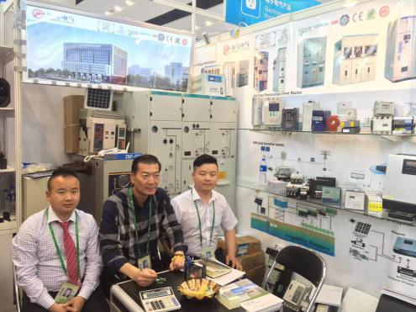 |  | 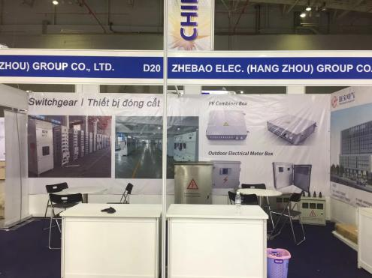 |  | 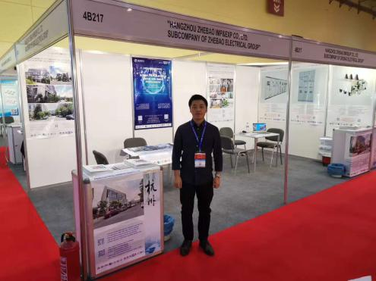
2018 spring Canton Fair |  | Electric and Power Vietnam 2018 |  | 2019 China Egypt Fair
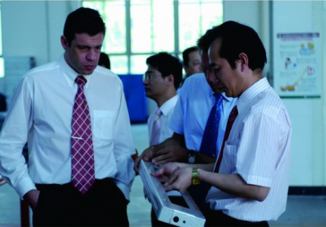 | 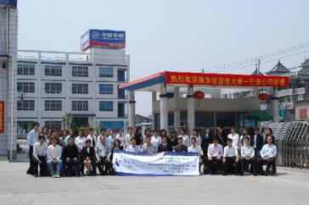 |  | 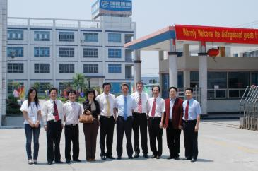 |  | 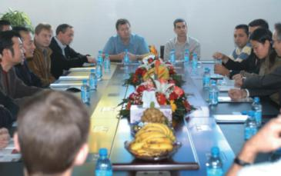
2005 Customer | 2006 Singapore |  | 2007 Siemens |  | 2007 ABB
 | 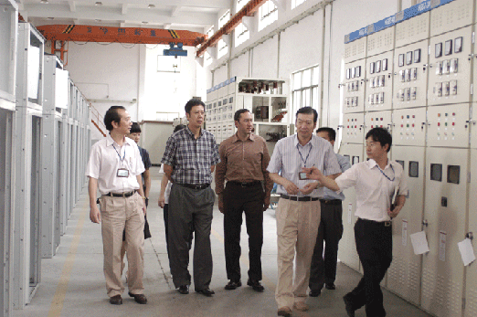 |  |  |  | 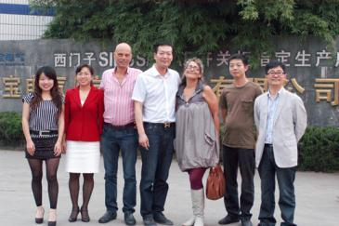
2007 British FKI | 2008 USA |  | 2009 Sudan |  | 2011 Israel
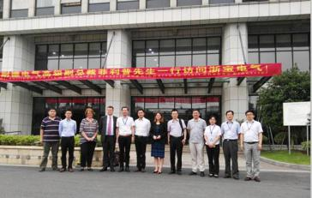 | 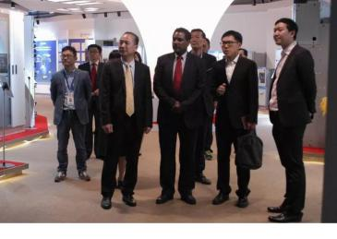 |  |  |  | 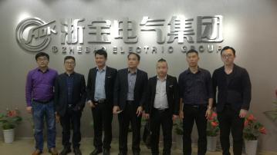
2017 Schneider | 2017 Ethiopia |  | 2018 UAE |  | 2018 Vietnam
 |  | 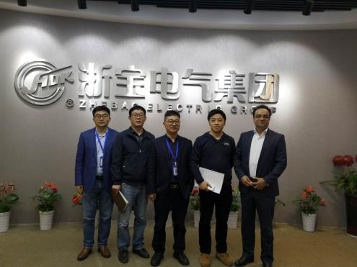 |  | 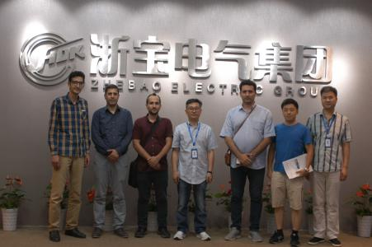
2019 Hongkong Rep |  | 2019 Iran |  | 2019 Middle East

[ Exhibitions and Interactions ] Page 19
[ Project Case > Successful Operating Projects ]

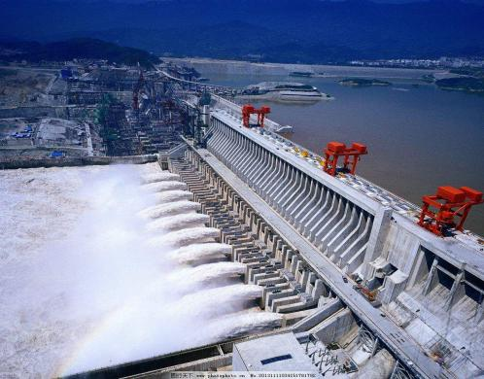 | 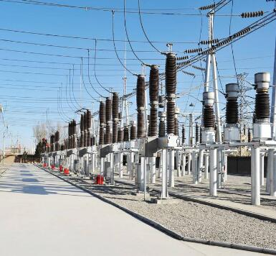 | 
Power Plants (hydropower wind solar thermo tidal nuclear generations)  ● The three gorges station (GGD / XGN2 / PK-10 / HZDW / GCK / KYN1 / PXTR);  ● The Zhoushan 3.4MW tidal generation;  ● The Haiyang nuclear power plant;  ● DT Wushashan power plant 4*600MW project (MNX);  ● Guangxi Qinzhou coal burning power plant 2*600MW project (MNX / busbar bridge);  ● Jingdezhen power plant 2*660 MW flue gas denitrification project (MNX) | Power Transmission (primary substations / secondary substations)  ● China national power grid;  ● Tibet power grid;  ● Fujian Yueyang 110kV substation;  ● The three gorges Gushuling substation (GCK / KYN1 / PXTR);  ● Zibo Hongda thermoelectricity substation (XGN / KYN28);  ● Shandong ZHWH thermoelectricity substation (KYN28/ XGN2/ KYN61/ GGD / MNX) | Heavy and Light Industrial (metallurgy / chemical / enterprises etc.)  ● China Sinosteel;  ● Wahaha power distribution projects;  ● Asia Pulp & Paper Co., Ltd. (APP);  ● Boeing 737 manufacturing base and supporting facility project (NSM / KYN28/ MNS / LCP distribution box);  ● Zhejiang petro chemical annual 40mn ton refining project (KYN28);  ● Shenghua Coal Ningxia annual 4mn liquefaction project (NSM)
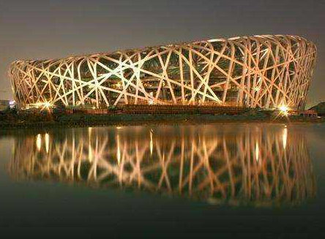 | 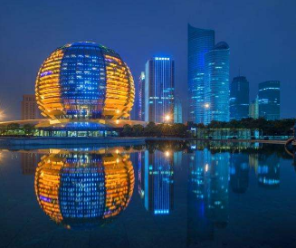 | 
Public Infrastructures (museum airport metro railway hospital etc.)  ● Beijing Olympic venues (MNX / KYN28 / ZBL / ZBX);  ● Hangzhou high-speed rail east station;  ● Shanghai pudong int’l airport;  ● The three gorges hospital project (GGD / XGN2 / PK10 / HZDW);  ● Hangzhou second water source Qiandaohu supply project (Simosec / Blokset / NXAirs/ MCC);  ● Zhejiang academy of music construction project (KYN28 / Uniswitch) | Commercial Facilities (tall building / theme park / supermarket etc.)  ● Hangzhou G20 int’l conference main meeting-place;  ● Hangzhou Qianjiang new city;  ● Wenzhou Sheraton Hotel;  ● Hangzhou Xizi Hotel (G20 reception) project (8PT / HDB);  ● Hangzhou int’l expo center project (Blokset);  ● Hangzhou bay sea-cross bridge project (8PT / KYN28/ GGD / HZDW) | Residential Facilities (RMU / package substation / LV distribution etc.)  ● Sino-ocean real estate;  ● Zhongyuan real estate;  ● Zhejiang zhongtian real estate ZT mansion (Sikus);  ● Hangzhou qianjiang new CBD int’l time square (MNX / ZBL / ZBX);  ● Hangzhou qianjiang new CBD Dikai silver square (KYN28 / Simosec / MNX);  ● Hangzhou changyu real estate (KYN28 / GCS / HDB / GGD / HYDS)

Page 20

[ Project Case > Exported Oversea Projects ]

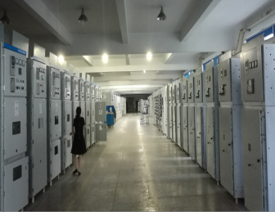
** Indonesia 60TPD air separation project (GCS / KYN28 / HZDW / HZDW11 / PK-10),
** Indonesia SYD Machinery Project (KYN28 / HYDS),
** Malaysia CP project (KYN28 / GCS),
** Vietnam Nam Muc hydropower project (SIKUS),
** Thailand AED generation project (KYN28),
** Thailand ZC Rubber Production Base Phase I (KYN61 / KYN28/ SPVOS)
** Pakistan N-J project & 4.5MW project (KYN28 / GGD / HZDW),
** India JBSL project (KYN28 / GCS / ZBL / ZBX),
** Syria air separation project (KYN28 / GCS),
** Angola Universostade Agostinho Neto project (ZBX),
** Ethiopia HS INT’L Project (KYN28 / KYN28-12 / GCK),
**Ethiopia Phase II Deep Well Water Supply Project Addis Ababa (PARTB) (Blokset),
** Ethiopia Addis Ababa water supply 3rd phase project (Blokset),
** Ethiopia Essex University Project (GCS),
** Iran petro air separation project (Schneider Blokset, MV Switchgears).
** Turkey 7500 air separation project (KYN28 / GCS),
** Russia air separation 10000 project (KYN28 / GCS / DC panel / MCC),
** Mexico 1700 high-nitrogen project (GCS, KYN28, Busbar Bridge, DC cabinet),
** KDONAr- 2800/2600/70 air separation project matching (KYN28/GGD/HZDW),
** Export 800Y Liquid 07-31 Project (KYN44/GCK/HZDW),
** Zhonghe project (KYN28 MV Switchgears),
** Hangzhou Oxygen Co., Ltd. 84000-KOT08A Project (Switchgears),
** Chuankong General Equipment Co., Ltd. (exported to Turkey, Syria, India, Indonesia, Malaysia) (8BK81/8PT/HDB).




ZHEBAO ELECTRICAL (HANGZHOU) GROUP CO., LTD.


● Switchgear expert since 1993, workshop area 41500 sqm eqv 446,702 sq ft,
● Annual revenue USD70 million, employees 560,
● Siemens ABB Schneider licensed, CE certificated,
● China national patent 25, China invention patent 2,
● ISO9001, ISO14001, OHSAS18001, GB/T50430, ISO10012, ERP; CE, CCC, CQC.

TEL: +86 571 88150078, +86 571 88150058
FAX: +86 571 88137953, +86 571 88137960
EMERGENCY: +86 18958066406
E-MAIL: EXPORT@HDK.COM.CN , sales@switchgearChina.com
ADD: NO.88 YUZHANG RD, HANGZHOU, 310021, CHINA
HTTP://HDK.COM.CN/EN/INDEX.ASPX
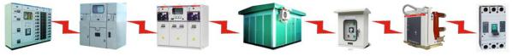



Page 21




   |       Licensed  Partner

___________________________________________________________________________________________

___________________________________________________________________________________________

___________________________________________________________________________________________

___________________________________________________________________________________________

___________________________________________________________________________________________

___________________________________________________________________________________________

___________________________________________________________________________________________

___________________________________________________________________________________________

___________________________________________________________________________________________

___________________________________________________________________________________________

___________________________________________________________________________________________

___________________________________________________________________________________________

___________________________________________________________________________________________

___________________________________________________________________________________________

___________________________________________________________________________________________

___________________________________________________________________________________________

___________________________________________________________________________________________

___________________________________________________________________________________________

___________________________________________________________________________________________

___________________________________________________________________________________________

___________________________________________________________________________________________

___________________________________________________________________________________________

___________________________________________________________________________________________

___________________________________________________________________________________________

[ NOTE MEMO ] Page 22

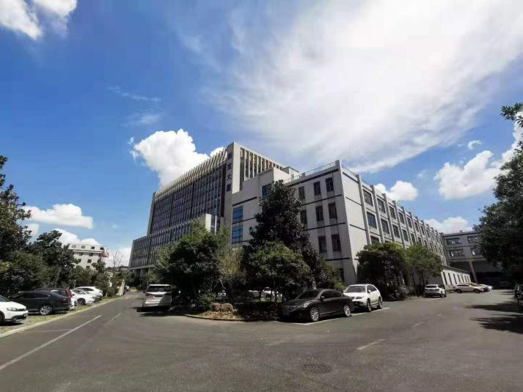
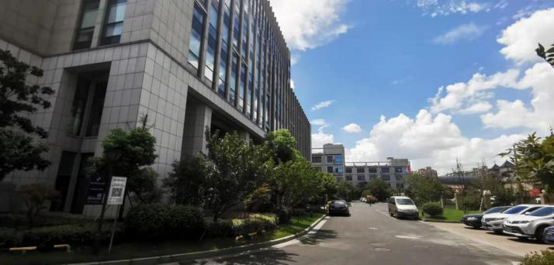
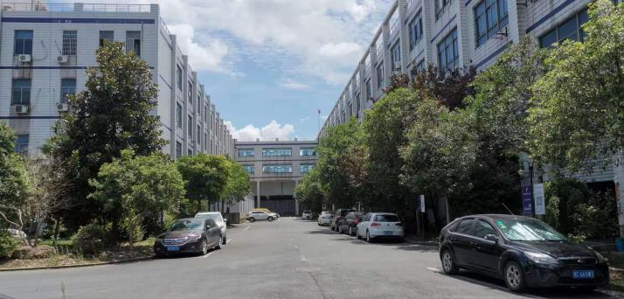

ZHEBAO ELECTRICAL (HANGZHOU) GROUP CO., LTD.  ● Switchgear expert since 1993, workshop area 41500 sqm eqv 446,702 sq ft,  ● Annual revenue USD70 million, employees 560,  ● Siemens ABB Schneider licensed, CE certificated,  ● China national patent 25, China invention patent 2,  ● ISO9001, ISO14001, OHSAS18001, GB/T50430, ISO10012, ERP; CE, CCC, CQC.  Whatsapp:+1 (458) 255 4060  Wechat: +86 13615600485  E-MAIL: 33822548@qq.com , zhoufeinih@gmail.com  ADD: NO.88 YUZHANG RD, HANGZHOU, 310021, CHINA  Https://www.cn-electric.net | 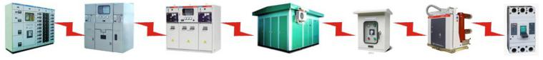   | All rights reserved by Zhebao Company.  Partial products eg. Electrical Components NOT included in this catalogue, please inquire for more.  The information provided in this catalogue belongs to general description and feature introduction, which may differ from the actual situation and may change or update. Zhebao only provides accurate description and characteristics when the relevant contract terms are clearly stipulated.  The company name(s), trademark(s) and product name(s) involved in this catalogue may be held by the relevant parties. Any third party should NOT use them without authorization.

