**[Title in Times New Roman and Bold No.14]**

Last name -First name, (in uppercase) -1st † Last name -First name (in uppercase) -2nd Author's name

*Institutional mail No.10 Times New Roman and Italic*

(Report Submission Date: Month, Day, and Year); Accepted (Insert date of Acceptance: Use Only ECORFAN)

___________________________________________________________________________________________________

**Abstract**

Title

Objectives, methodology

Contribution

(150-200 words)

Keywords

Indicate (3-5) keywords in Times New Roman and Bold No.11

___________________________________________________________________________________________________

**Citation:** Last name -First name (in uppercase) -1st † Last name -First name (in uppercase) -2nd Author's name. Paper Title. Title of the Journal. 2015 1-1: 1-11 - [All in Times New Roman No.10]

___________________________________________________________________________________________________

___________________________________________________________________________________________________

† Researcher contributing as first author.

**© ECORFAN-(** **Indicate the country of publication) www.ecorfan.org/ Indicate the country of publication**

**Introduction**

Text in Times New Roman No.12, single space.

General explanation of the subject and explain why it is important.

What is your added value with respect to other techniques?

Clearly focus each of its features

Clearly explain the problem to be solved and the central hypothesis.

Explanation of sections Article.

**Development of headings and subheadings of the article with subsequent numbers**

[Title No.12 in Times New Roman, single spaced and Bold]

Products in development No.12 Times New Roman, single spaced.

**Including graphs, figures and tables-Editable**

In the article content any graphic, table and figure should be editable formats that can change size, type and number of letter, for the purposes of edition, these must be high quality, not pixelated and should be noticeable even reducing image scale.

[Indicating the title at the bottom with No.10 and Times New Roman Bold]

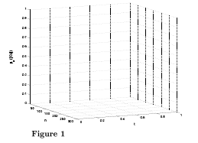

**Graphic 1** Title and Source (in italics).

Should not be images-everything must be editable.

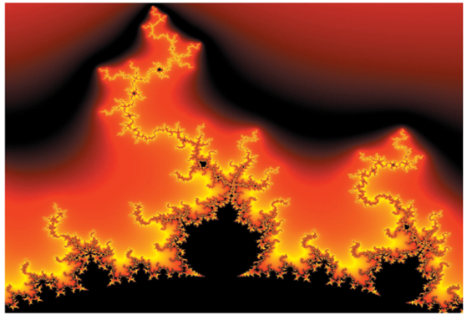

**Figure 1** Title and Source (in italics).

Should not be images-everything must be editable.

|  |  |  |  |  |
| --- | --- | --- | --- | --- |
|  |  |  |  |  |
|  |  |  |  |  |
|  |  |  |  |  |
|  |  |  |  |  |

**Table 1** Title and Source (in italics**).**

Should not be images-everything must be editable.

Each article shall present separately in **3 folders**: a) Figures, b) Charts and c) Tables in .JPG format, indicating the number and sequential Bold Title.

**For the use of equations, noted as follows:**

$Y_{ij}=α+ \sum_{h=1}^{r}{β_{h}X_{hij}}+u_{j}+e_{ij}$ (1)

They must be editable and number aligned on the right side*.*

**Methodology**

Develop give the meaning of the variables in linear writing and important is the comparison of the used criteria.

**Results**

The results shall be by section of the article.

**Annexes**

Tables and adequate sources thanks to indicate if they were funded by any institution, University or company.

**Conclusions**

Explain clearly the results and possibilities of improvement.

**References**

Using APA system, should **Not** be numbered, either bulleted, however, if necessary, will be because reference number or referred to in any of the article.

**Data Sheet**

Each article must submit your dates into a Word document (.docx):

Journal Name

Article title

Abstract

Keywords

Article sections, for example:

*1. Introduction*

*2. Description of the method*

*3. Analysis from the regression demand curve*

*4. Results*

*5. Thanks*

*6. Conclusions*

*7. References*

Author Name (s)

Email Correspondence to Author

References