An Undergraduate Experiment using Differential Scanning Calorimetry: A Study of the Thermal Properties of a Binary/Eutectic Alloy of Tin(Sn) / Lead (Pb)
Ronald P. D’Amelia*, Daniel Clark and William Nirode*
Hofstra University, Hempstead , NY 11549

Supplementary Material for Online Publication
The Laboratory Documentation Section

Safety Precautions for the Pyris 1 DSC

WARNING: Be sure that all instrument operators read and understand the following precautions. It is advisable to post a copy of these precautions on or near the instrument itself.
The following precautions must be observed when using the Pyris 1 DSC:
- Never press the Reset button on the computer if the software appears to malfunction. Press the Ctrl-Alt-Del keys simultaneously and select Task Manger. End the Pyris Software for Windows task
- Never remove the outer instrument cover or inside electrical cabinet panels of the Pyris 1 DSC without turning off the power and disconnecting the power cord from the power source
- Always use helium as the purge gas when liquid nitrogen is used in the subambient reservoir of the Pyris 1 DSC. At other times, use nitrogen, argon, oxygen or air as the purge gas.
- Do not immerse the purge gas exit line in a liquid since the liquid may be drawn back into the sample holder.
- Always observe the precautions indicated for the Intracollers 1P cooling device.
- When operating the Pyris 1 DSC in ambient mode, make sure that the cover heater is OFF.
- When operating the Pyris 1 DSC in the subambient mode, make sure that the Cover Heater is ON.
- Only high-quality purge gases should be used with the Pyris 1 DSC. Minimum purity of 99.9% is recommended. A high-quality filter dryer accessory is recommended for removal of any moisture from the purge gases.
- Always observe the startup and shutdown procedures for the Pyris 1 DSC and all related instruments.
- Do NOT use aluminum sample pan above 600ºC. Since aluminum melts at 660ºC, the pans will alloy with and destroy the sample holders. Entering a temperature above 600ºC will cause the computer to display a dialog box with a cautionary message. Always make sure that you are not using aluminum pans in either the sample or reference furnace before extending the Pyris 1 DSC temperature range above 500ºC.
- Always encapsulate indium, tin, lead, and zinc standards in aluminum or graphite pans. These metals will alloy with gold, copper, or platinum.
- Always have the guard ring inserts in place when removing or inserting sample or sample holder covers into the Pyris 1 DSC sample holder. This will protect the sample holder leads.
- It is important the nothing fall down into the cavity surrounding the sample holders. If this happens, turn off the power IMMEDIATELY and call your Perkin-Elmer representative for instructions.
- Do not force the platinum sample holder covers to fit the sample holders and do not deform the covers in any way. The sample holder covers should fit easily and loosely into the holders. When required, reform the covers with the reforming tool.
Student Handout

Objective: There are three basic objectives to this experiment: 1) to study the thermal properties of various compositions of tin and lead alloys ranging from 0.0% lead to 100% lead, 2) to establish the liquidus and solidus lines of the binary phase diagram for the tin and lead alloys and 3) to determine the tin / lead eutectic composition, melting temperature, and the ΔH_{fusion}.

IDEAS

ALLOYS:

Alloy comes from Latin: ad, to, + ligare, bind. An Alloy is an intimate association (which may be a compound, solution or mixture) of two or more metals, with or without definite composition, which has metallic properties. Alloys are often called solid solutions. In homogeneous alloys, atoms of the different metallic elements are distributed uniformly. Examples are Brass (Cu/Zn), Bronze (Cu/Sn/Pb) and the coinage metals. Heterogeneous alloys, like Tin-Lead solders and the mercury amalgams used to fill teeth, consist of a mixture of crystalline phases with different compositions. The structure of alloys are more complicated than those of the pure metals. Alloys maybe made up of separate crystals of the metallic components, solid solutions (e.g. Five cent piece 75%Cu/25%Ni), intermetallic compounds (Cu₂Mg), or various combinations of these types. In general, the properties of alloys are not the average of those of the component metals. Many alloys have lower melting points than each of the pure metals, and are usually harder and more resistant to corrosion. Coins, jewelry (sterling silver), steel (Fe/C), solder, sprinkler system heads (Pb/Sn/Bi), electrical heating elements are only a few examples of the endless array of metallic products composed of alloys.
An homogeneous alloy with a unique composition having the lowest possible melting point is called an Eutectic. Eutectic means melts easily. A composition consisting of only two metals having a well defined composition and melting point is called a binary eutectic alloy. A mixture of eutectic composition will melt sharply at the eutectic temperature to form a liquid of the same composition. For example, a binary eutectic mixture consisting of 62% Sn & 38% Pb has a sharp melting point at 183ºC. This composition is called electricians’ solder and behaves like a pure substance. A solder is defined as a fusible metal alloy with a melting point or range below 350ºC and is melted to join metallic surfaces. Manufacturing and understanding the properties of solders have become a very important effort in the modern technology of electronics and plumbing. The Sn/Pb solder has been the solder of choice used in both these industries throughout the world.

PHASE EQUILIBRIA, PHASE RULE and PHASE DIAGRAMS:

A phase is a homogeneous, physically distinct part of a system, separated from other parts by definite boundaries. For example, ice, liquid water and water vapor constitute three separate phases of the molecular compound of water. According to the phase rule derived by J. Willard Gibbs in 1876,
F = C – P + 2 (Equation 1)
In which: F = number of degrees of freedom
C = number of components
P = number of phases
The number of phases, P, is the number of physically distinct states (i.e. solid, liquid, or gas) which exist in a system at equilibrium. Only one gaseous phase is possible since all gases are miscible with each other. Several solid and several liquid phases are possible. The number of components, C, is the smallest number of chemical constituents which must be specified in order to express the composition of every phase present in the system. The number of degrees of freedom, F, is the number of variable factors (temperature, pressure and concentration) which must be specified in order that the condition of a system at equilibrium be defined completely. A phase diagram gives the equilibrium conditions between the various phases present in a system. Since in a one-component system, concentration is not a variable, the phase diagram may be represented by a plot of pressure versus temperature. For a two component system, F, is greatest when P = 1. Then there are three degrees of freedom that must be specified in order to describe the system – pressure, temperature, and the concentration of one of the components. In a two component solid – liquid system forming an eutectic, the vapor phase is disregarded and is fixed at 1 atm pressure. For solid-liquid equilibria the effect of pressure is negligible. A condensed system is one in which only solid and liquid phases are considered. For a two-component system at constant pressure only two variables must be specified in order to describe the system, and therefore the equilibrium can be represented in two dimensions by means of a temperature-composition diagram, an example of which is shown in Figure 1 below:
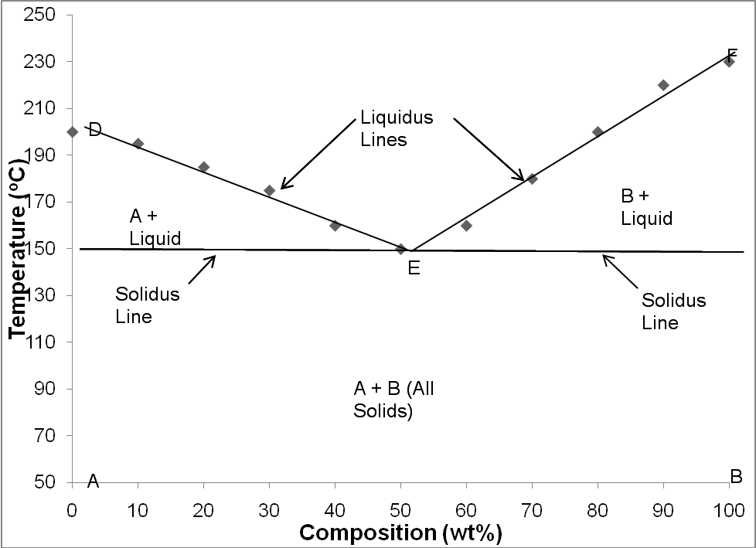
Point D represents the melting point of pure A, and F represents the melting point of pure B. It is seen that the addition of B to A lowers the melting point as does the addition of A to B. The curves DE and EF represent the melting points of various mixtures of A and B. Curves DE and EF are the surface on the phase diagram above which no solid exist and are called the liquidus lines. On the actual DE liquidus line there is an equilibrium between solid A and liquid (melt). On the liquidus lines the specification of either the temperature or the composition serves to define the system completely. At point E, there are three phases in equilibrium and thus the temperature and composition are automatically fixed The temperature at E represents the lowest temperature at which a liquid phase can exist. This temperature is called the eutectic temperature and point E is called the eutectic point. Below line DEF only solid is present. This line is called the solidus line and is a straight line representing constant temperature (isotherm). On this phase diagram the eutectic is the point of intersection between the liquidus and solidus lines.

Equipment:
Electronic Balance
Perkin-Elmer Pyris 1 DSC
Aluminum Pans (Volatile) (PE P/N: 02190062)
Crimper/Sealing tool (PE P/N: 02190061)
Hooked Forceps
Platinum (Pt) Covers
Tank of dry pure Nitrogen gas (99% +)
Micro spatula

Chemicals: The indium, tin and lead samples used for calibration were all 0.127 mm thick foils, of 99.99 purity, purchased from Alfa Aesar. The metals used for all preparations of the alloy mixtures were high purity metals. The tin was a Baker analyzed reagent grade mossy tin having a purity of 99.999%. The lead was obtained from Alfa Aesar in wire form one mm in diameter having a purity of 99.95%. The NaOH was Baker reagent grade quality.

Procedure
Note: The instructor will give a brief lecture on the use of the operation of the DSC, the Pyris for Windows software and the Crimper/Sealing Tool.

A) Calibration of the Perkin-Elmer DSC
The calibration of the Perkin-Elmer Pyris 1 DSC for use in the high temperature range should be performed by the instructor. The DSC should be calibrated for Temperature, Heat Flow, and Furnace balance. High purity indium, tin and lead samples should be used for calibrating both temperature and heat flow.

B) Determination of the Melting Point of Pure Tin and Lead Metals for the Experiment
Weigh accurately 20-30 mg of Tin directly in the Aluminum pan. Weigh to at least three significant figures after the decimal point. Seal the Al pan using the crimper sealing tool and then place the sealed pan on the sample side of the DSC holder which has been preset to 100ºC. Make sure that the reference side of the DSC holder contains an empty Aluminum pan. Cover both the sealed aluminum sample pan and the aluminum reference pans with a Platinum cover. Enter the weight of the tin, sample ID, file name and all other necessary information in the method editor. Then program the DSC for three temperature cycles as follows:
1st: Heat the Tin from 100.0ºC to 350.0ºC at 10.0 º C/min.
Equilibrate at 350.0ºC for 30 sec.
2nd: Cool from 350.0ºC to 100.0ºC at 10.0ºC/min
Equilibrate at 100.0ºC for 30 sec.
3rd: Heat from 100.0ºC to 350.0ºC at 10.0ºC/min.
Equilibrate at 350.0ºC for 30 sec

The end condition should return the DSC to 100.0ºC to facilitate the next run.
After obtaining the above thermograms, save the file using an appropriate file name. The analysis of the thermal transitions such as melting and freezing points as well as the enthalpy of each of these transition can be done using the Pyris for Windows software. The melting and freezing points are taken as the onset of the endothermic and exothermic transitions from the thermal baseline obtained from the cooling and heating cycle thermograms. The lead sample is performed in the exact same manner as described above. After obtaining the thermograms, the melting and freezing points, and the enthalpy data from the DSC data analysis software, complete the attached data Table 1 for each pure metal.

C) Preparation of the Binary and Eutectic alloys from the Pure Tin and Lead Metals
The tin and lead alloy samples ranging from 10% to 90% lead will be provided by the instructor. The student will prepare the eutectic composition of 62% Sn – 38% Pb by weighing the appropriate weight of each metal in a ceramic glazed Coors®Tek crucible in order to obtain 5.00 g of alloy. Add approximately 0.05 g of NaOH (approximately a half of a pellet) and heat the entire mixture with an open micro burner in a fume hood until both metals are molten. The molten mixture is then stirred with a capillary melting point tube until uniform. The molten samples were subsequently left to stand in the fume hood to cool until they solidified and formed a 5.00 g ingot.

D) Experimental Procedure for DSC Analysis of the Binary and Eutectic Alloys::
A sliver of alloy is cut using a single edge blade and a 25-30 mg sample is weighed in a Aluminum sample pan.. The alloy is subjected to three (3) thermal cycles: two heating and one cooling cycle. First, the alloy is heated from 100.0°C to 350.0ºC at 10.0º C/min, equilibrated at 350.0ºC for 30 seconds, cooled from 350.0ºC to 100.0ºC at 10.0 C/min, equilibrated at 100.0ºC for 30 seconds. Finally, the sample is heated for a second time at 10.0ºC/min up to 350.0ºC. This procedure is the same as performed for the DSC of the pure metals. The Perkin-Elmer thermal analyzer software, Pyris for Windows, is used to determine the onset and peak melting and freezing points as well as the enthalpies of fusion and crystallization. The onset melting and freezing points are taken as the point of first inflection from the baseline. After obtaining the thermograms and the melting and freezing points from the DSC data, complete the attached data Table 1.

E) Phase Diagram:
A binary phase diagram shows the phases formed in varying mixtures of the two metals over a range of temperatures. Compositions run from 100% tin or 0% lead to 100% lead and 0% tin. The composition is given as a weight %. A phase diagram is a plot of % composition on the x-axis and temperature on the y-axis. The temperature one uses is the peak melting point of the second peak as measured on the 2nd heating thermogram.

TABLE 1
Data Sheet for the Thermal Properties of the Binary/Eutectic Alloys for Tin and Lead Using Differential Scanning Calorimetry (DSC)

Table 1: Tin-Lead Alloy 2H 1C 30 mg Sample
 |  | 1st Cooling Cycle |  |  |  |  |  |  | 2nd Heating Cycle
 |  | 1st Peak |  |  | 2nd Peak |  |  |  | 1st Peak |  |  |  |  | 2nd Peak
% Sn | % Pb | Onset  (ºC) | Peak  (ºC) | ∆ H  (J/g) | Onset  (ºC) |  | Peak  (ºC) | ∆H  (J/g) | Onset  (ºC) |  | Peak  (ºC) | ∆H  (J/g) |  | Onset  (ºC) | Peak  (ºC) | ∆H  (J/g)
S = Sharp Peak
B = Broad Peak

Notes for the Instructor

A) A Summary of Experimental Conditions:

A Perkin-Elmer power compensated Differential Scanning Calorimeter (DSC) model Pyris 1 was used to determine the endothermic and exothermic properties of the pure metals and alloys. All experiments were run having all samples weighing 20 - 30mg under dry nitrogen flowing at 20 cc/min. The flowing nitrogen was used to prevent any moisture pickup or oxidative degradation. All samples were placed in aluminum pans having an internal volume of 20 micro liters. A thermal baseline was established by running empty pans in both the sample and reference cells. Calibration of the temperature and energy outputs of the DSC was performed using a high purity indium tin and lead metals. The calibration standards were subjected to three (3) thermal cycles or ramps: Two heating and one cooling. The samples were heated and cooled at 10.0º C/min over an appropriate temperature range

B) List of Equipment:
Electronic Balance
Perkin-Elmer Pyris 1 DSC
Aluminum Pans (Volatile) (PE P/N: 02190062
Crimper/Sealing tool (PE P/N: 02190061)
Hooked Forceps
Platinum (Pt) Covers
Tank of dry pure Nitrogen gas (99% +)
Micro spatula

C) Chemicals: All chemicals were used without further purification.
Indium, (99.99%, 0.127mm thick)-Product #12206 CAS# [7440-74-6], FW= 114.8
Tin,(99.99%, 0.127mm thick)- Product #00344 CAS#[7440-31-5], FW=118.7
Lead, ( 99.99%, 0.127mm thick)- Product #12050 CAS#[7439-92-1], FW = 207.2
All of the above were obtained from Alfa Aesar
The metals used for all preparations of the alloy mixture were high purity metals. The tin was a Baker analyzed reagent grade mossy tin having a purity of 99.999%. The lead was obtained from Alfa Aesar in wire form one mm in diameter having a purity of 99.95%. The NaOH was Baker reagent grade quality.

D) Procedure for Calibration of the Perkin-Elmer Pyris 1 DSC for use in the high temperature range:
Calibration of the Perkin-Elmer Pyris 1 DSC for use in the high temperature range requires three calibration routines: Temperature, Heat Flow, and Furnace. The temperature and heat flow calibration require a standard having a well defined melting point and Enthalpy of Fusion (ΔH_{f}). We used high purity indium, tin and lead as our reference standards. The calibration for Temperature and Heat Flow is as follows: Weigh out approximately 10 mg of high purity standard in a aluminum sample pan. Place the Al pan on the sample side of the DSC holder which is preset to 100.0ºC. Make sure that the reference side of the DSC holder contains an empty Al pan. Enter the weight of sample, sample ID, file name, and all other necessary information in the Method editor. The method editor is a set of parameters that determine the conditions under which the DSC system will collect data on a sample. In the method editor one also establishes the thermal program used to analyze the sample. The thermal program used for both temperature and heat flow calibrations is given below:
1st: Heat the standard from 100.0ºC to 350.0ºC at 10.0 º C/min.
Equilibrate at 350.0ºC for 30 sec.
2nd: Cool from 350.0ºC to 100.0ºC at 10.0ºC/min
Equilibrate at 100.0ºC for 30 sec.
3rd: Heat from 100.0ºC to 350.0ºC at 10.0ºC/min.
Equilibrate at 350.0ºC for 30 sec

The Perkin-Elmer thermal analysis software Pyris for Windows was used to determine the endothermic and exothermic transition temperatures and enthalpies of fusion and crystallization. The crystalline melting point and enthalpy of fusion for indium, tin and lead standards are shown in the table below

Sample ID | DSC Melting Point (⁰C) | Enthalpy of Fusion (J/g)
Indium | 157.2 | 28.7
Tin | 231.9 | 59.7
Lead | 327.0 | 23.3

For calibration of the furnace, use the instructions provided in the manual. For a complete operational instructions for the Perkin-Elmer DSC use the Pyris 1 manual provided in the Pyris for Windows software package.

E) Preparation of the Binary and Eutectic alloys from the Pure Tin and Lead Metals
The tin and lead alloy samples ranging from 10% to 90% lead will be provided by the instructor. The student will prepare the eutectic composition of 62% Sn – 38% Pb by weighing the appropriate weight of each metal in a ceramic glazed Coors®Tek crucible in order to obtain 5.00 g of alloy. Add approximately 0.05 g of NaOH and heat the entire mixture with an open micro burner in a fume hood until both metals are molten. The molten mixture is then stirred with a capillary melting point tube until uniform. The molten samples were subsequently left to stand in the fume hood to cool until they solidified and formed a 5.00 g ingot.

F) Experimental Procedure for DSC Analysis of the Binary and Eutectic Alloys::
A sliver of alloy is cut using a single edge blade and a 25-30 mg sample is weighed in a Aluminum sample pan. The alloy is subjected to three (3) thermal cycles or ramps: two heating and one cooling. First, the alloy is heated from 100.0°C to 350.0ºC at 10.0º C/min, equilibrated at 350.0ºC for 30 seconds, cooled from 350.0ºC to 100.0ºC at 10.0 C/min, equilibrated at 100.0ºC for 30 seconds. Finally, the sample is heated for a second time at 10.0ºC/min up to 350.0ºC. This procedure is the same as performed for the DSC of the pure metals. The Perkin-Elmer thermal analyzer software, Pyris for Windows, is used to determine the onset and peak melting and freezing points as well as the enthalpies of fusion and crystallization. The onset melting and freezing points are taken as the point of first inflection from the baseline. After obtaining the thermograms and the melting and freezing points from the DSC data, complete the attached data Table 1.

The thermogram for the 62 wt % Sn mixture on an expanded temperature axis is shown in Figure 2. This is the eutectic mixture of the Sn/Pb alloy and has an onset melting temperature of 182.4 ºC and a ΔH_{fusion} of 43.8 J/g. The onset melting temperature is determined by first setting the limits of the peak (beginning and end). Next, the Pyris for Windows software draws a baseline between the peak limits and then using triangulation the software determines the tangent to the curve and extrapolates to the baseline determining the onset and peak temperatures.

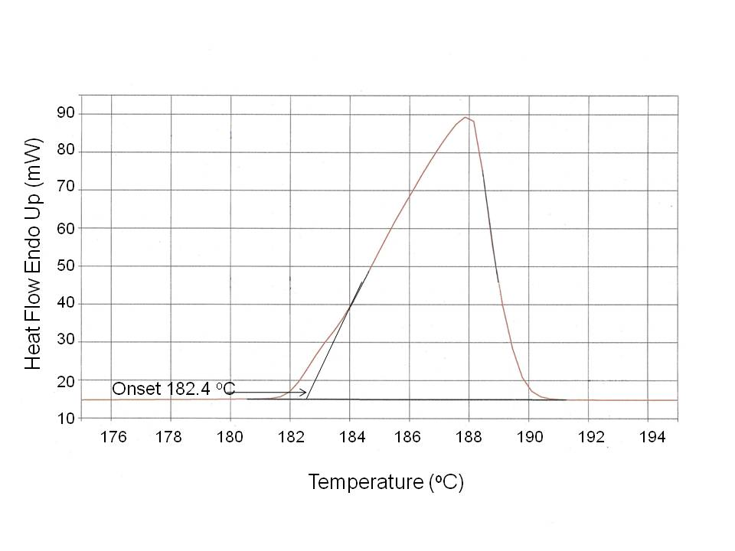
FIGURE 2. A heating DSC thermogram for the 62 wt. % Sn is shown. The melting point was determined to be 182.4 ºC by taking the peak onset temperature of the heating curve. A ΔH_{fusion} of 43.8 J/g is determined from the area under the heating curve. The temperature axis has been expanded to clearly show the onset temperature .

G) Data Sheet

Table 1: Tin-Lead Alloy 2H 1C 30mg Sample
 |  | 1st Cooling Cycle |  |  |  |  |  |  | 2nd Heating Cycle
 |  | 1st Peak |  |  | 2nd Peak |  |  |  | 1st Peak |  |  |  |  | 2nd Peak
% Sn | % Pb | Onset  (ºC) | Peak  (ºC) | ∆ H  (J/g) | Onset  (ºC) |  | Peak  (ºC) | ∆H  (J/g) | Onset  (ºC) |  | Peak  (ºC) | ∆H  (J/g) |  | Onset  (ºC) | Peak  (ºC) | ∆H  (J/g)
90 | 10 | 182.25 | 180.50 | -9.46 | 192.74 |  | 192.73 | -27.38 | 183.00 |  | 184.92 | 10.86 |  | 207.74 | 217.79 | 27.53
80 | 20 | 179.15 | 177.08 | -11.98 | 181.03 |  | 180.96 | -18.17 | 182.89 |  | 187.54 | 24.33 |  | 195.32 | 204.23 | 10.48
70 | 30 | 161.03 | 161.05 | -22.40 | ND |  | ND | ND | 182.72 |  | 187.92 | 34.55 |  | 190.74 | 192.56 | 0.36
60 | 40 | 167.23 | 166.89 | -35.28 | 182.8 |  | 180.3 | -1.35 | 182.67 |  | 188.44 | 42.99 |  | ------- | ------ | ------
50 | 50 | 168.54 | 168.29 | -22.18 | 208.8 |  | 205.3 | -1.98 | 182.82 |  | 186.16 | 32.72 |  | 192.33 | 210.0 | 2.39
40 | 60 | 178.19 | 176.27 | -22.30 | 233.46 |  | 231.36 | -2.74 | 183.18 |  | 187.70 | 23.54 |  | 208.18 | 231.18 | 5.14
30 | 70 | 176.26 | 175.79 | -13.69 | 252.74 |  | 250.79 | -4.00 | 182.23 |  | 185.82 | 14.74 |  | 230.90 | 252.17 | 7.54
20 | 80 | 179.75 | 178.80 | -6.45 | 272.63 |  | 271.05 | -10.18 | 182.84 |  | 185.63 | 6.86 |  | 254.12 | 273.61 | 12.29
10 | 90 | 181.33 | 180.43 | -1.09 | 295.43 |  | 293.80 | -16.12 | 184.65 |  | 185.89 | 1.31 |  | 285.20 | 297.19 | 17.80
62 | 38 | 164.22 | 164.02 | -24.16 | NA | NA |  | NA | 182.44 | 183.40 |  |  | 43.82 | NA | NA | NA

H) PHASE DIAGRAM:
A binary phase diagram shows the phases formed in varying mixtures of the two metals over a range of temperatures. Compositions run from 100% tin or 0% lead to 100% lead and 0% tin. The composition is given as a weight %. A phase diagram is a plot of % composition on the x-axis and temperature on the y-axis. The temperature one uses is the melting point of the alloy as measured on the 2nd heating thermogram.

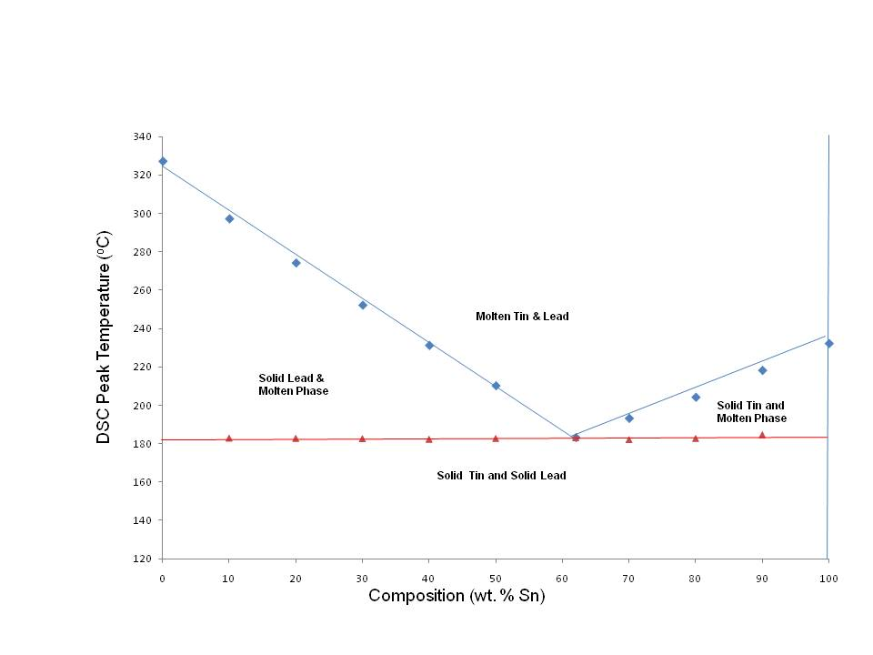
Notes for the Instructor: Using Indium Instead of Lead

A) Indium and Tin Binary Eutectic

Experimental Procedure used to prepare the binary Eutectic from the pure Indium and Tin metals: Circular disks of each of the pure metals were prepared using a #1 cork borer and then cut to specific weights so that a different % of each metal would be obtained. The total weight used for the composite alloy was 30 mg. Shown in Table 2 below are the ratios of each metal used in the composite alloy. The composite alloy was subjected to three (3) thermal cycles: two heating and one cooling cycles. First, both samples of pure metals were heated from 100.0°C to 240.0°C at 10°C/min., equilibrated at 240.0°C for 30 seconds, cooled from 240.0°C to 100.0°C at 10.0°C/min., equilibrated at 100.0°C for 30 seconds, and finally heated for a second time to 240.0°C at a 10.0°C/min. The Perkin-Elmer thermal analyzer software, Pyris for Windows, was used to determine the onset melting and freezing points. The melting and freezing points were taken as the point of first inflection or onset from the baseline. A summary of the thermal data obtained from the 1st cooling and 2nd heating cycles are given in Table 2.

B) Table 2 of Data for In/Sn Binary Eutectic

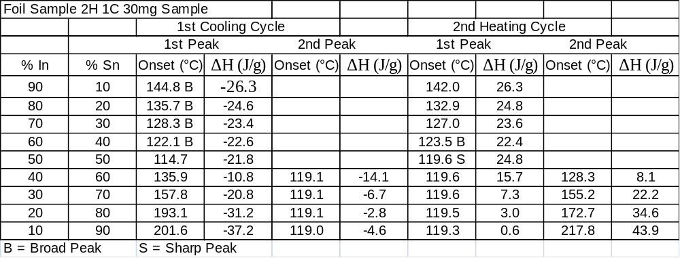

C) Phase Diagram for Indium and Tin Alloy:

Although a complete phase diagram for In and Sn cannot be plotted due to the solid solution regions, one can still obtain a typical phase diagram having the overall basic profile for a binary eutectic alloy.

FACT SHEET

Introduction to Thermal Analysis
The introduction of modern thermal analytical instrumentation into the laboratory over the last decade has taken thermal analysis from a relatively unknown technique to a highly sophisticated analytical method used routinely in academia and industry. Thermal analysis (TA) in its broadest sense is the measurement of changes in the physical and chemical properties of substances as a function of temperature. The visual observation of the melting of a compound is a very basic TA technique. Modern instruments are more complex and measure a wider scope of physical, chemical, and mechanical properties of materials but the fundamental principle is the same. Power-compensated Differential Scanning Calorimetry (DSC), which measures the heat flow into or from a sample as it is heated, cooled or held under isothermal conditions, is the most commonly used TA technique. Other methods include thermal gravimetric analysis (TGA) which measures weight loss as a function of temperature, thermal mechanical analysis (TMA) which measures dimensional changes as a function of temperature, and dynamic mechanical analysis (DMA) which measures the visco-elastic properties of a material as a function of temperature.

In a typical DSC experiment the sample and reference materials are each held in separate, self contained compartments, each with its own heater element. When an exothermic or endothermic change occurs in the sample, power or energy is applied to or removed from one or both of the compartments to compensate for the energy change occurring in the sample. Thus, the power-compensated DSC system is maintained in a “thermal null state” at all times. The temperature of the thermal transition and the amount of energy transferred during the thermal change are two important parameters measured in DSC.
DSC can provide valuable information on many important properties of materials such as melting and freezing points, glass transition temperatures, heats of fusion and crystallization, heat of reaction, purity, polymorphism, and thermal decomposition temperature.

Theory behind the operation of the Power-Compensated DSC
The measuring principle of a true power-compensated DSC requires that both the sample and reference holders have a built-in heater and temperature sensor. Both sample and reference are place on a distributed platinum resistance thermometer and a platinum resistance heater wire. The platinum temperature sensors detect change of the sample temperature with respect to the reference holder temperature caused by the endothermic or exothermic behavior of the sample. A closed-loop electronic system provides a differential electric power to the platinum heaters to compensate for the temperature changes. The differential power required to maintain this “thermal null” condition is read out in millicalories per second, and is at all times equivalent to the rate of endothermic or exothermic behavior of the sample. The above principle of operation for a power-compensated DSC should not be confused with heat flux DSC in which a differential temperature ( ΔT) signal is measured and converted to approximate energy units.

