Anchor Scan Parameters

Dataset Name jfo
File name C:\Users\etudiant\Desktop\OLIVIERI\jfo.xrdml
Sample Identification jfo
Comment Echantillon Maelly Zeynep
Measurement Start Date/Time 26/02/2042 22:17:51
Operator Instrument
Raw Data Origin XRD measurement (*.XRDML)
Scan Axis Gonio
Start Position [°2θ] 10,0109
End Position [°2θ] 69,9829
Step Size [°2θ] 0,0220
Scan Step Time [s] 18,8700
Scan Type Continuous
PSD Mode Scanning
PSD Length [°2θ] 5,54
Offset [°2θ] 0,0000
Divergence Slit Type Fixed
Divergence Slit Size [°] 0,9167
Specimen Length [mm] 10,00
Measurement Temperature [°C] 25,00
Anode Material Cu
K-Alpha1 [Å] 1,54060
Generator Settings 10 mA, 30 kV
Diffractometer Type 209559
Diffractometer Number 0
Goniometer Radius [mm] 145,00
Dist. Focus-Diverg. Slit [mm] 95,00
Incident Beam Monochromator No
Spinning Yes

Graphics

Peak List

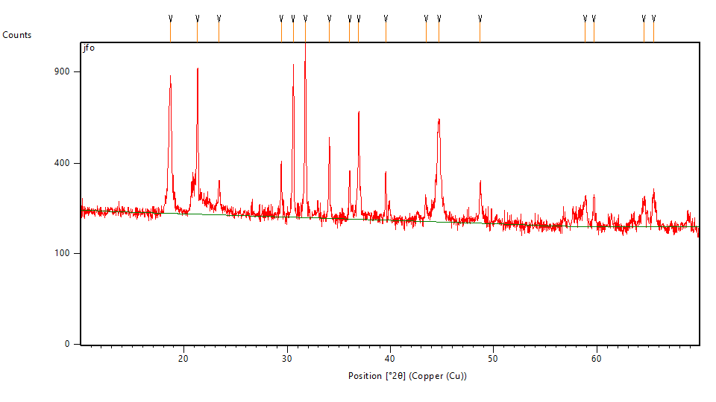

Pos. [°2θ] | Height [cts] | FWHM Left [°2θ] | d-spacing [Å] | Rel. Int. [%]
18,6810 | 664,16 | 0,1848 | 4,74609 | 72,39
21,3080 | 740,03 | 0,1320 | 4,16654 | 80,66
23,3932 | 120,88 | 0,1584 | 3,79965 | 13,18
29,4138 | 188,25 | 0,1584 | 3,03417 | 20,52
30,5727 | 683,57 | 0,1584 | 2,92175 | 74,51
31,7461 | 917,43 | 0,1320 | 2,81638 | 100,00
34,0632 | 300,42 | 0,1584 | 2,62991 | 32,75
36,0453 | 165,75 | 0,1584 | 2,48971 | 18,07
36,9365 | 469,59 | 0,2112 | 2,43166 | 51,18
39,5426 | 168,71 | 0,1584 | 2,27719 | 18,39
43,4446 | 65,09 | 0,3168 | 2,08128 | 7,09
44,7086 | 409,77 | 0,1584 | 2,02533 | 44,67
48,7016 | 125,68 | 0,2112 | 1,86820 | 13,70
58,8518 | 88,89 | 0,3168 | 1,56789 | 9,69
59,6981 | 95,24 | 0,1584 | 1,54766 | 10,38
64,5464 | 74,66 | 0,4224 | 1,44262 | 8,14
65,5173 | 100,10 | 0,3168 | 1,42358 | 10,91

Document History

ESD calculated from counts:
- Modification time = "13/12/2023 09:35:14"
- Modification editor = "etudiant"

Insert Measurement:
- File name = "jfo.xrdml"
- Modification time = "13/12/2023 09:35:14"
- Modification editor = "etudiant"

Default properties:
- Measurement step axis = "None"
- Internal wavelengths used from anode material: Copper (Cu)
- Original K-Alpha1 wavelength = "1,54060"
- Used K-Alpha1 wavelength = "1,54060"
- Original K-Alpha2 wavelength = "1,54443"
- Used K-Alpha2 wavelength = "1,54443"
- Original K-Beta wavelength = "1,39225"
- Used K-Beta wavelength = "1,39225"
- Irradiated length = "10,00000"
- Receiving slit size = "0,10000"
- Step axis value = "0,00000"
- Offset = "0,00000"
- Sample length = "10,00000"
- Modification time = "13/12/2023 09:35:14"
- Modification editor = "etudiant"

Interpolate Step Size:
- Initial Scan Range = 10,01090 - 69,99360
- Initial Step Size = 0,02173
- Derived Step Size = 0,02200
- Use Derived Step Size = "Yes"
- Modification time = "13/12/2023 09:35:15"
- Modification editor = "PANalytical"

Strip K-α2:
- Method = "Rachinger"
- Intensity ratio = "0,5"
- Delta wavelength ratio = "0"
- Modification time = "13/12/2023 09:36:07"
- Modification editor = "PANalytical"

Search Peaks:
- Minimum significance = "1,47"
- Minimum tip width = "0,1"
- Maximum tip width = "4"
- Peak base width = "6"
- Method = "Top of smoothed peak"
- Modification time = "06/12/2023 12:08:18"
- Modification editor = "etudiant"

