URL: <https://jfoo-monash.github.io/3179_week_9_homework/>

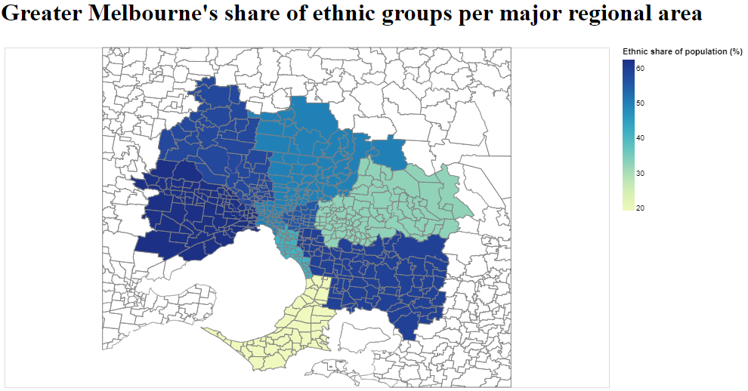

* Domain:
  + How much of Melbourne’s population is made up of people who are not of English, Australian or Aboriginal heritage?
* Visualised dataset:
  + Population data from the Australian Census, detailing the heritage of each of the people in each broad section of the greater Melbourne area.
  + <https://www.abs.gov.au/census/find-census-data/search-by-area>
* Data transformation:
  + Transformed data, dividing total ethnic population by total population of each region to obtain a percentage value representing how much of the population that the ethnic groups make up.
* Justification:
  + I chose to use a choropleth map because I thought that this particular map idiom would convey the data that I wanted to convey more accurately when I increased the granularity of the data. While I have my data covering large areas, I can obtain data from each suburb, resulting in a map which more accurately reflects the proportion of ethnic people in each suburb.