“ALIGN”
PROJECT PROPOSAL

Jordan Alonzo
Wilbert Dejesus
Justin Forbes
Alex Radion

- Title
ALIGN
- Introduction
The matter of movement patterns is of utmost importance in terms of longevity and safety but also efficiency when it comes to loaded huma movements. The matter of providing training in this realm, at reasonable ratios of price, effort and time, has long been under contention. At some point, pop fitness relegated itself to machinery that enforces movement of a force through space so as to throw away the necessity of expertise in these complicated movements all together. With the advent of computer vision and the knowledge bestowed upon by the work of kinesiologists and exercise scientists alike, it now may be possible to simulate the expertise of a movement specialist. This project codenamed ALIGN is an attempt and display of the possibility of doing just so.
ALIGN will attempt to be a mobile application to fulfill the need to be accessible and portable. The mobile application will include functionality that allows for form analysis of user recorded video via computer vision and supervised machine learning. The system will evaluate a movement pattern by analyzing joint positions and angles of user submitted recordings and will compare them to learned representations of “optimal” exercise forms. Optimal exercise form will try as much as possible to include biases towards certain limb proportions and exercise selection, but exceptions will have to be made. The system will give a determination as to the correctness of the submitted exercise attempt and provide, based on form structure at certain points in time, an analysis as to why and how the system judged so. This analysis should give users feedback that makes it possible to improve the system’s judgement of the exercise performance. Users can then track their progress of exercise performance via comparisons of form structure at aligned points in time; as well as a graph of system ratings over time.

- Design / Mockup
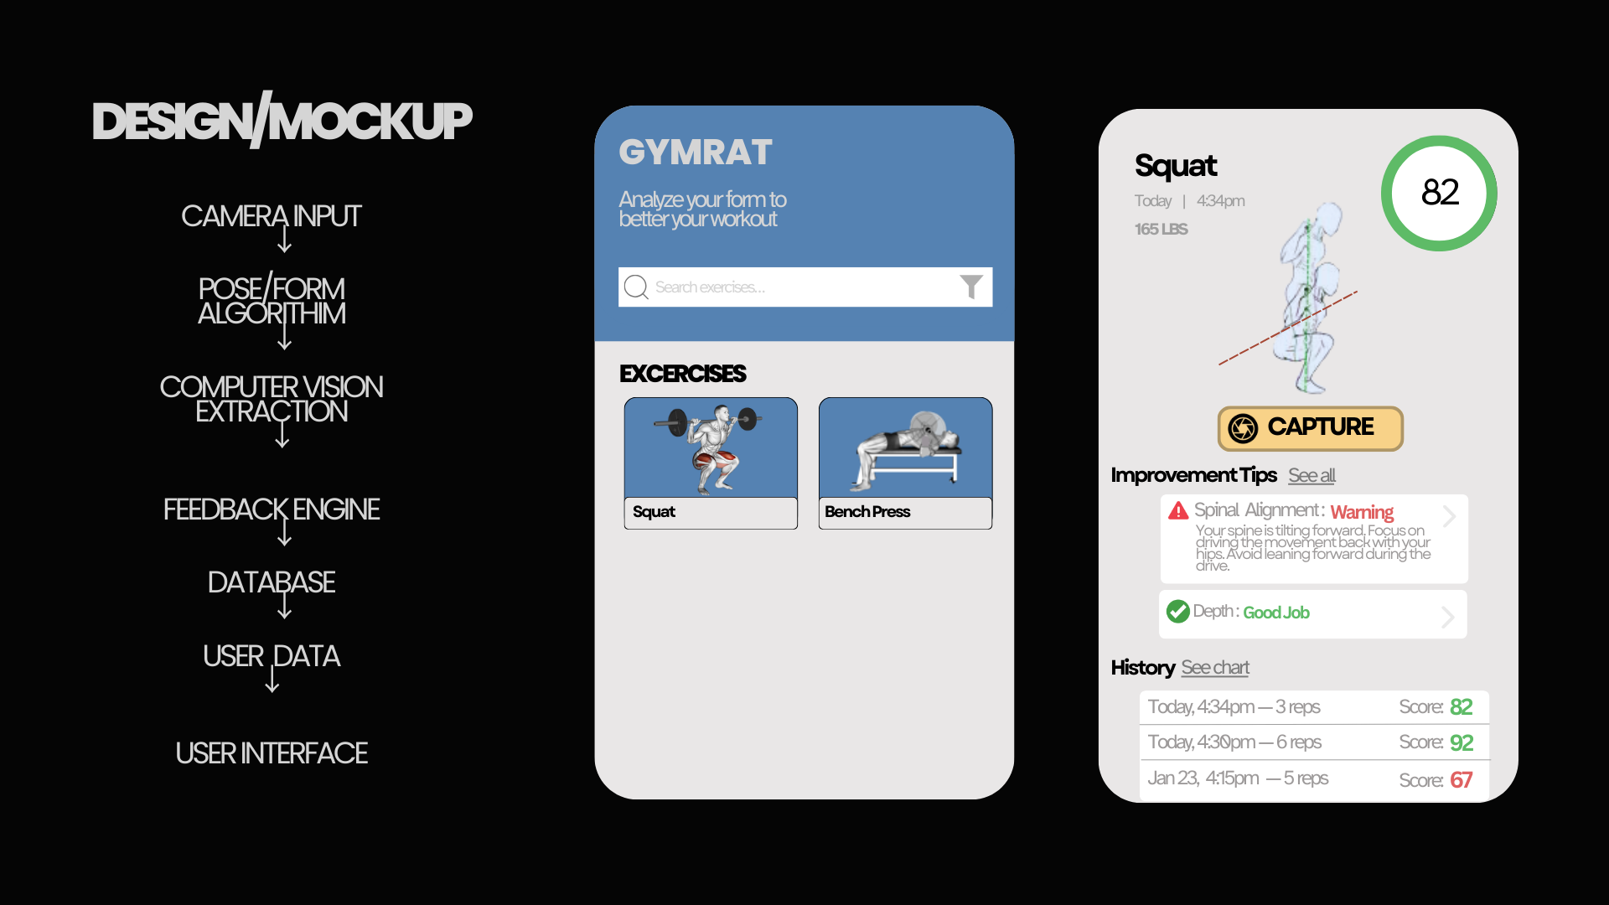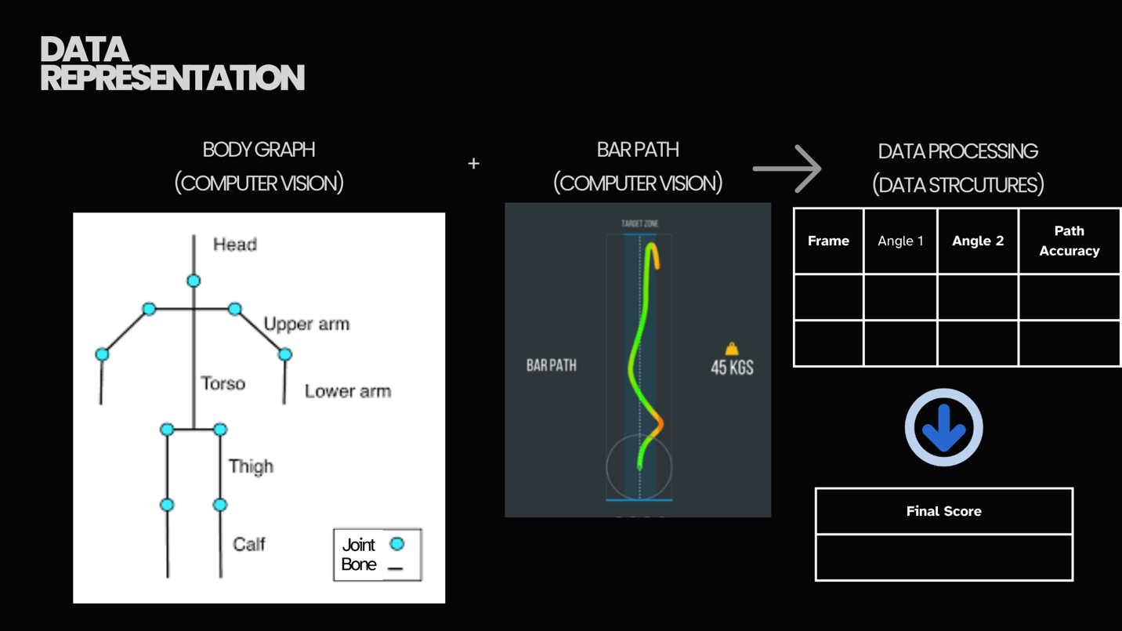
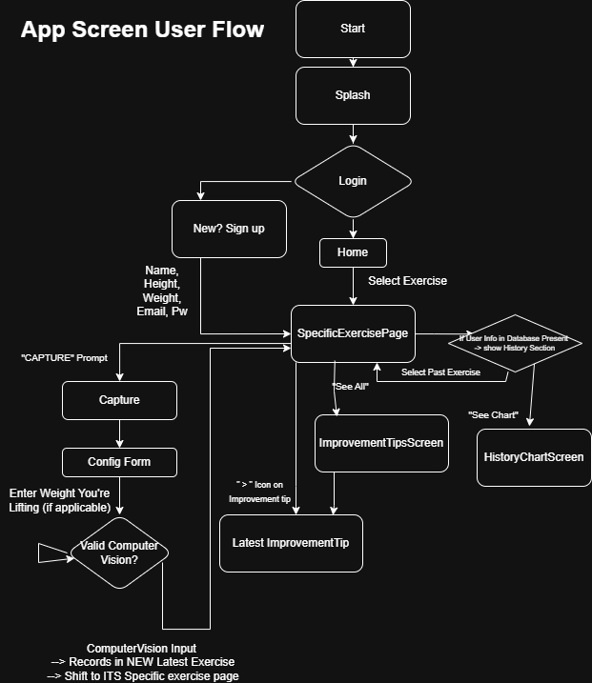

Link to edit the Flow – download it & import into draw.io (https://drive.google.com/file/d/1LCnbn5dmIYA6iUctb_W6_H_SjzBQDVsZ/view?usp=sharing)

- Methodology / Implementation / Details

Methodology and implementation details are primarily based on the definition of barbell exercises provided by Mark Rippetoe in his book “Starting Strength”. That is, “Properly performed, full-range-of-motion barbell exercises are essentially the functional expression of human skeletal and muscular anatomy under a load”. That is, how the exercise is performed is primarily a result of a person’s particular movement patterns. These movement patterns are determined by a person’s physiognomy, flexibility, and most importantly, what this application is attempting to alter in its user: neuromuscular efficiency. Simply: “every aspect of the movement is determined by the body”. Thus, in this project we will focus solely on movement patterns; using them as a proxy for whatever load is being applied to the lifter.
Pose Estimation
- Use computer vision to extract joint key points (per exercise – develop X for BEST form)
- Convert video frames into “data”
- Use computer vision to Path out the Key points
- Find difference between reference and new
Extraction
- Using the video frames as an input:
Compute joint angles, range of motion
Use motion for repetitions
- Each repeition goes into a table of numerical data

Supervised Learning Model
- Train a supervised learning model using labeled examples representing optimal exercise form
(in the form of joint angle ranges, movement consistency -> These features will become learned optimal patterns)
- compute final score out of 100 (based on learning + table data (per exercise)

Database Storing
- Store results per exercise repetition in the history
- Using history develop visual graphs
- Using results of joint angle ranges (from optimal)
-> Develop tips for user per exercise to get closer to “most optimal” form
Profiles will store the following information:
- Name
- Credentials
- History of Exercise performances

Supervised Learning Details (Rough)
Video --> pose key points --> joint angles --> labels + scores
Example For a Squat (looking at “biomechanical” angles)
- Knee angle --> between 90° and 120°
- Hip Depth --> parallel or below
- Knee tracking OVER toes
From this, score (0-100) and label (Good, Okay, Poor) --> PER Angle
From these, FINAL score is produced
All scores + labels stored in database and provided for user (user history)

