User Guide for Setting up Tomcat with Eclipse

November 2014

Version 1.0.0

Document Revisions

|  |  |  |
| --- | --- | --- |
| Date | Version Number | Document Changes |
| 05/02/2014 | 1.0 | Initial Draft |
|  |  |  |
|  |  |  |
|  |  |  |
|  |  |  |
|  |  |  |
|  |  |  |
|  |  |  |
|  |  |  |

Table of Contents

1 Introduction 1

1.1 Scope and Purpose 2

1.2 Overview 3

2 Download and Set up Eclipse 4

2.1 Download Eclipse 6

2.2 Download Java 9

3 Download and Set up Tomcat 4

3.1 Download Tomcat 6

3.2 Configure Tomcat 6

4 Integrate Tomcat with Eclipse 4

4.1 Understand Perspectives 6

4.1 Configure Tomcat in Eclipse 6

5 Create and setup Web Application 4

5.1 Configure Web application 6

5.2 Adding Web Application to Tomcat 6

5.3 Runnning Web application 6

5.4 Debugging Web application 6

Introduction

## Scope and Purpose

This User guide explains how to setup Eclipse IDE , Tomcat Web Server and integrating Tomcat with Eclipse.

This User guide is for intended Java Developers who have prior experience of using Tomcat and any other IDE for Java development but who have never used Eclipse OR tomcat along with Eclipse.

However knowledge of any specific tomcat version or any specific IDE is not required.

Running Tomcat with eclipse allows to run and debug the application easily without having to switch between Eclipse IDE and Tomcat Shell Windows.

## Overview

Eclipse is a popular IDE for Java development though not necessarily restricted to Java Development alone. E.g. PHP, Javascript development can also be done as easily as Java.

Eclipse is based on plugin architecture where components called as plugins can be installed to provide features required for development.

e.g. tomcat integration plugin that comes in built with certain versions of eclipse allows us to start restart stop tomcat within eclipse.

Tomcat is a popular web server used to host Java based web applications. It can serve static as well as dynamic content.

Integration of tomcat with eclipse allows ease of development.

2) Download and Set up Eclipse

* + 1. Download Eclipse IDE from following location :

[*https://eclipse.org/downloads/*](https://eclipse.org/downloads/)

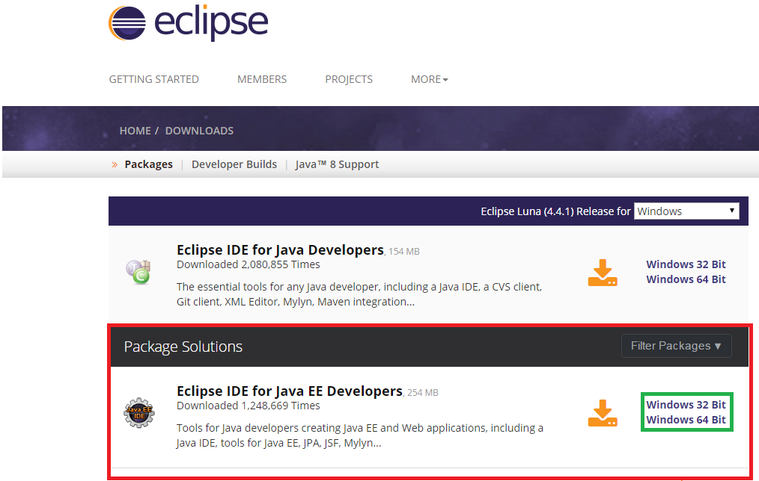

In above picture portion marked in red indicates the correct version and flavor of Eclipse IDE.

* + 1. As seen on the web-page there are various other versions of eclipse that are available which facilitate the development in other languages as well.

We have to choose Eclipse IDE for Java EE developers flavor and latest version so that we can run Java web applications in Eclipse. It comes prepackaged with plugin for integration of tomcat.

As indicated by portion marked in green Eclipse can be downloaded for both 32-bit windows and 64 bit windows.

To find out whether your machine is 32-bit or 64 bit follow below procedure:

1. Right click on My Computer Icon on the desktop and click Properties.
2. Look out for the System type option as shown below :

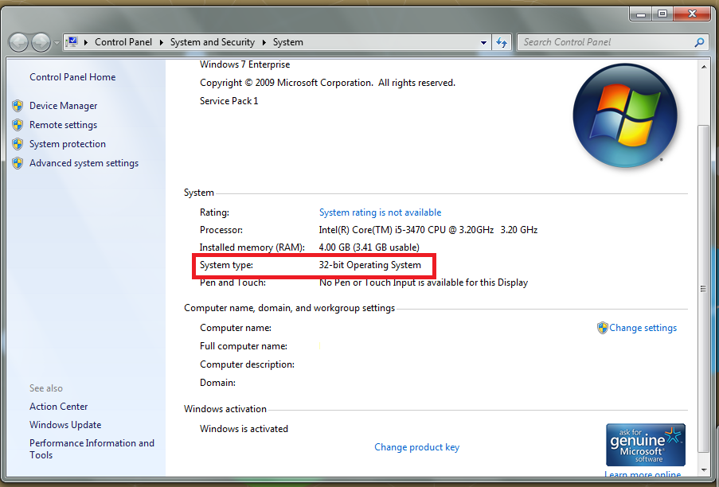

* + 1. Eclipse comes as an executable file. So there is no need to follow any separate installation steps. As shown in below picture click on the download arrow to download the .zip file. 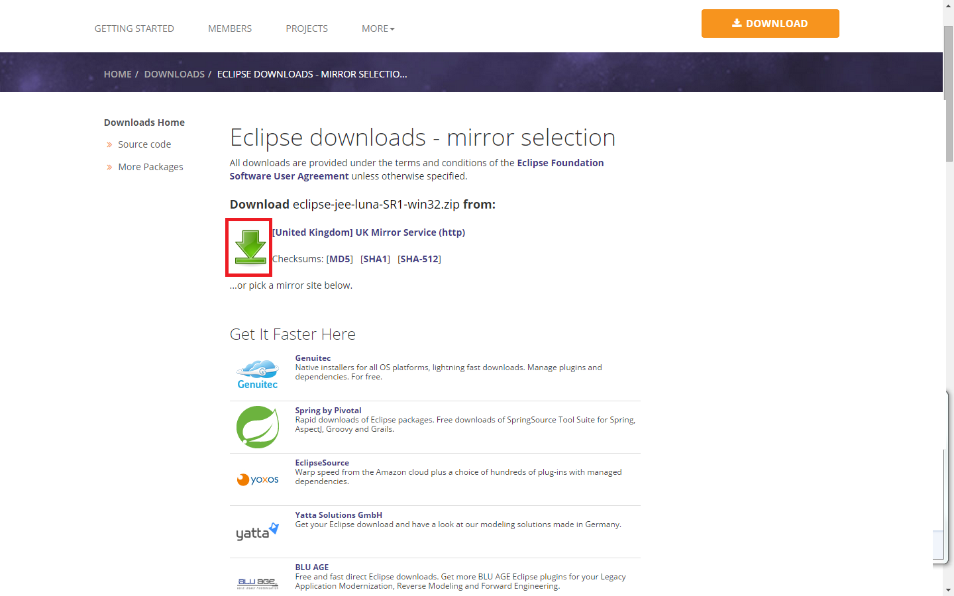
    2. After downloading the .zip file extract it using any .zip file extraction software such as WinZip or WinRAR or 7-Zip.
    3. In the extracted folder you will find a folder with name eclipse and inside that a file with name eclipse. The file type listed for this file is Application.

To start eclipse you can double click on above file. Please find below picture how the application file for eclipse looks like.

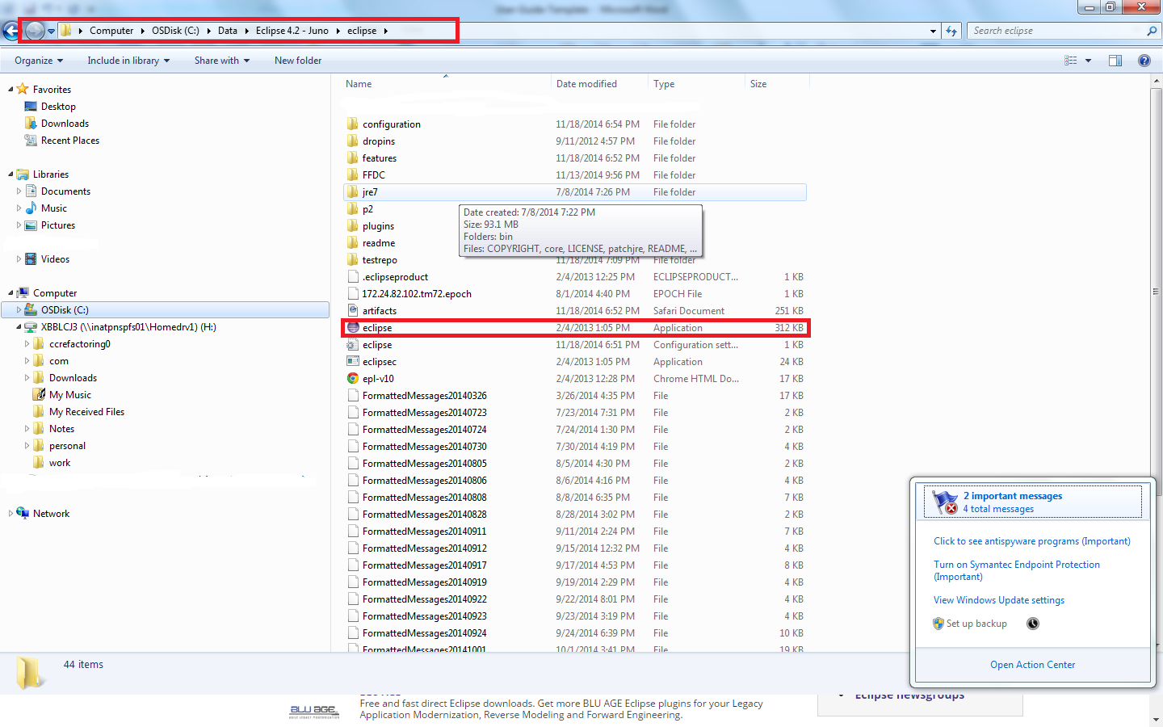

Before you can start working using Eclipse you need to setup JDK (Java develoement Kit ) as Eclipse uses Java to run. Please continue to read how to setup JDK.

2.2.1) Download JDK 7 from following location:

Insert URL

As shown in below picture download JDK version suitable for your operating

system.

Please make sure to download exact java version based on your operating system

32bit/64bit version.

Please select license agreement as marked in green as shown in below picture.

Insert Screenshot

2.2.2) Set up JAVA-HOME system environment variable

This environment variable is needed to let eclipse installation know location of java

installation on computer.

For e. g. If java is installed at c:/ program files /java /jdk1.17.0_71 then set JAVA_HOME equal to c:/programfiles/ Java /jdk1.7.0_71

Please follow following steps

1) Right click on my computer icon on desktop and click on properties.

2) click on advance system settings as shown below.

Insert Screensho

2.2.3) Click on environment variables as shown below in advanced tabs

Insert Screenshot

Click on new button to create a new environment variables.

In system variables section

Insert Screenshot

2.2.4)

set variable name to Java_ HOME and variable value to

c:/program files/ java/jdk1.7.0_71 and click on ok.

Insert Screenshot

3.1.1) Download and setup Tomcat

1) Download tomcat 7 from following location

Select appropriate version from your operating system and click on appropriate

link as mark in red in below picture.

Insert Screenshot

3.1.2) Extract downloaded.zip of archive on any directory .

It will be extracted to a directory with name corresponding tomcat version.

For e.g. Tomact version 7.0.52.It will be extracted zip available will create

a directory with name apache tomcat /7.0.52

3.2.1) Set up CATLINA_HOME environment variable.

please follow following steps

1) Right click on my computer on desktop and click on properties.

2) Click on advanced system settings as shown below.

3) Click on environment variable as shown below in advanced tab.

4) Click on new button to create a new environment variable in system variable

section.

5)Set variable name to CATLINA_HOME and

variable value to {path to Tomcat directory}. For E.g. if tomcat is installed at

c:/apche-tomcat then set the value to c:/apache tomcat and click on ok.

4.1.1) Integrate tomcat with Eclipse

Eclipse provides different perspectives to carry out different types of tasks.

Each perspective provides an environment and utilities to perform the task.

For E.g. java perspective allows to create stand alone java applications and

java ee perspective allows to create j2e applications.

Similarly debug perspective allows to debug an application.

To integrate a tomcat with eclipse we have to set up tomcat in j2ee perspective.

To switch to j2ee perspective click on window menu and select open perspective

as shown below.

Enter screenshot

From the list appears select j2ee as shown perspective as shown below.

Enter screenshot

4.1.2) In this perspective open the servers view as shown below by selecting

window-show view and servers.

This view is added by default at the bottom of the window.

Enter screenshot

Enter screenshot

In servers view right click and say create new server.

Select tomcat 7.0 from apache group as shown below.

Enter screenshot

# Index

[Depending on the size or complexity of the final document, consider pulling together an index to assist the using in location specific information. Index entries correspond to tags or categories, and are useful in navigating long books.]

## Style Sheet Information

The following styles have been set up in this template. Avoid applying manual character formatting to the document. Applying these styles will assist in the conversion process if the document is to be laid out in a structured authoring tool, content management tool, or an HTML editor.

| Style Name | Apply to |
| --- | --- |
| Title | Title as listed on the cover page of the document |
| Subtitle | Subtitle as listed on the cover page of the document |
| Heading 1 | Chapter Name or Process or Workflow |
| Heading 2 | Subsection or SubProcess or Workflow step |
| Heading 3 | Subsection 2 or Procedure |
| Callout Block Copy Note | Notes, cautions or warnings, use arrow graphic on the left margin |
| Chapter Body Copy | Generic text following a heading |
| * Chapter Body Copy – Bullet | Unordered list within a section or subsection, sometimes within a Step to indicate alternative ways to do something. |
| * + Chapter Body Copy – Bullet 2 | A secondary unordered list, within a higher level ordered or unordered list |
| 1. Chapter Body Copy – Step | An ordered list (sequential) used in a procedure to indicate the order of actions to be taken |
| 1. Chapter Body Copy – Step a | A secondary ordered list, e.g. substeps in a procedure |
| Chapter Body Copy – Indent | Sets additional text inward so that it aligns with either Chapter Body Copy – Bullet or Chapter Body Copy – Step |
| Chart Body Copy | Text within a table |
| Chart Header Information | The first row of a table. |
| Caption | Descriptive text for a table or graphic. |
| Header | Text that appears at the top of each page. |
| Footer | Text that appears at the bottom of each page. |
| Chart Title and Footer Info | Copyright and other front matter preceding the Table of Contents; additional information used to footnote or provide a legend for a table. |
| TOC Heading | Heading used for Table of Contents, Table of Figures (if applicable), and the Document Revisions pages of the front matter to the document. |
| TOC 1 | TOC display information for a chapter. Generated automatically from Heading 1. |
| TOC 2 | TOC display information for a sub-section. Generated automatically from Heading 2. |
| TOC 3 | TOC display information for a subsection 2. Generated automatically from Heading 3. |
| [Template Instructions] | Guidance on building out the user guide. Should be deleted prior to publishing. |